AI-Based Legal Document Search Using Vector Database
A Project Based Learning Report Submitted in partial fulfilment of the requirements for
the award of the degree
of
Bachelor of Technology
in the Department of Computer Science and Engineering
Database Engineering — Project Based Learning
Submitted by
2510030197 : Varshith
2510030127 : Srinikesh
2510030050 : Jatin
2510030019 : Girish Kumar
Under the guidance of
Dr. Rafeeq Mohammed

Department of Computer Science and Engineering
Koneru Lakshmaiah Education Foundation, Aziz Nagar
Aziz Nagar — 500075
OCTOBER — 2026
Abstract
This project presents an AI-based legal document search system designed to retrieve relevant legal passages from an indexed corpus using semantic similarity rather than relying only on exact keyword matching. The project was developed through four PBL reviews, moving from problem identification and feasibility analysis to literature review and gap analysis, then to a concrete methodology and finally to a working implementation with measurable retrieval results. The completed system uses a layered application architecture. React provides the browser interface, Spring Boot acts as the application-facing backend, and FastAPI owns the AI and semantic-search logic. ChromaDB stores embedding vectors and retrieval metadata. PostgreSQL stores structured document metadata and search history, while MongoDB Atlas stores legal-document content. The separation is deliberate: structured relational information, flexible document content, and vector similarity search have different storage requirements. The project corpus contains five focused legal reference PDFs: Constitution of India, Consumer Protection Act, Indian Contract Act, Copyright Act, and Information Technology Act. At the baseline validation checkpoint, 41 semantic chunks were indexed in ChromaDB. Seven manually selected legal-domain queries were tested through the working Spring Boot endpoint, producing 35 returned results. The expected document appeared at rank 1 for all seven queries; the mean top-1 similarity across the seven tested queries was 0.5937. These figures describe the tested query set, not a general benchmark of legal retrieval. The document also records verified API, integration, database, UI, and upload behavior. In particular, PDF ingestion was verified through FastAPI and then through Spring Boot, with Constitution and Consumer Act uploads returning 7 and 8 indexed chunks respectively. The project therefore demonstrates an operational end-to-end retrieval pipeline while clearly separating implemented features from future extensions such as production authentication, richer document management, source navigation, and formal latency benchmarking. Keywords: legal information retrieval, semantic search, legal embeddings, vector database, ChromaDB, PostgreSQL, MongoDB Atlas, FastAPI, Spring Boot, React, long-document chunking, source-aware retrieval, provenance, top-k search.
Core result: the project successfully routes natural-language legal questions through the full application stack to source-aware semantic retrieval.
List of Figures
Figure | Description
Figure 1 | Problem context motivating semantic legal retrieval.
Figure 2 | The four-review progression used to structure this project document.
Figure 3 | Proposed solution workflow derived from the problem identification.
Figure 4 | Simplified workflow: PDF ingestion and query retrieval converge on the same vector space.
Figure 5 | Seven-step literature review workflow used in Review-2.
Figure 6 | Recurring gap categories connected to the project direction.
Figure 7 | Data pipeline carried forward into Review-3 methodology.
Figure 8 | Preprocessing sequence from legal PDFs to vector-indexed chunks.
Figure 9 | Completed system architecture with application, AI and data layers.
Figure 10 | Why three stores are used for distinct data responsibilities.
Figure 11 | Implemented upload sequence that was verified through PowerShell.
Figure 12 | Actual React interface screenshot supplied from the current implementation.
Figure 13 | Upload path after integration fix.
Figure 14 | Top-1 similarity for the five newly tested legal domains.
List of Tables
Table | Description
Table 1 | Review-1 problem, need and objective mapping
Table 2 | Feasibility analysis
Table 3 | Literature study extraction framework
Table 4 | Review-2 comparison matrix
Table 5 | Gap categories and project response
Table 6 | Technology selection rationale
Table 7 | Project database responsibilities
Table 8 | Implementation modules
Table 9 | Verified API and integration tests
Table 10 | Seven-query semantic retrieval results
Table 11 | Upload/indexing verification results
Table 12 | Final measured project summary
Table of Contents
Section | Content
1 | INTRODUCTION — problem, context, scope and four-review roadmap
2 | METHODOLOGY — Review-1 problem definition; Review-2 literature, comparison and gap; Review-3 data pipeline and implementation
3 | EXPERIMENTS — execution environment, semantic-search protocol, API checks and document-upload verification
4 | RESULTS — seven-query retrieval, similarity scores, integration tests, upload results and analysis
5 | CONCLUSION AND FUTURE WORK — contribution, limitations and next steps
REFERENCES | Project review materials, research literature and India Code legal source documents
APPENDICES | Execution commands, test matrix, review traceability, reproducibility notes and detailed seven-query semantic-search evidence (Appendix D).
The ordering follows the supplied project-document template and maps the four PBL reviews into the requested academic report sequence. Review-1 establishes the problem and solution direction; Review-2 expands the methodology section through literature evidence and gap analysis; Review-3 deepens the methodology into implementation planning and experimentation; Review-4 supplies the final implementation results and analysis.
1. INTRODUCTION
Legal documents are large, structured, and often written using formal terminology that may differ from the wording used by a person asking a question. A researcher may know the legal issue but not the exact statutory phrase. This creates a practical information-retrieval problem: the document contains the evidence, but finding the right passage quickly is difficult when a search mechanism depends heavily on exact terms.
The project therefore treats legal search as an information-retrieval problem with a semantic component. Instead of comparing only strings, the system represents both documents and queries in a common vector space. Similarity between vectors becomes a signal for ranking candidate passages. Because retrieval alone is not enough, the system also preserves page, document, category, source, chunk and database identifiers so that a result can be inspected and traced.
The project was framed as a Database Engineering PBL because the problem is not only an AI problem. Legal documents have multiple data forms: structured metadata, document content, and vector representations. The final architecture therefore uses three data stores with distinct responsibilities, combined through a layered application stack.
The user-facing problem is best understood as a mismatch between natural-language questions and the formal language of legislation. A person may ask about consumer rights, contract validity or electronic records without knowing the relevant chapter, section heading or statutory phrase. A purely lexical query can return too much material when common words appear across many documents, yet miss a passage expressed with different terminology. Semantic retrieval addresses this mismatch by ranking passages according to their vector representations. It does not eliminate the need to inspect the source passage, but it can shorten the discovery step.
The project scope is a retrieval system, not an autonomous legal-advice engine. Its output is a ranked collection of passages with source information, rather than a final legal opinion. A result must remain inspectable through its filename, page, chunk number and associated metadata. This design choice is important in the legal domain because the applicable law can depend on jurisdiction, amendments, exceptions, facts and dates. The application therefore supports evidence discovery while leaving interpretation and legal decisions to a qualified human reader.
The work also provides a database-engineering case study. The same legal item has more than one useful representation: a structured metadata row for querying and reporting, a document-oriented record for content and flexible fields, and one or more vector records for similarity search. These representations have different query patterns and update requirements. Separating them makes each component easier to explain and maintain, although it introduces a synchronization responsibility that must be considered whenever new files are uploaded.
The development was staged through four PBL reviews. Review-1 established the problem and tested feasibility; Review-2 examined prior work and refined the gap statement; Review-3 converted that direction into data, architecture and implementation modules; and Review-4 concentrated on the running interface, integration tests, semantic-query results and limitations. The progression is reflected in the order of the report so that the reasoning behind the design can be traced to the implementation and its measured outcomes.
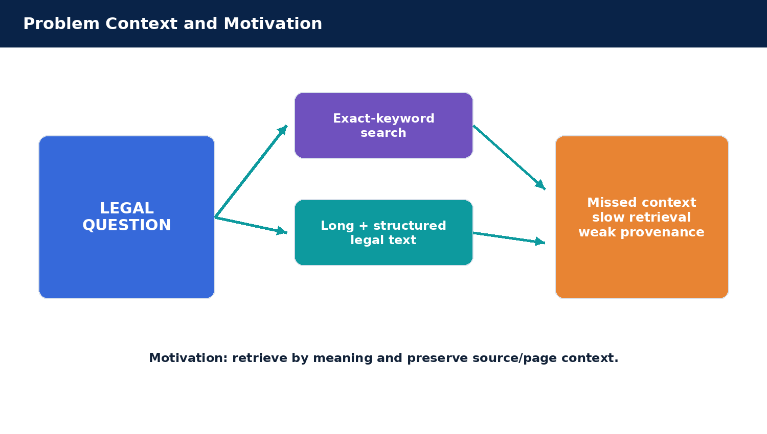
Figure 1. Problem context motivating semantic legal retrieval.

Report Structure and Four-Review Progression
The four review stages form one continuous engineering story rather than four disconnected submissions. Each review answers a different question: Why is the problem important? What has already been done and where is the gap? How will the proposed solution be implemented? What did the implemented system actually achieve?
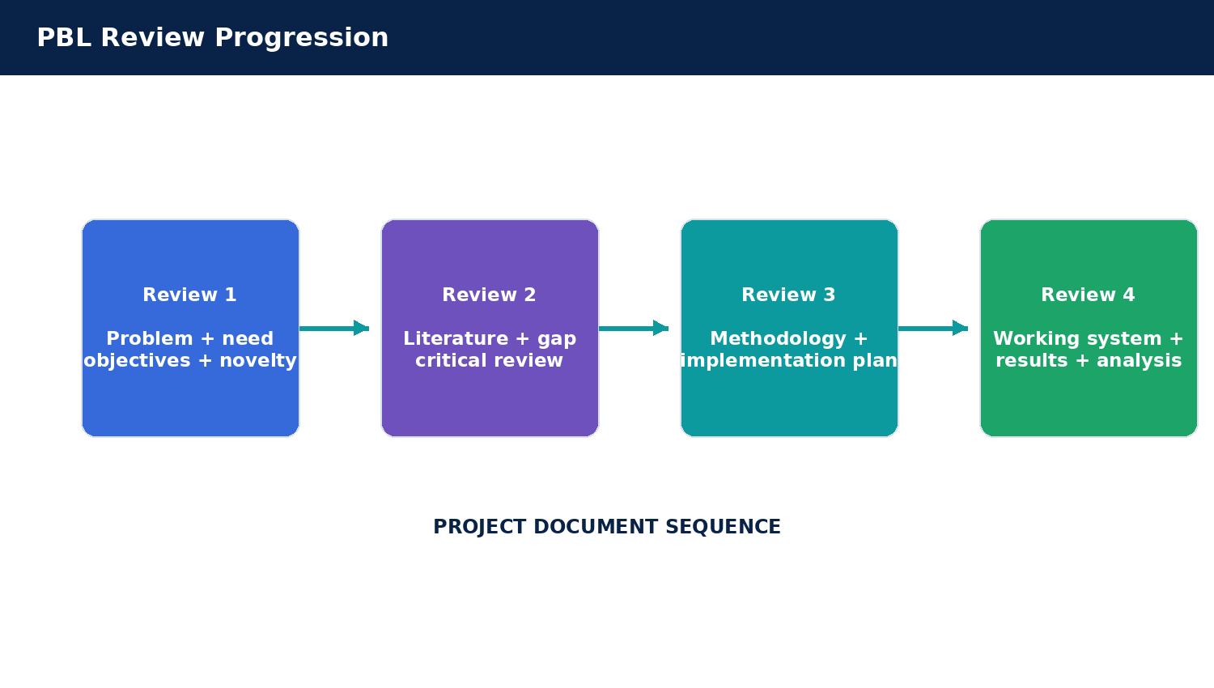
Figure 2. The four-review progression used to structure this project document.
Review | Primary question | Report contribution
Review-1 | Why this project? | Problem statement, societal need, objectives, feasibility, novelty
Review-2 | What is already known? | Literature review, comparison, gap analysis, critical review
Review-3 | How will it be built? | Methodology, data pipeline, architecture, technology and validation plan
Review-4 | What actually works? | Implementation, tests, measured retrieval results and analysis
2. METHODOLOGY

Problem Identification
The primary problem identified in Review-1 is that traditional keyword search can fail when the user’s wording and the legal document’s wording differ. A user may search for “what protections exist for copyrighted work?” while the underlying document describes ownership, licensing, infringement, exceptions and remedies using formal statutory terminology. A literal keyword match may fail to surface the strongest evidence consistently.
- Exact-keyword dependence can miss semantically related passages.
- Long and hierarchical legal documents contain relevant information across multiple sections and pages.
- Legal terminology is domain-specific and includes cross-references that are difficult to search with simple strings.
- The most useful result needs context such as document identity, page, category and source.
- A practical system needs a traceable storage design for vectors, structured metadata and document content.
The problem is therefore broader than “search is slow”. The engineering challenge is to build a retrieval workflow that understands meaning, preserves provenance, and integrates multiple data stores without making the user interact with each storage technology separately.
The problem statement was converted into a small set of observable requirements. First, a user must be able to submit an ordinary-language question without having to know the exact document filename. Second, the system must return multiple passages in an ordered list rather than a single opaque hit. Third, each hit should preserve provenance fields that help a user verify where it came from. Fourth, the same request should travel through the published application API so that the frontend is not coupled directly to the Python AI service. Finally, successful searches should leave a record of the query so the work can be inspected during testing.
The system is deliberately bounded. It does not determine which law applies to a real dispute, validate whether a statutory provision is current, or replace a lawyer. It does not yet enforce server-side user identity or roles. These boundaries keep the first implementation tractable and prevent the report from overclaiming the system’s legal capability. They also become useful future-work items because production deployment would require stronger authority checks, document-version management and security review.
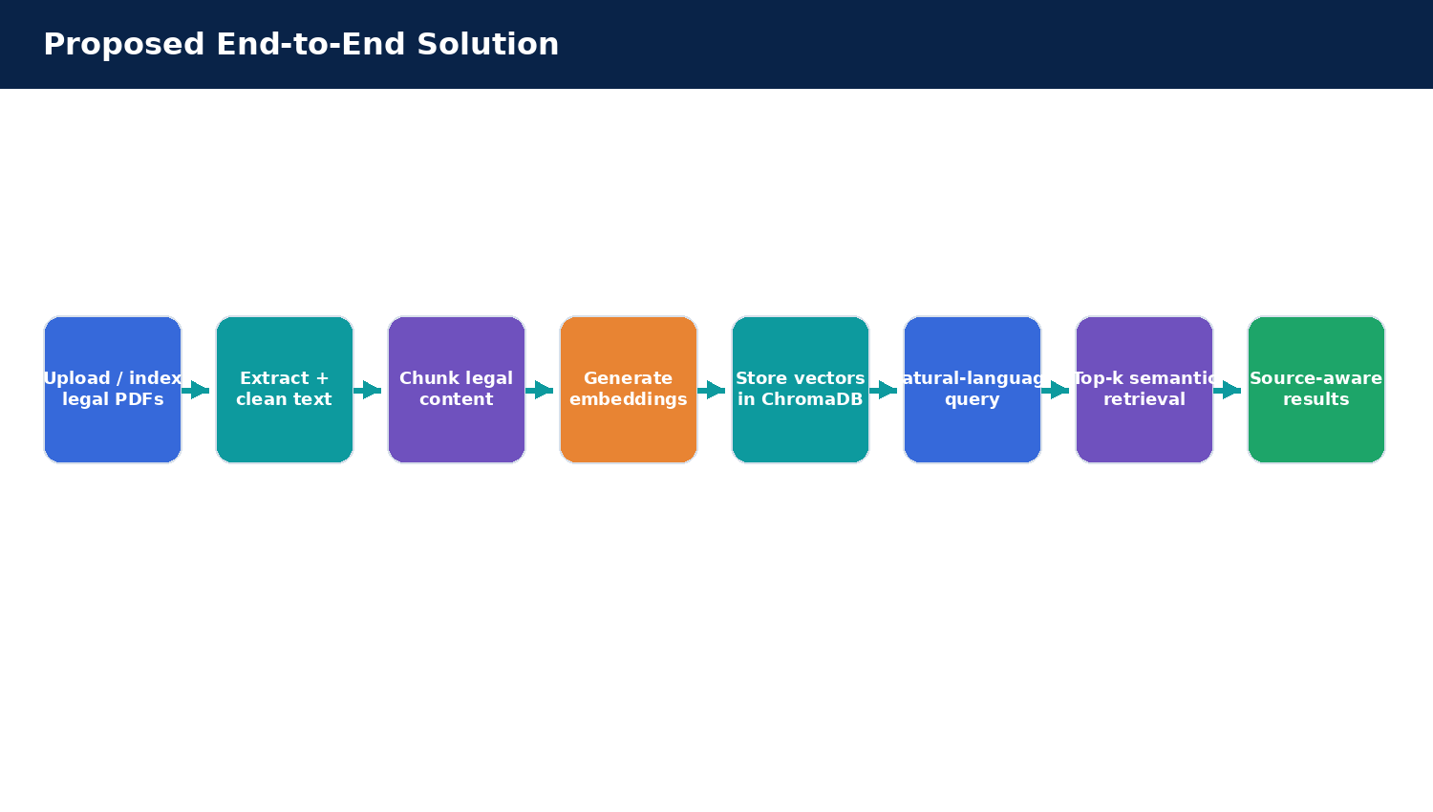
Figure 3. Proposed solution workflow derived from the problem identification.

Need for the Project
The need for the project arises from the practical effort required to navigate statutes, regulations and other legal documents. Lawyers and legal researchers may need to locate relevant provisions quickly; students need accessible tools for discovering source material; institutions may need structured access to legal content and metadata. The project direction is therefore motivated by faster information discovery and more transparent retrieval rather than automated decision-making.
Stakeholder | Observed need | System response
Legal researchers | Find relevant passages quickly | Natural-language semantic retrieval
Students | Discover legal material without knowing exact wording | Query by meaning using embeddings
Institutions | Maintain structured legal metadata | PostgreSQL metadata layer
Application developers | Support semantic retrieval as a service | FastAPI + Spring Boot APIs
Database engineers | Store different data types appropriately | Polyglot persistence
The social value is framed as improved access to legal knowledge and reduced manual search effort. The project does not claim that retrieval accuracy alone improves legal outcomes. Instead, it contributes an evidence-discovery layer that can support research and learning while encouraging users to inspect the underlying source material.
For students, the system can be used to discover which legal topic and source document deserve closer reading. For legal researchers, it provides a first-pass retrieval layer over a compact corpus. For institutions, the architecture illustrates how an application can combine browser interaction, service boundaries and multiple data stores. In all cases the value is reduced discovery friction, not automated adjudication.
Accessibility also depends on how results are presented. A similarity value without a document name or passage is difficult to trust; a passage without a source is difficult to check. For this reason the interface surfaces the title, filename, page, category, source and retrieval score where the API supplies them. The metadata is not decoration: it is part of the evidence needed to assess whether a retrieved passage is useful.

Project Objectives
The objectives established during Review-1 were carried forward into the later implementation and evaluation stages.
The objectives were carried into implementation as acceptance checks rather than left as broad intentions. The search objective was evaluated with a curated seven-query set across five legal domains. The integration objective was evaluated by calling FastAPI directly, calling the Spring Boot gateway, and then using the React browser interface. The ingestion objective was evaluated by submitting PDFs through the upload endpoints and checking the returned chunk count. Database responsibilities were checked against the baseline metadata and document records. This mapping helps distinguish features that have been demonstrated from items that remain planned.
Objective | Meaning | Implementation evidence
Semantic retrieval | Convert legal text and user questions into embeddings and rank related chunks. | FastAPI semantic search + ChromaDB.
Source-aware results | Return evidence with document/page/source context. | API response includes document, page, category, source, chunk and similarity.
Polyglot persistence | Use different databases for different data shapes. | PostgreSQL + MongoDB Atlas + ChromaDB.
Integrated services | Connect the user interface to the AI retrieval layer through a backend boundary. | React → Spring Boot → FastAPI.
Document ingestion | Turn legal PDFs into retrieval-ready chunks. | FastAPI `/documents/upload` with chunk indexing.
Traceable activity | Record search activity for application-level history. | PostgreSQL `search_history`.

Requirements Traceability and Acceptance Criteria
The project requirements were organized around observable outputs. A successful search should accept a non-empty natural-language query, return a list of at most five ranked chunks under the current default configuration, and preserve the document filename, page, chunk number and similarity value. Where a metadata record exists, the response should also contain the title, category, source, PostgreSQL document identifier and MongoDB reference. The frontend should render the data returned by the API rather than manufacturing a result list locally.
For document ingestion, a valid PDF should travel to FastAPI through the Spring Boot route, be processed by the ingestion function and return a response that identifies the file and the number of chunks indexed. An empty or non-PDF input should be rejected or reported as an error. A successful indexing response must be distinguished from full cross-database registration: those are separate conditions and require their own verification. These acceptance criteria became the basis for the integration checks reported in the Experiments and Results sections.
For data management, the baseline corpus provides a reference state of five legal PDFs, 41 indexed chunks, five PostgreSQL metadata rows and five MongoDB legal-document records. These are baseline counts observed before later upload demonstrations. They act as a consistency snapshot, not as a claim about the live number of ChromaDB entries after files were uploaded again during debugging.

Proposed Solution / Methodology
The proposed solution is a layered legal document retrieval platform. Legal PDFs are ingested and transformed into retrieval-ready chunks. Each chunk is represented by an embedding and stored in ChromaDB together with document, page and chunk metadata. A user enters a natural-language question through React. Spring Boot receives the request and forwards it to FastAPI. FastAPI embeds the query, performs top-k similarity retrieval, enriches the results with PostgreSQL metadata, and returns structured JSON to Spring Boot and then to React.
The solution has two related pipelines. The offline or upload-time pipeline converts a PDF into retrieval-ready chunks and persists their vectors. The online query pipeline takes a natural-language question, produces a vector representation using the same configured embedding process, retrieves the closest chunks, enriches them with metadata, and returns structured JSON. Keeping these pipelines conceptually separate is important: a query can only retrieve a new document after its content has actually been indexed, and a successful file selection in the browser is not evidence of ingestion by itself.
Figure 4. Simplified workflow: PDF ingestion and query retrieval converge on the same vector space.
- Prepare and index a curated legal-document corpus.
- Extract text while retaining page/document identifiers.
- Split long documents into manageable retrieval chunks.
- Generate embeddings for the chunks and store them in ChromaDB.
- Accept natural-language questions through the React interface.
- Generate a query embedding and retrieve the top-k chunks.
- Enrich the results with structured metadata and present them to the user.

Feasibility Analysis
Dimension | Assessment for the project
Hardware | A standard development laptop/desktop is sufficient for the current five-document academic corpus and local services.
Software | React, Spring Boot, Python/FastAPI, PostgreSQL, MongoDB Atlas and ChromaDB are all practical components for the prototype.
Data | Public legal reference documents provide a focused corpus suitable for indexing and semantic-search demonstration.
Integration | REST/HTTP APIs provide a clear boundary between browser, application backend and AI service.
Scalability | The modular design permits expansion of the corpus and eventual deployment without replacing the core retrieval concept.
Maintainability | Separating relational metadata, document storage and vector retrieval keeps responsibilities explicit.
The feasibility analysis also acknowledges constraints. A larger corpus would require formal benchmarking, vector-index tuning, stronger metadata filtering, more robust provenance, and production security. The current implementation should therefore be understood as a well-defined academic prototype rather than a production legal service.
Technical feasibility was demonstrated on a Windows development environment using Python, a Java Spring Boot service, a React/Vite frontend and the existing database services. The build was reproducible through the project Maven Wrapper, and the Python service ran in an isolated virtual environment. Economic feasibility for the prototype is favorable because the system uses the student development environment and local/open-source application components; however, this is not a cost model for a production service. Operational feasibility is shown by the explicit startup steps and local health endpoints.
The principal risks are indexing duplicate files, inconsistent metadata across stores, poor retrieval for questions outside the corpus, changes to legal source material, and performance degradation as the corpus grows. These risks do not make the prototype infeasible; they define the controls that a later version should add. A production system should assign a stable document identity, detect duplicates using a hash, version source documents, log ingestion status, and provide a re-indexing procedure when the parsing or embedding method changes.

Novelty and Project Contribution
The project novelty is not the claim that semantic legal search has never been implemented. Review-2 explicitly refined this position. The contribution is a practical student-scale integration that combines semantic retrieval with a deliberately separated data layer and source-aware results. The system makes vector retrieval visible as part of a broader database-engineering application.
The contribution is therefore integration-oriented and demonstrative. The project brings together the user-facing search flow, service-to-service communication, vector retrieval, structured metadata and document records in one runnable application. Its evaluation also includes concrete domain queries and visible similarity scores. The correct academic claim is that this implementation demonstrates a small, source-aware semantic-search workflow and documents its measured behavior on a selected set of queries; it is not a claim of state-of-the-art legal retrieval performance.
- Semantic AI retrieval instead of relying only on exact keyword matching.
- Hybrid SQL + document + vector storage using PostgreSQL, MongoDB Atlas and ChromaDB.
- Layered microservice-style architecture using React, Spring Boot and FastAPI.
- Source-aware retrieval that preserves document/page/chunk identity.
- A demonstrable upload path that converts a PDF into indexed semantic chunks.
- Measured multi-domain test cases showing correct top-1 document ranking on the selected query set.

Current Transition/Progress:
Review-1 established the problem and a plausible solution. The next question was whether the proposed direction was grounded in existing research. Review-2 therefore treated literature review as a structured engineering activity rather than a collection of unrelated papers. The project team investigated legal document representation, semantic similarity, embedding methods, vector retrieval, long-document handling, database architecture and evaluation considerations.
Review-1 output | Review-2 question | Resulting decision
Semantic search objective | What retrieval methods already exist? | Compare embedding/vector/graph/RAG approaches.
Polyglot database idea | Why multiple stores? | Study data-model fit for relational, document and vector data.
Source-aware results | What are the trust/provenance concerns? | Treat explainability and source grounding as design considerations.
Long legal documents | How is long-context retrieval handled? | Include chunking and provenance in the gap analysis.

Literature Review Foundations
A literature review was defined during Review-2 as the systematic study of existing work related to the project topic, including research papers, architectures, technologies, algorithms, limitations and possible improvements. The purpose was not merely to gather information. The literature study was intended to answer five practical questions: what already exists, how it works, what databases or vector stores are used, what problems remain, and what the project can improve or demonstrate.
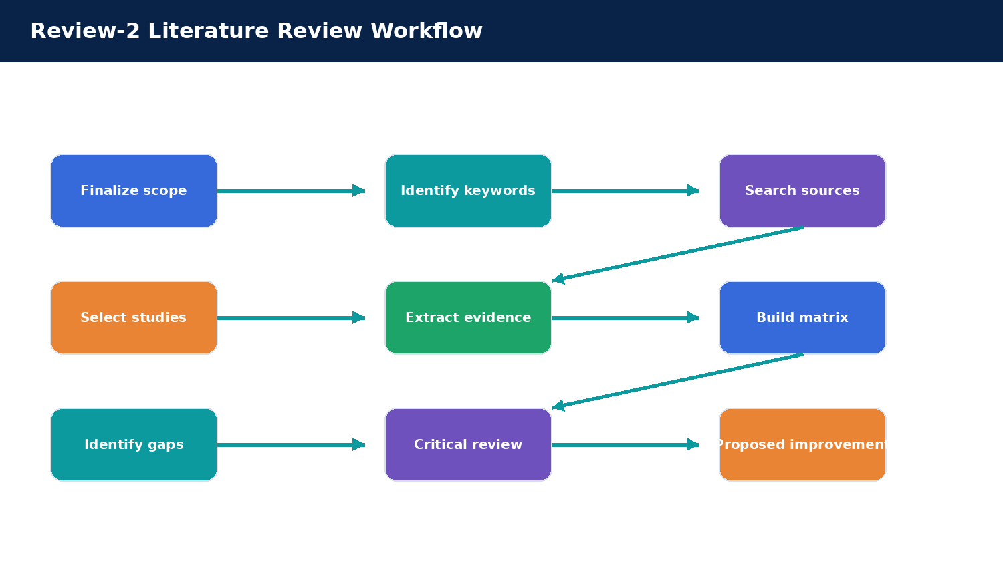
Figure 5. Seven-step literature review workflow used in Review-2.
The legal-search domain requires attention to both application and data architecture. Existing legal AI research can be viewed through the lenses of legal information retrieval, semantic similarity, domain-specific language representation, vector stores, knowledge graphs, RAG, source grounding and evaluation. Database engineering adds an additional dimension: how documents, metadata, embeddings, users and history should be persisted and accessed.

Why the Literature Review Was Necessary
Question | What the review learns
What already exists? | Existing semantic retrieval, Legal-BERT, legal case-retrieval, vector search and RAG approaches.
How was it developed? | Embedding, chunking, graph, benchmark and retrieval methodologies.
What database was used? | Vector stores, relational data stores, document stores or combinations.
What problems remain? | Long-document context, legal terminology, cross-references, provenance, evaluation and scalability.
What can we improve? | A practical integrated, source-aware database engineering implementation.
The review materials also distinguish internet search from literature review. A conventional web search may find information, but a literature review compares studies analytically by task, method, data, architecture, result and limitation. This distinction became the basis for the comparative matrix used in the project.

Topic, Keywords and Search Strategy
The review vocabulary was derived from the project’s actual components: legal information retrieval, semantic similarity, legal-domain language models, vector search, document chunking, retrieval-augmented generation, provenance and multi-database persistence. This prevents the literature review from drifting into unrelated AI topics. Source discovery used academic search platforms and publisher repositories, while official legislative sources were used for the legal corpus itself. The distinction is important: academic papers support design reasoning, while the official legal source supports the origin of the document content.
The working selection criteria were relevance to legal retrieval or legal document representation, an identifiable method, and enough bibliographic detail to trace the work. Papers about generic text classification were considered less central unless they informed domain adaptation or representation learning. The comparison focused on the problem addressed, representation or retrieval method, data model, evaluation evidence, strengths and limitations. This matrix-based method makes the review comparative rather than a sequence of unrelated paper summaries.
The project topic was decomposed into research keywords so that literature searches remained focused on legal retrieval rather than generic AI. The core terms were legal document retrieval, semantic legal search, legal embeddings, vector database retrieval, legal NLP, retrieval-augmented generation, long-document chunking, provenance and source-aware retrieval.
- “legal semantic search embeddings”
- “legal case retrieval vector database”
- “legal RAG document retrieval”
- “Legal-BERT legal retrieval”
- “vector database legal search”
- “legal RAG benchmark”
The Review-2 materials identify academic and official sources as the preferred evidence base: Google Scholar, IEEE Xplore, ACM Digital Library, SpringerLink, ScienceDirect, university repositories, Semantic Scholar and related discovery tools. Reference managers such as Zotero or Mendeley were also identified for organizing sources.

Source Selection and Evidence Extraction
For each selected source, the review records five recurring questions: what problem is addressed, what representation or search method is used, what evidence supports the result, what limitation remains, and how the finding relates to this project. Recording limitations matters as much as recording strengths. For example, a graph-based method may represent legal references more explicitly than plain vectors, but it adds schema-construction and maintenance costs. A dense vector index is simpler to prototype but relies on chunking and may return a relevant topic without resolving a formal cross-reference.
For each selected study, Review-2 proposed capturing the title, authors, year, problem addressed, embedding or retrieval method, vector/database technology, dataset or legal corpus, main result, advantages, limitations and future work. This extraction structure makes the comparison consistent and avoids treating a paper’s headline result as sufficient evidence.
Paper component | Extraction question
Title / year | What problem and research context are being addressed?
Abstract | What method and result are emphasized?
Methodology | How does the system retrieve or represent legal information?
Database / architecture | Which stores, indexes or services are used, and why?
Dataset / corpus | What legal data are used and at what scale?
Results | Which metrics or qualitative outcomes are reported?
Limitations | What remains weak, missing or untested?
Future work | What extensions are proposed?

Literature Review Matrix
The matrix supports three complementary families of research. The first concerns domain-adapted language representation, exemplified by LEGAL-BERT, which investigates how pre-training and fine-tuning strategies behave in legal NLP [16]. The second concerns direct legal retrieval with document embeddings. Sugathadasa and colleagues study legal document vectors and deep-learning retrieval, providing an early example of semantic representation in the legal domain [11]. The third family enriches representation with structure: heterogeneous legal graph embeddings model entities and relationships that a flat text vector may not express explicitly [12].
More recent work highlights that retrieval quality depends on the granularity of the retrieved unit. Research on legal chunking compares text splitting and semantic chunking approaches, noting that no single method guarantees strong relevance for every legal query [19]. Work evaluating multiple embedding methods on legal fact drafts also illustrates the importance of selecting a representation based on the legal task and the structure of the input [13]. These findings directly support retaining document, page and chunk identifiers in this project and evaluating several query domains instead of relying on a single illustrative question.
Study / year | Store / approach | Key finding | Limitation / gap
Sugathadasa et al. (2018) | Vector / legal embeddings + deep learning | Semantic representation can improve legal retrieval. | Older embedding approaches; limited modern vector DB focus.
Bi et al. (2022) | Knowledge graph + embeddings | Legal entities and relationships can enrich similarity. | Higher modeling and graph-construction complexity.
Legal semantic search (2024) | Vector retrieval + multiple embedding models | Embedding choice and chunking strongly influence retrieval. | Long-document context remains challenging.
LegisSearch (2025) | Vector + graph | Graph-enhanced context can enrich legal relations. | Graph design adds implementation complexity.
Poly-Vector Retrieval (2025) | Multiple vector representations | Separating content/reference representations can help reference-centric queries. | Emerging direction requiring broader evaluation.
The study labels above are preserved from the Review-2 project material. Where a slide did not provide complete bibliographic information, this report retains the project label rather than inventing missing author, venue or DOI details. Before publication outside the PBL context, the original papers should be checked and full citation metadata completed.

Additional Legal-AI Study Themes
Study / theme | Project interpretation
Legal-BERT (2020) | Domain-specific language representation illustrates why general-purpose language models may benefit from legal-domain adaptation.
LegalBench-RAG (2024) | Benchmark-oriented evaluation emphasizes the need for precise retrieval and grounded evidence rather than unsupported language generation.
JusBuild (2025) | Structured retrieval and legal drafting contexts show how vector search can support task-specific legal workflows.
Legal case retrieval surveys | Case retrieval literature highlights the importance of representation, relevance, ranking and evaluation.
Knowledge-graph legal search | Entity and relation modeling can add context but introduces more complex data construction.
RAG-based legal systems | Retrieval helps ground natural-language outputs, but source provenance and factuality remain essential.

Literature Synthesis by Research Theme
Domain-adapted language representation is one relevant research direction. LEGAL-BERT investigates how general-purpose BERT representations and legal-domain pre-training strategies behave on downstream legal NLP tasks [16]. Its relevance to this project is methodological: legal language has domain-specific terms and formulaic structures, so embedding choice should be treated as an engineering decision rather than assumed to be universal. The current application uses its configured embedding service for both indexed text and queries; the implementation report does not claim that the system itself fine-tunes LEGAL-BERT.
Direct semantic retrieval is represented by Sugathadasa and colleagues, who study legal document vector embeddings and deep-learning retrieval [11]. This line of work supports the core idea of representing a legal passage in a vector space and ranking candidates by semantic relation. The project implements a smaller version of that idea: create chunk vectors, store them in ChromaDB, and query them with an embedding generated from the user’s question. The project evaluation concentrates on whether the expected legal document appears first for the selected questions.
Structure-aware representation is represented by heterogeneous graph embeddings for Chinese legal-document similarity [12]. The central lesson is that legal documents do not exist as isolated paragraphs: entities and references can carry context. A graph can make those connections explicit, but creating and maintaining the graph adds design work beyond a compact student prototype. The present system therefore keeps source and document metadata and leaves an explicit legal knowledge graph as future work.
Recent retrieval work emphasizes the granularity of the retrieved unit. LegalBench-RAG focuses on evaluating retrieval with small, highly relevant snippets instead of only document identifiers or broad text blocks [17]. Legal chunking studies compare segmentation strategies and report that segment boundaries influence semantic relevance [19]. Those observations support retaining page and chunk identifiers and inspecting full passages in the result detail view. They also show why the existence of a vector score alone is not enough to prove that the best possible legal excerpt has been retrieved.
Poly-Vector Retrieval separates content embeddings from references and labels so that provision names and cross-reference markers can be retrieved differently from general semantic content [15]. LegisSearch combines graph structure with language models and text embeddings for navigating legislation [14]. Both lines suggest improvements that could be added after the base search and provenance contract is stable: query expansion for formal section labels, graph-based navigation, and a representation designed specifically for legal references. These capabilities are not claimed as implemented in the current version.
JusBuild explores retrieval-augmented assistance for legal document building, including segmentation, vector retrieval and human-controlled suggestions [18]. Its focus differs from this project, which retrieves legal passages instead of drafting a new legal document, but it reinforces an important safety principle: AI support should preserve human control. The present system follows that boundary by returning source-aware passages and avoiding an unsupported claim that the result is an authoritative legal opinion.
The literature synthesis therefore leads to a measured design decision. A dense-vector database is a useful baseline because it is straightforward to integrate and test. Metadata and page identifiers improve interpretability. More advanced approaches such as domain-specific embedding fine-tuning, graph-based legal relations and snippet-level relevance evaluation remain promising but require a larger corpus, formal labels and additional implementation effort.
Across these themes, the literature points repeatedly to semantic representation, retrieval quality, long legal documents, structured context and evaluation. These recurring patterns informed the project gap rather than any single paper dictating the final design.

Comparative Analysis
The comparison suggests a spectrum of design complexity. Keyword retrieval is easy to understand and useful when the user knows the exact statutory label, but it can be brittle when the wording differs. Dense-vector retrieval is a compact baseline for semantic matching and works naturally with a vector database, but it can miss label-centric references or relevant context split across chunk boundaries. Graph-enhanced retrieval can model cross-references and legal entities, but requires the graph to be built and maintained. RAG adds a generation layer, yet generated statements still depend on correct retrieval and explicit source grounding. Graph-oriented legal navigation is represented in recent systems such as LegisSearch [14], whereas precise chunk retrieval is emphasized by LegalBench-RAG [17] and chunking studies [19].
The project chooses a practical middle point: use embeddings and ChromaDB for retrieval, keep structured metadata in PostgreSQL, and retain the legal content representation in MongoDB Atlas. This design is smaller than a graph-based legal knowledge system and does not attempt to generate legal conclusions. It is appropriate for an academic prototype because each service has a clear responsibility and its output can be inspected. Formal comparison with a keyword baseline and larger retrieval benchmarks remains future evaluation work.
The comparative analysis distinguishes between approaches that focus on representation, approaches that enrich context with relationships, and approaches that emphasize retrieval benchmarks or application integration. Embedding-based retrieval offers a relatively direct path from text to semantic similarity. Knowledge-graph methods provide relation-aware context but require additional modeling. RAG architectures add answer-generation capabilities but increase the need for provenance controls. Benchmark studies provide evaluation discipline but do not necessarily provide a complete end-user database application.
Approach | Strength | Trade-off | Fit for this project
Embeddings + vector DB | Direct semantic similarity and simple retrieval boundary. | Quality depends on embedding and chunking. | High — core retrieval mechanism.
Knowledge graph + embeddings | Represents legal relations. | More complex data construction. | Medium — useful future enhancement.
RAG / answer generation | Natural-language explanations. | Risk of unsupported answers without grounding. | Future — retrieval is prioritized first.
Relational DB only | Strong structured metadata and transactions. | Not a natural semantic vector store. | High for metadata, not retrieval alone.
Document DB only | Flexible legal document structure. | Structured relationships and transactions need care. | High for document content, not vector retrieval alone.

What Is Gap Analysis?
The gap identified by the reviews is not that legal semantic search has never existed. The gap is practical and evaluative: a student-scale implementation needs to connect semantic retrieval, source-aware output, relational metadata, document storage and an application-facing API while documenting what was actually verified. Existing studies demonstrate promising methods, yet their datasets, languages, graph structure and evaluation protocols differ from this project’s compact India Code reference corpus. Their results therefore guide design but cannot be transferred as a performance claim for this implementation.
Gap analysis was defined as the identification of an important limitation or missing capability that existing work does not adequately address. The project avoids the incorrect claim that nobody has built legal semantic search. Instead, the gap is framed as an opportunity for a lightweight, modular academic implementation that combines structured metadata, legal document storage, vector retrieval and source-aware results in one system.
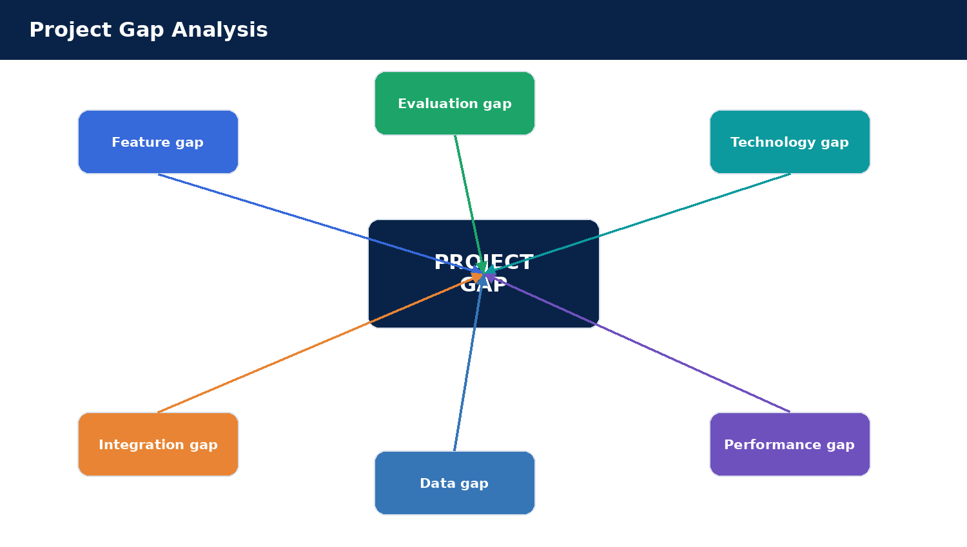
Figure 6. Recurring gap categories connected to the project direction.
The key recurring themes were feature gaps, technology gaps, performance gaps, scalability gaps, integration gaps, data-management gaps and evaluation gaps. These categories are more useful than a single vague statement because each one leads to a concrete engineering consideration.

Gap Categories and Project Response
The response to the integration gap is a three-service application boundary: React handles interaction, Spring Boot exposes the application API, and FastAPI performs the AI retrieval work. The response to the data-management gap is polyglot persistence. The response to the evidence gap is a test matrix with query text, expected top document, observed top document and similarity score. The response to the provenance gap is to return filename, page and metadata fields with each result. These responses are intentionally modest, testable and tied to observable project behavior.
Gap type | Observed issue | Project response
Feature | Retrieval may stop at ranked documents. | Source-aware result cards and metadata.
Technology | Modern embeddings/vector stores evolve rapidly. | Modular embedding + ChromaDB service boundary.
Performance | Retrieval quality depends on chunking, embedding and top-k. | Measured semantic test set; future formal benchmarking.
Scalability | Long legal corpora need efficient indexing/filtering. | Separate vector store and metadata layer.
Integration | Data and retrieval components are often separated. | React + Spring Boot + FastAPI + three stores.
Data management | Legal content is long, hierarchical and cross-referenced. | Page/chunk/document metadata preserved.
Evaluation | Relevance must be demonstrated with representative queries. | Seven-query test set and explicit top-1 reporting.

Critical Review
A critical assessment must also consider how the current evaluation could mislead. The seven questions were selected to correspond to known documents in a five-document corpus, so the test is useful for integration and smoke evaluation but is not a representative sample of all legal questions. The 7/7 top-1 result is therefore descriptive of this test set; it does not establish a general error rate or prove that every passage returned is legally sufficient. A stronger evaluation would use a larger, independently labelled set, multiple annotators where possible, and metrics such as Precision@k, Recall@k and Mean Reciprocal Rank.
The project also does not report response time because no controlled timing instrument was used during the captured tests. A single interactive request is affected by process startup, model loading, local hardware, network stack and cache state. A defensible latency result should report repeated measurements, a median and a high percentile, with the same corpus and model state. Until those measurements exist, the report records integration success and query relevance only, not a response-time claim.

Data Quality, Versioning and Legal Provenance
The retrieved chunks depend on the quality of the source files and the extraction pipeline. Scanned pages, repeated headers, malformed text encoding, missing page boundaries and long tables can all affect the resulting text. A robust ingestion process should log the original filename, source URL or source record, ingestion timestamp, file hash, parser result, chunk count and embedding version. That log would make a result reproducible and help the team explain why an uploaded document produces a particular ranking.
Legal text is version-sensitive. A provision may be amended, replaced or interpreted by later decisions. For this reason, the baseline PDFs are treated as project reference editions rather than a guarantee that the legal text is the latest consolidated law. A production system should record publication or access dates, identify applicable amendments, and provide a clear route to the authoritative source. The current UI presents source metadata as context and deliberately avoids generating definitive legal advice.
The system should also separate provenance from trust. An India Code source label helps users identify the origin of a document, but the search application itself does not certify that every extracted passage is complete or current. The result should be checked against the source document when used for study or research. This is particularly important if OCR, chunking or metadata synchronization changes the passage shown in the browser.
Critical review goes beyond describing what an existing study did. It asks whether the selected method is appropriate, reproducible, efficient and sufficient for the intended task. The project review questions included: Is the legal retrieval problem clearly defined? Why is the selected database/vector architecture appropriate? Are relationships and transactions important? Was performance measured? What dataset size was used? Was scalability considered? Are the results convincing? Were alternative approaches compared?
Aspect | Critical observation used in the project
Strengths | Flexible document structures and vector retrieval can simplify semantic matching.
Limitations | Complex relationships, legal cross-references and long context require careful design.
Evidence gap | Benchmark results may not map directly to end-user database applications.
Possible improvement | Compare relational and document models where transactions or relationships matter; add stronger retrieval evaluation.
Trust consideration | Show retrieved source passages instead of generating unsupported legal claims.

Tools, Resources and Responsible AI Use
- Google Scholar, IEEE Xplore, ACM Digital Library, SpringerLink and ScienceDirect for primary research discovery.
- Semantic Scholar and Connected Papers for related-paper discovery.
- Zotero or Mendeley for organizing papers, notes and references.
- AI tools for simplifying methodology, comparing database choices and generating structured notes — with verification against originals.
The project also applies a broader responsible-AI principle: a language model or assistant should not be treated as the source of legal authority. The system is designed around retrieval evidence from indexed legal sources. The final interface explicitly treats retrieved passages as evidence and warns that they are not legal advice.

Proposed Project Direction
The selected direction follows from the evidence rather than from novelty claims alone. The project adopts semantic embedding retrieval because it can match a natural-language question to related wording; ChromaDB because it supports vector similarity retrieval; PostgreSQL because document metadata and query history are structured records; MongoDB Atlas because document content can be represented flexibly; and separate Spring Boot/FastAPI services because the UI-facing API and Python retrieval logic have distinct implementation concerns. The design keeps source context attached to the ranked chunks so users can verify the passage rather than treating the score as a legal answer.
The literature findings support a modular direction: PostgreSQL for structured metadata and search history, MongoDB Atlas for legal document content, and ChromaDB for embedding vectors and similarity retrieval. FastAPI isolates the AI pipeline, while Spring Boot forms the application-facing service boundary and React provides the user interface. The selected direction also reflects the published retrieval literature on vector embeddings, legal-domain adaptation, structure-aware search and retrieval benchmarks [11]–[19].
Layer | Responsibility | Rationale
React | Search and document-management UI. | Keeps presentation separate from AI logic.
Spring Boot | Client-facing REST API and orchestration. | Provides an application boundary and integrates with FastAPI.
FastAPI | Embeddings, semantic retrieval, ingestion and enrichment. | Python ecosystem suits the AI/data-processing pipeline.
ChromaDB | Vector storage and top-k similarity retrieval. | Natural fit for embedding-based search.
PostgreSQL | Metadata and search history. | Strong structured schema and query support.
MongoDB Atlas | Legal-document records/content. | Flexible document-oriented representation.

Current Progress:
Review-2 converted the project from a general idea into a defensible engineering direction. Review-3 then answered the implementation question: what data will be used, how will it be preprocessed, which components will interact, what technologies are selected, and how will the system be tested?
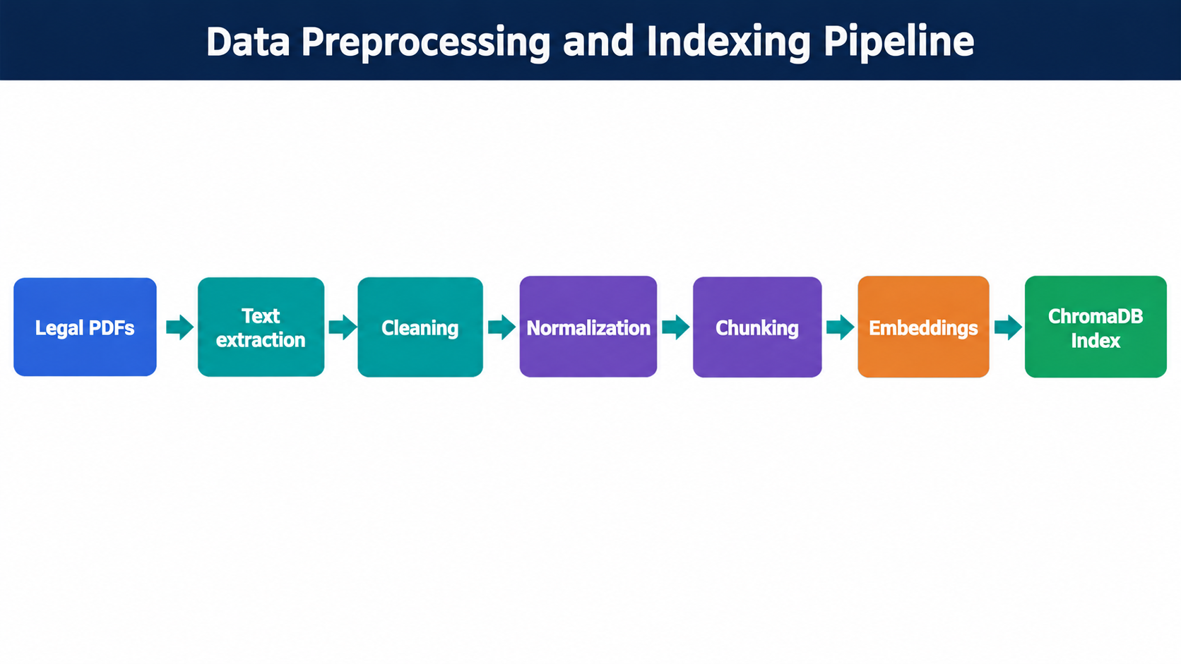
Figure 7. Data pipeline carried forward into Review-3 methodology.
The project therefore treats methodology as a complete pipeline: problem identification → data collection → preprocessing → system design → technology selection → workflow → implementation → validation → deployment. This sequence is the backbone of the Experiments section of this document.

Data Collection
The five baseline source files cover different legal domains so that the same retrieval pipeline can be checked against different query intents: constitutional rights and duties, consumer protection, contract requirements, copyright protections, and electronic records or cyber offences. The corpus is intentionally compact and curated for demonstration. It is sufficient to test whether the correct domain is ranked first, but too small to support claims about nationwide legal coverage, rare topics, or real-world legal search performance.
For every ingested item, the system needs a filename and page-level provenance. The index metadata identifies the document and chunk, while the PostgreSQL metadata maps known baseline documents to title, category and source. MongoDB Atlas holds the legal-document records used by the application. The baseline state recorded five metadata rows and five MongoDB legal documents. These baseline counts should be distinguished from later upload-test events, which returned chunk counts for files submitted to the ingestion endpoint.
The project uses a curated legal-document corpus rather than surveys, sensors or transactional business records. The primary data source is public legal material selected for indexing and demonstration. For each document, metadata such as title, category, source, document name, page information and database identifiers are preserved where available.
Document | Title | Category | Source
constitution.pdf | Constitution of India | Constitution | India Code
consumer_act.pdf | Consumer Protection Act | Consumer Law | India Code
contract_act.pdf | Indian Contract Act | Contract Law | India Code
copyright_act.pdf | Copyright Act | Intellectual Property | India Code
it_act.pdf | Information Technology Act | Cyber Law | India Code
At the baseline implementation checkpoint, the corpus contained five source PDFs. These were transformed into 41 retrieval-ready ChromaDB chunks. The source files are treated as project reference material; the underlying legal authority remains the official source material itself.

Data Preprocessing
Text extraction is a crucial boundary because a vector index can only represent the text that the PDF parser successfully extracts. Page identifiers should be retained before chunking so the result can point back to a location in the source file. Cleaning should remove obvious repeated whitespace and extraction artefacts without deleting section titles, numbered provisions or meaningful punctuation. Over-aggressive normalization can remove the distinction between sections or turn a citation into unrecognizable text.
Chunking converts a long legal document into units short enough for embedding and useful enough for retrieval. Very large chunks may mix several concepts and lower the precision of a result; very small chunks may omit qualifying phrases or split a provision from its heading. A practical chunking method should preserve overlap or structural boundaries where appropriate and store both the source page and chunk number. The current project records page and chunk metadata; tuning chunk size and evaluating alternative split strategies remain future work rather than completed experiments.
Figure 8. Preprocessing sequence from legal PDFs to vector-indexed chunks.
The preprocessing objective is to create clean, semantically meaningful chunks while preserving enough provenance to interpret a retrieval result. PDF/text extraction converts the source into machine-processable text. Cleaning removes repeated spaces and extraction noise. Normalization preserves headings and section context where available. Chunking breaks long documents into retrieval-sized pieces. Embedding maps each chunk into a numeric semantic representation. ChromaDB stores the resulting vectors along with document/page/chunk metadata.
- Preserve page and chunk identifiers to support traceability.
- Use consistent chunk processing for both stored passages and query-time search semantics.
- Separate preprocessing from retrieval so the corpus can be re-indexed when chunking or embedding logic changes.

System Design
The request path is deliberately asymmetric. At query time the browser sends a compact JSON request to Spring Boot, which delegates to the FastAPI `/search` endpoint. FastAPI embeds the question, retrieves top-k candidates from ChromaDB, enriches the candidates with metadata where available, writes the search event to PostgreSQL, and returns JSON. At upload time the browser sends multipart form data to Spring Boot; Spring Boot constructs a multipart request to FastAPI `/documents/upload`, which performs extraction, chunking, embedding and indexing. The two paths share the same vector collection but use different HTTP request types.
This boundary is useful for maintenance. The React interface does not need to know how the embedding model is loaded or how ChromaDB is queried. Spring Boot provides a stable browser-facing API. FastAPI can evolve its parsing or retrieval internals without changing the client request shape as long as the output contract remains stable. The database services stay behind the AI/application boundary, which also makes each integration point testable from PowerShell.
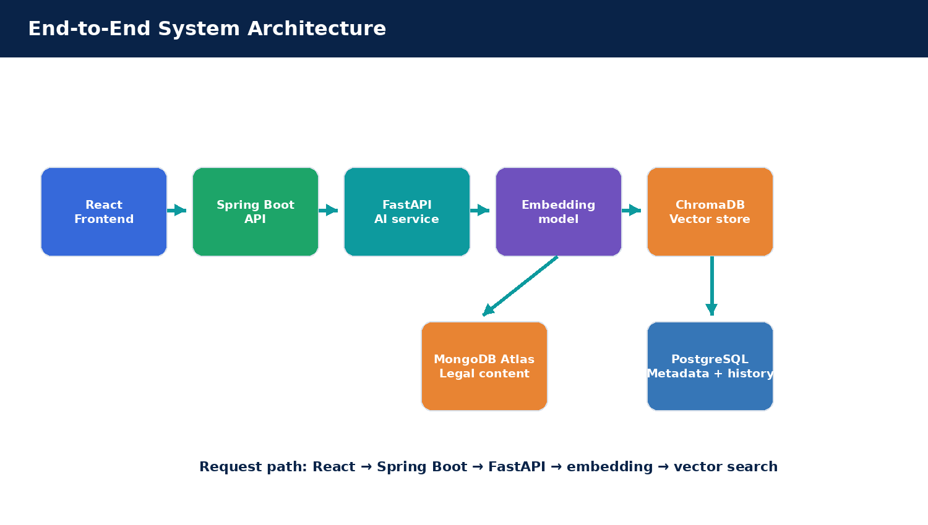
Figure 9. Completed system architecture with application, AI and data layers.
The architecture separates presentation, orchestration, AI retrieval and data persistence. React provides the user experience. Spring Boot is the application-facing backend and exposes `/api/health`, `/api/search` and the upload endpoint created during the implementation phase. FastAPI exposes the AI search service and the document-ingestion path. ChromaDB provides vector similarity retrieval; PostgreSQL supplies structured metadata and search history; MongoDB Atlas stores document content records.

Database Design and Polyglot Persistence
PostgreSQL is used for values that benefit from explicit columns and relational queries, including document identifiers, titles, categories, sources and the search-history record. MongoDB Atlas is used for the document-oriented legal content record and its flexible structure. ChromaDB is used for vector similarity retrieval and associated chunk metadata. These roles are complementary rather than redundant: a vector score does not by itself provide the complete business metadata, and a relational record does not by itself perform embedding similarity.
The important engineering trade-off is synchronization. An uploaded PDF can be successfully indexed in ChromaDB even if a corresponding PostgreSQL metadata row or MongoDB document has not been created. This means the retrieval result may still have a filename, page and text, while the enrichment fields may be absent for a truly new document. The current work verifies PDF extraction and vector indexing through the upload endpoint; fully automatic cross-store registration, duplicate detection and rollback across all stores should be implemented as a follow-up requirement.
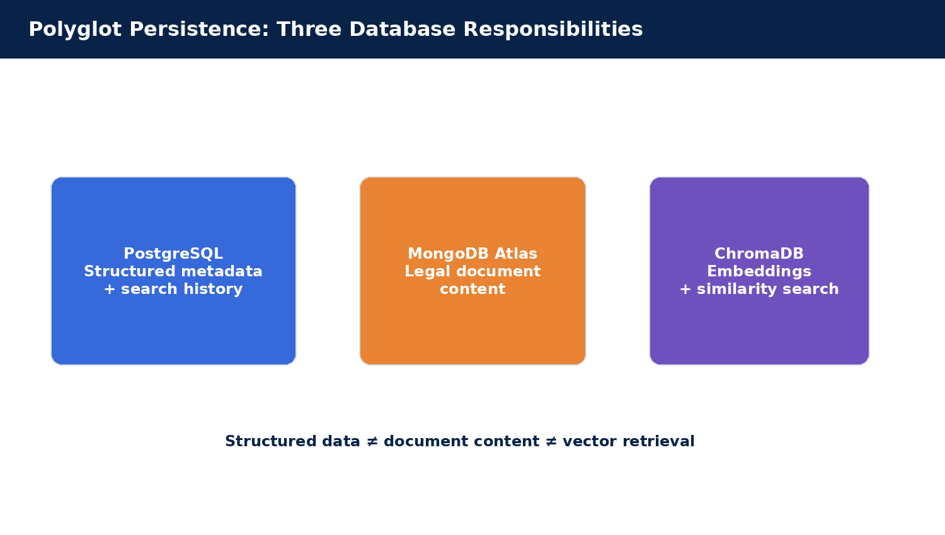
Figure 10. Why three stores are used for distinct data responsibilities.
Database | Primary responsibility | Observed project state
PostgreSQL 17 | Document metadata and search history | 5 baseline metadata records; search history populated by successful searches.
MongoDB Atlas | Legal document content/records | 5 legal document records at the baseline checkpoint.
ChromaDB | Embedding vectors, chunk metadata and similarity retrieval | 41 baseline indexed chunks.

Data Dictionary and Provenance Fields
At a minimum, a searchable chunk needs a source filename, page number, chunk number and text content. The filename identifies the original PDF, page indicates where the source passage was extracted, and chunk number distinguishes multiple segments produced from one page or document. The vector record uses these identifiers to keep the embedding associated with its text. The API response adds similarity for ranking and may add title, category, source, `document_id` and `mongo_document_id` when the baseline metadata is available.
The fields serve different purposes. `document` is a human-readable filename used by the browser and test scripts; `title` and `category` support display and potential filters; `source` provides provenance; `document_id` connects the result to the relational metadata record; and `mongo_document_id` provides a reference into the document store. These identifiers are useful when debugging because they allow the team to compare a returned passage with the source document and the corresponding database entry. Missing optional enrichment should be visible rather than silently replaced with invented metadata.
The design should eventually distinguish an uploaded file’s physical filename from its stable identity. A filename can be reused or changed, and two files may have the same name but different contents. A content hash and persistent document UUID would support duplicate detection, reproducible ingestion and coordinated deletion. The present prototype preserves filename/page/chunk traceability but does not claim complete idempotent upload management across all stores.
This is a polyglot persistence design: the system does not force every workload into one database. The database separation also helps explain the system during evaluation because each data type has a clear owner.

Technology Selection
React with Vite was selected for an interactive browser interface and quick development feedback. Spring Boot provides a typed Java API boundary and integrates with the project’s PostgreSQL setup. FastAPI was selected for the AI pipeline because Python has mature tools for PDF extraction, text processing, embedding generation and vector-search orchestration. ChromaDB handles similarity retrieval; PostgreSQL handles structured metadata and history; MongoDB Atlas handles document records. The selected stack makes each responsibility visible and independently testable.
The technology choice also reflects the project scale. A full production platform would require authentication backed by a server-side user store, authorization, file-size and content validation, rate limits, audit controls, backups, telemetry and deployment automation. The present React login/register experience is a local browser demo, not a server-side identity provider. This distinction is maintained in the report so that UI screens are not confused with fully implemented security services.
Technology | Selected role | Reason for selection
React + Vite | Frontend | Fast browser UI development and component-based rendering.
Spring Boot 4.1.1 | Application backend | REST APIs, validation and service orchestration.
FastAPI + Python | AI service | Lightweight HTTP service with the Python AI/data ecosystem.
Sentence-Transformers / embedding model | Semantic representation | Local embedding generation appropriate for an academic prototype.
ChromaDB | Vector retrieval | Embedding storage and similarity search with metadata.
PostgreSQL 17 | Structured data | Relational metadata and application-level search history.
MongoDB Atlas | Document store | Flexible legal-document records/content.
Maven Wrapper | Java build | Reproducible project build without a separately installed Maven command.

Workflow and User Interaction
The search page provides a natural-language input, a search action, loading and error states, and a list of ranked result cards. Each card exposes the document title or filename, category, page, source and similarity value, and a detail view exposes the retrieved passage and related identifiers. The history and dashboard pages are based on local browser activity and the current project corpus; they should therefore be described as UI-level views rather than as an enterprise analytics system with multi-user aggregation.
A predictable request lifecycle improves usability: the application should disable or indicate the search action while a request is pending, clear the previous error before a new attempt, display an explicit backend failure when a service is unavailable, and avoid showing stale results as though they correspond to the latest query. The browser’s “Backend Connected” indicator is a health hint, not proof that every upload or database operation will succeed; upload and search responses still need their own success/error handling.
- Start PostgreSQL and ensure the `legal_search` database is available.
- Start FastAPI on port 8000.
- Start Spring Boot on port 8080.
- Start React/Vite on port 5173.
- Use the browser search interface to submit a natural-language question.
- React sends the question to Spring Boot; Spring Boot forwards it to FastAPI.
- FastAPI performs embedding and vector retrieval, enriches metadata and returns JSON.
- The React interface renders ranked source-aware results.
The document-upload workflow follows the same layered model. A PDF selected in React is posted as multipart form data to Spring Boot. Spring Boot forwards the multipart payload to FastAPI `/documents/upload`. FastAPI extracts, chunks and indexes the document and returns a filename and chunk count. The UI reports the indexing result to the user.
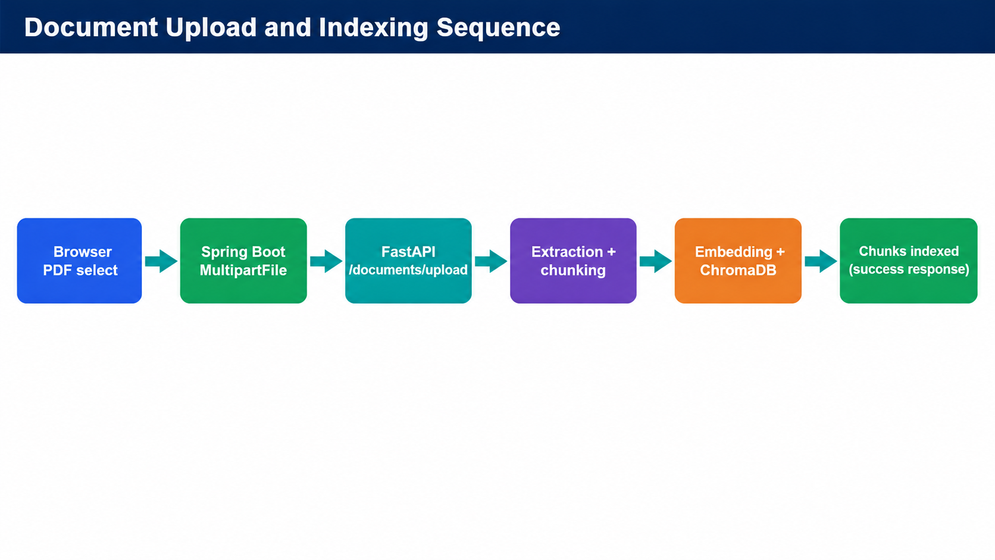
Figure 11. Implemented upload sequence that was verified through PowerShell.

Retrieval Algorithm and Similarity Semantics
The retrieval routine can be expressed as a short sequence. First, validate that the query is present and trim surrounding whitespace. Second, encode the query using the embedding configuration used by the indexing pipeline. Third, ask ChromaDB for the nearest stored vectors with `top_k = 5`. Fourth, read the returned chunk text and its metadata. Fifth, enrich known records using PostgreSQL metadata and assemble a JSON response containing `query`, `total_results` and `results`. Finally, render the ranked records in React, where similarity is shown as a value and a detail view exposes the passage.
The use of one embedding space for indexed chunks and user queries is a key requirement. If indexing uses one model and query time uses a different model or a changed preprocessing configuration, similarity values may no longer be comparable. The implementation should therefore record model and preprocessing versions in deployment configuration and re-index the corpus if a change makes existing vectors incompatible. The current report describes the configured project embedding process rather than assigning an unverified model name.
Similarity is a retrieval score, not a probability of legal correctness. A value such as 0.6677 does not mean there is a 66.77% chance that the legal conclusion is correct. It is a score used by the vector retrieval configuration to order candidate chunks. It can be compared within the same test run and configuration, but it must be evaluated against labelled relevant passages before being interpreted as a quality metric. A user should still inspect the text and original legal source.
Failure handling is equally important. An empty query should not be submitted. If Spring Boot is unavailable, React should present a connection error. If Spring Boot is running but FastAPI is unavailable, the gateway should return a service failure rather than a fabricated empty result. If a PDF upload fails after file selection, the browser must display the server error and must not mark the file Indexed. These behaviors protect the application from reporting success when a downstream service has not completed its work.

Development Environment and Project Structure
The local execution environment uses Windows PowerShell and keeps project files on the E: drive. The Python environment isolates FastAPI dependencies from the rest of the machine; Maven Wrapper supplies a consistent Maven version for the Spring Boot build; Vite serves the React frontend for local development. The expected local endpoints are FastAPI at `http://127.0.0.1:8000`, Spring Boot at `http://localhost:8080`, and React at `http://localhost:5173`. PostgreSQL runs as a Windows service on port 5432, while MongoDB Atlas is accessed remotely.
A reproducible run requires the services to be started in dependency order: make the database available, start FastAPI, start Spring Boot, and then start Vite. If FastAPI is unavailable, Spring Boot cannot delegate semantic search or upload. If Spring Boot is unavailable, the React client should report a backend error. This separation also provides a simple diagnostic strategy: test each service health endpoint before testing the full chain.
The project is organized as separate frontend, Spring Boot and FastAPI services under a common project root on the E: drive. This layout matches the student development environment and keeps the Python virtual environment, Java build, and Node/Vite workspace isolated.
E:\Second year KLH Softwares\DBMS PROJECT\AI Legal Document Search\
├── frontend\
├── backend\fastapi\
└── backend\springboot\legal-search-backend\
The Spring Boot project is built with Maven Wrapper using `./mvnw.cmd`. The final build command used for compilation and packaging is `./mvnw.cmd clean package -DskipTests`. The React project uses Vite and npm. FastAPI runs under a Python virtual environment using Uvicorn.

Module Implementation
The implemented modules can be grouped into user experience, semantic retrieval, data persistence and integration. The user-experience module presents a local demo login, query input, result cards, upload form, search history and dashboard. The retrieval module processes queries and ranks chunks. The data layer stores vector records, metadata and document content. The integration module connects React with Spring Boot and Spring Boot with FastAPI. The distinction helps explain why a screen can exist while the persistent backend feature behind it still needs additional wiring.
The upload module went through a concrete debugging cycle. Initially, file selection updated only the browser list. After a FastAPI upload route was tested directly, the Spring Boot route was implemented to accept `MultipartFile`, build a proper `multipart/form-data` request using Java `HttpClient`, and forward it to FastAPI. An intermediate implementation using `RestClient` failed at runtime because the dependency class `org.reactivestreams.Publisher` was missing. The final Java `HttpClient` implementation avoided that unresolved runtime dependency and allowed the Spring Boot upload endpoint to return the FastAPI indexing response.
Module | Function | Technology / data
User Interface | Login/demo profile, search, upload, history, dashboard and result details. | React
Authentication UI | Local demo sign-in/register state. | React localStorage; not server-side authentication yet.
Document ingestion | Upload, parse, clean, chunk and index PDFs. | FastAPI + Python + ChromaDB
Embedding pipeline | Generate vectors for chunks and queries. | Embedding model
Vector retrieval | Top-k semantic similarity search. | ChromaDB
Document store | Store legal document records/content. | MongoDB Atlas
Metadata/history | Structured metadata and search history. | PostgreSQL
Application gateway | Browser-facing REST API and service orchestration. | Spring Boot
The distinction between implemented and planned features is intentional. The browser UI includes a login screen and richer navigation because they are part of the application experience, but the login remains a local demo profile rather than a server-side authentication system.

Implementation: Spring Boot Service and API Integration
The search controller exposes `POST /api/search` and passes the query to `FastApiService`. The service constructs a JSON body, sends it to `http://127.0.0.1:8000/search` and returns the successful response body to the caller. For local traffic the Java `HttpClient` is configured with `NO_PROXY` and HTTP/1.1, choices made during the earlier service-integration debugging. The upload controller exposes `POST /api/documents/upload`, receives the multipart field named `file`, validates that the file is present and has a PDF filename, and delegates the upload to the same service class.
A successful Maven build is part of the implementation evidence. The project initially failed compilation because the public class `DocumentController` was stored in a file named `DocumentControl.java`; renaming the file to `DocumentController.java` corrected Java’s filename/class-name mismatch. The build then reached `BUILD SUCCESS` and produced the repackaged Spring Boot JAR. This illustrates why compile-time validation and runtime API testing are separate gates: the project still needed to exercise the upload request after it compiled.
Spring Boot serves as the application-facing API boundary. Its search controller accepts a JSON body containing the user query and delegates to `FastApiService`. The service uses Java `HttpClient` configured with `NO_PROXY` and HTTP/1.1 for local FastAPI communication. This integration was hardened after an earlier request-body issue was diagnosed and fixed.
POST /api/search
Request: { "query": "..." }
→ FastApiService.search(query)
→ POST http://127.0.0.1:8000/search
POST /api/documents/upload
MultipartFile file
→ FastApiService.uploadDocument(file)
→ POST http://127.0.0.1:8000/documents/upload
The final build produced `legal-search-backend-0.0.1-SNAPSHOT.jar`, confirming successful compilation and packaging after the filename mismatch in `DocumentControl.java` was corrected to `DocumentController.java`.

Implementation: FastAPI AI Service
FastAPI owns the operation that is closest to the retrieval model. It validates the query payload, invokes the project’s semantic-search function, asks ChromaDB for the closest vector chunks, and produces a structured response with the source text and identifiers. The current top-k default is five, which keeps the response compact enough for the browser while exposing more than one candidate. The numeric similarity field is treated as a ranking signal for this retrieval configuration, not as a calibrated probability that a legal interpretation is correct.
The upload endpoint follows a different input contract. It accepts a multipart field named `file`, saves or otherwise passes the file to the ingestion function, extracts text, splits the text into chunks, builds embeddings and records the chunks in ChromaDB. It returns the original filename and the number of chunks indexed. In the current implementation, this is strong evidence that ingestion occurred, but it does not by itself prove that a matching PostgreSQL metadata row and MongoDB document were also created for every new file.
FastAPI owns the AI/search operations. The `/search` endpoint validates a natural-language query using a Pydantic request model, performs semantic retrieval against ChromaDB, saves search history, enriches the retrieved chunks with PostgreSQL metadata and returns a clean JSON structure. The `/documents/upload` endpoint receives a PDF file, sends it through the ingestion function, and returns the filename and number of indexed chunks.
POST /search
query → semantic_search(query, top_k=5)
→ ChromaDB top-k results
→ PostgreSQL metadata enrichment
→ JSON response
POST /documents/upload
file → ingest_document(...)
→ extraction + chunking + embeddings
→ ChromaDB indexing
→ { filename, chunks_indexed }
The service boundary keeps the Python AI environment independent from the Java application layer, which simplifies debugging and allows future model changes without rewriting the browser-facing API.

Implementation: Actual React User Interface
The actual frontend has a light workspace layout with the product title, semantic-search subtitle and backend connection indicator. The home page invites natural-language questions and provides a search field; the Search Documents page renders the returned result list. The Upload Document page sends a selected PDF to the Spring Boot upload route and reports the backend’s returned chunk count. The login/register form remains a local demonstration profile backed by browser `localStorage`; it should not be described as authenticated server-side user management.
The frontend-to-backend contract is kept deliberately simple. Search requests use JSON with a `query` field. Upload requests use `FormData` with a `file` field and should not manually set the multipart content type in the browser, because the browser must add the boundary. The UI should display the response from the server rather than predicting an indexing count or labelling a file “Indexed” before the server confirms success.
The current React interface was supplied directly from the running project. It provides the user-facing search experience and navigation for the expanded application UI. The search page sends requests to Spring Boot, not directly to FastAPI, preserving the intended service boundary.
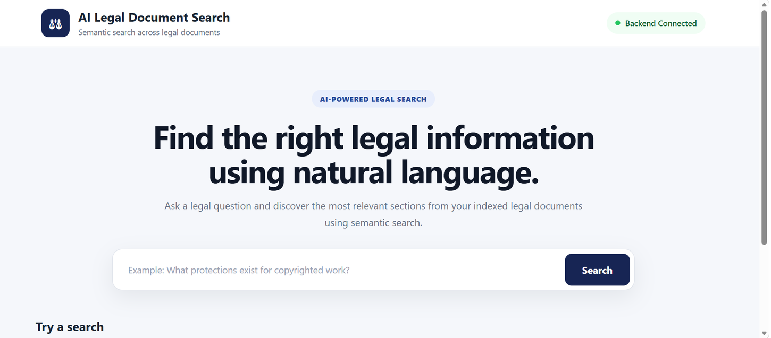
Figure 12. Actual React interface screenshot supplied from the current implementation.
- Natural-language search field and search action.
- Backend Connected / Offline status indicator.
- Ranked results with similarity scores and source metadata.
- Navigation for Home, Search Documents, Upload Document, Search History and Dashboard.
- Result-detail modal for inspecting retrieved passages.

Implementation: Document Upload and Searchability
Two upload calls were observed in the development session. A direct FastAPI upload of `constitution.pdf` returned “Document uploaded and indexed successfully” with `chunks_indexed: 7`. An upload through the Spring Boot `/api/documents/upload` route for `consumer_act.pdf` returned the same success message with `chunks_indexed: 8`. These values are the counts returned by those specific ingestion calls; they should not be added to the original 41-chunk baseline as though they were a deduplicated live count, because repeated indexing and duplicate-ID behavior were not separately audited.
For a production-ready ingestion workflow, the service should compute a stable file hash, distinguish a new upload from a re-upload, use a deterministic document ID, record ingestion state, and either complete metadata registration across all stores or return a clear partial-failure status. A rollback or retry strategy is needed if ChromaDB indexing succeeds but SQL or document-store persistence fails. The present prototype proves the PDF-to-vector path and the service gateway; consistent cross-database transaction semantics remain a limitation.
The first upload implementation only populated a browser-local list, which meant a selected PDF was not actually indexed. This was corrected by connecting the UI to the working Spring Boot upload endpoint. The Spring Boot implementation was then changed to use Java `HttpClient` to construct a valid multipart form-data request for FastAPI, avoiding the missing `org.reactivestreams.Publisher` runtime dependency encountered with the initial `RestClient` attempt.
Figure 13. Upload path after integration fix.
Observed step | Verification
FastAPI direct upload of constitution.pdf | PASS — 7 chunks indexed.
Spring Boot upload of consumer_act.pdf | PASS — 8 chunks indexed.
Browser UI upload integration | Frontend code connects to `/api/documents/upload`; final browser test should be rerun after any local code edits.
Search after indexing | Expected architecture: newly indexed chunks participate in ChromaDB top-k retrieval.
Important limitation: upload indexing was verified at the API layer; duplicate-handling and production metadata synchronization should be expanded before treating upload as a production document-management workflow.
3. EXPERIMENTS
Review-4 required measurable testing across the working application. The project therefore used three categories of evidence: service/integration checks, semantic retrieval queries, and document-upload/indexing checks. The retrieval tests were run through the Spring Boot endpoint so that the measured result included the actual application boundary rather than testing FastAPI in isolation only.
The experiments were executed locally against the running application services. The integration checks verified the FastAPI root response, Spring Boot health endpoint, direct FastAPI search, Spring Boot search gateway, React browser rendering, and upload calls. Semantic retrieval experiments used seven manually selected questions that represented the five legal categories in the baseline corpus. For each query, the expected document was determined from the question’s domain and checked against the first ranked result. Five results were requested for each query.
The retrieval test was a functional ranking check rather than a formal blinded benchmark. It did not include adversarial questions, out-of-corpus questions, independent relevance judgements for every returned passage, or comparisons with keyword search. Similarity values were recorded exactly as returned by the API, and the same request path was used through Spring Boot so the observations included service integration as well as vector ranking.

Experiment Protocol and Result Recording
Each semantic test consisted of a question chosen to represent one legal domain, the expected document determined from the question intent, the ordered top-five API response and the similarity score of the first result. The five newer tests covered Constitution, Consumer Law, Contract Law, Copyright and IT/Cyber Law. Two previously verified tests covered copyright protection and electronic-record/cyber-offence rules. The same expected-document rule was applied to all seven cases, so the test-set score does not depend on a different criterion for each domain.
The core success criterion was whether the expected source document appeared at rank one. The second observation was whether five results were returned, as configured. A third observation recorded the similarity value of the first result. This small protocol makes the results reproducible enough for a project demonstration, but it does not evaluate the semantic relevance of every passage in the top five. A future labelled benchmark should add a judgement for each returned passage and use ranking metrics over all positions.
The API integration experiment tested both sides of the service boundary. Direct FastAPI requests verified that the AI endpoint accepted a query and returned source-aware chunks. Requests through Spring Boot verified the application-facing gateway. The browser test verified that React could consume that gateway and render the returned records. A separate upload test sent a PDF directly to FastAPI and then through Spring Boot, so the test set covered both JSON request handling and multipart file transfer.
No instrumented latency benchmark was run for this report. The experiment therefore does not estimate mean or percentile response time, throughput under concurrent requests, ingestion speed per page, or scaling behavior as the corpus grows. Those measures are explicitly left for future work instead of being substituted with impressionistic values.
Evidence category | What was verified | Measurement
Service health | Spring Boot and FastAPI endpoints | PASS responses
Integration search | Spring Boot → FastAPI → ChromaDB → metadata | 5 ranked results per query
Semantic retrieval | Seven legal-domain questions | Expected document at rank #1 for 7/7
Upload/indexing | Two PDF upload executions | 7 and 8 chunks indexed
UI | Browser search interface | Results rendered in current React UI
History | Successful searches | Search history populated
4. RESULTS — Seven-Query Semantic Retrieval
The five newly run domain tests returned the expected source Act at rank one: Constitution of India (0.6677), Consumer Protection Act (0.5232), Indian Contract Act (0.6547), Copyright Act (0.5375), and Information Technology Act (0.6387). Two earlier verified questions were added to the same test set: a copyright-protection question returned `copyright_act.pdf` first at 0.5550, and an electronic-records/cyber-offences question returned `it_act.pdf` first at 0.5791. Each of the seven queries returned five ranked items, giving 35 returned results across the set.
The arithmetic mean of the seven observed top-one scores is 0.5937. This value summarizes the selected examples only. It is not a percentage accuracy metric and is not evidence that the embedding model is calibrated. The more direct test-set outcome is that all seven expected documents were ranked first, which gives a top-one document match rate of 7/7 (100%) for this small, manually selected set.

Interpreting the Metric Correctly
The top-one document match rate is the most direct measure available for this experiment. The expected document was ranked first for all seven questions, so the measured count is 7 correct top-one matches out of 7 tests. This equals 100% for the selected query set. It does not equal a general classification accuracy, and it should not be compared with published benchmark results unless the query construction, corpus, relevance labels and metric definitions are made comparable.
The mean top-one similarity of 0.5937 is descriptive. It indicates the arithmetic average of the seven scores returned by the configured system. It does not provide a pass/fail threshold and does not mean each query has the same retrieval quality. Scores should be monitored alongside the expected top document, rank distribution and human relevance judgements. The fact that the consumer query has a lower top-one score than the constitution query but still ranks the expected document first is an example of why both rank and score should be reported.
The top-five result list also provides diagnostic information. For the contract query, an Information Technology Act chunk appeared at rank three with similarity 0.4633. The correct Contract Act remained first at 0.6547. This behavior may be acceptable for exploratory retrieval, but it shows that related passages can cross document boundaries. Filters selected by the user, stronger section metadata, or a reranking stage could reduce irrelevant cross-domain results in future versions.
Test | Query domain | Expected / top document | Top similarity | Results
1 | Constitution | constitution.pdf | 0.6677 | 5
2 | Consumer Law | consumer_act.pdf | 0.5232 | 5
3 | Contract Law | contract_act.pdf | 0.6547 | 5
4 | Copyright | copyright_act.pdf | 0.5375 | 5
5 | IT / Cyber Law | it_act.pdf | 0.6387 | 5
6 | Copyright — earlier verified | copyright_act.pdf | 0.5550 | 5
7 | IT / Cyber — earlier verified | it_act.pdf | 0.5791 | 5
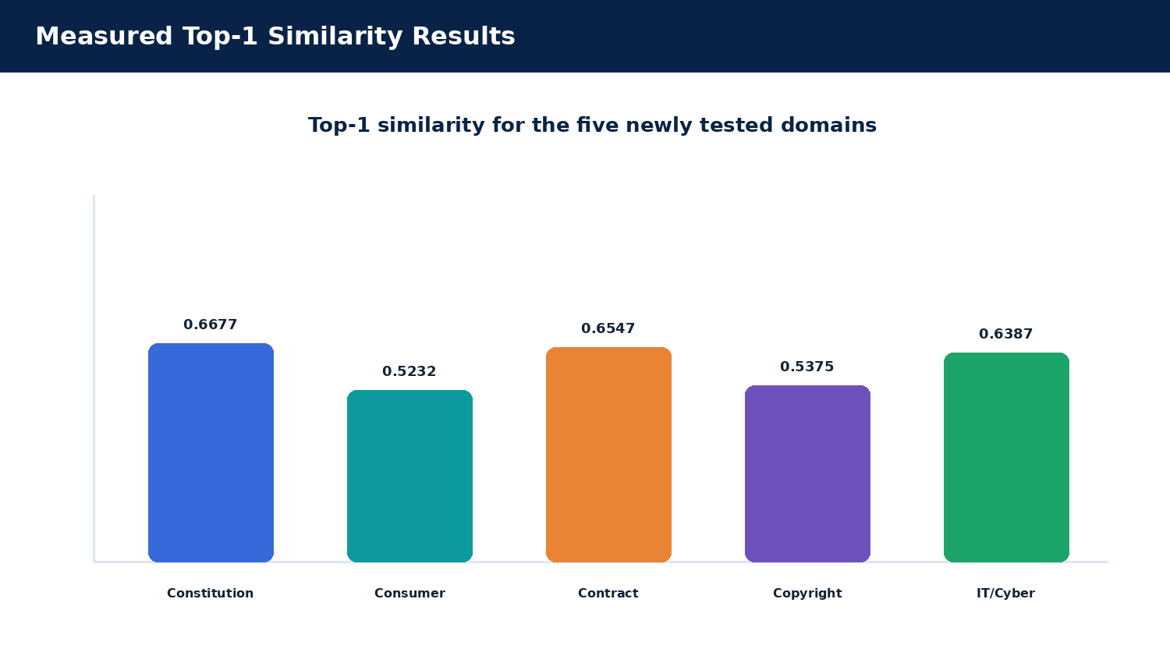
Figure 14. Top-1 similarity for the five newly tested legal domains.
Measured test-set result: 7/7 expected legal documents appeared at rank #1; 35 total result records were returned across seven queries; mean top-1 similarity = 0.5937.

Results: Retrieval Behavior and Interpretation
The highest top-one score in the seven-query set was the Constitution query at 0.6677, while the lowest was the consumer-rights query at 0.5232. This variation is expected because a vector similarity value depends on the exact query, chunk content, embedding representation and vector-distance configuration. It should not be interpreted as the consumer query being answered incorrectly: the Consumer Protection Act was still ranked first for that query. Scores are useful to compare ranks within a fixed test setup, but a universal pass threshold should only be chosen after relevance judgements and calibration experiments.
The contract query illustrates an important limitation. Its third result was `it_act.pdf` at 0.4633, while `contract_act.pdf` remained first at 0.6547. The cross-domain result shows that semantic search may retrieve passages that are related in wording or concept without belonging to the expected Act. A larger evaluation should examine the precision of all top-k results, not only whether rank one is correct, and could add a document-category filter for cases where the user explicitly selects a legal domain.
The seven-query test set demonstrates that the retrieval system is responsive to domain meaning. Constitution, consumer-law, contract-law, copyright and IT/cyber queries all produced the expected Act as the top-ranked document. The strongest top-1 similarity in the newly added five-query set was 0.6677 for the Constitution query, followed by 0.6547 for the contract query and 0.6387 for the IT/cyber query.
The contract query also illustrates that semantic search can return related material from outside the primary document. Its third result was `it_act.pdf` at 0.4633, while `contract_act.pdf` remained rank 1 at 0.6547. This is not automatically an error; the vector store ranks passages by similarity, and related digital-contract content can overlap semantically with information-technology law. The correct interpretation is therefore ranking quality, not perfect document exclusion.
The average top-1 similarity of 0.5937 is a descriptive statistic for this manually selected seven-query set. It should not be presented as a universal semantic-search score. A stronger future evaluation would construct relevance labels at chunk level, test multiple query formulations, compare against a keyword baseline, and report Precision@k, Recall@k or MRR.

Results: Functional and Integration Testing
The successful Spring Boot search response included the original query, `total_results: 5`, and the result list with document filename, page, chunk number, similarity score, title, category, source, PostgreSQL document ID and MongoDB document reference when available. These fields demonstrate that the integration is more than a bare vector-distance call: the response has enough provenance information for the UI to display the source and enough stable identifiers for debugging. The report does not treat every optional metadata field as guaranteed for documents uploaded outside the baseline metadata register.
The browser UI was also checked after the frontend was connected to the Spring Boot endpoint. The user could submit a query, see the backend connection state, and inspect result cards. Search history and dashboard figures in the current frontend reflect browser-local history and baseline project values. They are useful demonstrator screens, but they are not a centralized multi-user analytics subsystem.

Implemented Tests Versus Pending Validation
The completed checks include service health, direct and chained search requests, ranked results for the seven selected questions, metadata enrichment for baseline documents, browser rendering and the two upload-indexing observations. These are integration and functional checks. They establish that the main request path works on the development environment and that the ingestion endpoint actually processes PDF files.
Several valuable tests remain pending: malformed multipart requests, empty PDFs, non-PDF files with misleading extensions, duplicate uploads, upload interruption, FastAPI unavailability during a Spring Boot request, concurrent searches, larger documents and larger corpus sizes. Some client-side validation exists, but a negative test should only be marked PASS after its expected error response has been observed. The report consequently distinguishes verified outcomes from recommended test cases rather than presenting every planned check as completed.
Test case | Expected result | Observed result | Status
Spring Boot health | Backend available | “Spring Boot backend is running” | PASS
FastAPI search | Ranked semantic results | 5 results returned | PASS
Spring Boot search | Search forwarded correctly | 5 results returned through :8080 | PASS
Cyber-law semantic test | IT Act ranked first | 0.5791 top match in earlier verified run | PASS
React UI search | Results rendered | Browser results displayed | PASS
Search history | Successful search logged | PostgreSQL history populated | PASS
FastAPI constitution upload | PDF indexed | 7 chunks indexed | PASS
Spring Boot consumer upload | PDF indexed | 8 chunks indexed | PASS
The eight recorded checks shown here are the functional verification evidence available from the project execution history. All eight completed without a failure in the recorded runs, giving a 0/8 failure rate for this verification set. This statement is limited to these recorded checks; it is not a claim that every possible failure condition has been exhausted.

Results: Document Upload and Indexing Tests
The upload experiment also exposed why the frontend must wait for a backend response before updating its list. Initially, selecting a PDF only stored a browser-side entry, which made the UI look successful without changing the vector collection. After the upload handler was connected to `/api/documents/upload`, the browser could send real multipart data and display the actual `filename` and `chunks_indexed` returned by FastAPI. This is the difference between a visual placeholder and a working document-ingestion feature.
Document | Route used | Observed chunks | Status
constitution.pdf | FastAPI `/documents/upload` | 7 | PASS
consumer_act.pdf | Spring Boot `/api/documents/upload` → FastAPI | 8 | PASS
These tests show that the ingestion endpoint performs actual indexing rather than simply accepting the file. For Constitution, FastAPI returned “Document uploaded and indexed successfully” with seven chunks. For Consumer Protection Act, the Spring Boot endpoint returned the same success message with eight chunks. This verifies the repaired multipart integration path.
The indexing count is useful evidence because it connects user-visible upload behavior to the vector database state. The system can therefore report not only that a file was received, but how many retrieval chunks were created. Future versions should also register the uploaded file in PostgreSQL metadata and MongoDB document storage automatically and define a deterministic strategy for duplicate uploads.

Results: Structured API Response and Provenance
The response contract is useful because the React component can render results without knowing the database internals. The backend can evolve how it queries ChromaDB or performs metadata joins as long as it preserves the public fields. Conversely, changing a response field name may break the result card or detail modal, so API response shape should be treated as a versioned integration contract and covered by automated tests.
A successful `/api/search` response contains the query, result count and an array of source-aware retrieval objects. The verified copyright example returned `copyright_act.pdf`, page 4, similarity 0.555, title “Copyright Act”, category “Intellectual Property”, source “India Code”, PostgreSQL document ID 4, and a MongoDB document reference.
{
"query": "What protections exist for copyrighted work?",
"total_results": 5,
"results": [
{
"document": "copyright_act.pdf",
"page": 4,
"similarity": 0.555,
"title": "Copyright Act",
"category": "Intellectual Property",
"source": "India Code"
}
]
}
This response contract is intentionally lightweight. React does not need to understand the internal ChromaDB or PostgreSQL calls; it only needs the enriched result structure. This keeps the application boundary clean and makes the backend independently testable with PowerShell or any HTTP client.

Results and Analysis — Measurable Project Summary
The measured evidence falls into three categories. Corpus-state evidence records five baseline PDFs, an initial 41 indexed chunks, five PostgreSQL metadata rows and five MongoDB legal-document records. Retrieval evidence records the seven-query test set, 35 returned results, and 7/7 expected top-one documents. Ingestion evidence records a Constitution upload response of seven chunks and a Consumer Act upload response of eight chunks. These are separate measurement checkpoints and should not be combined into one current index size without a deduplication and live-count audit.
The performance dimension is only partially evaluated. Request completion and the number of returned results were observed, but response times, throughput, memory use during embedding, and behavior at larger corpus sizes were not measured under a controlled protocol. A technically honest report therefore describes the implementation as functionally verified on the selected setup and treats performance benchmarking as future work. This distinction is important because a system can return correct results in a small test and still require engineering work before it can support heavier workloads.

Operational Readiness and Remaining Risks
The local application is suitable for a controlled demonstration because the individual services can be started independently and tested with explicit endpoints. Operational readiness beyond the demonstration would require more than successful local execution. It would require stable configuration management, secret handling outside source files, logging that avoids exposing sensitive information, dependency updates, backups, controlled access to upload and delete operations, and a process for restoring the vector index from authoritative documents.
The highest-priority data risk is partial synchronization. If a new file is indexed in ChromaDB but not registered in PostgreSQL or MongoDB, search may return a passage whose optional metadata is missing. If a file is uploaded again without duplicate detection, the index may contain duplicated or overlapping chunks. If a document is removed from one store but not another, stale results may remain. A production ingestion workflow should therefore track state transitions and include retry, reconciliation and deletion procedures.
The highest-priority retrieval risk is overgeneralization from a small test. A result can match the topic while omitting a statutory exception or context that changes its meaning. An implementation that later adds generated answers should make citations traceable and must not suppress the underlying passage. The current design’s result-first approach is a useful starting point because it exposes evidence rather than presenting a generated conclusion as though it were the source.
Threats to validity include the small number of manually selected queries, a corpus of only five baseline legal documents, possible repeated indexing during upload demonstrations, dependence on the parser’s extracted text, and the use of a single development machine and local service setup. The top-one test set is not independently labelled by multiple legal experts, and the response similarity score has not been calibrated against legal correctness. These factors limit generalization but do not invalidate the integration results that were directly observed.
Metric | Measured / verified value | Interpretation
Baseline legal PDFs | 5 | Five legal domains are represented in the reference corpus.
Baseline ChromaDB chunks | 41 | Retrieval operates over 41 stored semantic chunks at the baseline checkpoint.
Results per search | 5 | The verified API default is top-k = 5.
Semantic queries tested | 7 | Queries span five legal domains plus two earlier verification queries.
Total returned results | 35 | 7 queries × 5 results each.
Correct top-1 document | 7/7 | 100% on the manually selected test set.
Mean top-1 similarity | 0.5937 | Descriptive mean for the seven-query test set.
Recorded functional checks | 8 | All eight recorded checks passed.
Upload indexing checks | 2 | Constitution and Consumer Act uploads successfully indexed.
The strongest conclusion from these results is not a single similarity threshold. It is the consistency of the application workflow across the stack. The same natural-language query can be sent through React, Spring Boot and FastAPI, retrieved through ChromaDB, enriched with structured metadata, logged in PostgreSQL and rendered in the browser.
Performance reporting principle: where no timing instrument was run, the report deliberately reports counts and retrieval outcomes rather than invented latency numbers.
Outputs:
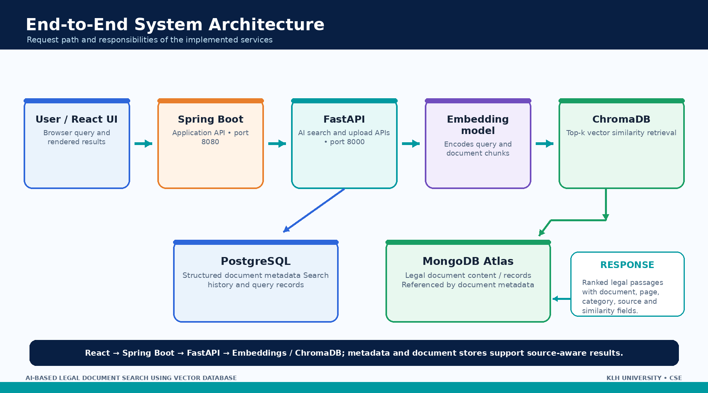
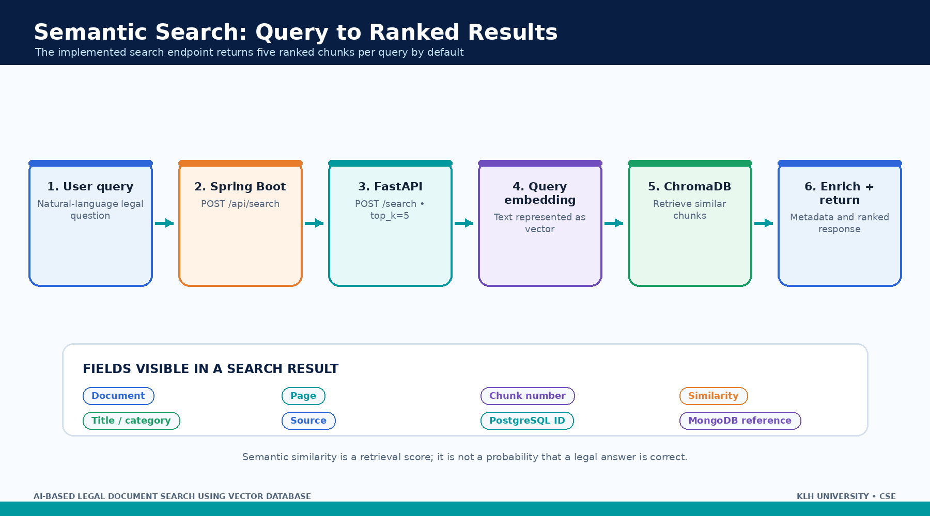
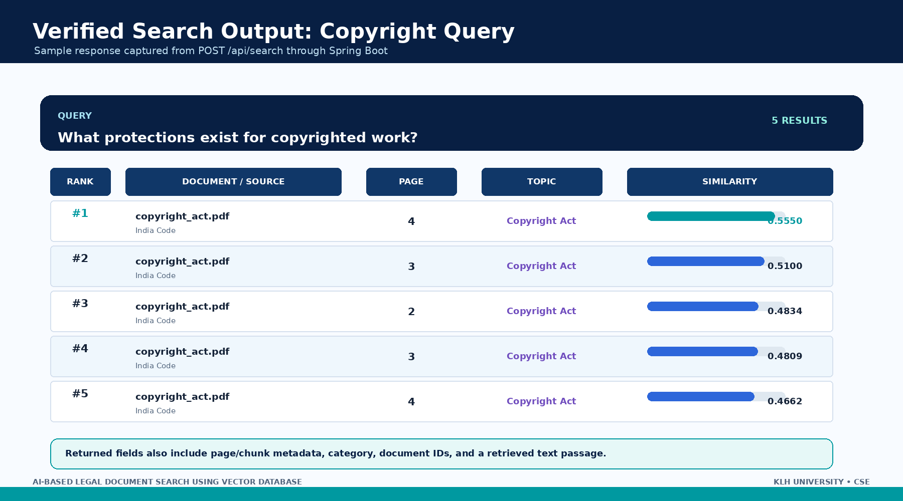
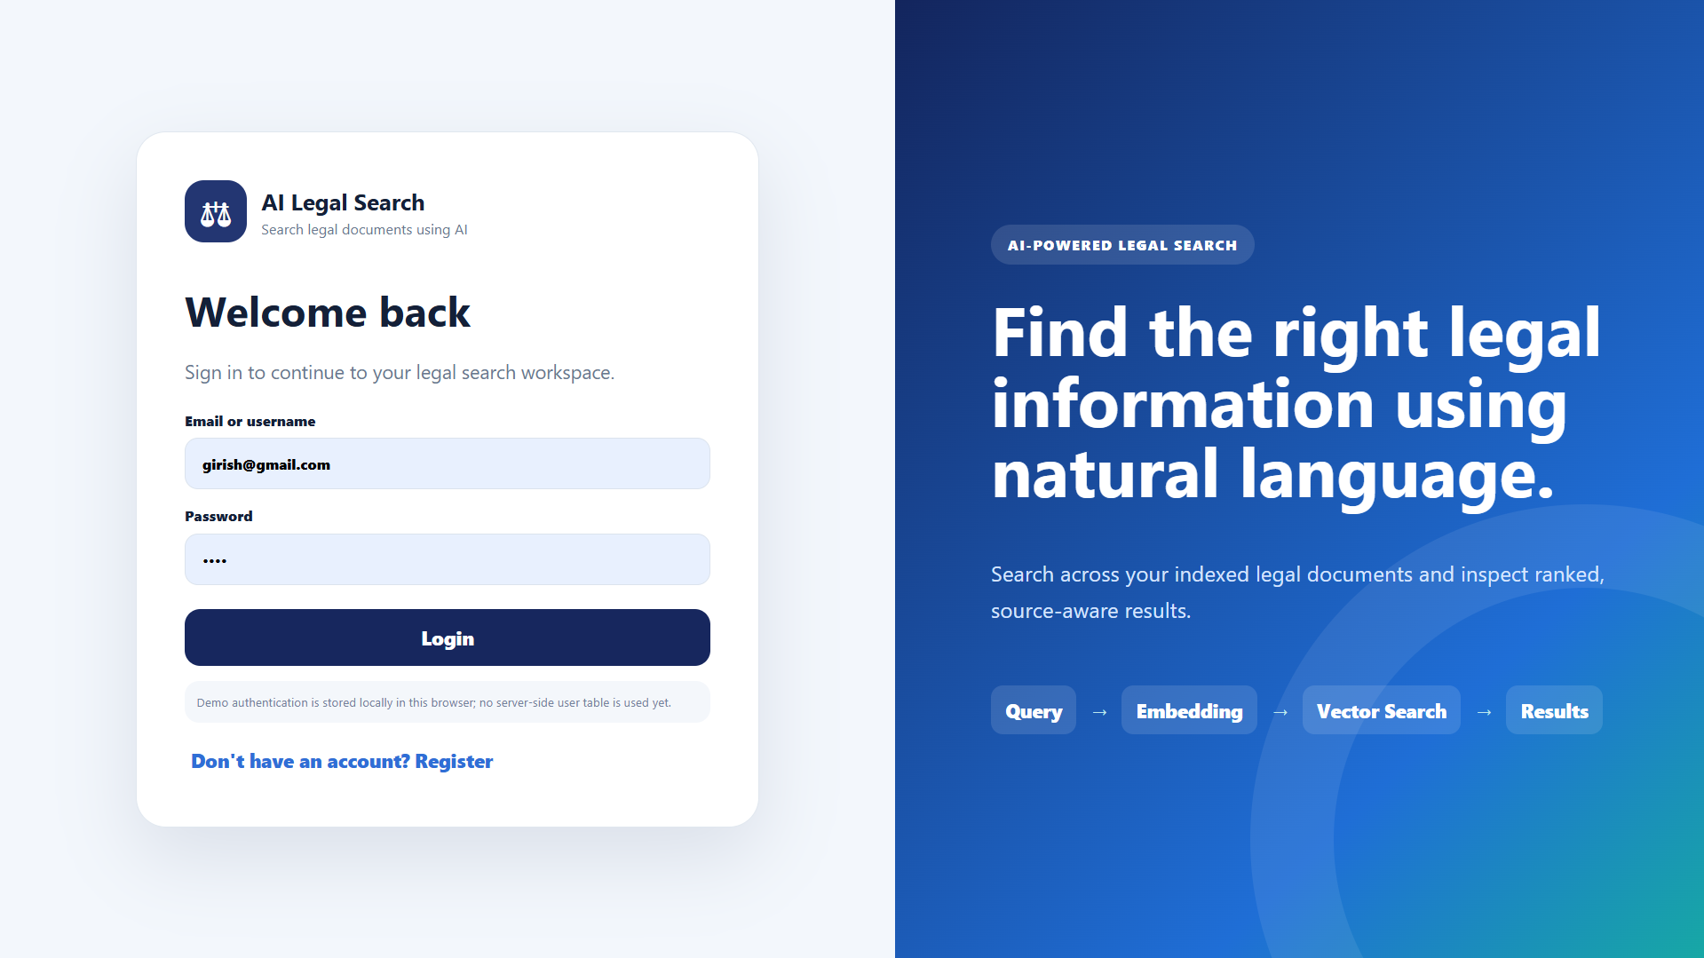
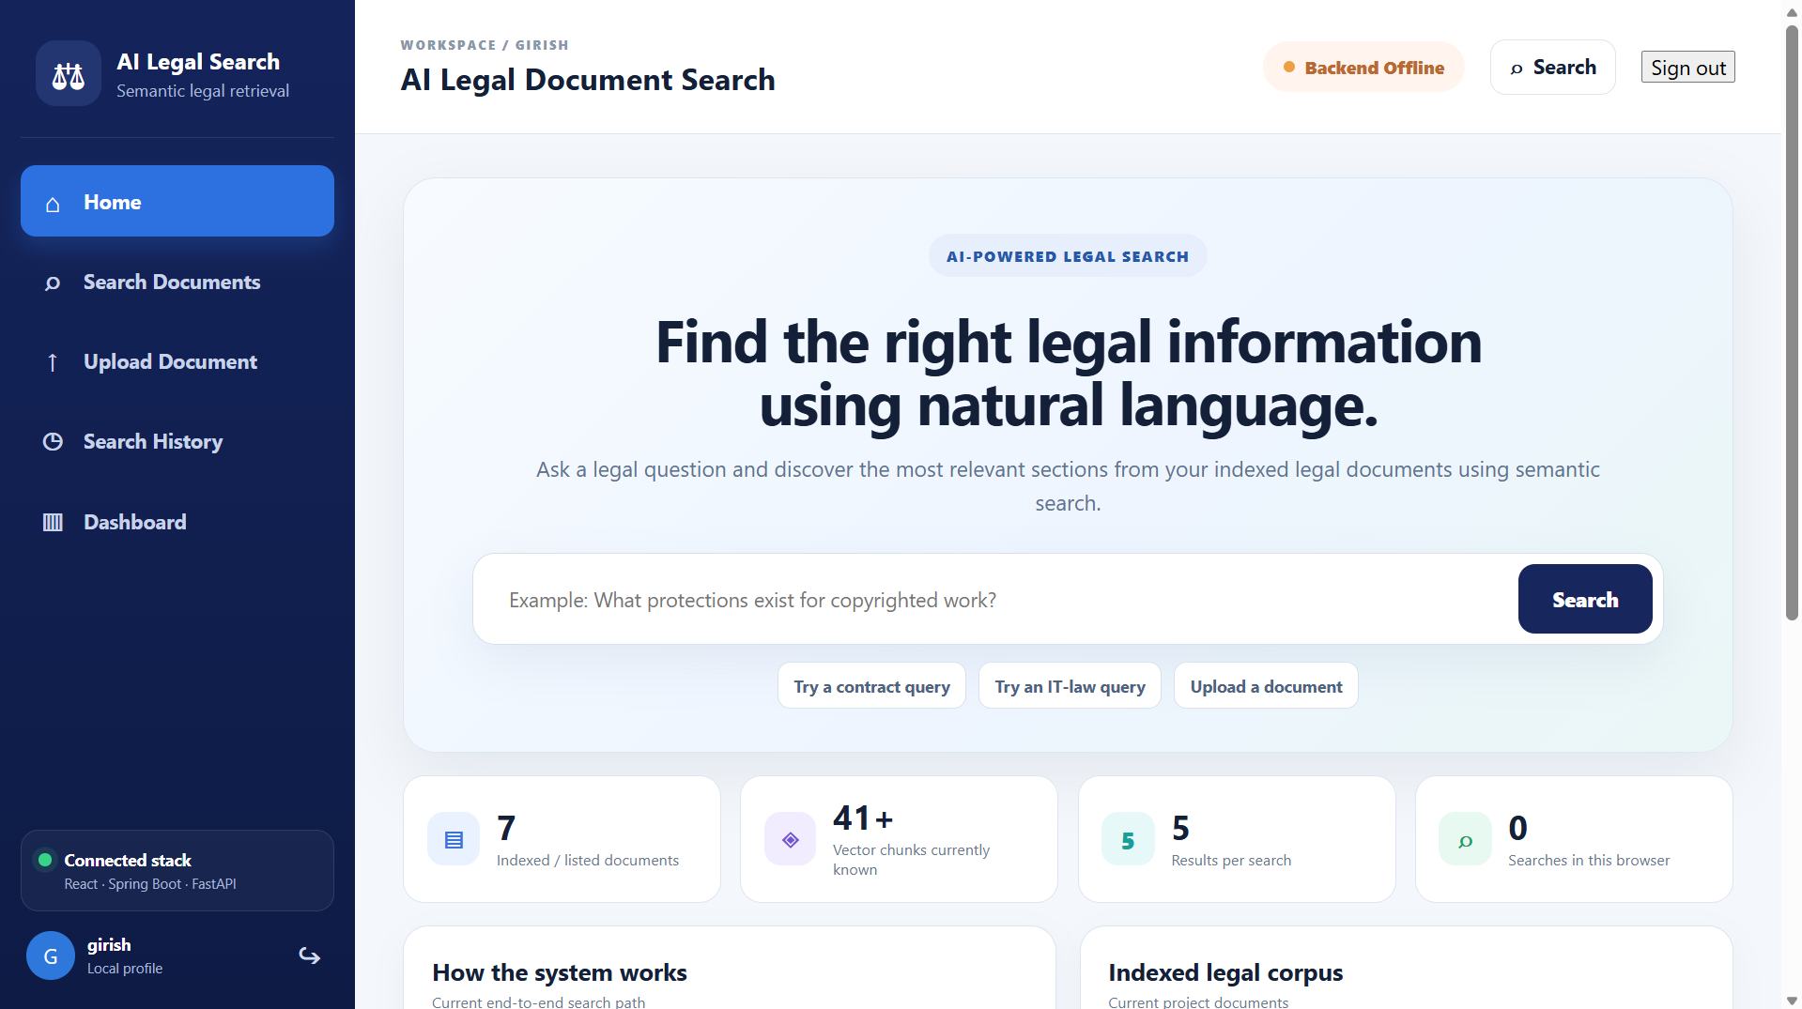
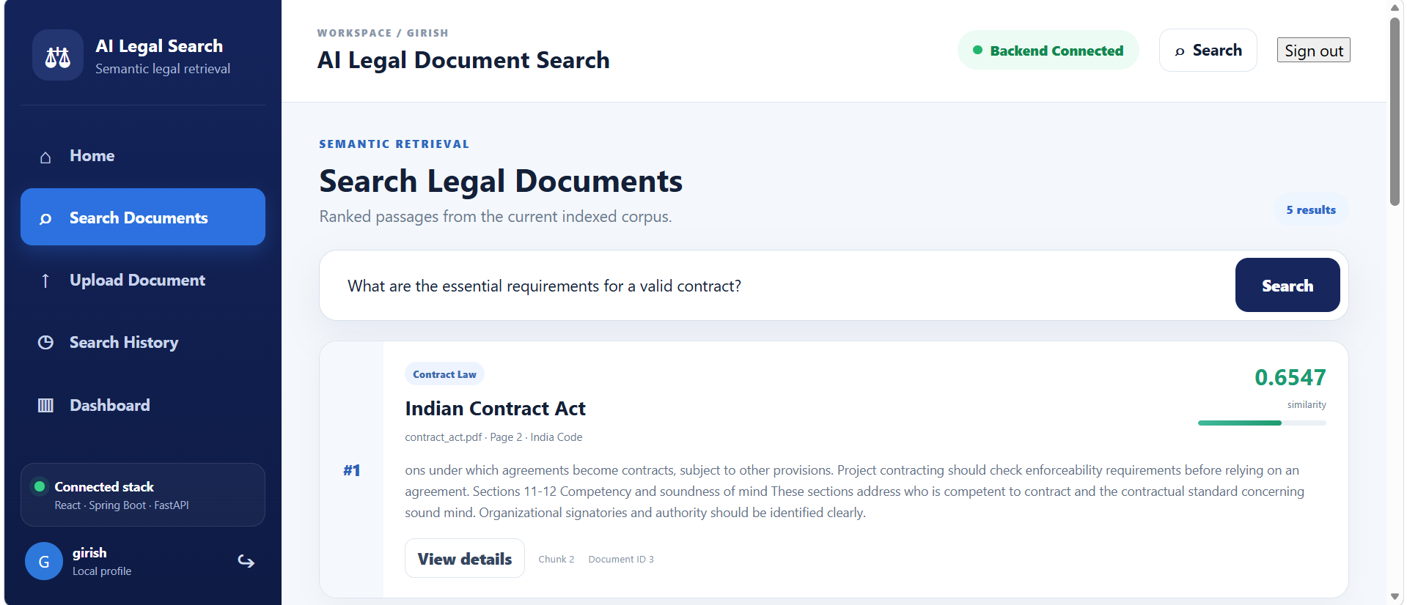
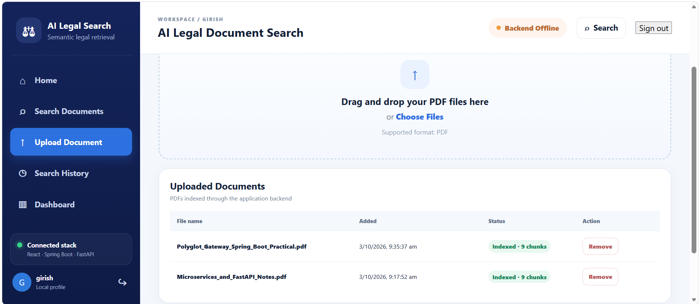
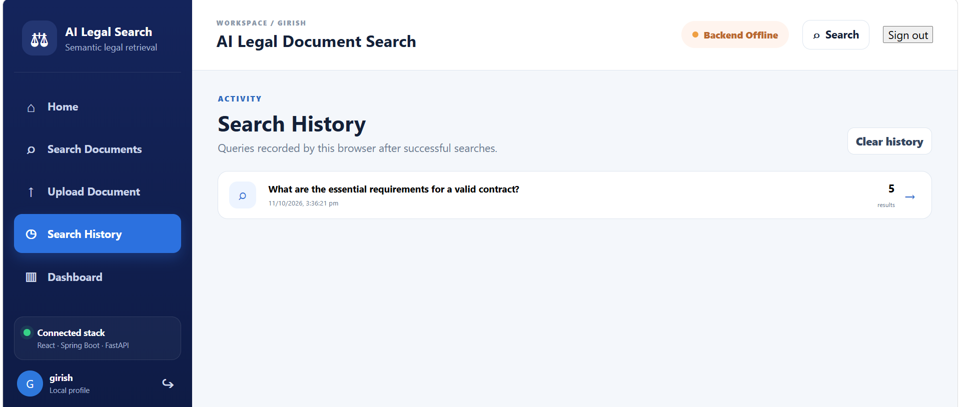
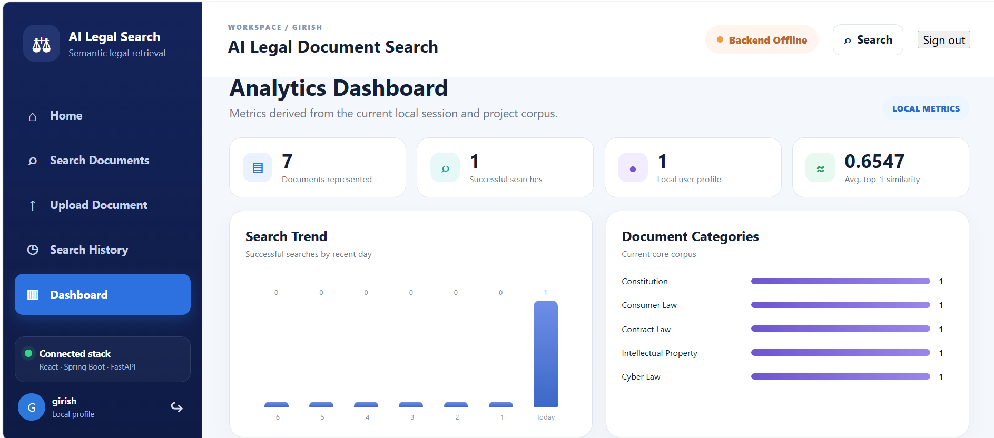
5. CONCLUSION AND FUTURE WORK
Future development should prioritize data integrity before adding more presentation features. Each uploaded file should receive a stable document identifier and content hash; ingestion should register metadata in PostgreSQL and the document record in MongoDB; retries should avoid duplicating existing vectors; and the UI should show whether each stage has completed. This would make the document list a reflection of persisted state rather than browser-local state.
Evaluation can then be expanded in a controlled way. A larger question set should include paraphrases, questions that require statutory labels, queries about overlapping topics, and out-of-corpus questions. The set should have explicit relevance judgements and compare vector retrieval against a keyword baseline. Precision@k, Recall@k, Mean Reciprocal Rank, and response-time percentiles can be reported once the benchmark is run and the results can be reproduced.
The project achieved its core objective of building a working AI-based legal document search application using vector retrieval. The final system accepts natural-language questions, generates semantic representations, retrieves relevant legal chunks from ChromaDB, enriches the results with structured metadata, and displays the evidence through a React interface. Spring Boot provides the application-facing API boundary and FastAPI isolates the AI logic.
The four-review sequence contributed to this outcome in a traceable way. Review-1 defined the problem and acceptance objectives. Review-2 converted the literature into a defensible gap and technology direction. Review-3 implemented the data pipeline, database responsibilities and layered services. Review-4 used real API responses, top-ranked documents and upload counts to verify the integrated workflow. This continuity is the main project-management result: the final report connects the motivation, design choices, executable application and measurable evidence.
The strongest verified claim is narrow but meaningful: in the seven manually selected semantic queries, the expected legal document was ranked first every time, and every query returned five results. In addition, PDF ingestion was exercised through the direct FastAPI endpoint and through the Spring Boot gateway. These results show that the core discovery path is operational. They do not prove that all legal questions can be answered correctly or that newly uploaded documents are fully synchronized across every database.
The project also demonstrates a deliberate database-engineering design. PostgreSQL handles structured metadata and search history; MongoDB Atlas stores legal-document content; ChromaDB stores vectors and retrieval metadata. The architecture is modular enough to evolve without forcing one data model to handle every workload.
The measured test set shows encouraging retrieval behavior: seven selected queries returned the expected legal document at rank 1, with a mean top-1 similarity of 0.5937. The upload pipeline was separately verified for two PDFs, showing that the system can perform real indexing rather than only recording a browser-local file selection.
- Add production authentication and role-based access control.
- Synchronize uploaded documents across ChromaDB, PostgreSQL and MongoDB automatically.
- Add document-level filters, source preview and navigation to original legal material.
- Formalize retrieval evaluation with relevance labels, Precision@k, Recall@k and MRR.
- Measure query latency, ingestion time and scalability using a controlled benchmark.
- Expand the corpus and support more legal document types and cross-reference relationships.
- Consider grounded RAG responses only after retrieval quality and provenance are sufficiently controlled.

APPENDIX A — Project Execution Commands
The following commands summarize the verified local execution flow used during development. The commands assume the project paths established during implementation.
Before the application demo, verify each health endpoint and avoid uploading the same baseline PDF repeatedly unless the intention is to test duplicate handling. The initial corpus count of 41 chunks is a recorded baseline. The upload tests subsequently returned seven chunks for the direct Constitution upload and eight for the Consumer Act upload; these responses should be retained as separate test events until an index-count and de-duplication audit is carried out.
For a repeatable evidence package, record the exact query, the top document, the top similarity, result count, upload filename, chunk count, HTTP status, and date of each test. If an endpoint changes, re-run the same cases and compare the output shape and expected top document. These basic controls make the project easier to demonstrate to faculty and create a foundation for automated integration tests.
# Start FastAPI
cd "E:\Second year KLH Softwares\DBMS PROJECT\AI Legal Document Search\backend\fastapi"
.\.venv\Scripts\Activate.ps1
python -m uvicorn app.main:app
# Start Spring Boot
cd "E:\Second year KLH Softwares\DBMS PROJECT\AI Legal Document Search\backend\springboot\legal-search-backend"
.\mvnw.cmd spring-boot:run
# Start React
cd "E:\Second year KLH Softwares\DBMS PROJECT\AI Legal Document Search\frontend"
npm run dev
# Search through Spring Boot
curl.exe -X POST "http://localhost:8080/api/search" -H "Content-Type: application/json" -d "{\"query\":\"What are the essential requirements for a valid contract?\"}"
# Upload through Spring Boot
curl.exe -X POST "http://localhost:8080/api/documents/upload" -F "file=@E:\Second year KLH Softwares\DBMS PROJECT\AI Legal Document Search\data\raw\consumer_act.pdf"

APPENDIX B — Review-to-Document Traceability
PBL Review | Instruction theme | Where covered in this report
Review-1 | Problem, need, objectives, proposed solution, feasibility, novelty | Introduction pages/sections and early methodology sections.
Review-2 | Literature review, matrix, gap analysis, critical review, tools/resources, proposed direction | Methodology literature-review sections and comparative-analysis pages.
Review-3 | Problem identification, data collection, preprocessing, system design, technology, workflow, implementation, validation, deployment | Experiments sections covering data, architecture, services, UI, upload and verification.
Review-4 | Objectives, development approach, implementation, architecture, demonstration, functional results, testing, performance, results and conclusion | Results & Analysis sections and concluding chapter.
The document follows the supplied academic report structure while incorporating the material developed during all four PBL reviews. It deliberately distinguishes measured results from planned metrics and implemented capabilities from future extensions.

APPENDIX C — Final Project State and Reproducibility Notes
Component | Verified state
Frontend | React/Vite interface runs on localhost:5173; current UI includes search and expanded navigation.
Spring Boot | Build succeeds; application runs on localhost:8080; `/api/health` and `/api/search` verified.
FastAPI | Runs on localhost:8000; search and `/documents/upload` verified.
ChromaDB | Baseline 41 indexed chunks in the validated corpus.
PostgreSQL | Database `legal_search`; metadata and search history used by the application.
MongoDB Atlas | Five baseline legal document records.
Search evaluation | Seven selected queries; 7/7 expected documents ranked #1.
Upload verification | constitution.pdf → 7 chunks; consumer_act.pdf → 8 chunks.
Known limitation | Production authentication, comprehensive duplicate handling, synchronized upload metadata and formal latency benchmarking are future extensions.

Reproducibility Procedure
The baseline state and the upload observations must be recorded separately. The validated baseline contained five legal reference PDFs and 41 ChromaDB chunks, together with five PostgreSQL metadata rows and five MongoDB Atlas document records. Later upload demonstrations returned seven indexed chunks for the direct Constitution upload and eight for the Consumer Act upload. Those two return values demonstrate that the ingestion endpoint processed the submitted PDFs; they are not a verified statement of the current total number of vectors after repeated uploads. A final audit should query the active ChromaDB collection and document identifiers before quoting a live total.
To reproduce the application flow, start PostgreSQL and confirm that the `legal_search` database is available. Start FastAPI from the backend/fastapi directory using the project virtual environment, then start Spring Boot from the nested `legal-search-backend` folder with the Maven Wrapper, and finally start React through Vite. Before running functional tests, check the FastAPI root endpoint and Spring Boot health endpoint. This simple order isolates infrastructure failures from application failures and reduces the chance of interpreting a backend-down message as a retrieval defect.
For retrieval reproducibility, use the same seven query texts recorded in the Results section and submit them through the application-facing Spring Boot `/api/search` endpoint. Record the query, expected legal Act, returned top document, top similarity, total result count and date of execution. The current experiment uses five returned chunks per query. The measured outcome was seven expected top documents at rank one across seven manually selected questions, with 35 result records and a mean top-one similarity of 0.5937. This is evidence for the selected set only; it is not a general legal-search benchmark or an evaluation with independent relevance labels for every returned passage.
For upload reproducibility, submit a valid PDF as multipart form data to Spring Boot `/api/documents/upload`. Confirm the filename and `chunks_indexed` value returned by FastAPI through the Spring Boot response. Then search for a topic distinctive to the uploaded PDF and inspect whether its chunks appear in the ranked results. A successful upload response verifies processing and indexing at the API layer, while the follow-up retrieval test verifies discoverability through the search path. These are separate checks and should be reported separately in test records.
Cross-store consistency remains an important extension. ChromaDB stores the vectors and chunk metadata used for retrieval, PostgreSQL stores structured metadata and search history, and MongoDB Atlas holds the document records. The upload path currently demonstrates PDF indexing, but a production workflow should also synchronize the new file across metadata and document stores. It should use a stable document identifier or content hash, detect duplicate submissions, record ingestion status, handle retries, and provide a reconciliation procedure for partial failures. Until those controls are implemented and tested, uploaded items should not be assumed to have complete metadata in every store.

APPENDIX D — Detailed Semantic Search Evidence
This appendix records the top-five results reported during the seven semantic-search tests. The scores below are the similarity values returned by the running system, not probabilities and not a generalized accuracy metric. Page numbers are included for result rows where they were present in the recorded PowerShell output; for the earlier electronic-record query, only the page span across the returned results was recorded.

Test D.1 — Constitution of India
Query: “What are the rights and duties under the Constitution of India?” The returned top five were: rank 1, constitution.pdf, page 1, 0.6677; rank 2, constitution.pdf, page 2, 0.6358; rank 3, constitution.pdf, page 3, 0.6330; rank 4, constitution.pdf, page 2, 0.5570; and rank 5, constitution.pdf, page 4, 0.5398. The expected Constitution document appeared first.

Test D.2 — Consumer law
Query: “What rights do consumers have when buying goods and services?” The returned top five were: rank 1, consumer_act.pdf, page 1, 0.5232; rank 2, page 2, 0.4765; rank 3, page 3, 0.4504; rank 4, page 2, 0.4373; and rank 5, page 4, 0.4355. All five rows belonged to consumer_act.pdf, and Consumer Protection Act was the expected first document.

Test D.3 — Contract law
Query: “What are the essential requirements for a valid contract?” The returned top five were: rank 1, contract_act.pdf, page 2, 0.6547; rank 2, contract_act.pdf, page 2, 0.5412; rank 3, it_act.pdf, page 2, 0.4633; rank 4, contract_act.pdf, page 4, 0.4598; and rank 5, contract_act.pdf, page 3, 0.4417. This test shows a related but different Act can enter the top five while the expected Contract Act remains first.

Test D.4 — Copyright infringement and remedies
Query: “What is copyright infringement and what remedies are available?” The returned top five were: rank 1, copyright_act.pdf, page 3, 0.5375; rank 2, page 3, 0.5110; rank 3, page 4, 0.4914; rank 4, page 2, 0.4208; and rank 5, page 4, 0.3617. The Copyright Act was ranked first, matching the query’s legal domain.

Test D.5 — Electronic records and cyber offences
Query: “What legal provisions apply to electronic records and cyber offences?” The returned top five were all from it_act.pdf: rank 1, page 3, 0.6387; rank 2, page 2, 0.6052; rank 3, page 1, 0.5953; rank 4, page 2, 0.5839; and rank 5, page 3, 0.5804. The Information Technology Act was the expected top document.

Test D.6 — Copyright protection (earlier verification)
Query: “What protections exist for copyrighted work?” The earlier verified response returned copyright_act.pdf at rank 1, page 4, 0.5550; rank 2, page 3, 0.5100; rank 3, page 2, 0.4834; rank 4, page 3, 0.4809; and rank 5, page 4, 0.4662. The first response included Copyright Act metadata, Intellectual Property category and India Code source details.

Test D.7 — Cyber-law rules (earlier verification)
Query: “What are the rules for electronic records and cyber offences?” The earlier verified top-five scores were 0.5791, 0.5264, 0.5238, 0.5207 and 0.5016, with all five retrieved chunks from it_act.pdf and pages spanning 1–3. The Information Technology Act appeared first, consistent with the query topic.
Interpretation: all seven selected questions returned the expected legal Act at rank one, resulting in 7/7 top-one matches and 35 returned result records. The arithmetic mean of the seven top-one scores is 0.5937. The evidence supports the system’s behavior on this curated set, while broader validation still requires more queries, independent relevance labels, out-of-domain questions and duplicate-upload checks. Similarity values should be interpreted together with rank, source passage, document/page provenance and human assessment of legal relevance.
REFERENCES
The reference set below combines the project review materials, the legal reference corpus used for indexing, and the literature records presented in Review-2. Where a Review-2 slide did not include full bibliographic information, the report preserves the study label instead of fabricating citation metadata.
[5] Supplied Project-Based Learning Report template. Academic report structure: Abstract, List of Figures, List of Tables, Table of Contents, Introduction, Methodology, Experiments, Results, Conclusion and Future Work, References.
[6] Constitution of India — India Code reference document used in the project corpus; project reference edition prepared for indexing and demonstration.
[7] Consumer Protection Act — India Code reference document used in the project corpus; project reference edition prepared for indexing and demonstration.
[8] Indian Contract Act — India Code reference document used in the project corpus; project reference edition prepared for indexing and demonstration.
[9] Copyright Act — India Code reference document used in the project corpus; project reference edition prepared for indexing and demonstration.
[10] Information Technology Act — India Code reference document used in the project corpus; project reference edition prepared for indexing and demonstration.
[11] K. Sugathadasa, B. Ayesha, N. de Silva, A. S. Perera, V. Jayawardana, D. Lakmal and M. Perera, “Legal Document Retrieval using Document Vector Embeddings and Deep Learning,” Proceedings of the Computing Conference 2018, Advances in Intelligent Systems and Computing, vol. 2, pp. 160–175, 2019. DOI: 10.1007/978-3-030-01177-2_12. Preprint: arXiv:1805.10685.
[12] S. Bi, Z. Ali, M. Wang, T. Wu and G. Qi, “Learning heterogeneous graph embedding for Chinese legal document similarity,” Knowledge-Based Systems, vol. 250, article 109046, 2022. DOI: 10.1016/j.knosys.2022.109046.
[13] “From Fact Drafts to Operational Systems: Semantic Search in Legal Decisions Using Fact Drafts,” Big Data and Cognitive Computing, vol. 8, no. 12, article 185, 2024. DOI: 10.3390/bdcc8120185.
[14] A. Colombo, A. Bernasconi, L. Bellomarini, L. Guiso, C. Michelacci et al., “LegisSearch: navigating legislation with graphs and large language models,” Artificial Intelligence and Law, 2025. DOI: 10.1007/s10506-025-09482-6.
[15] J. A. de Oliveira Lima, “Poly-Vector Retrieval: Reference and Content Embeddings for Legal Documents,” arXiv:2504.10508, 2025.
[16] I. Chalkidis, M. Fergadiotis, P. Malakasiotis, N. Aletras and I. Androutsopoulos, “LEGAL-BERT: The Muppets straight out of Law School,” Findings of the Association for Computational Linguistics: EMNLP 2020, pp. 2898–2904, 2020. DOI: 10.18653/v1/2020.findings-emnlp.261.
[17] N. Pipitone and G. Houir Alami, “LegalBench-RAG: A Benchmark for Retrieval-Augmented Generation in the Legal Domain,” arXiv:2408.10343, 2024.
[18] M. Buffa, A. Ferrara, S. Picascia, D. Riva and S. Castano, “Enhancing Legal Document Building with Retrieval-Augmented Generation,” Computer Law & Security Review, vol. 59, article 106229, 2025. DOI: 10.1016/j.clsr.2025.106229.
[19] A. F. Ferraris, D. Audrito, G. Siragusa and A. Piovano, “Legal Chunking: Evaluating Methods for Effective Legal Text Retrieval,” in Legal Knowledge and Information Systems, JURIX 2024, Frontiers in Artificial Intelligence and Applications, 2024. DOI: 10.3233/FAIA241255.

