TigerGraph & TigerGraph RAG Setup Guide.

- Install Docker Desktop
Download and install Docker Desktop for windows:
https://docs.docker.com/desktop/setup/install/windows-install/

- Open VS Code
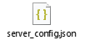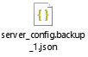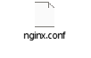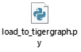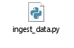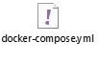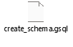
Copy the folders and open it using VS Code.
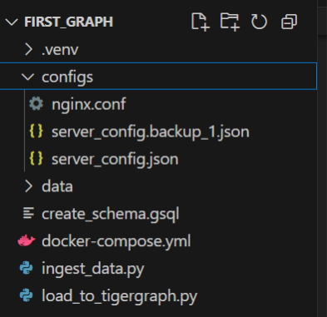

- Set Python Environment
make environment at root folder level and open the terminal and run below commands
python -m venv .venv
Once the .venv file is created activate the virtual environment
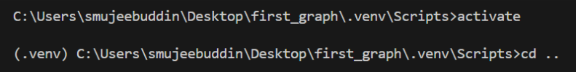
source demo/bin/activate
- Fix WSL Update Issue If Any
Open the Docker Desktop and if it gives WSL update error, Go to the parent folder in cmd and run the wsl update command.
wsl –update
- Download TigerGraph Community Edition Image.
Fill the form and download the TigerGraph image(.tar file) from: https://dl.tigergraph.com/
You will receive the download link in your mail provided in the form.
Example image version : Docker Image 4.2.2

- Load The Image into Docker
Open CMD in the folder where the image is downloaded and run
docker load -i tigergraph-4.2.2-community-docker-image.tar.gz
This loads the TigerGraph image into Docker Desktop.
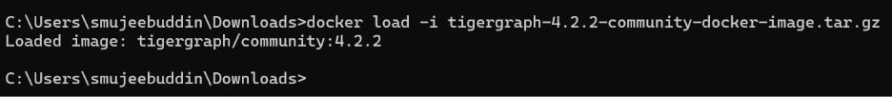
You can confirm it by checking the images section in Docker Desktop
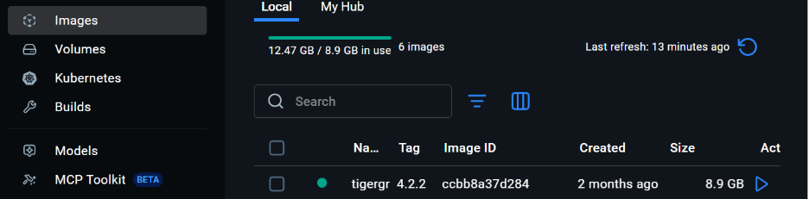

- Start TigerGraph Services
Run the following to command to start all required containers:
docker compose up -d
This will create all the required images and run them.
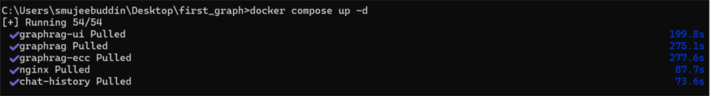

- Default TigerGraph Credentials
Once the services start
URL : https://localhost:14240
Username: tigergraph
Password : tigergraph
- Log in to TigerGraph Container
From terminal in VS Code open and interactive shell inside the TigerGraph container.
docker exec -it tigergraph bash
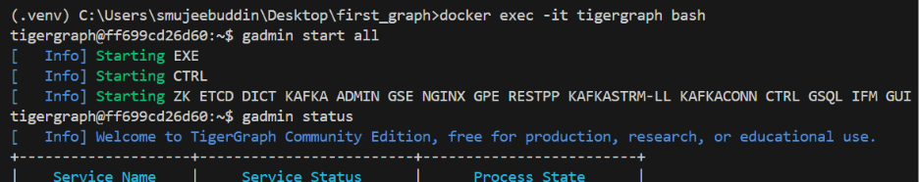

- Start All TigerGraph Services
Inside the container run >> gadmin start all
check status >> gadmin status
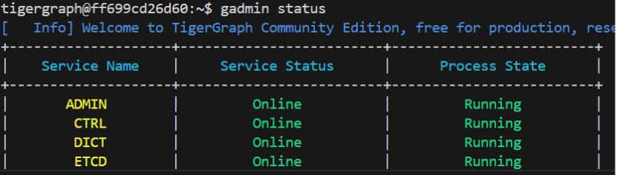
- Copy Schema File into the TigerGraph Container.
From your host machine(cmd), copy the file like below
docker cp C:\Users\smujeebuddin\Desktop\first_graph\create_schema.gsql tigergraph:/home/tigergraph/
- Create Schema & Nodes
Inside the Tiger Graph Container run below command.
gsql /home/tigergraph/create_schema.gsql
