How to create repository

<https://guides.github.com/activities/hello-world/>

Pull Request from UI :

Create a pull request, check two branches (base : on which it has to merge, actual : from which branch code has to merge to base)

If there conflicts : solve

If ready to merge : create pull request

From master branch, we can merge

Delete branch from UI:

Click branches and click delete

Blogs to learn more on github :

<https://github.com/blog>

Create new repo using command line

You cannot create a repo on github using git bash

go to https://github.com/ and create a repository “Study” on github, then run below lines.

### …or create a new repository on the command line

### Create a new empty repository from Ui and follow below steps

echo "# Study" >> README.md

git init

git config –global user.name “GirishVenkatesh1987”

git config –global user.email “girishprofile1987@gmail.com”

git add README.md

git commit -m "first commit"

git remote add origin https://github.com/GirishVenkatesh1987/Study.git

git push -u origin master

**…or push an existing repository from the command line**

git remote add origin https://github.com/GirishVenkatesh1987/Study.git

git push -u origin master

[**http://www.tutorialspoint.com/git/**](http://www.tutorialspoint.com/git/)

* Working Directory and Staging Area or Index

Only those files present in the staging area are considered for commit and not all the modified files.

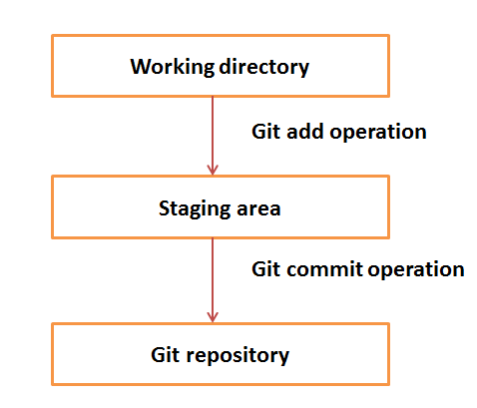

* Blobs

Blob stands for **B**inary **L**arge **Ob**ject. Each version of a file is represented by blob. A blob holds the file data but doesn’t contain any metadata about the file. It is a binary file, and in Git database, it is named as SHA1 hash of that file. In Git, files are not addressed by names. Everything is content-addressed

* Tags

Tag assigns a meaningful name with a specific version in the repository. Tags are very similar to branches, but the difference is that tags are immutable. It means, tag is a branch, which nobody intends to modify. Once a tag is created for a particular commit, even if you create a new commit, it will not be updated. Usually, developers create tags for product releases

Tags are used for creating stable releases. To create a tag for using with the Git Drupal Repository, first, ensure that you're [following the tag naming convention](http://drupal.org/node/1015226) if you're using this tag for making a release. From inside the directory of the project, an example is:

git tag 7.x-1.0

Once the tag is created, you need to push the tag up to the master repository. By itself, push doesn't send the tags up, you also need to tell it to include the tags in the push by appending the --tags flag:

git push origin --tags

If you don't want to push all your tags, you can also be specific:  
Example:

git push origin tag 7.x-1.0

To check and confirm remote tags, the command is  
git tag –l

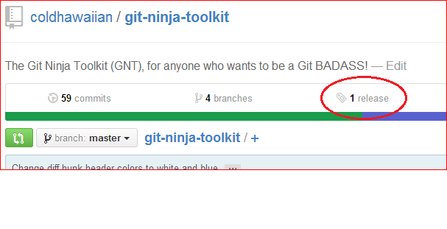

Once tag is pushed to repo, it can be viewed under releases

How to checkout/clone tag branch :

$ git clone will give you the whole repository.

After the clone, you can list the tags with $ git tag -l and then checkout a specific tag:

$ git checkout tags/<tag_name>

Even better, checkout and create a branch (otherwise you will be on a branch named after the revision number of tag):

$ git checkout tags/<tag_name> -b <branch_name> //create a branch for tag

* HEAD

HEAD is a pointer, which always points to the latest commit in the branch. Whenever you make a commit, HEAD is updated with the latest commit. The heads of the branches are stored in **.git/refs/heads/** directory.

[CentOS]$ ls -1 .git/refs/heads/

master

[CentOS]$ cat .git/refs/heads/master

570837e7d58fa4bccd86cb575d884502188b0c49

* To change remote url from

cloned with https url, change to ssh

git config remote.origin.url git@github.com:GirishVenkatesh1987/Documents.git

* To see the url details

git remote show origin

* To avoid username and pw popup for each push in windows for https remote url

git config --global credential.helper wincred