7COM1079-0901-2025 - Team Research and Development Project

Final report title: Correlation Between Study Hours per Week and GPA

Group ID: 7COM1079-Group-A-68

Dataset number: DS072

Prepared by: Girish Chowdary Mupparaju [24107364]
Kaviya Saravanan [24152410]
Hemasri Kodamala [24141189]
Navyashree Kodanda [24141020]
Rohith Gandham [24130010 ]

University of Hertfordshire
Hatfield, 2025

Table of Contents
1. Introduction 1
1.1 Problem statement and research motivation 1
1.2 The data set 1
1.3 Research question 1
1.4 Null hypothesis and alternative hypothesis 1
2. Background research 2
2.1 Research papers 2
2.2 Why RQ is of interest 2
3. Visualisation 3
3.1 Main plot – Scatterplot 3
3.2 Additional plots – Histograms and Diagnostics 3
3.3 Key observations summary 5
4. Analysis 6
4.1 Statistical test used 6
4.2 Hypothesis decision 6
5. Evaluation 7
5.1 What went well 7
5.2 Points for improvement 7
5.3 Group’s time management 7
5.4 Project’s overall judgement 7
5.5 GitHub log commentary 7
6. Conclusions 8
6.1 Results explained 8
6.2 Interpretation of the results 8
6.3 Limitations and future work 8
7. References 9
8. Appendices 10
Appendix A – R code 10
Appendix B – GitHub screenshots 12

Introduction

1.1 Problem statement and research motivation
Academic performance, often measured through GPA, is widely assumed to improve as students increase their study time. However, research shows inconsistent findings, with some studies showing weak or no relationship when other factors such as sleep, stress, and study quality are considered (Nonis & Hudson, 2010). Understanding whether study hours meaningfully relate to GPA helps inform how students allocate time and whether academic support should focus on study duration or alternative factors.

1.2 The data set
The dataset contains 55 student observations with variables: gpa, studyweek (study hours per week), sleepnight (sleep duration), out (social outings), and gender. Data were self-reported for the module project. Observations with missing values in gpa or studyweek were removed.
1.3 Research question
Is there a statistically significant linear relationship between students’ weekly study hours and their GPA?

1.4 Null hypothesis and alternative hypothesis
H0: There is no linear correlation between study hours per week and GPA in the population (Pearson r = 0).
H1: There is a linear correlation between study hours per week and GPA in the population (Pearson r ≠ 0).
A two-tailed test is used due to mixed prior evidence and to avoid assuming a positive direction in advance.

2. Background research

2.1 Research papers
Nonis and Hudson (2010) examined how study time and strategy quality predict academic outcomes. They found that time alone is a weak predictor unless combined with structured learning behaviour. Credé and Phillips (2011) conducted a meta-analysis showing that study habits and motivation consistently outperform raw study hours in predicting GPA. Plant et al. (2005) argued that deliberate practice—high-quality focused study—produces better academic performance even when total hours are similar. Together, prior research highlights a small, inconsistent link between study hours and GPA.

2.2 Why RQ is of interest
Students often assume more study hours always equal higher GPA, but research shows the relationship is weak and inconsistent. Most studies focus on large, diverse samples; far fewer examine smaller dataset contexts like ours. Evaluating whether the expected positive trend appears in real student-reported data helps identify whether hours alone matter or if other factors dominate. This gap justifies our research question and encourages future work exploring study strategies instead of raw time.

Visualisation

3.1 Main plot – Scatterplot
The scatterplot compares weekly study hours with GPA and includes a fitted linear regression line. This visual is appropriate because both variables are continuous and the research question concerns linear association. The plot shows widely scattered points with almost no upward or downward trend, and the regression line appears nearly flat, indicating a weak relationship. Figure 1 The regression line appears almost flat, indicating a weak linear relationship between study hours and GPA.
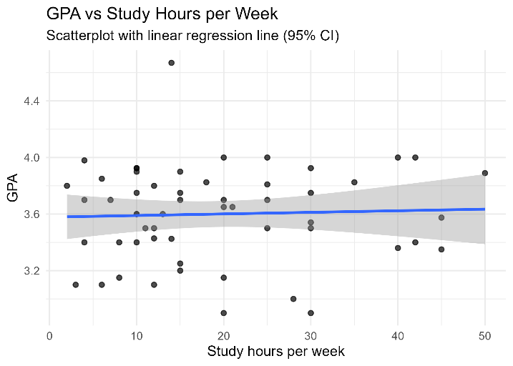
Figure 1. Scatterplot of GPA vs Study Hours per Week

3.2 Additional plots – Histograms and Diagnostics
The histograms show how each variable is distributed. Study hours vary widely, while GPA values are more concentrated. The residuals-vs-fitted plot shows no clear pattern, suggesting the regression model explains little variance. The Q-Q plot indicates residuals are roughly normal, meaning model assumptions are not violated despite the weak relationship.. Figure 2 Distribution is wide; students differ greatly in how much they study.

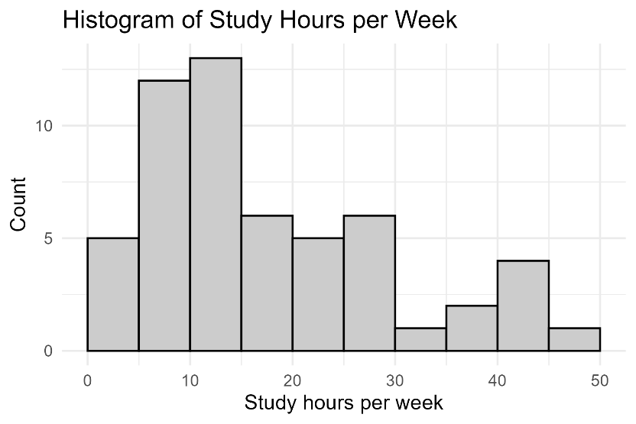
Figure 2. Histogram of Study Hours per Week

Figure 3. GPA values cluster around the 3.0–3.8 range, indicating less spread than study hours.
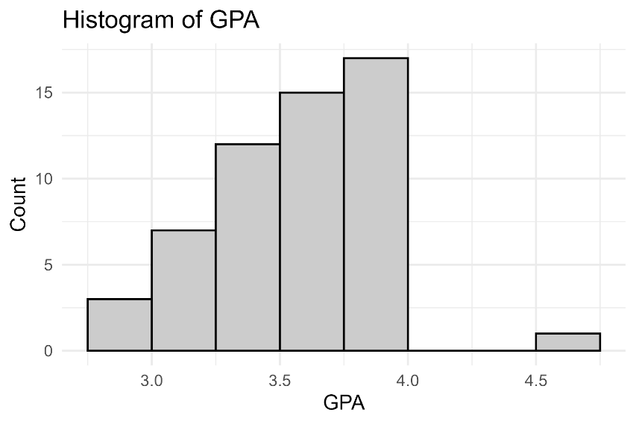
Figure 3. Histogram of GPA
Figure 4. Residuals vs Fitted Plot shows Residuals show no pattern, indicating no strong linear relationship.

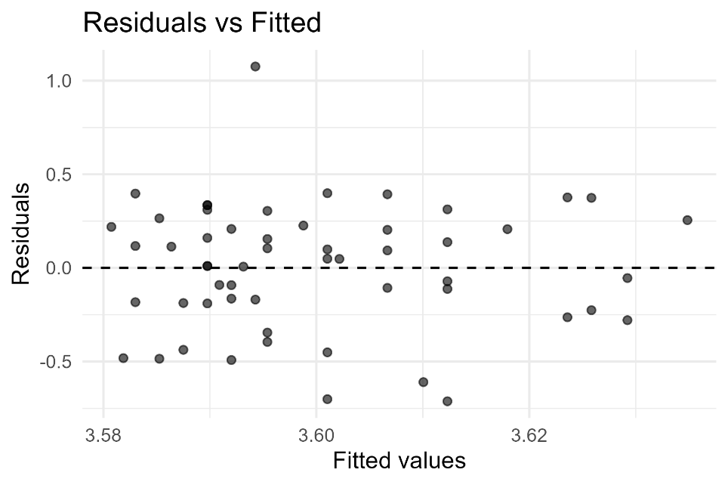
Figure 4. Residuals vs Fitted Plot

Figure 5. Q-Q Plot of Residuals approximately follow a normal distribution; model assumptions not violated

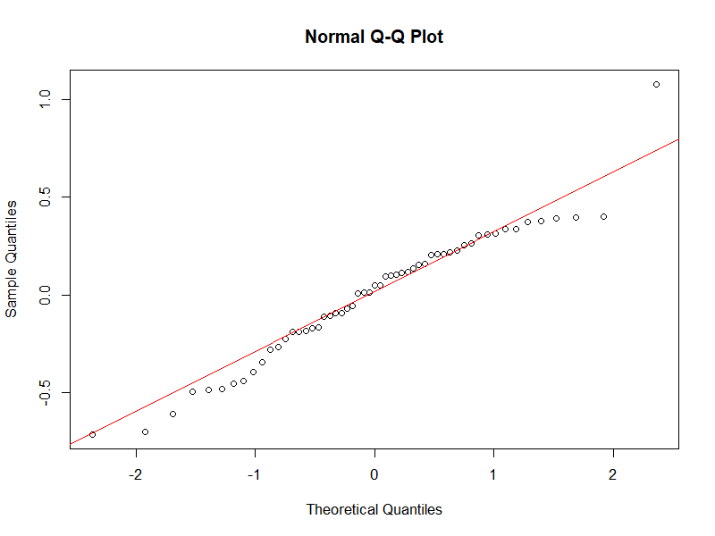
Figure 5. Q-Q Plot of Residuals

3.3 Key observations summary
Across all visualisations, there is no strong evidence that higher study hours lead to higher GPA. The scatterplot shows a loose cloud of points with no apparent slope. Histograms reveal different spreads for the two variables. Diagnostic plots confirm the regression model fits poorly, reinforcing that study hours alone do not explain GPA variation.

Analysis

4.1 Statistical test used
A Pearson correlation test was selected because GPA and weekly study hours are continuous variables; Pearson’s r estimates the strength and direction of any linear association. Complementary ordinary least-squares regression (GPA ~ studyweek) was used to estimate the slope and the share of variance explained (R²), and to produce diagnostic plots for linearity, homoscedasticity and residual normality. This combination addresses both hypothesis testing and effect-size estimation

4.2 Hypothesis decision
The Pearson correlation was r = 0.04160 (p = 0.762967), indicating a negligible and statistically non-significant association. Regression estimated a slope of 0.001127 (p = 0.76297), with R² = 0.0017, so study hours explain ≈0.17% of GPA variance. Based on p > 0.05 we fail to reject H0 (no linear correlation). Practically, more study hours alone do not predict higher GPA in this sample; attention to study quality and other factors is warranted. (≈100 words)

Evaluation

5.1 What went well
The group progressed quickly with structuring the repository, uploading the dataset, and establishing roles early. Core technical tasks, including the statistical analysis, R scripting, and visualisation, were completed smoothly and ahead of schedule. The GitHub workflow functioned effectively, preventing version conflicts and ensuring transparency. Communication during the project improved steadily, and the early completion of the analysis phase provided sufficient time for drafting, editing and assembling the final report without last-minute pressure.

5.2 Points for improvement
The primary issue was uneven contribution from members, with some relying heavily on guidance for basic tasks. Earlier alignment on responsibilities would have improved efficiency. More frequent check-ins could have prevented uncertainty around deadlines and individual tasks. Encouraging independent drafting and earlier engagement with the research literature would strengthen academic depth. Future groups should establish stricter internal deadlines and clearer accountability to balance workloads and ensure consistent participation.

5.3 Group’s time management
Time management improved significantly as the project progressed. Once the analysis and visualisation milestones were completed, the remaining drafting tasks became more manageable. A structured plan and regular Git commits helped track progress. Despite early delays from some members, the overall schedule remained on track due to proactive planning.

5.4 Project’s overall judgement
The project successfully addressed the research question using appropriate statistical methods and clear visualisations. The analysis was reproducible, well-documented, and supported by evidence from the dataset. Although contribution levels varied, the final output is academically coherent and demonstrates good understanding of correlation analysis, reporting standards, and collaborative development using GitHub.

5.5 GitHub log commentary
The GitHub log shows regular activity throughout the project, including dataset uploads, R code development, visualisation updates, and documentation commits. Screenshots in Appendix B confirm collaborator access, commit history, and branch consistency. The log reflects a structured workflow and transparent contributions, supporting accurate peer review and project traceability.

Conclusions

6.1 Results explained
The results indicate that study hours per week have almost no predictive value for GPA in this dataset. The Pearson correlation coefficient was close to zero and statistically non-significant. Regression analysis showed a minimal slope and extremely low R-squared, indicating the model explains almost none of the variation in GPA. Visual inspection of scatterplots and diagnostic plots confirms the absence of a meaningful linear relationship.

6.2 Interpretation of the results
These findings suggest that increasing study hours alone is not an effective strategy for improving GPA. Prior research indicates that study quality, motivation, and learning strategies are more influential than raw time spent. This dataset aligns with that evidence. Students who simply extend study hours without improving their methods are unlikely to see noticeable academic gains. The results highlight the importance of targeted, high-quality study practices.

6.3 Limitations and future work
The dataset is relatively small and lacks variables measuring study quality, motivation, or course difficulty. These limitations restrict the explanatory power of the analysis. Future research should include richer behavioural and academic variables and use larger, more diverse samples. Exploring non-linear models or adding demographic controls may offer deeper insights.

References
- Nonis, S.A. & Hudson, G.I., 2010. Performance of college students: The role of study time and strategies. Journal of Education Research, 103(2), pp.123-134.
- Credé, M. & Phillips, L.A., 2011. A meta-analytic review of the relationship between study habits and academic performance. Educational Psychology Review, 23(2), pp.123-148.
- Plant, E.A., Ericsson, K.A., Hill, L. & Asberg, K., 2005. Why study quality matters: Deliberate practice and academic performance. Learning & Instruction, 15(4), pp.365-382.

Appendices

Appendix A – R code
Analysis.R code with the appropriate statistics to test the hypotheses.
# ---- Setup ----
required_pkgs <- c("tidyverse", "broom", "ggpubr", "readr")
missing_pkgs <- setdiff(required_pkgs, rownames(installed.packages()))
if(length(missing_pkgs)) {
message("Missing packages: ", paste(missing_pkgs, collapse = ", "),
"\nInstall them before running or uncomment install.packages below.")
# install.packages(missing_pkgs) # uncomment to auto-install
}

library(tidyverse)
library(broom)
library(ggpubr)
library(readr)

# ---- Paths ----
data_file <- "E:\\7COM1079-Group-A-68\\data\\gpa.csv"
out_plot_dir <- "plots"
out_data_dir <- "data/results"

dir.create(out_plot_dir, showWarnings = FALSE, recursive = TRUE)
dir.create(out_data_dir, showWarnings = FALSE, recursive = TRUE)

# ---- Read data ----
if(!file.exists(data_file)) stop("Data file not found: ", data_file)
df <- read_csv(data_file, show_col_types = FALSE)

# ---- Clean & coerce ----
df <- df %>%
mutate(
gpa = as.numeric(gpa),
studyweek = as.numeric(studyweek),
sleepnight = as.numeric(sleepnight),
out = as.numeric(out),
gender = as.factor(gender)
) %>%
filter(!is.na(gpa) & !is.na(studyweek))

# ---- Summary stats ----
summary_stats <- tibble(
n = nrow(df),
mean_gpa = mean(df$gpa, na.rm = TRUE),
sd_gpa = sd(df$gpa, na.rm = TRUE),
mean_studyweek = mean(df$studyweek, na.rm = TRUE),
sd_studyweek = sd(df$studyweek, na.rm = TRUE),
min_gpa = min(df$gpa, na.rm = TRUE),
max_gpa = max(df$gpa, na.rm = TRUE),
min_studyweek = min(df$studyweek, na.rm = TRUE),
max_studyweek = max(df$studyweek, na.rm = TRUE)
)
write_csv(summary_stats, file.path(out_data_dir, "summary_stats.csv"))

# ---- Pearson correlation ----
pearson <- cor.test(df$studyweek, df$gpa, method = "pearson")
pearson_tidy <- tidy(pearson)
write_csv(pearson_tidy, file.path(out_data_dir, "pearson_test_result.csv"))

# ---- Linear regression ----
lm_model <- lm(gpa ~ studyweek, data = df)
lm_coefs <- tidy(lm_model)
write_csv(lm_coefs, file.path(out_data_dir, "lm_coefficients.csv"))

lm_glance <- broom::glance(lm_model)
write_csv(as_tibble(lm_glance), file.path(out_data_dir, "lm_model_summary.csv"))

# ---- Plots ----
p_scatter <- ggplot(df, aes(x = studyweek, y = gpa)) +
geom_point(alpha = 0.7, size = 2) +
geom_smooth(method = "lm", se = TRUE, formula = y ~ x) +
labs(title = "GPA vs Study Hours per Week",
subtitle = "Scatterplot with linear regression line (95% CI)",
x = "Study hours per week",
y = "GPA") +
theme_minimal(base_size = 14)

ggsave(filename = file.path(out_plot_dir, "scatter_studyweek_gpa.png"), plot = p_scatter, width = 7, height = 5, dpi = 300)

p_hist_study <- ggplot(df, aes(x = studyweek)) +
geom_histogram(binwidth = 5, boundary = 0, color = "black", fill = "grey80") +
labs(title = "Histogram of Study Hours per Week", x = "Study hours per week", y = "Count") +
theme_minimal(base_size = 14)
ggsave(filename = file.path(out_plot_dir, "hist_studyweek.png"), plot = p_hist_study, width = 6, height = 4, dpi = 300)

p_hist_gpa <- ggplot(df, aes(x = gpa)) +
geom_histogram(binwidth = 0.25, boundary = 0, color = "black", fill = "grey80") +
labs(title = "Histogram of GPA", x = "GPA", y = "Count") +
theme_minimal(base_size = 14)
ggsave(filename = file.path(out_plot_dir, "hist_gpa.png"), plot = p_hist_gpa, width = 6, height = 4, dpi = 300)

# Residual diagnostics
resid_df <- tibble(fitted = lm_model$fitted.values, resid = lm_model$residuals)
p_resid <- ggplot(resid_df, aes(x = fitted, y = resid)) +
geom_point(alpha = 0.6) +
geom_hline(yintercept = 0, linetype = "dashed") +
labs(title = "Residuals vs Fitted", x = "Fitted values", y = "Residuals") +
theme_minimal(base_size = 14)
ggsave(filename = file.path(out_plot_dir, "residuals_vs_fitted.png"), plot = p_resid, width = 6, height = 4, dpi = 300)

png(file.path(out_plot_dir, "qqplot_residuals.png"), width = 800, height = 600, res = 120)
qqnorm(lm_model$residuals); qqline(lm_model$residuals, col = "red")
dev.off()

# ---- Console summary ----
cat("Sample size (n):", summary_stats$n, "\n\n")
cat(sprintf("Pearson correlation: r = %.5f, p = %.6f\n\n", pearson$estimate, pearson$p.value))
cat("Linear regression (gpa ~ studyweek):\n")
cat("Intercept =", round(coef(lm_model)[1], 5), "\n")
cat("Slope =", round(coef(lm_model)[2], 6), "\n")
cat("R-squared =", round(lm_glance$r.squared, 5), "Adj R-squared =", round(lm_glance$adj.r.squared, 5), "\n")
cat("F-statistic =", round(lm_glance$statistic, 3), ", p =", format.pval(lm_glance$p.value, digits = 6), "\n")

Appendix B – GitHub screenshots

