Final Report: SmolVLM vs DINOv2 on Oxford-IIIT Pets
Prepared from available Kaggle result exports | 14 May 2026
Headline result. DINOv2-small achieved 80.4% accuracy and 79.2% macro F1, outperforming SmolVLM-256M-Instruct by 47.4 percentage points in accuracy on the available evaluation subsets.

Executive Summary
The available results compare a direct DINOv2-small image classifier against a fine-tuned SmolVLM-256M-Instruct visual-language model on the timm/oxford-iiit-pet dataset.
For closed-set breed classification, DINOv2-small is the stronger production candidate. It reaches substantially higher accuracy and macro F1 while using a larger evaluation subset.
SmolVLM remains useful where natural-language interaction is required, but its current outputs need stronger label normalization and additional fine-tuning before it can compete with a dedicated classifier on fixed breed labels.

Evaluation Setup
Item | Value
Dataset | timm/oxford-iiit-pet
DINO model | facebook/dinov2-small
VLM model | HuggingFaceTB/SmolVLM-256M-Instruct
DINO split | 1,200 train samples, 500 test samples
SmolVLM split | 600 train samples, 200 test samples
Primary metrics | Accuracy and macro F1

Final Results
Model | Task | Train | Test | Accuracy | Macro F1
DINOv2-small | closed-set image classification | 1200 | 500 | 80.4% | 79.2%
SmolVLM-256M-Instruct | image + question -> breed text | 600 | 200 | 33.0% | 29.7%

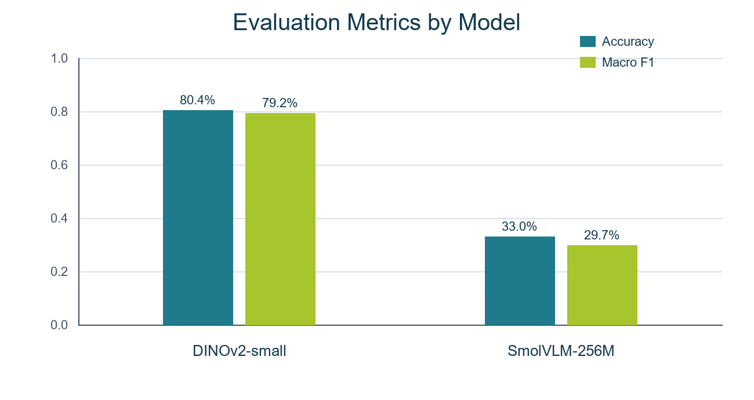
Figure 1. Accuracy and macro F1 from the available summary export.

Interpretation
DINOv2-small is optimized for visual representation learning and a closed classification head, which fits this task well. The row-level DINO predictions show 402 correct predictions out of 500.
SmolVLM produced 66 mapped-class correct predictions out of 200. It also generated 24 predictions that could not be mapped to a known class, which directly limited its score.
The VLM output format is more flexible, but that flexibility is a liability for strict label evaluation unless the answer schema is constrained or the post-processing mapper is improved.

Observed Error Patterns

DINOv2 weakest classes by class accuracy
Class | Correct / Total | Class Accuracy
american pit bull terrier | 4/9 | 44.4%
beagle | 5/11 | 45.5%
chihuahua | 4/8 | 50.0%
english cocker spaniel | 7/12 | 58.3%
ragdoll | 6/10 | 60.0%
american bulldog | 10/16 | 62.5%
pug | 8/12 | 66.7%
siamese | 8/12 | 66.7%

SmolVLM weakest classes by class accuracy
Class | Correct / Total | Class Accuracy
bombay | 0/8 | 0.0%
egyptian mau | 0/7 | 0.0%
keeshond | 0/7 | 0.0%
miniature pinscher | 0/7 | 0.0%
havanese | 0/6 | 0.0%
maine coon | 0/6 | 0.0%
staffordshire bull terrier | 0/6 | 0.0%
wheaten terrier | 0/5 | 0.0%

Most frequent SmolVLM mapped predictions
Mapped Prediction | Count
unknown | 24
american bulldog | 22
abyssinian | 15
shiba inu | 14
persian | 12
english setter | 11
american pit bull terrier | 10
english cocker spaniel | 9

Recommendation
- Use DINOv2-small as the baseline model for fixed Oxford-IIIT Pets breed classification.
- Continue SmolVLM only if the target experience needs natural-language question answering, explanations, or multimodal conversation rather than only label prediction.
- For the next SmolVLM experiment, constrain output to one breed label, increase the fine-tuning sample count, evaluate on the same 500-image test subset, and report both exact text-match accuracy and mapped-label accuracy.

Source Artifacts Used
Used exports: model-level summary CSV, SmolVLM row-level predictions CSV, DINOv2 row-level predictions CSV, dataset/model metadata JSON, and the exported DINOv2 confusion-matrix PNG.

Appendix: DINOv2 Confusion Matrix
The exported confusion matrix shows DINOv2 errors concentrated in visually similar pet breeds while preserving a strong diagonal overall.
