Project for the Degree of B.Sc Engineering

GreatMart | Online e-Commerce Platform

Course Title: Project

Course Code: CSE378

Submitted by

Girish Mondal

Student ID: 17CSE063

Under Supervision of

Dr. Mrinal Kanti Baowaly

Associate Professor

May 19, 2022



Department of Computer Science & Engineering,

Bangabandhu Sheikh Mujibur Rahman Science and Technology University

**Declaration**

The project work entitled “**GreatMart | Online e-Commerce Platform**” has been carried out in the Department of Computer Science and Engineering, Bangabandhu Sheikh Mujibur Rahman Science and Technology University is original and conforms the regulations of this University.

I understand the University’s policy on plagiarism and declare that no part of this project has been copied from other sources or been previously submitted elsewhere for the award of any degree or diploma.

**Counter Signed by**

1. …………………………………………………

**Dr. Mrinal Kanti Baowaly** (Supervisor)

Associate Professor

Department Computer Science & Engineering

BSMRSTU

**Candidate**

2. …………………………………………………

**Girish Mondal**

Student ID: 17CSE063

3rd Year 2nd Semester.

Department Computer Science & Engineering

**Table of Contents**

**Contents Page Number**

**1. Chapter 1: Introduction** 01-02

**1.1:**  Abstract

**1.2:** Acknowledgement

**1.3:**  Introduction

**2. Chapter 2: Motivation**  03

**2.1:** Motivation

**3. Chapter 3: Literature Review**  04

**3.1:** Related Works

**4. Chapter 4: Methodology and Features** 05-08

**4.1:** Specification

**4.2:** Design

**4.3:** Features

**5. Chapter 5: Implementation and User Manual** 09-27

**5.1:** Implementation

**5.2:** User Manuals

**6. Chapter 6: Future Work**  28

**6.1:** Future Works

**7. Chapter 7:** **Conclusion** 29

**7.1:** Conclusion

**8. Chapter 8: References**  30

**8.1:** References

**Chapter 1**

**Introduction**

**1.1. Abstract:**

The business to consumer aspect of electronic commerce (e-commerce) is the most visible business use of the World Wide Web. The primary goal of an e-commerce site is to sell goods and services online. This project deals with developing an e-commerce website for daily accessories, groceries, fashion, Electronic devices. The system is implemented using a backend database, a middle tier of Microsoft Internet Information Services (IIS) and a web browser as the front end client. In order to develop an e-commerce website, a number of Technologies must be studied and understood. These include multi-tiered architecture, server and client side scripting techniques such as programming language (such as python), relational databases (such as PostgreSQL).In this project, the aim is to demonstrate that with better interaction features in e-commerce web sites could improve sales over the net.

**1.2. Acknowledgement:**

In this very special moment, first and foremost I would like to express my heartiest gratitude to the almighty. God for allowing me to accomplish this project successfully. Then I like to give many thanks to my project supervisor **Dr. Mrinal Kanti Baowaly**, Associate Professor, Department of Computer Science and Engineering, who encouraged, supervised and supplied necessary requirements and guideline in performing this work. In achieving the gigantic goal, I have gone through the interactions with and help from internet and would like to extend my deepest appreciation to those who have contributed to this dissertation itself in an essential way.

**1.3. Introduction:**

Now we are living in the ocean of science and technology. This is possible for the purposes of programing. The main purpose of this project is to make an e-commerce platform where all the user can buy their daily needs within a second without hustle.

In our web application there will be two different user.

1. Customer
2. Admin

The customer needs to register and sign up for get into the web application and buy products. The web application has different categories of products. User can browse through and then they can add products to the cart. There is a payment gateway so the user can easily make their payment within a minute. They can also track their order and update their profile. There is also a search box for making a customer find their product easily. Customer can post their review and rating after buying products.

The admin also needs to get registered and signed up for accessing the web application. Basically, Admin can see all the events happening in the application and handled them. Admin can add, delete, modify or remove products. They can change order status.

Both user can’t get to the web application if they failed to give correct credentials. By using this project users can build their own e-commerce platform.

**Chapter 2**

**Motivation**

**2.1. Motivation:**

The motivations comes to me online marketplace because a few days ago I seen few e-commerce business holders start their business in locally that time I decided to start my new business through online, I think about my career if I start online business I can reduce time-consuming for setting new live shop business. Online business is awesome for everyone you can buy the product through online and I can sell product through online.

**Chapter 3**

**Literature Review**

**3.1. Related Works:**

Remotely order like an e-commerce Electronic commerce is like of e-commerce. This is not important to denote how website product is selling. Facebook like an e-commerce as I see most of the people are buying their product using Facebook. Like this project there are a lot of project available. There are some projects with different activities. They are

* Daraz
* Picaboo
* Monarch Mart

**Chapter 4**

**Methodology and Features**

**4.1. Specification:**

**Hardware specifications:**

* Processor : Dual core, core i3 , core i5
* Hard Disk : 512 GB
* RAM : 2 GB

**Software specifications:**

* Operating System : Windows 7, 8, 10 or Linux
* Software : Visual Studio, PyCharm

**Technical specifications:**

* Programming Language : Python, JavaScript
* Frontend : HTML, CSS, Bootstrap
* Version Control : Git
* Framework : Django
* Payment Gateway : Paypal Sandbox API
* Email Server : Gmail Smtp server
* Database : PostgreSQL
* Chatbot : DialogueFlow, Kommunicate

**4.2. Design:**

To develop my web application at first I design my database using ER-Diagram and then I design the use case diagram of this project also. They are

**ER- Diagram:**

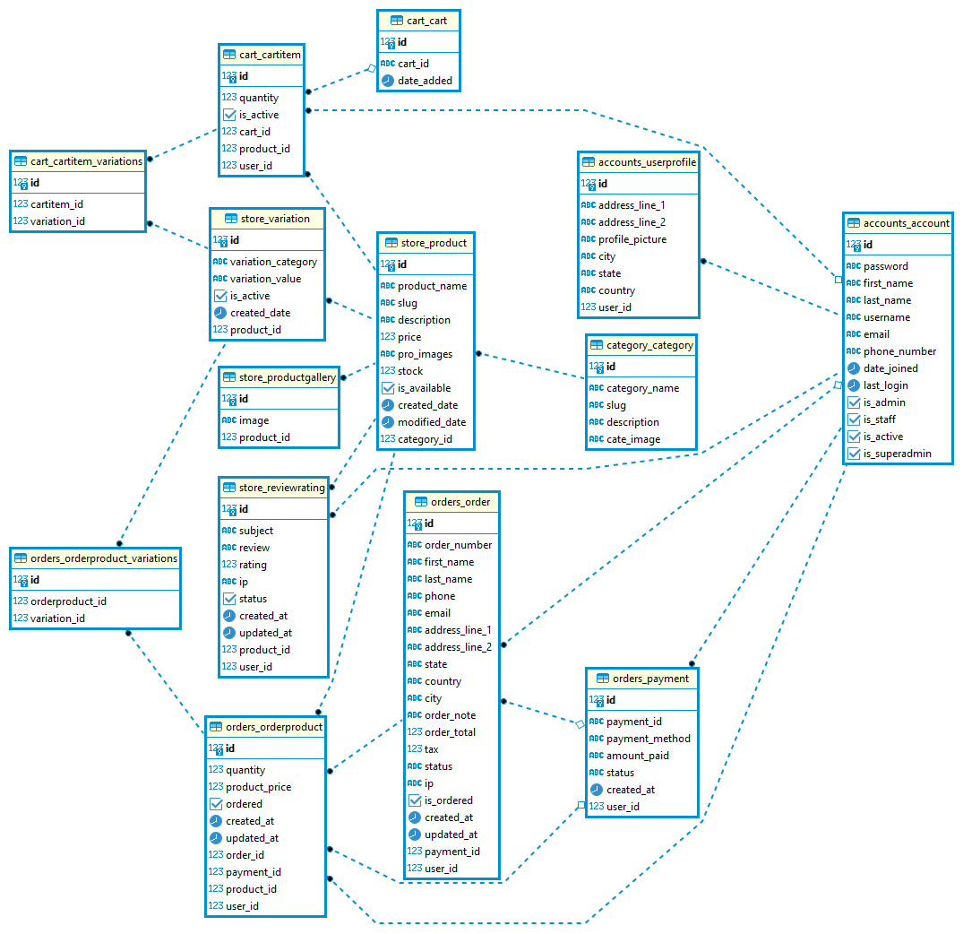

This is the ER diagram of **GreatMart | Online e-Commerce platform**. There is shown how the database should be design and how the relation should be in between various entities.

**Use Case Diagram:**

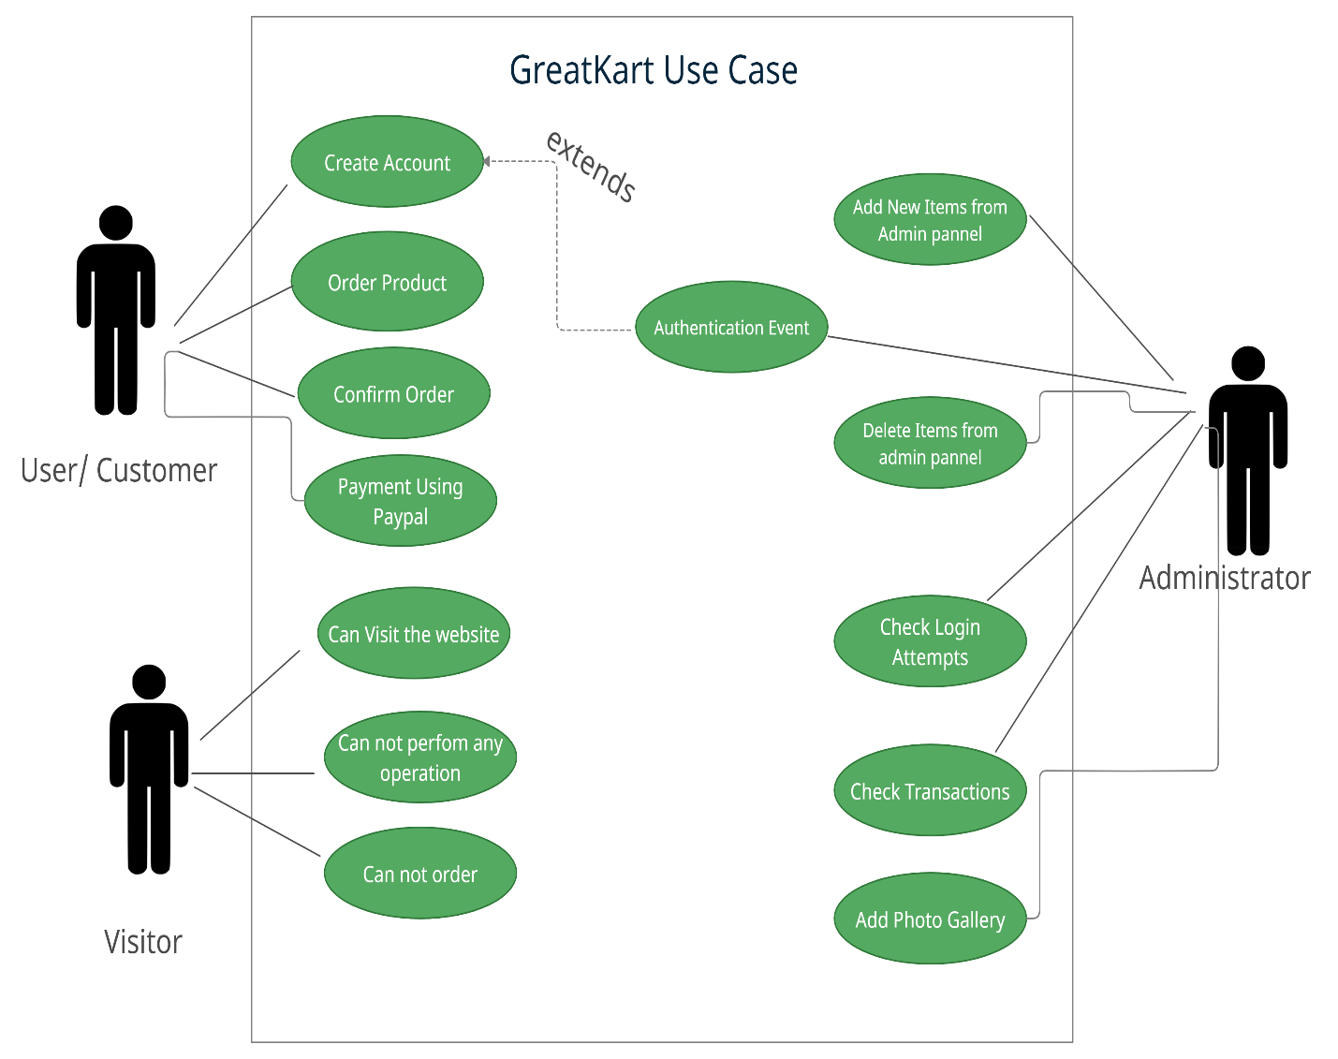

This is the use case diagram of **GreatMart | Online e-Commerce platform**. This shows how admin interact with user and how user can get through the website.

**4.3. Features:**

* Registration, Email Verification and Login
* Forget Password
* User Dashboard
* Admin Dashboard
* Payment Gateway
* Searching Product
* Admin Control
* Different Products Based on Categories
* Showing User about Best Selling Products
* Showing User about Top Rated Products

**Chapter 5**

**Implementation and User Manuals**

**5.1. Implementation:**

Implementing this project is not a very short time project. It is created by python language using Django Framework. It takes a long time to make this project. It needs some tools to complete this project such as Visual Studio, PyCharm. Here is the full project details. The version of python should be higher than 3.7 and Django version should be higher than 3.0. There are some library and packages which needs to be installed.

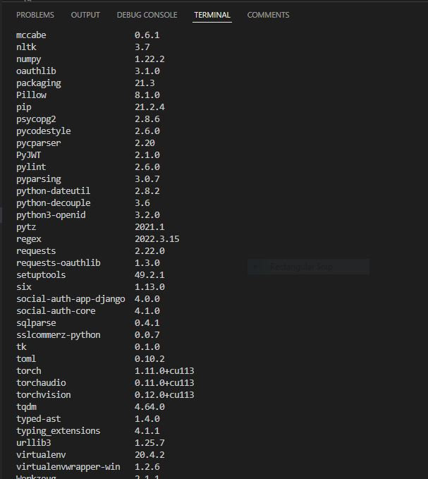

These library and packages showed in the above picture are needed for this project to run. Some of these are python library and some of these are django packages.

**5.1. Implementation**

I use postgresql database for this project. Here is the picture of the database.

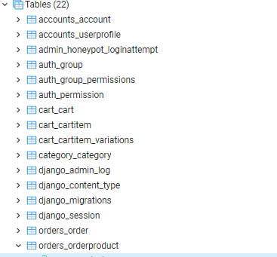

These are the tables created in this project.

**5.2. User Manuals:**

So User Manual section can be divided into multiple section like:

1. Registration, Email Verification and Login
2. Homepage
3. Store Page
4. Product Details Page
5. Cart Page
6. Checkout Page and Place Order Page
7. Payment Gateway
8. Email sent on Orders
9. User Dashboard
10. Order Details
11. Chatbot
12. Admin Login
13. Admin Dashboard

These are the user manuals of my web application. I provide how a user can register in my site to placing an order.

**i. Registration, Email Verification and Login:**

Here is the picture of registration form how anyone can register to the website. The user needs to give his/her name, email, phone number and password.

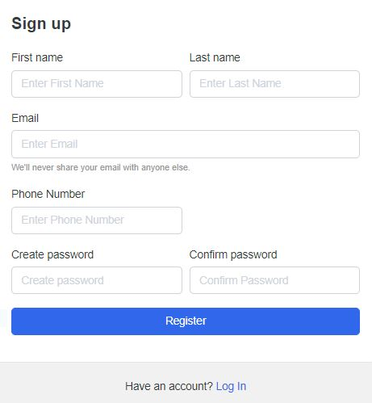

**Email Verification:**

After registration, there will be generated link in users email. The mail looks like this in the picture.

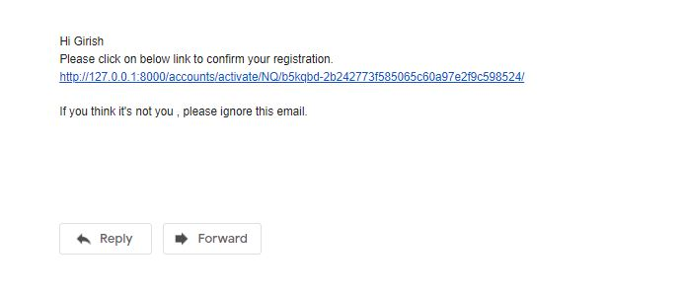

**Login:**

And the login looks like this picture in below. User has to give their mail and password in which they are registered and verified.

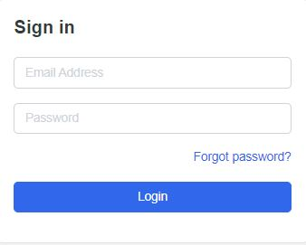

**ii. Homepage:**

After successfully registered and login the user can see the homepage or landing page of the website. Although they can visit the site but can’t order anything.

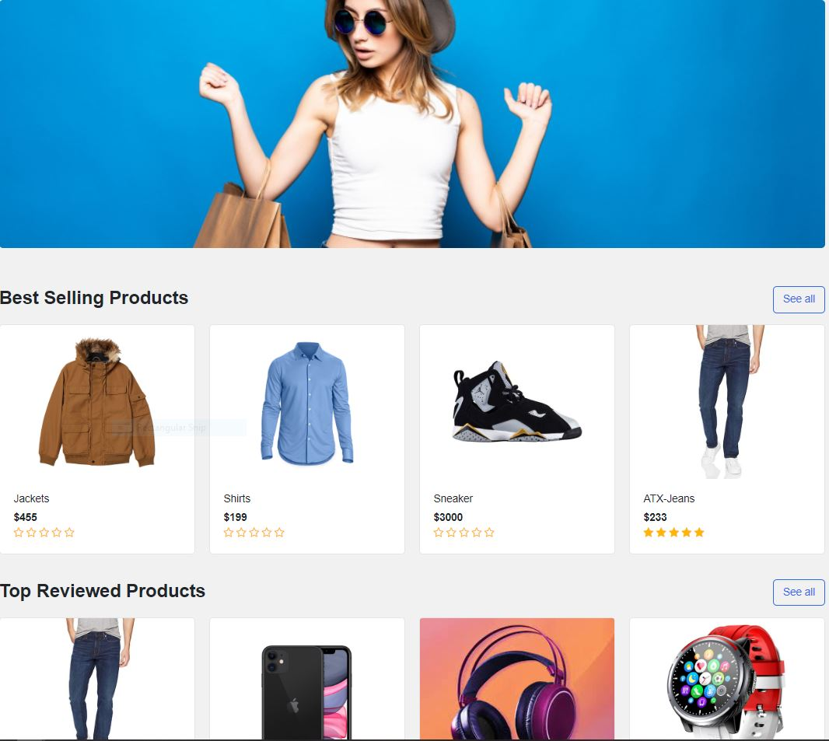

**iii. Store Page:**

Store page is where all the products you can see and all categories are available.

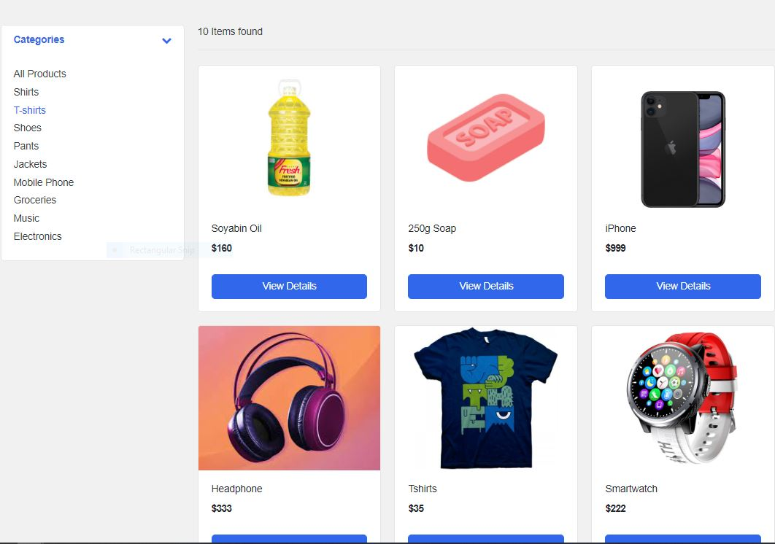

**iv. Search:**

The user can search any product which are available in the database of the site. Here is the example of it.

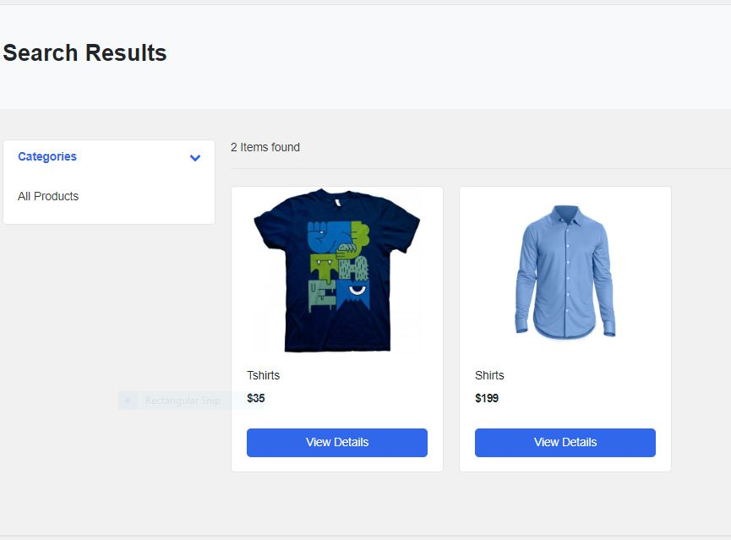

**v. Product Details Page:**

Here the details of a product are shown like what kind of product it is, what variation it has, what description it has and review and comments of that product.

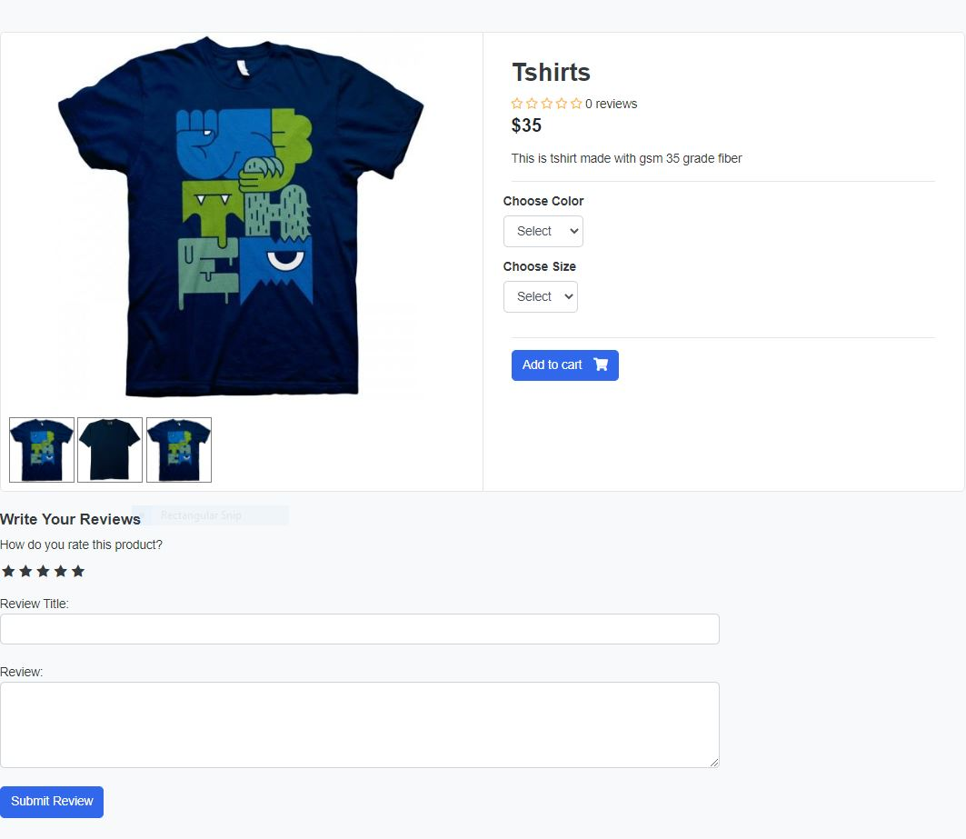

**vi. Cart Page:**

Here all products available which are added by the user. They can go to checkout page through this.

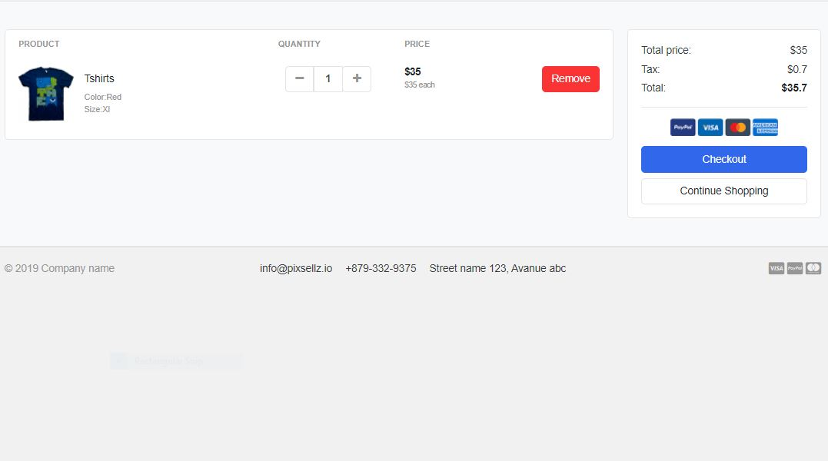

**vii. Checkout Page:**

The user needs to fill up the form to get the payment page. Here is the picture below.

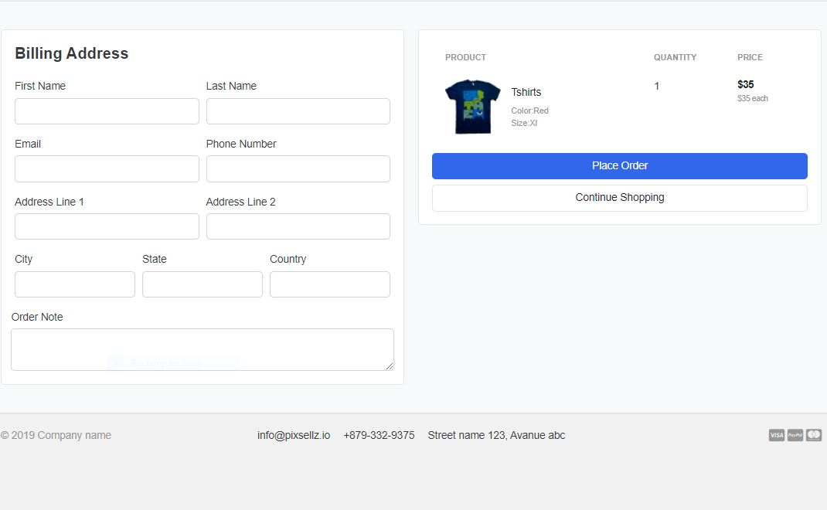

**viii. Place Order Page:**

The user needs to place the order and make payment. Here is the example.

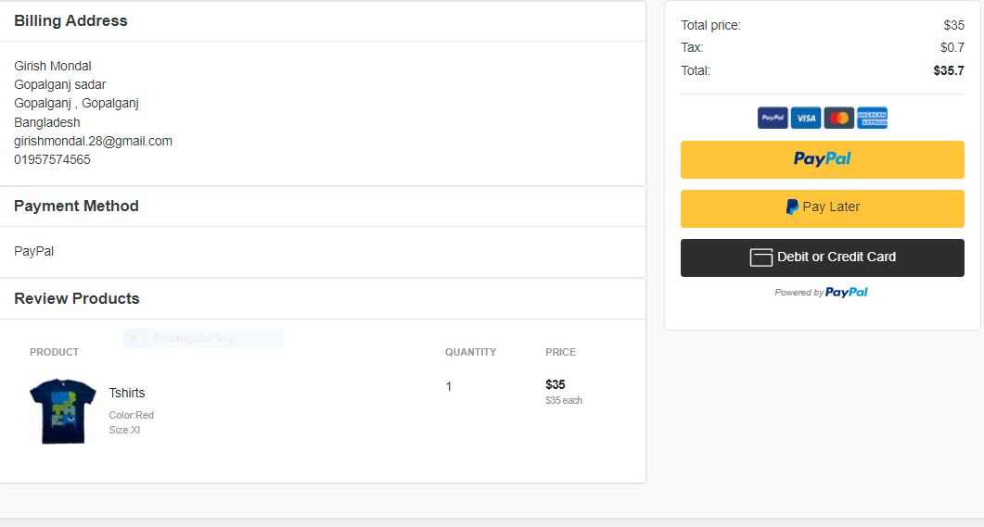

**ix. Payment Gateway Page:**

Here I use paypal sandbox for payment gateway. This is open source and gives developer dummy money to work with.

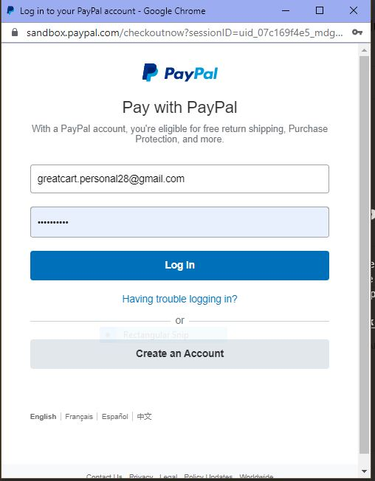

**x. Email sent on orders:**

An email sent to the users gmail account after successful order. The email looks likes in the picture below.

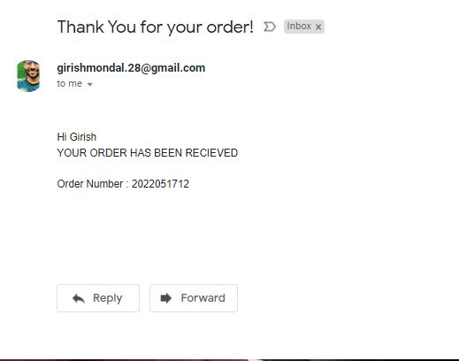

**xi. User Dashboard:**

The user dashboard looks like these in the picture. The user can see how many orders they have, and track them. They can change password from here and modify their information.

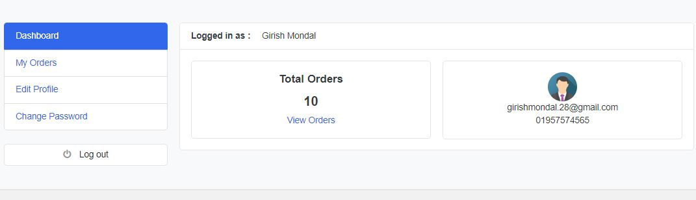

**xii. Admin Login:**

To create an admin, the creator needs to run a command: **python manage.py createsuperuser** and then gives username, email and password. Then registered admin can login to the admin panel.

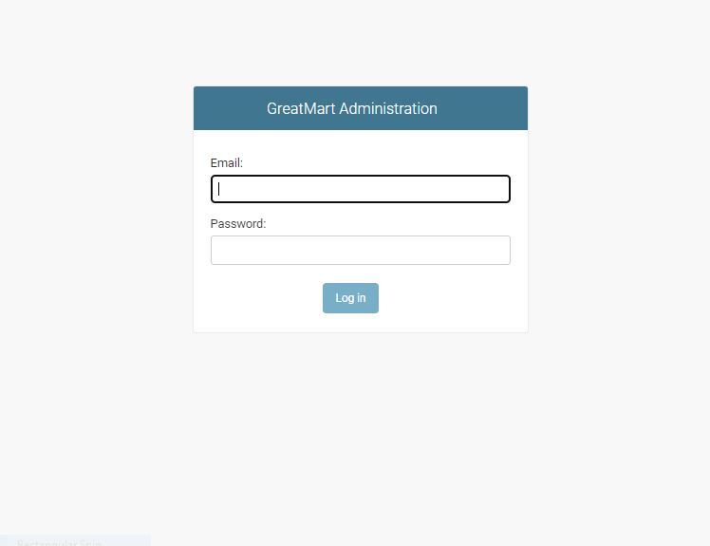

**xii. Admin Dashboard:**

In admin dashboard they can see all the events happening to the website. They can change the events or create events. They can see user profile, they can add products, edit products details, delete them. They can add product gallery.

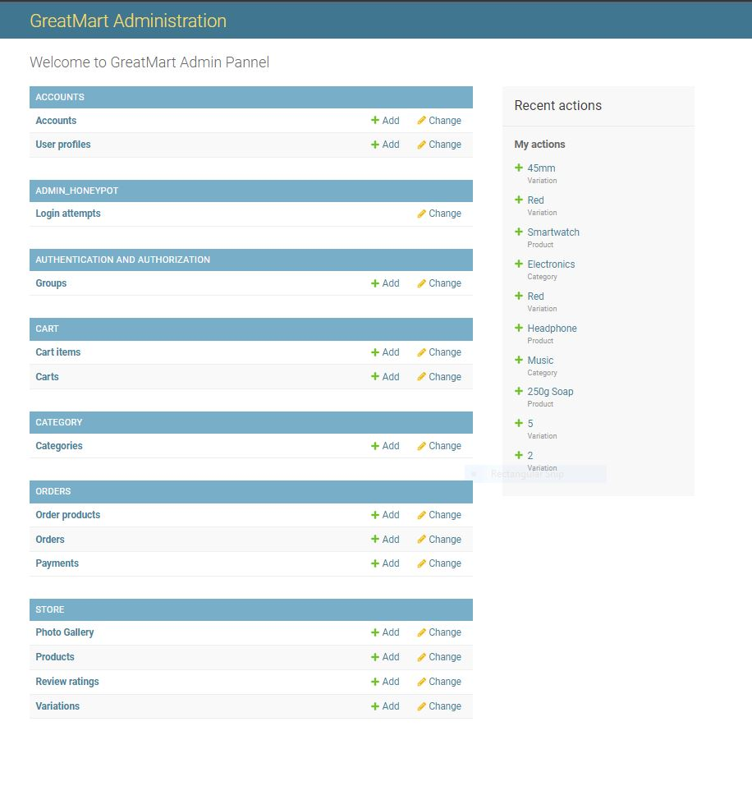

**xiii. Chatbot:**

I create a chatbot for my web application using Google’s DialogueFlow and Kommunicate. This will help the user to better understand the user interface and services we provide.

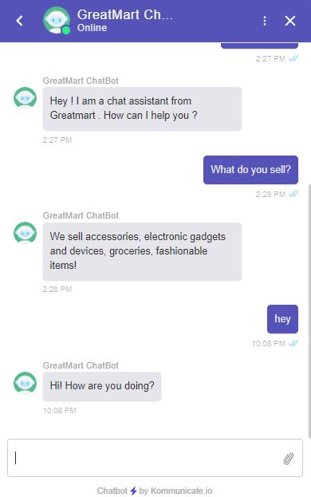

**Chapter 06**

**Future Work**

**6.1. Future Work:**

No project is at its best. Every project in this world gets its upgrade. So I thought I would also develop this project in the future. I want to add machine learning and Natural Language Processing to make it more user friendly and more optimized. I also add a Chatbot for my website for supporting the user in future. I will improve the design of this project because technology gets upgraded day by day. I will also develop a mobile application for this.

**Chapter 07**

**Conclusion**

**7.1. Conclusion:**

E-commerce still represents one of the business methods that take advantage if done the right way, even if the stock market and commodities fell, but E-Commerce still able to survive and receive high transaction. E-commerce has a tremendous opportunity in the course of or business in Bangladesh. In addition, it is also to introducing new techniques and styles in a transaction. Use the extensive E-Commerce in the Internet world is actually much better to bring the goodness of the individual or the state.

Commerce has undeniably become an important part of our society. The successful companies of the future will be those that take E-Commerce seriously, dedicating sufficient resources to its development. E-Commerce is not an IT issue but a whole business undertaking. Companies that use it as a reason for completely re-designing their business processes are likely to reap the greatest benefits. Moreover, E-Commerce is a helpful technology that gives the consumer access to business and companies all over the world.

**Chapter 08**

**References**

**8.1. References:**

* <https://www.google.com>
* <https://docs.python.org/3/>
* <https://docs.djangoproject.com/en/3.0/>
* <https://developer.paypal.com/developer>
* [https://www.](https://www.google.com)stackflow.com
* <https://www.wikipedia.org>
* <https://www.postgresql.org/docs/>
* <https://dialogflow.cloud.google.com/>
* <https://dashboard.kommunicate.io/>