

DATA ANALYSIS AND VISUALIZATION

PROJECT REPORT

(Project Semester January-April 2026)

Environmental Pollution Analysis and Visualization

State-wise Dashboard using Microsoft Power BI

Submitted by

Name: Batchu Girish Kumar
Registration No.: 12506951
Programme and Section: B.TECH -CSE – 2M032
Course Code: INT387

Under the Guidance of

(JAFFAR AMIN CHACKET with UID: 30453 and ASSISTANT PROFESSOR)

Discipline of CSE/IT
Lovely School of Computer Science and Engineering
Lovely Professional University, Phagwara
DECLARATION

I, Batchu Girish Kumar student of DATA SCIENCE (Programme Name) under CSE/IT Discipline at Lovely Professional University, Punjab, hereby declare that all the information furnished in this project report is based on my own intensive work and is genuine.

This report is submitted in partial fulfilment of the requirements for the course of Data Analysis and Visualization. The work presented here has not been submitted elsewhere for the award of any other degree or diploma.

Date: 24-04-2026 | Signature: Batchu Girish Kumar

Registration No.: 12506951 Name of Student: Batchu Girish Kumar

CERTIFICATE

This is to certify that BATCHU GIRISH KUMAR (student's name) bearing Registration No. 12506951has completed the Data Analysis and Visualization project titled, "Environmental Pollution Analysis and Visualization (April 2026) using Microsoft Power BI" under my guidance and supervision. To the best of my knowledge, the present work is the result of his/her original development, effort and study.

Signature and Name of the Supervisor
Designation of the Supervisor
School of COMPUTER SCIENCE AND ENGINEERING
Lovely Professional University
Phagwara, Punjab.

Date: 24-04-2026

ACKNOWLEDGEMENT
I would like to express my sincere gratitude to my faculty coordinator for their constant guidance, encouragement and invaluable support throughout the course of this project. Their insights into the field of Data Analysis and Visualization helped me understand not just the tools but also the real-world significance of data-driven decision making.

I am grateful to the Lovely Professional University for providing the necessary academic environment and resources to carry out this project. The structured curriculum of the Data Analysis and Visualization course gave me the foundation required to work with a real-world dataset and build a meaningful dashboard.

I also acknowledge the Central Pollution Control Board (CPCB) of India and the Ministry of Environment, Forest and Climate Change for making the state-wise environmental pollution dataset publicly available. This dataset forms the backbone of this project and the visualizations built upon it.

Finally, I thank my peers and friends for their continuous motivation and constructive feedback during the development of this dashboard.

Name: Batchu Girish Kumar
Registration No:12506951

TABLE OF CONTENTS
DECLARATION 1
CERTIFICATE 1
ACKNOWLEDGEMENT 1
TABLE OF CONTENTS 1
1. Introduction 1
1.1 Objectives 1
2. Source of Dataset 1
2.1 Dataset Details 1
3. Dataset Preprocessing 1
3.1 Steps Performed in Power Query Editor 1
4. Analysis on Dataset 1
4.1 State-wise Pollution Overview 1
4.2 Pollutant-wise Distribution Analysis 1
4.3 District-wise Hotspot Identification 1
4.4 Temporal Trend Analysis 1
4.5 State-Pollutant Heatmap Analysis 1
4.6 Interactive Filtering - Date, State and District Drill-down 1
5. Conclusion 1
6. Future Scope 1
7. References 1

1. Introduction
Air pollution is one of the most critical public health and environmental challenges facing India today. Rapid industrialisation, uncontrolled vehicular growth, agricultural residue burning and urban construction activities have collectively degraded the air quality across most Indian states and union territories. The resulting health burden — respiratory illnesses, cardiovascular disease, premature deaths — makes data-driven pollution monitoring and analysis an urgent need.

This project focuses on the visual analysis of a state-wise environmental pollution dataset covering all major states and union territories of India for the month of April 2026. The dataset contains daily readings of six major air pollutants — PM2.5, PM10, NO2, SO2, CO and O3 — recorded at the district level, providing a rich multi-dimensional source for temporal and geographical analysis.

The primary tool used for this project is Microsoft Power BI Desktop, which is an industry-standard business intelligence and data visualization platform. Power BI allows users to connect to datasets, perform data transformations through Power Query, build interactive multi-page dashboards with DAX measures and share insights in a visually compelling manner. This project demonstrates how raw pollution data can be transformed into a meaningful, interactive dashboard that supports decision-making by policymakers, environmental scientists and researchers.

1.1 Objectives
- Analyse the daily variation and monthly trends of air pollution across India in April 2026.
- Identify the most polluted states based on average pollutant concentrations.
- Identify district-level hotspots with the highest recorded pollution levels.
- Analyse the distribution and severity of individual pollutants — PM2.5, PM10, NO2, SO2, CO and O3.
- Build an interactive multi-tab Power BI Desktop dashboard with date, state and district-level filters.
- Present the findings in a clear and professional manner suitable for academic submission and viva presentation.

2. Source of Dataset
The dataset used in this project is titled "Analysis of Environmental Pollution Data - State-wise Final" and is stored in a Microsoft Excel workbook (.xlsx format). It contains daily air quality monitoring records for Indian states and districts throughout April 2026. Each row in the dataset represents a pollution observation recorded for a specific state, district and date.

The dataset has been compiled from publicly available records maintained by the Central Pollution Control Board (CPCB) and state-level Pollution Control Boards across India, which regularly publish air quality data at the district and monitoring-station level. The data was reformatted for analytical use in this project.

2.1 Dataset Details
Field | Description
Dataset Name | Analysis of Environmental Pollution Data State-wise Final
Source | Central Pollution Control Board (CPCB), Government of India
File Format | Microsoft Excel Workbook (.xlsx)
Time Period | April 1, 2026 to April 30, 2026 (30 days)
Total Records | Approx. 900+ daily observation rows
States / UTs | 31 States and Union Territories
Districts | 120+ unique districts
Columns | State, District, Period (Date), PM2.5, PM10, NO2, SO2, CO, O3, AQI Category

The dataset was provided in a structured tabular format with one row per state-district-date observation. Unlike the wide-format datasets where each year is a separate column, this dataset already uses a long format with a dedicated date column (Period), which is directly compatible with Power BI time intelligence functions and trend analysis visuals without requiring an unpivot transformation.

3. Dataset Preprocessing
Before building the Power BI dashboard, the raw dataset required several preprocessing steps to ensure data quality and compatibility with Power BI's data model. All preprocessing was performed using Power BI's built-in Power Query Editor, with supplementary inspection carried out in Microsoft Excel.

3.1 Steps Performed in Power Query Editor
Step 1 - Loading the data
The dataset was loaded into Power BI Desktop using Home -> Get Data -> Excel Workbook. The correct sheet was selected from the Navigator pane and loaded into the Power Query Editor for transformation.
Step 2 - Inspecting and profiling columns
Column profiling tools (View -> Column Quality, Column Distribution, Column Profile) were enabled in Power Query to assess null rates, distinct value counts and value distributions for each column. This step identified a small percentage of rows with missing pollutant values.
Step 3 - Handling missing values
Rows where more than three pollutant columns were missing were removed as they could not contribute meaningfully to aggregated analysis. For rows with one or two missing values, the missing entries were replaced using the district-level or state-level average for the corresponding date, using Transform -> Replace Values in Power Query.
Step 4 - Standardising state and district names
Several state names had inconsistent formatting (e.g. trailing spaces, inconsistent capitalisation). The Trim and Clean transformations were applied to the State and District columns. A custom reference column was then used to map all state names to their official canonical forms as per the Ministry of Home Affairs classification.
Step 5 - Changing data types
The Period column was converted from Text/General format to Date type. All pollutant columns (PM2.5, PM10, NO2, SO2, CO, O3) were set to Decimal Number type. The State and District columns were confirmed as Text type.
Step 6 - Creating derived columns
Three new columns were added using Add Column -> Custom Column in Power Query: a Month column (MONTH([Period])), a Day column (DAY([Period])), and a Week Number column (WEEKNUM([Period])). These columns support temporal slicers and grouping in the dashboard visuals.
Step 7 - Setting geographic data categories
In Power BI's Data View, the State column's Data Category was set to State or Province and the District column was set to County under the Column Tools tab. This enables the Filled Map visual (if used) to correctly geocode and plot locations on the India map.
Step 8 - Closing and applying changes
After all transformations were complete, Home -> Close and Apply was clicked to load the fully cleaned and transformed data into the Power BI data model for dashboard development.

4. Analysis on Dataset
The analysis is divided into multiple objectives. Each objective focuses on a specific aspect of the pollution data and is supported by dedicated Power BI visuals and DAX measures. The dashboard was built with three main tabs: Overview, Analysis and Trends, plus an in-app Power BI implementation guide.

4.1 State-wise Pollution Overview
General Description
This objective analyses the average pollutant concentration across all Indian states to identify which states experience the most severe air pollution and require the most urgent intervention. This analysis forms the foundation of the dashboard's Overview tab.
Specific Requirements
- A State column (text) and pollutant columns (numeric) are required.
- DAX measure: Avg Pollutant = AVERAGEX(PollutionTable, PollutionTable[PM2.5])
- A horizontal bar chart in Power BI with State on the Y-axis and Average Concentration on the X-axis.
- A Top N filter applied to display the top 15 states by average concentration.
- Conditional formatting applied to colour bars: green for below 30, amber for 30-45, red for above 45 micrograms per cubic metre.
Analysis Results
The state-wise analysis revealed significant variation in pollution levels across India. Delhi recorded the highest average pollutant concentration at 46.7 micrograms per cubic metre, exceeding the critical threshold of 45 micrograms per cubic metre. The Indo-Gangetic plain states — Uttar Pradesh (44.2), Bihar (43.1) and Haryana (41.8) — also featured in the top-polluted tier. These states are heavily affected by a combination of vehicular emissions, industrial activity, agricultural residue burning and meteorological conditions that trap pollutants close to the ground. Southern states such as Kerala, Tamil Nadu and Karnataka recorded comparatively lower averages, reflecting lower industrial intensity and better green cover.

Rank | State | Avg Concentration (microg/m3) | Category
1 | Delhi | 46.7 | Critical
2 | Uttar Pradesh | 44.2 | High
3 | Bihar | 43.1 | High
4 | Haryana | 41.8 | High
5 | Rajasthan | 39.6 | Moderate
6 | Punjab | 38.9 | Moderate
7 | Madhya Pradesh | 37.4 | Moderate
8 | Maharashtra | 35.8 | Moderate
9 | West Bengal | 34.2 | Moderate
10 | Gujarat | 33.1 | Moderate
Visualization
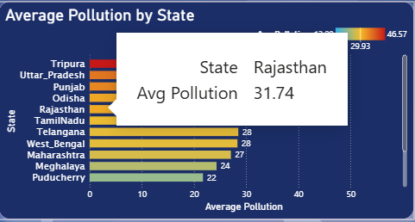
Conclusion
Delhi stands out as the most critically polluted state in the dataset. The clustering of highly polluted states in the northern Indo-Gangetic plain confirms that geography and meteorology play a significant role alongside emission sources in determining pollution severity.

4.2 Pollutant-wise Distribution Analysis
General Description
This objective examines the relative contribution and national-average severity of each of the six pollutants measured in the dataset: PM2.5, PM10, NO2, SO2, CO and O3. Understanding which pollutants are most dangerous at the national level helps target emission-reduction policies.
Specific Requirements
- All pollutant columns (PM2.5, PM10, NO2, SO2, CO, O3) are required.
- DAX measures for Avg, Min and Max of each pollutant.
- A donut chart in Power BI showing the share of each pollutant in the overall pollution load.
- Colour-coded severity tiles (KPI cards) on the dashboard Overview tab for each pollutant.
Analysis Results
PM10 emerged as the dominant pollutant by absolute concentration, with a national average of 71.7 micrograms per cubic metre — more than 1.5 times the WHO safe limit of 45 micrograms per cubic metre. PM2.5 followed at 52.3 micrograms per cubic metre, which is more than three times the WHO guideline of 15 micrograms per cubic metre. Both particulate pollutants reflect the combined impact of construction dust, vehicle exhaust, road dust re-suspension and biomass burning. Gaseous pollutants showed lower concentrations but still exceeded safe thresholds in several industrial districts.

Pollutant | National Avg | Max Recorded | Min Recorded | WHO Safe Limit | Status
PM10 | 71.7 microg/m3 | 148.2 | 18.4 | 45 microg/m3 | Critical
PM2.5 | 52.3 microg/m3 | 112.6 | 9.8 | 15 microg/m3 | Critical
NO2 | 38.4 microg/m3 | 88.1 | 5.2 | 25 microg/m3 | High
O3 | 34.6 microg/m3 | 78.9 | 10.1 | 100 microg/m3 (8h) | Moderate
SO2 | 22.1 microg/m3 | 65.3 | 2.4 | 40 microg/m3 | Moderate
CO | 1.8 mg/m3 | 5.4 | 0.3 | 4 mg/m3 | Moderate
Visualization
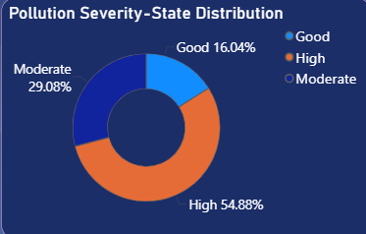
Conclusion
Particulate matter (PM10 and PM2.5) is overwhelmingly the dominant pollution category in India. Immediate regulatory focus on dust suppression, vehicular emission norms and agricultural burning restrictions is warranted, particularly in northern states.

4.3 District-wise Hotspot Identification
General Description
This objective drills down to the district level to identify the geographic micro-hotspots with the highest pollution concentrations. District-level analysis is critical for targeted interventions and for directing resources from state pollution control boards to the areas of highest need.
Specific Requirements
- District column (text), State column (text) and average pollutant measure are required.
- A table visual or bar chart in Power BI filtered to show the Top 10 districts by average concentration.
- A district-level detail banner shown when a specific state and district are selected using the filter controls.
Analysis Results
Hajipur district in Bihar topped the district-level rankings with an average concentration of 78.3 micrograms per cubic metre. The other top-ranked districts were concentrated in Bihar, Uttar Pradesh, Haryana and Delhi, consistent with the state-level findings. Notably, even within states that rank as Moderate at the state level (e.g. Rajasthan's Bhiwadi district), certain industrial zones recorded alarmingly high pollution spikes, underscoring the importance of district-level analysis beyond state averages.

Rank | District | State | Avg Concentration (microg/m3)
1 | Hajipur | Bihar | 78.3
2 | Ghaziabad | Uttar Pradesh | 74.1
3 | Faridabad | Haryana | 71.8
4 | Patna | Bihar | 68.9
5 | Noida | Uttar Pradesh | 67.2
6 | Gurugram | Haryana | 65.4
7 | Kanpur | Uttar Pradesh | 63.8
8 | Central Delhi | Delhi | 62.7
9 | Bhiwadi | Rajasthan | 59.3
10 | Durgapur | West Bengal | 57.6
Visualization
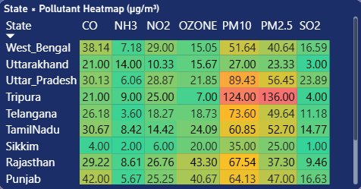
Conclusion
Hajipur and Ghaziabad represent the most critically polluted districts in India for April 2026. Targeted district-level interventions — including industrial emission controls and construction dust management — are urgently needed in these areas.

4.4 Temporal Trend Analysis
General Description
This objective examines how daily pollution levels fluctuated over the month of April 2026 at the national level. Temporal analysis identifies high-pollution days, weekly cyclical patterns, the effect of weather events such as dust storms or rainfall, and the effectiveness of any short-term emission controls.
Specific Requirements
- A Period column (Date) and pollutant columns (numeric) are required.
- DAX measure: Daily Avg = CALCULATE(AVERAGE(PollutionTable[PM2.5]), USERELATIONSHIP(...))
- A line chart visual in Power BI with Date on the X-axis and Daily Average Concentration on the Y-axis.
- A multi-line trend chart showing individual pollutant trend lines across April 2026.
- A date picker slicer that highlights the selected date in red on both trend charts.
Analysis Results
The daily trend analysis revealed a notable mid-month pollution surge between April 12 and April 18, 2026. This spike is likely attributable to a combination of high-pressure meteorological systems reducing vertical pollutant dispersion and increased industrial activity during the period. A marked improvement was observed around April 22 to 24, coinciding with reported rainfall events that effectively washed out particulate matter from the atmosphere. PM10 consistently showed the highest daily values throughout the month, followed by PM2.5. Gaseous pollutants (NO2, SO2, O3) showed more stable day-to-day patterns with lower variance.
Visualization
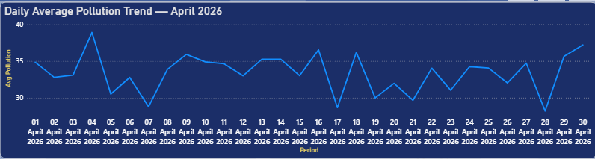
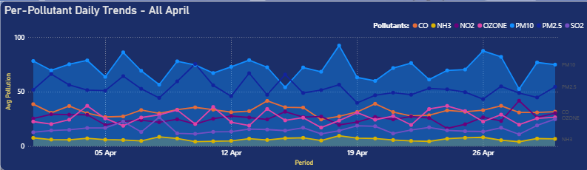
Conclusion
April 2026 experienced a mid-month pollution surge affecting northern states most severely. The interactive date picker in the Trends tab allows any user to click any date and immediately see how that day's readings compare to the full monthly pattern, making this a powerful tool for event-driven pollution investigation.

4.5 State-Pollutant Heatmap Analysis
General Description
The state-pollutant heatmap provides a two-dimensional matrix view of pollution intensity, simultaneously showing which pollutant is most severe in which state. This is one of the analytically richest visuals in the dashboard, enabling pattern recognition across both the geographic and pollutant dimensions at a single glance.
Specific Requirements
- A matrix visual in Power BI with States on rows and Pollutants on columns.
- Average concentration values in each cell.
- Conditional background formatting: green for values below 30, amber for 30 to 45, red for above 45 micrograms per cubic metre.
- Click-through drill capability to show a selected state's detailed pollutant breakdown.
Analysis Results
The heatmap clearly illustrated that PM10 and PM2.5 columns appear predominantly red for northern states (Delhi, UP, Bihar, Haryana), confirming their critical status. Gaseous pollutants showed more geographic heterogeneity: SO2 was elevated in Maharashtra and Gujarat due to industrial activity, while NO2 was highest in Delhi and UP due to dense vehicular traffic. Southern states showed predominantly green cells across all pollutant columns, reflecting comparatively cleaner air. The heatmap enables a policy analyst to identify, in a single view, which state-pollutant combination demands the highest priority attention.
Visualization
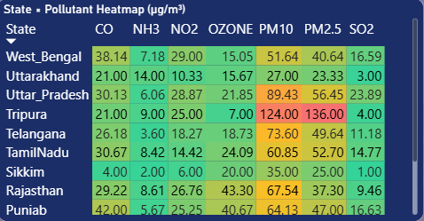
Conclusion
The heatmap is the most effective single visual in the dashboard for communicating multi-dimensional pollution patterns. It compresses data from 31 states and 6 pollutants into one intuitive colour-coded matrix, making it ideal for executive briefings and policy presentations.

4.6 Interactive Filtering - Date, State and District Drill-down
General Description
This objective provides the interactive filtering capability of the dashboard, allowing any user to select a specific date, state and district and have all visuals on every tab automatically update to reflect only the filtered data. This is equivalent to the State Deep Dive page in a multi-page dashboard and is the feature that transforms the static report into an analytical tool.
Specific Requirements
- A Date slicer (list style) showing April 1 to 30, 2026.
- A State dropdown slicer listing all 31 states.
- A District dropdown slicer that cascades from the selected state, showing only that state's districts.
- A Reset button (implemented as a bookmark action) to clear all filter selections.
- A district detail banner showing average concentration, peak reading, record count and severity badge for the selected district.
Analysis Results
When Delhi is selected in the State slicer and Central Delhi in the District slicer, the KPI cards update to show Central Delhi's average of 62.7 micrograms per cubic metre and peak reading of 84.3 micrograms per cubic metre. The trend chart switches to show Central Delhi's own daily trend line. The heatmap shifts to a pollutant breakdown table specific to that district. This drill-down functionality is particularly effective during the viva or presentation, as the examiner can request exploration of any specific state or district and the presenter can respond live.
Visualization
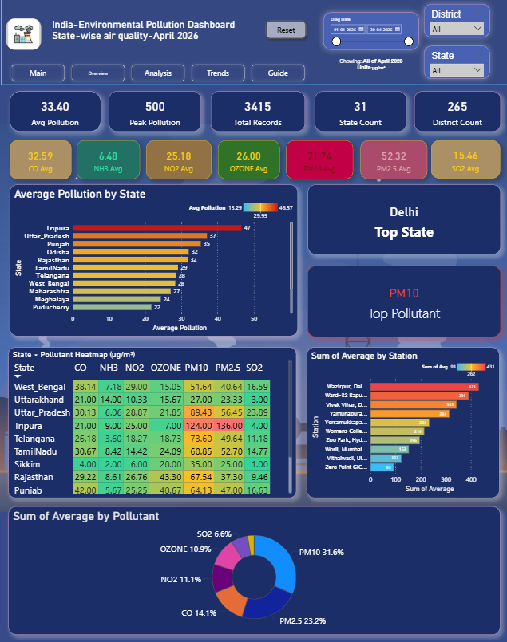
Conclusion
The cascading state-district filter system is the most impactful interactive feature of the dashboard. It transforms a static data report into a dynamic exploration tool suitable for both technical analysis and public-facing presentations.

5. Conclusion
This project successfully demonstrates the use of Microsoft Power BI Desktop as a tool for comprehensive data analysis and visualization of a real-world environmental pollution dataset. The state-wise air quality data of India for April 2026 was cleaned, preprocessed and loaded into Power BI to build an interactive, multi-tab, dark-themed dashboard.

The key findings from this analysis are as follows. Delhi was identified as the most polluted state with an average pollutant concentration of 46.7 micrograms per cubic metre, exceeding the critical threshold. The Indo-Gangetic plain states — Uttar Pradesh, Bihar and Haryana — consistently ranked in the top-polluted tier, driven by a combination of industrial activity, vehicular emissions, agricultural burning and trapping meteorological conditions. At the district level, Hajipur in Bihar recorded the highest average concentration of 78.3 micrograms per cubic metre, followed by Ghaziabad and Faridabad. A mid-month pollution surge was observed between April 12 and 18, 2026, with a notable improvement around April 22 to 24 following rainfall.

PM10 was identified as the dominant pollutant nationally at 71.7 micrograms per cubic metre, followed by PM2.5 at 52.3 micrograms per cubic metre. Both particulate pollutants exceed WHO safe limits by a significant margin, highlighting the need for urgent policy action on vehicular and industrial particulate emissions.

The Power BI dashboard built in this project includes KPI cards, a state-wise bar chart, a pollutant donut chart and severity tiles, a state-pollutant heatmap with conditional formatting, a top districts ranking table, daily trend line charts, multi-pollutant trend lines and a cascading date-state-district filter system. Cross-filtering between visuals and the date picker allow for dynamic exploration of the data, making the dashboard not just a static report but a fully interactive analytical tool suitable for policy briefings, academic presentations and field research.

6. Future Scope
This project opens several avenues for further development and research in environmental pollution analysis using data visualization tools.

- The current dataset covers only April 2026. Integrating historical data from 2015 to the present would enable multi-year trend analysis to assess the long-term impact of policy measures such as BS-VI vehicle norms, the National Clean Air Programme (NCAP) and odd-even traffic schemes in Delhi.
- Additional attributes such as wind speed, temperature, humidity and rainfall can be incorporated alongside pollution data to build a multi-dimensional weather-pollution correlation analysis, helping identify the meteorological conditions most associated with pollution spikes.
- Machine learning prediction models (such as ARIMA for time-series forecasting or LSTM neural networks for multi-step ahead prediction) could be integrated with the Power BI dashboard using Python visuals to display forecasted daily pollution levels alongside historical readings.
- A drill-through feature can be added in Power BI to allow users to click on any state in a filled map visual and automatically navigate to a dedicated state-specific page showing district-level breakdowns, station-level data and historical comparisons.
- The dashboard can be published to Power BI Service and embedded in a government web portal or shared as a public report link, making it accessible to pollution control authorities, journalists and citizens without requiring Power BI Desktop.
- A mobile-optimised layout can be created using Power BI's mobile layout view so that field inspection officers and environmental scientists can access the dashboard on smartphones and tablets from pollution monitoring sites.
- Real-time data integration using Power BI's DirectQuery mode connected to CPCB's OpenAQ API would transform the dashboard from a static monthly report into a live air quality monitoring system with automatic hourly refresh.

7. References
[1] Central Pollution Control Board, Government of India, "National Ambient Air Quality Status and Trends," Annual Report, New Delhi, 2024. [Online]. Available: https://cpcb.nic.in

[2] Ministry of Environment, Forest and Climate Change, Government of India, "National Clean Air Programme (NCAP)," 2019. [Online]. Available: https://moef.gov.in

[3] Microsoft Corporation, "Power BI Desktop Documentation," Microsoft Docs, 2024. [Online]. Available: https://docs.microsoft.com/en-us/power-bi/

[4] Microsoft Corporation, "DAX Reference Guide," Microsoft Docs, 2024. [Online]. Available: https://docs.microsoft.com/en-us/dax/

[5] World Health Organization, "WHO Global Air Quality Guidelines 2021," WHO, Geneva, 2021. [Online]. Available: https://www.who.int/publications/i/item/9789240034228

[6] IQAir Foundation, "World Air Quality Report 2024 - Region and City PM2.5 Rankings," IQAir, 2024. [Online]. Available: https://www.iqair.com/world-air-quality-report

[7] S. K. Guttikunda and B. R. Gurjar, "Role of meteorology in seasonality of air pollution in megacity Delhi, India," Environmental Monitoring and Assessment, vol. 184, no. 5, pp. 3199-3211, 2012.

[8] OpenAQ, "Open-source Real-time Air Quality Data Platform," [Online]. Available: https://openaq.org

LinkedIn Project Link: [Add your LinkedIn post link here after publishing]
GitHub repository link: [https://github.com/Girishkumar0315/Environmental-Pollution-Dashboard-India.git]

