Custom PCB for Real-Time Temperature, Humidity, and Ammonia Detection

Components:
- ESP32-WROOM-32D(Micro-controller)
- MQ 135 (Gas sensor sensing Ammonia)
- DHT22 (Temperature and Humidity)
- LCD Display (16x2)
- Buzzer
- Resistors(220ohms)
- 5v Power jack
- Jumper wires

Component Features:
- ESP32-WROOM-32D:A high-performance microcontroller featuring integrated Wi-Fi and Bluetooth for seamless wireless communication. Its low power consumption and robust processing capabilities make it ideal for iot applications.
- MQ135 (Gas Sensor):gas sensor that identifies gases like ammonia, carbon dioxide, and alcohol, typically employed for air quality assessment. It produces an analog signal that corresponds to the concentration of the gases detected.
- DHT11 (Temperature and Humidity Sensor):sensor used for measuring temperature and humidity. It provides a digital output and is known for being affordable, though it may have lower accuracy compared to more advanced sensors.
- 16x2 LCD Display:16x2 LCD display is a screen designed to show real-time environmental information, including temperature, humidity, and air quality. It features a matrix of 16 columns and 2 rows.
- Buzzer: Emits sound to alert or notify users when certain thresholds (e.g., temperature, humidity, or Ammonia) are exceeded.
- 5V Power Jack: Used to connect an external 5V power source to the system, powering the ESP32 and other components.
- 220 Ohm Resistors: Used to limit current in the circuit, protecting components like LEDs or the buzzer from excessive current.

Circuit Diagram:
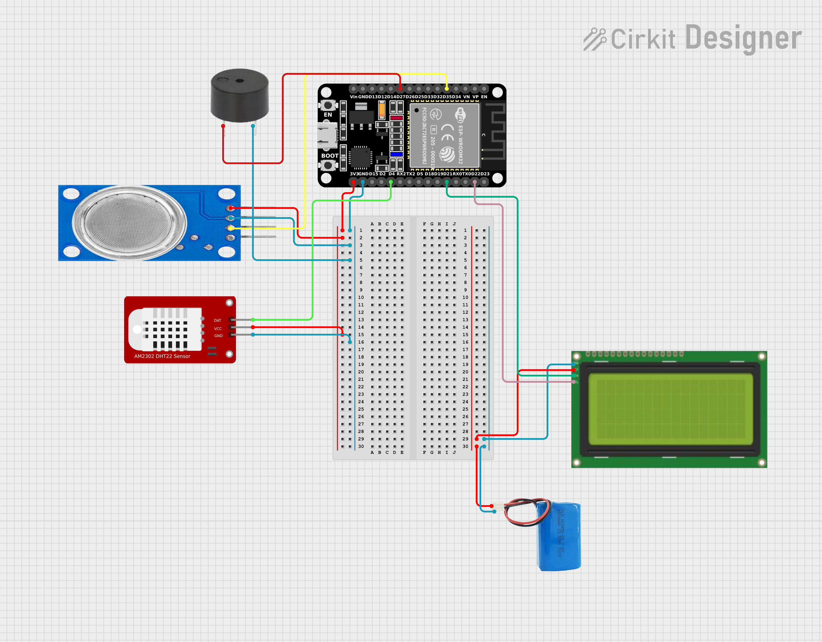

Schematic Diagram:
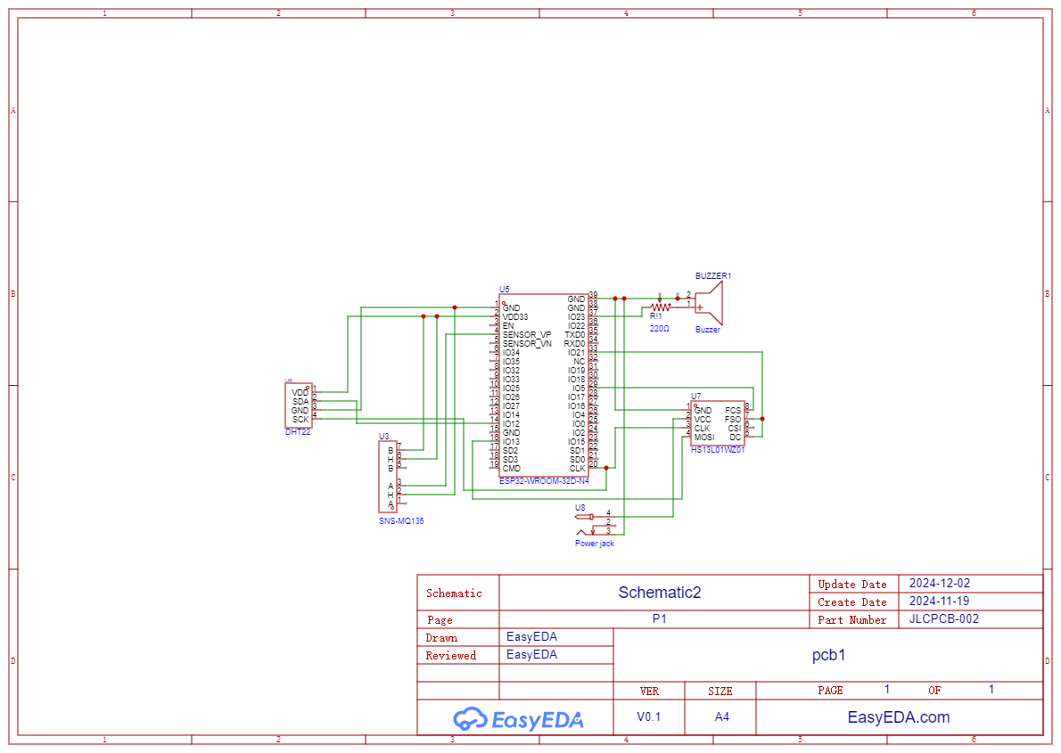

PCB

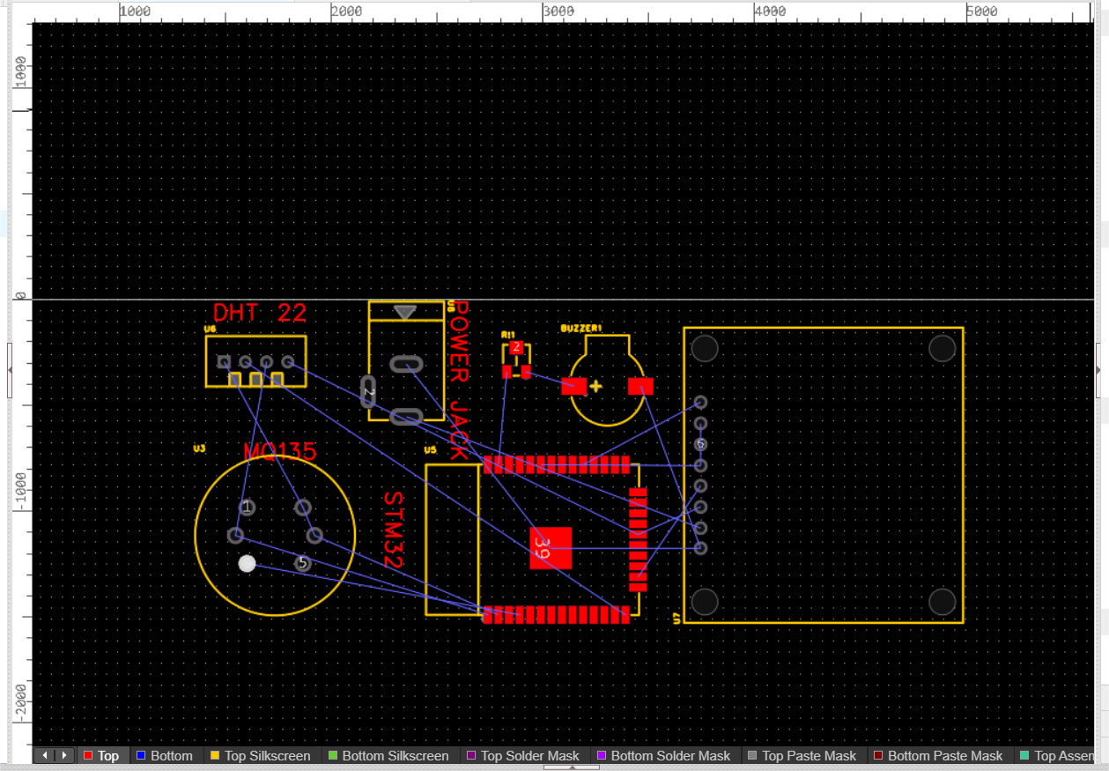

PCB(3D)

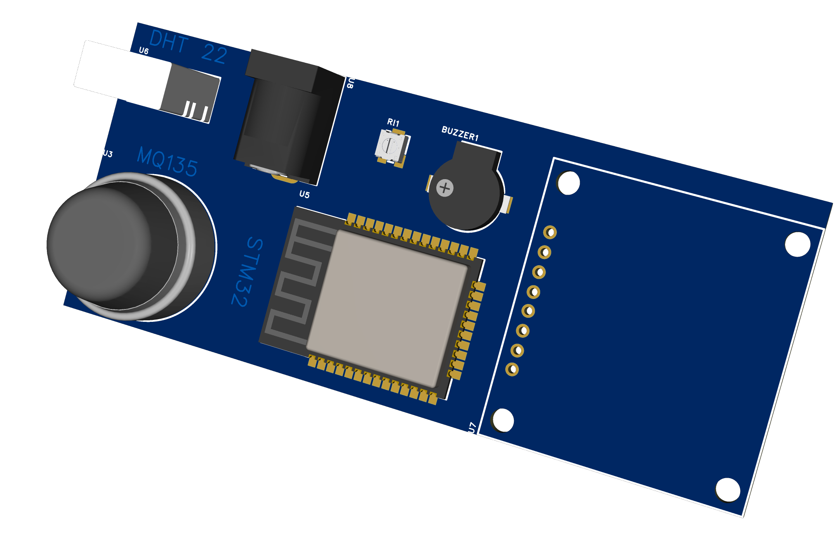

Code:
#include <Wire.h>
#include <DHT.h>
#include <Adafruit_SSD1306.h>
#include <Adafruit_GFX.h>

#define DHT_PIN 2
#define DHT_TYPE DHT22

#define MQ135_PIN A0 // Connect MQ135 sensor to analog pin A0

DHT dht(DHT_PIN, DHT_TYPE);

// OLED display dimensions
#define SCREEN_WIDTH 128
#define SCREEN_HEIGHT 64

Adafruit_SSD1306 display(SCREEN_WIDTH, SCREEN_HEIGHT, &Wire, -1);

float TEMP_THRESHOLD_HIGH = 40.0;
float HUM_THRESHOLD_HIGH = 70.0;
float AMMONIA_THRESHOLD = 50.0;

void setup() {
Serial.begin(115200);
dht.begin();

if (!display.begin(SSD1306_I2C_ADDRESS, SCREEN_WIDTH, SCREEN_HEIGHT)) {
Serial.println(F("SSD1306 allocation failed"));
for (;;);
}
display.display(); delay(2000);
display.clearDisplay(); r
}

void loop() {
float temperature = dht.readTemperature();
float humidity = dht.readHumidity();

int mq135Value = analogRead(MQ135_PIN);
float ammoniaConcentration = map(mq135Value, 0, 1023, 0, 500);
Serial.print("Temperature: ");
Serial.print(temperature);
Serial.print(" C, Humidity: ");
Serial.print(humidity);
Serial.print(" %, Ammonia Concentration: ");
Serial.print(ammoniaConcentration);
Serial.println(" ppm");

display.clearDisplay();

display.setTextSize(1);
display.setTextColor(SSD1306_WHITE);
display.setCursor(0, 0);
display.print("Temp: ");
display.print(temperature);
display.println(" C");

display.print("Hum: ");
display.print(humidity);
display.println(" %");

display.print("Ammonia: ");
display.print(ammoniaConcentration);
display.println(" ppm");

// Check for high thresholds and display alerts on OLED
if (temperature > TEMP_THRESHOLD_HIGH) {
display.setCursor(0, 48); // Move cursor to lower part of the screen
display.print("ALERT: High Temp!");
}

if (humidity > HUM_THRESHOLD_HIGH) {
display.setCursor(0, 40); // Move cursor for alert
display.print("ALERT: High Humidity!");
}

if (ammoniaConcentration > AMMONIA_THRESHOLD) {
display.setCursor(0, 32); // Move cursor for alert
display.print("ALERT: High Ammonia!");
}

display.display();
delay(2000);
}

Cost analysis:
- ESP32-WROOM-32D(Microcontroller): 600Rs
- MQ 135 (Gas sensor sensing Ammonia): 120Rs
- DHT11 (Tmperature and Humidity):150Rs
- LCD Display (16x2):450Rs
- Buzzer:40Rs
- Resistors(220ohms):1rs
- 5v Power jack:70Rs
- Jumper wires:30Rs

Total :1500Rs(Approx)

Total System:3000Rs(Approx)
Estimated lifespan :1-1.5Years

