WINDROSE AI · CHARGEBACK REPRESENTMENT

Agent Playbook
How to put the nine Windrose agents to work in chargeback representment.

This playbook maps each of Windrose’s nine agents to a concrete job in this vertical, grounded in the real chargeback-representment pack.

Pack: chargeback-representment v1.0.0
Domain: payments · merchants · chargebacks · representment · fraud
Regulatory: visa_rules, mastercard_rules
Golden rule: Windrose proposes; a human decides. No autonomous writes — four-eyes on every action.
Date: 2026-07-17

Contents

1. What this pack does
AI-assisted chargeback representment for merchants, PSPs/acquirers offering managed disputes, and marketplaces: incoming-chargeback triage with response-deadline awareness, fight/accept economics, reason-code-matched compelling-evidence assembly (Visa CE 3.0 pre-screen, delivery confirmation, usage logs, policy disclosure), friendly-fraud pattern flagging with block-list feed, pre-arbitration escalation discipline, pre-dispute alert deduplication (RDR/Ethoca-style), dispute-program KPI semantic model and dashboards (fight rate, win rate, net recovery, accept-liability share, monitoring-program mix), network-rule grounding memories, and order-anomaly + win-likelihood training pipelines.
Windrose makes it a governed decision workflow: the source data lands as governed datasets; the agents watch the queue and propose — a disposition, a model, a dashboard — grounded in the domain rules; and a human approves. Every correction trains the next model. The nine agents are the workforce; this playbook is their job description.
The rule that shapes everything
Windrose proposes; a human decides. Proposal-mode + four-eyes: no agent writes or actions on its own — every consequential step is a human-approved proposal. Enforced by the platform.

2. The team (who does the approving)
The pack ships these roles. Each person only sees what their role allows; the approver on a proposal is never the one (or the agent) who created it.
Role | Responsibility
Dispute Response Analyst | —
Evidence Specialist | —
Pre-Arbitration Lead | —
Dispute Program Manager | —
Payments Compliance Auditor | —

3. The nine agents, mapped to this vertical
Every agent below is the same platform agent — specialised to this domain through tenant configuration (persona + domain + rule grounding), not a code fork. case-triage and analytics carry explicit domain instructions today; the rest apply unchanged.
Agent | Its job here | Who approves
onboarding | Propose how to land the source feeds as governed datasets | Director / Data admin
analytics | Answer KPI questions over the governed models — read-only | — (no write)
dashboard-designer | Draft the operational dashboards | Director
model-training | Propose a order-anomaly + win-likelihood training run | Director / Data scientist
ml-engineer | Autonomously build & compare candidate models, propose the winner | Director (four-eyes)
inference | Batch-score with the production model | Analyst / Manager
case-triage | The reviewer: propose a disposition on each queued case | Domain reviewer
governance | Open a retrain proposal when a model drifts | Director / Data scientist
meta-router | Front door: route a free-text request to the right agent | (delegate’s approver)

The domain data these agents reason over is live in the platform’s governed layer:
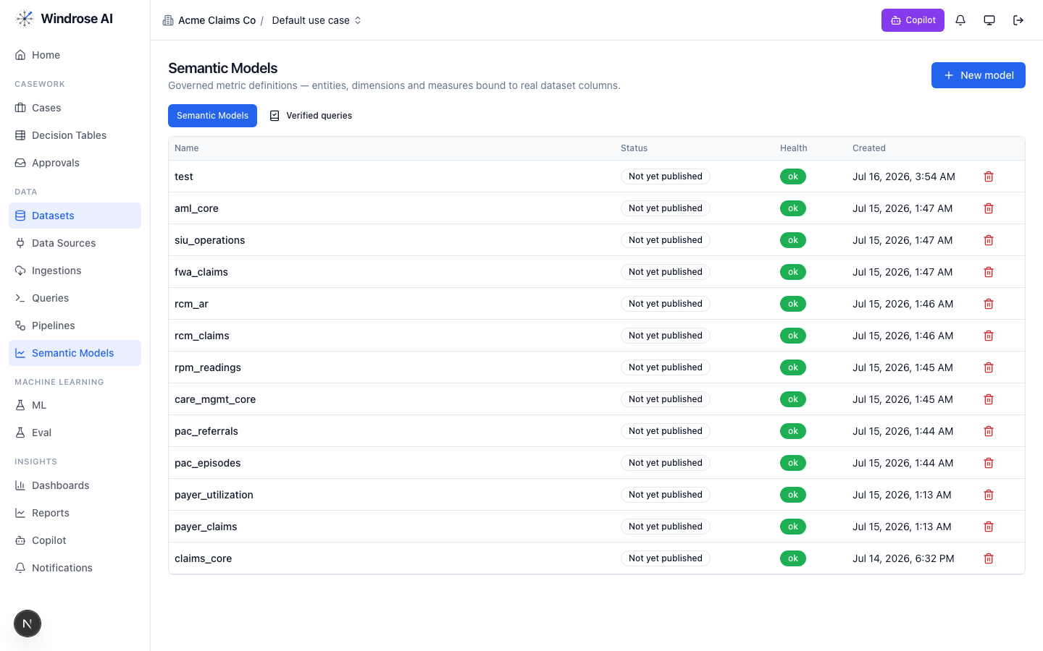
Figure 1. The platform’s Semantic Models surface (models from many installed packs shown). This pack adds: representment_core.
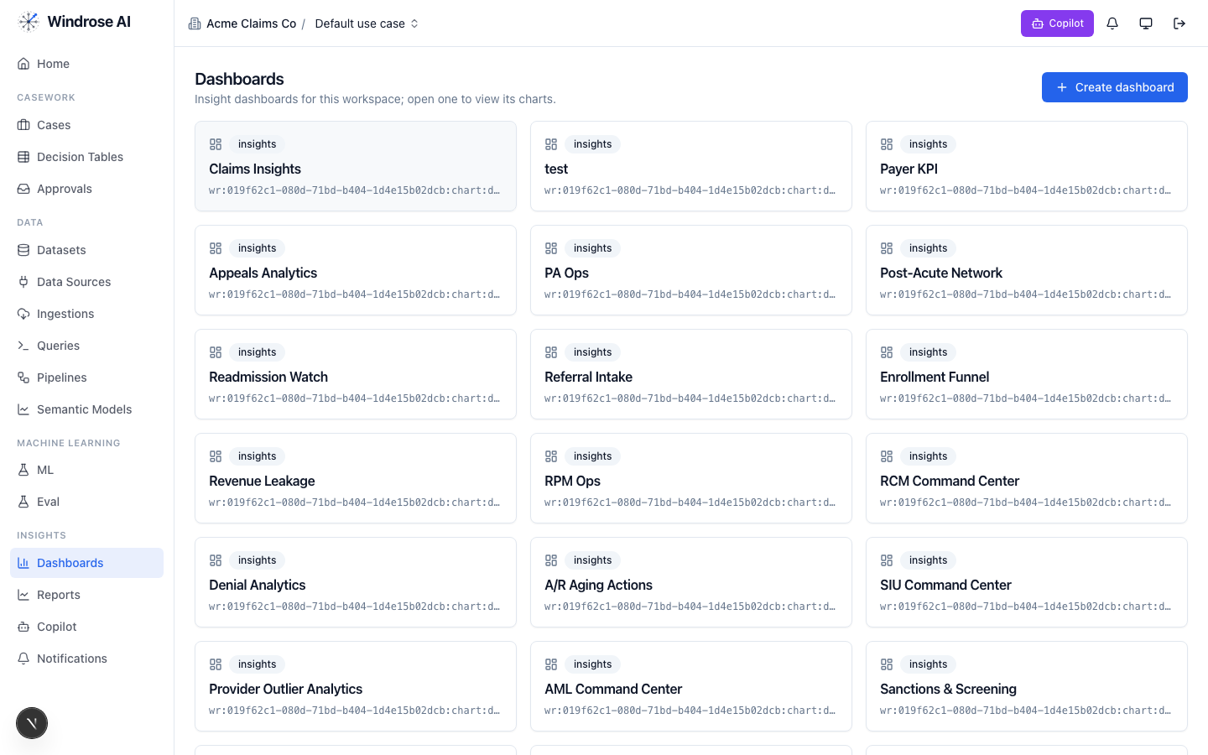
Figure 2. The Dashboards surface. This pack installs: Chargeback_response_center, Win_rates_evidence, Program_health_thresholds.

4. Agent-by-agent playbook

onboarding 4.1. Bring the data in
The onboarding agent inspects a source and proposes an ingestion config + column mapping, grounded in the connector catalog and a live preview.
- Go to Data → Data Sources → New data source; pick a connector or upload a seed extract.
- Ask it to “onboard this feed as a dataset.” It returns an ingestion.create proposal; a data admin approves; the feed lands ready.

analytics 4.2. Ask the KPIs
The analytics agent answers KPI questions over the governed representment_core model(s) — read-only, citing the measures it used. From the pack’s own analytics instructions:
Analytics grounding (from the pack)
Answer dispute-program KPI questions from the governed semantic model representment_core: fight_rate, win_rate, net_recovery_rate, accept_liability_share, friendly_fraud_share, avg_chargeback_age_days (response cycle time), deadline runway (open_chargeback_count by deadline_bucket), monitoring-program surfaces (fraud_family_count — the Visa VDMP/VFMP and Mastercard ECM numerator families), and evidence coverage (strong_evidence_count, delivery_confirmed_order_count, device_match_order_count). Use plain operational language for dispute-operations and payments-compliance staff and always cite the measure names you …
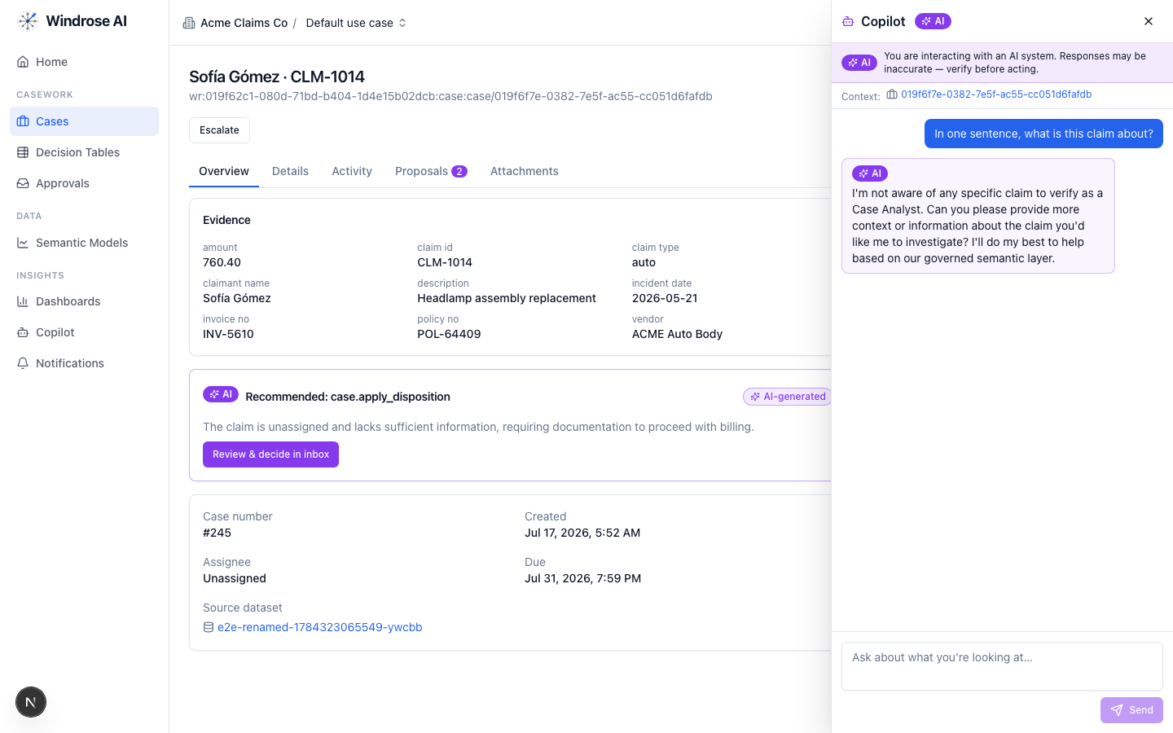
Figure 3. The role-grounded Copilot answering over the governed semantic layer — grounded, never fabricated. The same surface serves this vertical.

dashboard-designer 4.3. Stand up the boards
It proposes a draft dashboard — title + charts bound to real measures/dimensions — grounded in the semantic layer. Ask “design a board for this program”; review the chart.dashboard.create proposal; a director approves (the boards appear as in Figure 2).

model-training 4.4. Propose a order-anomaly + win-likelihood model
It turns a plain-language goal into a governed training-run proposal — algorithm, hyperparameters, label/features — grounded in the algorithm catalog and prior runs. The pack ships a real order-anomaly + win-likelihood training pipeline.
- Ask “train a order-anomaly + win-likelihood model on the panel.” It returns a pipeline.template.create_from_algorithm proposal; approve → the pipeline runs and registers a model.
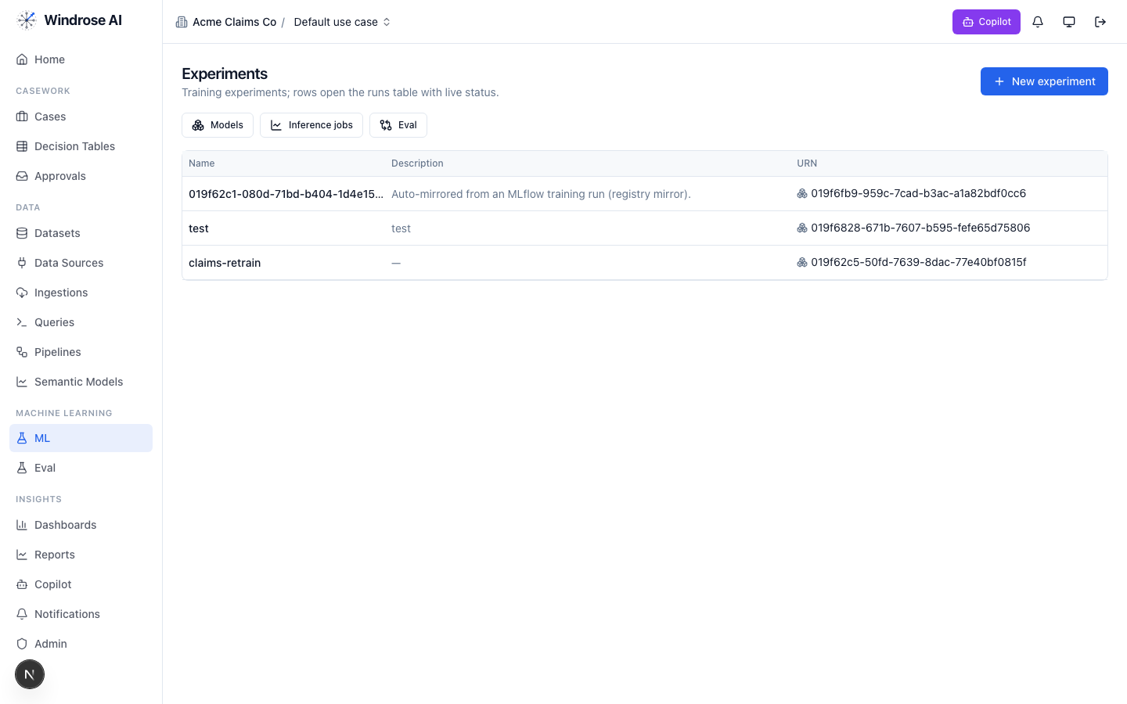
Figure 4. Experiments & the model registry — a pipeline-trained model auto-mirrors here, ready to gate and promote.

ml-engineer 4.5. Build the model for me
The ml-engineer agent runs the whole loop autonomously: inspects the schema, launches candidate models in sandboxed pipeline runs, compares real metrics, and proposes promoting the winner via experiment.model.promote — four-eyes, never promoting directly.

inference 4.6. Score the population
The inference agent proposes a batch scoring job: it resolves the model’s production version, checks input-schema compatibility, and proposes an inference.submit job whose output is a scored dataset the team works from. A human approves before it runs.

case-triage 4.7. The reviewer (the heart of it)
Each queued case (response_queue) gets a proposed disposition, grounded in the domain rules and citing the exact basis. It never takes the action itself. From the pack’s own triage instructions:
Triage grounding (from the pack)
You triage incoming chargebacks for a merchant/PSP dispute-response team and recommend whether to fight (represent / second presentment) and with what evidence, under Visa and Mastercard dispute rules. Ground every recommendation in the specific order evidence — cite chargeback ids, order ids, amounts, AVS/CVV results, delivery confirmation, device match, and the customer's history (prior chargebacks band, tenure, order count). Watch the response clock first: acquirer response deadlines are materially shorter than the network windows, and a strong case filed late is a lost case — flag any chargeback whose days_to_deadline puts the response at risk. Match evidence to the reason family: for 13.1/not-received, carrier delivery confirmation (ideally signed) to the AVS-matched address; for digital goods, usage/download/login logs; for 13.3/cancellations, proof the refund/cancellation policy w…
The dispositions it proposes
Disposition | Meaning | Category
represent_with_evidence | Represent — fight with compelling evidence | true_positive
accept_liability_refund | Accept liability — refund, fight not warranted | false_positive
pre_arbitration_escalate | Escalate to pre-arbitration / arbitration | other
flag_friendly_fraud_pattern | Flag friendly-fraud pattern (block-list / prevention) | inconclusive
close_duplicate_or_resolved | Close — duplicate or already resolved via alert/refund | benign
How the team uses it:
- Open Cases — the ranked review worklist. Each row is a queued item with its context.
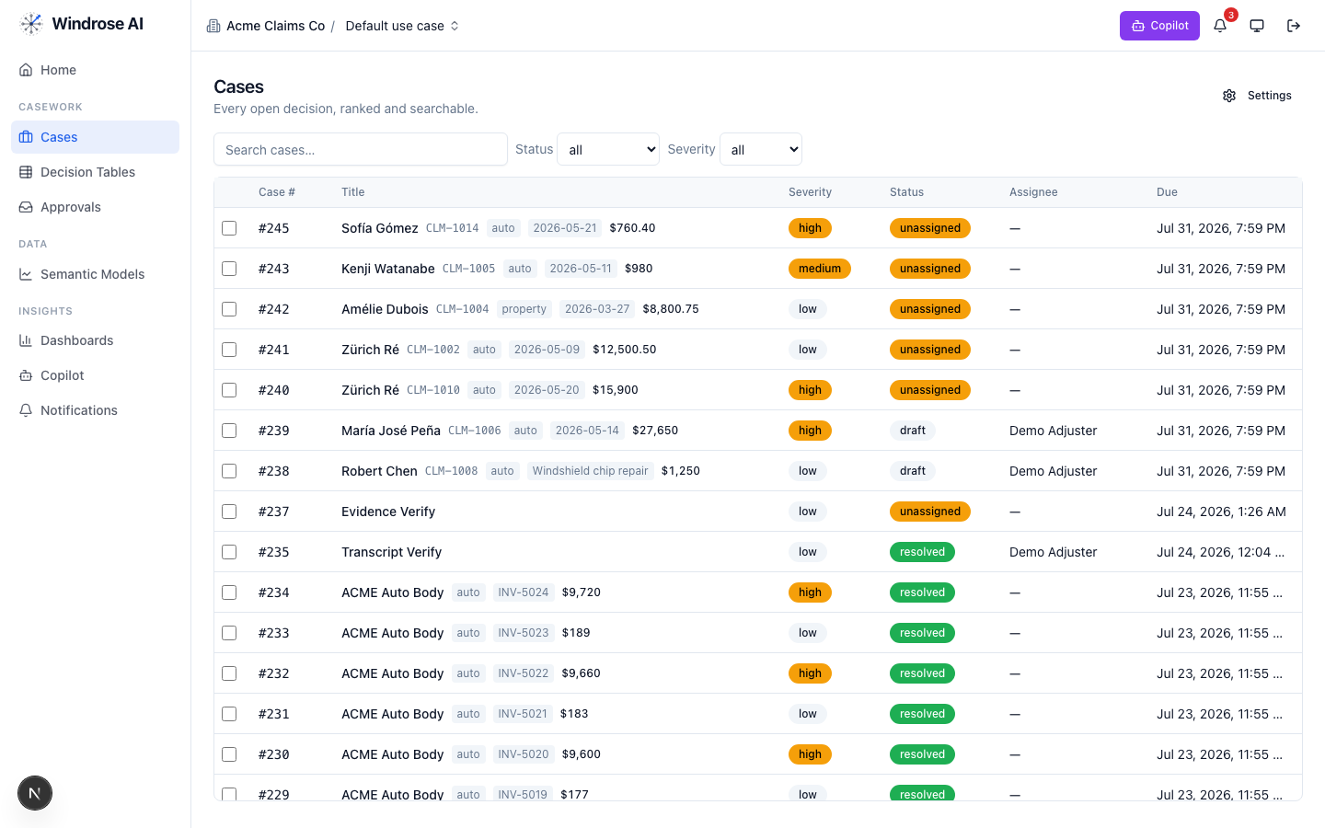
Figure 5. The review worklist surface (claims demo shown; this pack drives the identical surface with its own queue).
- Open an item; the Overview shows the evidence and the AI recommendation citing the rule + source. Open Proposals to see the disposition as a diff.
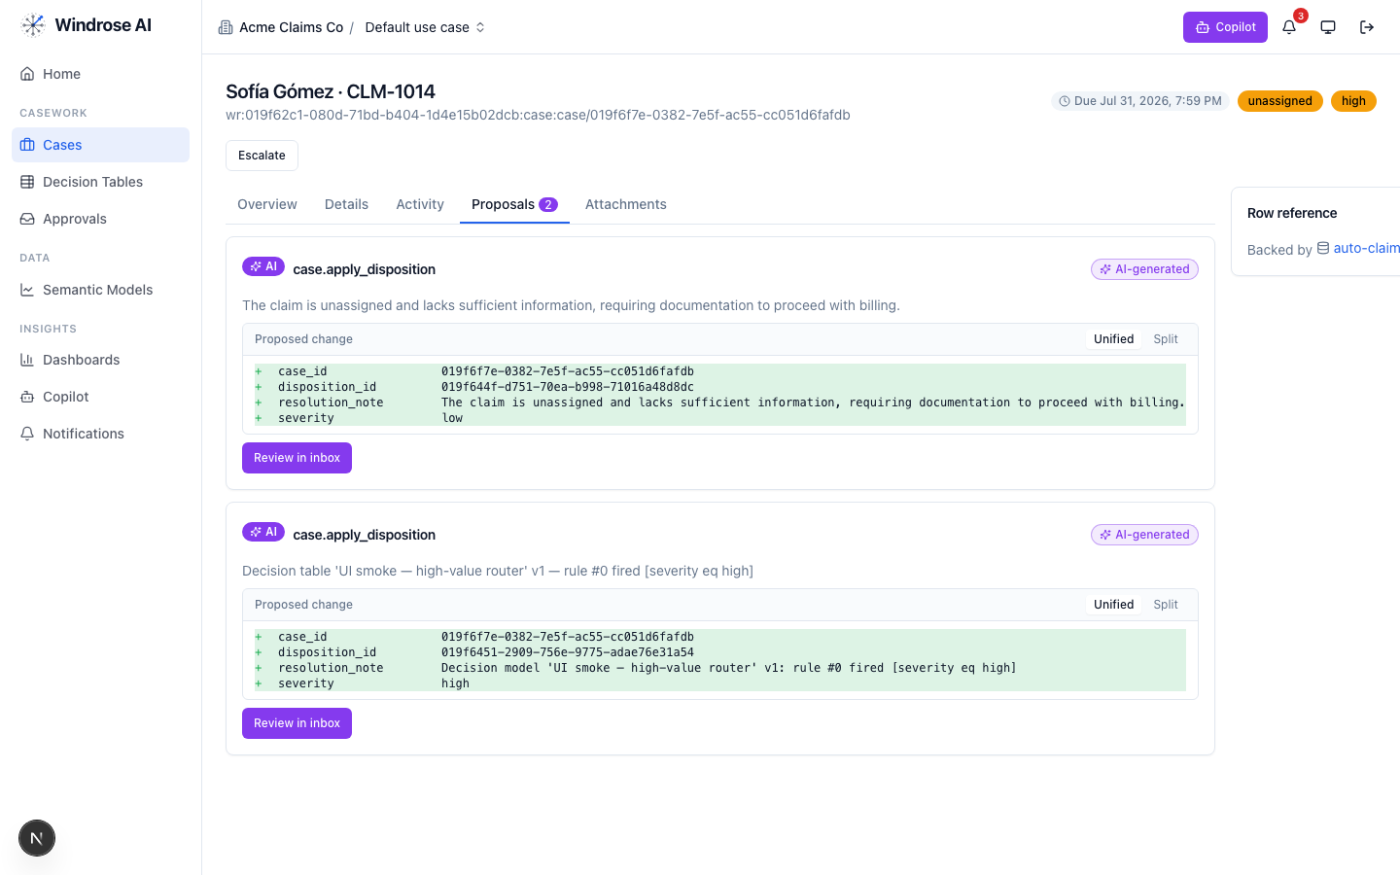
Figure 6. A disposition proposal as a field-level diff — inert until a human approves.
- Approve, edit (the correction becomes training data), or reject with a reason from the Approvals inbox — four-eyes.
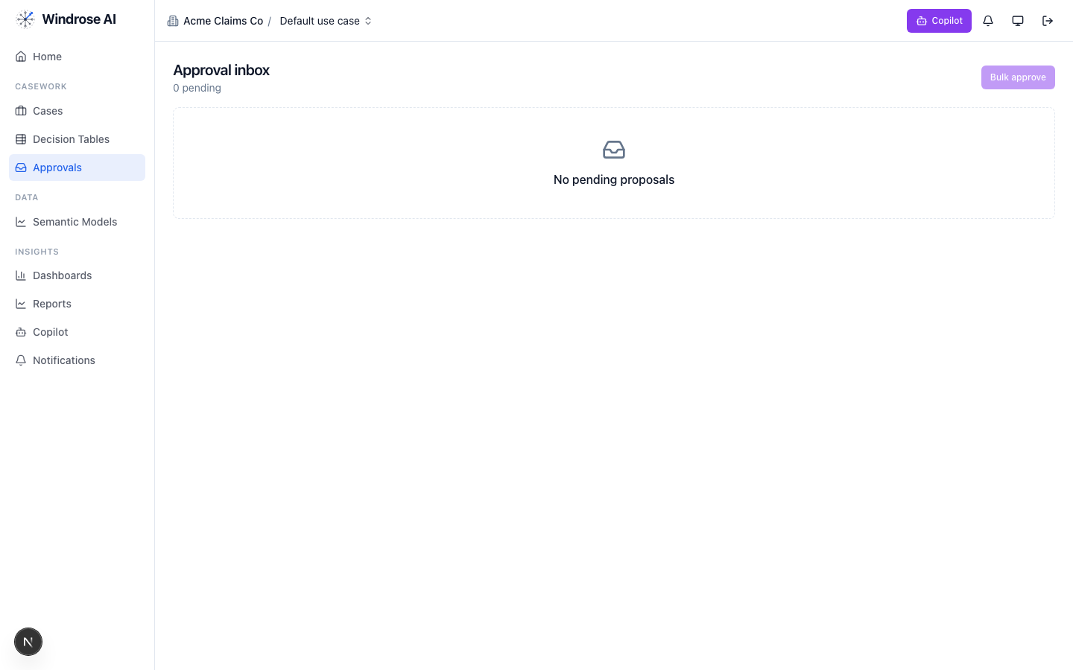
Figure 7. The approval inbox. Every disposition is approved by someone other than the proposer — four-eyes.

governance 4.8. Keep the models honest
The governance agent runs autonomously under its own agent principal; when a model drifts or corrections pile up past threshold it opens a mlops.open_retrain proposal with the evidence summarised. A director approves.

meta-router 4.9. The team’s front door
The meta-router takes a free-text request, classifies it, and delegates to the right specialist — analytics for a question, case-triage for a queued item, ml-engineer for a model. Everything still flows through the same proposal + approval gate.

5. The operating cycle

Governed automation is real
Decision tables let you encode deterministic rules that propose a disposition for approval — never decide autonomously — alongside the agents.
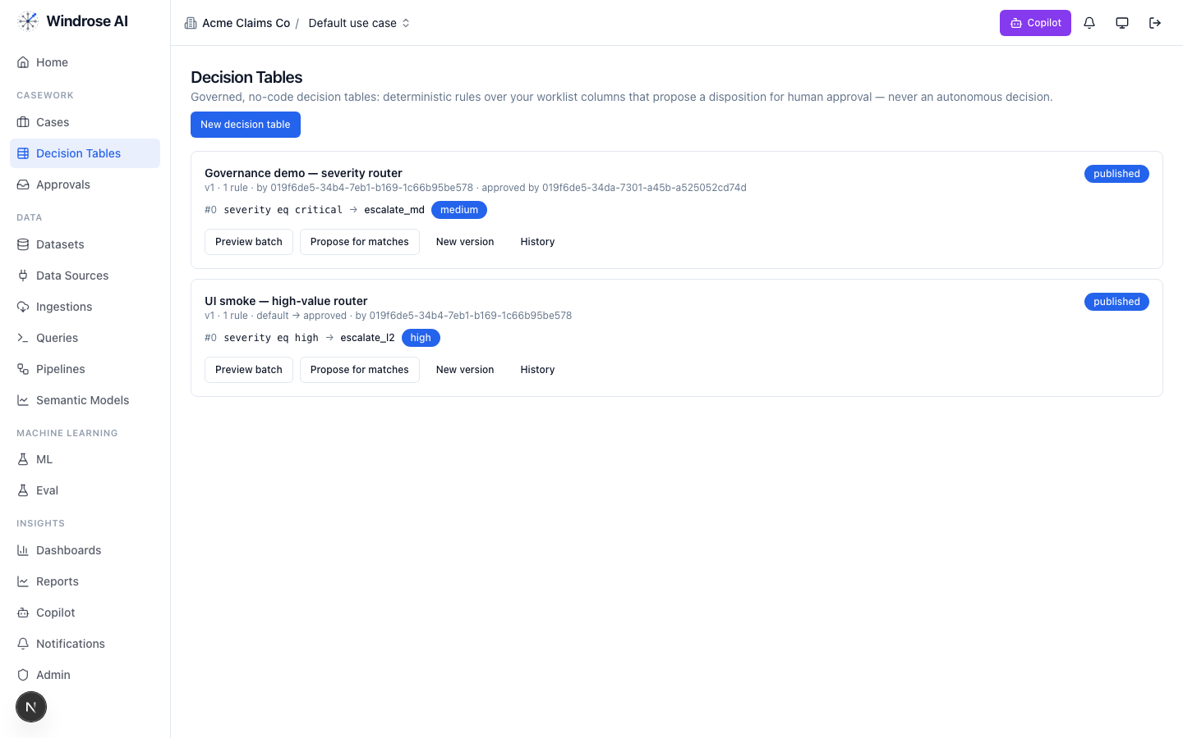
Figure 8. Governed decision tables: deterministic rules that propose a disposition for human approval, versioned and approved by a named user.

6. Governance & the eval gate
- No autonomous action. Every consequential step is a human-approved proposal (four-eyes).
- Rules as grounding. The domain’s regulatory rules are retrieved as grounding the agents must cite (visa_rules, mastercard_rules).
- Eval-gated models. A model is promoted only after passing its eval suite; rollback = demote.
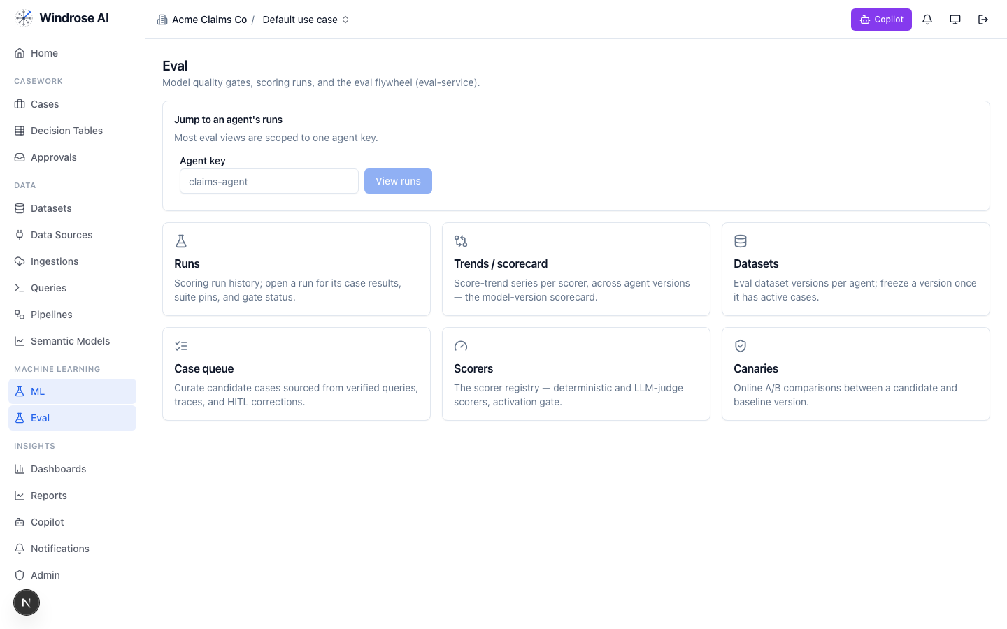
Figure 9. The eval flywheel — the promotion gate for this vertical’s models: runs & gates, scorers, and canary A/B.

7. What is live today vs pack-service-deferred
In the spirit of no-fake: what Core materialises today is live; the rest is recorded in the install ledger as deferred, with the proposal-mode + four-eyes guarantees already holding. Nothing is stubbed.
Capability | Status
Semantic models (representment_core), dashboards, saved/verified queries | Live
Review case queue + disposition taxonomy + role catalog | Live
case-triage + analytics specialised to this domain (rule grounding) | Live
order-anomaly + win-likelihood training pipeline | Live
Deferred to pack-service: guardrails, agent_recipes, connection_templates, write_adapters, eval_sets, ontology, case_schemas, model_archetypes, display_labels | Deferred → served today via config + seed data; guarantees hold

Grounded in the real chargeback-representment pack (its own pack.yaml, dispositions, roles, and agent instructions). The domain-asset captions name this pack’s real models/dashboards; agent-surface screenshots are the shared, pack-agnostic surfaces (claims demo shown) — this pack drives the identical surfaces with its own data. Where a capability awaits pack-service, this playbook says so.

