WINDROSE AI · CONSTRUCTION CLAIMS

Agent Playbook
How to put the nine Windrose agents to work in construction claims.

This playbook maps each of Windrose’s nine agents to a concrete job in this vertical, grounded in the real construction-claims pack.

Pack: construction-claims v1.0.0
Domain: construction · claims · change_orders · disputes · infrastructure
Regulatory: contract_law, far_dsc_clause, mechanics_lien, surety_bonds, prompt_payment
Golden rule: Windrose proposes; a human decides. No autonomous writes — four-eyes on every action.
Date: 2026-07-17

Contents

1. What this pack does
AI-assisted construction claim and change-order adjudication for owners, GCs, CMs, sureties, and infrastructure agencies: claim intake triage with contractual notice-provision awareness, entitlement-first analysis (differing site conditions Type I/II, directed vs constructive acceleration, concurrent delay), quantum review grounded in measured-mile vs total-cost methodology, defect-backcharge and surety-notice handling, pay-if-paid/pay-when-paid payment-dispute screening, a claims-operations KPI semantic model and dashboards (approval/rejection/negotiated rates, claimed-vs-approved ratio, deadline runway, schedule-impact mix), a party-to-project exposure network, claims-law grounding memories, and contract-anomaly + claim-outcome training pipelines.
Windrose makes it a governed decision workflow: the source data lands as governed datasets; the agents watch the queue and propose — a disposition, a model, a dashboard — grounded in the domain rules; and a human approves. Every correction trains the next model. The nine agents are the workforce; this playbook is their job description.
The rule that shapes everything
Windrose proposes; a human decides. Proposal-mode + four-eyes: no agent writes or actions on its own — every consequential step is a human-approved proposal. Enforced by the platform.

2. The team (who does the approving)
The pack ships these roles. Each person only sees what their role allows; the approver on a proposal is never the one (or the agent) who created it.
Role | Responsibility
Claims Analyst | —
Scheduling & Delay Specialist | —
Contract Administrator | —
Claims Review Board Manager | —
Project Controls Auditor | —

3. The nine agents, mapped to this vertical
Every agent below is the same platform agent — specialised to this domain through tenant configuration (persona + domain + rule grounding), not a code fork. case-triage and analytics carry explicit domain instructions today; the rest apply unchanged.
Agent | Its job here | Who approves
onboarding | Propose how to land the source feeds as governed datasets | Director / Data admin
analytics | Answer KPI questions over the governed models — read-only | — (no write)
dashboard-designer | Draft the operational dashboards | Director
model-training | Propose a contract-anomaly + claim-outcome training run | Director / Data scientist
ml-engineer | Autonomously build & compare candidate models, propose the winner | Director (four-eyes)
inference | Batch-score with the production model | Analyst / Manager
case-triage | The reviewer: propose a disposition on each queued case | Domain reviewer
governance | Open a retrain proposal when a model drifts | Director / Data scientist
meta-router | Front door: route a free-text request to the right agent | (delegate’s approver)

The domain data these agents reason over is live in the platform’s governed layer:
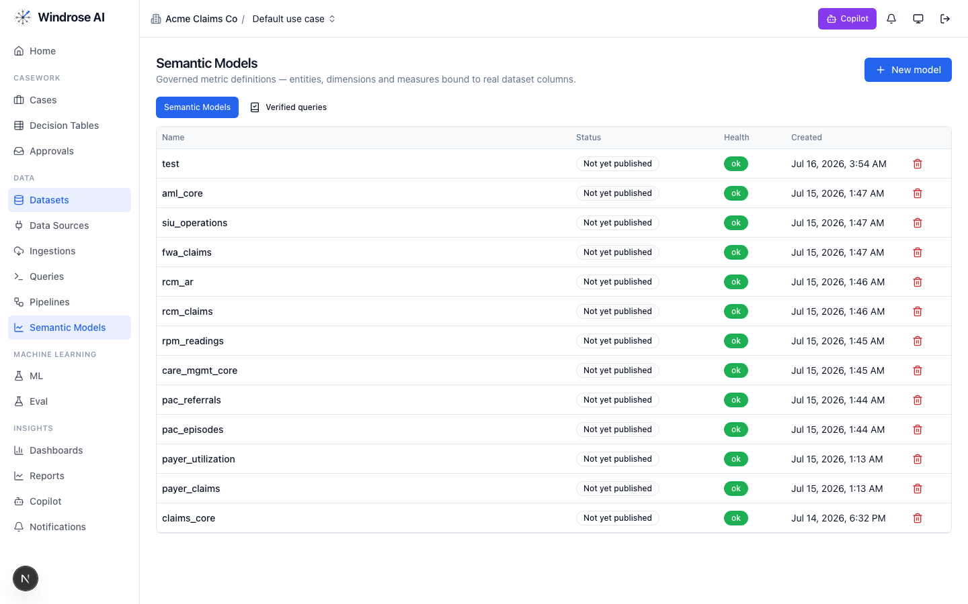
Figure 1. The platform’s Semantic Models surface (models from many installed packs shown). This pack adds: construction_claims_core.
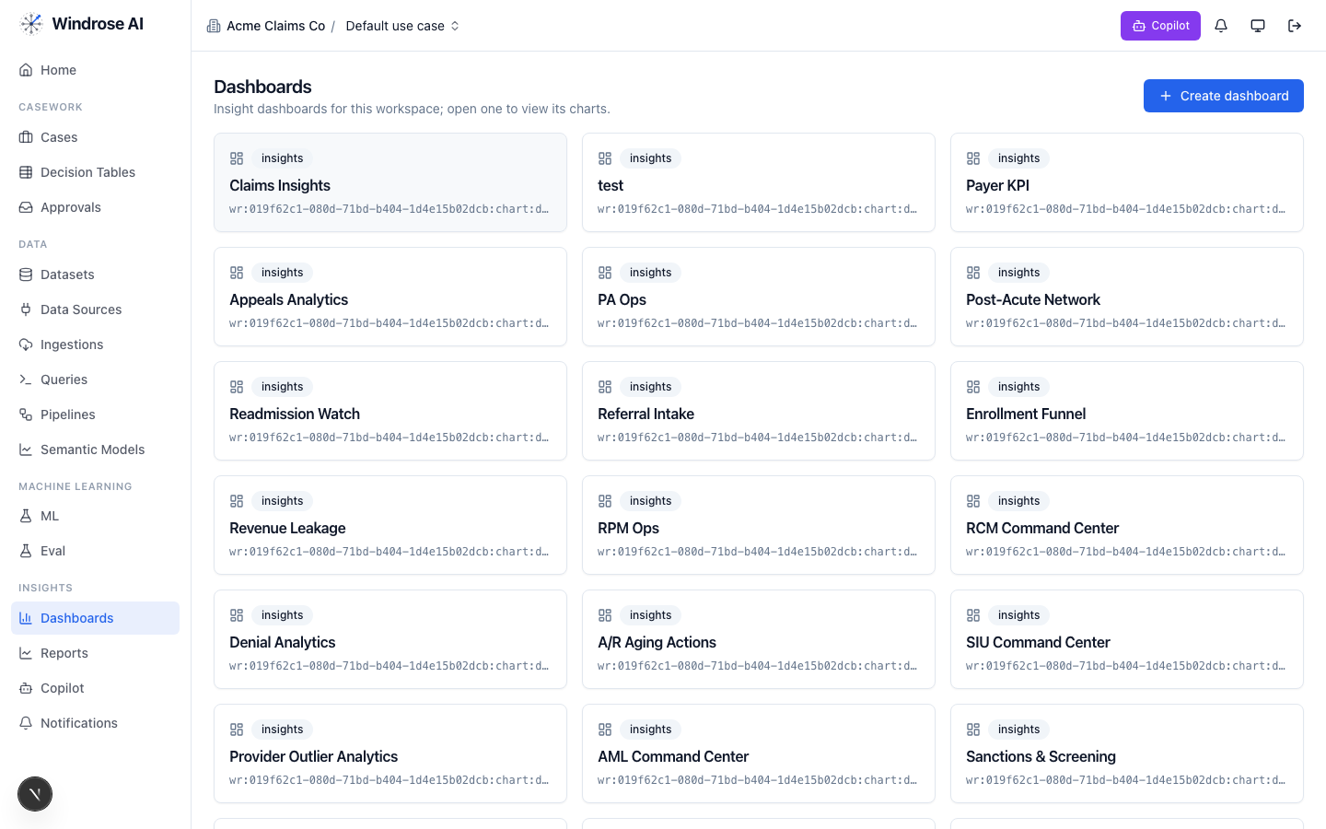
Figure 2. The Dashboards surface. This pack installs: Claims_command_center, Entitlement_schedule_impact, Party_risk_recovery.

4. Agent-by-agent playbook

onboarding 4.1. Bring the data in
The onboarding agent inspects a source and proposes an ingestion config + column mapping, grounded in the connector catalog and a live preview.
- Go to Data → Data Sources → New data source; pick a connector or upload a seed extract.
- Ask it to “onboard this feed as a dataset.” It returns an ingestion.create proposal; a data admin approves; the feed lands ready.

analytics 4.2. Ask the KPIs
The analytics agent answers KPI questions over the governed construction_claims_core model(s) — read-only, citing the measures it used. From the pack’s own analytics instructions:
Analytics grounding (from the pack)
Answer claims-program KPI questions from the governed semantic model construction_claims_core: approval_rate, rejection_rate, negotiated_share, approved_to_claimed_ratio (quantum discipline), delay_claim_share, avg_claim_age_days (backlog aging), open backlog and deadline runway (open_claim_count by deadline_bucket), notice hygiene (late_notice_count), schedule exposure (major_schedule_impact_count), and party-book surfaces (subcontractor_count, surety_backed_party_count, repeat_claimant_party_count). Use plain operational language for project-controls, executive, and surety/lender audiences and always cite the m…
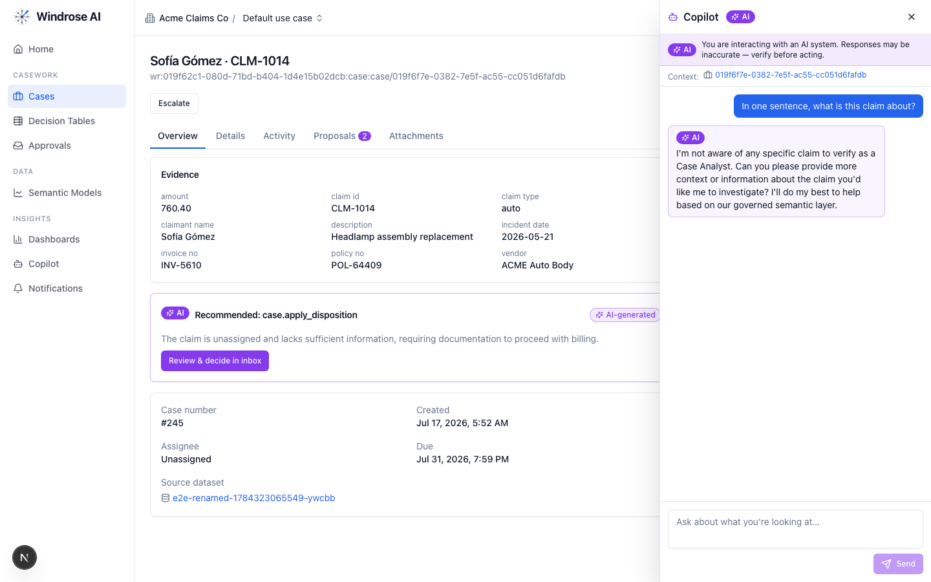
Figure 3. The role-grounded Copilot answering over the governed semantic layer — grounded, never fabricated. The same surface serves this vertical.

dashboard-designer 4.3. Stand up the boards
It proposes a draft dashboard — title + charts bound to real measures/dimensions — grounded in the semantic layer. Ask “design a board for this program”; review the chart.dashboard.create proposal; a director approves (the boards appear as in Figure 2).

model-training 4.4. Propose a contract-anomaly + claim-outcome model
It turns a plain-language goal into a governed training-run proposal — algorithm, hyperparameters, label/features — grounded in the algorithm catalog and prior runs. The pack ships a real contract-anomaly + claim-outcome training pipeline.
- Ask “train a contract-anomaly + claim-outcome model on the panel.” It returns a pipeline.template.create_from_algorithm proposal; approve → the pipeline runs and registers a model.
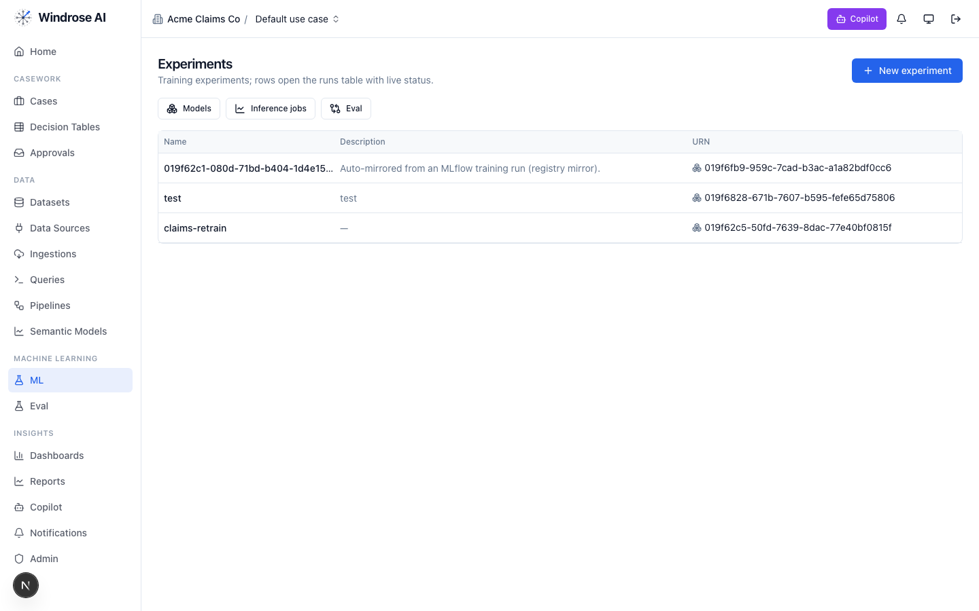
Figure 4. Experiments & the model registry — a pipeline-trained model auto-mirrors here, ready to gate and promote.

ml-engineer 4.5. Build the model for me
The ml-engineer agent runs the whole loop autonomously: inspects the schema, launches candidate models in sandboxed pipeline runs, compares real metrics, and proposes promoting the winner via experiment.model.promote — four-eyes, never promoting directly.

inference 4.6. Score the population
The inference agent proposes a batch scoring job: it resolves the model’s production version, checks input-schema compatibility, and proposes an inference.submit job whose output is a scored dataset the team works from. A human approves before it runs.

case-triage 4.7. The reviewer (the heart of it)
Each queued case (claims_queue) gets a proposed disposition, grounded in the domain rules and citing the exact basis. It never takes the action itself. From the pack’s own triage instructions:
Triage grounding (from the pack)
You triage construction claims and change-order requests for the paying side of the contract (owner, GC, or CM). Analyze entitlement FIRST, quantum second: identify the governing contract clause (changes, differing site conditions, delay/time-extension, notice, payment) and whether the asserted basis — design change, owner directive, weather, site conditions, subcontractor default, or spec ambiguity — actually engages it. Ground every recommendation in the specific record evidence: cite claim ids, contract ids, party ids, claimed amounts, notice timeliness, and the party's history (prior claims, prior rejections, prequal tier, surety backing). Check the contractual notice provision first — timely written notice is often a condition precedent and strictly enforced in many jurisdictions — and watch days_to_deadline: never let analysis depth blow a contractual response deadline; propose an …
The dispositions it proposes
Disposition | Meaning | Category
approve_change_order | Approve — entitlement and quantum substantiated | true_positive
reject_no_entitlement | Reject — no contractual entitlement | false_positive
negotiate_partial_merit | Negotiate — partial merit, settle at adjusted quantum | other
request_substantiation | Request substantiation — quantum or causation unsupported | inconclusive
close_withdrawn_resolved | Close — withdrawn or resolved in the field | benign
How the team uses it:
- Open Cases — the ranked review worklist. Each row is a queued item with its context.
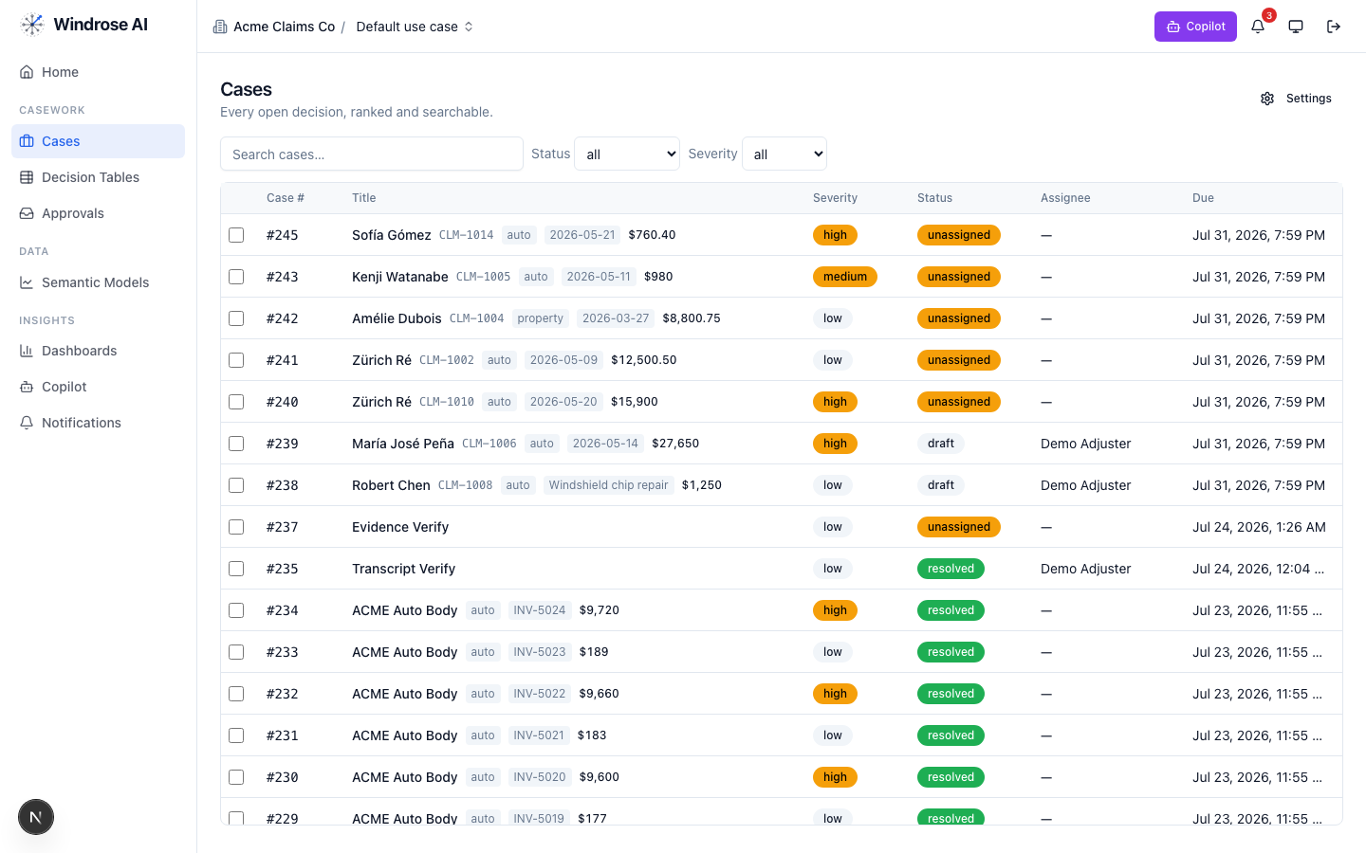
Figure 5. The review worklist surface (claims demo shown; this pack drives the identical surface with its own queue).
- Open an item; the Overview shows the evidence and the AI recommendation citing the rule + source. Open Proposals to see the disposition as a diff.
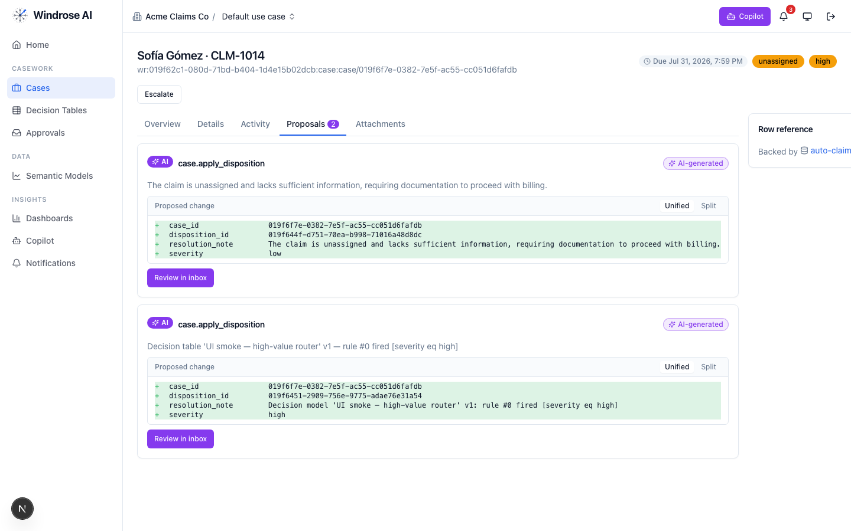
Figure 6. A disposition proposal as a field-level diff — inert until a human approves.
- Approve, edit (the correction becomes training data), or reject with a reason from the Approvals inbox — four-eyes.
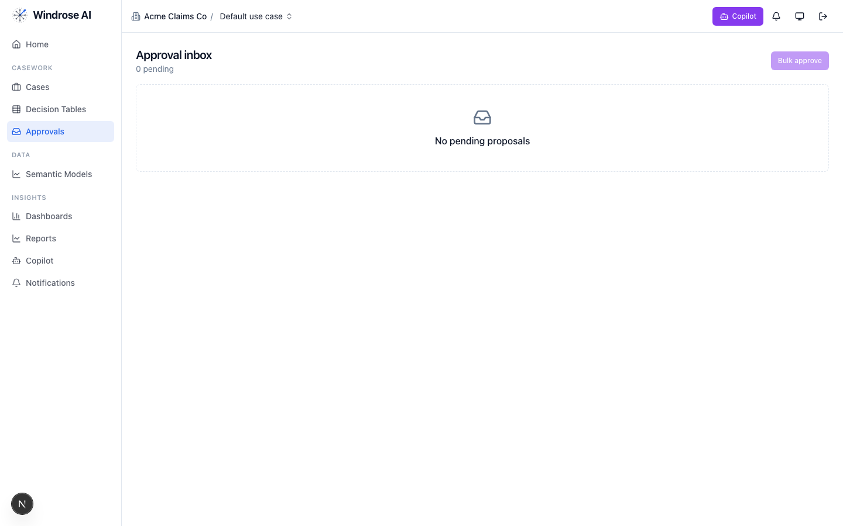
Figure 7. The approval inbox. Every disposition is approved by someone other than the proposer — four-eyes.

governance 4.8. Keep the models honest
The governance agent runs autonomously under its own agent principal; when a model drifts or corrections pile up past threshold it opens a mlops.open_retrain proposal with the evidence summarised. A director approves.

meta-router 4.9. The team’s front door
The meta-router takes a free-text request, classifies it, and delegates to the right specialist — analytics for a question, case-triage for a queued item, ml-engineer for a model. Everything still flows through the same proposal + approval gate.

5. The operating cycle

Governed automation is real
Decision tables let you encode deterministic rules that propose a disposition for approval — never decide autonomously — alongside the agents.
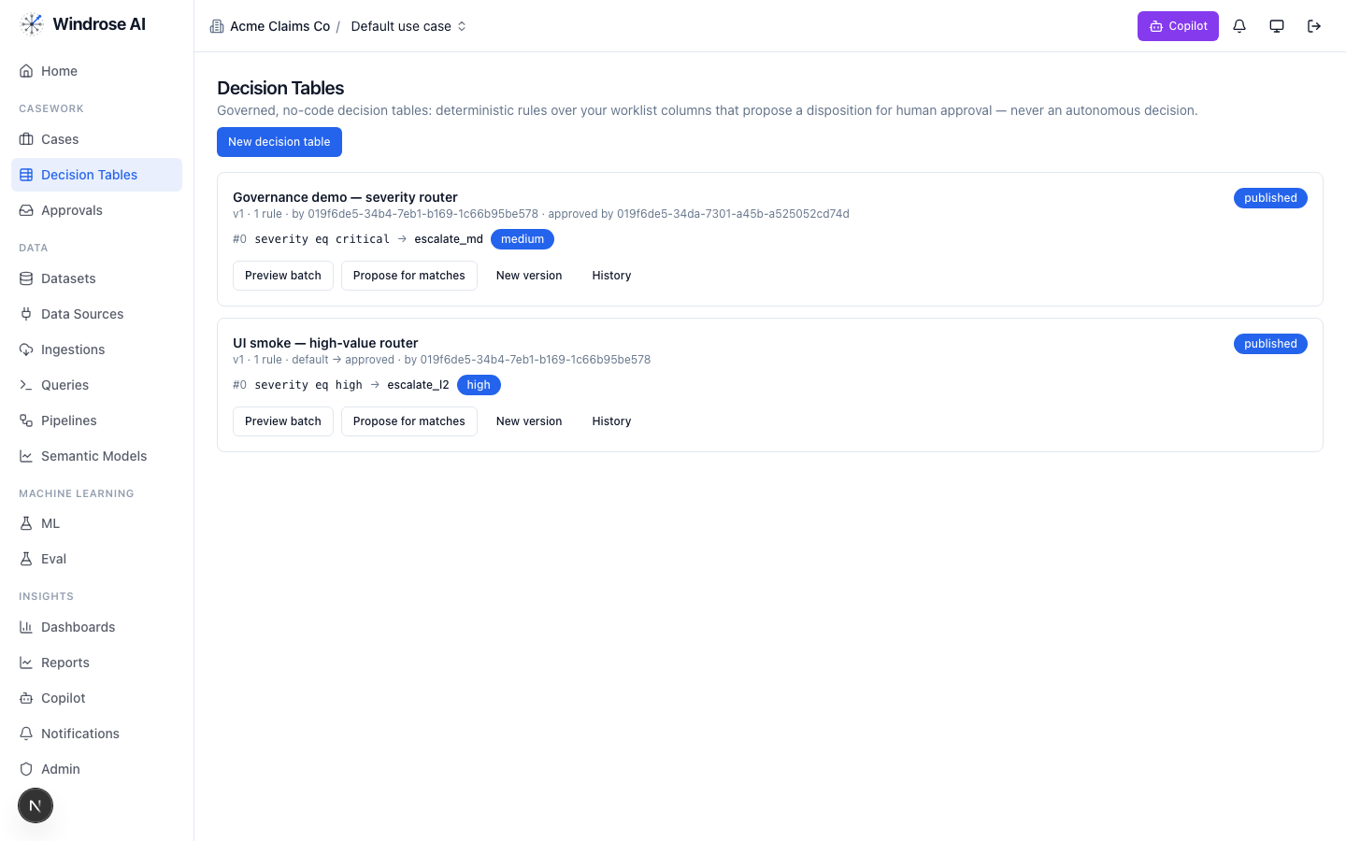
Figure 8. Governed decision tables: deterministic rules that propose a disposition for human approval, versioned and approved by a named user.

6. Governance & the eval gate
- No autonomous action. Every consequential step is a human-approved proposal (four-eyes).
- Rules as grounding. The domain’s regulatory rules are retrieved as grounding the agents must cite (contract_law, far_dsc_clause, mechanics_lien, surety_bonds, prompt_payment).
- Eval-gated models. A model is promoted only after passing its eval suite; rollback = demote.
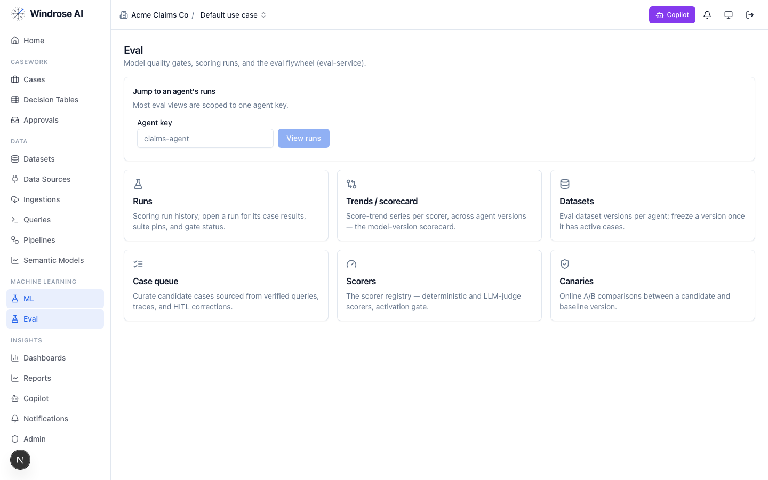
Figure 9. The eval flywheel — the promotion gate for this vertical’s models: runs & gates, scorers, and canary A/B.

7. What is live today vs pack-service-deferred
In the spirit of no-fake: what Core materialises today is live; the rest is recorded in the install ledger as deferred, with the proposal-mode + four-eyes guarantees already holding. Nothing is stubbed.
Capability | Status
Semantic models (construction_claims_core), dashboards, saved/verified queries | Live
Review case queue + disposition taxonomy + role catalog | Live
case-triage + analytics specialised to this domain (rule grounding) | Live
contract-anomaly + claim-outcome training pipeline | Live
Deferred to pack-service: guardrails, agent_recipes, connection_templates, write_adapters, eval_sets, ontology, case_schemas, model_archetypes, display_labels | Deferred → served today via config + seed data; guarantees hold

Grounded in the real construction-claims pack (its own pack.yaml, dispositions, roles, and agent instructions). The domain-asset captions name this pack’s real models/dashboards; agent-surface screenshots are the shared, pack-agnostic surfaces (claims demo shown) — this pack drives the identical surfaces with its own data. Where a capability awaits pack-service, this playbook says so.

