WINDROSE AI · TRUCKING CLAIMS

Agent Playbook
How to put the nine Windrose agents to work in trucking claims.

This playbook maps each of Windrose’s nine agents to a concrete job in this vertical, grounded in the real trucking-claims pack.

Pack: trucking-claims v1.0.0
Domain: logistics · trucking · cargo_claims · safety · carrier_fraud
Regulatory: carmack_amendment, cfr49_part370, fmcsa_csa, bill_of_lading_terms
Golden rule: Windrose proposes; a human decides. No autonomous writes — four-eyes on every action.
Date: 2026-07-17

Contents

1. What this pack does
AI-assisted trucking and logistics claims & safety adjudication for motor carriers, freight brokers, and 3PLs: cargo OS&D claim triage with Carmack-liability and filing-deadline awareness (9-month claim / 2-year suit windows on standard bill-of-lading terms), reefer temperature-excursion evidence workflow, carrier recovery filing, double-brokering and carrier identity-theft fraud vetting, telematics safety-event review with preventability-and-coaching discipline (litigation-discoverable decision files), a claims-and-safety KPI semantic model and dashboards (pay rate, denial rate, recovery rate, deadline runway, coaching closure, carrier risk mix, on-time share), carrier-lane network analytics, Carmack/FMCSA grounding memories, and shipment-anomaly + claim-outcome training pipelines.
Windrose makes it a governed decision workflow: the source data lands as governed datasets; the agents watch the queue and propose — a disposition, a model, a dashboard — grounded in the domain rules; and a human approves. Every correction trains the next model. The nine agents are the workforce; this playbook is their job description.
The rule that shapes everything
Windrose proposes; a human decides. Proposal-mode + four-eyes: no agent writes or actions on its own — every consequential step is a human-approved proposal. Enforced by the platform.

2. The team (who does the approving)
The pack ships these roles. Each person only sees what their role allows; the approver on a proposal is never the one (or the agent) who created it.
Role | Responsibility
Claims Analyst | —
Carrier Compliance Analyst | —
Safety Review Specialist | —
Claims & Safety Manager | —
Fleet Compliance Auditor | —

3. The nine agents, mapped to this vertical
Every agent below is the same platform agent — specialised to this domain through tenant configuration (persona + domain + rule grounding), not a code fork. case-triage and analytics carry explicit domain instructions today; the rest apply unchanged.
Agent | Its job here | Who approves
onboarding | Propose how to land the source feeds as governed datasets | Director / Data admin
analytics | Answer KPI questions over the governed models — read-only | — (no write)
dashboard-designer | Draft the operational dashboards | Director
model-training | Propose a shipment-anomaly + claim-outcome training run | Director / Data scientist
ml-engineer | Autonomously build & compare candidate models, propose the winner | Director (four-eyes)
inference | Batch-score with the production model | Analyst / Manager
case-triage | The reviewer: propose a disposition on each queued case | Domain reviewer
governance | Open a retrain proposal when a model drifts | Director / Data scientist
meta-router | Front door: route a free-text request to the right agent | (delegate’s approver)

The domain data these agents reason over is live in the platform’s governed layer:
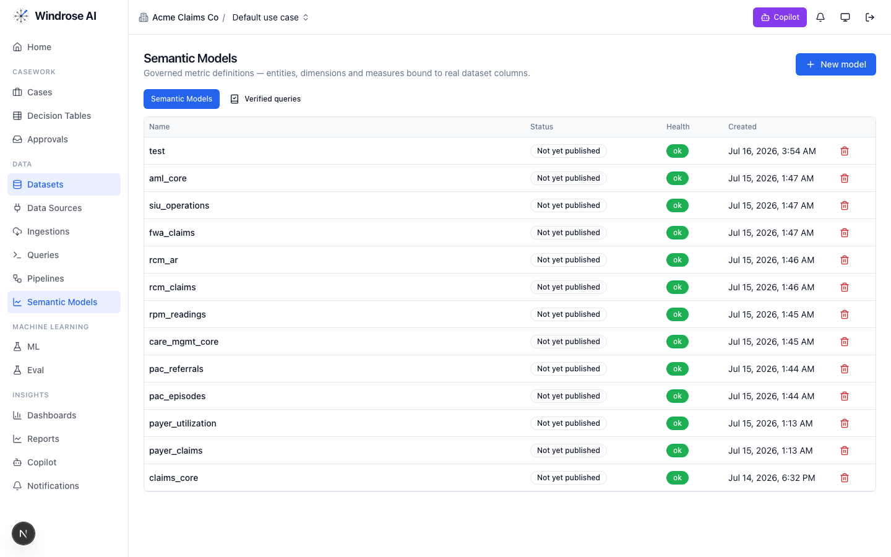
Figure 1. The platform’s Semantic Models surface (models from many installed packs shown). This pack adds: trucking_claims_core.
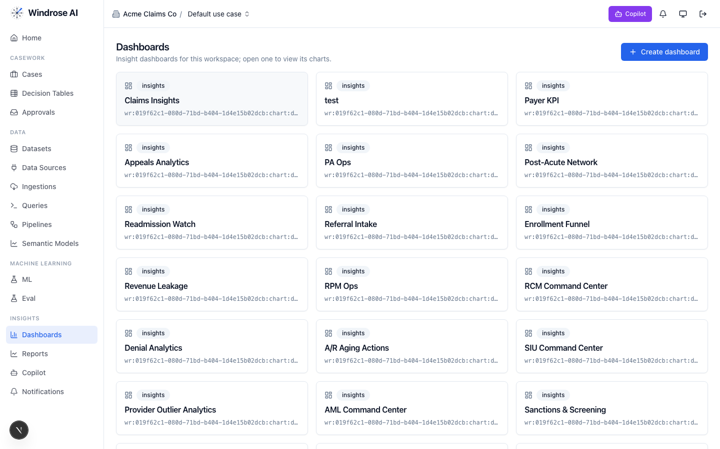
Figure 2. The Dashboards surface. This pack installs: Claims_safety_command_center, Cargo_claims_recovery, Carrier_risk_watch.

4. Agent-by-agent playbook

onboarding 4.1. Bring the data in
The onboarding agent inspects a source and proposes an ingestion config + column mapping, grounded in the connector catalog and a live preview.
- Go to Data → Data Sources → New data source; pick a connector or upload a seed extract.
- Ask it to “onboard this feed as a dataset.” It returns an ingestion.create proposal; a data admin approves; the feed lands ready.

analytics 4.2. Ask the KPIs
The analytics agent answers KPI questions over the governed trucking_claims_core model(s) — read-only, citing the measures it used. From the pack’s own analytics instructions:
Analytics grounding (from the pack)
Answer claims-and-safety KPI questions from the governed semantic model trucking_claims_core: claim_pay_rate, claim_denial_rate, recovery_rate, fraud_escalation_share, coaching_closure_rate, on_time_share, avg_claim_age_days (backlog aging), deadline runway (open_claim_count by deadline_bucket), and the carrier risk posture (watch_tier_carrier_count, insurance_lapsed_carrier_count, high_fraud_risk_carrier_count). Use plain operational language for claims, safety, and compliance staff and always cite the measure names you used. Slice by claim kind, claim type, liability band, severity, deadline bucket, filed month…
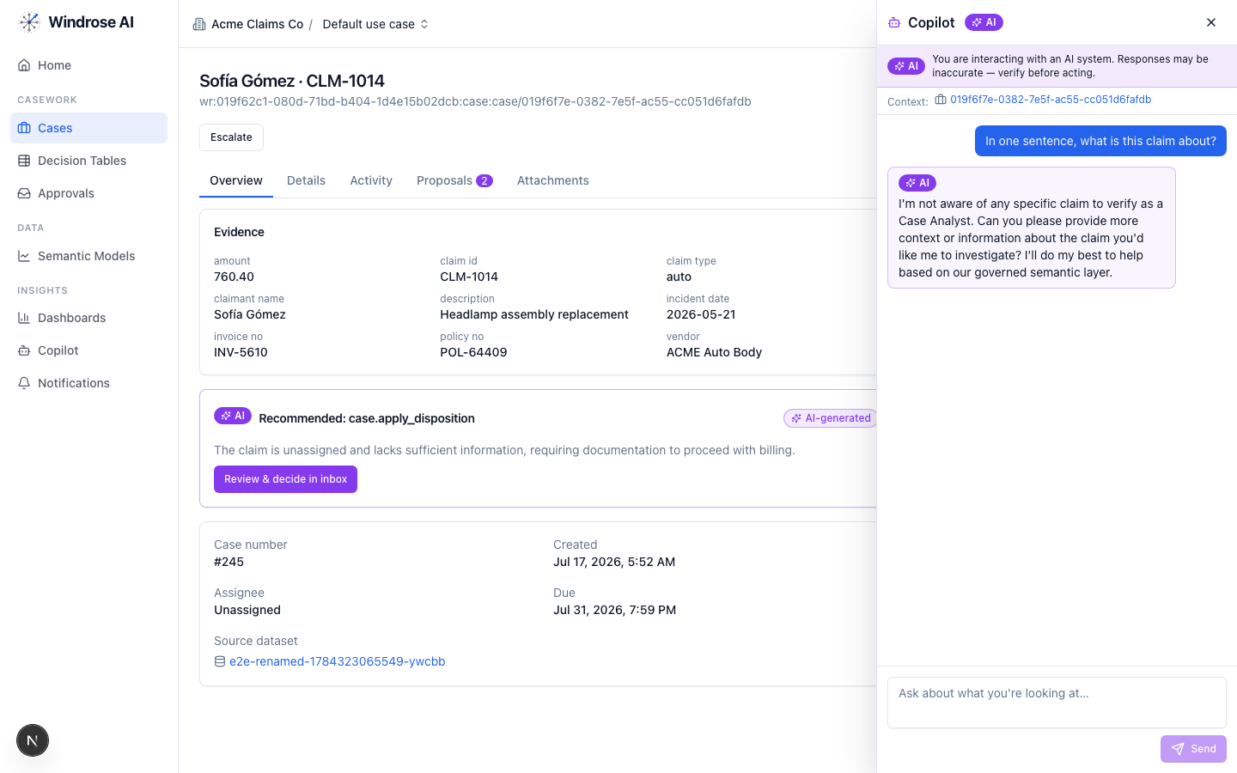
Figure 3. The role-grounded Copilot answering over the governed semantic layer — grounded, never fabricated. The same surface serves this vertical.

dashboard-designer 4.3. Stand up the boards
It proposes a draft dashboard — title + charts bound to real measures/dimensions — grounded in the semantic layer. Ask “design a board for this program”; review the chart.dashboard.create proposal; a director approves (the boards appear as in Figure 2).

model-training 4.4. Propose a shipment-anomaly + claim-outcome model
It turns a plain-language goal into a governed training-run proposal — algorithm, hyperparameters, label/features — grounded in the algorithm catalog and prior runs. The pack ships a real shipment-anomaly + claim-outcome training pipeline.
- Ask “train a shipment-anomaly + claim-outcome model on the panel.” It returns a pipeline.template.create_from_algorithm proposal; approve → the pipeline runs and registers a model.
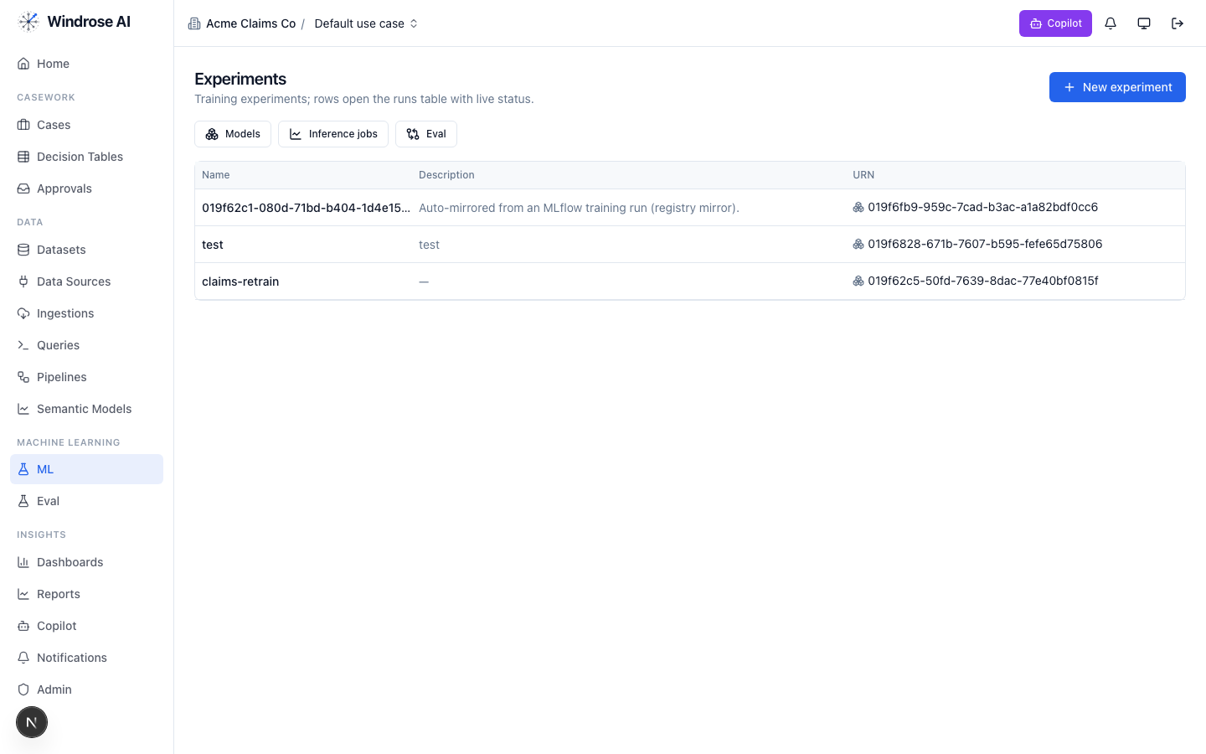
Figure 4. Experiments & the model registry — a pipeline-trained model auto-mirrors here, ready to gate and promote.

ml-engineer 4.5. Build the model for me
The ml-engineer agent runs the whole loop autonomously: inspects the schema, launches candidate models in sandboxed pipeline runs, compares real metrics, and proposes promoting the winner via experiment.model.promote — four-eyes, never promoting directly.

inference 4.6. Score the population
The inference agent proposes a batch scoring job: it resolves the model’s production version, checks input-schema compatibility, and proposes an inference.submit job whose output is a scored dataset the team works from. A human approves before it runs.

case-triage 4.7. The reviewer (the heart of it)
Each queued case (claims_safety_queue) gets a proposed disposition, grounded in the domain rules and citing the exact basis. It never takes the action itself. From the pack’s own triage instructions:
Triage grounding (from the pack)
You triage cargo OS&D claims, telematics safety events, and carrier fraud-vetting items for a motor carrier / freight brokerage under the Carmack Amendment liability framework and standard bill-of-lading terms. Ground every recommendation in the specific row-level evidence — cite claim ids, shipment ids, carrier ids, lanes, amounts, seal and temperature records, and the carrier's history (safety tier, authority age, insurance status, fraud-risk tier, prior claims on the lane). Watch the clocks first: standard bill-of-lading terms give claimants nine months to file a cargo claim and two years to sue after a declination, and claims-handling practice requires timely acknowledgment and resolution — flag any item whose days_to_deadline puts a filing, response, or payment-release decision at risk. Apply Carmack burden-shifting: the claimant's prima facie case is good condition at origin, loss …
The dispositions it proposes
Disposition | Meaning | Category
accept_pay_claim | Accept — pay claim, liability confirmed | true_positive
deny_claim_documented | Deny claim / clear flag — documented findings | false_positive
file_carrier_recovery | File recovery against responsible carrier | other
escalate_fraud_investigation | Escalate to fraud investigation (double-broker / staged-loss watch) | inconclusive
close_coaching_completed | Close safety event — coaching completed & documented | benign
How the team uses it:
- Open Cases — the ranked review worklist. Each row is a queued item with its context.
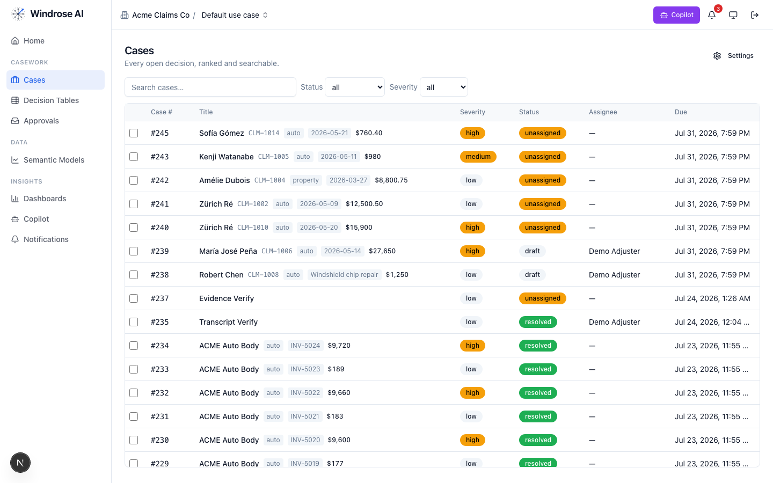
Figure 5. The review worklist surface (claims demo shown; this pack drives the identical surface with its own queue).
- Open an item; the Overview shows the evidence and the AI recommendation citing the rule + source. Open Proposals to see the disposition as a diff.
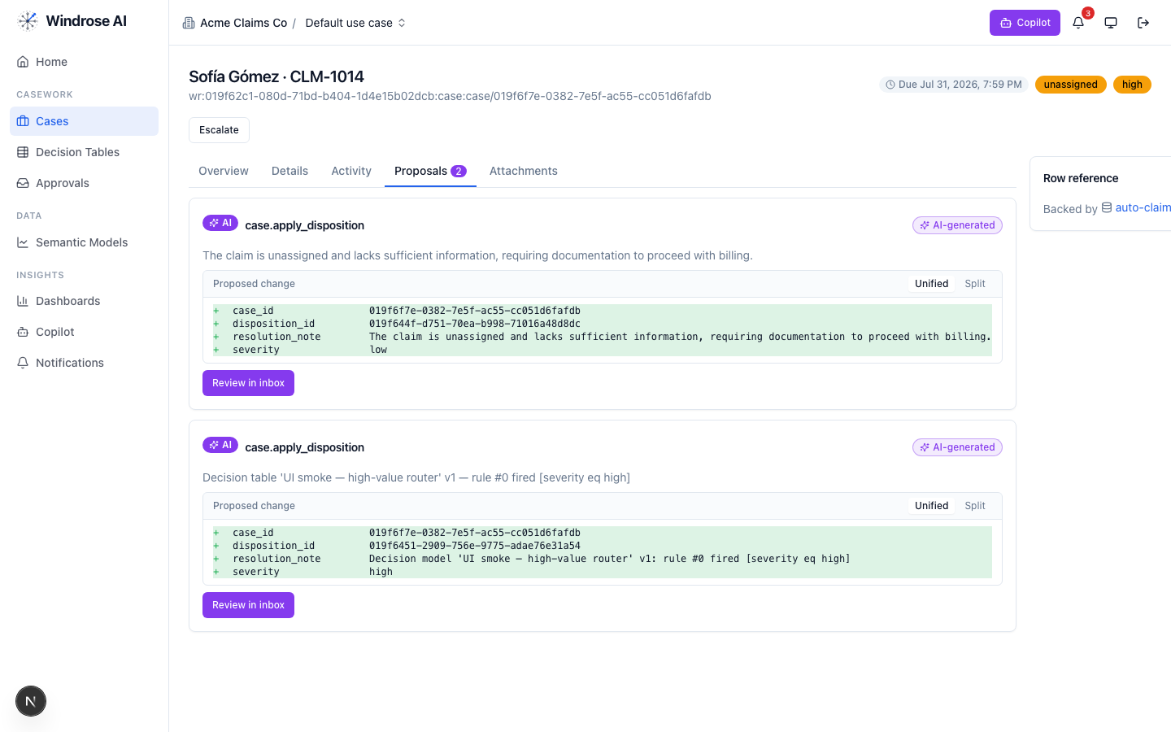
Figure 6. A disposition proposal as a field-level diff — inert until a human approves.
- Approve, edit (the correction becomes training data), or reject with a reason from the Approvals inbox — four-eyes.
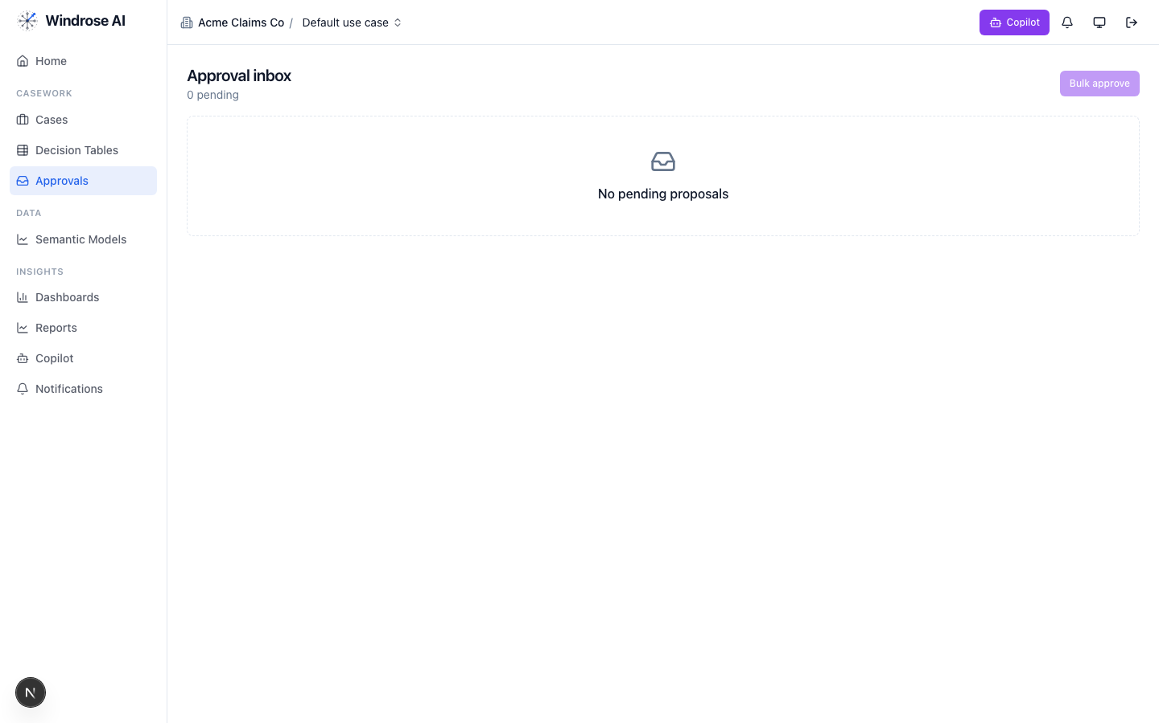
Figure 7. The approval inbox. Every disposition is approved by someone other than the proposer — four-eyes.

governance 4.8. Keep the models honest
The governance agent runs autonomously under its own agent principal; when a model drifts or corrections pile up past threshold it opens a mlops.open_retrain proposal with the evidence summarised. A director approves.

meta-router 4.9. The team’s front door
The meta-router takes a free-text request, classifies it, and delegates to the right specialist — analytics for a question, case-triage for a queued item, ml-engineer for a model. Everything still flows through the same proposal + approval gate.

5. The operating cycle

Governed automation is real
Decision tables let you encode deterministic rules that propose a disposition for approval — never decide autonomously — alongside the agents.
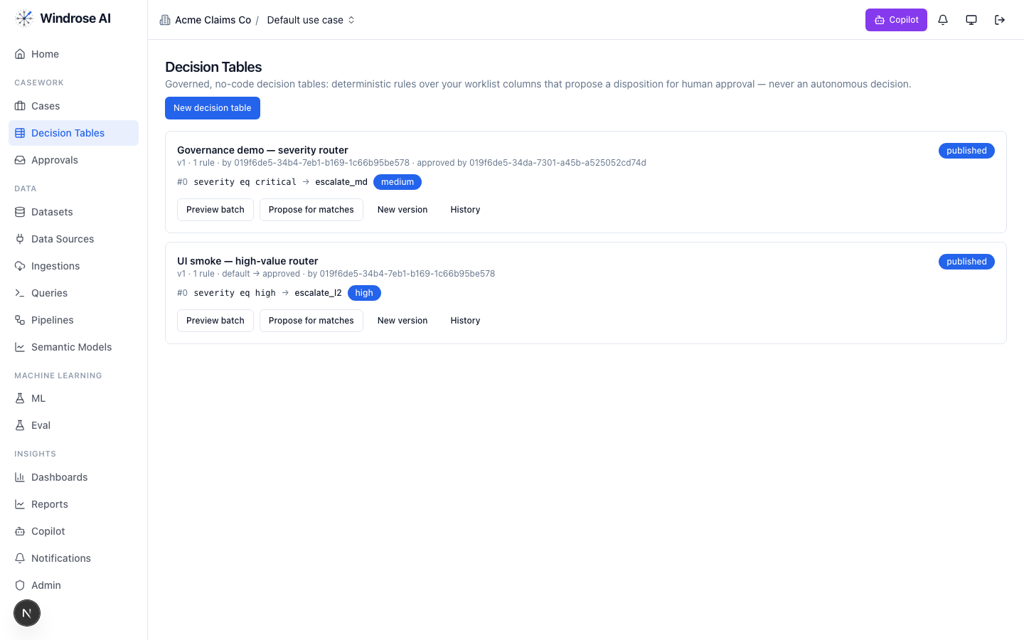
Figure 8. Governed decision tables: deterministic rules that propose a disposition for human approval, versioned and approved by a named user.

6. Governance & the eval gate
- No autonomous action. Every consequential step is a human-approved proposal (four-eyes).
- Rules as grounding. The domain’s regulatory rules are retrieved as grounding the agents must cite (carmack_amendment, cfr49_part370, fmcsa_csa, bill_of_lading_terms).
- Eval-gated models. A model is promoted only after passing its eval suite; rollback = demote.
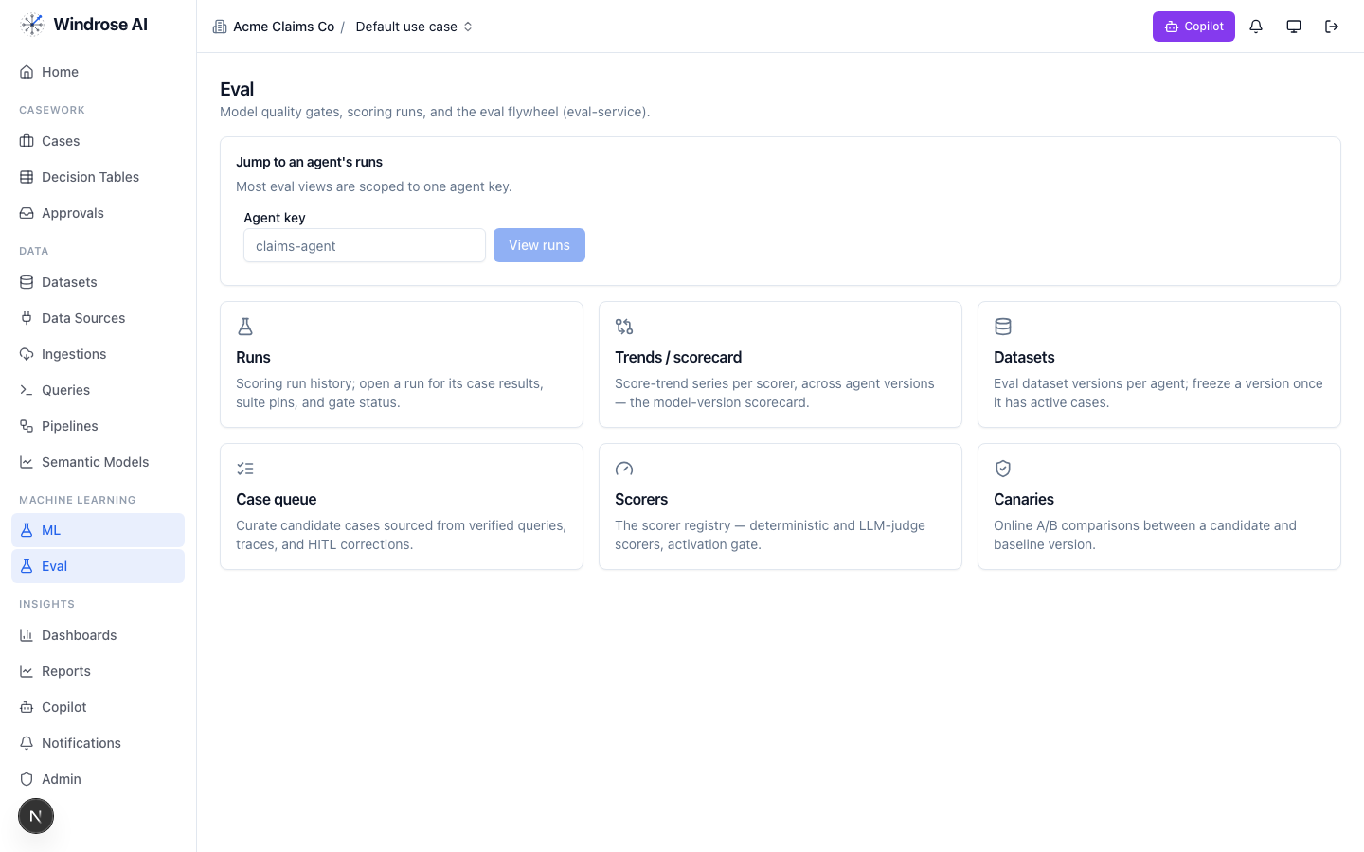
Figure 9. The eval flywheel — the promotion gate for this vertical’s models: runs & gates, scorers, and canary A/B.

7. What is live today vs pack-service-deferred
In the spirit of no-fake: what Core materialises today is live; the rest is recorded in the install ledger as deferred, with the proposal-mode + four-eyes guarantees already holding. Nothing is stubbed.
Capability | Status
Semantic models (trucking_claims_core), dashboards, saved/verified queries | Live
Review case queue + disposition taxonomy + role catalog | Live
case-triage + analytics specialised to this domain (rule grounding) | Live
shipment-anomaly + claim-outcome training pipeline | Live
Deferred to pack-service: guardrails, agent_recipes, connection_templates, write_adapters, eval_sets, ontology, case_schemas, model_archetypes, display_labels | Deferred → served today via config + seed data; guarantees hold

Grounded in the real trucking-claims pack (its own pack.yaml, dispositions, roles, and agent instructions). The domain-asset captions name this pack’s real models/dashboards; agent-surface screenshots are the shared, pack-agnostic surfaces (claims demo shown) — this pack drives the identical surfaces with its own data. Where a capability awaits pack-service, this playbook says so.

