Ideation Phase
Brainstorm & Idea Prioritization Template

Date | DECEMBER, 2025
Team ID | LTVIP2026TMIDS84701
Project Name | Online Payments Fraud Detection using ML
Maximum Marks | 4 Marks
Team Members
- M Chaithanya (23BFA05L28)
- Pavan Sai Varma Konduru (23BFA05L17)
- V Vinay Karthik Reddy (22BFA05450)
- Vundrakonda Satyanarayanacharyulu (22BFA05452)

Brainstorm & Idea Prioritization:

Brainstorming provides a free and open environment that encourages everyone within a team to participate in the creative thinking process that leads to problem solving. Prioritizing volume over value, out-of-the-box ideas are welcome and built upon, and all participants are encouraged to collaborate, helping each other develop a rich amount of creative solutions.

Mural Link (Brainstorming) https://app.mural.co/t/atgsworkspace2758/m/atgsworkspace2758/1697613685502/8d94fdae546f3e85faa57 e0e0eb2532a7b52d5a8?sender=u6662b8c63e5c4dfa94ac8405

Step-1: Team Gathering, Collaboration and Select the Problem Statement
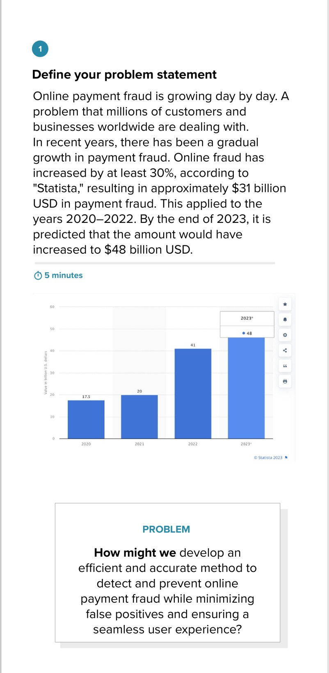

Step-2: Brainstorm, Idea Listing and Grouping
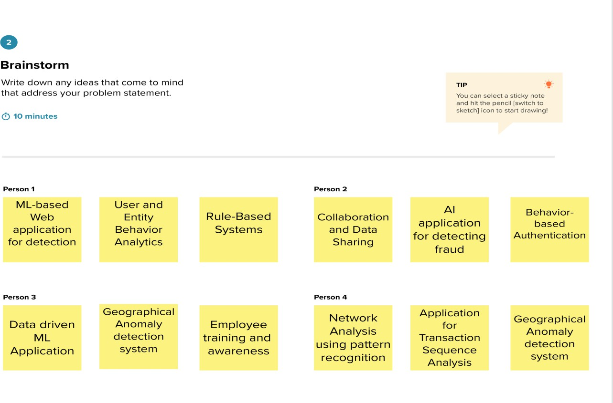

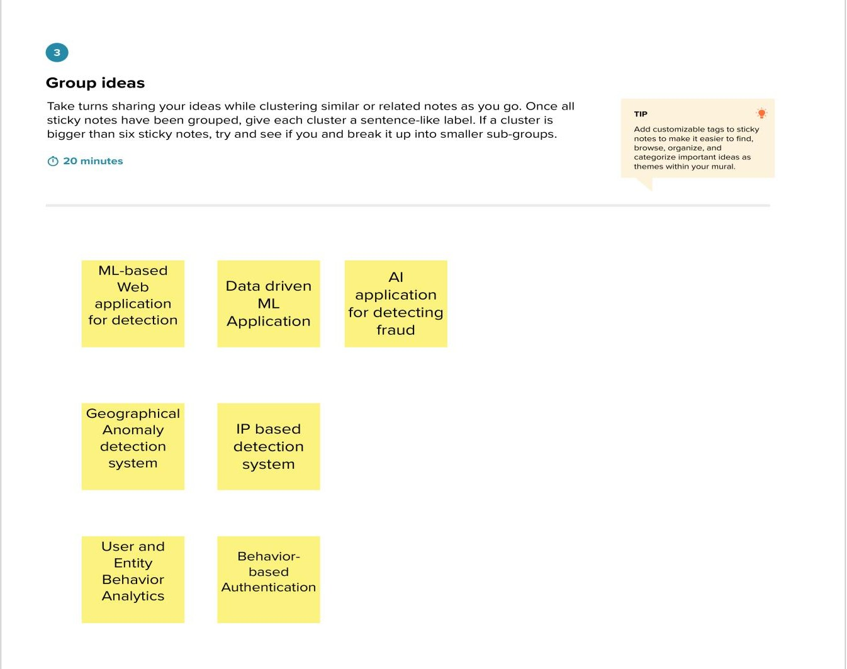

Step-3: Idea Prioritization

