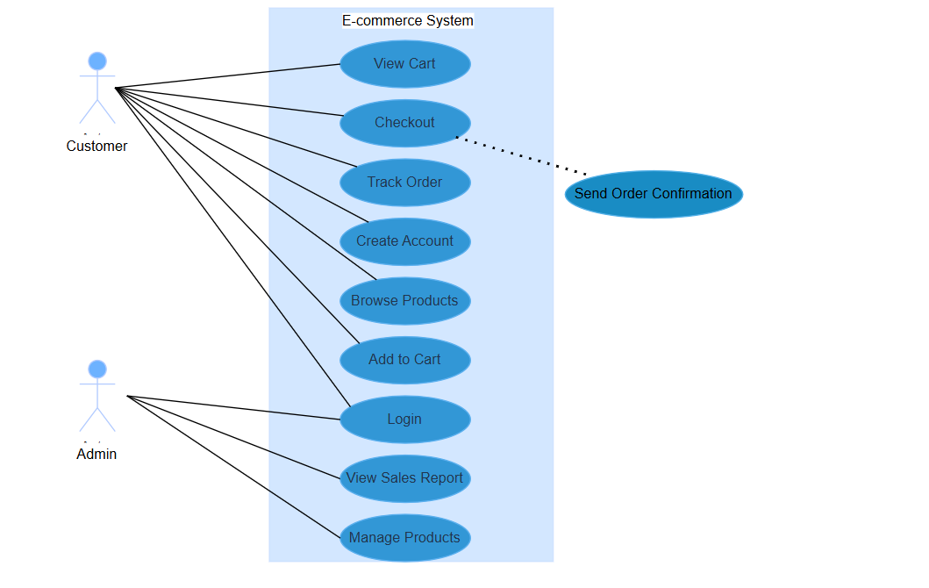

**Use Case Diagram:** This diagram illustrates the high-level functionalities of the e-commerce system from the perspective of external actors (Customer and Admin). It shows what each actor can do within the system, such as creating an account, browsing products, managing products, and viewing sales reports.

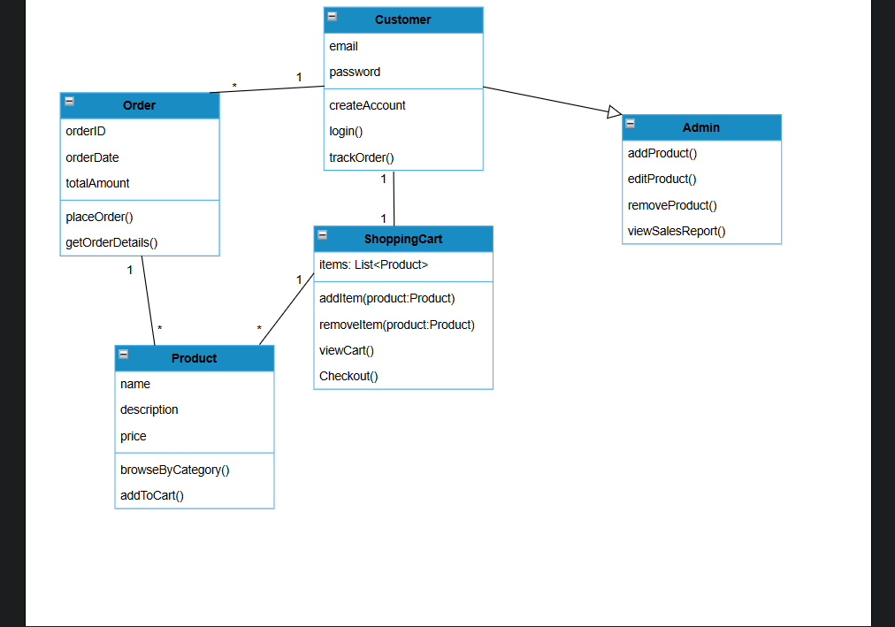

**Class Diagram:** This diagram provides a static view of the system by showing the main classes and their relationships. It details the attributes (data) and methods (operations) of each class, such as Customer, Product, Order, Admin and ShoppingCart, and how they are connected to each other.

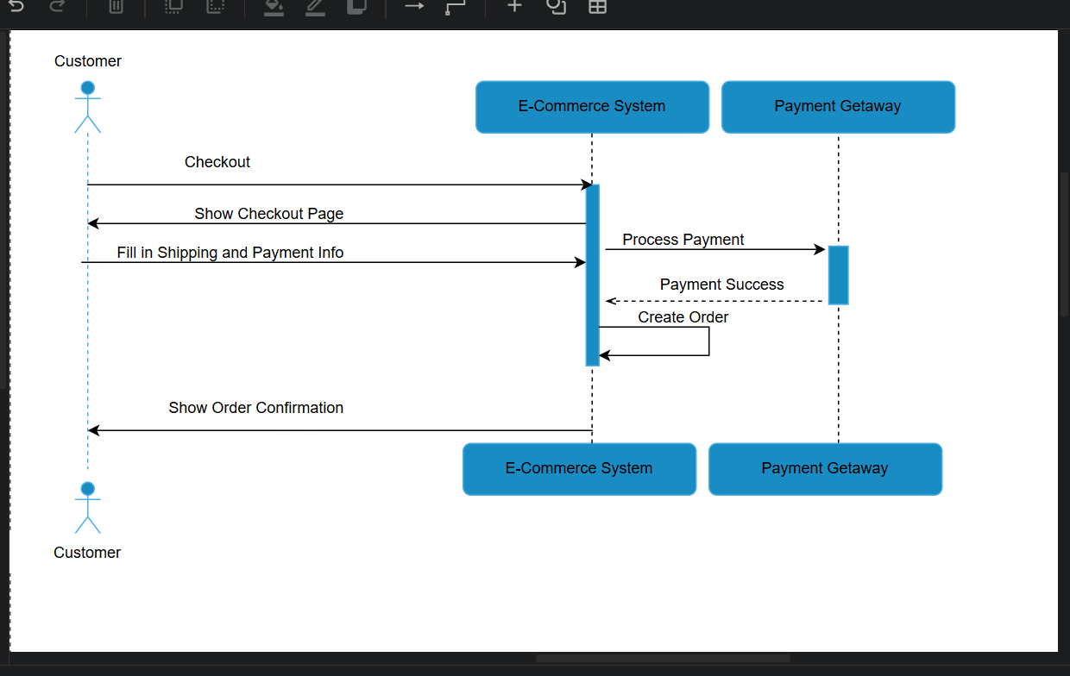

**Sequence Diagram — Checkout:** This diagram shows the interaction between the Customer, the E-commerce System, and the Payment Gateway during the checkout process. It illustrates the sequence of messages exchanged between these components to complete a purchase, from initiating the checkout to receiving an order confirmation.

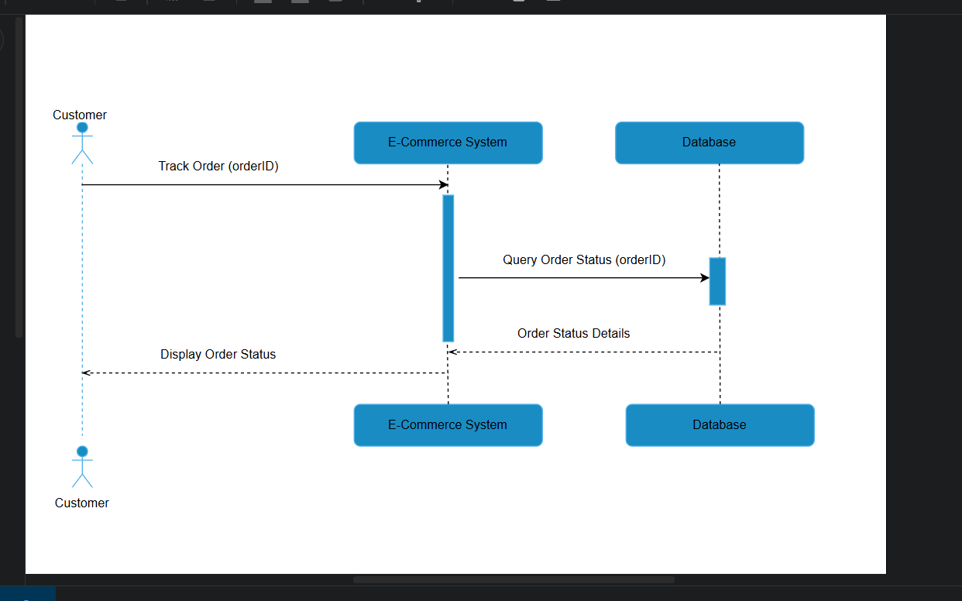

**Sequence Diagram — Order Tracking:** This diagram illustrates the interaction between a Customer, the E-commerce System, and the Database when a customer tracks an order. It shows the flow of information from the customer's request to the system querying the database for order status and then displaying the details back to the customer.

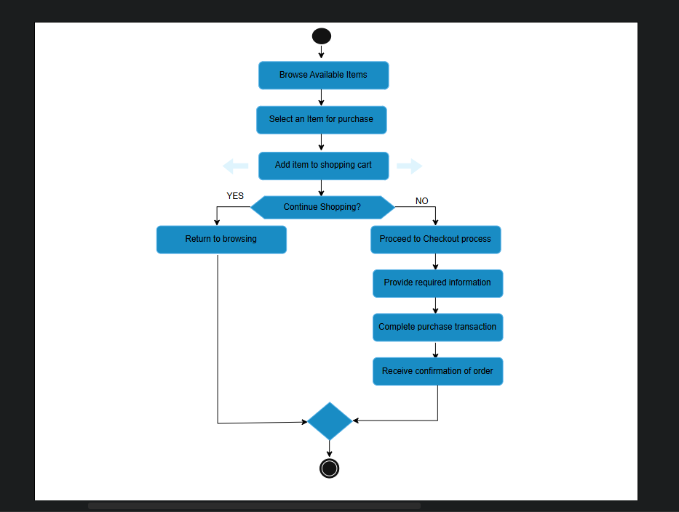

**Activity Diagram — Customer Purchase:** This diagram models the workflow of a customer making a purchase. It shows the flow of activities from browsing products, adding items to the cart, proceeding to checkout, and finally placing an order. It provides a step-by-step view of the customer's journey.

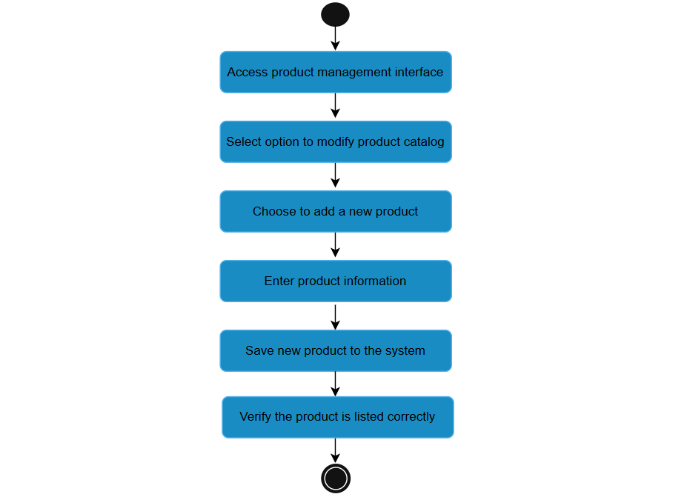

**Activity Diagram — Admin Product Management:** This diagram illustrates the workflow for an administrator managing products in the e-commerce system. It shows the sequence of actions from logging in, navigating to the product management section, adding a new product with its details, and verifying its addition to the product catalog.