**BIT504 Assignment 2**

Anne-Lise Mornard  
Student #5018797

**Task C: Using GitHub**

Please find my GitHub repository at <https://github.com/Gisele732/BIT504_AT2_TaskB>

1. Create a new repository and name it BIT504_AT2_TaskB

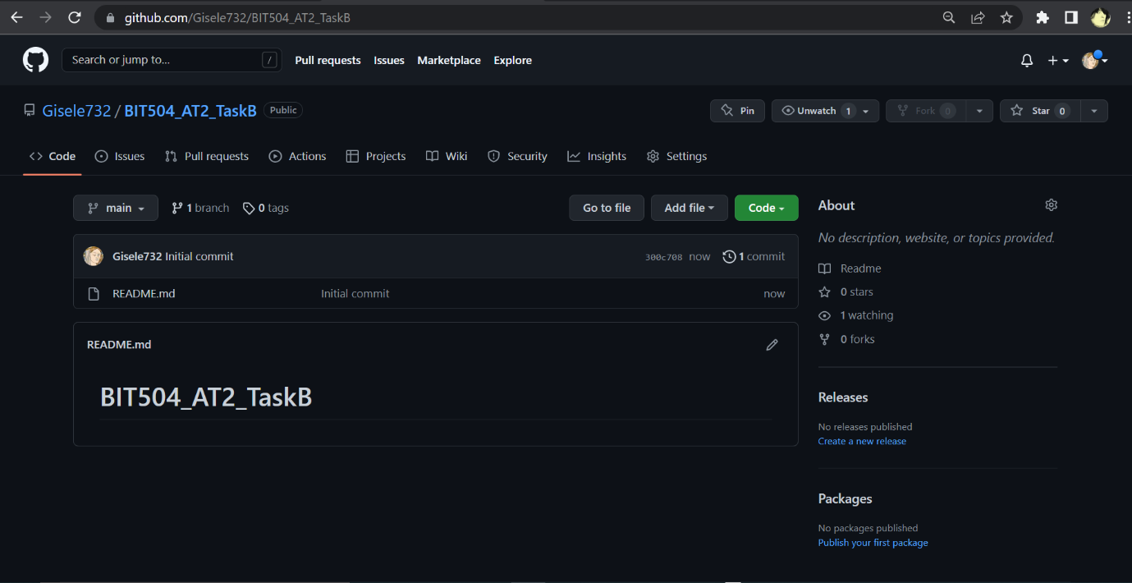

1. Upload a Java project

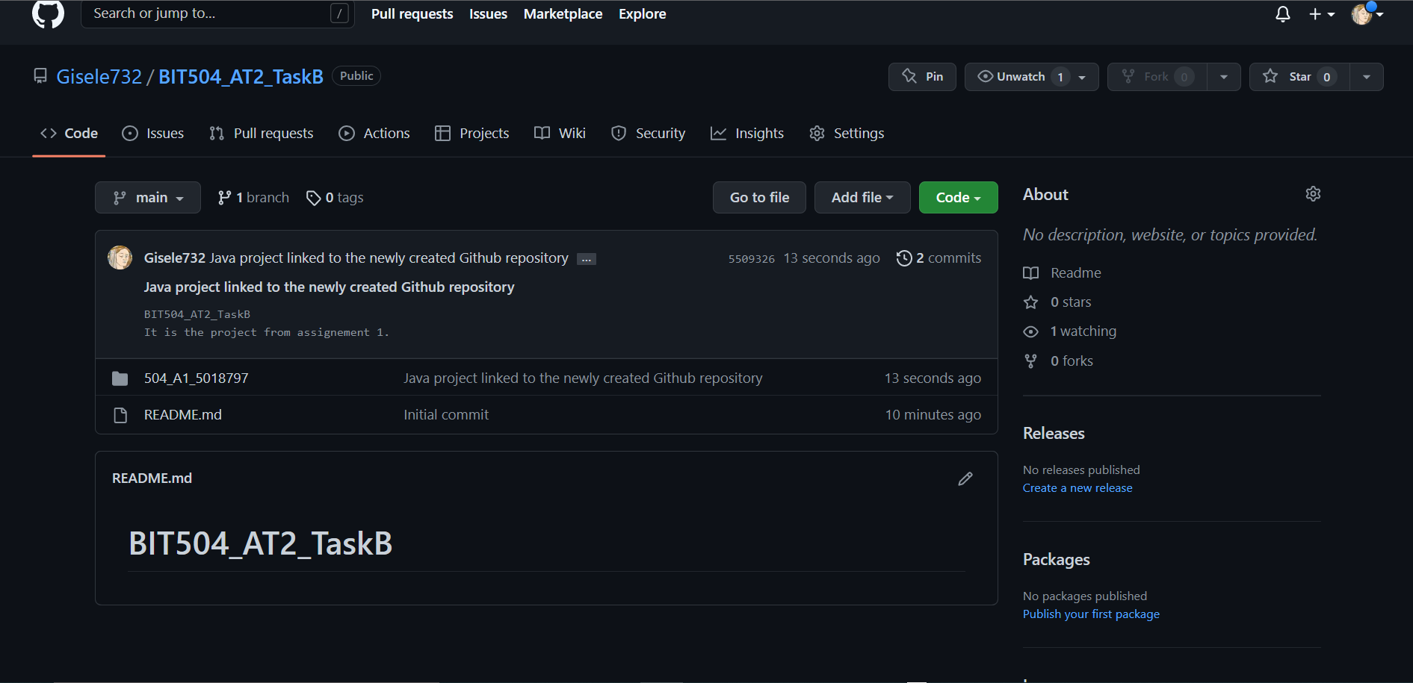

1. Make changes to the project and commit them to a new branch called experiment_1

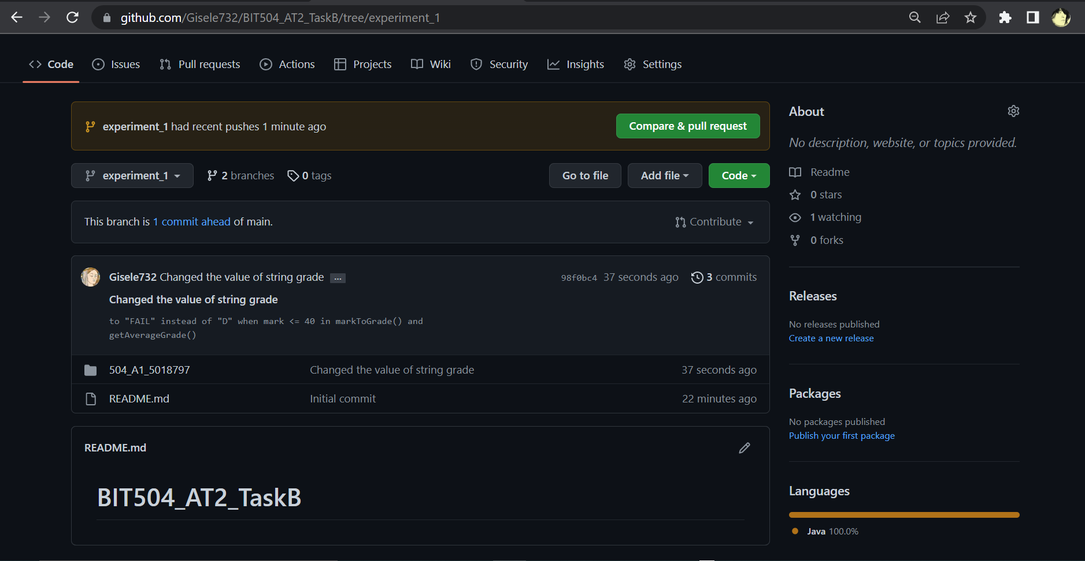

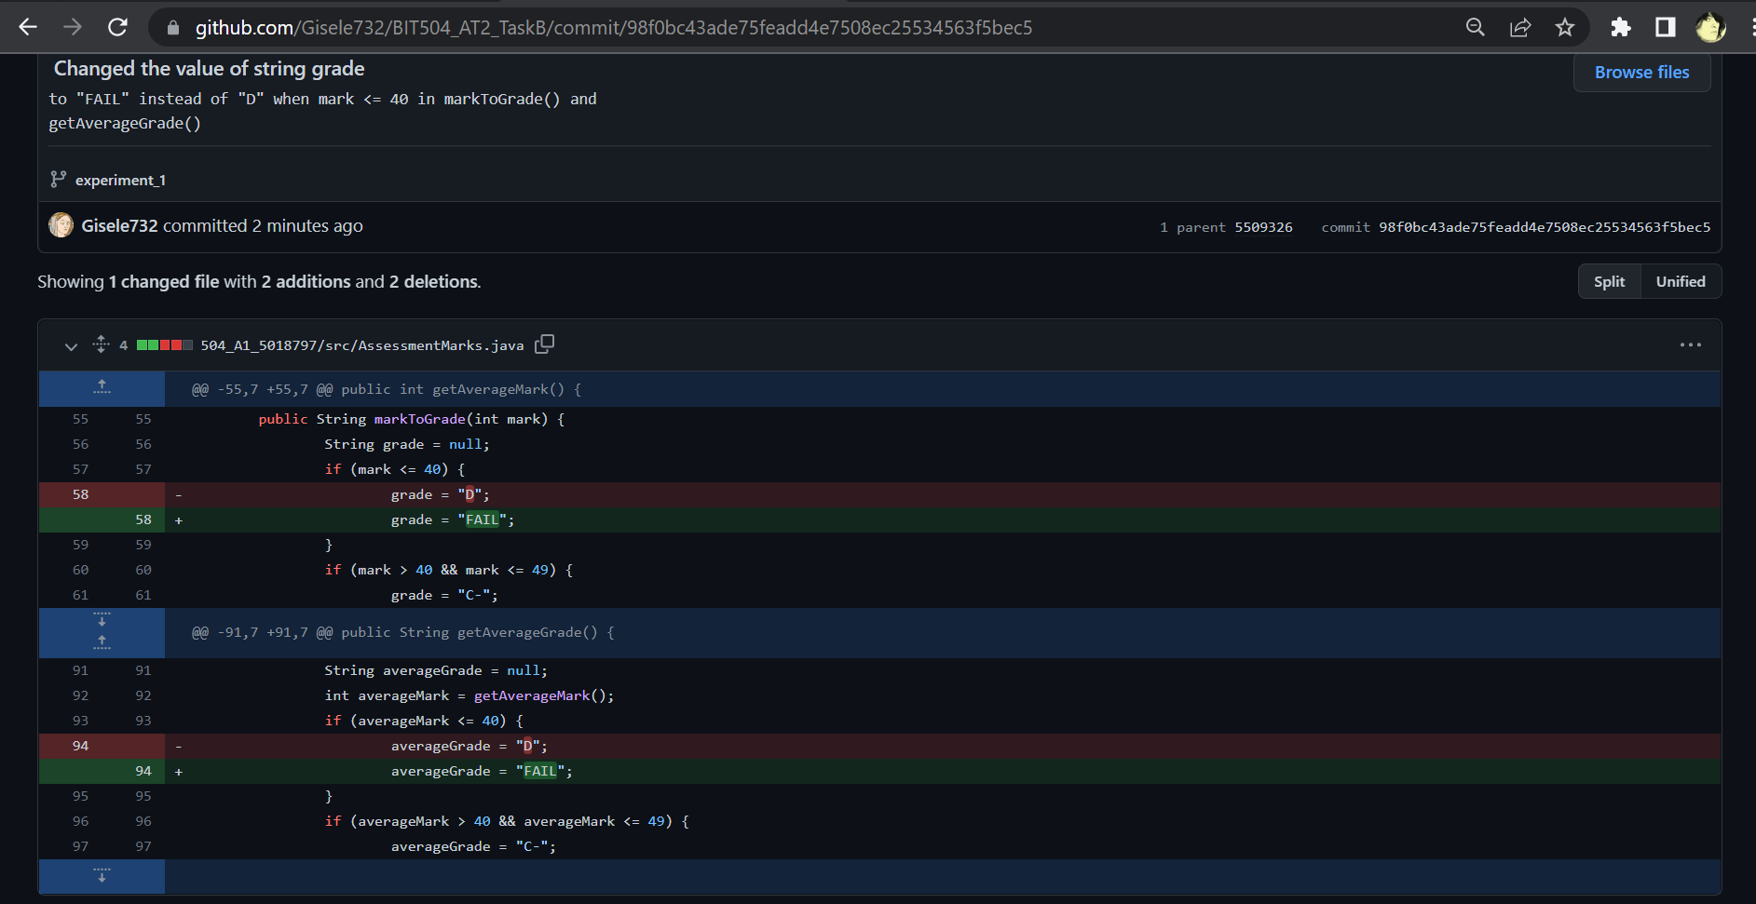

1. Make further changes to the project and commit them to a second branch called experiment_2

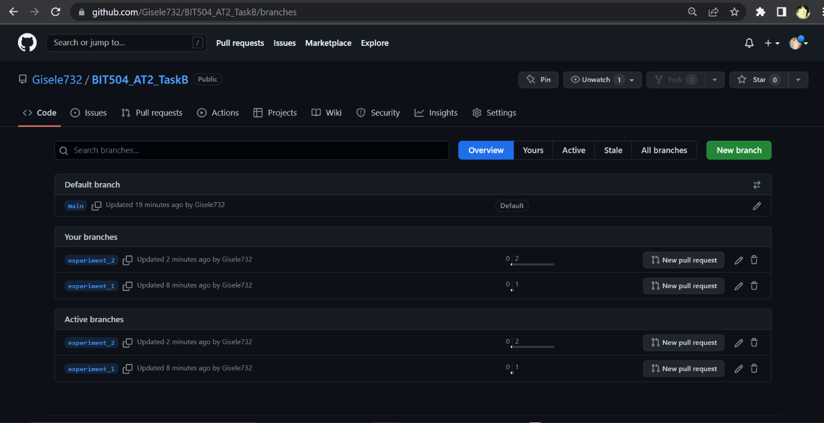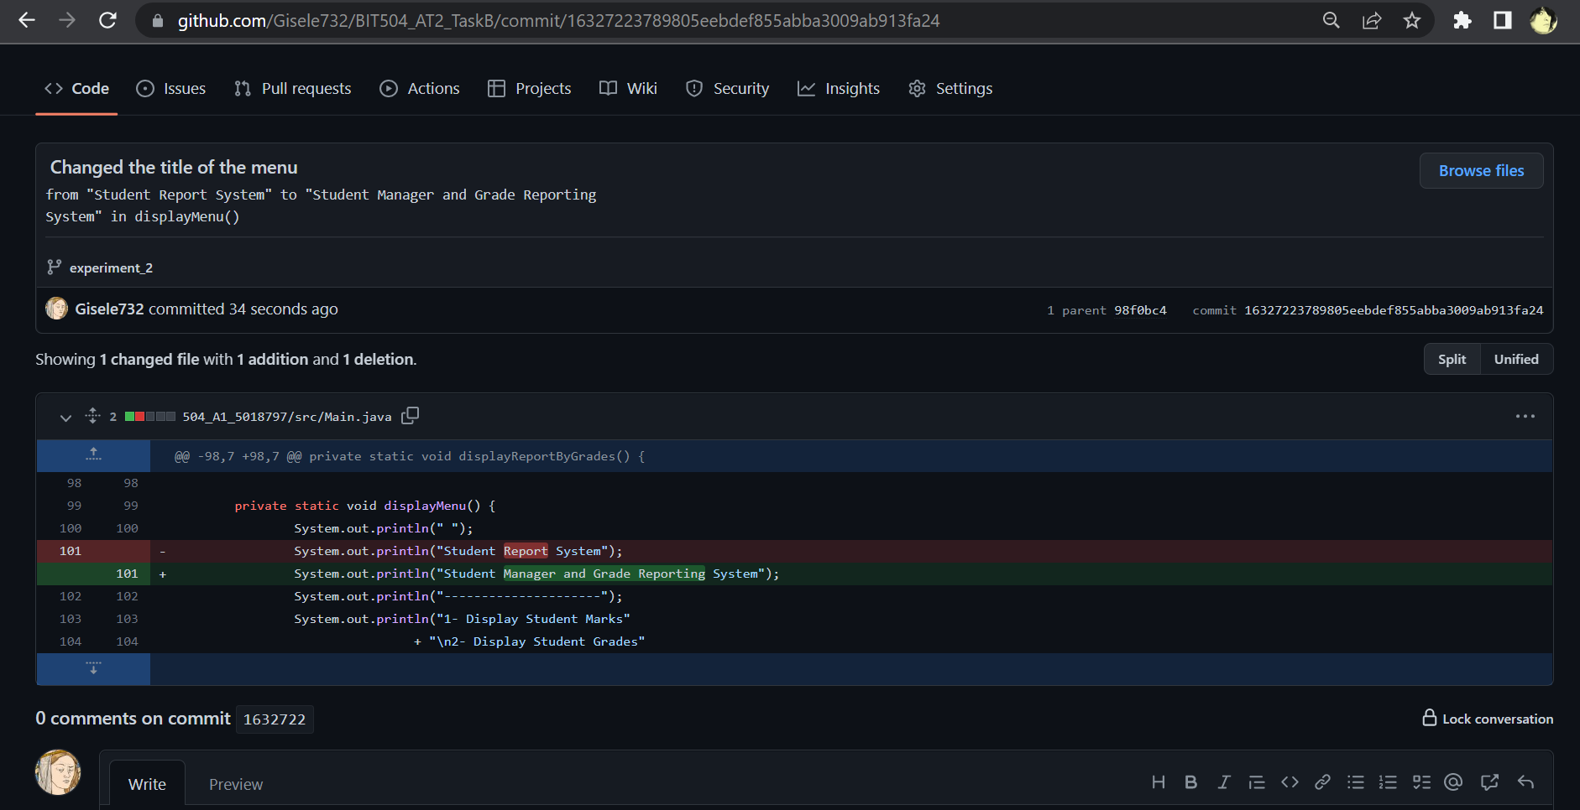

1. Merge the pull requests into the main branch

