**ENG-110S TIP Assignment #1: Questioning and Rhetorical Analysis**

***Note*: There are two parts to this assignment. Complete both parts before submitting.**

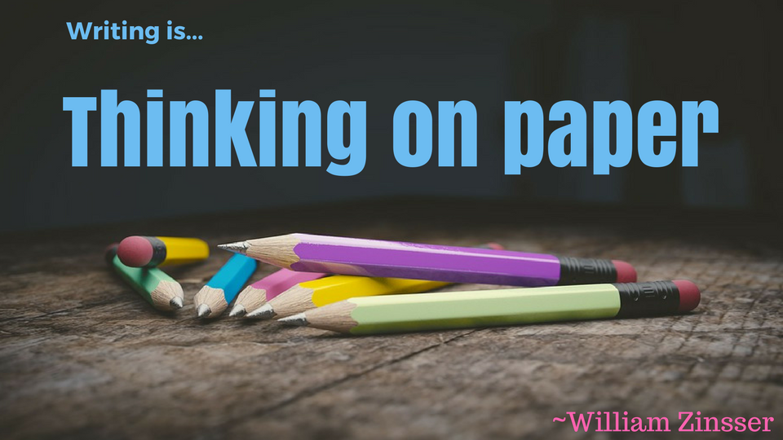

**Part One—What do I really think about this topic right now?**

Part One of this worksheet asks you to apply what you’ve learned about asking yourself, “What do I really think?” and then challenges you to apply what you learned about asking questions to think critically.

Before we dig deeper into research about a topic, we must be honest with ourselves. Take a deep breath and close your eyes. Repeat this phrase out loud three times, “I have an opinion, but I am not my opinion.” (This helps to calm our emotions before writing and remind us that our identities as human beings are much more than our opinions; we need not feel threatened by questioning our own opinions but instead very excited to see what new information we can find out). When you open them, write 200 words about your opinion on one of the topics below. (Although you may use your opinions, please use professional writing including complete sentences and proofread carefully for grammar and spelling).

**Mark an X next to your topic of choice:**

[ ] Prisons run by private for-profit companies

[ ] Legalization of marijuana

[x] Gun control

[ ] Housing assistance for the mentally ill

[ ] U.S. aid/weapons/troops to other countries asking for assistance in times of war

[ ] Paid maternity leave

**Write your honest opinion about this topic in your own words here (200 words minimum):**

|  |
| --- |
| I chose gun control because it is a topic I am familiar with. I have done research about it in previous cases and I have found a lot of ironic and interesting facts about it.  I personally am a mostly neutral writer and have written both in favor and against this one. If I’m given to choose a side however, I will always side against gun control. Simply and plainly because there are many many many cases in which it is proven useless or counterproductive- or both, and most certainly biased in many ways because they are widely based on either assumptions or generalizations.  My favorite piece of evidence in this matter is the example of California’s gun control laws. Maybe it has changed from what it was before, but 2 years ago when I researched it last it remained as remarkably the strongest system of gun control (aka, the hardest to get a gun permit on).  Nothing special though. The good parts come from pointing out that it is also the one with the highest rates of deaths by gunshot.  It doesn’t end there – the majority of these cases are non-accidents. Normal for murderers, right?  Probably would be, if the majority of these were not also by individuals with the license/permit with registered and approved guns who had passed from the whole process that included psychological exams and training certifications in handling guns.  SO – if that is not quite ironic, then I do not know what ironic means. |

**Questioning**

Write your own questions for yourself about at least 3 of your sentences (at least three, but don’t feel like you need to stop there). To help you get started, which words that you used might be defined in different ways by different readers (recall from Chapter 1 that words like “support” or “danger” can be interpreted in many ways)? What do you think your readers might want more information about? Where do you see opportunities to add more details? Where do you see places that you might want to explain how you formed this opinion? Where do you see a place that you don’t have a lot of facts yet?

Question 1: If I was to use the mentioned piece of evidence, the first thing that is to be pointed out is: What is the current state of those statistics?

Question 2: How can these laws be biased, generalizing, or assuming?

Question 3: If those are the cons what is a pro you (I) would give to gun control?

Question 4 (optional):

Question 5 (optional):

**Part Two—What have others said about this topic?**

People do rhetorical analysis whenever they want to understand the way an idea is presented to them. Rhetorical analysis involves taking apart or breaking down a text. Separation of the parts from the whole enables understanding and evaluating how the strategies being used work together to achieve the text’s purpose. First, you read the text to understand its purpose: to explain an idea, to share information, to convey a feeling or emotion, to argue a position – whatever you think the text was created to do. Second, you read the text to see how it works: for example, its tone, choice of words and kinds of sentences, the emotion created, the context implied, or the relationship to the audience.

This helpful “Anatomy of a Rhetorical Analysis” graphic below comes from p. 518 of your textbook:

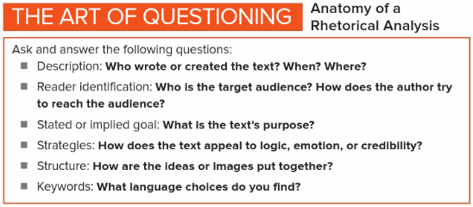

Use this “Anatomy of a Rhetorical Analysis” along with Chapter 27 of your textbook to perform an analysis on one of these articles: (you don’t have to stick with the topic you chose in Part 1, but you can)

**Mark an X next to the article you read:**

[ ] <https://www.nytimes.com/2018/02/25/opinion/america-is-the-gun.html>

[ ] <https://www.nytimes.com/2018/02/16/opinion/paid-family-leave-trump.html>

[ ] <http://civilrights.findlaw.com/other-constitutional-rights/private-jails-in-the-united-states.html>

[ ] <https://www.nami.org/Find-Support/Living-with-a-Mental-Health-Condition/Securing-Stable-Housing>

[ ] <http://www.phoenixnewtimes.com/news/arizonas-week-in-weed-cannabis-legalization-campaign-submits-signatures-more-foes-emerge-8427650>

|  |
| --- |
| **Description: Who wrote or created the text? When? Where?** |
| Charles M. Blow, Feb 25th, 2018.  If by where you meant the website: The New York Times |
| **Reader identification: Who is the target audience? How does the author try to reach the audience?** |
| **All of America.**  **The author is using a combination of pathos, ethos and logos through the article.** |
| **Stated or implied goal: What is the text’s purpose?** |
|  |
| **Strategies: How does the text appeal to logic, emotion, or credibility?** |
| 1. He points out how Dickey’s amendment was illogical (even to Dickey’s opinion itself) 2. No other point was most critical to emotion than this one: “By the way, the Post estimates that this would put 718,000 guns in our schools and could put hundreds of millions into the coffers of gun makers.” And at the same time also calls out to logic because it is a quite ironic point to highlight. 3. Several links and references pointing to the sources he was referring to. |
| **Keywords: What words in the text stood out to you? Include a few words or quotes that made you think or change your mind about the topic.** |
| The conclusion bought it for me most.  While I have analyzed this topic in several different occasions, I have been undermining the fact he highlighted – the fact that guns are scared into the American culture and spirit. |

Who knows what you’ll discover about this topic next? Stay curious! ☺



Save this document and submit it when complete.