**CSCC01 Fall 2016**

**Table of Contents:**

1. Cover Page……………………………………………………. 1
2. Biography……………………………………………………… 3
3. Team Goals…………………………………………………… 8

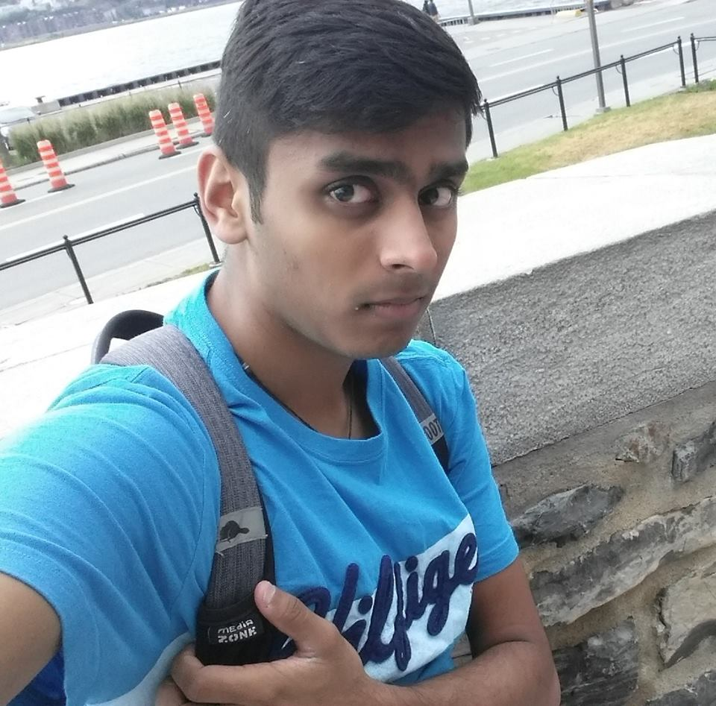

My name is Harshil Patel; I am a 3rd year student at University of Toronto studying Software Engineering. I always had a strong interest towards computers and their software. I tend to be very curious when it comes to analyzing a software, which is why I chose to be in the field of Computer Science. Coding is one of my favourites things to do, I have experience working with Java, Python, C, Assembly, bash and a bit of HTML. I also like to do other things outside of school work and coding, which includes outdoor physical activities. In my free time, I head outside and look to play cricket, basketball, flag football and swimming. I am very outgoing and an approachable person, I always look to start a conversation and make new friends. At the end of the day, I always look to have fun and enjoy every second of my life.

