**CSCC01 Deliverable 4**

Team Sierra

Venkat Korapaty  
Amine Benaicha   
Gisho Pushaparajah   
Muneeb Khan  
Harshil Patel

Contents

Product Backlog 3

John 3

Alice 4

Release Plan 4

Deliverable 5 Overview/ Sprints 5

Sprint 5 5

Sprint Backlog 5

Iteration plan 6

Task Board 6

Burndown Chart 7

Sprint 6 8

Sprint Backlog 8

Iteration plan 8

Task Board 9

Burndown Chart 9

System Components: 11

Changes to design: 12

Code Inspection: 13

Project Overview 15

# Product Backlog

## John

1. I John, a researcher, want the program to extract information about exoplanets and their systems from the other catalogues (NASA and exoplant.eu) and convert them into the structure of the OEC so they can be added to the OEC.

**Priority: High, Cost: 8**

1. I john, a researcher, want the program to determine if an exoplanet/system is new and needs to be added or already exists and can be updated/merged in the OEC.

**Priority: High, Cost: 22**

1. I John, a researcher, want to be able to manually update the catalogue by running the program through the command line, by calling a command on a terminal to initiate the updating/merging process.

**Priority: High, Cost: 6**

1. I John, a researcher, want to be shown all new additions and changes made to pre-existing entries in the OEC when manually merging with other catalogues.

The planets/systems that were added should be listed, as well as the old and new values for any field/value of a pre-existing planet/system that was updated.

**Priority: High Medium, Cost: 14**

1. I John, a researcher, want to be able to resolve individual conflicts when merging, by being shown the two versions and being prompted (in the terminal) to choose which version of the conflict to merge into the OEC.

**Priority: Medium, Cost: 17**

1. I John, a researcher, want to be able to configure how often (in days) the program runs automatically to attempt to merge/update the OEC.

**Priority: Medium, Cost: 12**

1. I John, a researcher, want to be notified by email of conflicts when an automatic merge occurs, so I can manually go in and choose which conflicts to merge.

**Priority: Low Medium, Cost: 12**

1. I John, a researcher, want to get a report by email after an automatic merge, containing the changes and additions made to the OEC. It should list all the planets and their systems that were added and updated. It should also list what was changed for planets/systems that were updated.

**Priority: Low, Cost: 8**

1. I John, a researcher, want the git repository to be updated with a successful merged catalogue, by pushing the updated catalogue onto the repo, so that I have a log of all merges/changes made to the OEC.

**Priority: Low, Cost:10**

1. I John, a researcher, want the new changes when merging to match the units and format of the OEC.

**Priority: Low, Cost: 14**

## Alice

1. I Alice, a professor, want the application to regularly run automatically so that the catalogue can stay up to date.

**Priority: Low, Cost: 5**

1. I Alice, a professor, want the merge to automatically solve any conflicts and apply the changes without my input by either choosing my conflict or their conflict for every conflict.

**Priority: Low, Cost: 5**

# Release Plan

Each sprint will be 1 week, from Monday to Sunday.

* Sprint 1 (Oct 17th – Oct 23rd): John user stories 1, 3
* Sprint 2 (Oct 24th – Oct 30th): John user stories 2, 5
* Sprint 3 (Oct 31st – Nov 06th): John user stories 2, 10
* Sprint 4 (Nov 7th – Nov 13th): John user stories 2, 10
* Sprint 5 (Nov 17th – Nov 23rd): John user stories 10, 4, ~~7~~, 9
* Sprint 6 (Nov 24th – Nov 30th): John: ~~8~~, 6 AND Alice user stories 1, 2

# Deliverable 5 Overview/ Sprints

During the course of this deliverable, we completed user stories 10, 4, 9, 6 and (Alice)2. We decided that user stories 7 and 8 were not feasible within the scope of our project, and we were not able to complete Alice user story 2. Nearing the end of the semester, many assignments and other course work was due, making it difficult to stay on schedule. Upon reflection, our sprint planning and project velocity should have taken into account the work load of other courses. In a working environment, this wouldn’t be as big of a problem since allocations and schedules are much more predictable.

## Sprint 5

### Sprint Backlog

I John, a researcher, want the new changes when merging to match the units and format of the OEC.

**Priority: Low, Cost: 14**

I John, a researcher, want to be shown all new additions and changes made to pre-existing entries in the OEC when manually merging with other catalogues.

The planets/systems that were added should be listed, as well as the old and new values for any field/value of a pre-existing planet/system that was updated.

**Priority: High Medium, Cost: 14**

I John, a researcher, want the git repository to be updated with a successful merged catalogue, by pushing the updated catalogue onto the repo, so that I have a log of all merges/changes made to the OEC.

**Priority: Low, Cost:10**

### Iteration plan

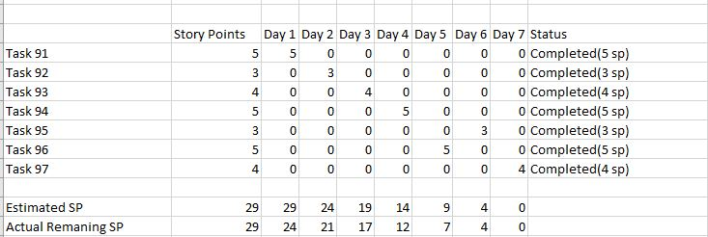

Project Velocity: 29

### Task Board

Start:

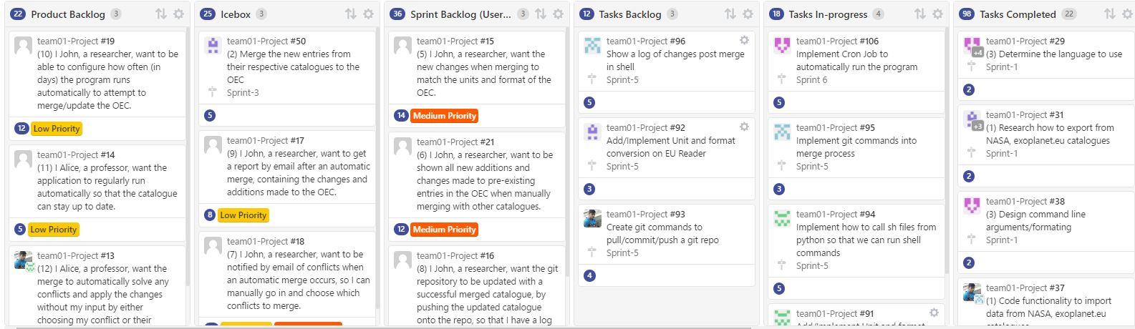

End: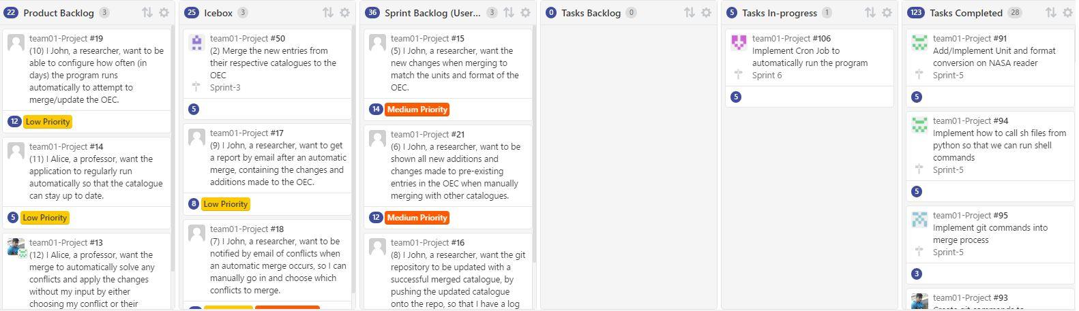

### Burndown Chart

Start:

End:

## Sprint 6

### Sprint Backlog

I John, a researcher, want to be able to configure how often (in days) the program runs automatically to attempt to merge/update the OEC.

**Priority: Medium, Cost: 12**

I Alice, a professor, want the application to regularly run automatically so that the catalogue can stay up to date.

**Priority: Low, Cost: 5**

I Alice, a professor, want the merge to automatically solve any conflicts and apply the changes without my input by either choosing my conflict or their conflict for every conflict.

**Priority: Low, Cost: 5**

### Iteration plan

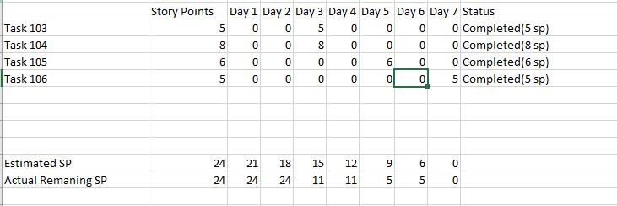

Project Velocity: 24

### Task Board

Start:

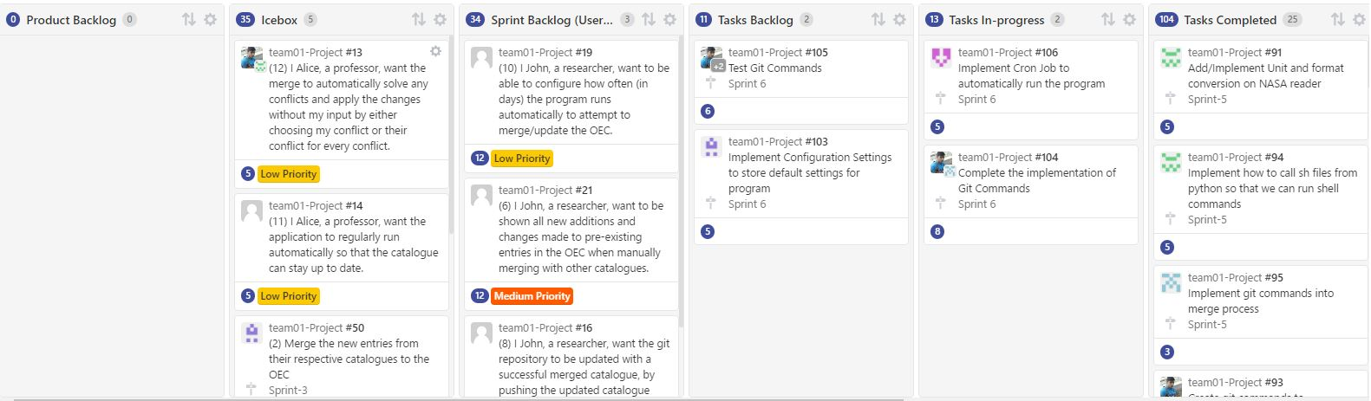

End:

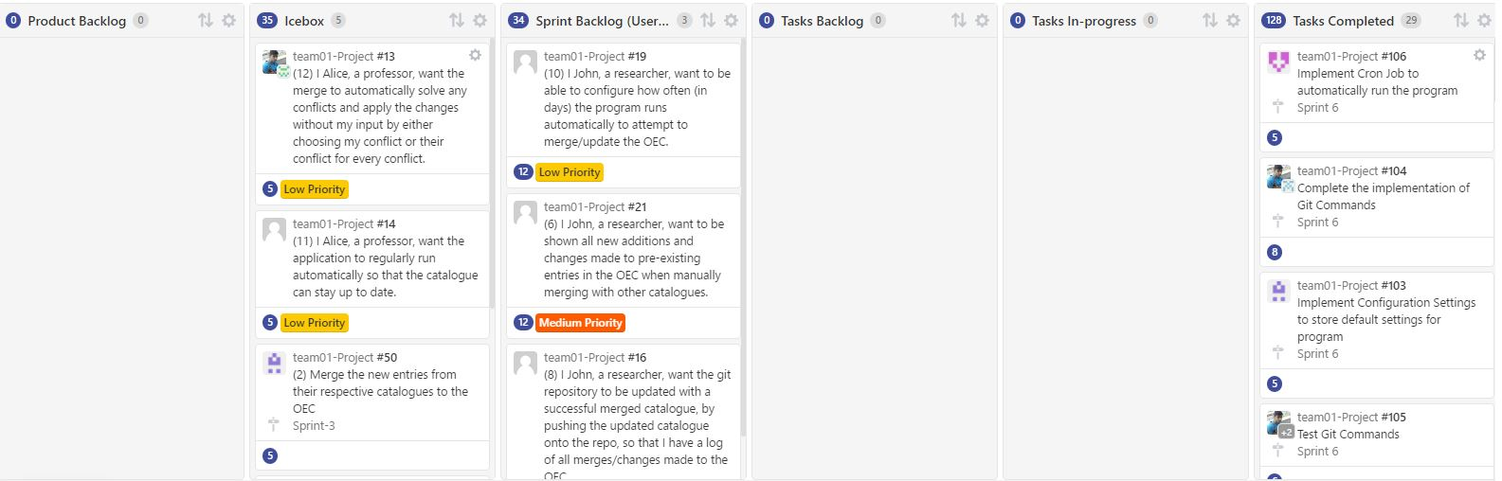

### Burndown Chart

Start:

End:

## System Components:

Readers:

The readers read from the different sources and convert them all into one usable format.

* OECReader.py: responsible for all interactions with local copy of Open exoplanet catalogue. It reads, writes and searches the catalogue. It makes use of Xmltodict and dicttoxml
  + Xmltodict: for converting xml format to dict
  + Dicttoxml: for converting back to xml from dict once merge of a system is complete
* NASAReader: Makes api call and retrieves NASA catalogue(json). It then converts it into a dict that is the same format as the one used in the open exoplanet catalogue
* exoplanetEUreader: Makes api call and reads from the exoplanet EU database(csv). It then converts it into a dict format that is the same as NASA and open exoplanet catalogue

Note: if an new source of exoplanets were to be added, a new reader would have to be created for it, since the formatting will be different for every source. The reader is the only place where the formats of the individual sources will have to be taken into consideration.

System Classes:

The system classes are wrapper classes that encapsulate the individual system, star, planet dicts.

* System: Contains the dict of a system. Also stores the star and planet objects of its system. It also can merge itself with another system object by merging its attributes
* Star: Contains the dict of a star. It also stores the planet objects of the exoplanet’s system. It can also merge itself with another star object by merging attributes like in a system.
* Planet: contains the dict of a planet. It can also merge itself with another planet object.

Git integration:

* gitCommands.py: Connects python with command line by running gitCommand.sh script that will run the appropriate git commands.
* gitCommands.sh: bash script that contains all the necessary git commands that is needed for the project. Can be called through gitCommand.py python functions
* run.py: Core functionality of the project that will run the merge as well as call and the necessary git commands when needed.

### Changes to design:

There were no major changes to design. Only small tweaks and fixes were made to its implementation.

## Code Inspection:

**Reviewer: Harshil**

**Code: system_class_tests.py**

**Date of review: 11/29/2016**

**Author: Venkat**

* **Bugs:**

There was a bug that your testing did find, which was in the method that tested updating multiple catalogues.

**Suggestion:** Fix the update catalogue method

* **Poor code logic:**

Code logic was perfectly fine

* **Missing Documentation:**

There were some documentation missing, definitely needed comments explaining a bit more on what was being tested.

**Suggestion:**  Add comments on what you are testing

* **Unreadable code:**

Code was readable

* **Vulnerabilities in code:**

None found

* **Poor test:**

Testing was done well

**Reviewer: Amine**

**Code: exoplanetEUreader.py**

**Date of review: 11/29/2016**

**Author: Gisho**

* **Bugs:**

Small bug where one system retrieved has a name that is incorrectly formatted. It may be bad date from the exoplanet eu site.

**Suggestion:** Double check this case and check to see if the problem is from their end.

* **Poor code logic:**

The mappings are hard coded and should be more dynamic and reusable.

**Suggestion:**  If possible, create global variables to manage all the mappings in one spot.

* **Unreadable code:**

Code was readable

* **Vulnerabilities in code:**

None found

* **Poor test:**

Testing was thoroughly done well. It also was able to convert all of the exoplanet eu database without problems and cleanly.

**Reviewer: Muneeb**

**Code: gitCommands.sh**

**Date of review: 11/29/2016**

**Author: Harshil**

* **Bugs:**

No bugs. Everything works well and gives the desired output

* **Poor Code Logic:**

Code logic is good. No useless global variables and repetitive code.

* **Poor Coding Style:**

Some sh guidelines are not met such as no indenting allowed (two spaces only) and use "$@" instead of “$*”.  
**Suggestions:**

<https://google.github.io/styleguide/shell.xml#Formatting>

* **Missing documentation**

There is no commendation done whatsoever. The if cases may be self explanatory for the Author but commends should be added explaining what each case does

* **Unreadable Code:**

Code is perfectly readable with clean breaks however one variable is not named well. On line 50, a variable “i” is used in the for loop. A more appropriate name like “letter” would be better.

* **Vulnerabilities in code:**

None found

* **Poor Testing:**

Testing was done for all cases.

# Project Overview

It was a good project overall, the team had a lot of fun working together. Our team has known each other a long time, and which is why we were able to work so well with each other. We were caught up with the project throughout the semester, except for a few phases where we needed to meet and re-plan what we had to do. The project velocity stayed the same throughout the project being around 25/sprint. It didn’t make a big change with each deliverable, because we had planned the project out by taking it inconsideration with the time we were given. We started off the project following up with the plans, but then near the midpoint, we did realize we had to meet often to re-plan and make sure everyone was caught up with the progress of the project and how the set of tasks assign will impact the project. So in short, we didn’t exactly meet with the plan, we did have a few re planning stages. The work done in deliverable 5 has been larger compare to the ones in previous deliverables, it seems as if, we had to make sure everything was going fine and whether our program was running or not, so we needed to put a lot more effort into deliverable 5 as it was the last 2 sprints left. The end result of deliverable 5 was certainly great, we had a product that had more features working than the previous deliverable, and our program certainly made a huge progress in terms of features.