**CSCC01 Deliverable 4**

Team Sierra

Venkat Korapaty  
Amine Benaicha   
Gisho Pushaparajah   
Muneeb Khan  
Harshil Patel

Contents

Product Backlog 3

John 3

Alice 4

Release Plan 4

Deliverable 4 Overview/ Sprints 5

Sprint 2 5

Sprint Backlog 5

Iteration plan 5

Burndown Chart 6

Task Board 6

Sprint 3 7

Sprint Backlog 7

Iteration plan 7

Burndown Chart 8

Task Board 8

Sprint 4 9

Sprint Backlog 9

Iteration plan 9

Burndown Chart 10

Task Board 10

Change in system components 11

Code Inspection Summary 12

Harshil 12

Gisho 12

Muneeb 13

Amine 14

# Product Backlog

## John

1. I John, a researcher, want the program to extract information about exoplanets and their systems from the other catalogues (NASA and exoplant.eu) and convert them into the structure of the OEC so they can be added to the OEC.

**Priority: High, Cost: 8**

1. I john, a researcher, want the program to determine if an exoplanet/system is new and needs to be added or already exists and can be updated/merged in the OEC.

**Priority: High, Cost: 22**

1. I John, a researcher, want to be able to manually update the catalogue by running the program through the command line, by calling a command on a terminal to initiate the updating/merging process.

**Priority: High, Cost: 6**

1. I John, a researcher, want to be shown all new additions and changes made to pre-existing entries in the OEC when manually merging with other catalogues.

The planets/systems that were added should be listed, as well as the old and new values for any field/value of a pre-existing planet/system that was updated.

**Priority: High Medium, Cost: 14**

1. I John, a researcher, want to be able to resolve individual conflicts when merging, by being shown the two versions and being prompted (in the terminal) to choose which version of the conflict to merge into the OEC.

**Priority: Medium, Cost: 17**

1. I John, a researcher, want to be able to configure how often (in days) the program runs automatically to attempt to merge/update the OEC.

**Priority: Medium, Cost: 12**

1. I John, a researcher, want to be notified by email of conflicts when an automatic merge occurs, so I can manually go in and choose which conflicts to merge.

**Priority: Low Medium, Cost: 12**

1. I John, a researcher, want to get a report by email after an automatic merge, containing the changes and additions made to the OEC. It should list all the planets and their systems that were added and updated. It should also list what was changed for planets/systems that were updated.

**Priority: Low, Cost: 8**

1. I John, a researcher, want the git repository to be updated with a successful merged catalogue, by pushing the updated catalogue onto the repo, so that I have a log of all merges/changes made to the OEC.

**Priority: Low, Cost:10**

1. I John, a researcher, want the new changes when merging to match the units and format of the OEC.

**Priority: Low, Cost: 14**

## Alice

1. I Alice, a professor, want the application to regularly run automatically so that the catalogue can stay up to date.

**Priority: Low, Cost: 5**

1. I Alice, a professor, want the merge to automatically solve any conflicts and apply the changes without my input by either choosing my conflict or their conflict for every conflict.

**Priority: Low, Cost: 5**

# Release Plan

Each sprint will be 1 week, from Monday to Sunday.

* Sprint 1 (Oct 17th – Oct 23rd): John user stories 1, 3
* Sprint 2 (Oct 24th – Oct 30th): John user stories 2, 5
* Sprint 3 (Oct 31st – Nov 06th): John user stories 2, 10
* Sprint 4 (Nov 7th – Nov 13th): John user stories 2, 10
* Sprint 5 (Nov 14th – Nov 20th): John user stories 10, 4, 7, 9
* Sprint 6 (Nov 21st – Nov 27th): John: 8, 6 AND Alice user stories 1, 2

# Deliverable 4 Overview/ Sprints

During the course of this deliverable, we completed 3 sprints, each 1-week long. The first sprint (sprint 2) progressed smoothly and we were able to better estimate how much work we can complete in a sprint. For sprint 3, we hit a road block in terms or design and had to rethink and redesign our project. This lead to some tasks being removed and others being unfinished because of the re-planning. In sprint 4 we were able to get back on track and complete a sizable portion of the work.

## Sprint 2

### Sprint Backlog

I john, a researcher, want the program to determine if an exoplanet/system is new and needs to be added or already exists and can be updated/merged in the OEC.

**Priority: High, Cost: 22**

I John, a researcher, want to be able to resolve individual conflicts when merging, by being shown the two versions and being prompted (in the terminal) to choose which version of the conflict to merge into the OEC.

**Priority: Medium, Cost: 17**

### Iteration plan

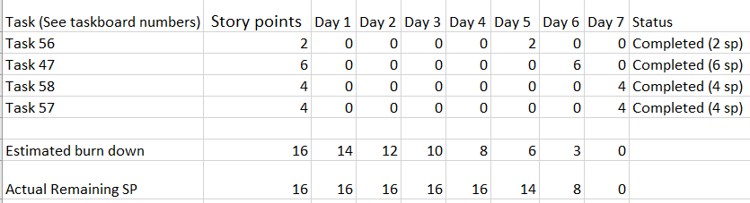

### Burndown Chart

### Task Board

Start: 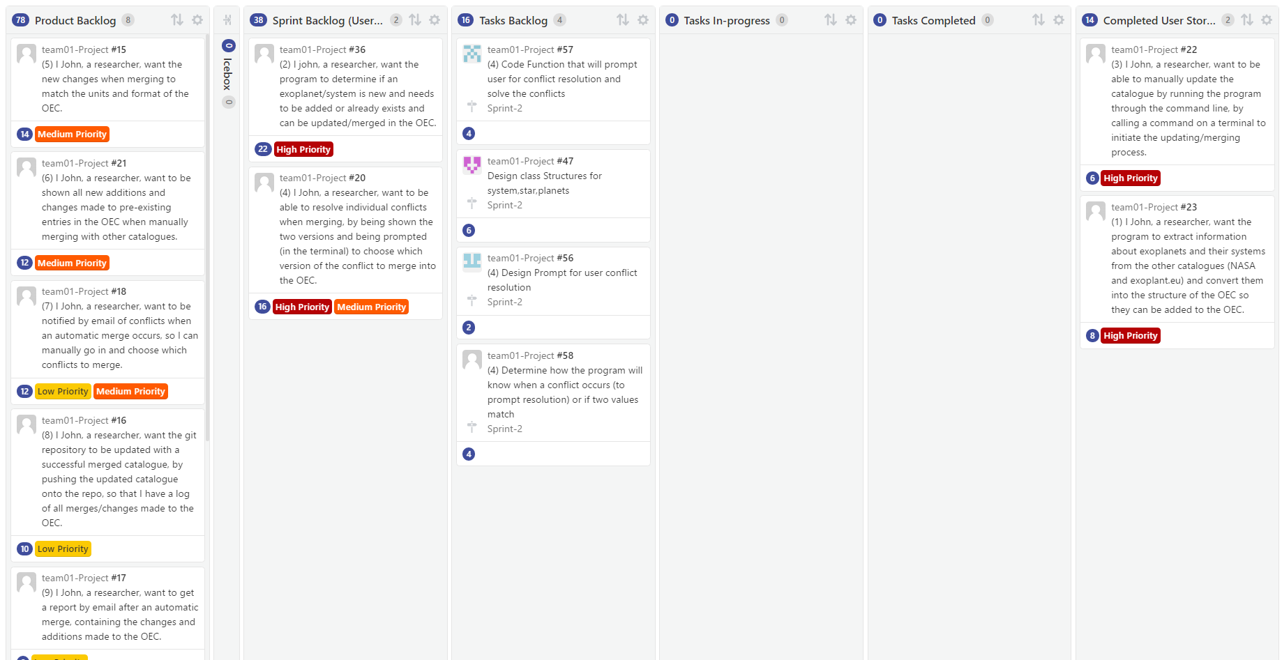

End: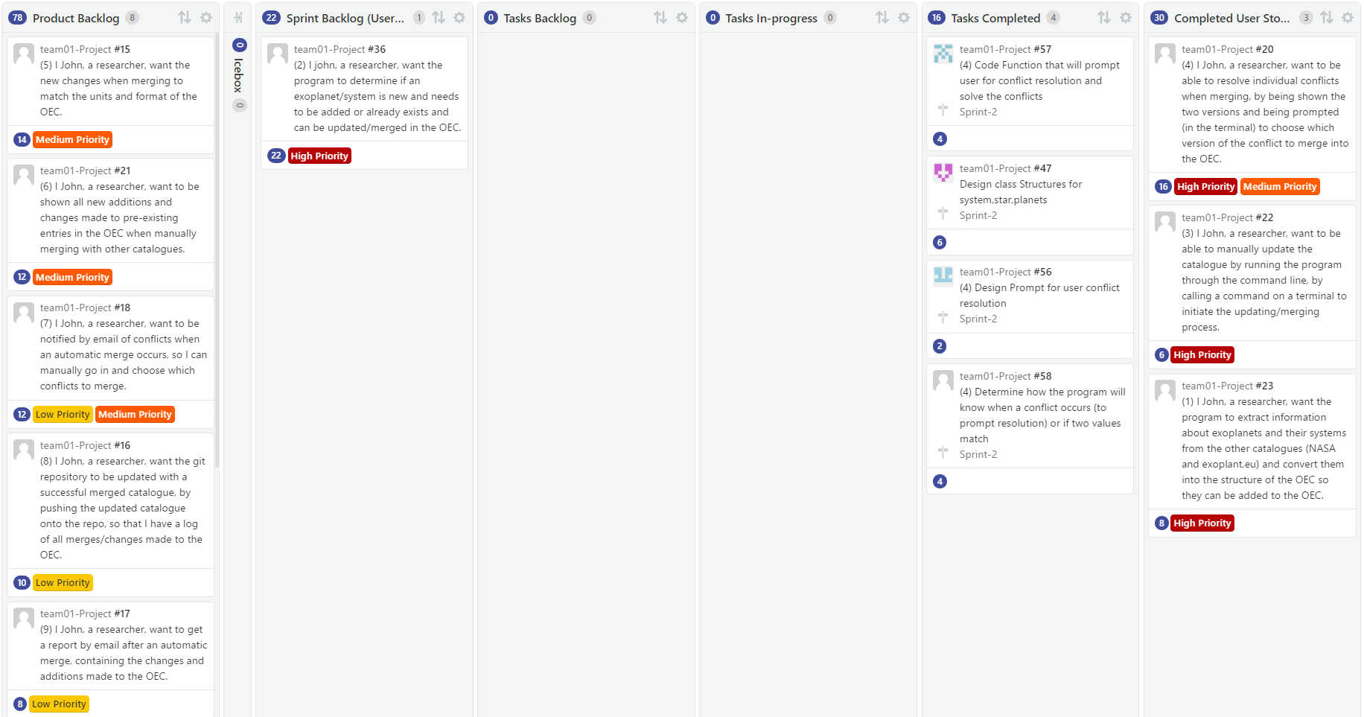

## Sprint 3

### Sprint Backlog

I john, a researcher, want the program to determine if an exoplanet/system is new and needs to be added or already exists and can be updated/merged in the OEC.

**Priority: High, Cost: 22**

I John, a researcher, want the new changes when merging to match the units and format of the OEC.

**Priority: Low, Cost: 14**

### Iteration plan

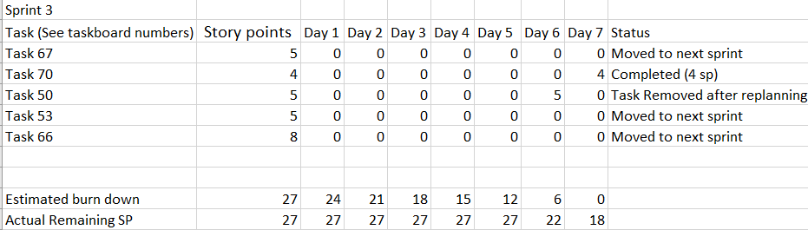

### Burndown Chart

### Task Board

Start: 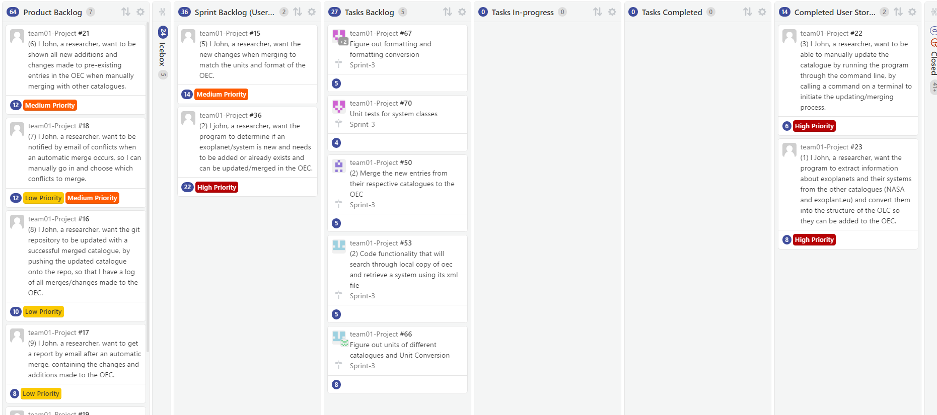

End: 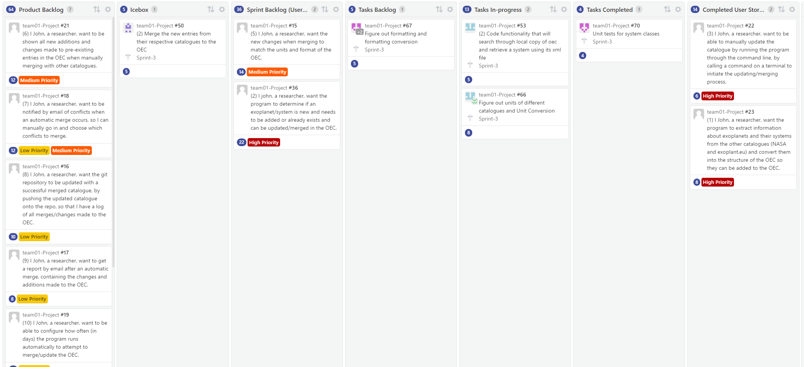

## Sprint 4

### Sprint Backlog

I john, a researcher, want the program to determine if an exoplanet/system is new and needs to be added or already exists and can be updated/merged in the OEC.

**Priority: High, Cost: 22**

I John, a researcher, want the new changes when merging to match the units and format of the OEC.

**Priority: Low, Cost: 14**

### Iteration plan

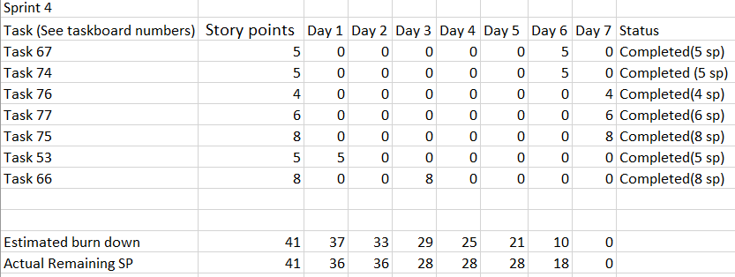

### Burndown Chart

### Task Board

Start:

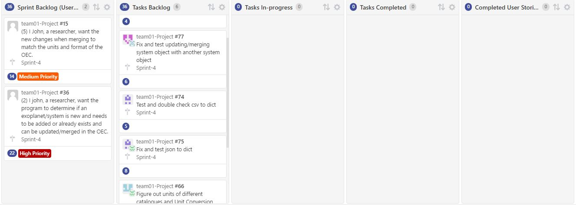

End: 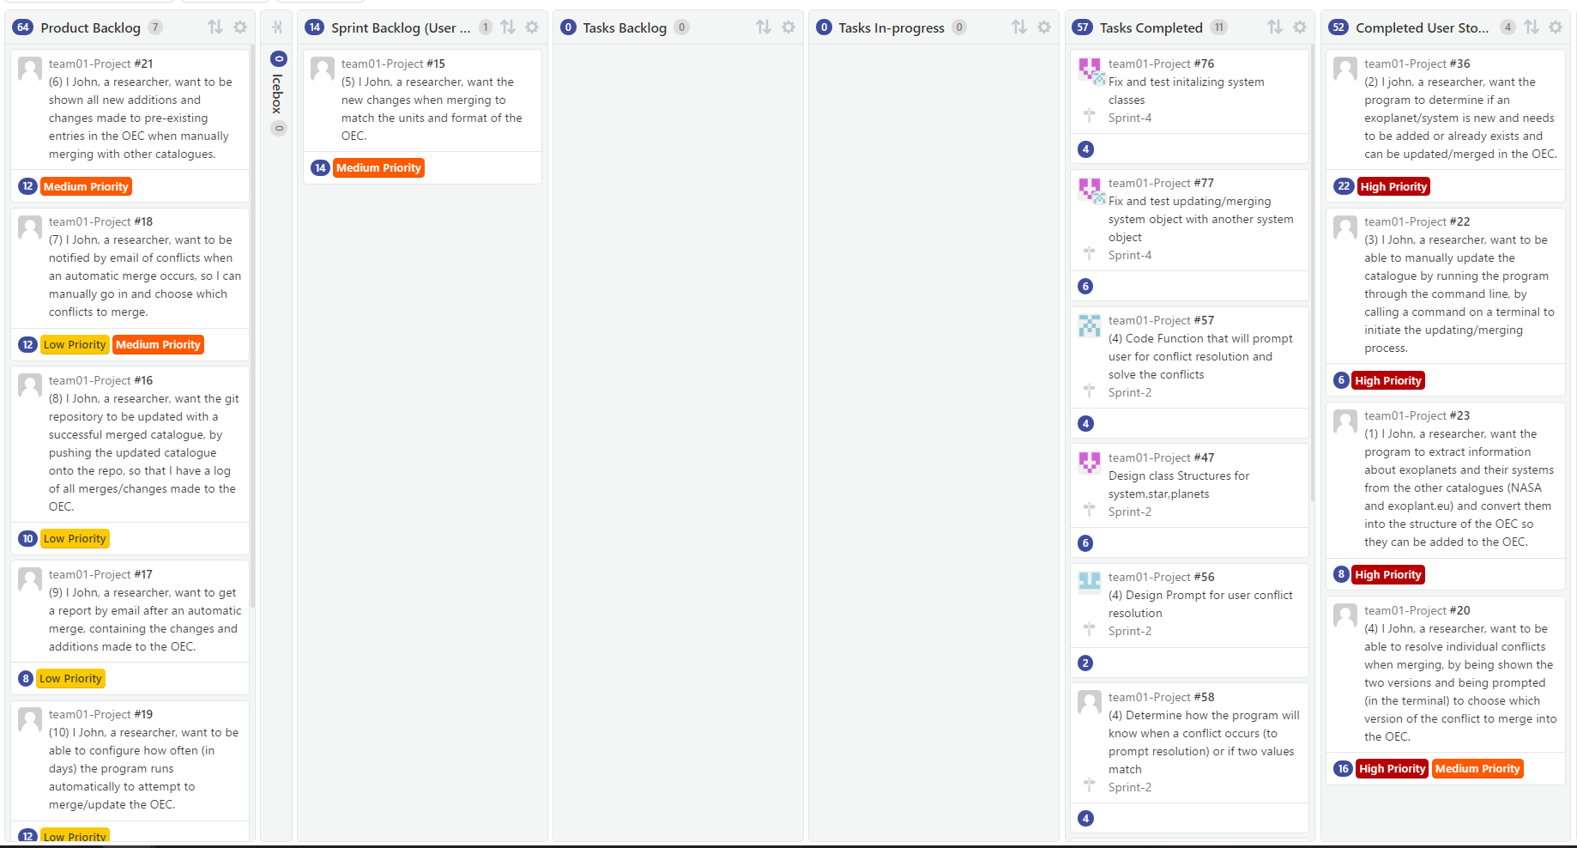

# Change in system components

We had to make quite bit of changes on our system components. One of the biggest changes made was the

# Code Inspection Summary

## Harshil

**Reviewer: Harshil**

**Code: Conflict.py**

**Date of review: 11/11/2016**

**Author: Amine**

* **Bugs:**

No bugs as of yet

* **Poor Code Logic:**

Code logic is perfectly fine

* **Missing Documentation:**

Missing documents on functions

Missing comments for code where needed, especially for large chunks of code

**Suggestions:**

Add some documentation and code where needed

* **Unreadable Code:**

Line 8: If statement is on the same line as a variable assignment, it makes it harder to read the if,

**Suggestions:**

Make the if statement on a new line with indentation

* **Vulnerabilities in code:**

None found

* **Poor Test:**

Testing was done well.

## Gisho

**Reviewer: Gisho (Girrshotan)**

**Code: NASAReader.py**

**Date of review: 11/11/2016**

**Author: Muneeb**

* **Bugs:**

Planets under the same star/system were being stored in different systems. This should be refactored to store all planets with the same star under one system

A list of systems is required to be returned, but a dictionary of systems is being returned, refactor this.

* **Poor Code Logic:**

The variable a is being used for storing the json data, rename it to something more meaningful like data

* **Missing Documentation:**

There is no documentation at all.

Add documents for each method and some comments in the actual code explaining what each chunk is doing

* **Unreadable Code:**

Line 16 & 17: This is very hard to read since the code goes way to far to the right. You should probably use line breaks and format it like an xml (indent and line break wise) so it's easier to read

* **Vulnerabilities in code:**

None found

* **Poor Test:**

There was no testing done. Once you have it working, you should add some tests covering the edge cases like multiple planets for a system, ensuring no null values, and some others.

## Muneeb

**Reviewer: Muneeb**

**Code: exoplanetEUreader.py**

**Date of review: 11/11/2016**

**Author: Gisho**

* **Bugs:**

No bugs. Everything works well and gives the desired output

* **Poor Code Logic:**

Code logic is good. No useless global variables and repetitive code.

* **Poor Coding Style:**

Some python guidelines are not met such as missing whitespaces, lines are too long and no newline at the end of the code   
**Suggestions:**

Use PEP-8 to fix this

* **Missing documentation**

The functions in the code do not have any docstrings explaining the function itself. It is absolutely necessary to add that. Otherwise, the code is nicely documented.

* **Unreadable Code:**

Code is perfectly readable with clean breaks. Variables are named well and no unnecessary code commented out

* **Vulnerabilities in code:**

None found

* **Poor Testing:**

Absolutely no testing was done. Should add some cases where there are multiple planets in a system or not, if there are empty attributes and others.

## Amine

**Reviewer: Amine**

**Code: System.py, Star.py, Planet.py**

**Date of review: 11/11/2016**

**Author: Venkat**

* **Bugs:**

When creating or updating an object, if an attribute is missing the program will throw an error because it will try to access it. We can’t assume we will have all attributes since as the exoplanets are discovered, the information about them wont necessarily be complete. To fix this you should have checks to see if an attribute exists for a system/star/planet before accessing or updating it

* **Poor Code Style:**

For the system/star/planet classes, having methods such as getName, toDict will allow for more encapsulated and cleaner code. Suggestion: you should implement common class methods to create more modular and reusable objects.

* **Documentation:**

Docstrings for python should be inside the function/method. Please move the docstrings for the methods in the classes to the inside

* **Poor Test:**

Please create more test cases, and thoroughly test the system, star, planet classes, since they are core functionality of the program. Bugs in them will create problems for the rest of the code.