|  |
| --- |
| TEAM SIERRA |
| Release Plan |
|  |
|  |
| |  | | --- | | **Muneeb Khan, Harshil Patel, Amine Benaicha, Venkat Korapaty, Gisho Pushparajah** | |
| **10/14/2016** |



**TABLE OF CONTENTS**

Sprint 1……………………………………………………………………………………………….3  
October 17 – October 24

Sprint 2 ……………………………………………………………………………………………….4  
October 24 – October 31

Sprint 3 ……………………………………………………………………………………………….5  
October 31 – November 7

Sprint 4 ……………………………………………………………………………………………….6  
November 7 – November 14

Sprint 5 ……………………………………………………………………………………………….7  
November 14 – November 21

Sprint 6 ……………………………………………………………………………………………….8   
November 21 – November 28

**SPRINT 1 (October 17 – 24)**  
User Story 1 - I John, a researcher, want the newly discovered exoplanets and their systems in the other catalogues (NASA and Exoplanets.eu) added to the open exoplanet catalogue.  
  
User Story 2 - As a researcher, I want to be able to manually update the catalogue merging the new entries from the other catalogues by running the program through the command line.

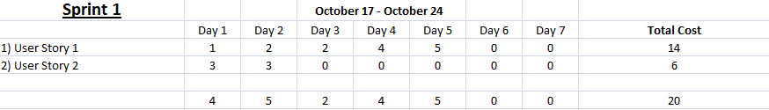  
  
  
  
  
  
  
**RULES**- Attend Team meetings   
- Follow each task by priority   
- Ask other group members for help if you are having trouble with something  
- Stay on Schedule!

**SPRINT 2 (October 24 – 31)**

**SPRINT 3 (October 31 – November 7)**

**SPRINT 4 (November 7 – November 14)**

**SPRINT 5 (November 14 – November 21)**

**SPRINT 6 (November 21 – November 28)**