**CSCC01 Deliverable 4**

Team Sierra

Venkat Korapaty  
Amine Benaicha   
Gisho Pushaparajah   
Muneeb Khan  
Harshil Patel

**John**

1. I John, a researcher, want the program to extract information about exoplanets and their systems from the other catalogues (NASA and exoplant.eu) and convert them into the structure of the OEC so they can be added to the OEC.

**Priority: High, Cost: 8**

1. I john, a researcher, want the program to determine if an exoplanet/system is new and needs to be added or already exists and can be updated/merged in the OEC.

**Priority: High, Cost: 22**

1. I John, a researcher, want to be able to manually update the catalogue by running the program through the command line, by calling a command on a terminal to initiate the updating/merging process.

**Priority: High, Cost: 6**

1. I John, a researcher, want to be shown all new additions and changes made to pre-existing entries in the OEC when manually merging with other catalogues.

The planets/systems that were added should be listed, as well as the old and new values for any field/value of a pre-existing planet/system that was updated.

**Priority: High Medium, Cost: 14**

1. I John, a researcher, want to be able to resolve individual conflicts when merging, by being shown the two versions and being prompted (in the terminal) to choose which version of the conflict to merge into the OEC.

**Priority: Medium, Cost: 17**

1. I John, a researcher, want to be able to configure how often (in days) the program runs automatically to attempt to merge/update the OEC.

**Priority: Medium, Cost: 5**

1. I John, a researcher, want to be notified by email of conflicts when an automatic merge occurs, so I can manually go in and choose which conflicts to merge.

**Priority: Low Medium, Cost: 4**

1. I John, a researcher, want to get a report by email after an automatic merge, containing the changes and additions made to the OEC. It should list all the planets and their systems that were added and updated. It should also list what was changed for planets/systems that were updated.

**Priority: Low, Cost: 6**

1. I John, a researcher, want the git repository to be updated with a successful merged catalogue, by pushing the updated catalogue onto the repo, so that I have a log of all merges/changes made to the OEC.

**Priority: Low, Cost:4**

1. I John, a researcher, want the new changes when merging to match the units and format of the OEC.

**Priority: Low, Cost: 3**

**Alice**

1. I Alice, a professor, want the application to regularly run automatically so that the catalogue can stay up to date.

**Priority: Low, Cost: 5**

1. I Alice, a professor, want the merge to automatically solve any conflicts and apply the changes without my input by either choosing my conflict or their conflict for every conflict.

**Priority: Low, Cost: 5**

**Release Plan**

**Sprint 2:**

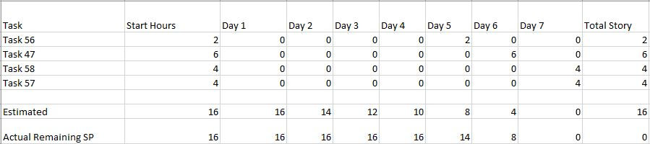

**Sprint 3**

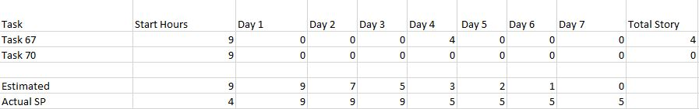

**Sprint 4**

**Sprint 2:**

Task Board:

Start:

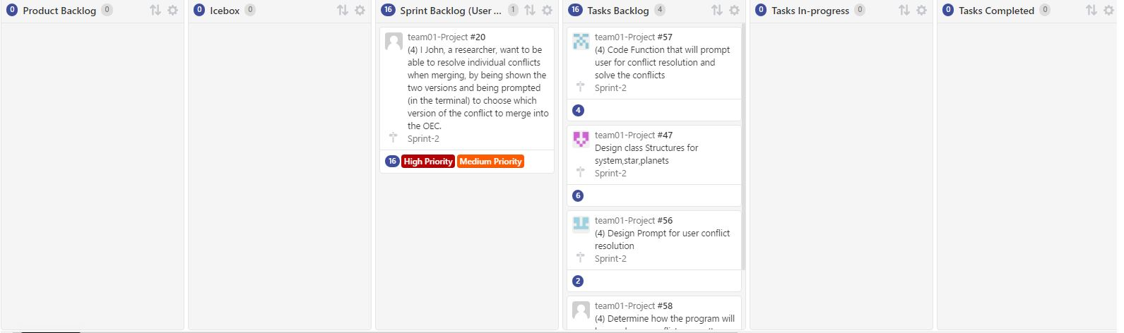

End:

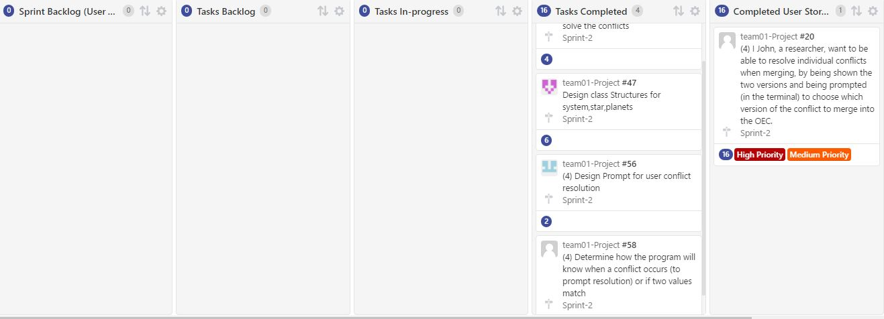

Burndown Chart:

Start:

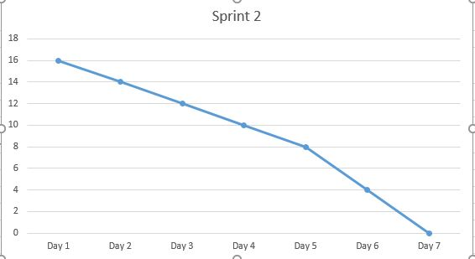

End:

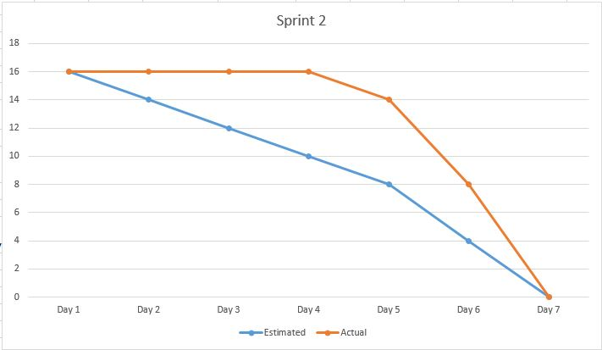

**Sprint 3:**

Task board start:

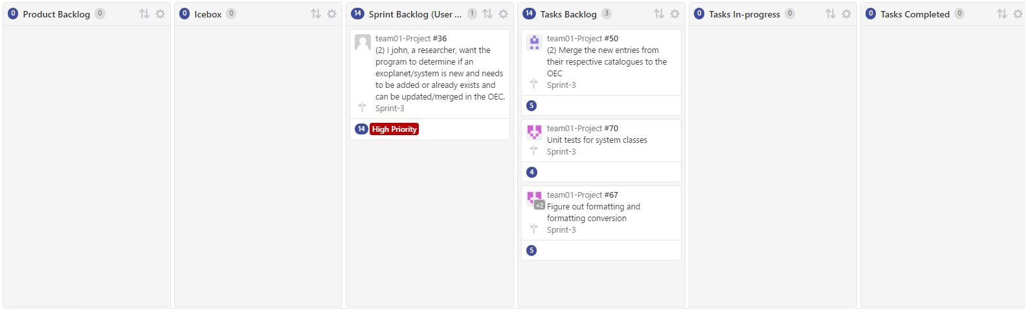

Task Board end:

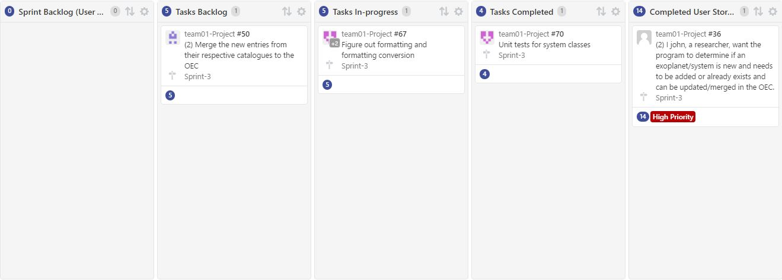

Spring 3 burndown chart:

Start

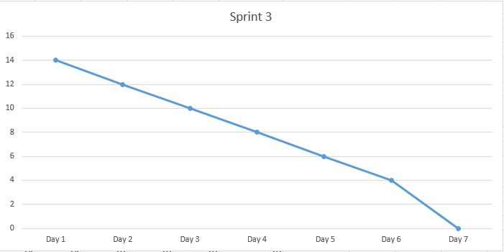

End

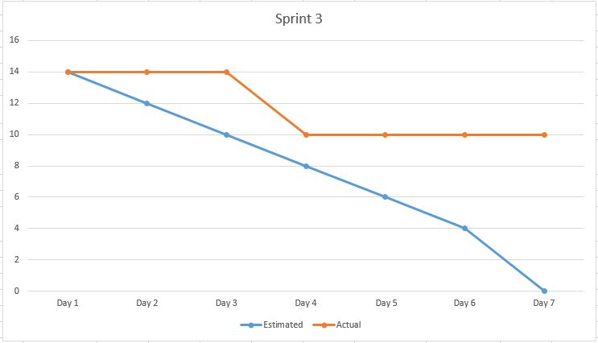

**Sprint 4:**

Sprint 4 Taskboard start:

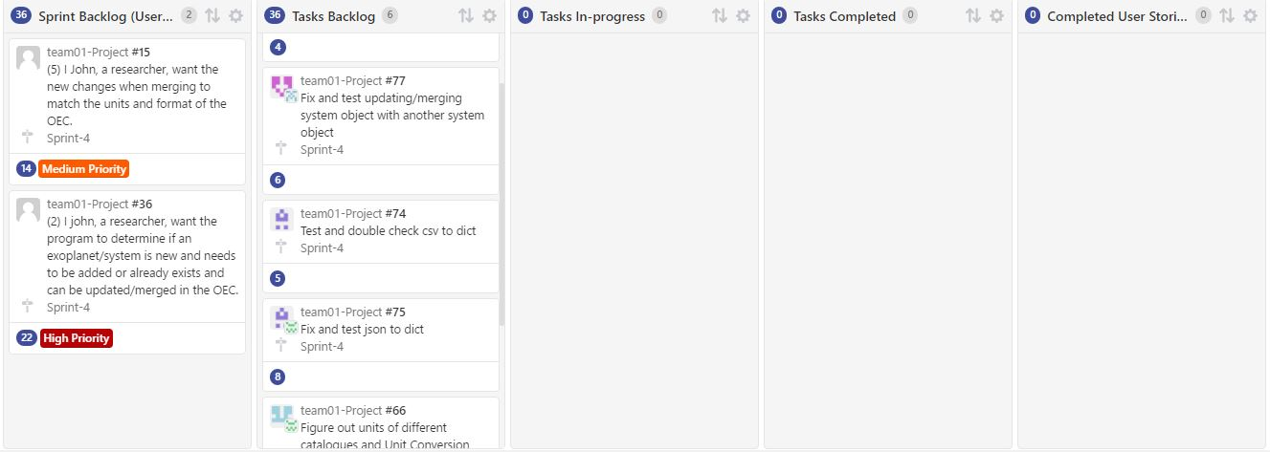

Burndown chart:

Start:

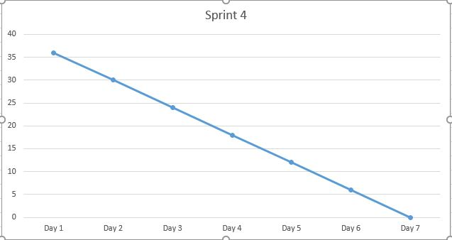

End:

**Change in system components:**

We had to make quite bit of changes on our system components. One of the biggest changes made was the

**Code Inspection Summary**

**Reviewer: Harshil**

**Code: Conflict.py**

**Date of review: 11/11/2016**

**Author: Amine**

* **Bugs:**

No bugs as of yet

* **Poor Code Logic:**

Code logic is perfectly fine

* **Missing Documentation:**

Missing documents on functions

Missing comments for code where needed, especially for large chunks of code

**Suggestions:**

Add some documentation and code where needed

* **Unreadable Code:**

Line 8: If statement is on the same line as a variable assignment, it makes it harder to read the if,

**Suggestions:**

Make the if statement on a new line with indentation

* **Vulnerabilities in code:**

None found

* **Poor Test:**

Testing was done well.