**How to connect Rstudio and GitHub**

Create a new file > new project > version control > git

Go to GitHub and open the repository. Go to code (green button on the right side) and copy HTTPS.

Paste the HTTPS in repository URL and click “create project”.

Now all the files from this GitHub repository are available in Rstudio.

If new files are added or changed in Rstudio it is important to commit the changes and push!!!

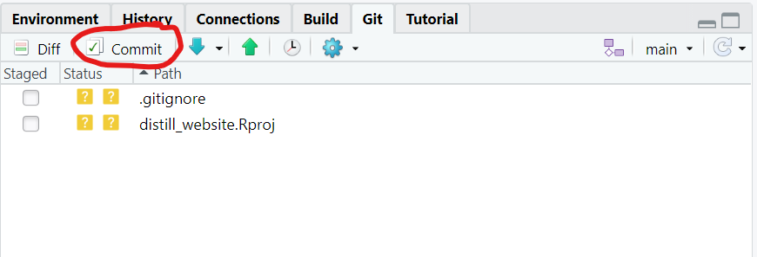

Click commit

Then a window like this opens:

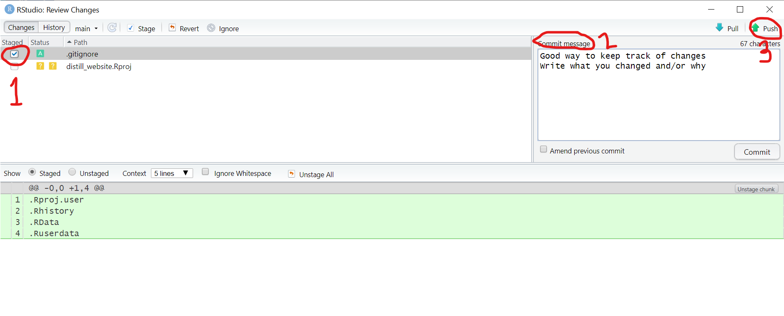

1. Make sure that the file you edited is checked in the column staged.
2. Write a commit message and press the commit button on the right side.
3. Press the green Push button.

Now changes have been made and can be seen on GitHub.

To have the newest version from GitHub press the blue arrow (pull)



**Edit articles**

Open article, go to _posts 🡪 select desired article

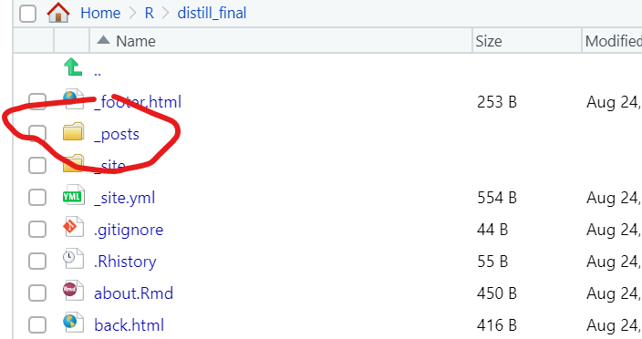

Edit the file that ends with .Rmd

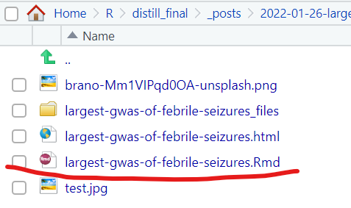

Always remember that when you edit file to save file, commit and push



**View website**

To view website it is important to knit

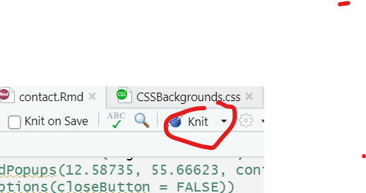

To knit everything at once, go to: knit 🡪 knit directory 🡪 project directory

