GOALS
When an organization is of considerable size, it is necessary to organize the structure into managements. Giswater allows you to organize the management of information by managers in such a way that an operator is assigned to a management, and the management to a set of exploitations and everything is linked. In this way, it is possible to manage the permission to consult one or other exploitations for users, even if all the information is in the same data schema.

DESCRIPTION

The configuration is very simple. You just have to:

1) Put variable admin_exploitation_x_user of config_param_system in TRUE.
2) Fill the management records in the cat_manager table where they are linked:
- Management
- Roles
- Exploitations
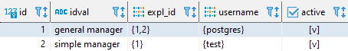

The names of username must already exist in the table cat_users.

3) After the configuration, we can consult the table config_user_x_expl where the values for the relationship between user and exploitation will have been inserted.

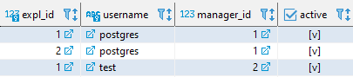

4) We can now verify that the restrictions for configured users are applied in the QGIS project. In this example, the user 'postgres' can see exploits 1 and 2, but the user 'test' can only see the 1.

ADICIONAL

ALTER TABLE ws.arc ENABLE ROW LEVEL SECURITY;
CREATE POLICY arc_role_edit ON ws.arc for all TO role_edit using (expl_id IN (SELECT expl_id FROM ws.config_user_x_expl WHERE username = current_user));
CREATE POLICY arc_role_basic ON ws.arc for select TO role_basic using (expl_id IN (SELECT expl_id FROM ws.config_user_x_expl WHERE username = current_user));
ALTER TABLE ws.arc DISABLE ROW LEVEL SECURITY;

ALTER TABLE ws.node ENABLE ROW LEVEL SECURITY;
CREATE POLICY node_role_edit ON ws.node for all TO role_edit using (expl_id IN (SELECT expl_id FROM ws.config_user_x_expl WHERE username = current_user));
CREATE POLICY node_role_basic ON ws.node for select TO role_basic using (expl_id IN (SELECT expl_id FROM ws.config_user_x_expl WHERE username = current_user));
ALTER TABLE ws.node DISABLE ROW LEVEL SECURITY;
Same for connec, link, dma, presszone, dqa and all those that tables wich works with expl filtered

REVIEWS

Action | User | Date
Created | Xavi | 16/04/2020
Updated | Albert | 13/09/2021

