GOALS
Have a single schema with the street data - municipality, streetaxis, plot and address. In this way, if any value is inserted into one of these tables, it is propagated directly to both schemas, thus avoiding having to keep the data up to date in two different places.

DESCRIPTION

To generate a ‘utils’ schema, there must first be a ‘ws’ schema and a ‘ud’ schema.
- From the Project Management tool, the 'utils' schema can be automatically generated.

- We open the tool and go to the 'Advanced' tab. If this tab does not appear, check the file 'C:\ Users\user\AppData\Roaming\Giswater\3.5\config\init.config' and its variables 'showadminadvanced' and 'level', which define the level of permissions of the user.

- To generate the 'utils' schema and all the changes it implies, we simply have to press the 'Create' button.

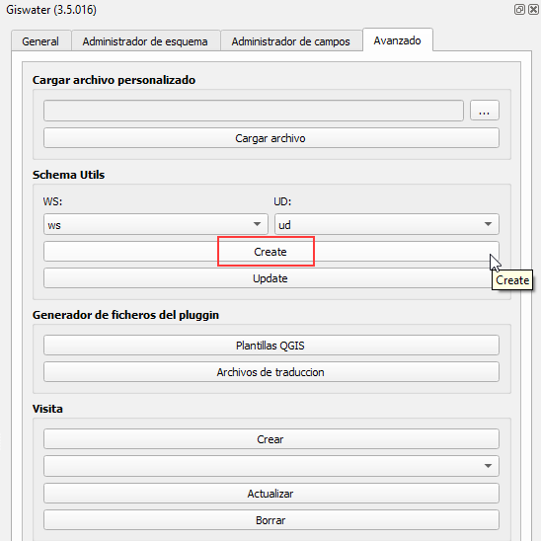

- The changes made, approximately, are:
  - Variable of config_param_system ‘admin_utils_schema’ = TRUE.
  - The tables of ext_* are renamed to old and views with the same name are generated, but which attack 'utils'.
  - The values are passed from the ws and ud tables to the 'utils' schema.
- Only one thing should be configured. In the config_param_system table of the ‘utils’ schema there are two variables:
  - ws_current_schema – We must put the name of our scheme to ws.
  - ud_current_schema – We must put the name of our scheme to ud.

All UPDATES that are read can be found in the plugin folder ...\QGIS\QGIS3\profiles\default\python\plugins\giswater\dbmodel\corporate\utils

REVIEWS

Action | User | Date
Created | Albert | 14/10/2019
Updated | Albert | 05/02/2020
Updated | Albert | 02/11/2021

