GOALS
Know which steps must be taken both in QGIS and in the database to add a new mapzone and subsequently configure its use and impact. This always taking into account the use of dynamic mapzones, managed by the user but created from an internal Giswater algorithm.

DESCRIPTION
Below are the steps to add a new mapzone. For the different types that exist, the steps to follow are exactly the same.

Background

1. In system variable utils_dynamicmapzones_status, om_dynamicmapzones_status (v3.3) define the graph classes that are enabled:

{"SECTOR":true, "PRESSZONE":true, "DQA":true, "MINSECTOR":true, "DMA":true}
2. In the cat_feature_node table, node_type (v3.3), for each type of node we define graf_delimiter. The sample has:
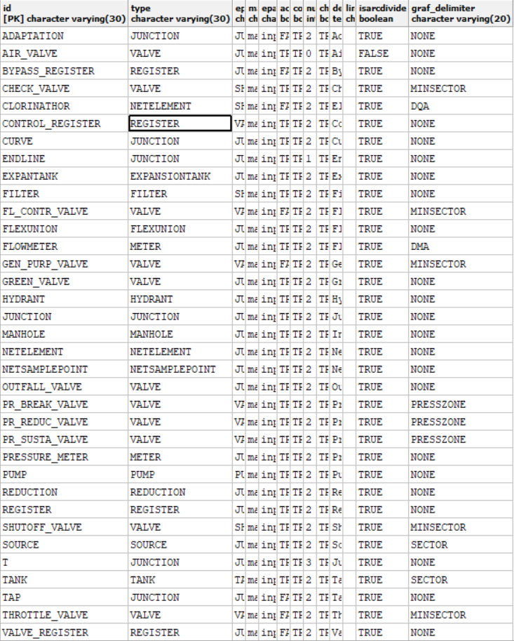

3. In the valve configuration table config_valve, anl_mincut_selector_valve (v3.3) define the valves that act as stoppers

Example to add a new DMA type mapzone:

1) Add in QGIS a new node in the desired location. The type of node must be one that in the node_type table has as a value in the column graf_delimiter 'DMA', since this column establishes which areas of the map can delimit the different types of node. If we want to make an area of ​​the map different than dma, the only necessary thing to do is to insert a node that is the delimiter of the desired area. For DMA it will usually be 'METER' type nodes.

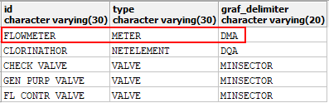

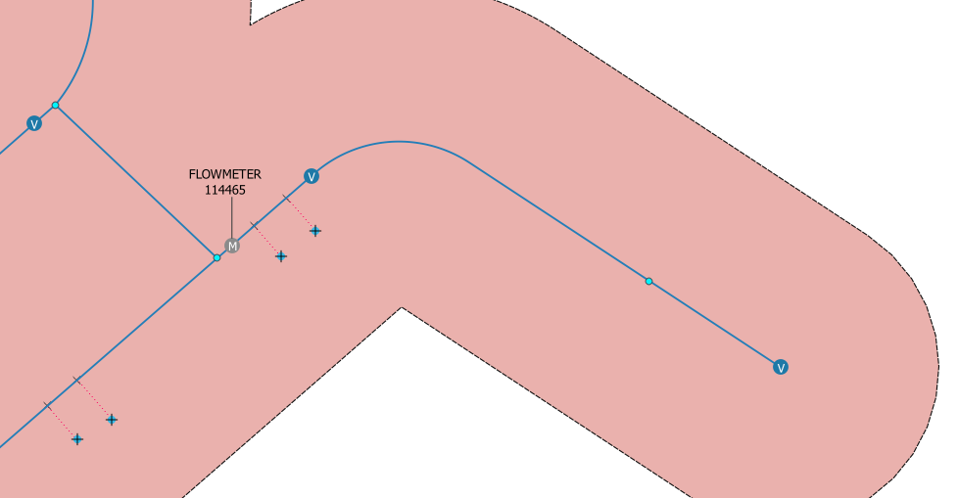

2) Add to the dma table (if we make another mapzone fill the corresponding table) a new value, with the name of the dma that we want to create and, above all, fill the grafconfig value with the following json. In the value of nodeParent we must put the id of the node that we just inserted, which will be the header of the new dma and in toArc we indicate the direction to take by means of the id of the section. Example:

{"use":[{"nodeParent":"1080", "toArc":[2092]}], "ignore":[], "stopper":[1057,41,1060]}

In ignore (optional) we will put, if it is the case, those nodes that being grafdelimiter, we do not want them to participate in the algorithm (for being out of service or for not doing its job).

In stopper (optional) we will put, if it is the case, those nodes that we want to force stop the flood algorithm.

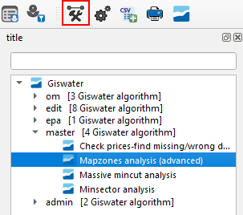
3) We use the Giswater toolbox to recalculate the mapzones with the modification that we have made for dma's, by selecting the shape of the geometry that we want.
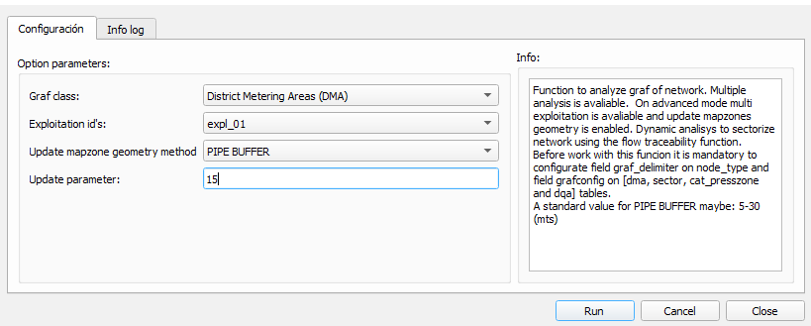

An alternative to using the Giswater toolbox, is to shoot the function directly from the database, making a call such that:

SELECT gw_fct_grafanalytics_mapzones('{"data":{"parameters":{"grafClass":"DMA", "exploitation":[1], "macroExploitation":[1], "checkData":false,
"updateFeature":true, "updateMapZone":2, "geomParamUpdate":15,"debug":false, "usePlanPsector":false, "forceOpen":[1,2,3], "forceClosed":[2,3,4]}}}');

where:

4) Once the process is finished, we must check again the geometries of the dma. In our example, we see that the geometry has been generated for the new dma that has the FLOWMETER that we have added as a delimiter node.
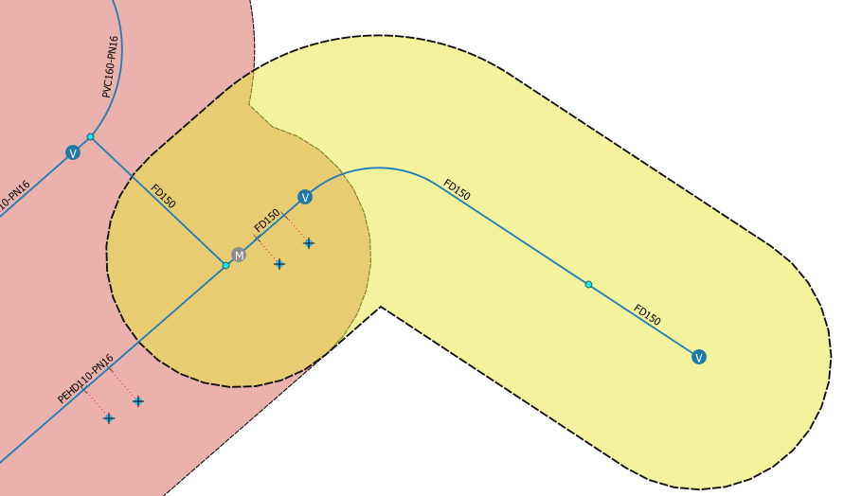

REVIEWS

Action | User | Date
Created | Albert Bofill | 09/04/2020
Updated | Xavier Torret | 01/08/2020
Updated | Xavier Torret | 01/12/2021

