Upload scripts via GitBash

1. Go to Application Catalog and search for Git. Install the latest version of Git application.

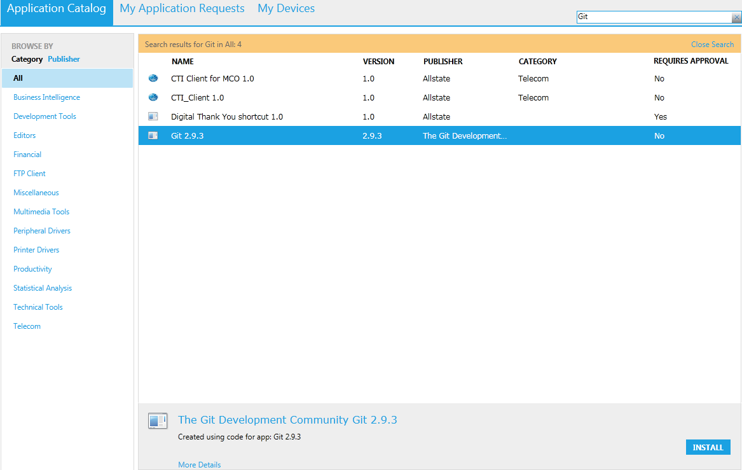

1. Once it’s successfully installed in your local system, do right click on any folder in File Explorer.

You will find two new option for Git.

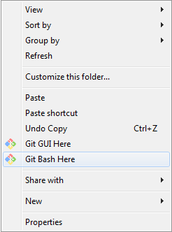

1. Place ReadyAPI script along with dependent items (like Input data sheet, External Jar, Input Request XMLs) in a single folder

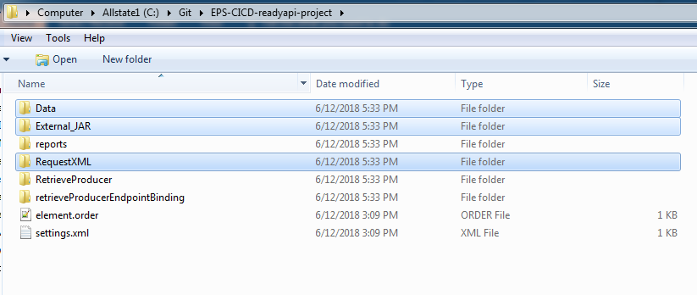

1. Create a GitHub Repository under <https://github.allstate.com/SOATeamHub>. Repository name should be the service full name.

(Example) Enterprise Producer Service, Agent Locator Service

Git Command Prompt

1. Navigate to your project folder created in step No:3 . Do right click and select “*Git Bash Here*”. Git Command prompt will appear.

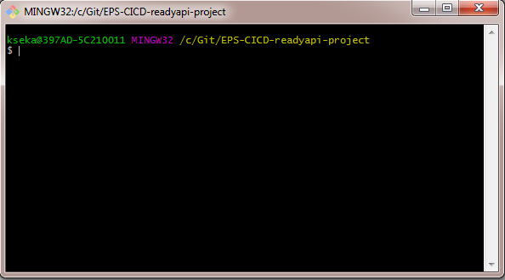

1. Run *git init* command

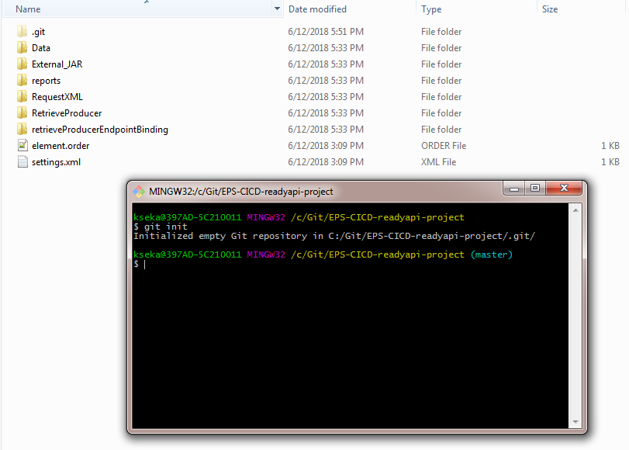

1. Run *git add \** - To add all files in project directory

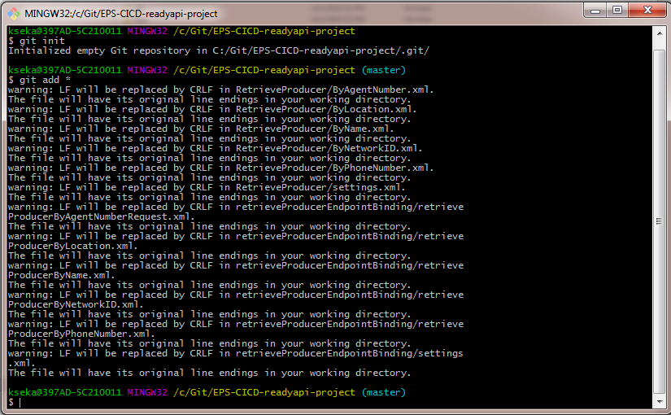

1. Run *git status* – To see the files which are in staging area

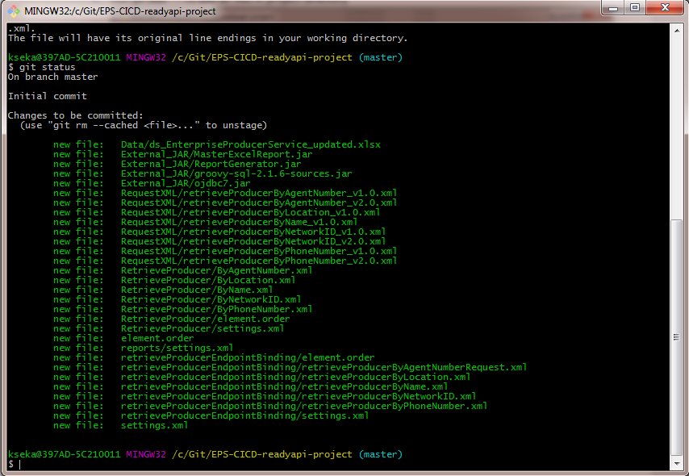

1. Run *git commit -m “<Commit Comments>”* – To confirm changes. Providing commit comments is mandatory

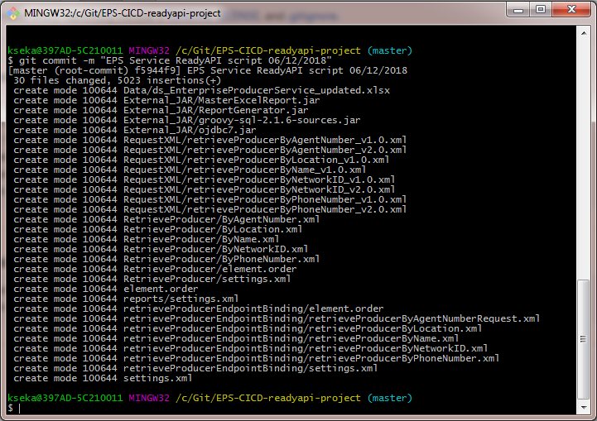

1. Run *git remote add origin <GitRepository URL>*

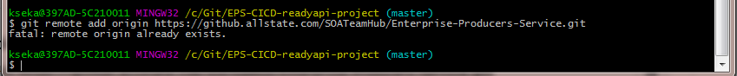

1. Run *git push -f origin master* – To upload script in master branch. Popup window will open. Provide your GitHub user name and password. Then scripts will be started uploaded to designated GitHub Repository.

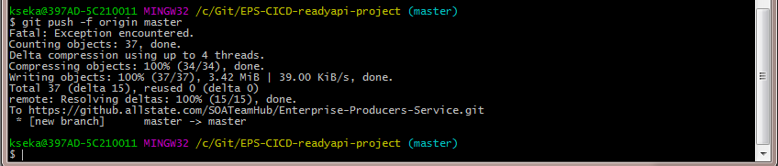

Scripts uploaded 