## Microstrip antenna and coordinate system

* uStrip antennas consists of a very thin (t << λ0, where λ0 is the free-space wavelength) metallic strip (patch) placed a small fraction of a wavelength (h << λ0, usually 0.003λ0 ≤ h ≤ 0.05λ0) above a ground plane.
* For a rectangular patch, the length L of the element is usually λ0/3 <L < λ0/2,
* The strip (patch) and the ground plane are separated by a dielectric sheet (referred to as the substrate)
* Dielectric constants are usually in the range of 2.2 ≤ Ir ≤ 12.
* The ones that are most desirable for good antenna performance are **thick substrates** whose **dielectric constant is in the lower end of the range** because they provide better efficiency, larger bandwidth, loosely bound fields for radiation into space, but at the expense of larger element size.

* microstrip antennas are also referred to as patch antennas.
* **Microstrip dipoles are attractive because they inherently possess a large bandwidth and occupy less space, which makes them attractive for arrays.**

### Feeding Methods

* The four most popular are the microstrip line, coaxial probe, aperture coupling, and proximity coupling.

1. microstrip line - The microstrip feed line is also a conducting strip, usually of much smaller width compared to the patch. The microstrip-line feed is easy to fabricate, simple to match by controlling the inset position and rather simple to model. However as the substrate thickness increases, surface waves and spurious feed radiation increase, which for practical designs limit the bandwidth (typically 2–5%).
2. Coaxial-line feeds - e inner conductor of the coax is attached to the radiation patch while the outer conductor is connected to the ground plane, are also widely used. The coaxial probe feed is also easy to fabricate and match, and it has low spurious radiation. However, it also has narrow bandwidth and it is more difficult to model, especially for thick substrates (h > 0.02λ0).

* Both the microstrip feed line and the probe possess inherent asymmetries which generate higher order modes which produce cross-polarized radiation.

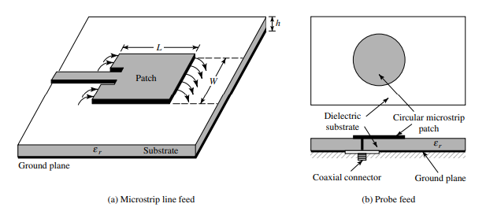

## RECTANGULAR PATCH

### Fringing Effects

* Because the dimensions of the patch are finite along the length and width, the fields at the edges of the patch undergo fringing.
* For the principal E-plane (xy-plane) fringing is a function of the ratio of the length of the patch L to the height h of the substrate (L/h) and the dielectric constant of the substrate. Since for microstrip antennas L/ h >> 1, fringing is reduced; however, it must be taken into account because it influences the resonant frequency of the antenna. The same applies for the width.
* **effective dielectric constant** - some of the waves travel in the substrate and some in air. Effective dieectric constant account for fringing and the wave propagation in the line.
* 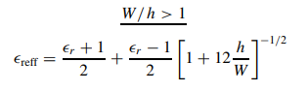

Design

Specify : $ϵ_{r},f_{r}\left(in Hz\right) and h$

Determine : W,L

#### Design procedure:

**Step 01.** For an efficient radiator, a practical width that leads to good radiation efficiencies is,

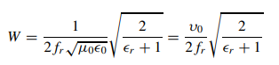

where υ0 is the free-space velocity of light.

**Step 02.** Determine the effective dielectric constant of the microstrip antenna using

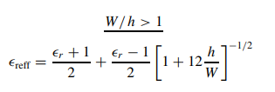

**Step 03.** determine the extension of the length $Δ$ L using

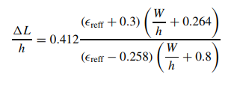

**Step 04.** The actual length of the patch can now be determined by solving

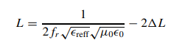

#### Resonant Input Resistance

* it has been shown that the resonant input resistance can be changed by using an inset feed
* recessed a distance y0 from slot #1, as shown in Figure 14.11(a). This technique can be used effectively to match the patch antenna using a microstrip-line feed whose characteristic impedance is given by,

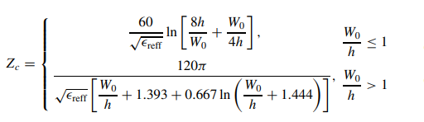

* the input resistance for the inset feed is given approximately by

where Yc = 1/Zc. Since for most typical microstrips G1/Yc 1 an d B1/Yc 1,

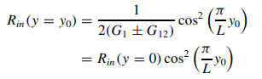

#### Directivity

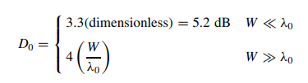

# CIRCULAR PATCH