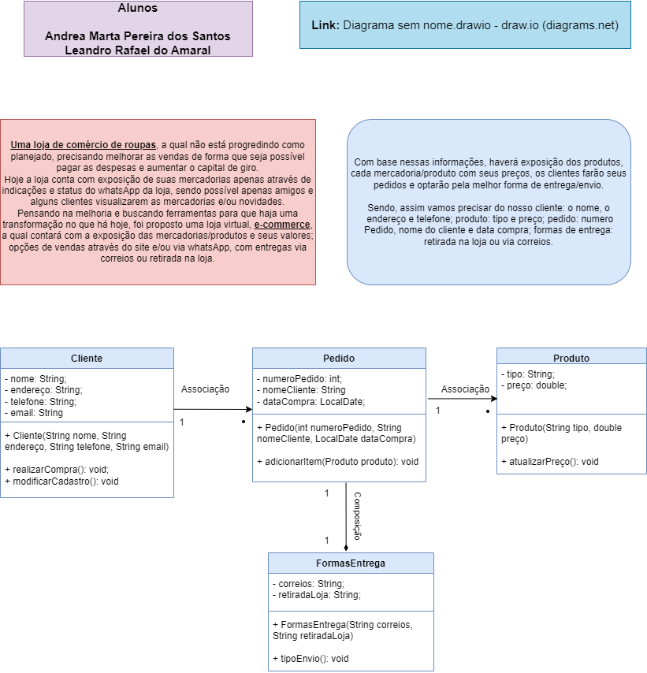

**Link**: [Checkpoint.drawio - draw.io (diagrams.net)](https://app.diagrams.net/#G1cyP1NHu5sbN2udtm4KUMqOJpusdMsq2i)