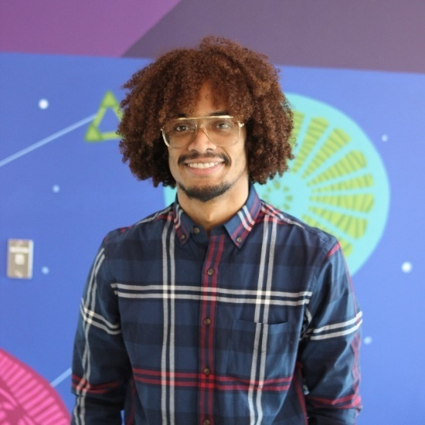

**About**  
- Leon Hunter is a technical instructor, curriculum developer, and [DevOps Engineer](https://en.wikipedia.org/wiki/DevOps) specializing in [Cloud Native Application Development](https://en.wikipedia.org/wiki/Cloud_native_computing) and [Test Driven Methodologies](https://en.wikipedia.org/wiki/Test-driven_development).  
- Leon graduated from William Penn High School in New Castle, DE where he excelled in Graphic Design I, II, and III before achieving a Bachelor of Science (BS) focused in Computer Science, Mathematics Minor from Delaware State University.  
- Leon enjoys creating digital media, running long distances, skateboarding, and attending music festivals.  
  
**Pre-Graduation Experience**  
- In January 2013, Leon began working for the computer and information science department at Delaware State University as a programming tutor.  
  
- After working as programming tutor, in May 2013, Leon worked as a biomedical researcher funded by Science and Mathematics Initiative for Learning Enhancement at the LIPS ([Laboratory for Intelligent Perceptual Systems](cis.desu.edu/research/lips)) Laboratory, developing a system that would aid in the prevention of catastrophic medical events through persistent intelligent monitoring and early-warning alerting. The research received a [publication, which you can read about by clicking here](http://tiij.org/issues/issues/spring2015/X__TIIJ%20spring%202015%20v15%20n2%20(PDW-2).pdf).  
  
- in August 2015, Leon was employed at the BIL ([Biophotonic Imaging Laboratory](https://oscar.desu.edu/research/areas/biophotonic-imaging/)) in the OSCAR (Optical Science Center for Applied Research) building on DSU’s (Delaware State University’s) campus working to [implement an evolutionary algorithm for adaptive optical instruments](https://github.com/Git-Leon/adaptive-optic-ga).  
  
- Upon graduating, in December 2015, Leon completed more than 20 relevant math and information technology courses: Analysis of Algorithms, Calculus III, Combinational Logic, Computer Networking, Data Structures II, Database Management Systems, Digital Forensics, Discrete Mathematics, Discrete Structures, Elements of Computer Programming II, Graphic Design III, Linear Algebra, Physics II, Principles of Programming, Probability, Scripting Languages, Sequential Circuits, Software Engineering Design, Theory of Computing, Theory of Operating Systems.

**Post-graduation**  
- After college, Leon worked for a year and a half at [Marlette Funding](https://www.marlettefunding.com/) as a Test Automation Engineer, building a testing framework using [Selenium](https://www.selenium.dev/), [ExtentReports](https://www.extentreports.com/), and [TestNG](https://testng.org/doc/).  
  
- [ZipCodeWilmington](https://www.zipcodewilmington.com/) hired Leon where he worked as a technical instructor until being promoted to lead technical instructor and eventually lead curriculum developer. ZipCodeWilmington contracted with J.P. Morgan Chase Bank to deliver an internal training program named TechConnect. Leon taught for the training program in the Glasgow Scotland, United Kingdom and Wilmington, DE sites.  
  
- After two and a half years of working with ZipCodeWilmington, Leon left to work as a contractor for 6 months as the initial Curriculum Designer for a start-up company, named [CodeDifferently](https://codedifferently.com/). CodeDifferently provides hands on training and education that gives participants the technical and cognitive skills they need to excel in technology-driven workplaces.  
  
- Later, Leon transitioned into a contract-to-hire position as the Technical Instructor for [PerScholas](https://perscholas.org/) to pilot a full-stack java cohort in their new Philadelphia site. Leon completed the contract and was on boarded as a full-time curriculum developer and technical instructor hybrid position. Leon also created curriculum assets and piloted the technical instruction for one of the most advanced technical courses offered, Cloud Developer Operation Engineering.  
  
- Leon began developing his own curriculum, named [Curriculeon](https://curriculeon.github.io/Curriculeon/) in the July of 2020. Curriculeon is an online curriculum built in [RevealJs](https://github.com/hakimel/reveal.js/), [Jekyll](https://jekyllrb.com/), and [Github Pages](https://pages.github.com/), which offers free open-source learning content for the following topics:

* Java Web Development
* Command Line Scripting
* GitCli
* HTML/CSS/JS
* Python Scripting
* Cloud Computing & Cloud Infrastructure
* Development Operations - (DevOps)

- Today, Leon works as curriculum developer for TalentPath and Techpreneur contractor for ZipCodeWilmington.