Initial Setup 1
Experimental Setup 1
Run Experiment 1
Print experiment details 4

Initial Setup
clc; close all;
diary OFF; force_delete('diary'); diary ON;
organize_workspace()
printl = @(varargin) ...
sprintf(arrayfun(@(i) sprintf('%c',i), cell2mat(varargin)),0);
report = @(results) printl(...
sprintf('\n-----------EXECUTION FINISHED-----------'), ...
sprintf('\n\tBest score:\t\t%g', results{2}),...
sprintf('\n\tTime elapsed:\t%.5f seconds', toc));

Experimental Setup
% Initial values
no_members = 20;
no_gens = 20;
stall_lim = 8;
no_genes = 20;
phase_range = 100;
pad_size = 2^13;
min_grade = 20; % min of max intensity
fcn_getScore = @(member, technique) ...
fitness(member, pad_size, min_grade, technique, 5, 0);
% FUNCTION HANDLE; fitness function
fcn_getScores = @(members, technique) ...
fitnesses(members, pad_size, min_grade, technique, 5)
% FUNCTION HANDLE; run experiment
fcn_testGA = @(technique) ... set experiment & control values
testGA(no_members, no_gens, stall_lim, technique, no_genes, phase_range, pad_size, min_grade);
fcn_getScores =
@(members,technique)fitnesses(members,pad_size,min_grade,technique,5)

Run Experiment
Get Polynomial phase; technique0 - with symmetry
tic;
[best0, fval0, exitflag0, output0, population0, scores0, results0] = fcn_testGA(0);
report0 = report(results0); % get results0
tic;
[best1,fval1, exitflag1, output1, population1, scores1, results1] = fcn_testGA(1);
report1 = report(results1); % get results1
Best Mean Stall
Generation f-count f(x) f(x) Generations
1 40 10.47 16.22 0
2 60 10.58 15.15 1
3 80 9.859 15.36 0
4 100 10.54 15.9 1
5 120 10.11 15.93 0
6 140 8.953 14.58 0
7 160 9.983 14.52 1
8 180 8.229 13.06 0
9 200 9.096 15.07 1
10 220 8.05 13.81 0
11 240 7.783 13.77 0
12 260 8.268 14.39 1
13 280 7.642 14.31 0
14 300 7.959 13.91 1
15 320 8.186 13.78 2
16 340 7.934 13.56 0
17 360 8.052 14.26 1
18 380 7.997 13.39 0
19 400 8.427 12.62 1
20 420 7.743 14.77 0
Optimization terminated: maximum number of generations exceeded.
Best Mean Stall
Generation f-count f(x) f(x) Generations
1 40 9.119 14.82 0
2 60 7.846 13.64 0
3 80 9.527 14.43 1
4 100 5.369 14.52 0
5 120 8.946 14.56 1
6 140 10.31 14.51 2
7 160 8.083 13.68 0
8 180 9.435 14.85 1
9 200 8.286 14.65 0
10 220 11.01 16.66 1
11 240 2.961 14.31 0
12 260 9.789 15.81 1
13 280 9.262 14.45 0
14 300 10.61 16.8 1
15 320 9.82 15.15 0
16 340 8.719 14.47 0
17 360 9.371 15.49 1
18 380 8.87 15.39 0
19 400 8.802 14.96 0
20 420 8.99 14.91 1
Optimization terminated: maximum number of generations exceeded.
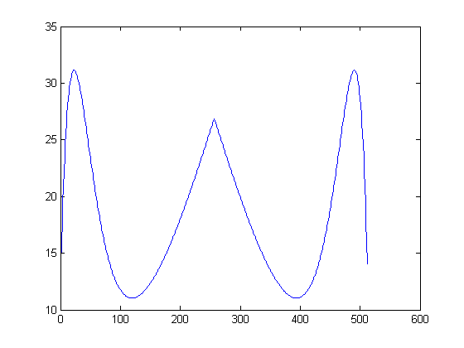
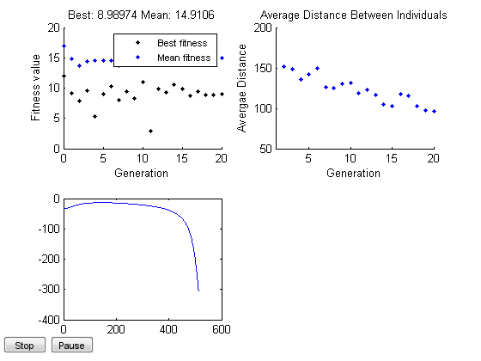

Print experiment details
display(report1);
display(report0);
diary OFF;
report1 =
-----------EXECUTION FINISHED-----------
Best score: 8.98974
Time elapsed: 13.02541 seconds
report0 =
-----------EXECUTION FINISHED-----------
Best score: 7.74327
Time elapsed: 13.15086 seconds
Published with MATLAB® R2012b

