**CSS (Cascading Style Sheet)**

Types of CSS

1. Inline CSS

Single line ,y; CSS nra;tjhFk;.

<h1 Style = “color : red;” > headings </h1>

1. Internal CSS

Fwpj;j HTML page ,dpNy style tag ,id gad;gLj;jp nra;tjhFk;

<style>

H1 {

Color : Red;

}

</style>

<h1> headings </h1>

1. External CSS

Create another file like the html file and must want to introduce the created CSS file to the html file.

The way to introduce.

< link rel = “stylesheet” href = “StyleSheet.CSS”>

CSS Selectors

1. Simple Selector

* Element

Give styles in .CSS using an element. If you have 2 headings in h1 tag, then the element selector give the styles both the h1 tags.

h1{

styles.

}

* Class

Give styles in .CSS using a class. The classes want to create into tags. <h1 class = “myHeading”>. So, we can call the class to give styles. Can create many classes in one class name. If you want to call the class, then use the full-stop symbol before the class name.

**.**myHeading{

Styles

}

* Id

It’s working like class, but we can’t set the already given name to the new id’s name. If we want to call an id then, must we want to use the case-symbol before the id.

<h1 id = “Heading”>.

**#**Heading{

Styles

}

**Note** :- we can set id and class to one tag and id is first-priority.

* Universal

Using the universal selector, we can give styles to all html elements.

**\***{

Styles.

}

1. Combinator Selector

* Descendent
* Direct Child
* Adjustment Sibling
* General Sibling

1. Attribute Selector
2. Pseudo Class Selector
3. Pseudo Element Selector

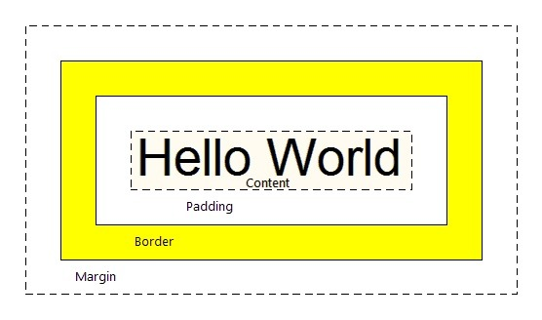CSS Box Model

* Padding
* Margin
* Boarder
* Content

Display Property

* Inline : same line, automatically fill the size to content. So, we can’t set width and height.
* Inline – block : same line, automatically fill the size to content. But we can set width and height.
* Block : default, different line, automatically fill the size to content. But we can set width and height.
* A screenshot of a computer program

  Description automatically generatedNone : this will hide the element from the html.

Flex Box

Grid

Background

Blend-Mode

Opacity

Text Properties

Create Table In CSS

Position Properties

* Static
* Relative
* Absolute
* Sticky

Out Line

Z-Index

Height And Width

Overflow

CSS Units

Transition

Justify

Align

Extra Notes :-

<nav> == navigation

<div> == division

Lorem 200 == to take 200 words

Li:hover { color : white ;} == change the color as white while hover the list.

Cursor: pointer == change cursor design

<input placeholder = “search”>

Font – variant : small / caps;

commants