CS397 Sam Jeon – Final Project Proposal
- A system design diagram
  - Minimum
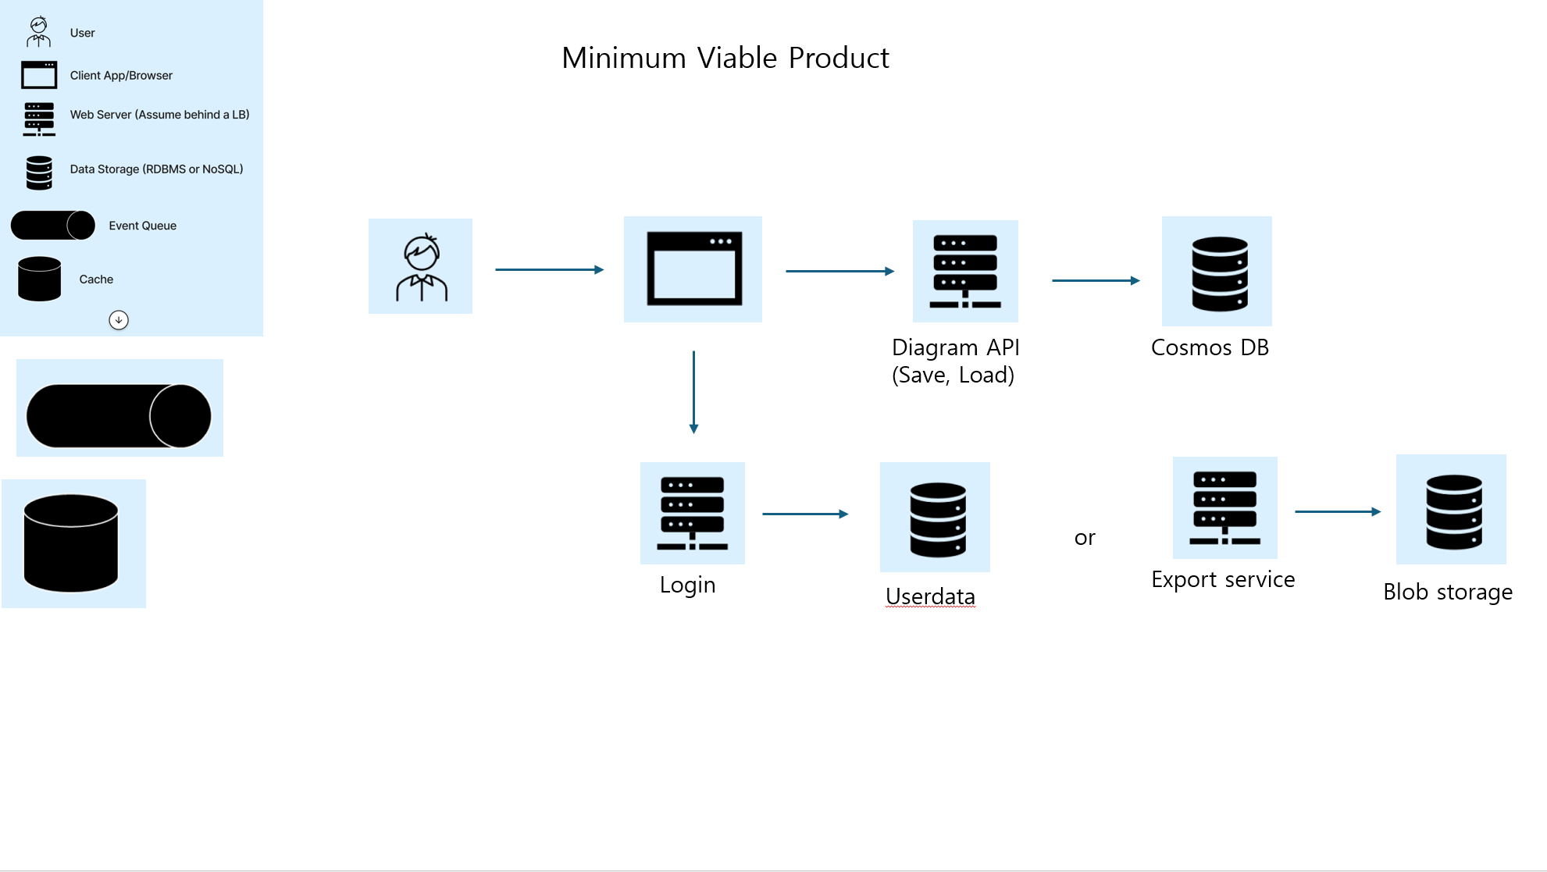
  - Final Form
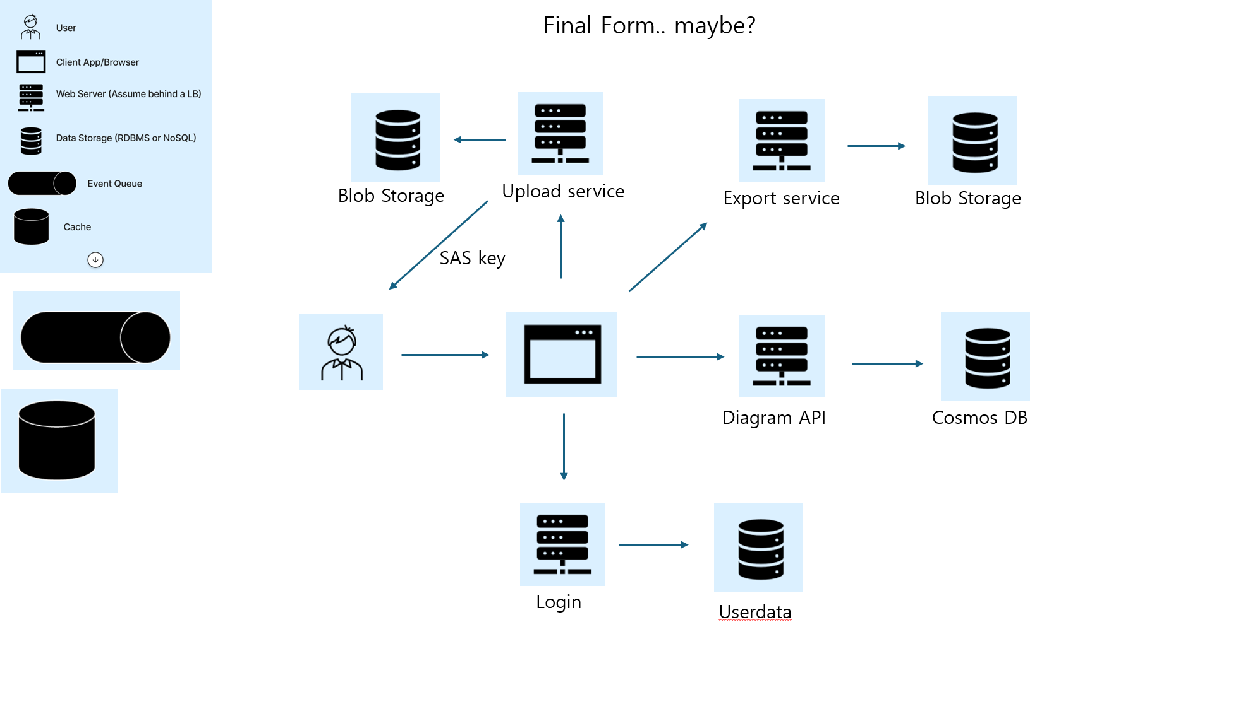

- System overview
I am building a web-based cloud architecture design tool. A user can open the site and design a simple cloud diagram by dragging predefined icons (e.g., service, database, event/queue) onto a canvas, moving them around, and arranging them visually. The user can then save their design so they can load it again later and continue editing. The design is represented as JSON generated on the front end (using React Flow), and the system stores and retrieves those designs through a backend API. Also user can export canvas to pdf or png files.
If time permits, the system may also support either:
- Uploading an image as icon (e.g., PNG/PDF), or
- A simple login/authentication flow so that saved diagrams are associated with a user account rather than just a browser identity.

- Requirements

Required (Minimum)
- The user can move, drag and place nodes and the canvas updates accordingly.
- The front end maintains the diagram as a JSON model (nodes + positions, and optionally edges).
- The user can save/load a diagram to/from the backend.
- The backend provides a Save/Load API service and stores diagrams in a single database (CosmosDB).
- The user can export canvas to pdf or png files.

Stretch Goals (if time permits)
- Asset Upload: The user can upload a custom image/icon and use it as a node in the diagram (stored in Blob Storage).
- Login/Auth: The user can sign in, and saved diagrams are associated with their account (rather than only browser-based identity).
- Auto-save: The system periodically saves changes automatically.
- Sharing: The user can share a diagram (read-only link or shared project access).
- Observability: Add basic logging/metrics to track requests and export outcomes.

