**GITHUB SEARCH USER PROJECT NOTES- MISHRA**

* Importing all files in the index.js of the pages folder to finally export them in the format of named import, this way we can import everything in one line in the App.js file (Works only if the export is in index.js because by default react servers index.js in any folder)

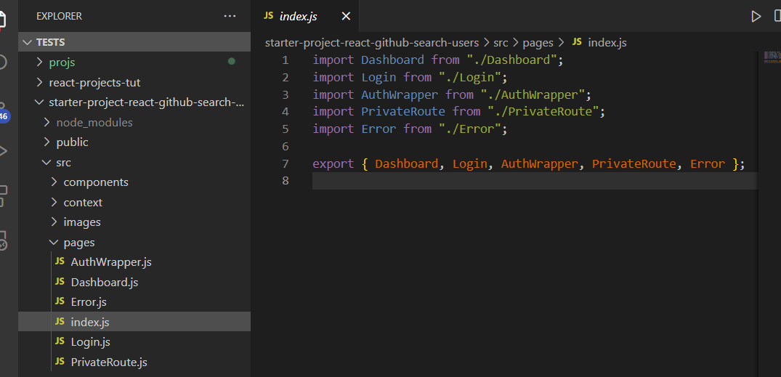

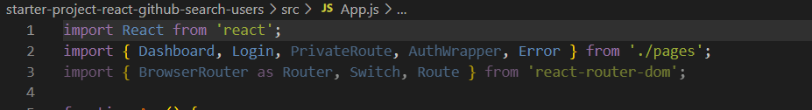

* Router -> Route; can use switch statements
* Context API (Learn More)
* Passing props in a functional component

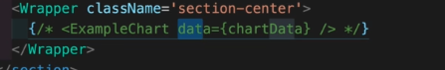

* Catching the prop

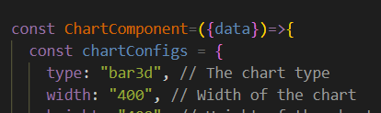

* Converting an object into an array (language is the object here) using the Object.values method

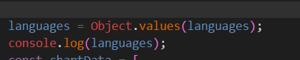

* Custom Slice method on the map method applied to followers (To show only 5 followers at once)

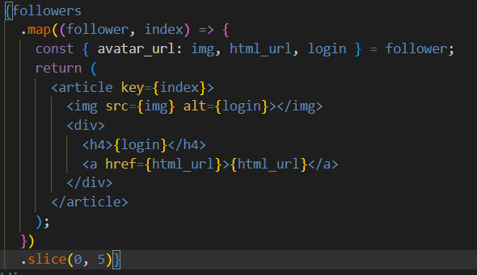

* Align-items: start; // align items as per the space taken by the content

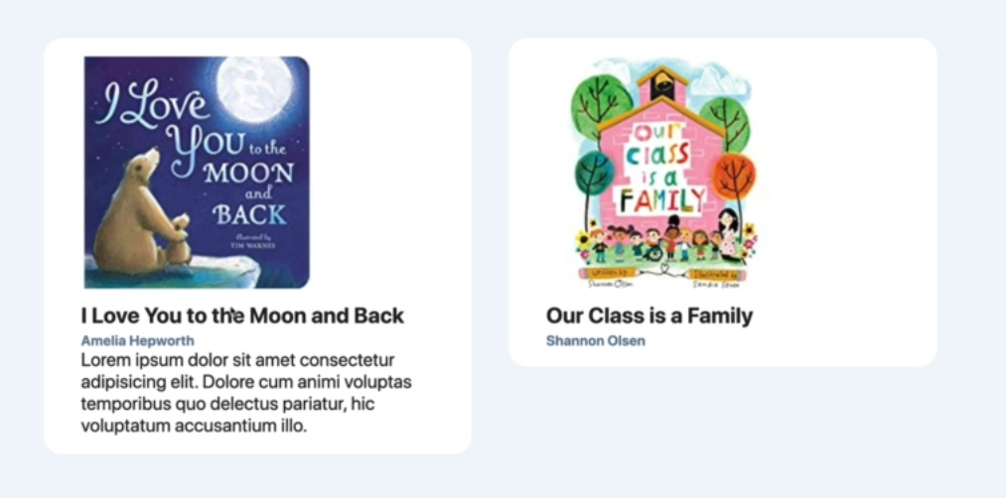

* Events in ReactJS e.g., onClick, onFocus, onChange etc (<https://reactjs.org/docs/events.html>)
* Parse any JSON data from any API to an Object

