**1. Abstract**

Since the era of technical advancements, organizations needed circulation of data and files among their employees to have specific job done by specific departments to achieve efficiency and accuracy. This is information age and we have to deal with a lot of data every day. But keeping data at a local system/place doesn’t seems to be a good idea as it would be required at any place any time. File sharing applications are one of the necessities of today’s technical growth. Currently these organizations often used emails/file sharing applications to share their data and files among the organization itself but, in the light of scandals of data piracy and misuse of collected information by companies providing these services, questions of privacy arises. This Project comes with a very good solution to that problem. This paper provides an application, WorkStation, a solution to problems of piracy, data breach and unethical data mishandling and sharing. It is programmed using PHP, JavaScript, MySQL in the backend and HTML and CSS in the frontend providing a very stable, secure and effortless File Management Service for any organization to adapt. It works for any workgroup using a common Wi-Fi network (with/without internet), a computer using XAMPP to use APACHE AND MySQL to provide with content and database support to clients. Workstation works as secure and inexpensive Project Management System. Furthermore use of WorkStation can also be as an online abode for friends, colleagues, neighbours, etc.

**2. Introduction**

In today’s industry, anything requiring more than an individual to develop/create/review, requires early making of the product to be shared among various developers/creators/reviewers to be integrated with various features. Today, most of the information of these organizations are shared via emails. Although, emails are secured by standard encryption like TLS (C. Allen, T. Dierks – 1999), they are still available to the company/organization/service provider providing these services, as Google, the most popular emailing service provider, scans through inboxes of its users. All the data is very much available to these service providers, invoking further vulnerability and unethical breach of data is possible. For any organization confidentiality and privacy of data is crucial. Requirement for a secure and confidential file sharing application, built around ease of access and usability is soaring high.

**KEYWORDS**

Web Application, Online Repository, Data Security, and File Management Service.

**3. METHODOLOGY**

Before even starting this project, I went through vigorous planning and feedback for the project to be developed not only upon my imagination but real world feedback and requirements, collected from my peer students at Chandigarh University and few people in software industry, who I’m lucky to know. I also studied few projects providing similar usage, but mostly lacked ease to use layout and effortless functionality. Upon completion of Planning and Requirement analysis, and considering feedback of potential users, basic functional layout of the project was crafted as following,

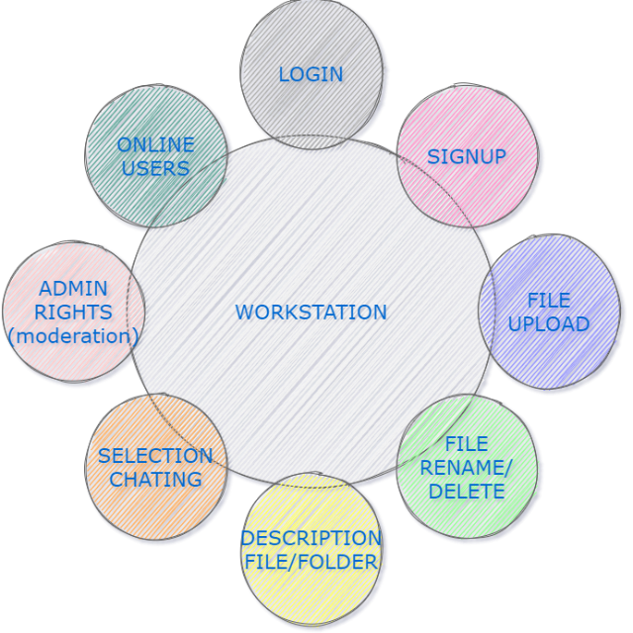

**Fig 2.2 Basic Functional Layout**

**3.1. PROJECT DEVELOPMENT**

Development of a project like this required technical selection of suited frameworks and programming languages. The development sector further involved two major ends,

* + 1. **Frontend/User-End**

Frontend of any website is what is presented for consumption. It is made of User Interface designs, responsive buttons, forms, content, etc. Frontend is what is being shown and all the actions of the website are instigated by user through frontend. The frontend or User Interface is designed using *HTML, CSS, BOOTSTRAP, GOOGLE-FONTS AND FONT AWESOME.* HTML is used to create divisions, containers and layout of the web page using <div> tags along with classes of these <div> tags. These layouts are further modified and styled using CSS to give it a smooth user experience and ease to use. All the buttons, drop-down lists, file/folder view, chat interface, etc. is styled using CSS. BOOTSTRAP is further injected into these styling sheets to create basic layouts and styling functionality hassle free. All the icons are provided by GOOGLE-FONTS and FONT AWESOME CDN (Content Delivery Network).

**3.1.2 Backend/Developer-End**

Backend is the backbone of any working website/webpage. The Backend is where all the processes instigated by the frontend is carried out, like checking credentials for log-in, fetching messages, delivering messages, fetching files, maintaining flow of interface, etc. PHP, JavaScript and MySQL is used for developing the backend. PHP is extensively used for developing backend. All the functions instigated by buttons on the interface is programmed using PHP alongside with JavaScript. PHP injected with MySQL is used to fetch messages, files, folders, user credentials, chat-rooms, etc. The database (stores all the data of the website) is created using MySQL and is updated using MySQL query and jQuery. Furthermore, the scripting of the website is achieved using JavaScript. JavaScript is used for the automation of functionalities.

* 1. **MODULES/ USE CASE MODELING**

WorkStation provides 2 different use case scenarios, Users and Administrator (Admin).

* + 1. **User use case scenario/ User Module**

Any user registered to WorkStation will be provided with functionalities as following,

* Download shared files
* Upload Files
* Mark Files to be private or shared to all users
* Create Folders
* Add description to folders and files
* Search Folders
* Join Chat Rooms
* Chat with other members of the chat group
* Log Out of Workstation

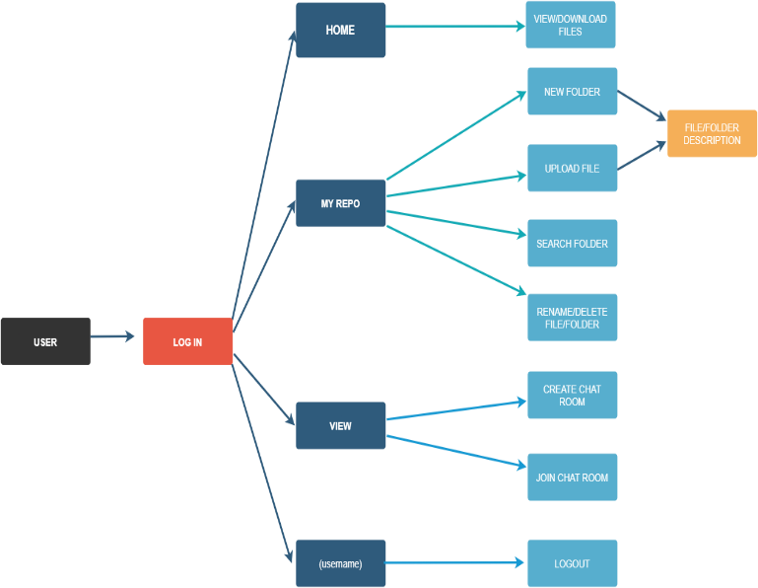

**Fig. 2.2.1 User Module/ User use case modelling**

* + 1. **Administrator use case scenario/ Admin Module**

Administrator will be provided with the same usage functionality as of user alongside with one major difference, i.e. functionality to edit, delete and add a new user.

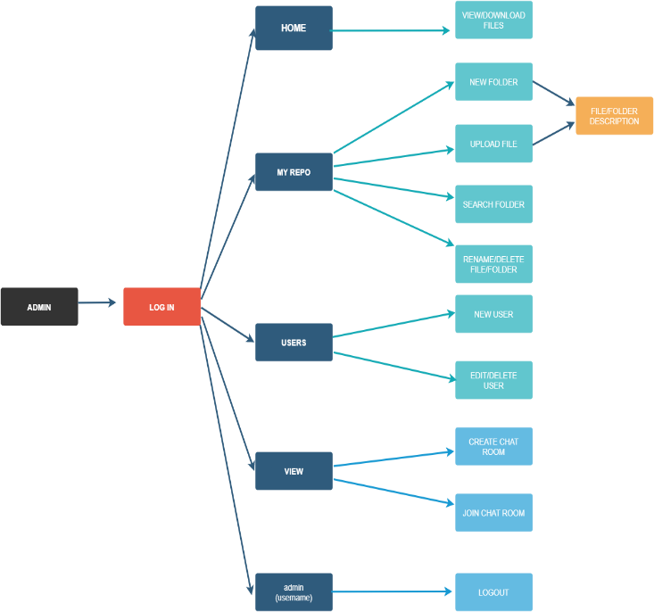

**Fig. 2.2.2 Administrator Module/ Administrator use case modelling**

**4. RESULTS AND DISCUSSIONS**

Upon completion of development, the project, WorkStation offers a very simplistic design with friendly UX (User Experience). It provides all the basic necessities of a file sharing application, i.e. file sharing functionality, added description of files for further clarification, private file sharing, public file sharing, showing concurrently online users, etc. It is also integrated with real-time chatting functionality with specific grouping. WorkStation also encrypts passwords using bcrypt (Niels Provos, David Mazières, 1999) before saving them in the database. The server and the database is further encrypted with Native MySQL Authentication.

Major shortcomings of this project is that it provides basic functionalities. This project also does not feature AES encryption ([Vincent Rijmen](https://en.wikipedia.org/wiki/Vincent_Rijmen), Joan Daemen, 1998), making is vulnerable to attacks.

**5. CONCLUSION**

The web application, WorkStation version 1.0, opens great future scope of secure file sharing applications over the web. The application achieves its major goal of easy to use and easy to implement and a secure file sharing web application. The friendly UX design and well coded backend makes it effortless to push further updates to the application.

1. **REFERENCES**

* Transport Layer Security (TLS), T. Dierks, C. Allen, January 1999, The Internet Society.
* Bcrypt, Niels Provos, David Mazières: A future Adaptable Password Scheme, June 1999, The OpenBSD Project, USENIX.
* Advanced Encryption Standard (AES), [Vincent Rijmen](https://en.wikipedia.org/wiki/Vincent_Rijmen), Joan Daemen: The Rijndael Block Cipher, 1999.