Step-by-Step Guide: AWS Lambda → S3 → DynamoDB

1. Create an AWS Account
- Sign up at https://aws.amazon.com/.
- Complete the account setup and log in to the AWS Management Console.

2. Open AWS Lambda Console
- In the AWS Management Console, search for Lambda in the top search bar and click on it.

3. Create a New Lambda Function
- Click Create function.
- Choose Author from scratch.
- Enter a name for your function (e.g., S3ToDynamoDB).
- Runtime: Select Python 3.x (latest version recommended).
- Under Permissions:
  - Option 1: Create a new role with basic Lambda permissions.
  - Option 2: Use an existing role that already has permissions for S3 and DynamoDB.
- Click Create function.
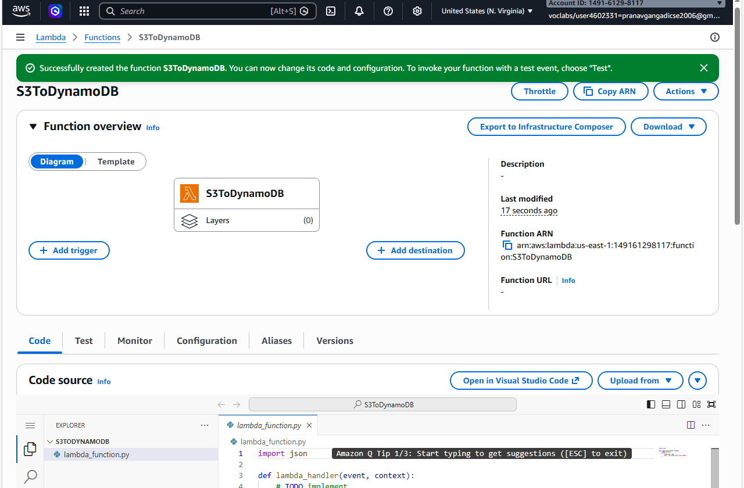

4. Add Lambda Function Code
- Scroll to the Code section.
- Replace the default code with the following Python snippet:
import boto3
from uuid import uuid4
def lambda_handler(event, context):
dynamodb = boto3.resource('dynamodb')
dynamoTable = dynamodb.Table('newtable2') # Replace 'newtable2' with your DynamoDB table name
if 'Records' in event:
for record in event['Records']:
bucket_name = record['s3']['bucket']['name']
object_key = record['s3']['object']['key']
size = record['s3']['object'].get('size', -1)
event_name = record['eventName']
event_time = record['eventTime']
# Insert data into DynamoDB
dynamoTable.put_item(
Item={
'unique': str(uuid4()),
'Bucket': bucket_name,
'Object': object_key,
'Size': size,
'Event': event_name,
'EventTime': event_time
}
)
else:
print("No S3 event received")
return {
"statusCode": 200,
"body": "Data stored in DynamoDB"
}
Make sure to replace 'newtable2' with your actual DynamoDB table name.
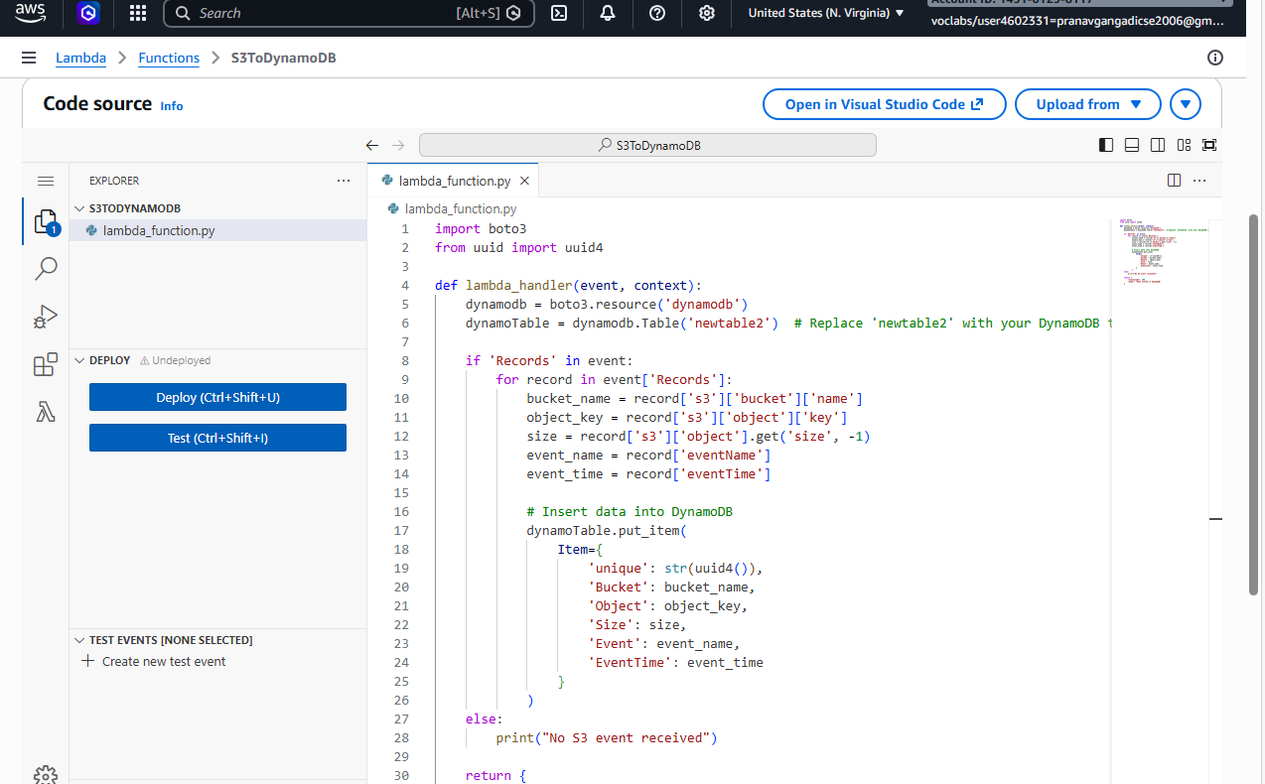

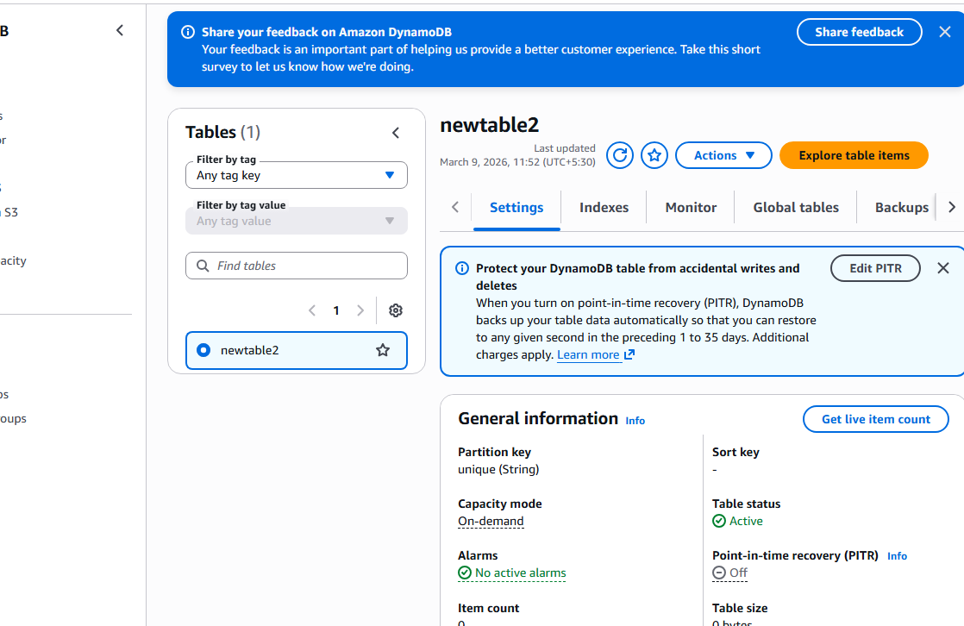

5. Configure the S3 Trigger
- In the Designer section of the Lambda console, click Add trigger.
- Select S3 as the trigger type.
- Choose the S3 bucket you want to monitor.
- Event type: Select All object create events.
- Click Add.
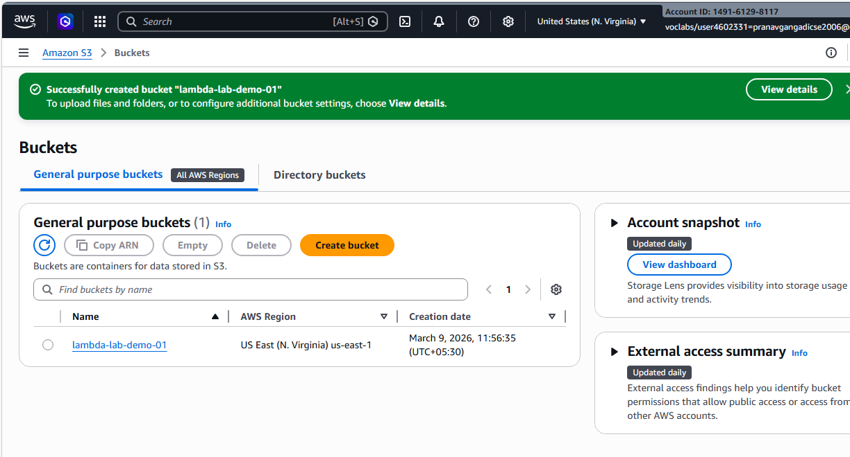
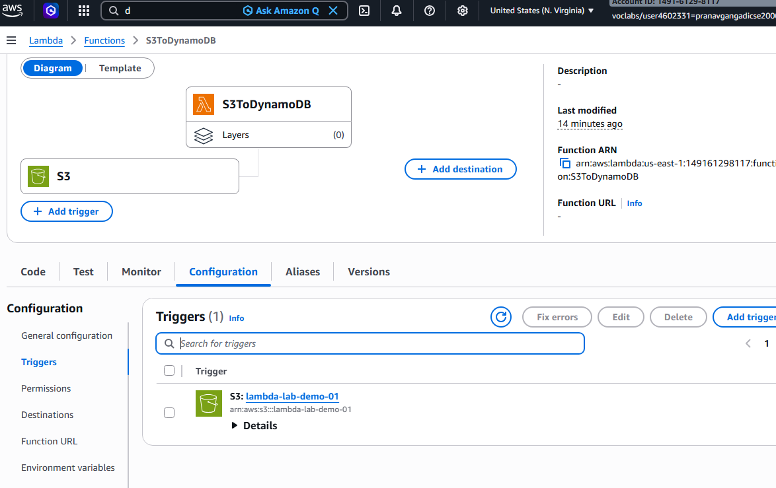

6. Test Your Lambda Function
- Click Test in the Lambda console.
- Create a sample test event:
{
"Records": [
{
"eventVersion": "2.1",
"eventSource": "aws:s3",
"awsRegion": "us-east-1",
"eventTime": "2026-03-09T12:00:00.000Z",
"eventName": "ObjectCreated:Put",
"s3": {
"bucket": {
"name": "your-bucket-name"
},
"object": {
"key": "example.txt",
"size": 123
}
}
}
]
}
- Click Test to simulate the S3 event.
- Check the DynamoDB table to verify the data was inserted.
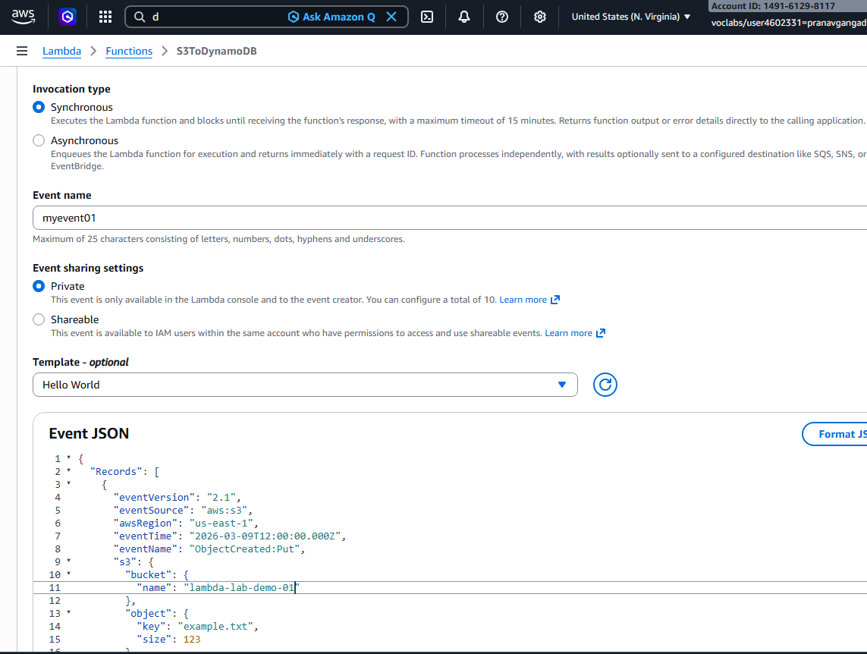

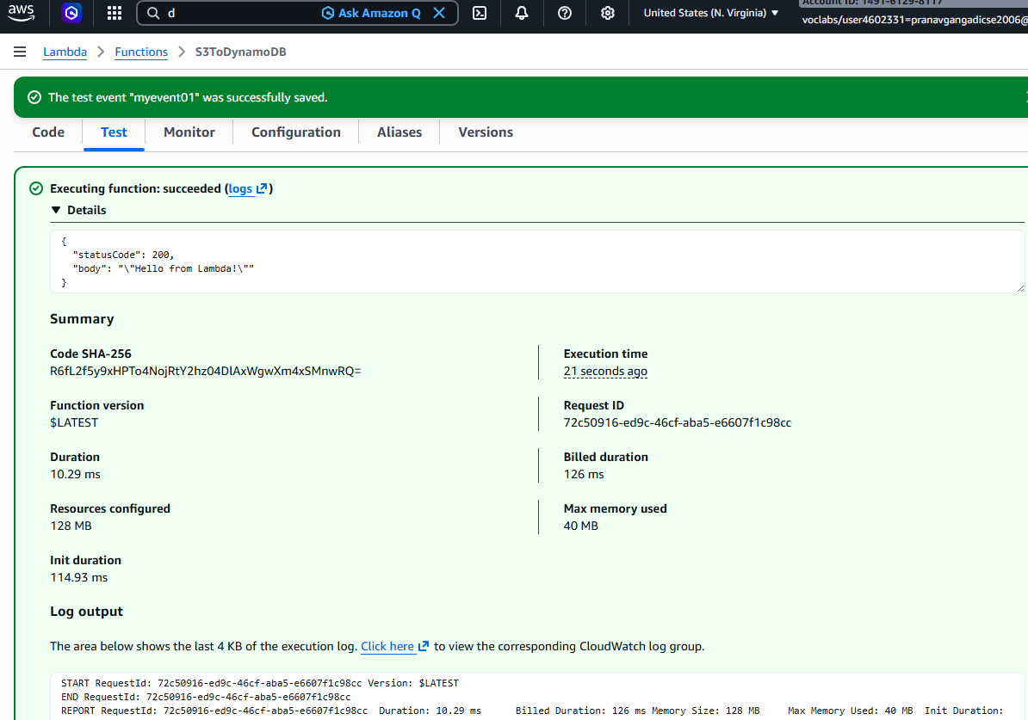

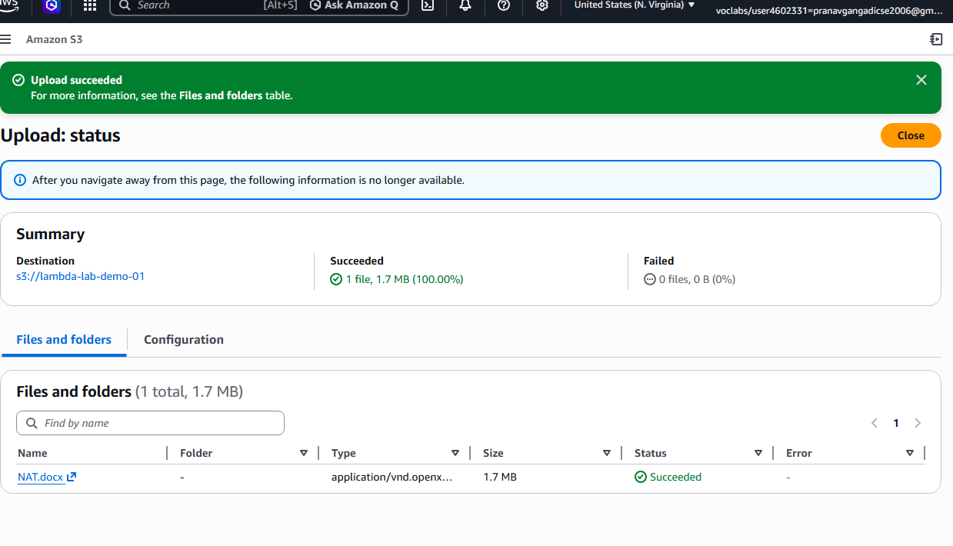

7. Deploy the Lambda Function
- Click Deploy in the Lambda console to save all changes.

8) Upload a file into bucket
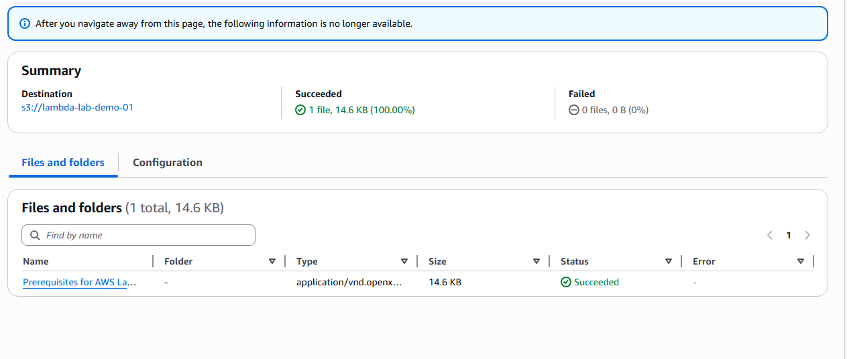
9)We can see it in the table
