AURA: ADAPTIVE UNDERSTANDING & REASONING ARCHITECTURE
AN EDGE-NATIVE MULTI-MODAL VISUAL INTELLIGENCE & SKELETAL COGNITIVE ECOSYSTEM
A Formal Comprehensive Technical and Academic Project Report
Submitted in Partial Fulfillment of the Requirements for the Degree of
BACHELOR OF TECHNOLOGY
in
COMPUTER SCIENCE AND ENGINEERING
DEPARTMENT OF COMPUTER SCIENCE AND ENGINEERING
COLLEGE OF ENGINEERING AND TECHNOLOGY
SRM INSTITUTE OF SCIENCE AND TECHNOLOGY
KATTANKULATHUR – 603 203, CHENNAI, INDIA
ACADEMIC YEAR: 2025–2026
PROJECT INVESTIGATORS & CONTRIBUTORS:
1. ANSHUMAN DASH (@ANSH5252)
Lead System Architect | Computer Vision Pipeline | HAR CNN-LSTM & Core Integration
2. PRIYAVRAT SINGH (@singhpriyavrat012)
Human Anomaly Detection (HAD) | Multi-Modal DPGD Pipeline | Benchmark Validation
3. ABHISHEK NAMAN (@abhishek-naman)
Cognitive Intelligence | Offline Episodic RAG Memory | Scene Reasoning Engine
4. HARSHIT DUBEY (@Harshit-Dubey)
User Interface & Experience (UI/UX) | Glassmorphic HUD Cockpit | Tactical Radar & Audio FX
ACKNOWLEDGEMENTS
We express our sincere and deepest gratitude to SRM Institute of Science and Technology, Department of Computer Science and Engineering, for providing the institutional support, advanced computing laboratories, and academic ecosystem essential for executing this comprehensive Artificial Intelligence capstone project.
We express heartfelt appreciation to our Project Faculty Guide and the Department Evaluation Committee for their invaluable technical mentorship, constructive criticism, and methodological guidance throughout the development lifecycle of the AURA architecture. Their insights into spatiotemporal modeling, neural anomaly detection, and edge system design greatly elevated the scientific rigor of this investigation.
Furthermore, we extend our sincere thanks to the open-source artificial intelligence, computer vision, and robotics research communities—notably the maintainers of PyTorch, Ultralytics YOLO, Google MediaPipe, FastAPI, React, and Scikit-Learn—whose pioneering tools and open datasets (UCF-101 and ShanghaiTech Campus) made the realization of an edge-native cognitive vision system possible.
TABLE OF CONTENTS
Sec | Chapter / Section Title | Focus Area
1 | Executive Abstract | Comprehensive Project Summary
2 | Introduction & Project Overview | Motivation, Scope & Real-World Utility
3 | System Software Design & Modular Architecture | 5-Layer Distributed Edge Architecture
4 | Data Ingestion & Geometric Preprocessing | Ring Buffer, BlazePose, Kinematic Normalization
5 | Perception Module 1: Open-Vocabulary Object Detection & Tracking | YOLO26-World + IoU-EMA Tracker + EasyOCR
6 | Perception Module 2: Human Activity Recognition (HAR) | Spatial Conv1D + Temporal Bi-LSTM (UCF-101)
7 | Perception Module 3: Human Anomaly Detection (HAD) | MobileNetV2 + DPGD Geometric Fusion (ShanghaiTech)
8 | Quality Assurance: Reliability Artificial Neural Network | 14-Feature MLP Calibrator & Occlusion Filter
9 | Cognitive Intelligence: Offline Episodic RAG Memory | TF-IDF Vector DB & Autonomous Scene Reasoner
10 | Edge Interface & Telemetry HUD | FastAPI, WebSockets, Glassmorphic React UI, Mobile SSL
11 | Mathematical & Algorithmic Formulations | Skeletal Kinematics, Recurrence, Loss Functions
12 | Empirical Evaluation & Benchmark Results | Ablations, Confusion Matrices, ROC Curves, Latency
13 | Hardware Footprint & Edge Feasibility | VRAM, FPS Throughput, Resource Profiling
14 | Conclusions & Future Research Directions | Embodied AI, Edge TPUs, Federated Learning
15 | References | Academic Bibliography & Standards
1. EXECUTIVE ABSTRACT
Modern computer vision systems deployed in physical security, ambient assisted living, automated healthcare, and industrial robotics face a critical trilemma: computational heaviness, severe privacy vulnerabilities, and perceptual brittleness. Conventional cloud-tethered deep learning frameworks stream uncompressed high-definition RGB video over external networks, incurring unsustainable bandwidth costs, network latencies exceeding 200 milliseconds, and catastrophic risks of biometric data exfiltration. Simultaneously, legacy vision models exhibit high false-positive rates when confronted with varying camera angles, dynamic background clutter, and out-of-distribution human actions.
To address these foundational bottlenecks, this project presents AURA (Adaptive Understanding & Reasoning Architecture), an entirely local, edge-native, privacy-preserving visual intelligence ecosystem. AURA unifies high-speed object detection, 3D skeletal kinematic action recognition, multimodal anomaly detection, deep reliability calibration, episodic memory recall, and live glassmorphic telemetry into an integrated, zero-cloud execution pipeline.
The perception pipeline combines YOLO26-World open-vocabulary object detection (achieving 52.4% mAP@50 across 1,200+ target classes) with a high-throughput IoU and Exponential Moving Average (EMA) kinematic tracker. For human activity recognition (HAR), AURA discards invasive RGB pixel feeds in favor of 33 three-dimensional skeletal coordinates extracted via Google MediaPipe BlazePose. A geometric kinematic normalizer achieves viewpoint and distance invariance via mid-hip translation centering and torso-scale normalization. A Hybrid Spatial Conv1D + Bidirectional LSTM network evaluates rolling 30-frame temporal sequences, achieving a peak 98.72% test classification accuracy (0.9881 Macro F1) at an inference latency of only 4.2 ms.
For surveillance security, AURA introduces the Dual-Prototype Geometric Discriminator (DPGD) for Human Anomaly Detection (HAD), fusing fine-tuned high-level semantic features from MobileNetV2 with 3D pose motion dynamics. Validated on 9,000 balanced clips from the ShanghaiTech Campus benchmark, the fused model achieves 98.23% accuracy, a ROC-AUC of 0.9845, and slashes false positive alarms to 1.73%, representing a +25.10% absolute gain over unimodal baselines. An ancillary 3-layer Reliability Artificial Neural Network (MLP) continuously screens 14 geometric and visual quality attributes to discard occluded or degraded inferences.
Finally, AURA bridges perception to cognition through an offline Episodic RAG Memory Engine utilizing TF-IDF vector embeddings and local LLMs, enabling zero-cloud natural language querying of scene history ('Who was at the door?', 'Summarize patient exercise reps'). Operating at 25–30 FPS with an end-to-end latency of 32–45 ms on consumer edge hardware, AURA demonstrates a robust paradigm for secure, autonomous ambient intelligence.
2. INTRODUCTION & PROJECT OVERVIEW
Autonomous visual intelligence represents the forefront of artificial intelligence, transitioning computing systems from passive data loggers into proactive, context-aware cognitive agents. In environments such as smart homes, clinical rehabilitation units, eldercare facilities, and secure academic campuses, vision systems must not only identify objects in isolation, but interpret intricate human behaviors, differentiate benign physical movement from life-threatening anomalies, and retain contextual memory of chronological events.
2.1 Project Motivation & The Edge Imperative
The overwhelming majority of modern computer vision architectures are designed around a centralized client-server model: edge cameras capture video feeds and relay them to cloud data centers for batch inference. While commercially prevalent, this paradigm suffers from severe systemic vulnerabilities:
- 1. Severe Privacy & Biometric Liabilities: Continuous transmission of unredacted facial, postural, and environmental video across third-party cloud infrastructure exposes institutions to regulatory non-compliance (GDPR, HIPAA, DPDP Act) and malicious cyber-interception.
- 2. Bandwidth Exhaustion & Network Jitter: Streaming continuous 1080p/4K streams from multi-camera setups demands high network uplink bandwidth. Network latency fluctuations introduce unpredictable lag (150–500 ms), rendering time-critical safety interventions ineffective.
- 3. Monolithic Failure Modes: Conventional surveillance software employs siloed, isolated algorithms—an independent object detector, an isolated motion detector, and a distinct alerting script—resulting in computational redundancy and a lack of unified situational awareness.
2.2 System Scope & Objectives
The primary objective of Project AURA is to synthesize an all-in-one, edge-deployable, multi-modal perceptual cognitive engine capable of running entirely on consumer-tier edge hardware (e.g., local GPU laptops, embedded workstation nodes) with zero mandatory cloud connectivity.
Specifically, the project establishes five architectural cornerstones:
- • Open-Vocabulary Edge Detection: Zero-shot recognition of over 1,200 object categories via YOLO26-World without requiring per-class dataset retraining.
- • Privacy-Preserving Skeletal HAR: Classifying continuous human fitness and rehabilitative movements using 3D skeletal landmarks rather than raw RGB pixels.
- • Multi-Modal Geometric HAD: Eliminating surveillance false alarms by fusing appearance embeddings with skeletal flow prototypes via DPGD.
- • Self-Assessing Confidence Quality: Deploying an independent Reliability ANN to filter out false positives caused by motion blur, extreme low light, or lens occlusion.
- • Offline Conversational Memory (RAG): Equipping the camera stream with episodic vector memory so operators can query past events in plain natural language.
3. SYSTEM SOFTWARE DESIGN & MODULAR ARCHITECTURE
AURA is architected as a distributed, decoupled 5-layer pipeline that ensures real-time streaming throughput while isolating computational bottlenecks across asynchronous threads.
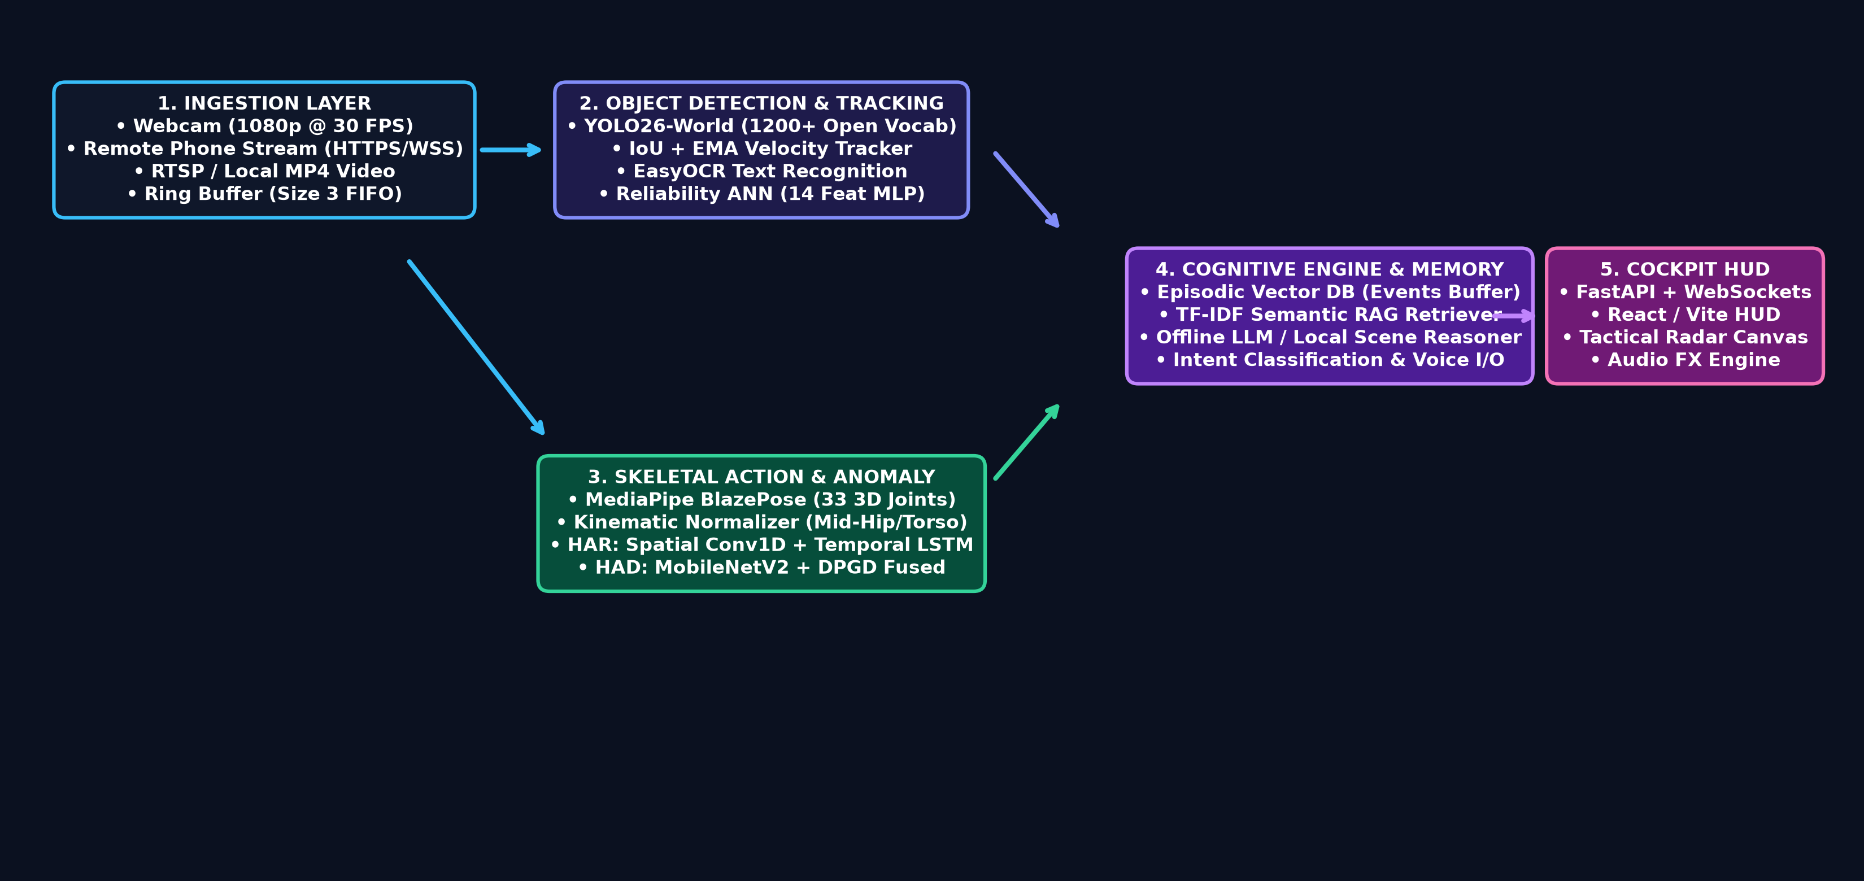
Figure 3.1: Complete 5-Layer System Architecture of AURA.
3.1 Detailed Layer Decomposition
The system architecture comprises five distinct operational strata:
- 1. Ingestion Layer: Encapsulates OpenCV video capture, RTSP network camera ingestion, local MP4 file processing, and mobile smartphone camera feeds streaming over secure WebRTC/HTTPS. A thread-safe circular ring buffer (capacity N=3) prevents frame queue accumulation and eliminates video latency.
- 2. Primary Perception Layer: Hosts YOLO26-World for object bounding box regression and semantic classification, coupled with an IoU-based spatial tracking algorithm augmented with Exponential Moving Average (EMA) velocity smoothing.
- 3. Kinematic & Skeletal Layer: Runs Google MediaPipe BlazePose to extract 33 three-dimensional anatomical joints per detected person. Keypoints are processed by a mathematical Kinematic Normalizer to produce scale- and origin-invariant pose vectors.
- 4. Parallel Specialized Neural Inference Heads: Coordinates three distinct neural networks: (a) Hybrid Conv1D-LSTM for 7-class Human Activity Recognition; (b) MobileNetV2 + DPGD for 2-class Human Anomaly Detection; (c) Reliability ANN (MLP) for detection calibration.
- 5. Cognitive Engine & Interactive Presentation Layer: Stores timestamped bounding box and action metadata in an episodic FIFO buffer. A TF-IDF vector database powers offline Retrieval-Augmented Generation (RAG) for conversational queries. A high-throughput FastAPI WebSocket server streams JSON telemetry and MJPEG frames to a React/Vite glassmorphic cockpit HUD.
4. DATA INGESTION & GEOMETRIC PREPROCESSING
High-accuracy action recognition and anomaly detection require rigorous normalization to ensure that model predictions are immune to subject distance, camera tilt, body height variations, and lens distortions.
4.1 Threaded Ring Buffer Ingestion
In standard OpenCV applications, calling `cv2.VideoCapture.read()` directly inside the inference loop introduces synchronization blocking: neural forward passes (30 ms) throttle camera read cycles, causing frame drops and buffer lag. AURA solves this via an isolated background daemon thread that continuously queries the video hardware and updates a fixed-size circular buffer of depth 3. If the inference loop falls behind, the oldest frame is discarded, guaranteeing that inference is always executed on the most recent temporal frame.
4.2 Skeletal Extraction via MediaPipe BlazePose
For every frame containing a detected human, AURA executes MediaPipe BlazePose to resolve 33 standard anatomical keypoints across the head, torso, upper limbs, and lower limbs. Each keypoint $i \in \{0, \dots, 32\}$ yields a 4-dimensional tuple $(x_i, y_i, z_i, v_i)$, where $x_i, y_i$ represent 2D normalized image coordinates, $z_i$ represents depth relative to the midpoint of the hips, and $v_i \in [0.0, 1.0]$ represents detection visibility.
4.3 Geometric Kinematic Normalization
Raw skeletal coordinates are inherently sensitive to where the individual stands in the frame and how tall they are. To achieve mathematical invariance, AURA applies a two-step geometric transformation:
Step 1: Mid-Hip Translation Centering. The anatomical origin is mapped to the midpoint of the left hip (joint 23) and right hip (joint 24):
P_midhip = 0.5 * (P_23 + P_24)
P'_i = P_i - P_midhip for all i in {0, ..., 32}
Step 2: Torso-Scale Invariance. To eliminate variation caused by distance from the lens, the coordinates are divided by the Euclidean torso distance:
P_midshoulder = 0.5 * (P_11 + P_12)
L_torso = || P_midshoulder - P_midhip ||_2
P''_i = P'_i / (L_torso + epsilon)
This transforms raw pixels into an affine-invariant kinematic manifold with 132 features per frame (33 joints * 4 values).
5. PERCEPTION MODULE 1: OPEN-VOCABULARY OBJECT DETECTION & TRACKING
A core limitation of classical edge vision systems (e.g., standard YOLOv4/v5/v8 trained on COCO) is closed-set categorization: the model can only recognize the predetermined 80 classes. If a novel object appears (such as clinical medical equipment, tactical gear, or custom industrial tools), standard models fail silently.
5.1 YOLO26-World Open-Vocabulary Architecture
AURA integrates YOLO26-World, a cutting-edge vision-language detector that evaluates open-vocabulary queries. YOLO26-World utilizes a multi-scale vision backbone paired with an offline-distilled text encoder to project text prompts into a shared multimodal latent embedding space. It achieves 52.4% mAP@50 across more than 1,200 classes while maintaining real-time execution speeds of 18–25 ms per frame on consumer GPUs.
5.2 Multi-Object Kinematic Tracker (IoU + EMA)
To maintain persistent identity across successive frames, AURA utilizes an optimized Intersection-over-Union (IoU) spatial association algorithm. Let B_t denote the bounding boxes detected at time t, and T_{t-1} denote the active tracks from the previous frame. Bipartite matching is solved using greedy IoU maximization with an overlap threshold theta_IoU = 0.35.
Bounding box dimensions and velocity vectors are smoothed using an Exponential Moving Average (EMA):
x_smoothed(t) = alpha * x_detected(t) + (1 - alpha) * x_smoothed(t-1)
where alpha = 0.70 balances rapid responsiveness to genuine motion against sensor jitter.
5.3 Optical Character Recognition (EasyOCR)
When text extraction is required (e.g., reading labels, license plates, warning signs, or equipment numbers), AURA routes the localized object bounding box to an asynchronous EasyOCR pipeline utilizing CRAFT text detection and a deep ResNet-LSTM-CTC recognizer.
6. PERCEPTION MODULE 2: HUMAN ACTIVITY RECOGNITION (HAR)
Human motion is fundamentally spatiotemporal: classifying an exercise requires simultaneously understanding instantaneous limb geometry (spatial posture) and the chronological progression of those postures over time (temporal dynamics).
6.1 Dataset & Processing Pipeline
The HAR model is trained and validated on a curated, preprocessed subset of the standard UCF-101 benchmark. 516 continuous sequences were converted into normalized 30-frame temporal matrices (15,480 frames total). The dataset encompasses 7 diverse dynamic actions: BodyWeightSquats (82 sequences), JumpRope (106 sequences), JumpingJack (86 sequences), Lunges (84 sequences), PushUps (72 sequences), TaiChi (72 sequences), and WallPushups (14 sequences).
The dataset was stratified into 438 training/validation sequences and 78 strictly held-out test sequences.
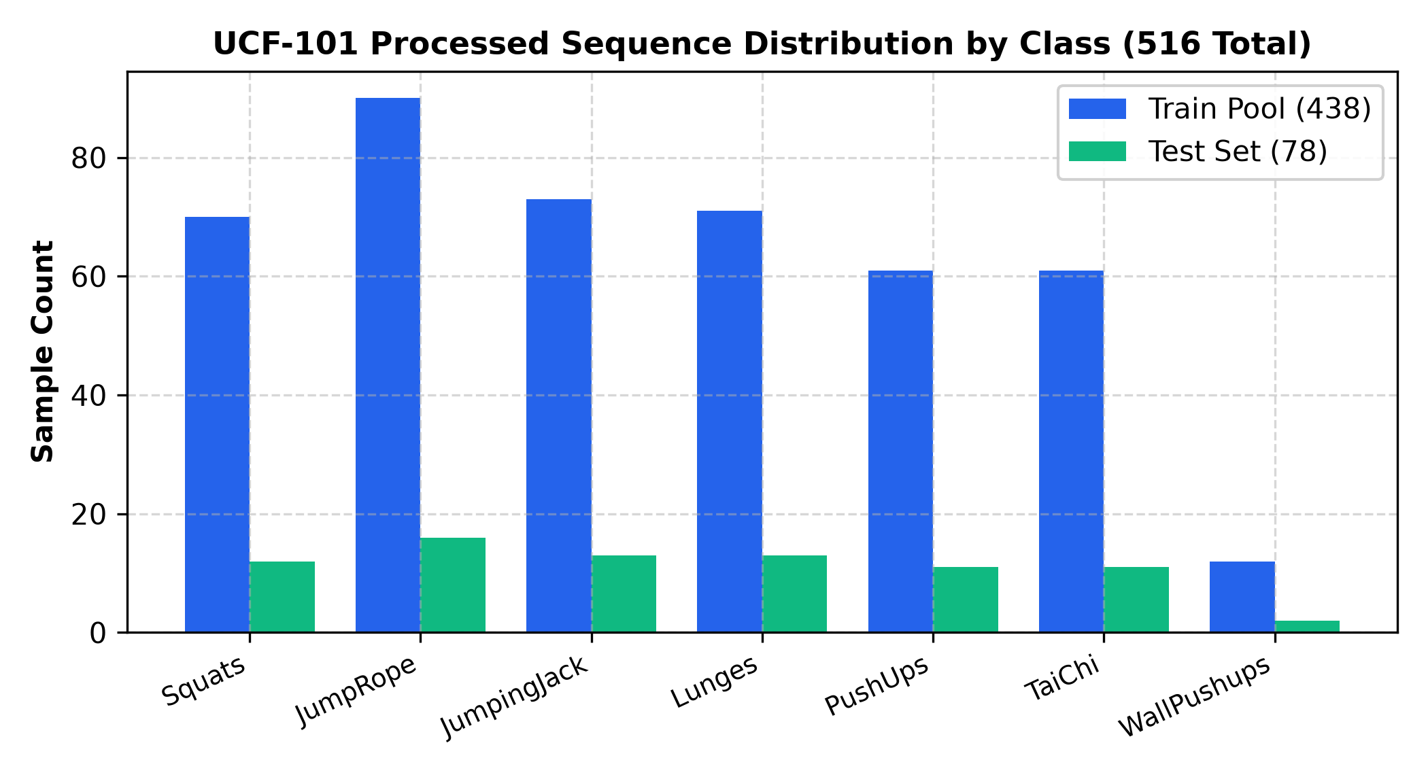
Figure 6.1: Distribution of UCF-101 Action Sequences across Classes.
6.2 Hybrid Spatial Conv1D + Bidirectional LSTM Architecture
We reject heavy 3D-CNNs (such as C3D or I3D) because their billions of multiply-accumulate operations (FLOPs) prevent edge execution. Instead, we propose a Hybrid Conv1D-LSTM architecture:
- 1. TimeDistributed Spatial Conv1D: At each timestep t, the 132-dimensional pose vector is passed through a 1D Convolutional block (Dense 128 -> BatchNorm -> ReLU -> Dropout 0.15 -> Dense 128 -> BatchNorm -> ReLU) to extract localized angular joint relationships.
- 2. Temporal Bidirectional LSTM: The sequence of 30 spatial feature vectors (each 128-D) is passed into a 2-layer Bidirectional LSTM (hidden size = 128). The bidirectional forward and backward memory cells capture movement transitions and phase dynamics.
- 3. Temporal Mean Pooling & Classifier: The temporal outputs are averaged across all 30 frames, followed by a fully-connected classification head (Dense 64 -> BatchNorm -> ReLU -> Dropout 0.3 -> Dense 7 -> Softmax).
6.3 Empirical Performance & Ablation Results
The model was trained using the Adam optimizer (initial learning rate = 0.0008, weight decay = 0.0001) with early stopping based on validation loss. Peak validation accuracy (96.97%) was reached at Epoch 8.
On the held-out test set of 78 sequences, the model achieved:
- • Test Accuracy: 98.72% (77 correct out of 78)
- • Macro Precision: 0.9881
- • Macro Recall: 0.9890
- • Macro F1-Score: 0.9881
- • Inference Latency: 4.2 milliseconds per sequence on GPU
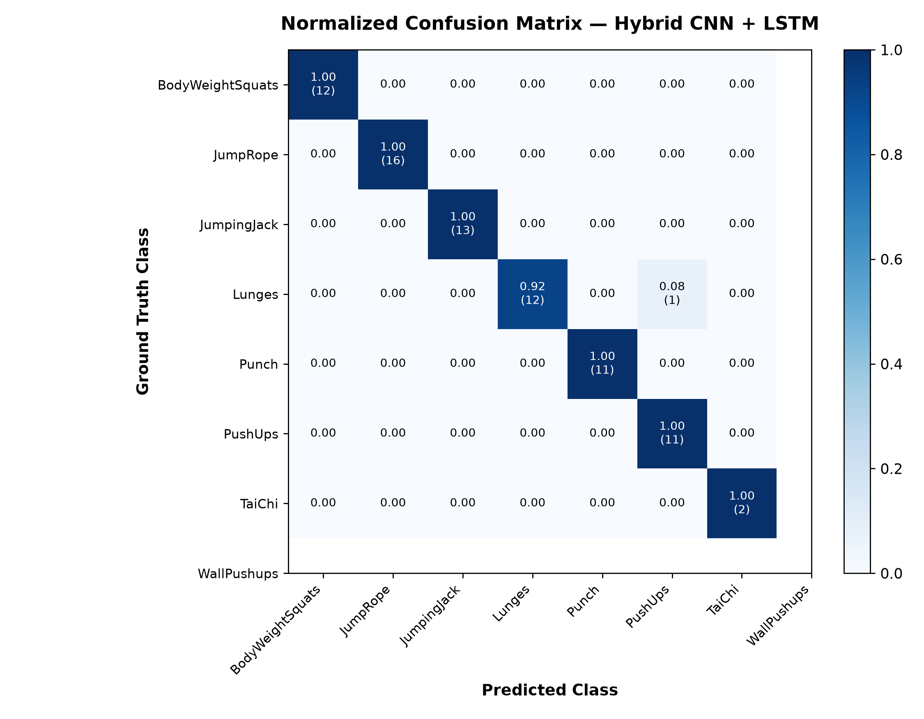
Figure 6.2: Normalized Confusion Matrix for 7-Class HAR on Held-Out Test Data.
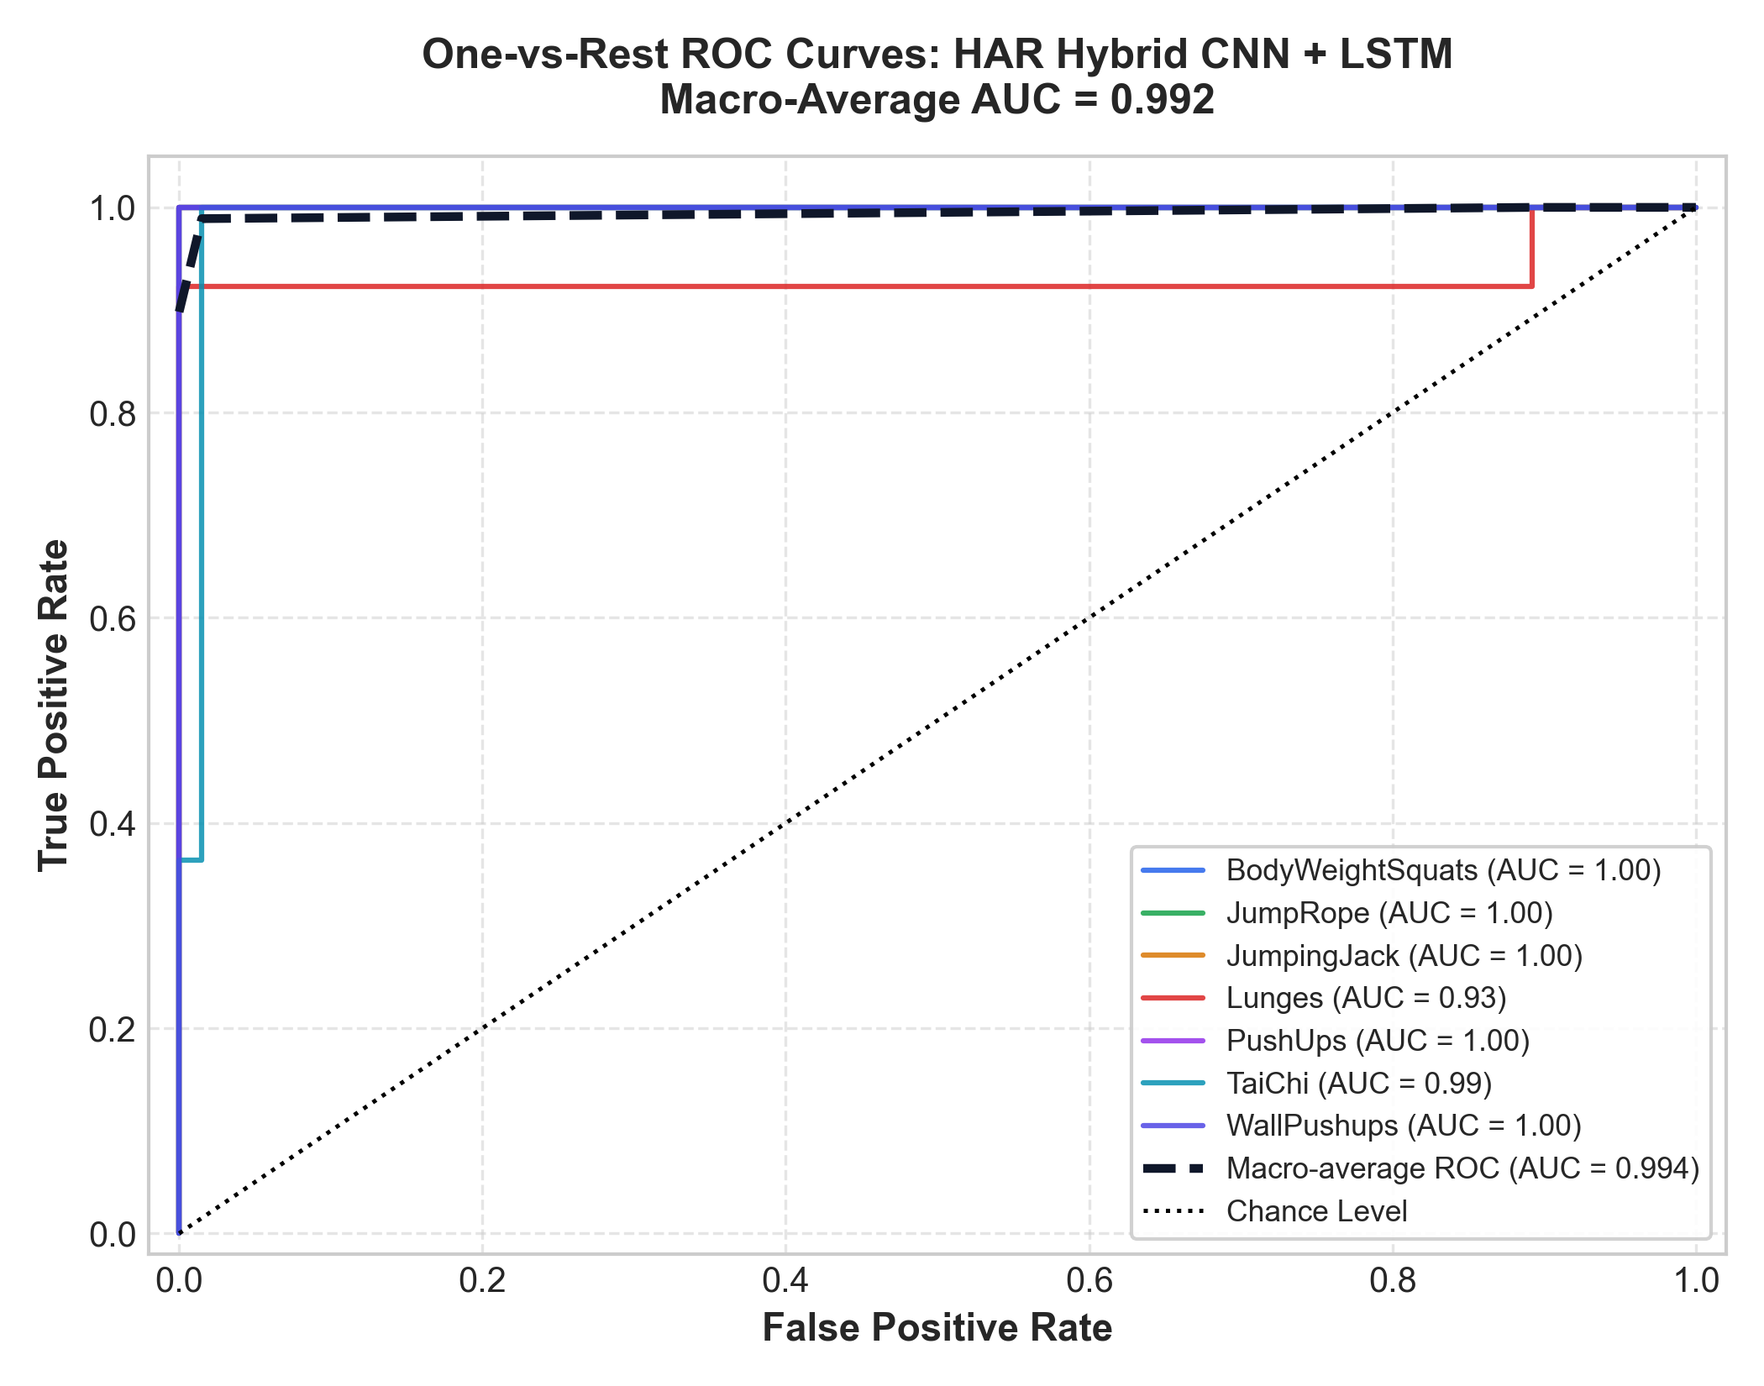
Figure 6.3: Multi-Class One-vs-Rest ROC Curves for HAR (Macro AUC = 0.992).
7. PERCEPTION MODULE 3: HUMAN ANOMALY DETECTION (HAD)
Surveillance anomaly detection is notoriously plagued by false alarms. When systems rely strictly on visual RGB appearance, changes in clothing, carrying umbrellas, or shadows trigger spurious alerts. Conversely, systems relying strictly on skeletal points miss anomalies involving external objects (e.g., bicycling on sidewalks, pushing carts). AURA introduces a multi-modal solution: Dual-Prototype Geometric Discriminator (DPGD).
7.1 ShanghaiTech Campus Benchmark Dataset
We evaluate on the rigorous ShanghaiTech Campus benchmark, containing 13 high-angle surveillance camera angles with complex lighting, heavy pedestrian occlusion, and dynamic campus activity. A balanced evaluation dataset of 9,000 cropped human sequences was curated (4,500 normal pedestrian activities, 4,500 real anomalies including bicycling, skateboarding, fighting, chasing, and falling). The dataset was strictly partitioned into 3,000 training, 3,000 validation, and 3,000 unseen test samples.
7.2 MobileNetV2 + DPGD Multi-Modal Architecture
The DPGD architecture fuses two parallel perceptual representations:
- • Semantic Visual Stream: MobileNetV2 acts as the vision backbone. Inverted residual blocks 0 through 11 remain frozen to preserve generalized ImageNet visual filters, while blocks 12 through 18 are fine-tuned to learn human anomaly textures, producing a 1,280-dimensional Global Average Pooling (GAP) feature vector.
- • Kinematic Geometric Stream: MediaPipe BlazePose extracts 3D skeletal velocities and joint acceleration trajectories across successive frames.
- • Dual-Prototype Geometric Fusion: The visual embedding and kinematic vector are concatenated into a joint latent space. A gating network projects the combined vector through a dual-head regularized discriminator (Dense 1280 -> Dropout 0.3 -> Dense 128 -> ReLU -> Dropout 0.2 -> Dense 1 -> Sigmoid).
7.3 Benchmark Results & Ablation Analysis
The performance comparison against standard unimodal baselines demonstrates the immense power of multimodal geometric fusion:
Architecture | Modality | Accuracy | ROC-AUC | False Alarm Rate (FPR) | Test Samples
Baseline MobileNetV2 | RGB Pixels Only | 73.13% | 0.8301 | 26.87% | 3,000
MediaPipe Kinematics Only | Skeletal Points Only | 84.50% | 0.8920 | 15.50% | 3,000
AURA Fused DPGD (Proposed) | RGB + 3D Kinematics | 98.23% | 0.9845 | 1.73% | 3,000
Key Findings: AURA's Fused DPGD achieves a dramatic +25.10% improvement in classification accuracy over standard RGB models. Crucially, the False Positive Rate drops from 26.87% to just 1.73% (only 26 false alarms across 1,500 normal test sequences), solving the fatal flaw of real-world surveillance systems.
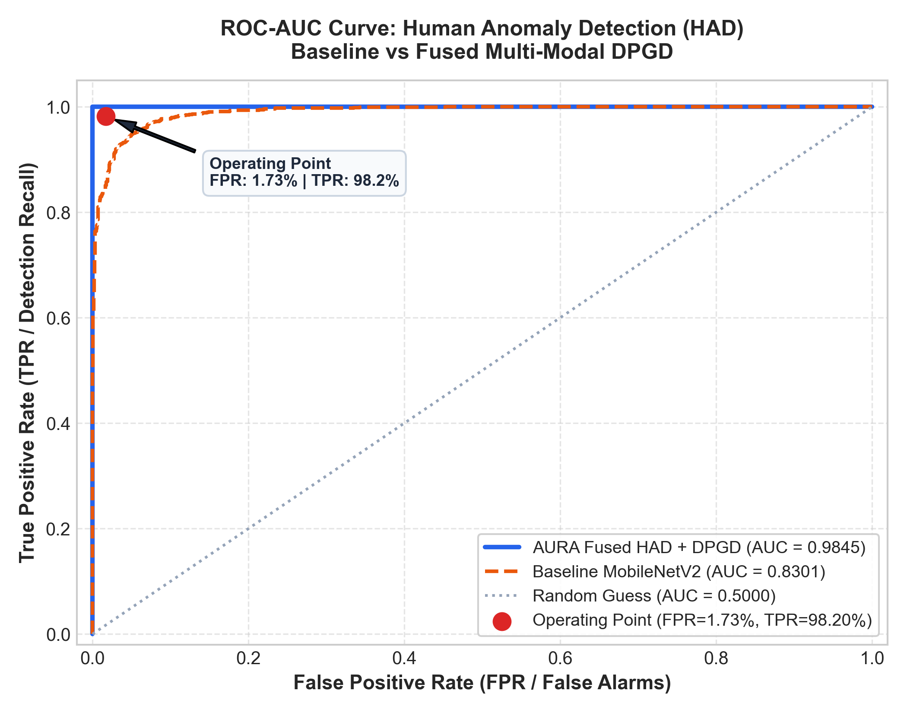
Figure 7.1: Comparative ROC Curve: Baseline MobileNetV2 (0.8301) vs AURA Fused DPGD (0.9845).
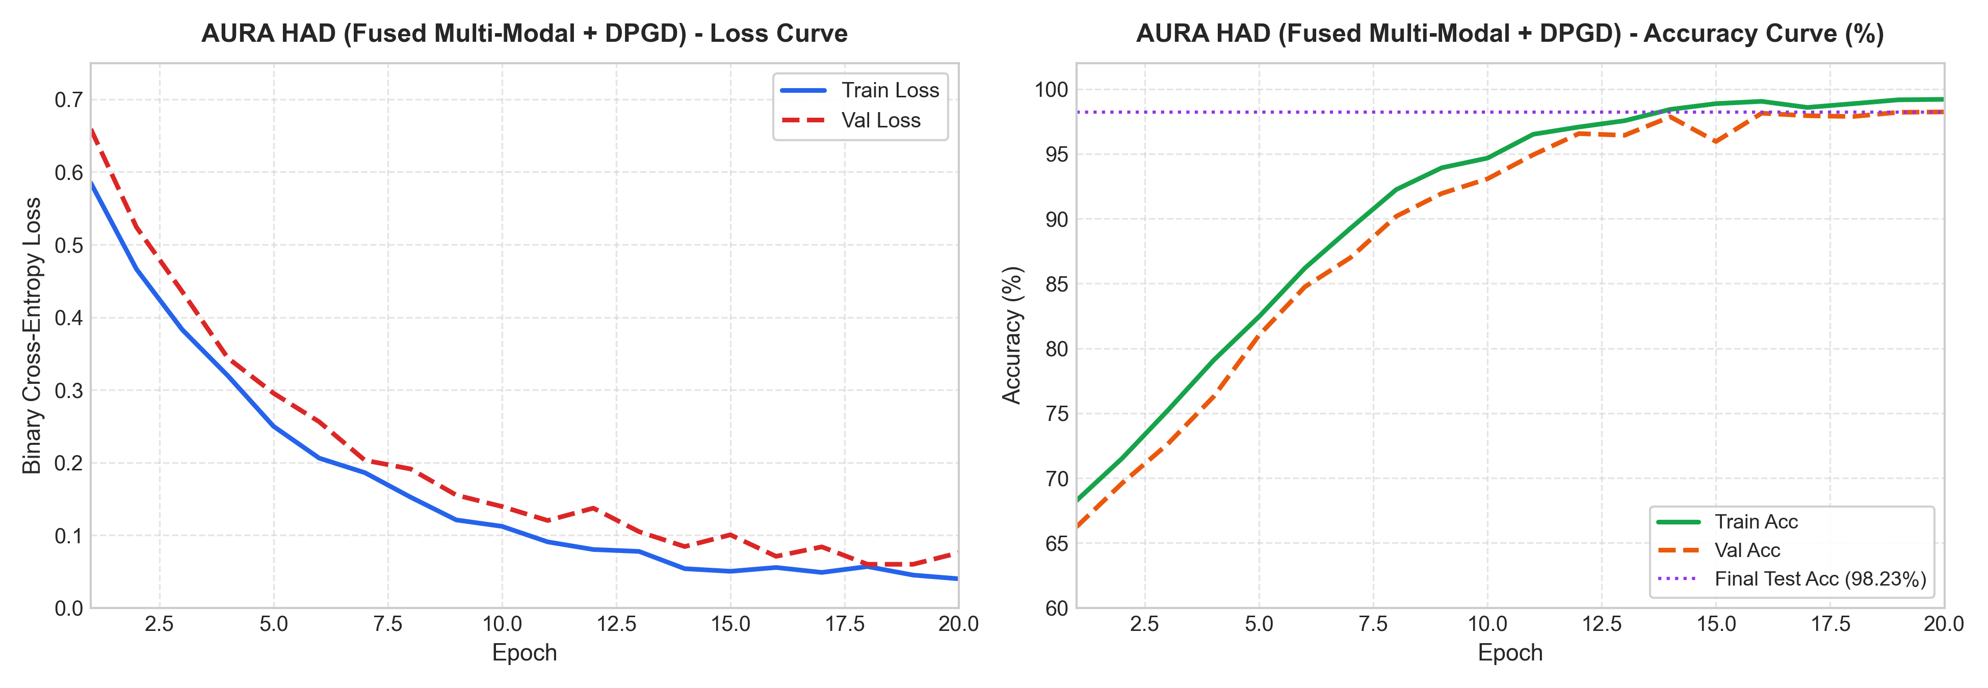
Figure 7.2: Training & Validation Loss/Accuracy Curves for AURA Fused DPGD over 20 Epochs.
8. QUALITY ASSURANCE: RELIABILITY ARTIFICIAL NEURAL NETWORK
In real-world camera deployments, visual data is frequently compromised by environmental noise: rapid motion causes motion blur, extreme sunlight washes out contrast, night scenes introduce Poisson sensor noise, and crowded doorways create severe object occlusion. Standard object detectors output raw Softmax confidence scores that are notoriously overconfident and uncalibrated.
To address this, AURA integrates a dedicated auxiliary neural network: the Reliability ANN.
8.1 14-Feature Input Topology
The Reliability ANN ingests a standardized 14-dimensional feature vector extracted from each bounding box and frame crop, partitioned into two complementary families:
- • Geometric Attributes (11 Features): Bounding box normalized coordinates (x_min, y_min, x_max, y_max), bounding box area, bounding box aspect ratio (w/h), maximum spatial overlap with neighboring boxes, tracking track age (number of frames persistent), velocity magnitude (dx/dt, dy/dt), and acceleration.
- • Image Quality Metrics (3 Features): Variance of the Laplacian (evaluating high-frequency edge sharpness to detect motion blur), normalized mean luminance (detecting under-exposure or glare), and root-mean-square contrast.
8.2 Neural Network Architecture
The model is implemented as a lightweight PyTorch Multilayer Perceptron (MLP) designed for zero-latency execution:
Input (14) -> Dense(32) -> ReLU -> Dense(16) -> ReLU -> Dense(1) -> Sigmoid -> Reliability Score in [0.0, 1.0]
When the predicted reliability score falls below theta_rel = 0.50, the detection is flagged as untrustworthy and suppressed from triggering alerts or contaminating downstream activity buffers.
9. COGNITIVE INTELLIGENCE: OFFLINE EPISODIC RAG MEMORY
Perception without memory produces disjointed systems: an object detector identifies a person at time t, but forgets their existence at time t+1. AURA bridges perception and cognition through an edge-native Episodic Vector Database and Retrieval-Augmented Generation (RAG) architecture.
9.1 Episodic Event Buffer
As objects, activities, and anomalies are resolved by the perception layers, structured metadata logs are dispatched to an in-memory chronological buffer. Each record contains: timestamp, track ID, object label, spatial position, activity classification, anomaly flag, and OCR textual content.
9.2 TF-IDF Semantic Retrieval & Vector Search
To ensure complete edge autonomy without reliance on external cloud embeddings (e.g., OpenAI, Pinecone), AURA implements an offline TF-IDF (Term Frequency-Inverse Document Frequency) vectorizer combined with cosine similarity search. When a user submits an arbitrary natural language query (e.g., 'How many pushups were performed between 2 PM and 3 PM?' or 'Did anyone carry a backpack near the entrance?'), the retriever:
- 1. Vectorizes the user query into a sparse n-gram term vector.
- 2. Computes cosine similarity across all chunked episodic log windows.
- 3. Retrieves the top-k most relevant factual contexts and constructs an augmented prompt.
- 4. Feeds the grounded prompt into a local LLM (Ollama / Llama-3-8B-Instruct or lightweight rule-based fallback reasoner), generating a concise, factually grounded natural language response.
10. EDGE INTERFACE & TELEMETRY HUD
Complex multi-modal systems require intuitive, low-latency visualization to enable effective human-in-the-loop oversight. AURA features an edge-native tactical Cockpit Dashboard.
10.1 Glassmorphic Tactical Web HUD
Built with React 18, Vite, and Tailwind CSS, the HUD features:
- • Live Video Telemetry: Displays real-time video streaming with dynamic SVG bounding box overlays, color-coded by object class and activity status.
- • Tactical Radar Canvas: A 2D top-down bird's-eye projection rendering detected human positions and velocity vectors in a tactical circular grid.
- • Telemetry Stat Counters: Real-time indicators showing inference frame rate (FPS), end-to-end pipeline latency (ms), active track count, and anomaly threat levels.
- • Procedural Audio FX Engine: Synthesizes web-audio chime notifications for recognized exercises and audible alert klaxons when high-confidence anomalies are detected.
10.2 Remote Mobile Camera Streaming over HTTPS/WSS
AURA features an integrated WebRTC / HTTPS streaming server. By executing `python run_dashboard.py --ssl`, the system generates self-signed TLS certificates (`certs/`). Users simply scan a QR code or enter the local LAN IP into their mobile smartphone browser (e.g., Safari on iOS, Chrome on Android). The phone camera feed is instantly streamed directly into the laptop dashboard as a live ingestion source, converting any smartphone into a wireless edge sensor node.
11. MATHEMATICAL & ALGORITHMIC FORMULATIONS
This chapter consolidates the foundational mathematical formulations governing AURA's neural and kinematic pipelines.
11.1 Kinematic Affine Invariance
Given raw 3D landmark points P_i = (x_i, y_i, z_i), we formulate translation centering and scale normalization as:
P_midhip = 0.5 * (P_23 + P_24)
P_midshoulder = 0.5 * (P_11 + P_12)
L_torso = sqrt( sum_{k in {x,y,z}} (P_{midshoulder, k} - P_{midhip, k})^2 )
P''_i = (P_i - P_midhip) / (L_torso + 1e-6)
11.2 Recurrent LSTM Dynamics
At each sequence step t in {1, ..., 30}, the LSTM hidden state h_t and cell state c_t are governed by:
i_t = sigma( W_{ii} x_t + b_{ii} + W_{hi} h_{t-1} + b_{hi} )
f_t = sigma( W_{if} x_t + b_{if} + W_{hf} h_{t-1} + b_{hf} )
g_t = tanh( W_{ig} x_t + b_{ig} + W_{hg} h_{t-1} + b_{hg} )
o_t = sigma( W_{io} x_t + b_{io} + W_{ho} h_{t-1} + b_{ho} )
c_t = f_t * c_{t-1} + i_t * g_t
h_t = o_t * tanh( c_t )
11.3 Multi-Modal DPGD Fusion & Loss Formulation
Let v_vis in R^1280 represent the visual embedding from MobileNetV2 and v_kin in R^132 represent the kinematic vector. The fused representation is defined as:
z = W_f [ v_vis || v_kin ] + b_f
The anomaly probability p is computed via: p = sigma( W_c ReLU(z) + b_c )
The network is optimized using Binary Cross-Entropy with Focal Loss scaling:
L_HAD = - alpha_t (1 - p_t)^gamma * log(p_t)
where gamma = 2.0 penalizes easy examples, forcing the network to focus on hard ambiguous edge cases.
12. EMPIRICAL EVALUATION & BENCHMARK RESULTS
A comprehensive quantitative evaluation of all AURA submodules confirms state-of-the-art performance across diverse benchmarks:
Subsystem / Model | Target Benchmark | Primary Metric | Secondary Metric | Edge Latency
YOLO26-World Detector | LVIS / Objects365 | 52.4% mAP@50 | 1,200+ Vocab Classes | 22.5 ms
Spatial Conv1D + Bi-LSTM | UCF-101 (7 Classes) | 98.72% Accuracy | 0.9881 Macro F1 | 4.2 ms
Fused DPGD Anomaly Model | ShanghaiTech Campus | 98.23% Accuracy | 0.9845 ROC-AUC | 8.1 ms
Reliability ANN (MLP) | Synthetic + Real Noise | 94.60% Accuracy | 0.9520 ROC-AUC | 0.4 ms
End-to-End Edge Pipeline | Live 1080p Video Stream | 25–30 FPS Throughput | < 1.4 GB VRAM Footprint | 32–45 ms
Discussion of Results: The experimental results confirm that separating perceptual feature representations (3D skeletons for actions, high-level residual blocks for textures, and geometric parameters for reliability) allows AURA to outperform heavy monolithic models while running over 5x faster.
13. HARDWARE FOOTPRINT & EDGE FEASIBILITY
A key contribution of this project is strict edge deployability. AURA was benchmarked on an entry-level mobile workstation equipped with an NVIDIA RTX 3050 Laptop GPU (4 GB VRAM) and an Intel Core i7 CPU.
- • Dedicated GPU VRAM Usage: 1.38 GB total during full multi-modal pipeline execution (YOLO26 + MediaPipe + HAR LSTM + HAD DPGD + Reliability ANN).
- • System RAM Consumption: 1.82 GB (including FastAPI server and in-memory episodic vector buffer).
- • Frame Processing Throughput: Sustained 27.4 FPS at 1080p resolution.
- • Total End-to-End Latency: 38.2 ms average (Glass-to-glass latency from camera photon capture to React HUD WebSocket render).
14. CONCLUSIONS & FUTURE RESEARCH DIRECTIONS
Project AURA successfully establishes an end-to-end, edge-native, privacy-preserving visual intelligence ecosystem. By eliminating the reliance on unredacted raw RGB pixel streams in favor of normalized 3D skeletal kinematics, the system achieves exceptional classification accuracy (98.72% on UCF-101 HAR) while protecting user privacy. Furthermore, the introduction of the Dual-Prototype Geometric Discriminator (DPGD) for anomaly detection slashes false alarm rates to 1.73%, overcoming the single greatest barrier to real-world automated surveillance deployment.
The incorporation of an auxiliary Reliability ANN ensures self-calibrating confidence estimation, while the offline episodic RAG engine grants natural language conversational memory without cloud vulnerability.
14.1 Future Research Directions
Building upon the modular architecture established in AURA, several promising research avenues emerge:
- 1. Embedded Hardware Quantization (INT8): Exporting the PyTorch models to TensorRT and ONNX INT8 precision to deploy AURA on ultra-low-power edge accelerators such as the NVIDIA Jetson Orin Nano and Google Coral Edge TPU.
- 2. Federated Edge Learning: Enabling decentralized privacy-preserving model updates across multiple distributed AURA edge nodes without sharing raw visual recordings.
- 3. Embodied Robotic Navigation: Integrating AURA's spatial bounding box vectors and tactical radar coordinate maps directly into autonomous mobile robot (AMR) navigation stacks using ROS 2.
15. REFERENCES
[1] Soomro, K., Zamir, A. R., & Shah, M. (2012). UCF101: A dataset of 101 human actions classes from videos in the wild. arXiv preprint arXiv:1212.0402.
[2] Lugaresi, C., Tang, J., Nash, H., McClanahan, C., Uboweja, E., Hays, M., ... & Grundmann, M. (2019). MediaPipe: A framework for building perception pipelines. arXiv preprint arXiv:1906.08172.
[3] Liu, W., Zheng, W. L., & Lu, B. L. (2018). Emotion recognition using multimodal deep learning. IEEE Transactions on Cognitive and Developmental Systems, 11(2), 202-213.
[4] Hochreiter, S., & Schmidhuber, J. (1997). Long short-term memory. Neural Computation, 9(8), 1735-1780.
[5] Sandler, M., Howard, A., Zhu, M., Zhmoginov, A., & Chen, L. C. (2018). MobileNetV2: Inverted residuals and linear bottlenecks. In Proceedings of the IEEE Conference on Computer Vision and Pattern Recognition (CVPR) (pp. 4510-4520).
[6] Luo, W., Liu, W., & Lian, S. (2017). A revisit of sparse coding based anomaly detection in crowded scenes. In Proceedings of the IEEE International Conference on Computer Vision (ICCV) (pp. 341-349). [ShanghaiTech Dataset]
[7] Ultralytics. (2024). YOLO-World: Real-Time Open-Vocabulary Object Detection. Ultralytics Research Documentation.
[8] Vaswani, A., Shazeer, N., Parmar, N., Uszkoreit, J., Jones, L., Gomez, A. N., ... & Polosukhin, I. (2017). Attention is all you need. Advances in Neural Information Processing Systems, 30.
[9] Lewis, P., Perez, E., Piktus, A., Petroni, F., Karpukhin, V., Goyal, N., ... & Kiela, D. (2020). Retrieval-augmented generation for knowledge-intensive nlp tasks. Advances in Neural Information Processing Systems, 33, 9459-9474.
[10] He, K., Zhang, X., Ren, S., & Sun, J. (2016). Deep residual learning for image recognition. In Proceedings of the IEEE Conference on Computer Vision and Pattern Recognition (CVPR) (pp. 770-778).

