**Day 2 – Assignment**

**Pratik K Kamble**

**Employee ID : 46263548**

**10 – 09 – 2022**

**Q1** : Create a method to find the sum of the cubes of the digits of an n digit number

**Solution –**

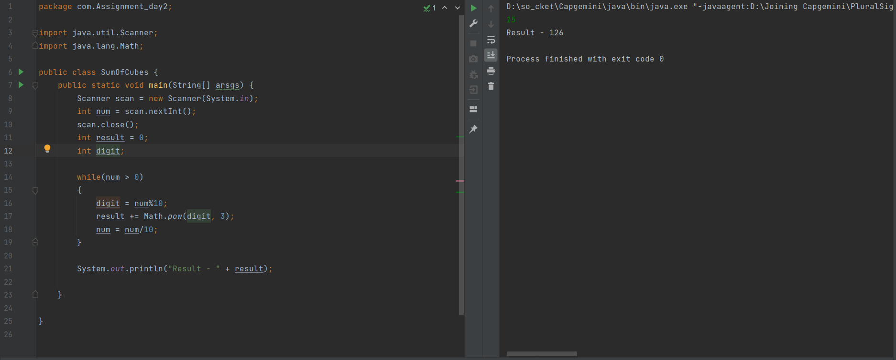

**Q2:** Write a program that should ask a number from user. You need to display all the prime numbers till that number. For exam: 25

**Solution –**

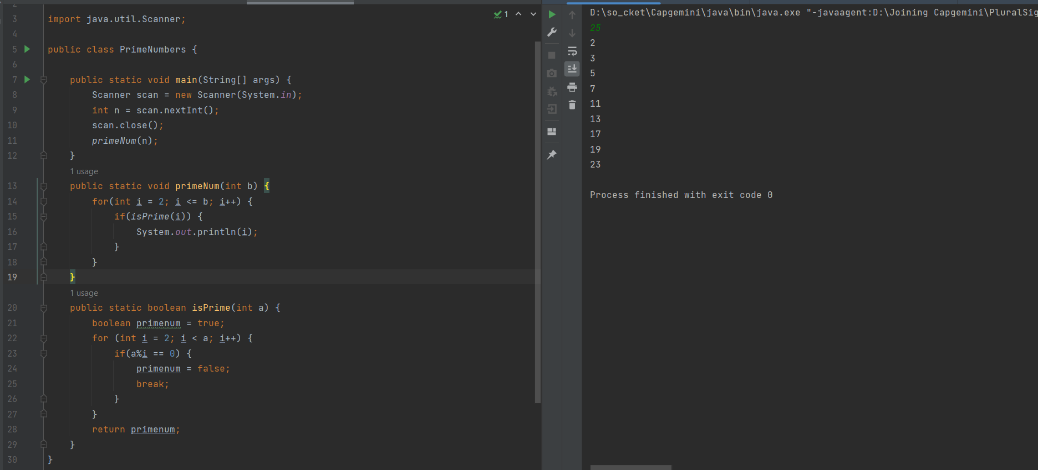

Q3: Create a class NaturalNumberSumDemo, Here you need to calculate the sum of first n natural numbers which are divisible by 3 and 5. Follow below table:

|  |  |
| --- | --- |
| ClassName | NaturalNumberSumDemo |
| Helper Method | calculateSum |
| Name Method Description | To find the sum first n natural number divisible by 3 and 5 |
| Argument | int number |
| Return type | Int |
| Logic | Calculate the sum of first n natural numbers divisible by 3 and 5 |

**Solution –**

Logic I used here is - To find the sum first n natural number divisible by 3 and 5

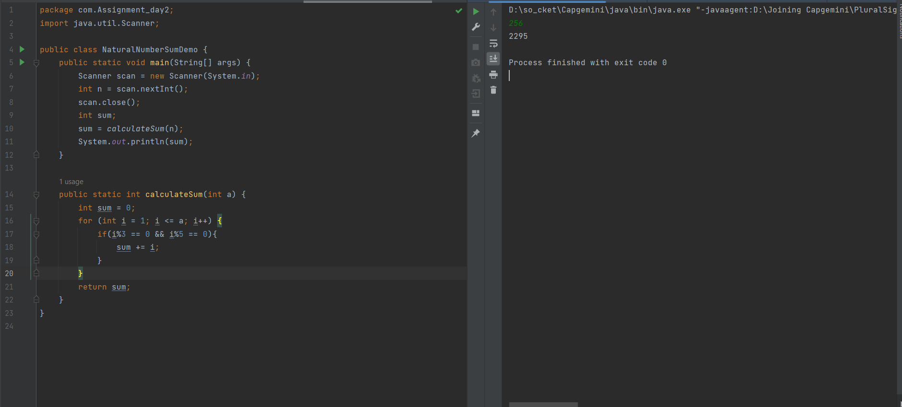

**Q4:** Imagine that you are working on a library management app. In this app, members can get the books issued. We have a data of books which are issued by members. Your job is to find out the average number of books that are issued in a month by library members.

Follow the below instructions to attempt this exercise.

1. Create a Person class

2. Keep id, name, books_issued fields in Person class.

3. Create a parameterized constructor in Person class, and you must have getters for all fields. 4. Create a LibraryDemo class with main method

5. Use below table for further reference.

6. Make sure to use modular approach.

|  |  |
| --- | --- |
| Persons data | Person[] persons=new Person[]{ new Person(101,"pankaj",3), new Person(102,"vikas",2), new Person(103,"vineet",3), new Person(104,"akash",1), new Person(105,"shalini",0), new Person(106,"shikha",1), new Person(108,"prateek",3) }; |
| Get only books_issued number | private int[] getBooksIssued(Person[] persons){ //TODO: Write your logic here  } |
| Find the average books issued by all members | private int findAvgBookIssued(int[] books_issued){ //TODO: Write your logic here } |

**Solution –**



