**Day 5 – Assignment**

**Pratik K Kamble**

**Employee ID : 46263548**

**15 – 09 – 2022**

**Q1:** Work on the below requirement.

1. Make a parent class Person.

a. Make Employee, UnEmployed and SelfEmployed as the subclasses. Make calculateSalary method as a base method in Person class.

b. Override this calculation method in all the other classes (Employee, Unemployed, and SelfEmployed)

c. Make parameterized constructor in individual derived subclasses which takes calculation parameters (like tax %, Salary, etc) as parameters and does the salary calculations.

d. Make another class CalculateSalary with overloaded parameterized constructors. These parameterized constructors take empType and other parameters as tax%, salary etc. and calculates the salary.

2. Make use of access Specifies in the above program:

a. Make the calculateArea method private in the parent class.

b. Make the overridden methods public in the subclasses.

**Solution –**

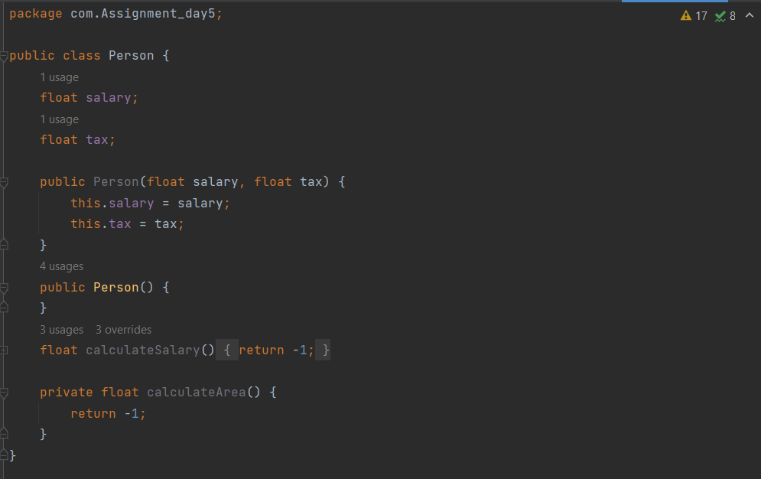 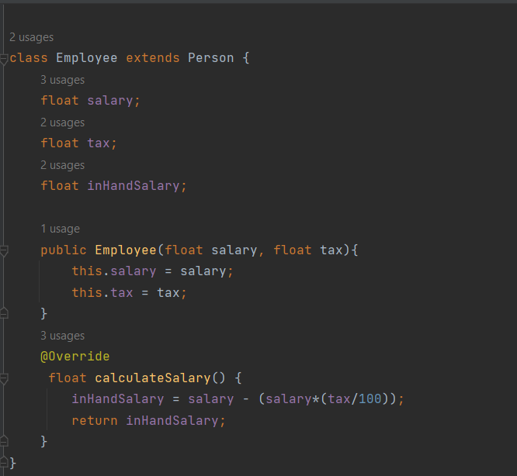

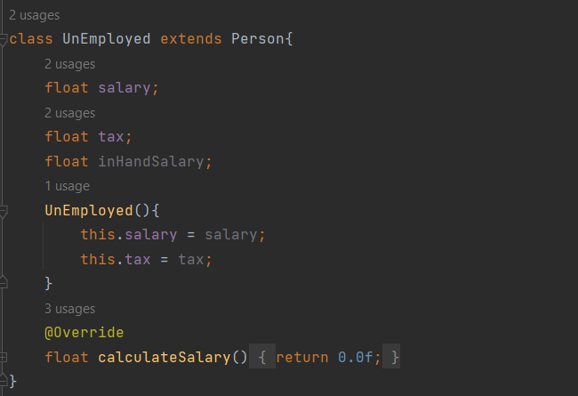 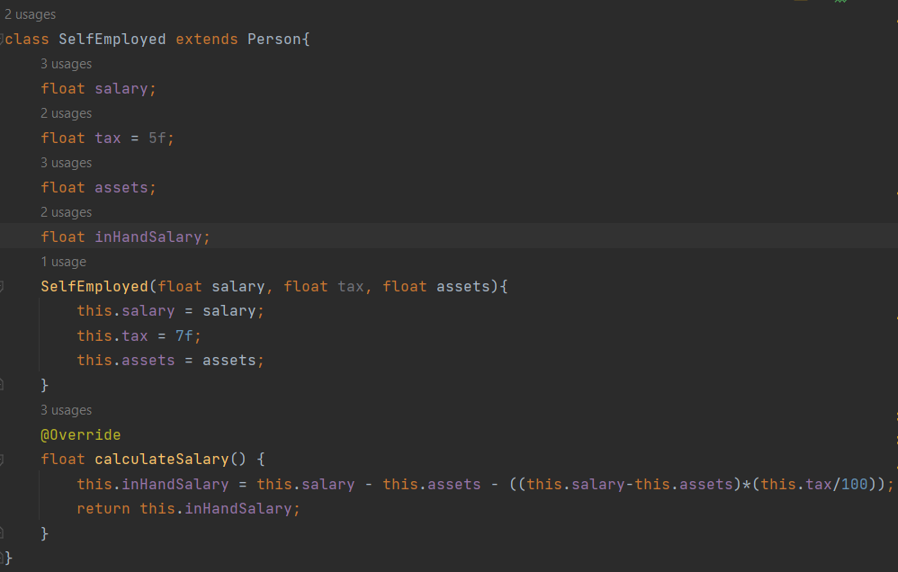

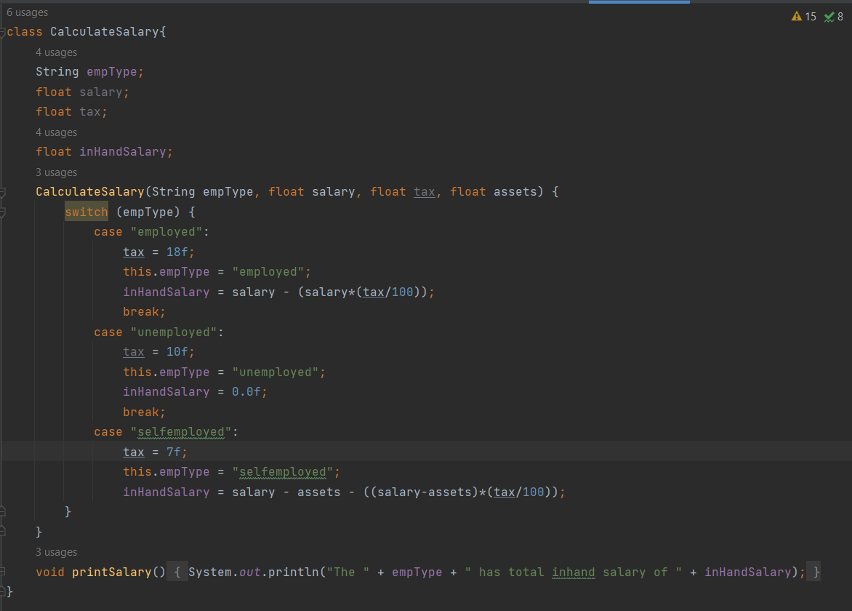

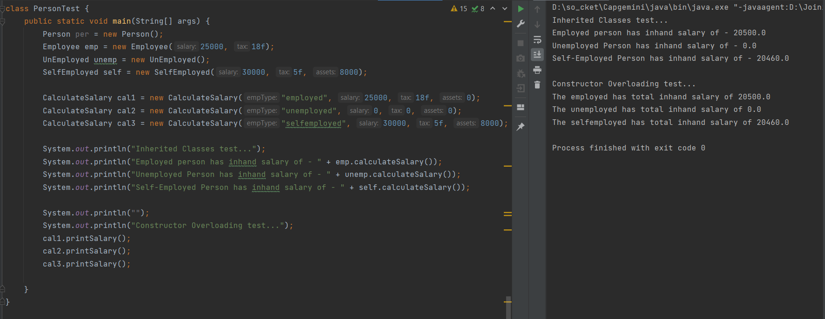

**Q2:** Create a class that imitates part of the functionality of the basic data type int. Call the class Int (note different capitalization). The only data in this class is an int variable. Include member functions to initialize an Int to 0, to initialize it to an int value, to display it (it looks just like an int), and to add two Int values.

Write a program that exercises this class by creating one uninitialized and two initialized Int values, adding the two initialized values and placing the response in the uninitialized value, and then displaying this result.

Follow below table for more understanding.

|  |  |
| --- | --- |
| ClassName | Public class Int |
| Fields | private int sum |
| Methods | Generate all getter and setter and parameterized constructor |
| Must have | Default constructor, that will initialize the sum with default value as 0 |
|  | Getter for sum field |
| public void addNumber(int i, int j){} | Will add the value of two ints and keep it in sum |
| ClassName | public class CheckInt |
| Method | main(String[] args): to test Int class |

**Solution –**

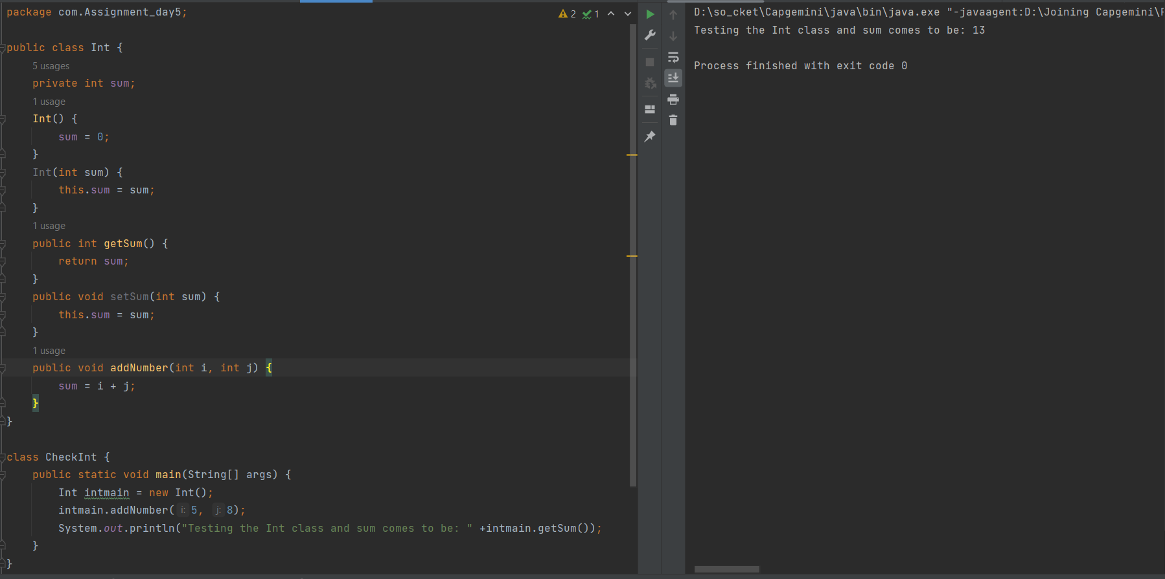

**Q3:** Imagine a tollbooth at a bridge. Cars passing by the booth are expected to pay Rs 50 toll. Mostly they do, but sometimes a car goes by without paying. The tollbooth keeps track of the number of cars that have gone by, and of the total amount of money collected. Model this tollbooth with a class called TollBooth. The two data items are a type int to hold the total number of cars, and a type double to hold the total amount of money collected. A constructor initializes both of these to 0. A member function called payingCar() increments the car total and adds Rs 50 to the cash total. Another function called noPayCar(), increments the car total but adds nothing to the cash total. Finally, a member function called display() displayes the two totals. Make appropriate member functions.

Create a main class to test this app. This program should allow the user to push one key to count a paying car, and another to count a nonpaying car. Pushing the Esc key should cause the program to print out the total cars and total cash and then exit

**Solution –**

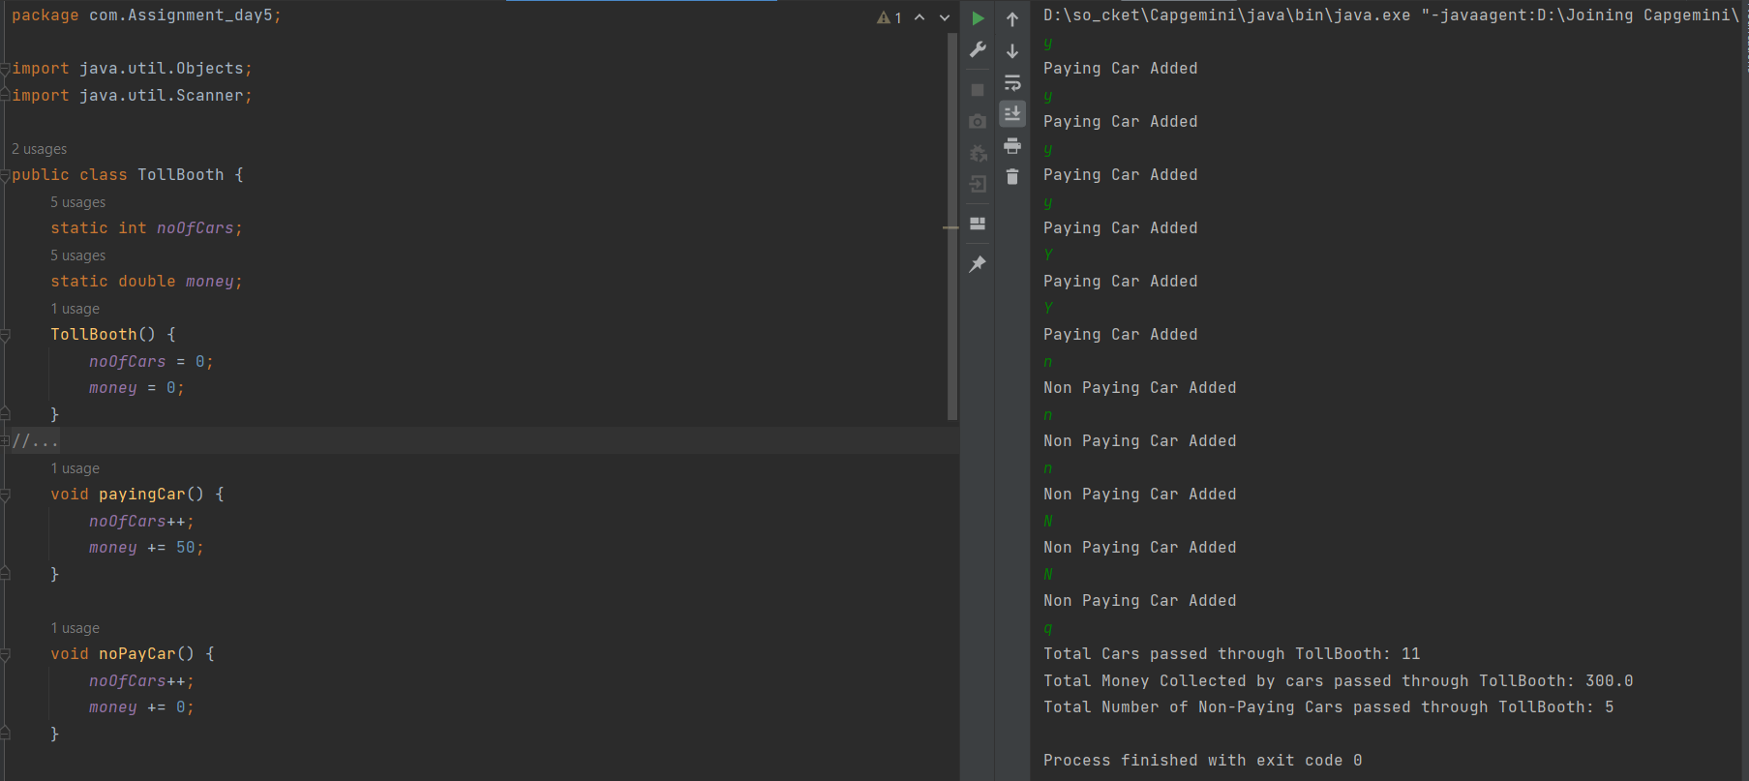

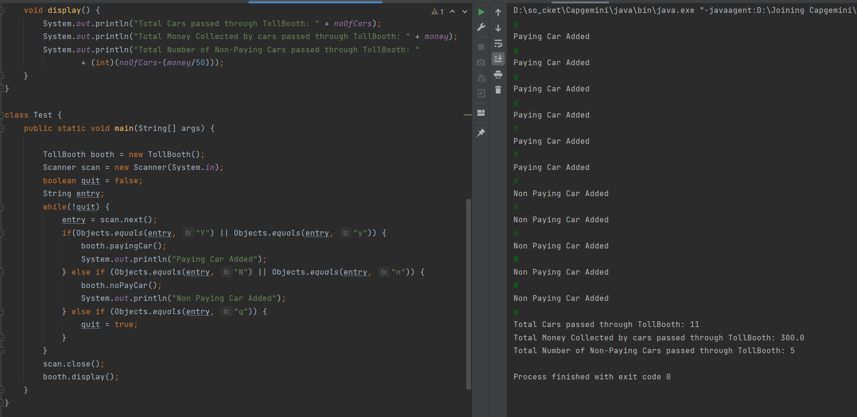

**Q4:** You need to work on Doctor Information System. Below is the problem definition and business requirement.

**Problem Definition**

You need to store the information of Doctors, which is going to hold information like, name, speciality, and Patient. Patient will have information like name, problem. In this application doctors will be of below specialities. Neurologist, Dermitologist, Dentst, Orthopedist. If patient inquire about Doctor’s speciality which is not available in record, specific exceptin must be reported. Data should be stored in array as local repository. Use the standard practice of development, your code must be properly structured and documented.

**Business Requirement**

• Application must have proper table structure with proper relationships.

• There should not be a prefilled data local repository.

• Perform all the CRUD operations on arrays

• You must use the concepts of oops properly at appropriate situations

• Modular approach must be used in application development

• Create a menu driven program

You must have main menu that must have operations related to Doctor and Patients

**Solution –**

