**Day 6 – Assignment**

**Pratik K Kamble**

**Employee ID : 46263548**

**16 – 09 – 2022**

**Q1:** I am providing you the skeleton code. Write it as it is in your code editor. And follow the below instruction.

Add a **readList** method to **ListOfNumbers.java** (in a .java source file). This method should read in int values from a file, print each value, and append them to the end of the vector. You should catch all appropriate errors. You will also need a text file containing numbers to read in.

|  |
| --- |
| import java.io.*; import java.util.Vector;    public class ListOfNumbers {     private Vector victor;      private static final int size = 10;        public ListOfNumbers () {         victor = new Vector(size);         for (int i = 0; i < size; i++)              victor.addElement(new Integer(i));      }      public void writeList() {         PrintStream out = null;            try {              System.out.println("Entering try statement");              out = new PrintStream(new FileOutputStream("OutFile.txt"));                for (int i = 0; i < size; i++)                  out.println("Value at: " + i + " = " + victor.elementAt(i));          } catch (ArrayIndexOutOfBoundsException e) {              System.err.println("Caught ArrayIndexOutOfBoundsException: " +    e.getMessage());          } catch (IOException e) {              System.err.println("Caught IOException: " + e.getMessage());          } finally {              if (out != null) {                  System.out.println("Closing PrintStream");                 out.close();              } else {                  System.out.println("PrintStream not open");              }          }      }  } |

**Solution –**

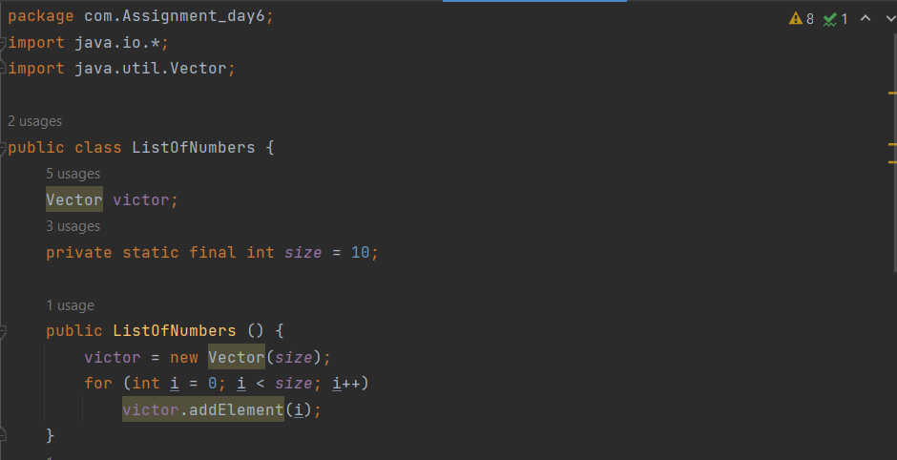

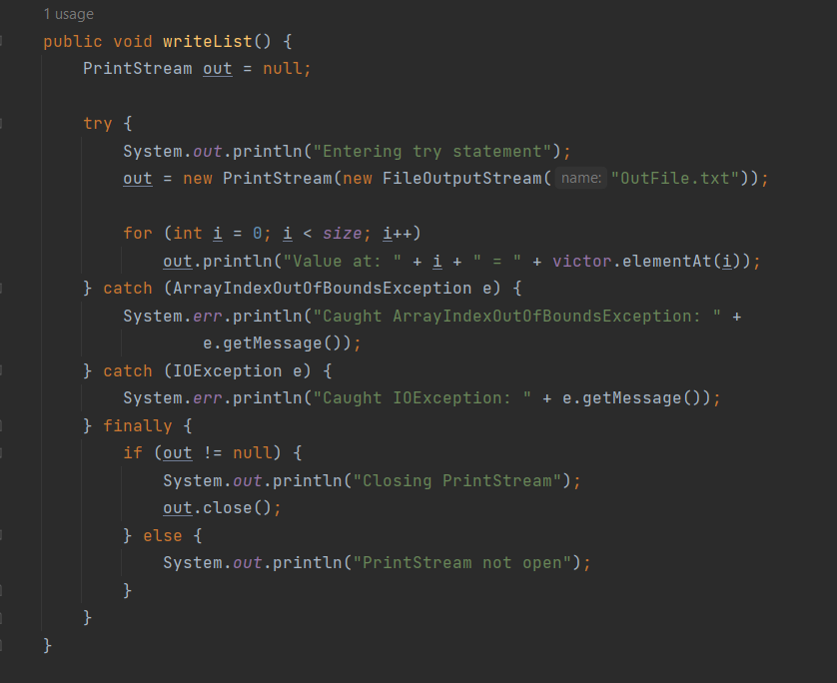

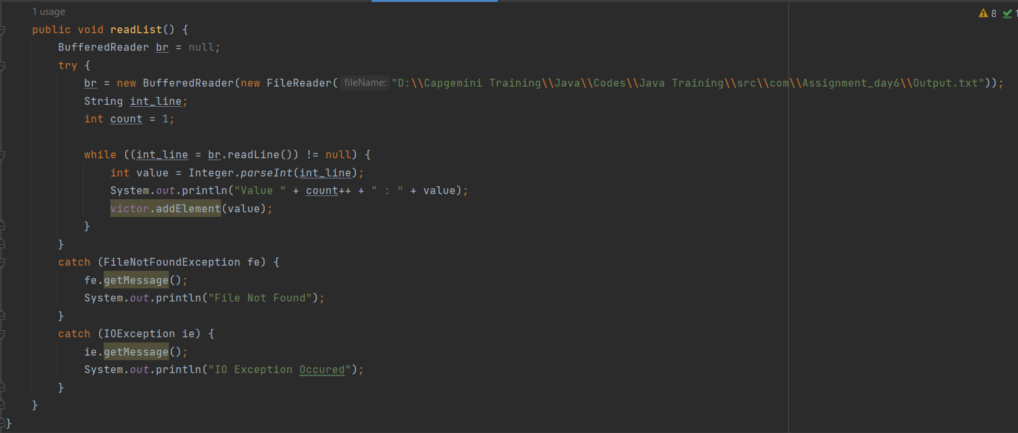

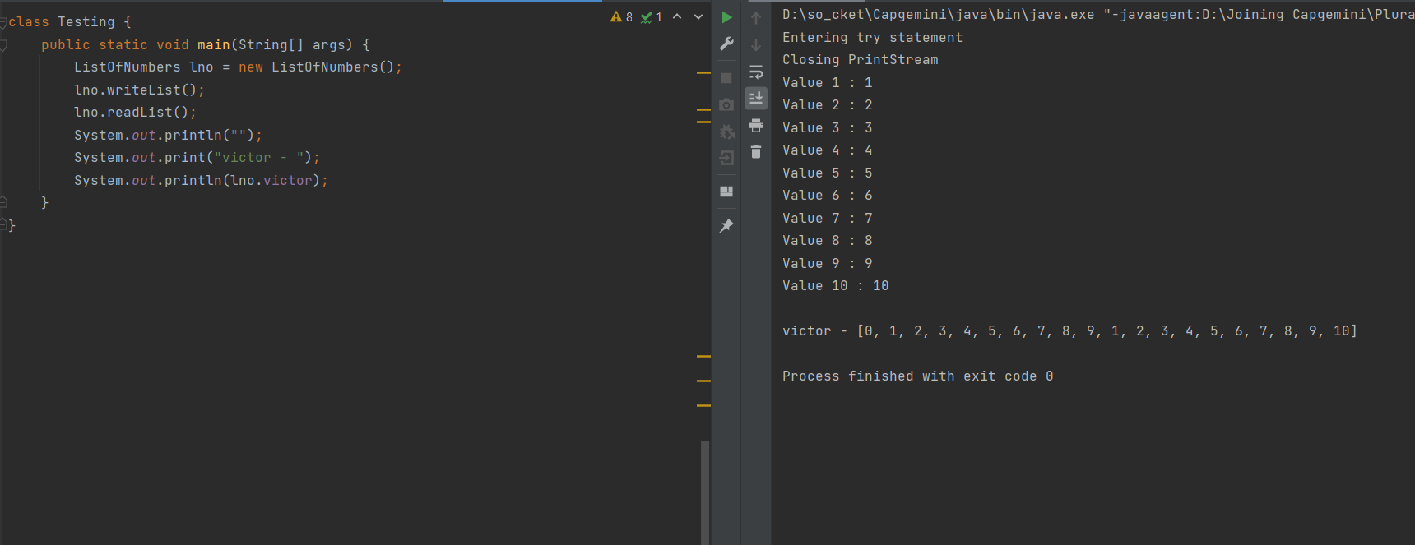

**Q2:** Write a program for the StringCalculator. This program will take the comma separated numbers and print the sum of the numbers as output. You need to make sure that the numbers that are input in String form must be numeric, not the string. You need to handle the proper exception and show the proper error message to user.

Follow below table for more understanding.

|  |  |
| --- | --- |
| Class Name | StringCalculator |
| Method | public int calculate(String input){return 0;} |
| Description | Input will be comma separated numbers. And output will be the sum of all the numbers that are provided in input.  For example  Case 1: “10,20”  Output : 30    Case 2: “10”  Output: 10    Case 3: “”  Output: 0    Case4:”One, 2”  Output: Invalid Input |

**Solution –**

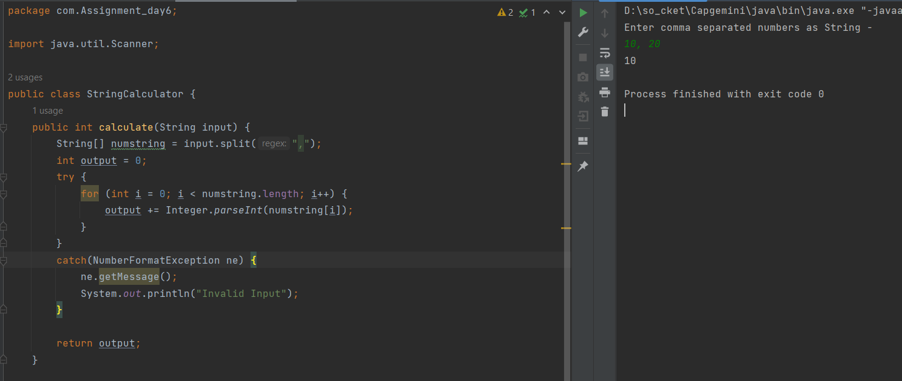

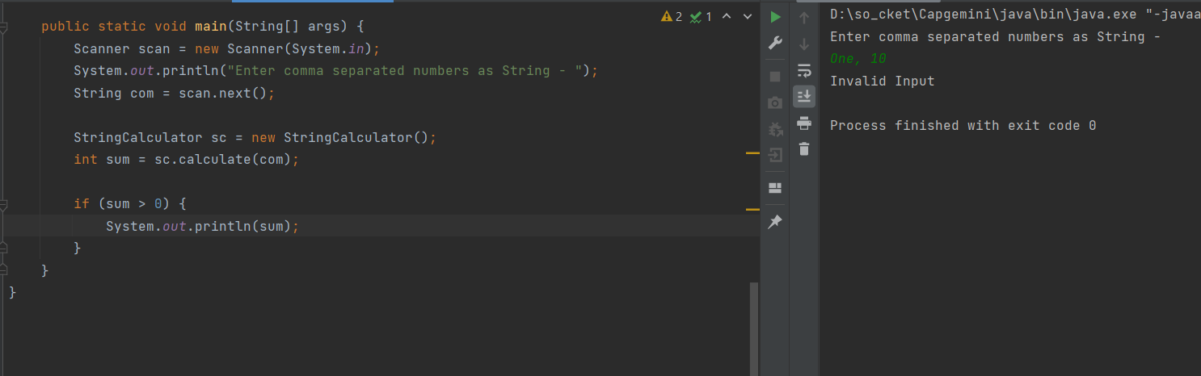

**Q3:** Create a BankService, which will have withdraw method. This method will receive two input as account number and amount to be withdrawn. When this method is called, it should prompt that it may throw InvalidAccountNumberException and InsufficientAmountException. Programer will have to handle these exception.

Assume that you will have some initial balance. So incase if amount that is withdrawn exceeds the balance then InsufficientBalanceException must be reported.

If account number is not valid then InvalidAccountNumberException must be reported.

Create a separate class to test the functionality of the BankService.

**Solution –**

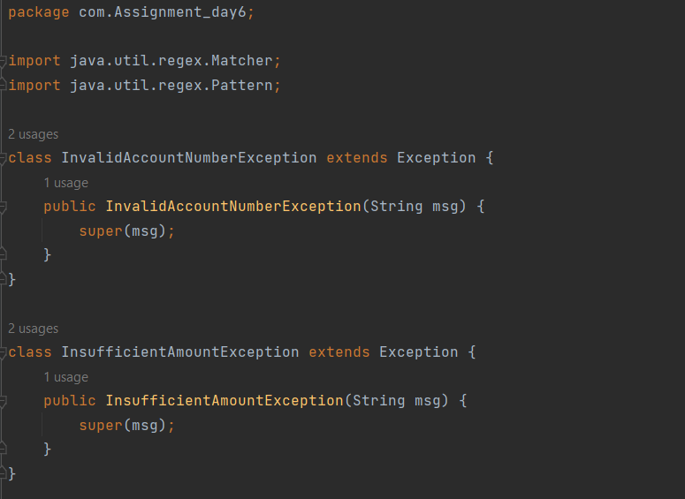 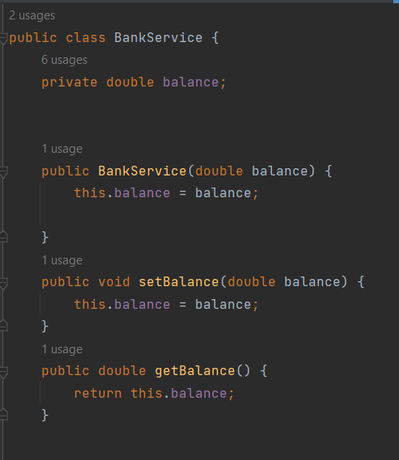

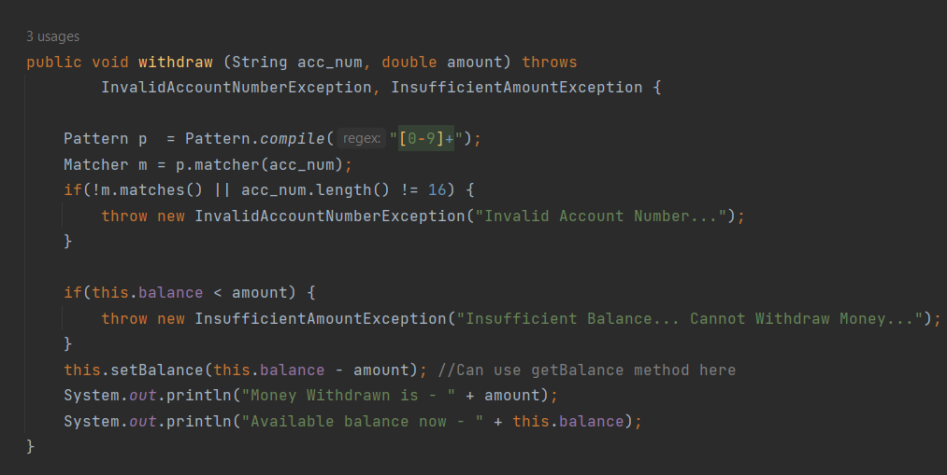

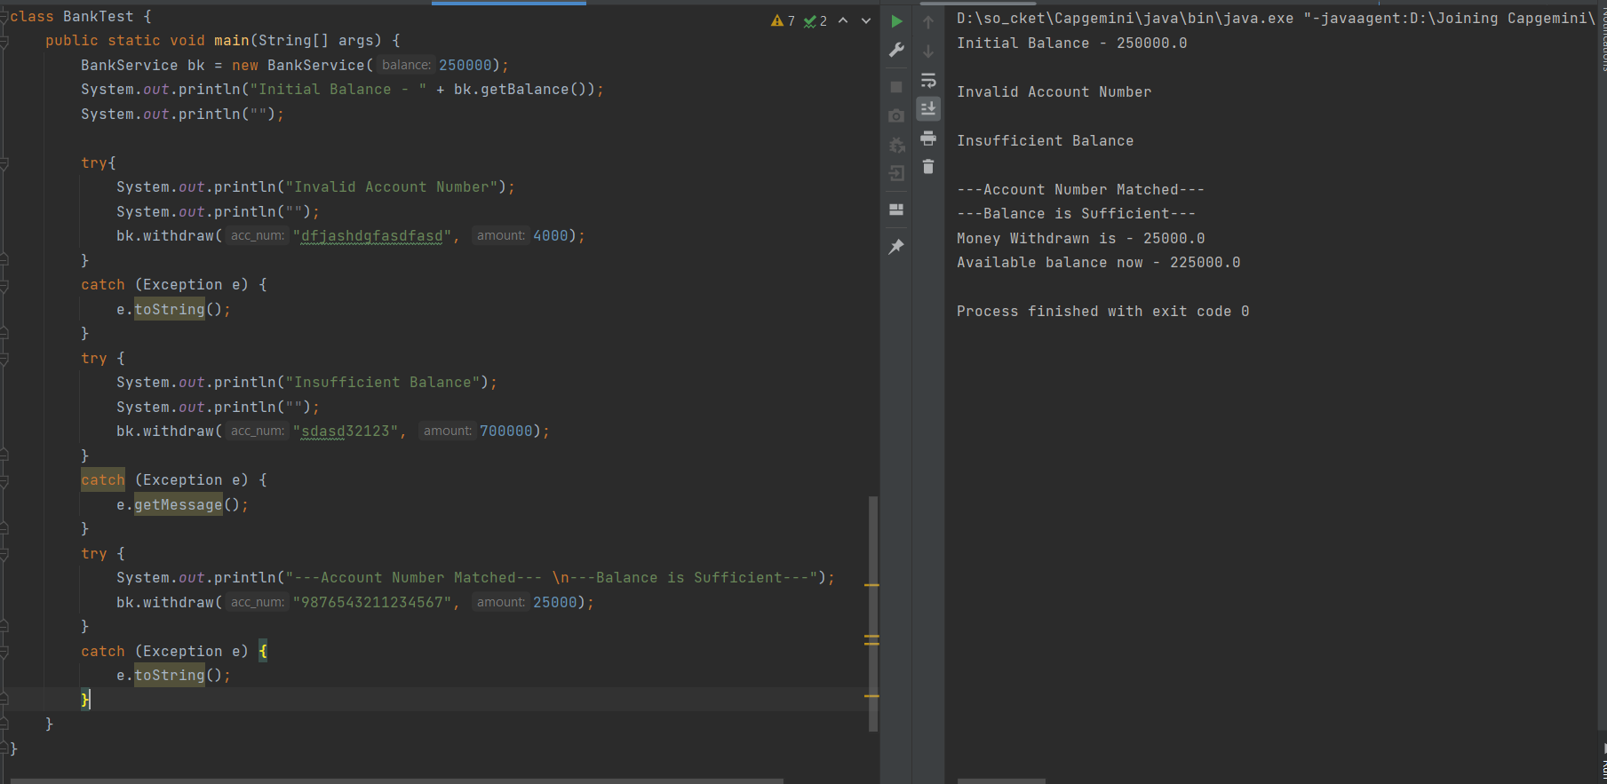

**Q4:** Refer the Exercise 3 from the OOPs Lab (Doctor Information System). There are multiple places where different type of issues can come. You need to Create appropriate Exceptions and handle them properly in the application. So this is the addition of your OOPs Lab, Question 3.

Follow below table for the different type of issues and the probable Exception that you need to manage.

|  |  |
| --- | --- |
| When saving Doctor detail. Check before saving that doctor object should not be null. Otherwise appropriate Exception should be reported | Look for the NullPointerException |
| When accessing or trying to save the object out of array index. | Look for the ArrayIndexOutOfBoundsException |
| When accessing the doctor by id | DoctorNotFoundException: Need to create a custom Exception. Create it as RuntimeException.  And understand the importance of  RuntimeException |
| When accessing the patient by id | PatientNotFoundExcepiton: make it as checked exception. |
| Note: | You must handle the same exceptions for Patients as well. While saving patient detail. |
| Handle situation, when patient looks for doctor as per the speciality. | SpecialityNotFoundException: Create a custom exception, that must be handled, so that if patient look for any other specialty which is not supported. |

**Solution –**

package com.Assignment_day6;  
  
import java.util.Objects;  
import java.util.Scanner;  
  
class DoctorNotFoundException extends RuntimeException {  
 public DoctorNotFoundException(String s) {  
 super(s);  
 }  
  
 @Override  
 public String toString() {  
 return super.toString();  
 }  
}  
  
class PatientNotFoundExcepiton extends Exception {  
 public PatientNotFoundExcepiton(String s) {  
 super(s);  
 }  
  
 @Override  
 public String toString() {  
 return super.toString();  
 }  
}  
class Doctor{  
 String name;  
 String speciality;  
  
 public Doctor(String name) {  
 this.name = name;  
 }  
 public Doctor(String name, String speciality) {  
 this.name = name;  
 this.speciality = speciality;  
 }  
  
}  
  
class Patient {  
 String name;  
 String problem;  
 String reqspecial;  
  
 public Patient(String name) {  
 this.name = name;  
 }  
 public Patient(String name, String problem, String reqspecial) {  
 this.name = name;  
 this.problem = problem;  
 this.reqspecial = reqspecial;  
 }  
}  
public class HospitalManagement {  
 Doctor[] doctors = new Doctor[10];  
 Patient[] patients = new Patient[10];  
  
 public void addDoctor(String name, String speciality){  
 Doctor newd = new Doctor(name, speciality);  
 for (int i = 0; i < doctors.length; i++) {  
 if(this.doctors[i] == null) {  
 this.doctors[i] = newd;  
 break;  
 }  
 }  
 System.*out*.println("Doctor datails added successfully...");  
 System.*out*.println("");  
 }  
  
 public void addPatient(String name, String problem, String reqspecial) {  
 Patient newp = new Patient(name, problem, reqspecial);  
 for (int i = 0; i < this.patients.length; i++) {  
 if(patients[i] == null) {  
 this.patients[i] = newp;  
 break;  
 }  
 }  
 System.*out*.println("Patient datails added successfully...");  
 System.*out*.println("");  
 }  
  
 public void removeDoctor(String name) throws DoctorNotFoundException{  
 try {  
 Doctor rd = new Doctor(name);  
 for(int i = 0; i < this.doctors.length; i++) {  
 if(Objects.*equals*(doctors[i].name, rd.name)) {  
 doctors[i] = null;  
 break;  
 }  
 }  
 System.*out*.println("Doctor has been removed successfully...");  
 System.*out*.println("");  
 }  
 catch (DoctorNotFoundException de) {  
 de.toString();  
 }  
 catch (NullPointerException ne) {  
 ne.toString();  
 }  
 }  
  
 public void removePatient(String name) throws PatientNotFoundExcepiton, NullPointerException {  
 try {  
 Patient rp = new Patient(name);  
 for(int i = 0; i < this.patients.length; i++) {  
 if(Objects.*equals*(patients[i].name, rp.name)) {  
 patients[i] = null;  
 break;  
 }  
 }  
 System.*out*.println("Patient removed successfully...");  
 System.*out*.println("");  
 } catch (NullPointerException ne) {  
 ne.toString();  
 }  
 }  
 public void showDoctors() throws DoctorNotFoundException, NullPointerException {  
 try {  
 System.*out*.println("All the available doctors in the hospital - ");  
 int count = 1;  
 for (Doctor doctor : doctors) {  
 if (doctor == null) {  
 } else {  
 System.*out*.println(count++ + " | " + doctor.name + " | " + doctor.speciality);  
 }  
 }  
 System.*out*.println("");  
 }  
 catch (DoctorNotFoundException de) {  
 de.toString();  
 }  
 catch (NullPointerException ne) {  
 ne.toString();  
 }  
 }  
  
 public void showPatients() throws NullPointerException, PatientNotFoundExcepiton {  
 try {  
 System.*out*.println("All the Patients having today's appointment - ");  
 int count = 1;  
 for (Patient patient : this.patients) {  
 if (patient == null) {  
 continue;  
 } else {  
 System.*out*.println(count++ + " | " + patient.name + " | " + patient.problem);  
 }  
 }  
 System.*out*.println("");  
 } catch (NullPointerException ne) {  
 ne.toString();  
 }  
 }  
  
 public void viewAppointment() throws PatientNotFoundExcepiton, NullPointerException, DoctorNotFoundException {  
 int count = 1;  
 try{  
 for(int i = 0; i < doctors.length; i++) {  
 if (this.doctors[i] != null){  
 for (int j = 0; j < patients.length; j++) {  
 if(this.patients[j] != null) {  
 if (this.doctors[i].speciality.equals(this.patients[j].reqspecial) ) {  
 System.*out*.println(count++ + " | " + this.doctors[i].name  
 + " -|- " + this.patients[j].name + " -|- "  
 + this.patients[j].problem);  
 throw new PatientNotFoundExcepiton("Patient Not Found...");  
 }  
 }  
 else {  
// System.out.println("Patient is not present in the database...");  
// break;  
 }  
 }  
 throw new DoctorNotFoundException("Doctor Not Found...");  
  
 }  
 else {  
// System.out.println("Doctor is not present in the database...");  
// break;  
 }  
 }  
 }  
 catch (PatientNotFoundExcepiton pe) {  
 pe.toString();  
 }  
 catch (DoctorNotFoundException de) {  
 de.toString();  
 }  
 catch (NullPointerException ne) {  
 ne.toString();  
 }  
 }  
  
  
 public static void main(String[] args) throws PatientNotFoundExcepiton {  
 HospitalManagement hm = new HospitalManagement();  
  
 System.*out*.println("Welcome to the Hospital Management System...");  
 System.*out*.println("");  
 Scanner scan = new Scanner(System.*in*);  
  
 boolean quit = false;  
 while(!quit) {  
 System.*out*.println("Choose your Option - ");  
 System.*out*.println("A - Add Doctor");  
 System.*out*.println("B - Remove Doctor");  
 System.*out*.println("C - Add Patient");  
 System.*out*.println("D - Remove Patient");  
 System.*out*.println("E - Show Todays Appointments");  
 System.*out*.println("Q - Exit !");  
 String choice = scan.next();  
 switch (choice) {  
 case "A" :  
 System.*out*.println("Please Enter the name of the Doctor - ");  
 String dname = scan.next();  
 System.*out*.println("Enter the Speciality - ");  
 String speciality = scan.next();  
 hm.addDoctor(dname, speciality);  
 System.*out*.println("");  
 hm.showDoctors();  
 break;  
 case "B" :  
 System.*out*.println("Please Enter the name of the Doctor - ");  
 String drname = scan.next();  
 hm.removeDoctor(drname);  
 break;  
 case "C" :  
 System.*out*.println("Please Enter the name of the Patient - ");  
 String pname = scan.next();  
 System.*out*.println("Please Enter the Problem - ");  
 String problem = scan.next();  
 System.*out*.println("Which Specialist do you need ?");  
 String reqspecial = scan.next();  
 hm.addPatient(pname, problem, reqspecial);  
 System.*out*.println("");  
 hm.showPatients();  
 break;  
 case "D" :  
 System.*out*.println("Please Enter the name of the Patient - ");  
 String prname = scan.next();  
 hm.removePatient(prname);  
 break;  
 case "E" :  
 hm.viewAppointment();  
 break;  
 case "Q" :  
 System.*out*.println("Exiting from the Database...");  
 quit = true;  
 break;  
 default :  
 System.*out*.println("Please Enter the correct choice - ");  
 break;  
 }  
 }  
  
  
// System.out.println("");  
// hm.addDoctor("Neeta", "Dentist");  
// hm.addDoctor("Kevin", "Neurologist");  
// hm.showDoctors();  
// System.out.println("");  
// hm.addPatient("Praveen", "Brain Stroke", "Neurologist");  
// hm.showPatients();  
// System.out.println("");  
//// hm.removePatient("Praveen");  
//// hm.showPatients();  
// System.out.println("These are today's Appointments - ");  
// hm.viewAppointment();  
// hm.removeDoctor("Neeta");  
// hm.showDoctors();  
 }  
  
}

