Primary and Backup path optimization using Suurballe’s Algorithm

Shreyas Kalammanagudi Shankaresh
School of Computing
University of Nebraska-Lincoln
skalammanagudishan2@unl.edu

Abstract

In the field of Optical Communication, the source, from where the data is sent and the Destination, where the sent data is captured, processed and analyzed completes the part of the communication cycle. In the stages of optical communication, the Links, nodes, network size and strength, topology of the network, Signal Properties etc., plays a major role in transferring the data from one end to another end, so the path carrying the information defines the life of the communication. Hence, Path protection, optimization of available paths and efficient network routing plays a very important role in maintaining a seamless and reliable data transmission across communication networks. While, the identification of the shortest primary path and a disjoint backup path is necessary and in order to find shortest paths, we can use the algorithms such as Dijkstra's algorithm, Bellman–Ford algorithm, Floyd-Warshall Algorithm and many more. And to calculate the disjoint backup path, we have algorithms such as Suurballe’s algorithm, k shortest path routing etc. In this project, we have used Suurballe’s algorithm to identify and formulate a reliable primary path and a backup path to ensure efficient and reliable data transmission. The methodology involves formulating a solution using Suurballe's Algorithm to find the optimal paths. The results show significant steps involved in enhancing network performance and reliability. The project concludes by giving a framework using Suurballe's Algorithm as an effective method for optimizing primary and backup paths in network routing.
Keywords: Suurballe's Algorithm, Dijkstra's algorithm, Bellman–Ford algorithm, Floyd-Warshall Algorithm, k shortest path routing.

- Introduction

In today’s world, optical network and the optical elements are essential for supporting the growing demands of most of the important supply and demand architectures, such as, supporting internet traffic, cloud computing, and multimedia services etc. While, a single link or node failure in the network can disrupt the communication from happening anywhere between the world. However, ensuring network reliability and resilience against failures remains a significant challenge, particularly in the presence of node or link disruptions. Route protection, which involves establishing both primary and backup paths, is a critical aspect of addressing these challenges. The main goal and objective for this project happened by observing the increasing need for reliable and efficient communication in optical networks. As network infrastructures continue to expand, the demand for solutions that can minimize service interruptions and optimize resource utilization has grown exponentially. So, in this project in order to handle link failures and to find the shortest path for the efficient communication, we have used Suurballe’s algorithm. In this project we have built a framework where, when a random topology is given to the system, at first the system identifies and reads the topology file, understanding its structure and location of the nodes, and then after the successful identification of the topology, the shortest path for that particular topology will be found using Dijkstra’s algorithm, and then the same found shortest path from the Dijkstra’s algorithm will be added and used as the input for the Suurballe’s algorithm, and then for after evaluating and eliminating all the possible possibilities, the best edge-disjoint will be found and generated by the system , which is the essential reliable Primary path, and later the second shortest path will be figured out by the Dijkstra’s algorithm, and later the similar steps will be followed in the process and after careful calculation and elimination the important Backup path would be generated, which will be of greater help when in the case of link failure. Later, in the project we have generated the diagrams and graphs for each phase starting from the original topology to generating graphs of primary and backup paths, which demonstrates the visualization strategy that we have implemented i our project. By understanding and addressing the challenges of fault tolerance and optimization techniques, this project enhances our understanding of how to improve the performance of optical networks, particularly in dynamic and resource- constrained environments.

Related Work

2.1 Network Routing and Path Optimization

Finding the most effective way to send data packets between source and destination nodes is known as routing in communication networks. This task is especially important in optical networks because of the high bandwidth requirements and the special limitations imposed by signal quality and wavelength continuity. In order to decrease latency, maximize resource utilization, and prevent congestion, effective routing algorithms are crucial.

Conventional Algorithms for Routing: -Conventional routing techniques have depended on fundamental algorithms: Because of its ease of use and effectiveness in sparse networks, Dijkstra's Algorithm is frequently used to determine the shortest path based on edge weights. The Bellman-Ford algorithm works well for networks with negative edge weights, but its increased computational complexity makes it less effective for large-scale networks. Despite their effectiveness, these algorithms are frequently insufficient for contemporary optical networks, where more complex solutions are required.

Dynamic Routing Advances: - With the growth of software-defined networking (SDN), dynamic routing has become more and more significant.

Important traits consist of:

Real-Time Path Selection: Adjusting to network circumstances such as link outages or traffic jams. Reconfigurable networks allow nodes and links to be added or removed dynamically without affecting service.

Scalability: Making sure algorithms can manage the quick expansion of network complexity and scale.

2.2 Fault Tolerance in Communication Networks

The ability of a network to function normally even when some of its components malfunction or fail is known as fault tolerance. Communication networks, especially optical ones, need to be able to withstand a number of failures, including node failures, link outages, and even more significant network disruptions. Fault tolerance aims to reduce service interruptions and guarantee that the network can bounce back fast without seriously impairing communication.

Communication Network Failure Types: -Any communication network may have issues from a number of sources: Hardware failures include the physical destruction or malfunction of network equipment such switches, routers, and optical fibers. Software failures include bugs or incorrect configurations in routing protocols or network management systems. Network congestion is an overload brought on by a large volume of traffic that causes packet drops or delays. Link failures are the interruption of communication links brought on by transmission medium flaws, network intrusions, or infrastructure damage.

Node Failures: - Issues with intermediary nodes, such as switches or routers, that result in routing problems or packet loss. Different fault tolerance techniques are needed for each type of failure in order to guarantee the least amount of disturbance.

Strategies for Fault Tolerance in Communication Networks: -

Redundancy: - Using several routes for data transmission so that, in the event of a path failure, another can take over without affecting service is known as path redundancy. Having backup nodes ready to take over in the event of a breakdown is known as node redundancy. Component redundancy is the process of replicating essential network elements, such as servers or switches, in order to ensure uninterrupted functioning.

Mechanisms for Failover: - Systems or backup parts that are kept in a ready state to take over right away in the event of a breakdown are known as hot standby systems. In order to avoid congestion and service interruption, load balancing and traffic diversion involve rerouting traffic to alternate routes or systems in the event of a failure.

Error Identification and Fixing: - Error detection codes are used by checksums and parity bits to find and fix mistakes in data that has been transferred. The ability to reconstruct lost or corrupted data without requiring retransmission is known as forward error correction, or FEC, and it is essential for high-speed optical communication.

2.3. Simulation Tools and Techniques
In order to comprehend, construct, and optimize complicated communication networks especially optical networks simulation is essential. Real-time performance analysis, scalability testing, and economical experimentation are all made possible by simulation. Cost-effective testing, risk-free experimentation, performance evaluation, and scenario analysis are some of the significant benefits of simulation in optical networks.
Some of the types being: -

General-Purpose Network Simulators: - A flexible platform for modeling and analyzing different kinds of networks, including optical networks, is offered by these simulators. Usually, they enable flexible traffic modeling and network settings. NS-3 (Network Simulator 3), GNS3.

Optical Network-Specific Simulators: - These are specialist simulators designed for the particular features of optical networks, like dynamic reconfiguration, path protection, and wavelength division multiplexing (WDM), Simon (Simulation of Optical Networks), Net2Plan.

Traffic Simulation and Modeling Tools: - In order to assess how well the network manages different traffic volumes and service requirements, these technologies are used to model user behaviors, traffic patterns, and network load. OMNeT++ (with additional traffic models), NS-3 (with traffic generation modules).

2.4.⁠ ⁠ Primary and Backup Path Mechanisms
Some key highlights on ‘Path Protection Strategies’: -

1+1 protection (Dedicated protection): Two separate routes primary and backup are set up between the source and the destination in this arrangement. The identical data is sent via both pathways at the same time, so in the event that one fails, the other can take over right away. Although this offers excellent reliability, it uses a lot of resources and raises the overall cost of the network.
1:1 Protection (Shared Protection): Only one path (main or backup) is used at a time under 1:1 protection. Only in the event that the primary path fails is the backup path activated. Although this approach uses resources more effectively, it causes a delay in the failover procedure.
Fast Reroute (FRR): In the event of a failure, fast reroute mechanisms use pre-established other routes that can be quickly activated. This method shortens the failover period and is especially helpful for high-speed networks, such as 5G and optical networks.
Mesh-based Protection: - In the event of a failure, a mesh network can reroute traffic using a combination of several paths that are available. Because mesh networks include numerous redundant channels, they are extremely resilient; yet, maintaining these paths can be challenging.

Some Key Highlights on Path Recovery Mechanisms: -
Dynamic Routing Protocols: Depending on the available primary and backup paths and the current network topology, traffic can be rerouted using dynamic routing protocols such as OSPF (Open Shortest Path First) or BGP (Border Gateway Protocol).

Backup Path Activation: Backup pathways are triggered to restore communication in the event of a failure. In order to reduce downtime, the activation time is crucial.

Load Balancing During Recovery: Traffic may be redirected via available backup routes while the recovery operation is underway. Algorithms for load balancing can assist in preventing traffic from overloading the backup routes, which could cause more network deterioration.

Methodology

Pseudocode: -

Input: Consider a network map (nodes and edges), a starting point (S), and an ending point (D). [For simplification purpose, we have used the notation ’S’ and ‘D’]

Output: Two routes—a primary path (P1) and a backup path (P2).

A. Shortest Path Calculation [Primary Path Calculation]

1) Initialize the setup:

First, we will keep the track of the shortest distances from the starting point (S) to other points in a list called visited.

Now, use another list called path to remember how you got to each point.

2) Finding shortest path using Dijkstra’s Algorithm:

Begin at the starting point (S) and set its distance to 0.

Add all other points into a group of "unvisited" points.

While, If there are still unvisited points:

Then ->

Look for the closest unvisited point.

Update distances to all of its neighbors based on the path cost.

Mark the closest point as "visited" and move to the next.

Backtrack to find the route (P1): [Re-routing from Destination to source]

Start from the end point (D) and follow the path list back to the start point (S).

This is our primary path (P1).

B. Backup Path Calculation

Adjust the map:

Make a copy of the original network map to save the current state.

Change the cost of each edge in the network using a formula. This adjustment makes it easier to find a backup path later.

w′(u,v)=w(u,v)+distance(source,u)−distance(source,v)

Modify the map for P1:

Look at the edges used in the primary path (P1).

Reverse the direction of these edges and give them a special cost (-1) to make them less likely to be chosen again.

Run the shortest path search again:

Use the updated network map to find another path from S to D.

This will be your backup path (P2).

Ensure the two paths are independent:

Check if any edges from the primary path (P1) are also in the backup path (P2).

If they overlap, remove those shared edges from both paths.

C. Final Integration and Visualization

Create a final result:

Put together all the unique edges from P1 and P2.

Use the original map to restore the actual costs of these edges.

Generate diagrams:

Show the network with:

The original setup.

The adjusted network.

Both the primary and backup routes.

This concludes the pseudocode for the given suurballe’s algorithm. Now, the following set of information will shed some light on the obtained results.

Figure no 1: Original Network Topology: -

This graph visualizes the initial network from the input file, displaying nodes and their connections as edges as it is after reading the .txt file and the Edge weights are also represented.

It serves as the base graph for the Suurballe's algorithm. It highlights the initial state of the network before any modifications or optimizations.

Figure no 2: Directed Graph Representation: - It is a converted representation of the original network as a directed graph. Here, each edge now has a defined direction, essential for the next steps of Suurballe's algorithm. This prepares the network for directed path computations and it ensures the algorithm processes direction-specific edge costs.

Figure no 3: Transformed Graph: - This graph shows the topology after transforming the directed graph to enable unique vertex identification. The modifications allow the algorithm to distinguish paths more effectively by splitting vertices. Here the edge weights and directions may have been altered to support primary path computation. It also demonstrates the first step towards creating disjoint paths.

Figure no 4: Transformed Graph with Unique Vertices: - It is a further transformation of the directed graph, emphasizing unique vertex assignments. Additional modifications ensure the second path computed will be disjoint from the first. It shows intermediate preparation for secondary path computation and it ensures paths remain independent and avoid shared vertices or edges.

Figure no 5: Primary Path: - This graph highlights the shortest path computed from the source to the destination. The Nodes and edges belonging to the primary path are distinctly marked in red color highlighting the path. This is the most cost-efficient route through the network and it demonstrates the first phase of Suurballe's algorithm in action.

Figure no 6: Backup Path: - This Graph displays the second shortest path that is disjoint from the primary path. Edges in the backup path are marked differently (e.g., blue) to differentiate them. This graph validates the algorithm's ability to compute independent paths.

And it ensures the backup path does not share any edges or vertices with the primary path.

Figure no 7: Final Result (Primary Path on Original Graph): - The primary path is overlaid on the original graph, showing how the algorithm selects the optimal route based on initial weights. Non-path edges remain visible but unmarked. This graph demonstrates how the primary path integrates with the original network topology.

Figure no 8: Final Result (Backup Path on Original Graph): - The backup path is overlaid on the original graph, illustrating its cost-efficiency and independence from the primary path. This reinforces the fault-tolerant design achieved through Suurballe's algorithm. This path ensures network reliability even in failure scenarios.

Results

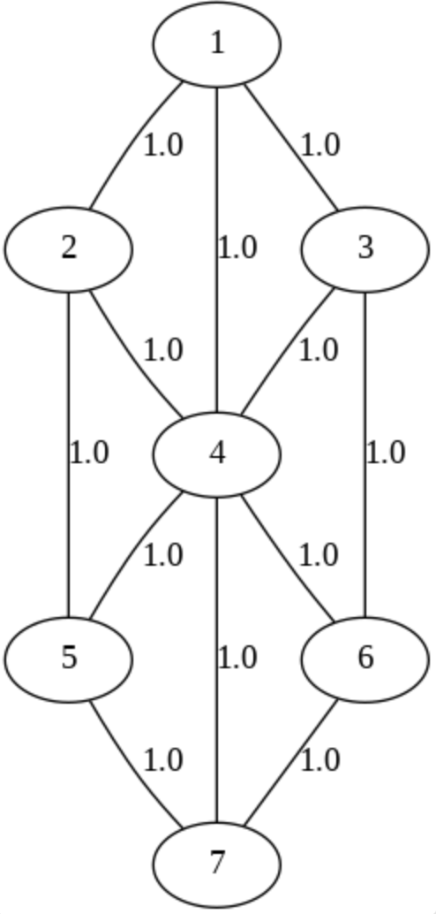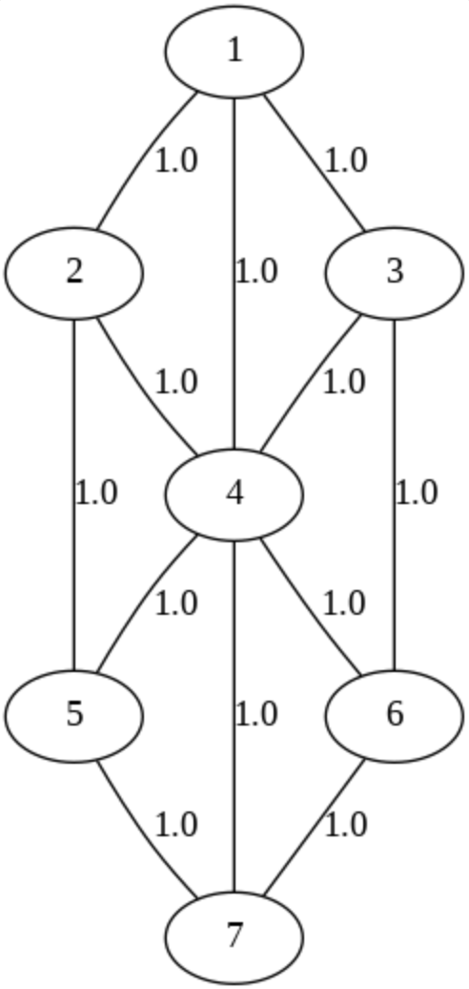
Figure no: 1 Figure no: 2

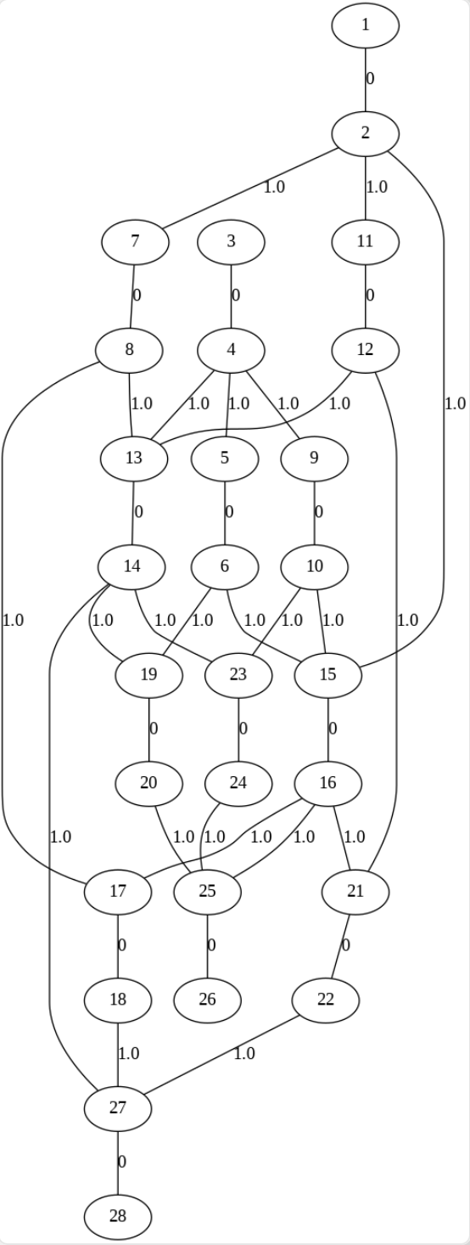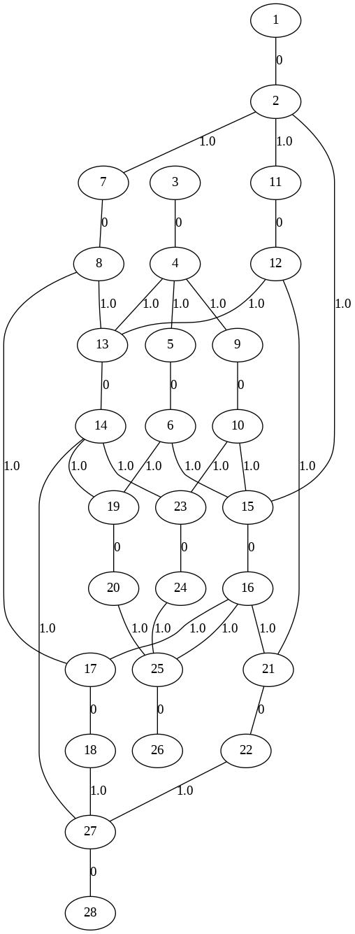

Figure no: 3 Figure no: 4

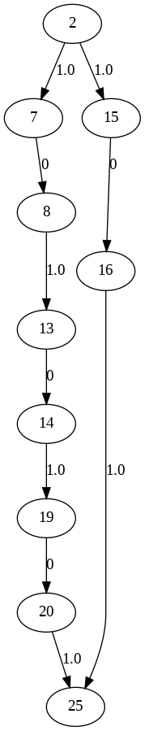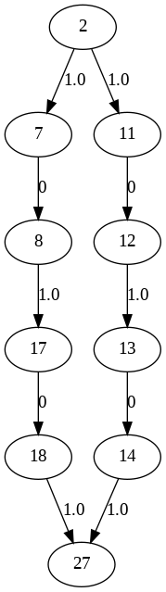

Figure no: 5 Figure no :6

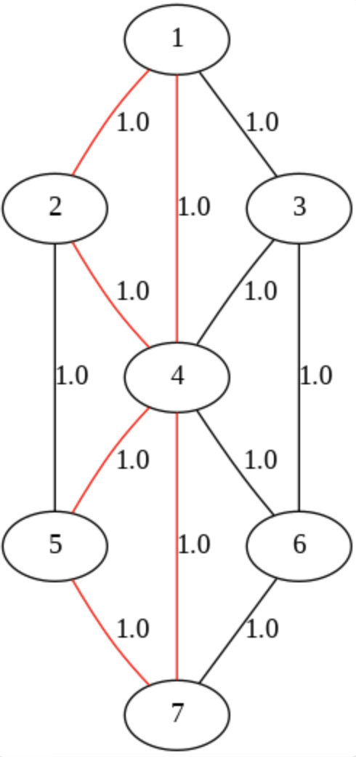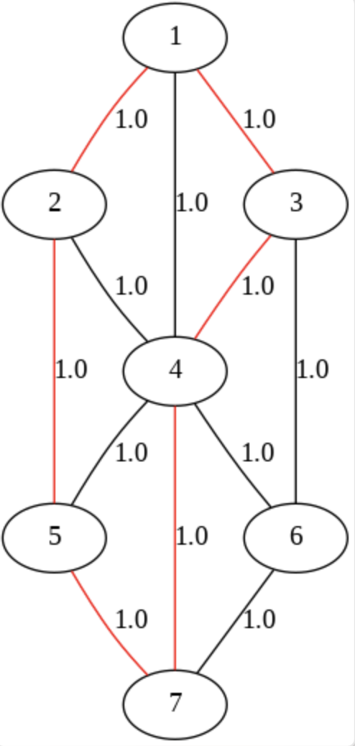
Figure no: 7 Figure no: 8

Conclusion

The motive to compute the stable and reliable primary and backup paths to improve the communication log, by virtue of which the fault tolerance can be achieved and mitigated to a certain level in the optical communication sector, we have successfully implemented Suurballe’s algorithm to compute and optimize the paths. The project successfully demonstrated the implementation of Suurballe's Algorithm to optimize route protection in optical networks. By employing this algorithm, we achieved dual-path routing with both primary and backup paths, ensuring network reliability and robustness in the event of failures. The methodology showcased the ability to balance computational efficiency with practical network demands, highlighting the effectiveness of Suurballe's Algorithm for fault-tolerant communication systems. With the algorithm implementation, we have also demonstrated the visualization of the results in the form of graph, by which the paths computed can be visualized and analyzed with the better understanding.
Our results emphasize the importance of optimized routing techniques in meeting the increasing demand for reliable data transmission in modern optical networks. The use of simulation tools will allow us to visualize and validate the performance of the algorithm, offering a clear representation of its applicability in real-world scenarios, which we are considering as our next objective to continue working on this real-world issue.
Overall, this project contributes to the field of optical networking by providing insights into how advanced algorithms can enhance fault tolerance and service continuity. Future research can extend this work by exploring multi-failure scenarios, dynamic traffic conditions, or integrating machine learning for predictive failure analysis. This project serves as a foundational step towards building more resilient and adaptive communication networks.

References
- B. Mukherjee, Optical Communication Networks, McGraw-Hill, New York, 1997.
- R. Ramaswami and K. N. Sivarajan, “Routing and Wavelength Assignment in All- Optical Networks,” IEEE/ACM Transactions on Networking, vol. 3, no. 5, pp. 489- 500, Oct. 1995.
- Gomes, Teresa, et al. "Fundamental schemes to determine disjoint paths for multiple failure scenarios." Guide to Disaster-Resilient Communication Networks (2020): 429-453.
- Suurballe, John W. "Disjoint paths in a network." Networks 4.2 (1974): 125-145. [4] Ramaswami, R., Sivarajan, K.N., & Sasaki, G.H. (2010). Optical Networks: A Practical Perspective. Elsevier
- Szviatovszki, Balázs, S. Szentesi, and A. Juttner. "On the effectiveness of restoration path computation methods." 2002 IEEE International Conference on Communications. Conference Proceedings. ICC 2002 (Cat. No. 02CH37333). Vol. 4. IEEE, 2002.
- Shen, Victor RL, et al. "Cost optimization of a path protection system with partial bandwidth using petri nets." Wireless Personal Communications 90 (2016): 1239-1259
- Rak, Jacek. "Efficient Methods to Determine Disjoint Paths for Single Demands." Resilient Routing in Communication Networks: A Systems Perspective. Cham: Springer International Publishing, 2024. 177-198.

