Contents
Executive Summary 2
Introduction 2
About QS World Ranking Dataset 2
Features 3
Methodology 4
Data Cleaning 6
Machine Learning Models 7
Results 8
How to run ML models - USER MANUAL 9
References 11

Executive Summary
This report classifies universities into performance tiers, low, medium and high, using their QS World University Ranking indicators. Two distinct modelling approaches were used, regression models that predict a continuous score and then bin it into a tier, and classification models that predict the tier directly. The neural network model performed best overall, reaching close to 95 percent accuracy, with the Support Vector Machine close behind. The regression models were less accurate but considerably faster to train. Both approaches were able to recover a university's performance tier reliably from its QS scores.

Introduction
University rankings play a significant role in how students, employers and institutions themselves assess academic standing, yet the process of translating a wide set of indicators into a single performance tier is not always transparent. This report addresses that by using the QS World University Rankings dataset to predict whether a university falls into a low, medium or high-performance tier, based on its published scores.
Two different modelling strategies were used. The first treats the problem as regression: Linear, Ridge, Lasso and Elastic Net Regression were each trained to predict the continuous overall score, with the predicted value then binned into a tier using the same thresholds that define the tiers in the data. The second treats the problem as classification directly: a Support Vector Machine and a Multi-Layer Perceptron were trained to predict the tier itself, without an intermediate score prediction.
Every model, regression and classification alike, was evaluated using a hold-out test set and 10-fold cross-validation, and was run twice, once with the full set of 20 features and once with the 8 rank columns removed, so the contribution of rank information could be assessed directly. The remainder of this report covers the dataset and its features, the methodology used for data cleaning and modelling, the results for each model, and a user manual for running the accompanying code.

About QS World Ranking Dataset
The QS World University Rankings dataset is one of the most widely recognized global higher education benchmarking datasets, published annually by QS Quacquarelli Symonds (QS), a United Kingdom-based higher education analytics organization. Established in 1990, QS specializes in evaluating and comparing higher education institutions worldwide through a range of performance indicators. The QS World University Rankings were first published in 2004 and have since become an influential source for assessing institutional performance, academic reputation, employability outcomes, research impact, and internationalization [1]. The dataset contains annual rankings and indicator scores for universities across the world, enabling comparative analysis of higher education systems and institutional competitiveness over time.
Among the various indicators employed in the QS ranking methodology, the International Student Ratio (ISR) is of particular relevance. ISR measures the proportion of international students enrolled at a university relative to its total student population [2]. This indicator serves as a proxy for the degree of internationalization of an institution and reflects its ability to attract students from diverse geographical and cultural backgrounds. A higher ISR is often associated with enhanced global reputation, increased cross-cultural interaction, broader knowledge exchange, and stronger international networks, all of which contribute positively to the educational experience and global competitiveness of a university [2]. Consequently, the QS World University Rankings dataset provides a valuable resource for researchers, policymakers, and educational institutions seeking to analyse trends in internationalization and institutional performance within the global higher education sector.

Features
The dataset was sourced from the QS World Rankings website, where records spanning 2023 to 2027 were extracted and consolidated into a single dataset comprising 20 features. The target variable for the classification task is the Overall Score, which was grouped into three performance tiers : Low (11–18), Medium (19–28), and High (29–100), using score-based thresholds that produce an approximately equal distribution of roughly one-third of institutions in each category, ensuring a balanced and well-structured basis for model training.
Several categorical features were transformed to make them suitable for machine learning. The Research intensity variable, which originally carried four ordinal levels ranging from Low to Very High, was converted into a numeric scale of 1 to 4 and stored as a new feature, Research_ordinal. The same treatment was applied to the Size variable, producing Size_ordinal. Institution type, whether a university is privately or publicly funded, was encoded as a binary indicator, with Private and Public assigned 0 or 1 based on the institute funding mechanisms. The full set of features used for model training is outlined in the table below.

Table 1 : features(X) and Outputs(Y) in dataset
Sno. | Parameter | Variable
1. | Academic Reputation Rank | X
2. | Academic Reputation Score | X
3. | Citations per faculty rank | X
4. | Citations per faculty score | X
5. | Employer reputation rank | X
6. | Employer reputation score | X
7. | Employment outcomes rank | X
8. | Employment outcomes score | X
9. | Faculty student ratio rank | X
10. | Faculty student ratio score | X
11. | International faculty ratio rank | X
12. | International faculty ratio score | X
13. | International research network rank | X
14. | International research network score | X
15. | International students ratio rank | X
16. | International students ratio score | X
17. | Size Ordinal | X
18 | Research Ordinal | X
19. | Private | X
20. | Public | X
1. | Score Category | Y
2. | Overall Score | Y

Methodology
The QS World University Rankings dataset was collected from the official QS World Rankings website. A comprehensive data cleaning and missing value imputation process was carried out to ensure a complete and reliable dataset suitable for machine learning model training. The final dataset consisted of 20 input features and two target variables: Overall Score and Score Category.
Six machine learning models were developed and evaluated: Linear Regression, Lasso Regression, Ridge Regression, Elastic Net Regression, Multi-Layer Perceptron (MLP), and Support Vector Machine (SVM). For the MLP and SVM models, hyperparameter tuning was performed using cross-validation to identify optimal configurations and improve generalization performance.
These models were applied for classification to predict university categories: High, Medium, and Low. For regression-based approaches, the Overall Score was predicted first and then mapped to the corresponding score category using predefined thresholds.
Model performance was evaluated in 2 different scenarios. In Scenario 1, All 20 features were selected and in Scenario 2, all the ranks were excluded, making the feature count 12. The performance was evaluated using Accuracy, Precision, and Recall, which are defined as follows:
Accuracy measures the proportion of correctly classified instances among all instances and is given by:
$$Accuracy=\frac{TP+TN}{TP+TN+FP+FN}$$
where TP is True Positives, TN is True Negatives, FP is False Positives, and FN is False Negatives.
Precision measures the proportion of correctly predicted positive observations out of all predicted positives:
$$Precision=\frac{TP}{TP+FP}$$
Recall (also known as Sensitivity) measures the proportion of correctly predicted positive observations out of all actual positives:
$$Recall=\frac{TP}{TP+FN}$$
These metrics were used to compare and assess the predictive performance of all models. The figure 1, explains the complete methodology.
Figure 1 : Methodology
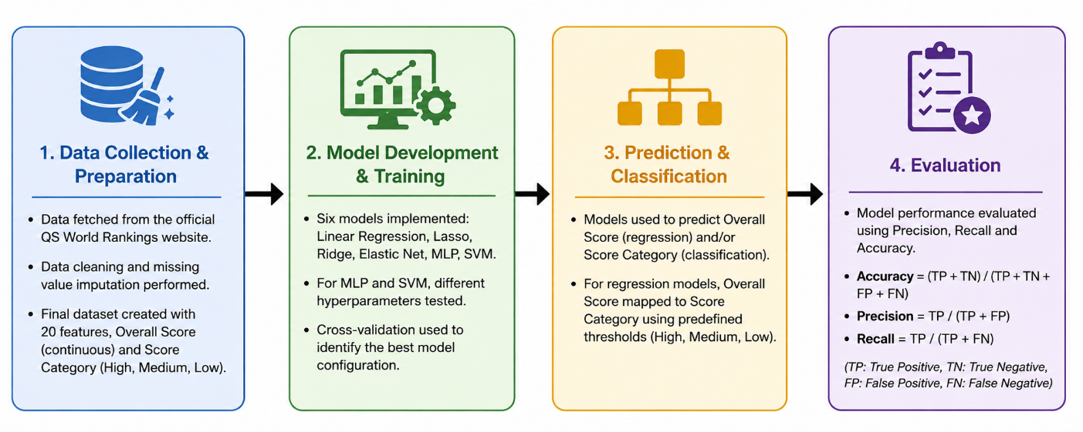

Data Cleaning
Before any analysis was conducted, a thorough audit of missing values was carried out across the dataset to understand not just where data was absent, but why. This distinction proved critical, as the causes of missingness varied considerably across columns and directly shaped the imputation choices made.
A regression-based approach was therefore used, leveraging the strong and consistent relationship between rank and score observed in the available data to estimate plausible scores for institutions where none had been published. For the remaining score columns, which had relatively small and scattered gaps, a more sophisticated multivariate imputation technique was employed. Rather than filling each column in isolation using a simple average.
This was especially important given that several of these columns were skewed in their distributions, meaning a flat average fill would have distorted their shape and introduced systematic bias into the dataset.
The rank columns paired with each score were treated as derived quantities rather than independent variables to be imputed separately. Once the score columns had been completed, the corresponding rank columns were recalculated directly from those scores within each year, ensuring that the two remained logically consistent with one another throughout the dataset.
For the categorical variables describing institutional characteristics, such as institution type, research intensity, size, and academic focus, missingness was low and scattered, with no discernible pattern. In these cases, the most frequently occurring category was used to fill the gaps, which is a well-established and appropriate approach when dealing with nominal variables that have no meaningful numeric scale.

Machine Learning Models
Three supervised machine learning approaches, Support Vector Machine (SVM), Multi-Layer Perceptron (MLP), and regression-based classification, were developed and evaluated to classify universities into performance tiers. Two feature configurations were investigated: Without ranks (12 Features), comprising eight QS score-based indicators (academic reputation, citations per faculty, employer reputation, employment outcomes, faculty-student ratio, international faculty ratio, international student ratio, and international research network) together with four institutional attributes (size, research intensity, and public/private status); and With ranks (20 Features), which additionally included the ranking-related variables.
For each feature configuration, the dataset was partitioned into training (75%) and testing (25%) subsets using a stratified train-test split to preserve the class distribution, with a fixed random seed ensuring reproducibility. Continuous input variables were standardised using StandardScaler within a scikit-learn pipeline to prevent data leakage during cross-validation.
For the Support Vector Machine (SVM) model, a grid search with five-fold cross-validation (GridSearchCV, cv=5) was performed to optimize the kernel type and associated hyperparameters. The search considered linear, radial basis function (RBF), and polynomial kernels, with the regularisation parameter (C in {0.1, 1, 10}), while the kernel coefficient (gamma {0.01, 0.1, 1}) was additionally tuned for the RBF and polynomial kernels. The optimal model was selected based on mean cross-validation accuracy.
The Multi-Layer Perceptron (MLP) classifier was implemented using the Adam optimiser with a maximum of 100 training iterations, convergence tolerance of [10^(-4)], and a patience parameter (n_iter_no_change) of 15 iterations. Early stopping was disabled because of a compatibility issue between MLPClassifier and string-valued class labels in the employed version of scikit-learn. Hyperparameter optimisation was conducted using three-fold cross-validation (GridSearchCV, cv=3), exploring three network architectures ((25)), ((25, 50)), and ((128, 64, 32)), two L2 regularisation strengths [alpha = 10^(-4) and 10^(-2)], and two initial learning rates ((0.001) and (0.01)), while employing the ReLU activation function throughout.
The regression-based classification approach first predicted the continuous university overall score using four regression algorithms: Ordinary Least Squares (Linear Regression), Ridge Regression with internal cross-validation over logarithmically spaced regularisation parameters, Lasso Regression with five-fold cross-validation, and Elastic Net Regression with five-fold cross-validation and (l_1)-ratio values of 0.2, 0.5, and 0.8. The predicted continuous scores were subsequently converted into categorical performance tiers using predefined score.thresholds (Low: 1-18), Medium: (18-28), High: (>28). Model performance across all approaches was evaluated using classification accuracy together with macro-averaged precision and recall, allowing a fair comparison of predictive performance across the different machine learning techniques and feature configurations.

Results
The following section highlights are results of the Machine Learning model results in case of general regression

No. | Model | Precision | Recall | Accuracy | Hyperparameters | Training Time
1 | Regression (Linear Regression) | 0.8960 | 0.8960 | 0.8977 | LinearRegression; no regularisation penalty | Fastest; not explicitly timed
2 | Regression with Lasso | 0.8960 | 0.8960 | 0.8980 | LassoCV; α selected automatically; cv = 5; max_iter = 20000 | Fast; not explicitly timed
3 | Regression with Ridge | 0.8970 | 0.8960 | 0.8983 | RidgeCV; α selected automatically from a log-spaced grid | Fast; not explicitly timed
4 | Regression with Elastic Net | 0.8990 | 0.8990 | 0.9004 | ElasticNetCV; α and l1_ratio selected automatically; cv = 5; max_iter = 20000 | Fast; not explicitly timed
5 | SVM | 0.9360 | 0.9370 | 0.9370 | GridSearchCV over kernel {linear, rbf, poly}, C tuned, gamma tuned for rbf/poly | Moderate; slower than regression, faster than MLP
6 | MLP | 0.9490 | 0.9490 | 0.9494 | GridSearchCV over hidden_layer_sizes {(100,50,25), (128,64,32)}, activation {relu, tanh}, α {0.0001, 0.01}, learning_rate_init {0.001, 0.01}, solver = adam | Slowest; iterative neural-network training

How to run ML models - USER MANUAL
How to run ML models – User Manual The models described in this report were developed across three separate Jupyter notebooks, one for the regression-based models, one for the Support Vector Machine, and one for the Multi-Layer Perceptron. This section outlines what each notebook does and how to run it.
Requirements Each notebook requires Python 3 with pandas, numpy, scikit-learn, matplotlib, seaborn and openpyxl installed. The cleaned dataset, QS_world_ranking.xlsx, should be placed in the same folder as the notebooks, as each one reads the Cleaned_Data sheet directly from that file.
Loading and Preparing the Data Every notebook begins the same way, loading the cleaned dataset and splitting the feature set into two groups, one with the rank columns and one without.
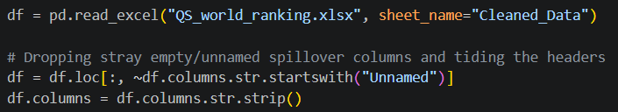
Figure 1: Loading the cleaned QS ranking dataset
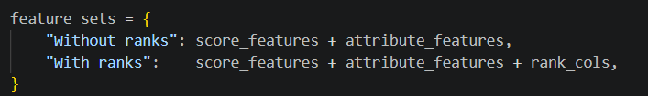
Figure 2: Defining the "With ranks" and "Without ranks" feature sets
Running the Regression Models QS_World_Ranking_Regression.ipynb trains Linear, Lasso, Ridge and Elastic Net Regression on the overall score, then converts each predicted score into a tier using fixed cut-offs, and reports the full precision, recall and accuracy for every model and feature set.
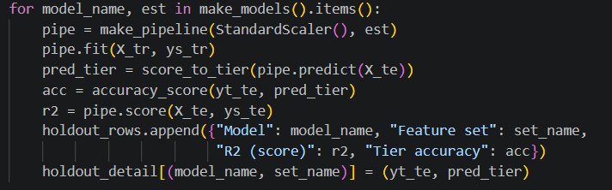
Figure 3: Fitting each regression model and binning predictions into a tier
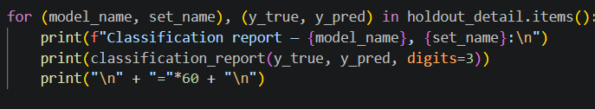
Figure 4: Generating classification reports for all four regression models
Running the Support Vector Machine Model QS_World_Ranking_SVM.ipynb uses GridSearchCV to tune the kernel, C and gamma of a Support Vector Classifier, then evaluates the tuned model on a hold-out set.
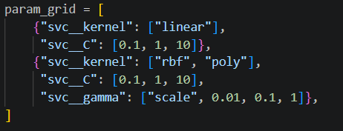
Figure 5: Hyperparameter grid and GridSearchCV setup for the SVM
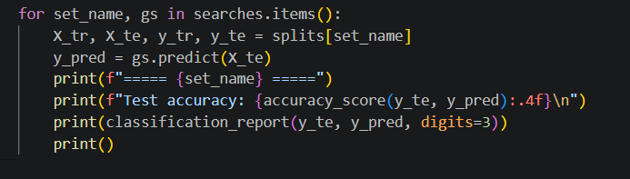
Figure 6: Test accuracy and classification report for the tuned SVM
Snippet: the short loop, for set_name, gs in searches.items(): ..., already only 5 lines.
Running the Multi-Layer Perceptron Model
QS_World_Ranking_MLP.ipynb follows the same approach as the SVM notebook, tuning the hidden layer sizes, alpha and learning rate of an MLPClassifier.
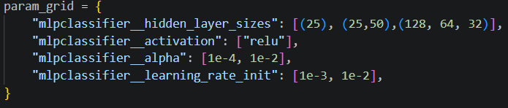
Figure 7: Hyperparameter grid and GridSearchCV setup for the MLP
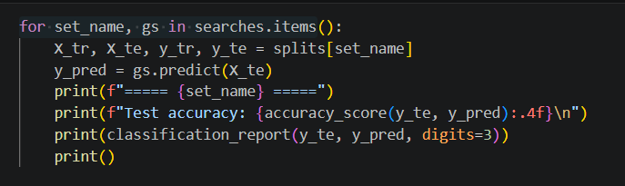
Figure 8: Test accuracy and classification report for the tuned MLP
Snippet: the same short loop as Figure 6, from the MLP notebook.
Reproducing the Results A fixed random state is used throughout all three notebooks, so re-running any of them from top to bottom will reproduce the figures reported in the Results section. The notebooks are independent of one another and can be run in any order, provided the dataset file is present in the working directory.

References
[1] QS (2025) QS World University Rankings 2026: Methodology. Available at: https://www.qs.com/insights/world-university-rankings-methodology (Accessed: 22 June 2026).
[2] QS (2025) International Student Ratio Indicator. Available at: https://support.qs.com/hc/en-gb/articles/4403961727506-International-Student-Ratio-Indicator (Accessed: 22 June 2026).
[3] QS Quacquarelli Symonds (2025) About QS. Available at: https://www.qs.com/about-qs/ (Accessed: 22 June 2026).

