Statistical Analysis of Rainfall Variability and Regional Monsoon Patterns in India
  - An undergraduate Probability and Statistics project using India Meteorological Department rainfall records
B.Tech Probability and Statistics Course Project
October 2026
Table of Contents

Title page
Project title. Statistical Analysis of Rainfall Variability and Regional Monsoon Patterns in India
Course. Probability and Statistics (undergraduate / B.Tech)
Software. R 4.6.1 and RStudio; analysis scripts in R_code/
Data. India Meteorological Department (IMD) area-weighted all-India rainfall, 1901–2015, and IMD meteorological subdivision rainfall, 1901–2017
Units. Millimetres (mm) throughout
Declaration. All numerical results in this report are taken from the project’s saved R outputs. No external rainfall datasets were added, and no values were invented. Student name, roll number and institution should be written here before submission.

Abstract
This project studies rainfall variability and monsoon patterns over India using two official India Meteorological Department (IMD) series: an all-India area-weighted monthly-to-annual record for 1901–2015 ($n=115$ complete years) and a panel of 36 meteorological subdivisions for 1901–2017. After a documented quality audit, the original CSV files were left unchanged and analysis copies were used. All-India mean annual rainfall is 1182.03 mm (median 1190.50 mm; SD 110.69 mm; CV 9.36%). About three-quarters of that mean (75.3%) falls in June–September. Historical relative frequencies, with an IMD-style 90%/110% rule applied to this series mean, classify 21.7% of years as deficient monsoon, 64.3% as normal and 13.9% as excess. All-India annual totals are close to both a normal and a gamma model (Shapiro–Wilk $p=$ 0.8014; bootstrap Kolmogorov–Smirnov $p=$ 0.3725 for gamma); an exponential model is incompatible with the data. A 95% $t$ interval for the all-India mean annual total is 1161.59 to 1202.48 mm under an independent-years approximation. Tests confirm the expected climatic contrasts (southwest monsoon versus post-monsoon; Kerala versus West Rajasthan) and do not detect a statistically significant linear or Mann–Kendall trend in all-India annual rainfall over 1901–2015. Serial correlation at lag 2 and the fact that years are a single climate path, not a simple random sample, limit causal language. Correlation is not treated as causation, and this analysis does not prove climate change.

Introduction
Rainfall over India is concentrated in a few months, varies sharply from the Western Ghats and north-east to the Thar Desert, and is the main natural control on agriculture and water supply. Undergraduate Probability and Statistics is well suited to this topic: the data are continuous millimetre measurements, they come in months, seasons and years, and they exist both as a national series and as regional series.
The scientific aim is modest and honest. The project describes the 1901–2015 all-India record and compares selected IMD subdivisions. It estimates means and proportions with confidence intervals, tests clearly stated hypotheses, fits simple probability models, and looks for monotonic association with time. It does not reconstruct daily storms, does not downscale climate models, and does not attribute rainfall change to greenhouse gases.
Two government files already in data/ are used and never replaced. Scripts R_code/01–09 produce the tables in results/tables/ and the figures in graphs/. This report cites those artefacts.

Problem statement
Decision makers often quote a single “average Indian rainfall” and a simple wet/dry story. The data are richer and more awkward than that slogan:
- The national series is area-weighted. It is not the unweighted mean of 36 subdivisions.
- Many subdivision years are missing some months. Annual totals are then undefined unless missing months are ignored, which would be incorrect.
- Rainfall is bounded below by zero, often skewed in dry months, and ordered in time, so textbook normal and independent-sample assumptions need checking.
- Seasonal totals that add up to the annual total must not be correlated with the annual total as if they were independent causes.
The problem is therefore to apply a wide, but justified, set of probability and statistics tools to these two series, to report what the numbers support, and to state clearly what they do not support.

Aim and objectives
Aim. To quantify rainfall variability and regional monsoon contrasts in India from official IMD records using standard methods of Probability and Statistics, with fully reproducible R code.
Objectives.
- Audit and clean the two source files without fabricating rainfall.
- Describe monthly, seasonal, annual and regional rainfall with appropriate summaries.
- Compute empirical probabilities with explicit thresholds and denominators.
- Assess normal, gamma and exponential models, including zeros where they occur.
- Demonstrate sampling variability, the Central Limit Theorem, and confidence intervals.
- Test pre-registered hypotheses at $α=0.05$.
- Study association among different seasons, not part–whole pairs.
- Fit simple and multiple linear regressions only where a question exists.
- Compare regions with ANOVA or a robust alternative after checking variances.
- Describe time series behaviour and test for monotonic trend without claiming attribution.

Research questions
- What are the location, spread and shape of all-India monthly, seasonal and annual rainfall in 1901–2015?
- How often, in this record, was the southwest monsoon deficient, normal or excess under a stated 90%/110% rule?
- Is a normal, gamma or exponential law a reasonable model for all-India annual rainfall?
- How precise is the estimated all-India mean, and how does interval width change with confidence level?
- Does the all-India mean differ from a 1180 mm textbook benchmark?
- Do Kerala and West Rajasthan differ in mean annual rainfall?
- Within the same year, does June–September rainfall differ from October–December rainfall?
- Are the four IMD seasons equally likely to be the wettest season?
- How strongly are winter and monsoon rainfall associated?
- Is there a statistically detectable linear or monotonic trend in all-India annual rainfall over 1901–2015?
- How do mean rainfall and relative variability differ among IMD subdivisions?

Dataset descriptions and official sources

Provenance
Both files are rainfall series of the India Meteorological Department (IMD), Ministry of Earth Sciences, Government of India. They were supplied as CSV files in data/ and were not downloaded from third-party contest sites for this project.
File | Spatial support | Time span in file | Role in this project
data/rainfall_area-wt_India_1901-2015.csv | One all-India area-weighted series (REGION = INDIA) | 1901–2015 | National climatology, distributions, inference, trend
data/Sub_Division_IMD_2017.csv | 36 IMD meteorological subdivisions | 1901–2017 (unbalanced) | Regional means, CV, ANOVA, selected regional trends

Schema actually used
The national file has columns REGION, YEAR, months JAN–DEC, ANNUAL, and seasons Jan-Feb, Mar-May, Jun-Sep, Oct-Dec.
The subdivision file has SUBDIVISION, YEAR, months JAN–DEC, ANNUAL, and seasons JF, MAM, JJAS, OND.
Season groups follow the standard IMD calendar: winter (January–February), pre-monsoon (March–May), southwest monsoon (June–September), post-monsoon (October–December). Units are millimetres. A recorded zero is a dry month, not a missing value. The token NA in the subdivision file is a true missing report.

Geographical and temporal scope
The national series has 115 rows, one per year, with no internal year gap. The subdivision file has 4188 rows. Arunachal Pradesh starts in 1916. Internal missing years include Andaman & Nicobar Islands (1909, 1943–1945, 1948), Arunachal Pradesh (1954–1956) and Lakshadweep (1918). Joint national–regional work uses 1901–2015. The two extra subdivision years 2016–2017 are not mixed into national trend tests.

Data cleaning and preprocessing
Cleaning is implemented in R_code/01_data_inspection.R and R_code/02_data_cleaning.R. Original files in data/ were never overwritten. Analysis copies live in results/cleaned_data/.
Table 1 records every transformation and the number of affected observations (from results/tables/cleaning_log.csv).
Table 1. Cleaning log (analysis copies only; originals untouched).
Step | Dataset | Action | n affected | Justification
1 | national_area_weighted | import | 115 | Read original CSV with explicit NA strings; originals not modified.
2 | national_area_weighted | trim_REGION | 0 | Remove leading/trailing whitespace from region labels.
3 | national_area_weighted | YEAR_to_integer | 0 | Calendar year is a discrete index, not a continuous measurement.
4 | national_area_weighted | rainfall_to_numeric | 0 | Rainfall is a continuous millimetre measurement; coercion failures would become NA (none expected).
5 | national_area_weighted | negative_rainfall_screen | 0 | Negative millimetres are physically impossible; none are deleted because none were found, or they would be flagged not dropped.
6 | national_area_weighted | duplicate_investigation | 0 | Exact row duplicates and REGION-YEAR duplicates were counted. No rows removed because none were found.
7 | national_area_weighted | consistency_flags | 0 | Source seasonal/annual totals were retained. Differences > 1 mm versus the sum of constituent months are flagged, not overwritten.
8 | national_area_weighted | annual_reconstruct_if_source_NA | 0 | Not imputation of unobserved rain: ANNUAL is a total of observed months. Filled only when all 12 months exist and source ANNUAL is NA.
9 | national_area_weighted | outlier_flag_iqr_k3 | 2 | Extreme rainfall years are scientifically informative (floods/droughts). Flagged with a conservative 3xIQR rule; no rows deleted.
10 | national_area_weighted | write_cleaned_copy | 115 | Analysis copy written; original data/ CSV untouched.
11 | imd_subdivision | import | 4188 | Read original CSV with explicit NA strings; originals not modified.
12 | imd_subdivision | standardise_SUBDIVISION_whitespace | 0 | Trim and collapse repeated whitespace. Historical IMD names (Orissa, Matathwada, Rayalseema) are retained so records stay matchable to the source.
13 | imd_subdivision | YEAR_to_integer | 0 | Calendar year is a discrete index.
14 | imd_subdivision | rainfall_to_numeric | 0 | Rainfall coerced to numeric millimetres. Source ‘NA’ tokens already mapped to R NA on import.
15 | imd_subdivision | retain_zeros_and_missing | 70 | Zero millimetres remain as dry months. NA remains missing. Incomplete rows were not deleted.
16 | imd_subdivision | negative_rainfall_screen | 0 | Negative rainfall would be flagged, not deleted.
17 | imd_subdivision | duplicate_investigation | 0 | No SUBDIVISION-YEAR duplicates. No rows removed.
18 | imd_subdivision | consistency_flags | 0 | Source derived totals retained. Inconsistencies > 1 mm versus complete month sums are flagged, not overwritten.
19 | imd_subdivision | reconstruct_derived_totals_if_source_NA | 0 | Where IMD omitted ANNUAL/JF/MAM/JJAS/OND but all constituent months are observed, the analysis column is the month sum. This does not invent monthly rain.
20 | imd_subdivision | outlier_flag_iqr_k3_by_subdivision_month | 887 | Outliers flagged within each subdivision and month using 3xIQR. Extreme monsoon totals are retained.
21 | imd_subdivision | retain_unbalanced_panel | 9 | Internal missing years (e.g. a subdivision with 1908 then 1910) are left as absent rows. No years were invented.
22 | imd_subdivision | write_cleaned_copy | 4188 | Analysis copy written; original data/ CSV untouched.
Decisions that matter for later inference.
- Missing months. Seventy monthly cells in the subdivision file are NA. Incomplete rows were kept. Annual and monsoon analyses of subdivisions use years with all 12 months observed (months_complete).
- Zeros. 3720 monthly zeros were retained as genuine dry months.
- No imputation. Where a source annual or seasonal total was missing, reconstruction from months was allowed only if every constituent month was present. That case never occurred (ANNUAL_filled = 0), because every missing annual already had a missing month.
- Duplicates. None in either file.
- Consistency. Source seasonal and annual totals agree with month sums within rounding (maximum absolute difference 0.3 mm nationally and 0.4 mm for subdivision annual totals). Nothing was overwritten.
- Outliers. Conservative $3×$IQR flags were stored. Two national rows and 887 subdivision rows had at least one flagged month. No extreme year was deleted; wet and dry extremes are part of the climate.
- Labels. Historical IMD names (Orissa, Matathwada, Rayalseema) were kept after trimming whitespace.

Statistical methodology
Notation: $X_{1},…,X_{n}$ are rainfall values in millimetres for a stated series; $\overset{‾}{x}$ is the sample mean; $s$ is the sample standard deviation with divisor $n−1$; $α=0.05$ unless stated.
Mean, variance, SD and CV.
$$\overset{‾}{x}=\frac{1}{n}\sum_{i=1}^{n}{x_{i}}, s^{2}=\frac{1}{n−1}\sum_{i=1}^{n}{(}x_{i}−\overset{‾}{x})^{2}, CV=100⋅\frac{s}{\overset{‾}{x}}.$$
The CV compares relative variability of a wet coast and a dry desert.
Standard error of the mean (independent observations): $SE(\overset{‾}{x})=s/\sqrt{n}$.
Student $t$ interval for a mean:
$$\overset{‾}{x}±t_{n−1,1−α/2} \frac{s}{\sqrt{n}}.$$
Wald interval for a proportion $\hat{p}=x/n$:
$$\hat{p}±z_{1−α/2}\sqrt{\hat{p}(1−\hat{p})/n}.$$
Pearson correlation (for linear association, not causation):
$$r=\frac{∑(x_{i}−\overset{‾}{x})(y_{i}−\overset{‾}{y})}{\sqrt{∑(x_{i}−\overset{‾}{x})^{2}∑(y_{i}−\overset{‾}{y})^{2}}}.$$
Simple linear regression. $Y_{i}=β_{0}+β_{1}t_{i}+ε_{i}$ with year $t_{i}$. Ordinary least squares is used as a descriptive line. Residual plots, Shapiro–Wilk on residuals, a screen of $e_{i}^{2}$ against fitted values, Cook’s distance and the Durbin–Watson statistic $d=∑({\hat{e}}_{i}−{\hat{e}}_{i−1})^{2}/∑{\hat{e}}_{i}^{2}$ are reported. If residuals are serially correlated, OLS $p$-values are treated as approximate.
Welch two-sample $t$ is used when two places are compared and variances differ. Paired $t$ is used when two seasons belong to the same year. Independent-sample tests are not applied to paired seasons.
ANOVA. Classical one-way ANOVA assumes independent groups, similar variances and approximate normality. Fligner–Killeen tests variances. If they differ, Welch ANOVA and Bonferroni pairwise Welch tests are preferred; Kruskal–Wallis is reported as a rank alternative.
Distributions. Gamma (positive, possibly skewed) is fitted by maximum likelihood. Exponential (gamma with shape 1, and $SD=mean$) is fitted only as a poor reference. The ordinary one-sample Kolmogorov–Smirnov $p$-value is not used when parameters are estimated from the same sample (Lilliefors problem). A parametric bootstrap with $B=400$ and seed 19012015 re-estimates parameters in each replicate.
Trend. Mann–Kendall tests $H_{0}$: no monotonic trend, using
S=i<j​sign(xj−xi),
with a normal approximation for $Z$ after a tie correction. Sen’s slope is the median of pairwise slopes $(x_{j}−x_{i})/(t_{j}−t_{i})$. These tests describe association with time in 1901–2015; they are not attribution.
Software. Base R 4.6.1 only for analysis (stats, graphics, grDevices). Random seed for simulations: 19012015.

Descriptive statistics
All-India results use 115 complete years, 1901–2015. Table 2 summarises seasons and the year.
Table 2. All-India seasonal and annual rainfall (mm), 1901–2015.
Series | n | Mean | Median | SD | CV % | Min | Max | Skewness | Excess kurtosis
annual | 115 | 1182.03 | 1190.5 | 110.69 | 9.36 | 920.8 | 1480.3 | 0.02 | -0.19
Jan-Feb winter | 115 | 43.19 | 41.3 | 14.48 | 33.52 | 11.7 | 86.3 | 0.39 | 0.01
Mar-May pre-monsoon | 115 | 128.69 | 125.1 | 22.90 | 17.79 | 84.5 | 209.7 | 0.74 | 0.80
Jun-Sep southwest monsoon | 115 | 890.26 | 897.8 | 89.18 | 10.02 | 679.5 | 1094.5 | -0.29 | -0.43
Oct-Dec post-monsoon | 115 | 119.88 | 116.2 | 32.47 | 27.08 | 52.7 | 207.5 | 0.38 | -0.23
What the measures say. The mean annual total is 1182.03 mm and the median is 1190.50 mm, so the centre is not being pulled by a few catastrophic years. The range is 920.80 to 1480.30 mm. The SD of 110.69 mm and CV of 9.36% show moderate year-to-year variation relative to the mean. Skewness 0.020 and excess kurtosis -0.193 are close to the normal values 0 and 0: at the all-India annual scale, spatial averaging has already removed much of the skewness seen in local daily rain. A unique sample mode after rounding to 0.1 mm does not exist for annual totals (continuous series with almost unique values).
June–September averages 890.26 mm, which is 75.3% of the annual mean. Winter averages only 43.19 mm. Relative variability is highest in winter (CV 33.52%) and post-monsoon (CV 27.08%), and lowest in the monsoon (CV 10.02%).
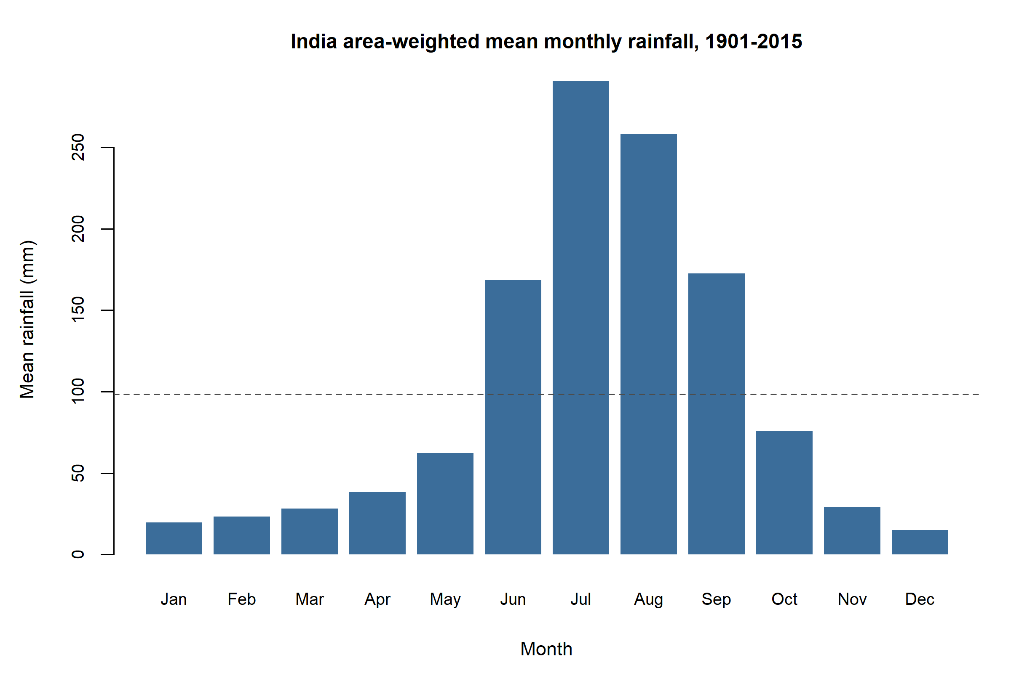
Figure 1. All-India area-weighted mean monthly rainfall (mm), 1901–2015.
Figure 1 and Table 3 show the annual cycle: July (291.02 mm) and August (258.40 mm) dominate; December is driest (14.98 mm) with the largest CV (58.67%).
Table 3. All-India monthly rainfall (mm), 1901–2015, n = 115.
Month | Mean | Median | SD | CV % | Min | Max
JAN | 19.76 | 17.8 | 9.99 | 50.57 | 2.7 | 58.5
FEB | 23.43 | 22.5 | 11.51 | 49.13 | 2.7 | 53.8
MAR | 28.25 | 25.5 | 12.29 | 43.48 | 7.2 | 63.3
APR | 38.24 | 37.4 | 10.35 | 27.07 | 16.1 | 69.4
MAY | 62.19 | 59.5 | 15.67 | 25.20 | 32.1 | 114.5
JUN | 168.36 | 165.6 | 35.57 | 21.13 | 86.5 | 275.5
JUL | 291.02 | 295.8 | 41.16 | 14.14 | 138.9 | 383.4
AUG | 258.40 | 259.3 | 34.98 | 13.54 | 191.7 | 335.5
SEP | 172.47 | 173.1 | 36.64 | 21.24 | 96.9 | 281.0
OCT | 75.70 | 69.2 | 28.27 | 37.34 | 20.0 | 158.8
NOV | 29.21 | 26.1 | 16.10 | 55.13 | 3.6 | 74.2
DEC | 14.98 | 14.1 | 8.79 | 58.67 | 1.6 | 54.4
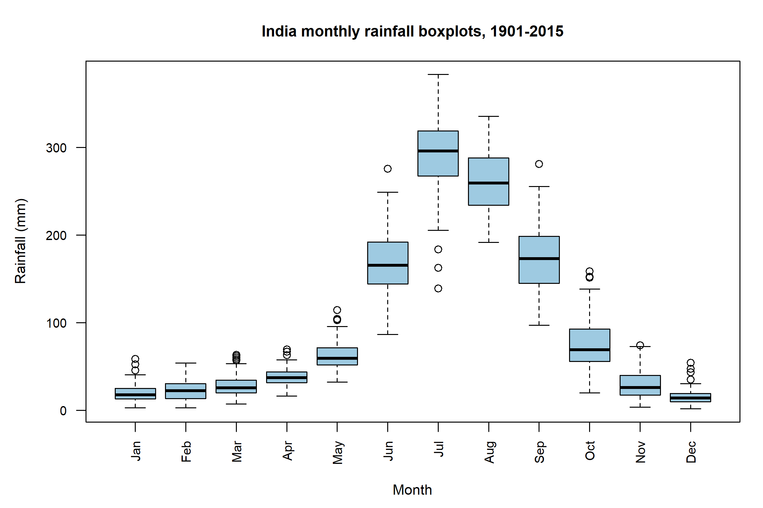
Figure 2. All-India monthly rainfall boxplots (mm), 1901–2015.
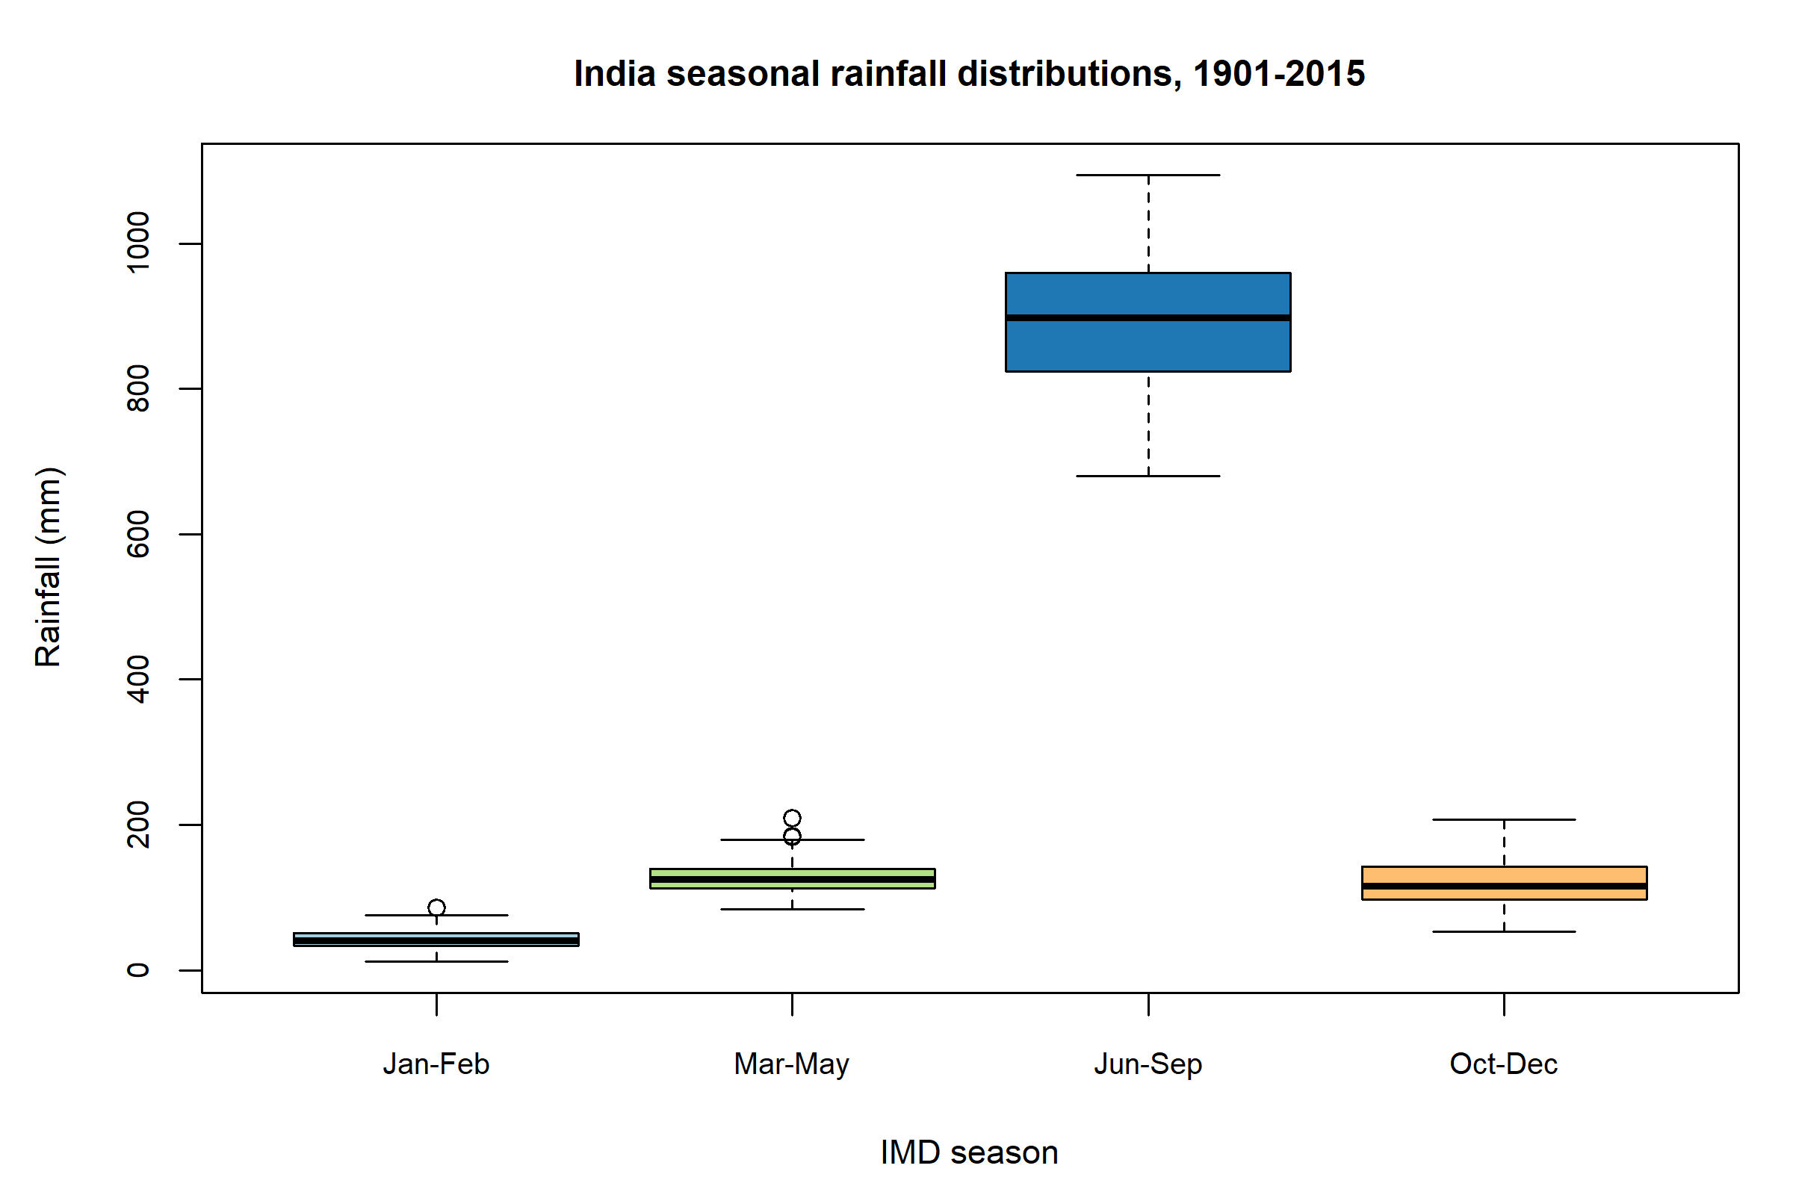
Figure 3. All-India seasonal rainfall distributions (mm), 1901–2015.
Figures 2 and 3 make the same point visually: monsoon boxes sit far above the other seasons, with no overlap of typical years.
Among subdivisions (complete years, 1901–2015), mean annual rainfall runs from West Rajasthan (292.67 mm, CV 37.19%) to very wet western-coast and north-eastern subdivisions (Coastal Karnataka and Arunachal Pradesh exceed 3400 mm). Kerala averages 2925.49 mm (CV 14.43%). Drier regions tend to have larger CVs: relative variability, not only the mean, differs by climate. Full regional tables are in results/tables/regional_annual_summaries.csv.

Probability and distribution analysis

Empirical probabilities
These quantities are historical relative frequencies in 1901–2015. They equal long-run probabilities only if one accepts extra assumptions (a stationary process, a well-defined random year). They are not forecasts.
The long-period average (LPA) analogue used here is the sample mean of this series, not the official IMD 50-year LPA, which is not stored in the CSV files. Deficient monsoon: June–September $<90\%$ of that mean (801.23 mm). Excess: $>110\%$ (979.29 mm).
Table 4. Empirical probabilities, all-India, 1901–2015 (n = 115).
Event | Definition | Numerator | Denominator | Relative frequency
Annual rainfall greater than the 1901-2015 sample mean (LPA analogue) | ANNUAL > 1182.03 mm | 59 | 115 | 0.513
Unusually dry year (below historical 10th percentile) | ANNUAL < 1041.30 mm (10th percentile of 1901-2015) | 12 | 115 | 0.104
Unusually wet year (above historical 90th percentile) | ANNUAL > 1331.30 mm (90th percentile of 1901-2015) | 12 | 115 | 0.104
Deficient southwest monsoon (IMD-style: JJAS < 90% of series mean) | Jun-Sep < 0.90 * 890.26 mm | 25 | 115 | 0.217
Normal southwest monsoon (90-110% of series mean) | 0.90LPA <= Jun-Sep <= 1.10LPA | 74 | 115 | 0.643
Excess southwest monsoon (JJAS > 110% of series mean) | Jun-Sep > 1.10 * 890.26 mm | 16 | 115 | 0.139
Conditional: deficient monsoon given dry winter (JF < 25th percentile) | P(JJAS deficient | Jan-Feb < 33.80 mm) | 6 | 29 | 0.207
Conditional: deficient monsoon given not-dry winter | P(JJAS deficient | Jan-Feb >= 25th percentile) | 19 | 86 | 0.221
Southwest monsoon is the wettest IMD season of the year | Jun-Sep == max(Jan-Feb, Mar-May, Jun-Sep, Oct-Dec) | 115 | 115 | 1.000
About 64.3% of years are “normal” under this rule, 21.7% deficient and 13.9% excess. Unusually dry and wet annual years, defined by the sample 10th and 90th percentiles (1041.30 mm and 1331.30 mm), each occur in 12 of 115 years by construction of a 10% tail.
The conditional probability of a deficient monsoon given a dry winter (January–February below its 25th percentile) is 0.207, versus 0.221 given a not-dry winter. The two frequencies are almost the same: this record does not show a useful winter–monsoon dependence of that form. That is association only, not a physical conclusion about teleconnections.
In every one of the 115 years, June–September was the wettest of the four IMD seasons (relative frequency 1).

Probability models
A normal law can assign probability to negative rainfall, so it is not automatic for millimetres. A gamma law is supported on $(0,∞)$ and can be right-skewed. An exponential law is a gamma with shape 1 and forces $SD=mean$. For all-India annual rainfall, SD (110.69 mm) is far smaller than the mean (1182.03 mm), so exponential is scientifically implausible and is fitted only as a bad reference.
Parameters were estimated by maximum likelihood. Goodness-of-fit $p$-values for KS tests with estimated parameters come from a parametric bootstrap ($B=400$).
Table 5. Fitted distributions. KS p-values are parametric bootstrap, not ordinary ks.test p-values.
series | distribution | param1_name | param1 | param2_name | param2 | aic | ks_stat | ks_p_bootstrap | shapiro_p
India annual | gamma | shape | 114.0443 | rate | 0.09648 | 1412.3 | 0.0612 | 0.3725 | 0.8014
India annual | normal | mean | 1182.0348 | sd_mle | 110.20392 | 1411.9 | 0.0517 | 0.6100 | 0.8014
India annual | exponential | rate | 0.0008 | mean | 1182.03478 | 1859.2 | 0.5411 | 0.0000 | 0.8014
India Jun-Sep | gamma | shape | 97.5089 | rate | 0.10953 | 1364.9 | 0.1155 | 0.0000 | 0.0581
For all-India annual rainfall, Shapiro–Wilk $W=$ 0.9926, $p=$ 0.8014: the normal model is not rejected. Bootstrap KS $p=$ 0.6100 (normal) and $p=$ 0.3725 (gamma). AIC slightly favours the normal (1411.9) over the gamma (1412.3). Exponential AIC is 1859.2 and bootstrap KS $p=$ < 0.0001: it is rejected.
The gamma MLE for annual totals is shape $\hat{α}=$ 114.04 and rate $\hat{β}=$ 0.0965 mm$​^{−1}$. A large shape is consistent with a nearly symmetric, peaked distribution, which matches the small sample skewness.
June–September is slightly left-skewed (skewness -0.294). A right-skewed gamma is therefore a poorer match: bootstrap KS $p=$ < 0.0001 and Shapiro–Wilk $p=$ 0.0581. That is a limitation of forcing a gamma onto monsoon totals, not a reason to switch to exponential.
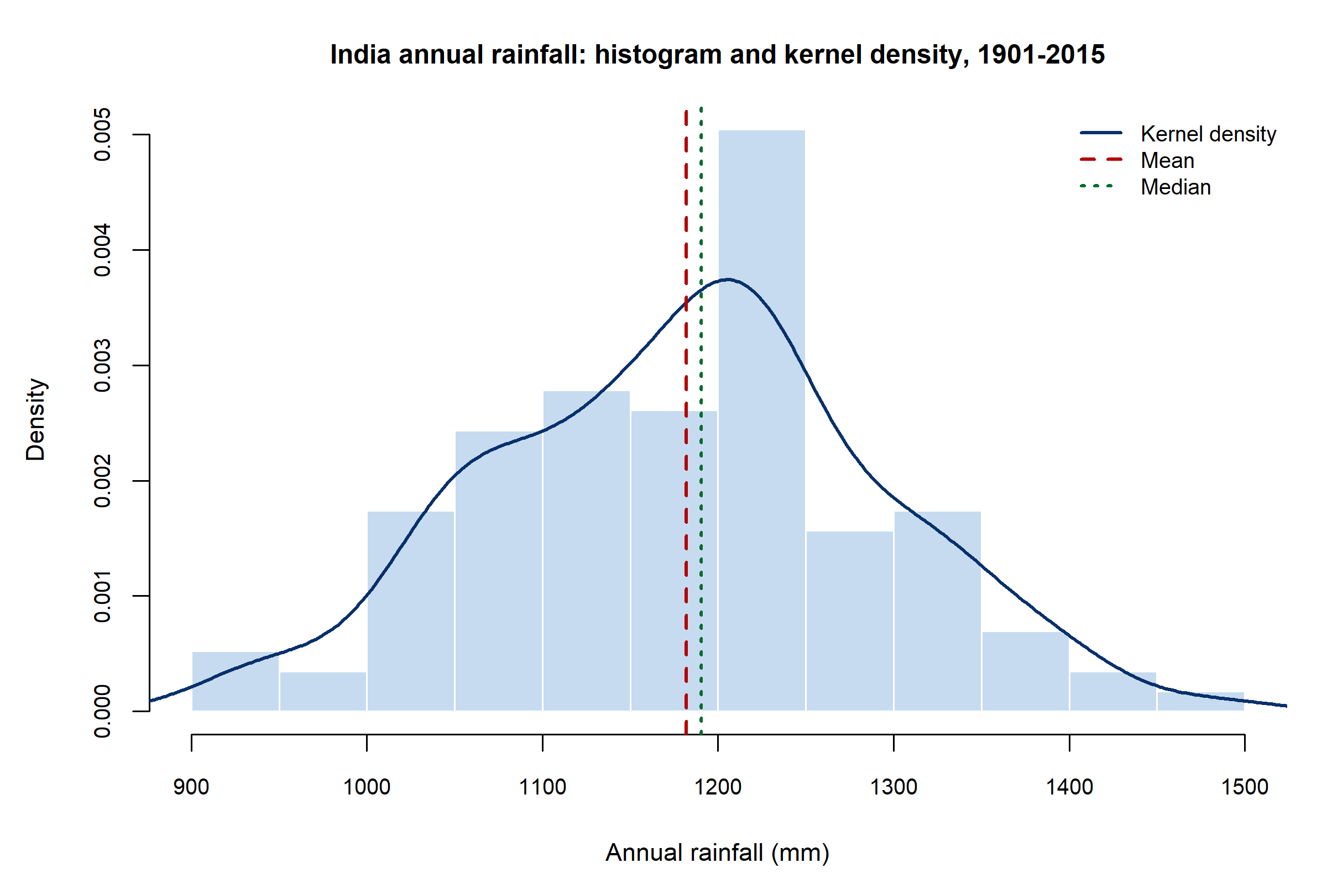
Figure 4. Histogram and kernel density of all-India annual rainfall (mm), 1901–2015.
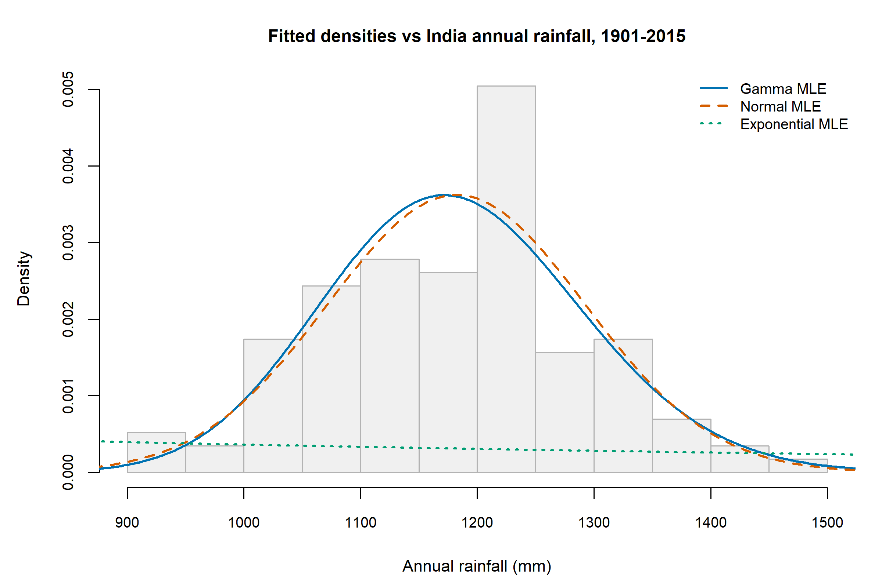
Figure 5. Gamma, normal and exponential densities fitted to all-India annual rainfall.
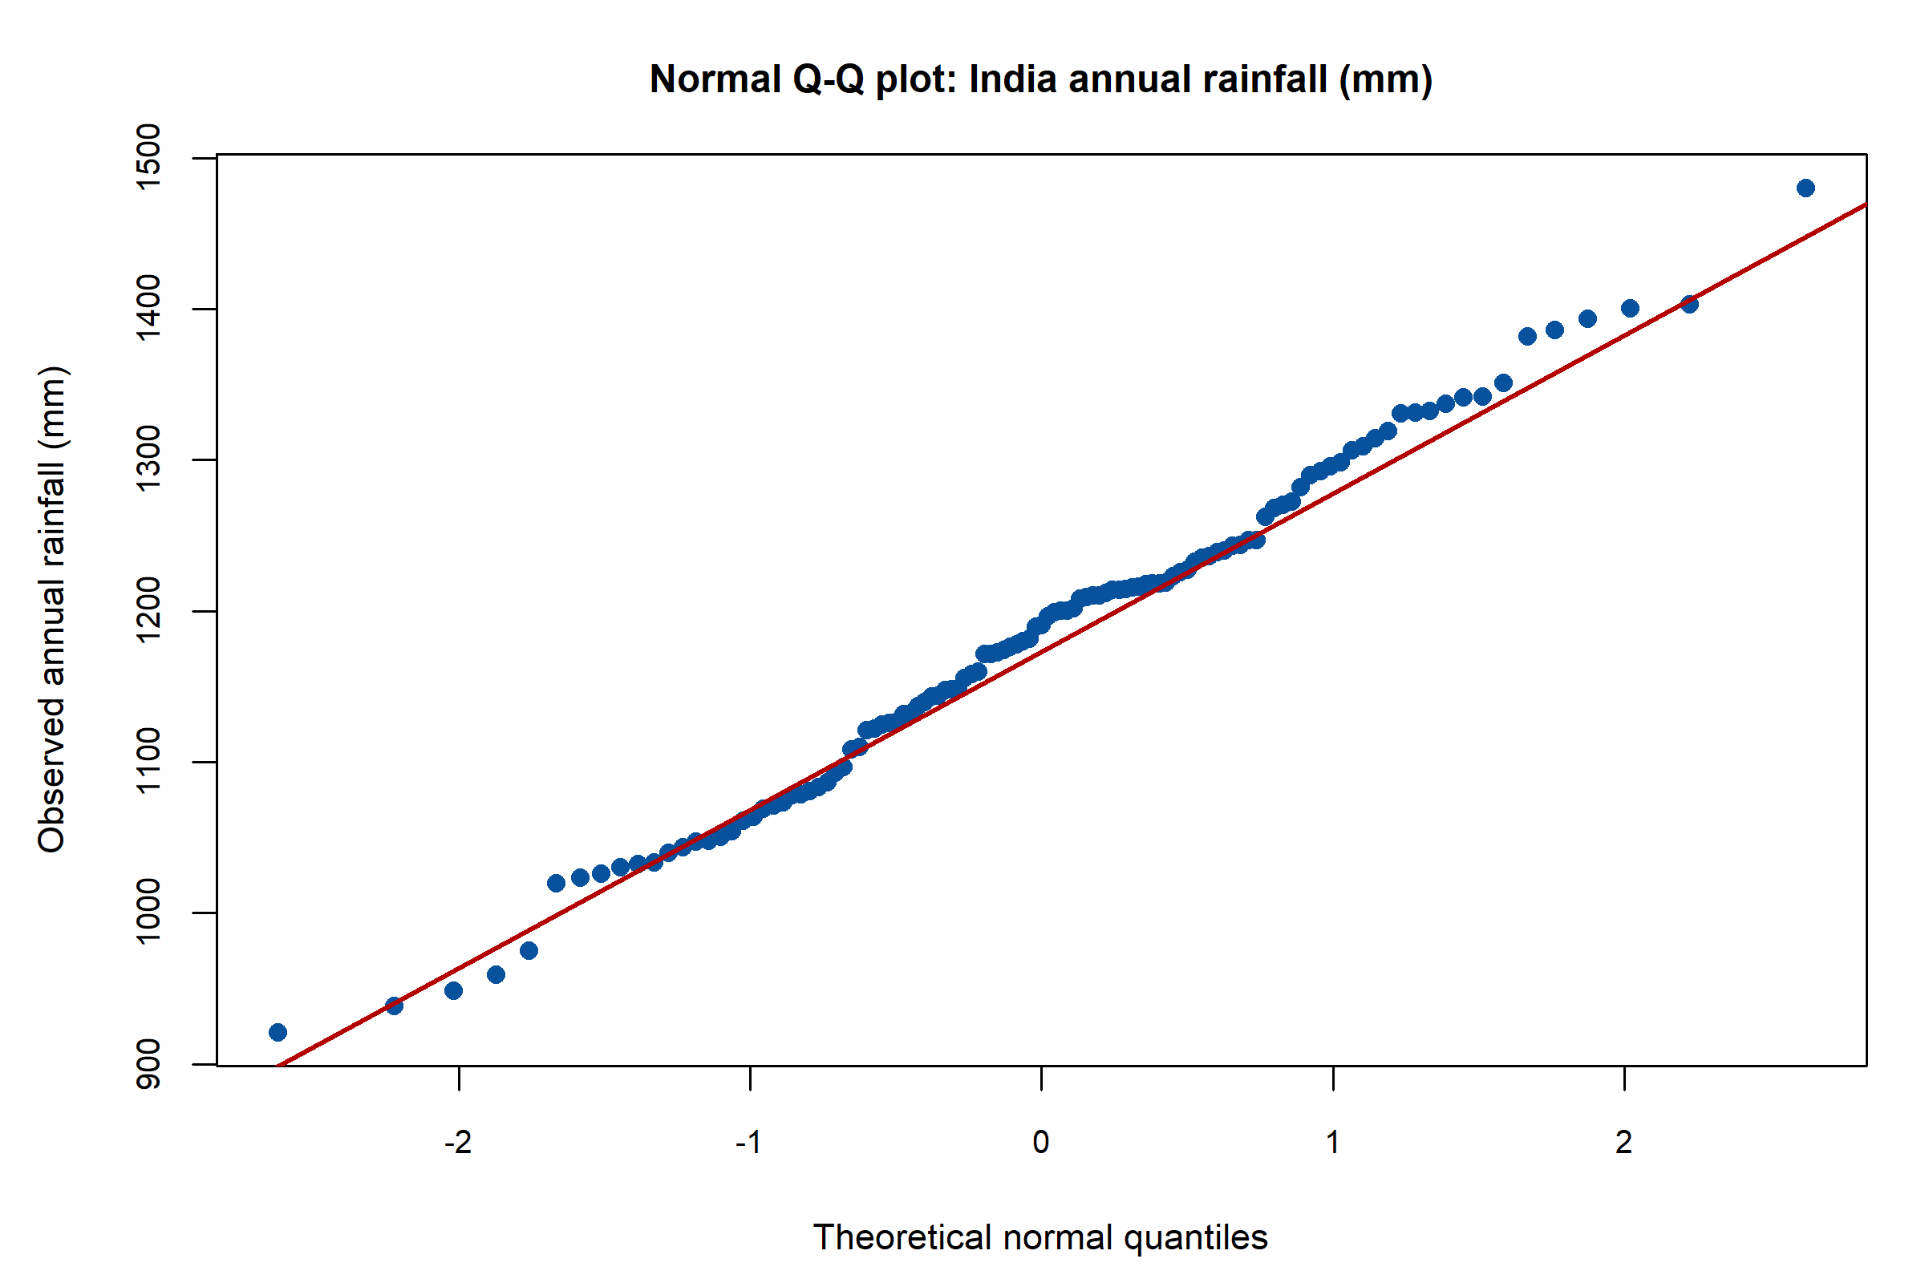
Figure 6. Normal Q–Q plot of all-India annual rainfall (mm).
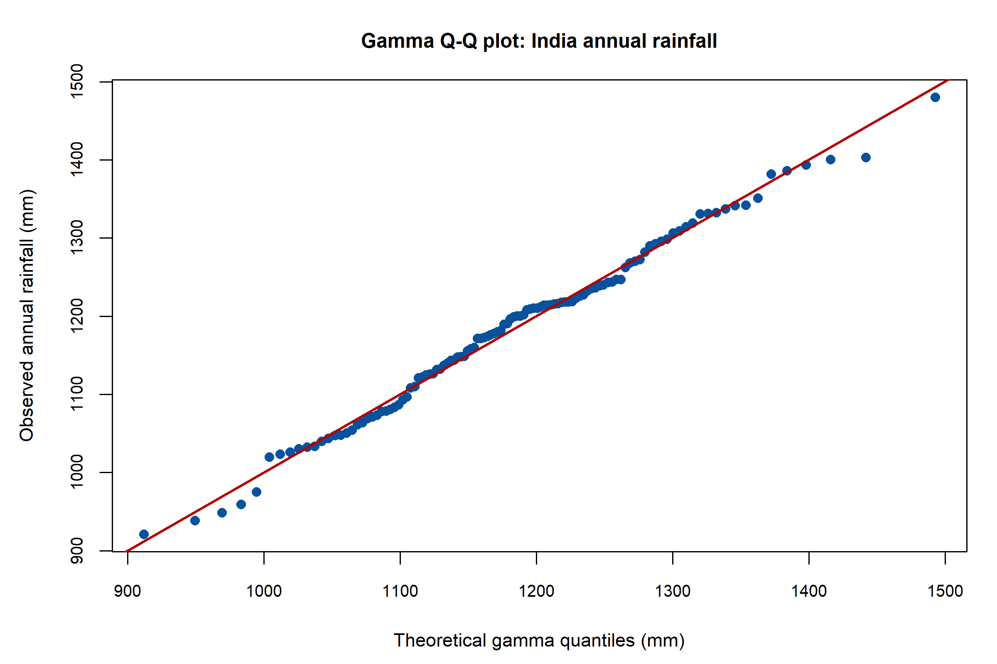
Figure 7. Gamma Q–Q plot of all-India annual rainfall (mm).
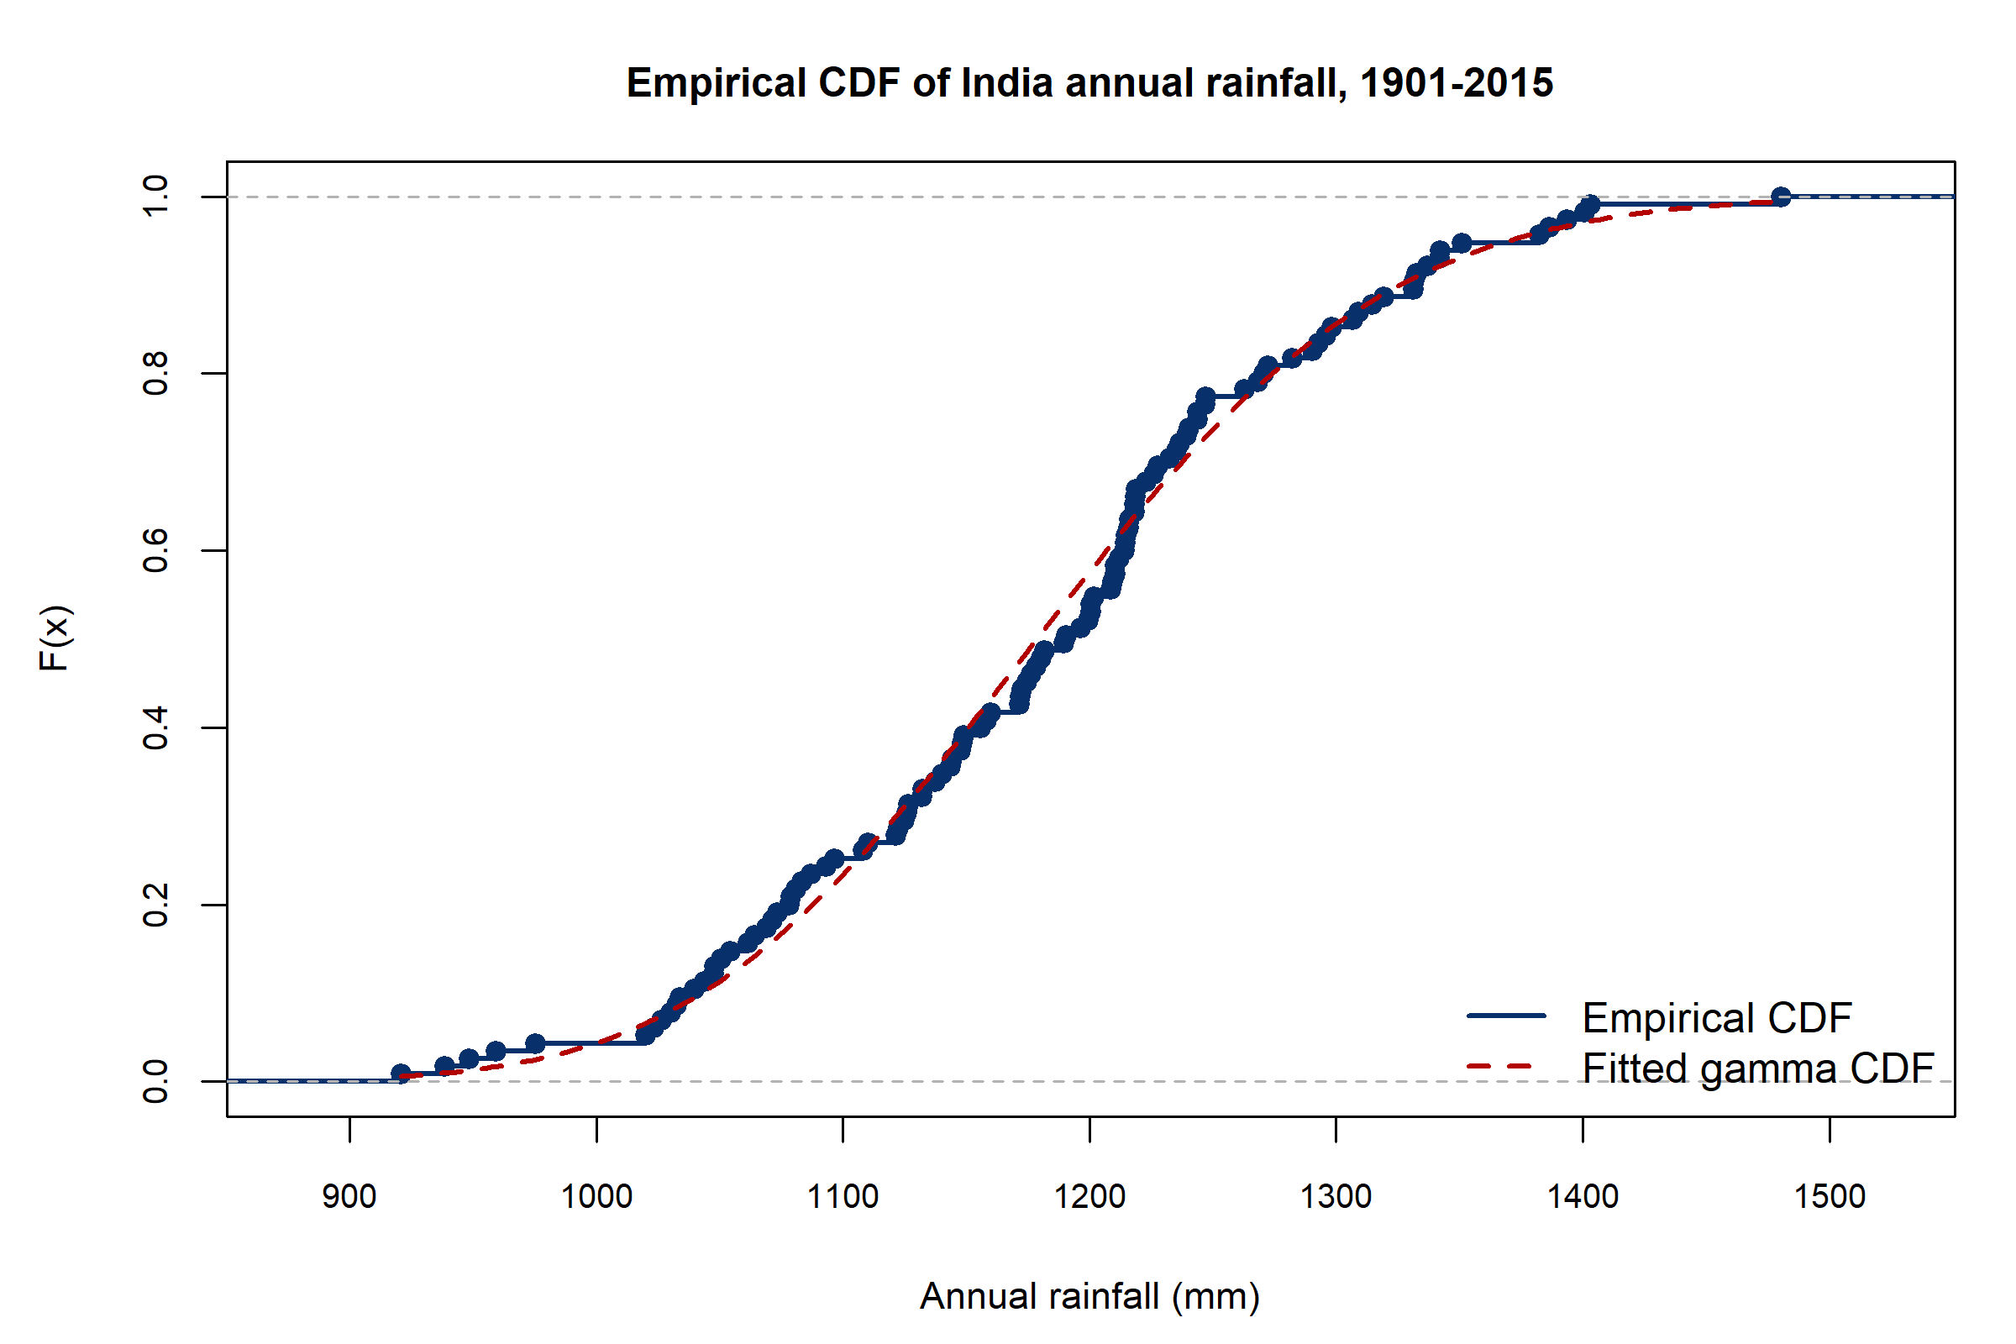
Figure 8. Empirical CDF of all-India annual rainfall with the fitted gamma CDF.
Figures 4–8 agree with Table 5: the histogram is unimodal and fairly symmetric; exponential is far too spread out; normal and gamma Q–Q plots are both reasonable.
Zeros. The national monthly series has no zeros. Subdivision dry-season months do. A single gamma or exponential cannot place a point mass at zero. For West Rajasthan December (complete years, $n=$ 117), 43 months are zero, so the empirical $P(X=0)=$ 0.368. Positive amounts were given a separate gamma (shape 0.654, rate 0.219). This is a hurdle description, not a claim that December rain is a waiting time.

Sampling and estimation
The 115 years are one realised path of a climate process. Treating them as iid draws from a super-population is an approximation used to illustrate textbook sampling theory.
The estimated standard error of the all-India annual mean is $s/\sqrt{n}=$ 10.32 mm.
A teaching simulation (seed 19012015) drew 4000 bootstrap samples with replacement from the 115 observed annual totals, for sample sizes 5, 15 and 40. These draws are not extra meteorological years and must not be averaged into the data.
Table 6. CLT resampling demonstration from the empirical all-India annual distribution (4000 replications).
sample_size | n_replications | mean_of_sample_means | sd_of_sample_means | theoretical_se | skewness_of_means | shapiro_p_500
5 | 4000 | 1182.007 | 49.270 | 49.500 | 0.001 | 0.425
15 | 4000 | 1181.403 | 28.530 | 28.579 | 0.020 | 0.547
40 | 4000 | 1182.223 | 17.351 | 17.501 | -0.013 | 0.598
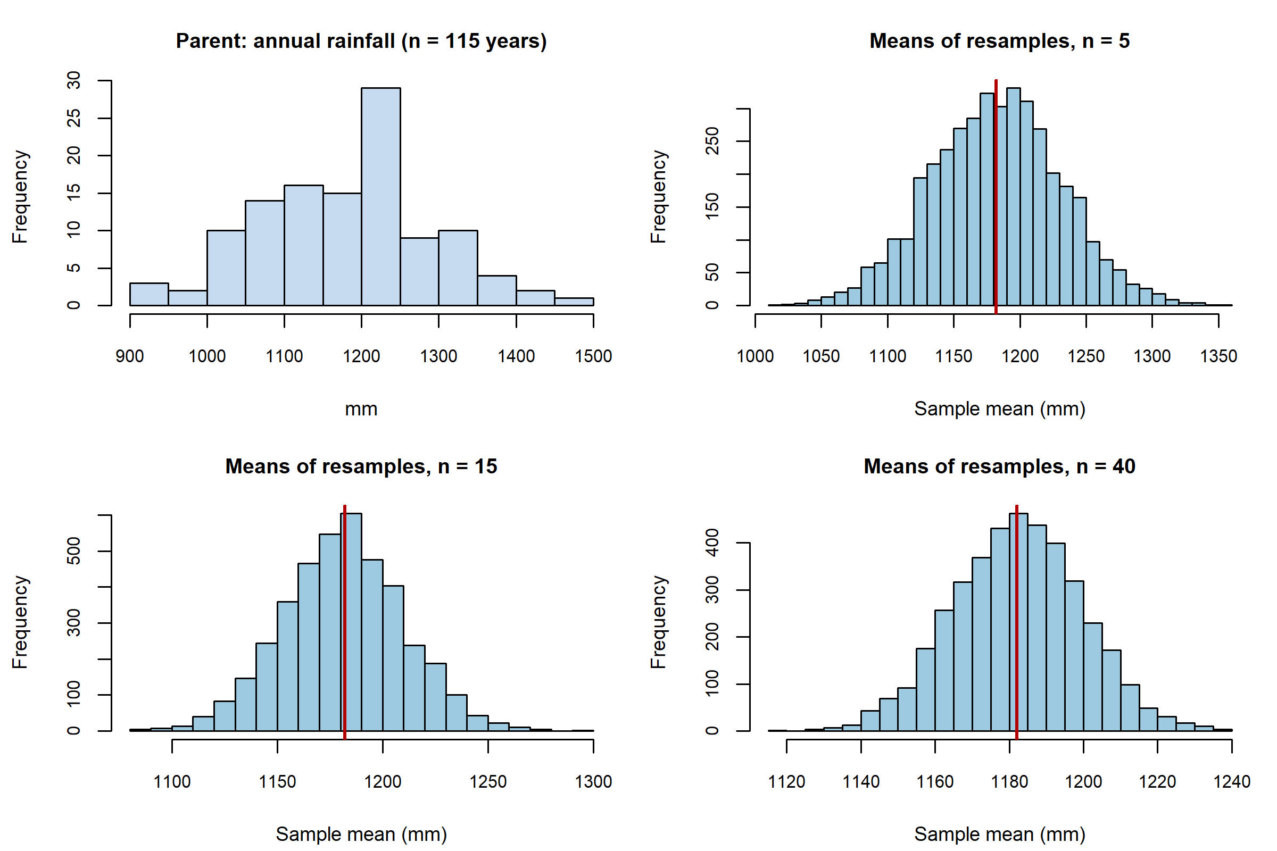
Figure 9. Parent annual-rainfall histogram and sampling distributions of the mean for n = 5, 15 and 40. Simulated draws are teaching devices, not new observations.
As $n$ grows, the histogram of sample means concentrates at about 1182.03 mm and the simulated SD of means tracks $s/\sqrt{n}$ (for $n=40$, 17.35 mm versus theoretical 17.50 mm). Skewness of the means is near zero. This is the Central Limit Theorem in a resampling illustration, not a proof that annual climate is iid.

Confidence intervals
Parameter. The mean of all-India area-weighted annual rainfall, in millimetres, for the 1901–2015 record under the iid-normal (or CLT) approximation.
Method. Student’s $t$ with $n−1=114$ degrees of freedom. Assumptions: independent years and either normality or a large-sample mean. Shapiro–Wilk did not reject normality of annual totals, but lag-2 autocorrelation (Section 18) means the reported intervals are iid-benchmark intervals and may be slightly too narrow.
Table 7. Confidence intervals. Mean intervals are Student t; proportion intervals are Wald.
series | parameter | confidence_level | n | estimate | se | lower | upper | method
India annual rainfall | mean (mm) | 0.90 | 115 | 1182.03 | 10.322 | 1164.92 | 1199.15 | Student t, iid assumption
India annual rainfall | mean (mm) | 0.95 | 115 | 1182.03 | 10.322 | 1161.59 | 1202.48 | Student t, iid assumption
India annual rainfall | mean (mm) | 0.99 | 115 | 1182.03 | 10.322 | 1155.00 | 1209.07 | Student t, iid assumption
India Jun-Sep rainfall | mean (mm) | 0.90 | 115 | 890.26 | 8.316 | 876.47 | 904.05 | Student t, iid assumption
India Jun-Sep rainfall | mean (mm) | 0.95 | 115 | 890.26 | 8.316 | 873.79 | 906.73 | Student t, iid assumption
India Jun-Sep rainfall | mean (mm) | 0.99 | 115 | 890.26 | 8.316 | 868.48 | 912.05 | Student t, iid assumption
India Jun-Sep deficient years | proportion deficient (<90% of series mean) | 0.90 | 115 | 0.22 | 0.038 | 0.15 | 0.28 | Wald (normal) interval for a binomial proportion
India Jun-Sep deficient years | proportion deficient (<90% of series mean) | 0.95 | 115 | 0.22 | 0.038 | 0.14 | 0.29 | Wald (normal) interval for a binomial proportion
India Jun-Sep deficient years | proportion deficient (<90% of series mean) | 0.99 | 115 | 0.22 | 0.038 | 0.12 | 0.32 | Wald (normal) interval for a binomial proportion
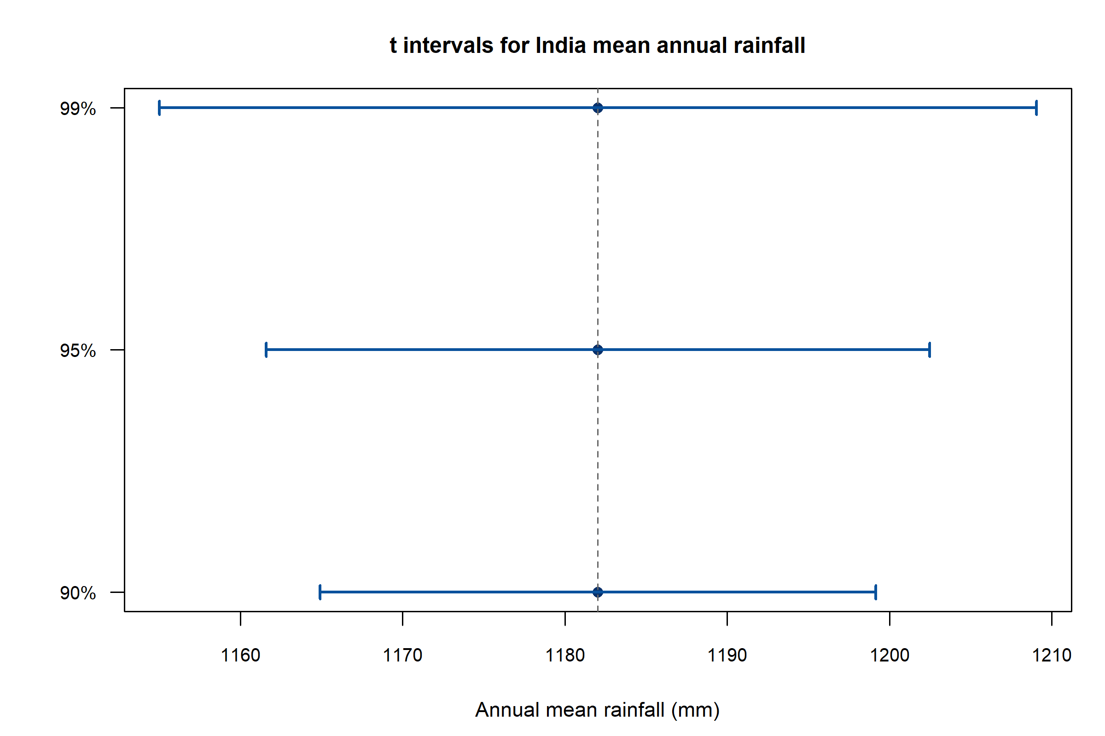
Figure 10. t intervals for the all-India mean annual rainfall at 90%, 95% and 99% confidence. Higher confidence produces a wider interval.
The 90%, 95% and 99% intervals for the annual mean are [1164.92, 1199.15], [1161.59, 1202.48] and [1155.00, 1209.07] mm. The 95% interval for mean June–September rainfall is 873.79 to 906.73 mm.
The Wald 95% interval for the proportion of deficient monsoon years is 0.142 to 0.293, around $\hat{p}=$ 0.217. Years are not independent Bernoulli trials; the interval is a teaching calculation with that caveat.

Hypothesis testing
All tests use $α=0.05$. Failure to reject $H_{0}$ does not prove $H_{0}$. $P$-values are not posterior probabilities of hypotheses.
Table 8. Hypothesis tests at alpha = 0.05. Full write-ups follow.
test_id | procedure | H0 | n | statistic | df | p_value | ci_95 | decision
1 | One-sample t-test | mu = 1180 mm | 115 | 0.197 | 114.0000 | 0.8441 | [1161.588, 1202.482] | Do not reject H0
2 | Wilcoxon signed-rank (one-sample) | median = 1180 mm | 115 | 3420.000 | NA | 0.8136 | [1160.850, 1204.150] | Do not reject H0
3 | Welch two-sample t-test | mu_Kerala = mu_WestRajasthan | 115+115 | 64.768 | 129.0925 | < 0.0001 | [2552.389, 2713.241] | Reject H0
4 | Wilcoxon rank-sum | P(Kerala > Rajasthan) = 0.5 (equal distributions on a shift) | 115+115 | 13225.000 | NA | < 0.0001 | see output file | Reject H0
5 | Paired t-test | mu_(JJAS - OND) = 0 | 115 | 96.377 | 114.0000 | < 0.0001 | [754.543, 786.213] | Reject H0
6 | Wilcoxon signed-rank (paired) | median(JJAS - OND) = 0 | 115 | 6670.000 | NA | < 0.0001 | [755.000, 789.250] | Reject H0
7 | Chi-square goodness-of-fit | p_JF = p_MAM = p_JJAS = p_OND = 1/4 | 115 | 345.000 | 3.0000 | < 0.0001 | NA | Reject H0
8 | Chi-square test of independence | period and monsoon category are independent | 115 | 0.335 | 2.0000 | 0.8456 | NA | Do not reject H0

One-sample $t$-test (all-India annual mean versus 1180 mm)
Question. Is the mean of this area-weighted annual series different from 1180 mm (a round textbook figure of about 118 cm)?
Hypotheses. $H_{0}:μ=1180$ mm versus $H_{1}:μ≠1180$ mm.
Method and assumptions. One-sample $t$, $n=115$, df $=114$. Shapiro–Wilk $W=0.9926$, $p=0.8014$. Independence of years is approximate.
Result. $\overset{‾}{x}=$ 1182.03 mm, $t=$ 0.197, $p=$ 0.8441, 95% CI [1161.59, 1202.48] mm.
Decision. Do not reject $H_{0}$.
Interpretation. This historical mean is compatible with 1180 mm. That does not validate every textbook sentence, and it does not say the true generating mean “is” 1180 mm.
Wilcoxon signed-rank against median 1180 mm: $V=3420$, $p=$ 0.8136; same decision.

Welch two-sample $t$-test (Kerala versus West Rajasthan)
Question. Do two climatic extremes differ in mean annual rainfall?
Hypotheses. $H_{0}:μ_{K}=μ_{R}$ versus $H_{1}:μ_{K}≠μ_{R}$.
Design. Independent samples (different places), complete years 1901–2015, $n_{K}=n_{R}=115$. Variances are unequal (Kerala $s^{2}≈1.78×{10}^{5}$, West Rajasthan $s^{2}≈1.18×{10}^{4}$), so Welch’s $t$ is used, not Student’s equal-variance $t$. Shapiro–Wilk $p=0.046$ (Kerala) and $p=0.001$ (West Rajasthan); the rank-sum test is therefore reported as well. An independent two-sample test would be wrong for two seasons of the same year.
Result. $t=$ 64.768, df $≈$ 129.1, $p<$ 0.0001, 95% CI for $μ_{K}−μ_{R}$: 2552.4 to 2713.2 mm.
Decision. Reject $H_{0}$. Wilcoxon rank-sum $W=13225$, $p<$ 0.0001.
Interpretation. Kerala is wetter by about 2.6 metres per year on average. That is the climatology of a monsoon coast versus the Thar margin, not a surprising discovery. The test documents the contrast with uncertainty.

Paired $t$-test (June–September versus October–December)
Question. Within a year, does southwest-monsoon rainfall differ from post-monsoon rainfall?
Hypotheses. $H_{0}:μ_{JJAS−OND}=0$ versus $H_{1}≠0$.
Design. Pairing is required because both seasons belong to the same year.
Assumptions. Shapiro–Wilk on differences: $W=0.9856$, $p=0.2557$.
Result. $t=$ 96.377, df $=114$, $p<$ 0.0001, 95% CI 754.5 to 786.2 mm.
Decision. Reject $H_{0}$. Paired Wilcoxon $p<$ 0.0001.
Interpretation. The monsoon exceeds post-monsoon by roughly three-quarters of a metre in a typical year. This is the definition of a monsoon climate, confirmed statistically.

Chi-square goodness-of-fit (wettest season)
Raw millimetres were not put into a chi-square test. Each year was classified by which IMD season had the largest total. Under $H_{0}$, each season has probability $1/4$, so expected count $=115/4=28.75$ (all $>5$).
Observed counts: January–February 0, March–May 0, June–September 115, October–December 0. $χ^{2}=345$, df $=3$, $p<$ 0.0001. Reject $H_{0}$. The southwest monsoon was the wettest season in every year of this national series.

Chi-square test of independence (period $×$ monsoon class)
Years were split at 1958. Monsoon class uses 90%/110% of the full-series June–September mean. $H_{0}$: period and class are independent.
Counts: 1901–1957: 12 deficient, 38 normal, 7 excess; 1958–2015: 13, 36, 9. $χ^{2}=$ 0.34, df $=2$, $p=$ 0.8456. Do not reject $H_{0}$. Adjacent years are dependent, so the nominal $p$-value is approximate. This is not a test of climate change.

Correlation and covariance
Pearson $r$ measures linear association; Spearman $ρ$ measures monotonic association. Neither is causation. June–September was not correlated with the annual total, because the monsoon is a large numerical part of the year (part–whole artefact).
Table 9. Pairwise season correlations, all-India, 1901–2015. Annual totals are omitted (part–whole).
var_x | var_y | pearson_r | pearson_p | pearson_ci_lower | pearson_ci_upper | spearman_rho | spearman_p | n
JanFeb | MarMay | 0.003 | 0.9728 | -0.180 | 0.186 | 0.014 | 0.8782 | 115
JanFeb | JunSep | 0.143 | 0.1281 | -0.041 | 0.318 | 0.130 | 0.1677 | 115
JanFeb | OctDec | -0.060 | 0.5261 | -0.240 | 0.125 | -0.055 | 0.5618 | 115
MarMay | JunSep | 0.104 | 0.2671 | -0.080 | 0.282 | 0.082 | 0.3829 | 115
MarMay | OctDec | 0.074 | 0.4327 | -0.111 | 0.254 | 0.068 | 0.4711 | 115
JunSep | OctDec | 0.287 | 0.0019 | 0.109 | 0.446 | 0.224 | 0.0161 | 115
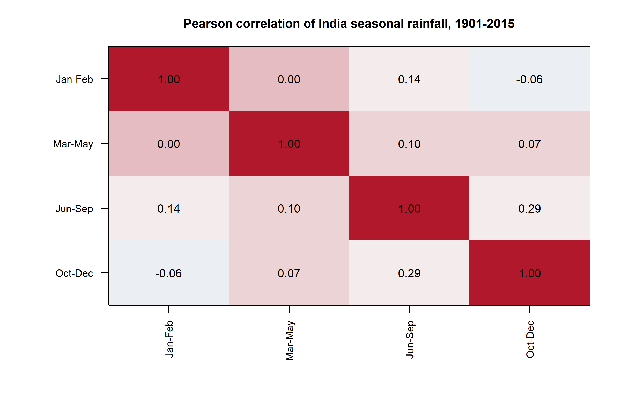
Figure 11. Pearson correlation heatmap of the four IMD seasonal totals, all-India, 1901–2015.
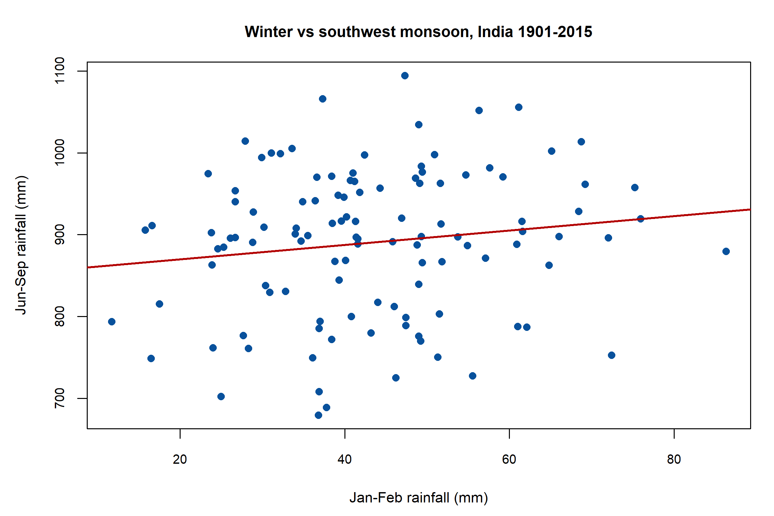
Figure 12. January–February versus June–September rainfall (mm). The line is a descriptive OLS fit, not a causal model.
Winter versus monsoon: Pearson $r=$ 0.143, $p=$ 0.1281, 95% CI $−0.041$ to $0.318$. The interval includes 0; there is no significant linear association in this record. Spearman $ρ=$ 0.130, $p=$ 0.1677.
The only clearly significant seasonal pair is June–September with October–December: $r=$ 0.287, $p=$ 0.0019. That is still association (wet years can be wet in both seasons), not a claim that the monsoon causes post-monsoon rain.
Year versus annual rainfall: $r=$ -0.089, $p=$ 0.3423. No significant linear time association; see Section 18.

Simple and multiple regression

Model 1. Annual rainfall on year
$${ANNUAL}_{i}=β_{0}+β_{1} {YEAR}_{i}+ε_{i}.$$
Fitted equation (OLS):
$$\hat{ANNUAL}=1762.9−0.2967×YEAR.$$
Slope ${\hat{β}}_{1}=$ -0.2967 mm year$​^{−1}$, SE 0.3110, $t=$ -0.954, $p=$ 0.3423, 95% CI -0.9129 to 0.3196 mm year$​^{−1}$.
$R^{2}=$ 0.0080 (adjusted $R^{2}=$ -0.0008): year explains well under 1% of annual variance. Overall $F=$ 0.910 on 1 and 113 df, $p=$ 0.3423.
Diagnostics. Residual Shapiro–Wilk $p=$ 0.8300; screen of $e^{2}$ on fitted values $p=$ 0.2430; Durbin–Watson $d=$ 1.742; lag-1 residual correlation $p=$ 0.2098. Cook’s distance exceeds $4/n$ in 8 years; those years were not deleted. Residual lag-1 is not significant, but the ACF of the series (Section 18) still shows lag-2 structure, so OLS inference remains an approximation.
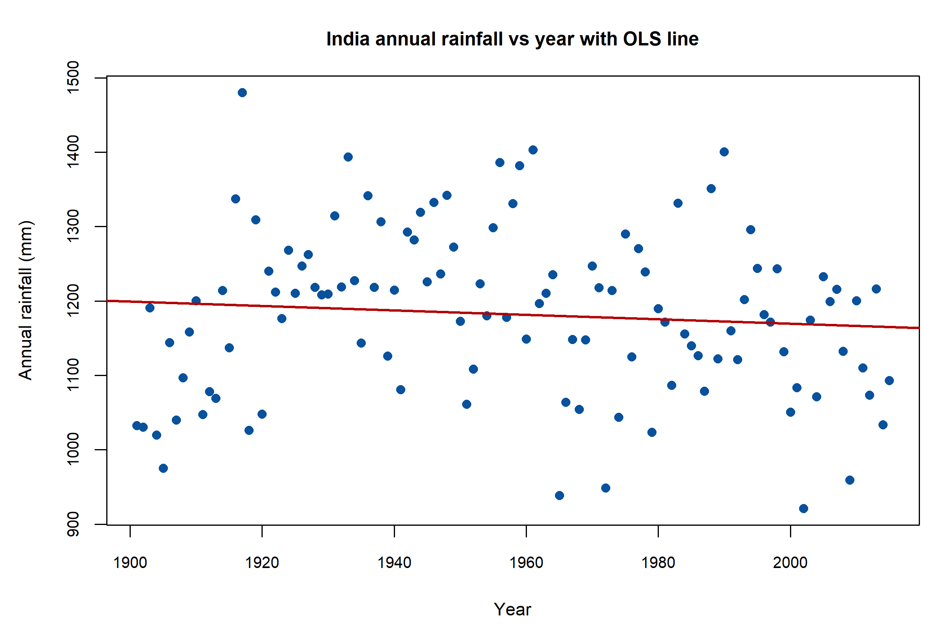
Figure 13. All-India annual rainfall (mm) versus year with the OLS line. The line is a weak descriptive summary; R-squared is 0.008.
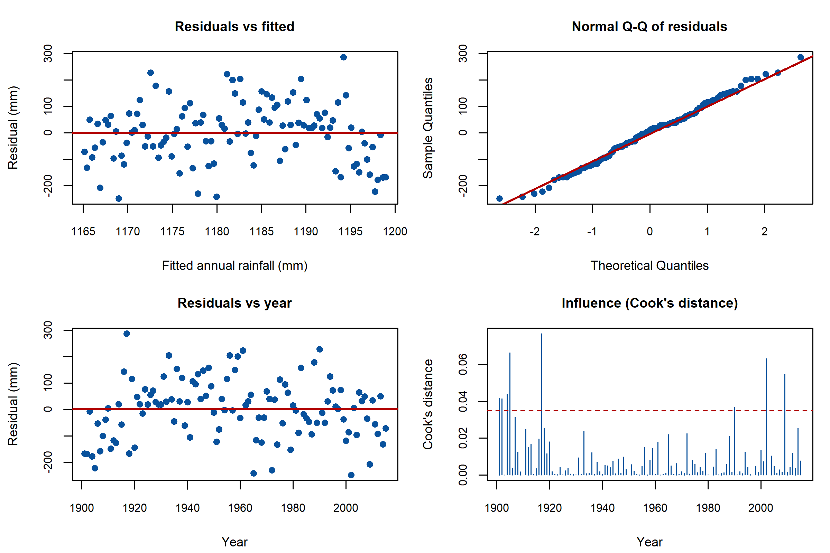
Figure 14. OLS residual diagnostics for annual rainfall on year: residuals versus fitted, normal Q–Q, residuals versus year, and Cook’s distance.
Interpretation. There is no statistically significant linear decline or rise in all-India annual rainfall in this OLS model. The fitted slope of about $−0.30$ mm year$​^{−1}$ would be only about $−34$ mm over 115 years, well within year-to-year noise of SD 110.69 mm. This is not a climate-change attribution.

Model 2. Monsoon on year and winter
$${JunSep}_{i}=β_{0}+β_{1} {YEAR}_{i}+β_{2} {JanFeb}_{i}+ε_{i}.$$
Winter is a different season, not a subset of June–September. No extra predictors were added to inflate $R^{2}$.
$R^{2}=$ 0.0242, adjusted $R^{2}=$ 0.0068, $F=$ 1.390 ($p=$ 0.2534). Year coefficient $p=$ 0.5079; January–February coefficient ${\hat{β}}_{2}=$ 0.816 (SE 0.583, $p=$ 0.1643). Durbin–Watson $d=$ 1.865.
The multiple regression does not detect a useful linear link from winter rain or year to all-India monsoon totals in this sample.

ANOVA and regional comparison
Regional means use complete-month years in 1901–2015. Equal-weighted averages of subdivisions are not the national area-weighted series. Different climates are expected: a significant ANOVA is largely a confirmation of geography.
Six subdivisions were compared on a balanced window of 114 common years: Kerala, Coastal Karnataka, Gangetic West Bengal, Tamil Nadu, Punjab and West Rajasthan.
Table 10. Tests of equal mean annual rainfall among six subdivisions (balanced common years).
test | statistic | df1 | df2 | p_value | n_years_balanced | n_regions
Classical one-way ANOVA | 2134.70 | 5 | 678.00 | 0 | 114 | 6
Welch one-way ANOVA | 1988.47 | 5 | 307.23 | 0 | 114 | 6
Kruskal-Wallis | 639.91 | NA | 5.00 | 0 | 114 | 6
Fligner-Killeen (variances) | 202.21 | 5 | NA | 0 | 114 | 6
Fligner–Killeen rejects equal variances ($χ^{2}=$ 202.2, $p<$ 0.0001). Classical ANOVA $F=$ 2134.7 is therefore not the primary result. Welch ANOVA $F=$ 1988.5, $p<$ 0.0001. Kruskal–Wallis $χ^{2}=$ 639.9, df $=5$, $p<$ 0.0001. Reject equal regional means.
Bonferroni-adjusted pairwise Welch tests reject every pair among the six regions at $α=0.05$ (all adjusted $p<$ 0.0001; see anova_pairwise_welch_bonferroni.csv). Tukey HSD, which assumes equal variances, is saved but should be treated cautiously given Fligner’s result. Wilcoxon pairwise tests agree on the same qualitative separations.
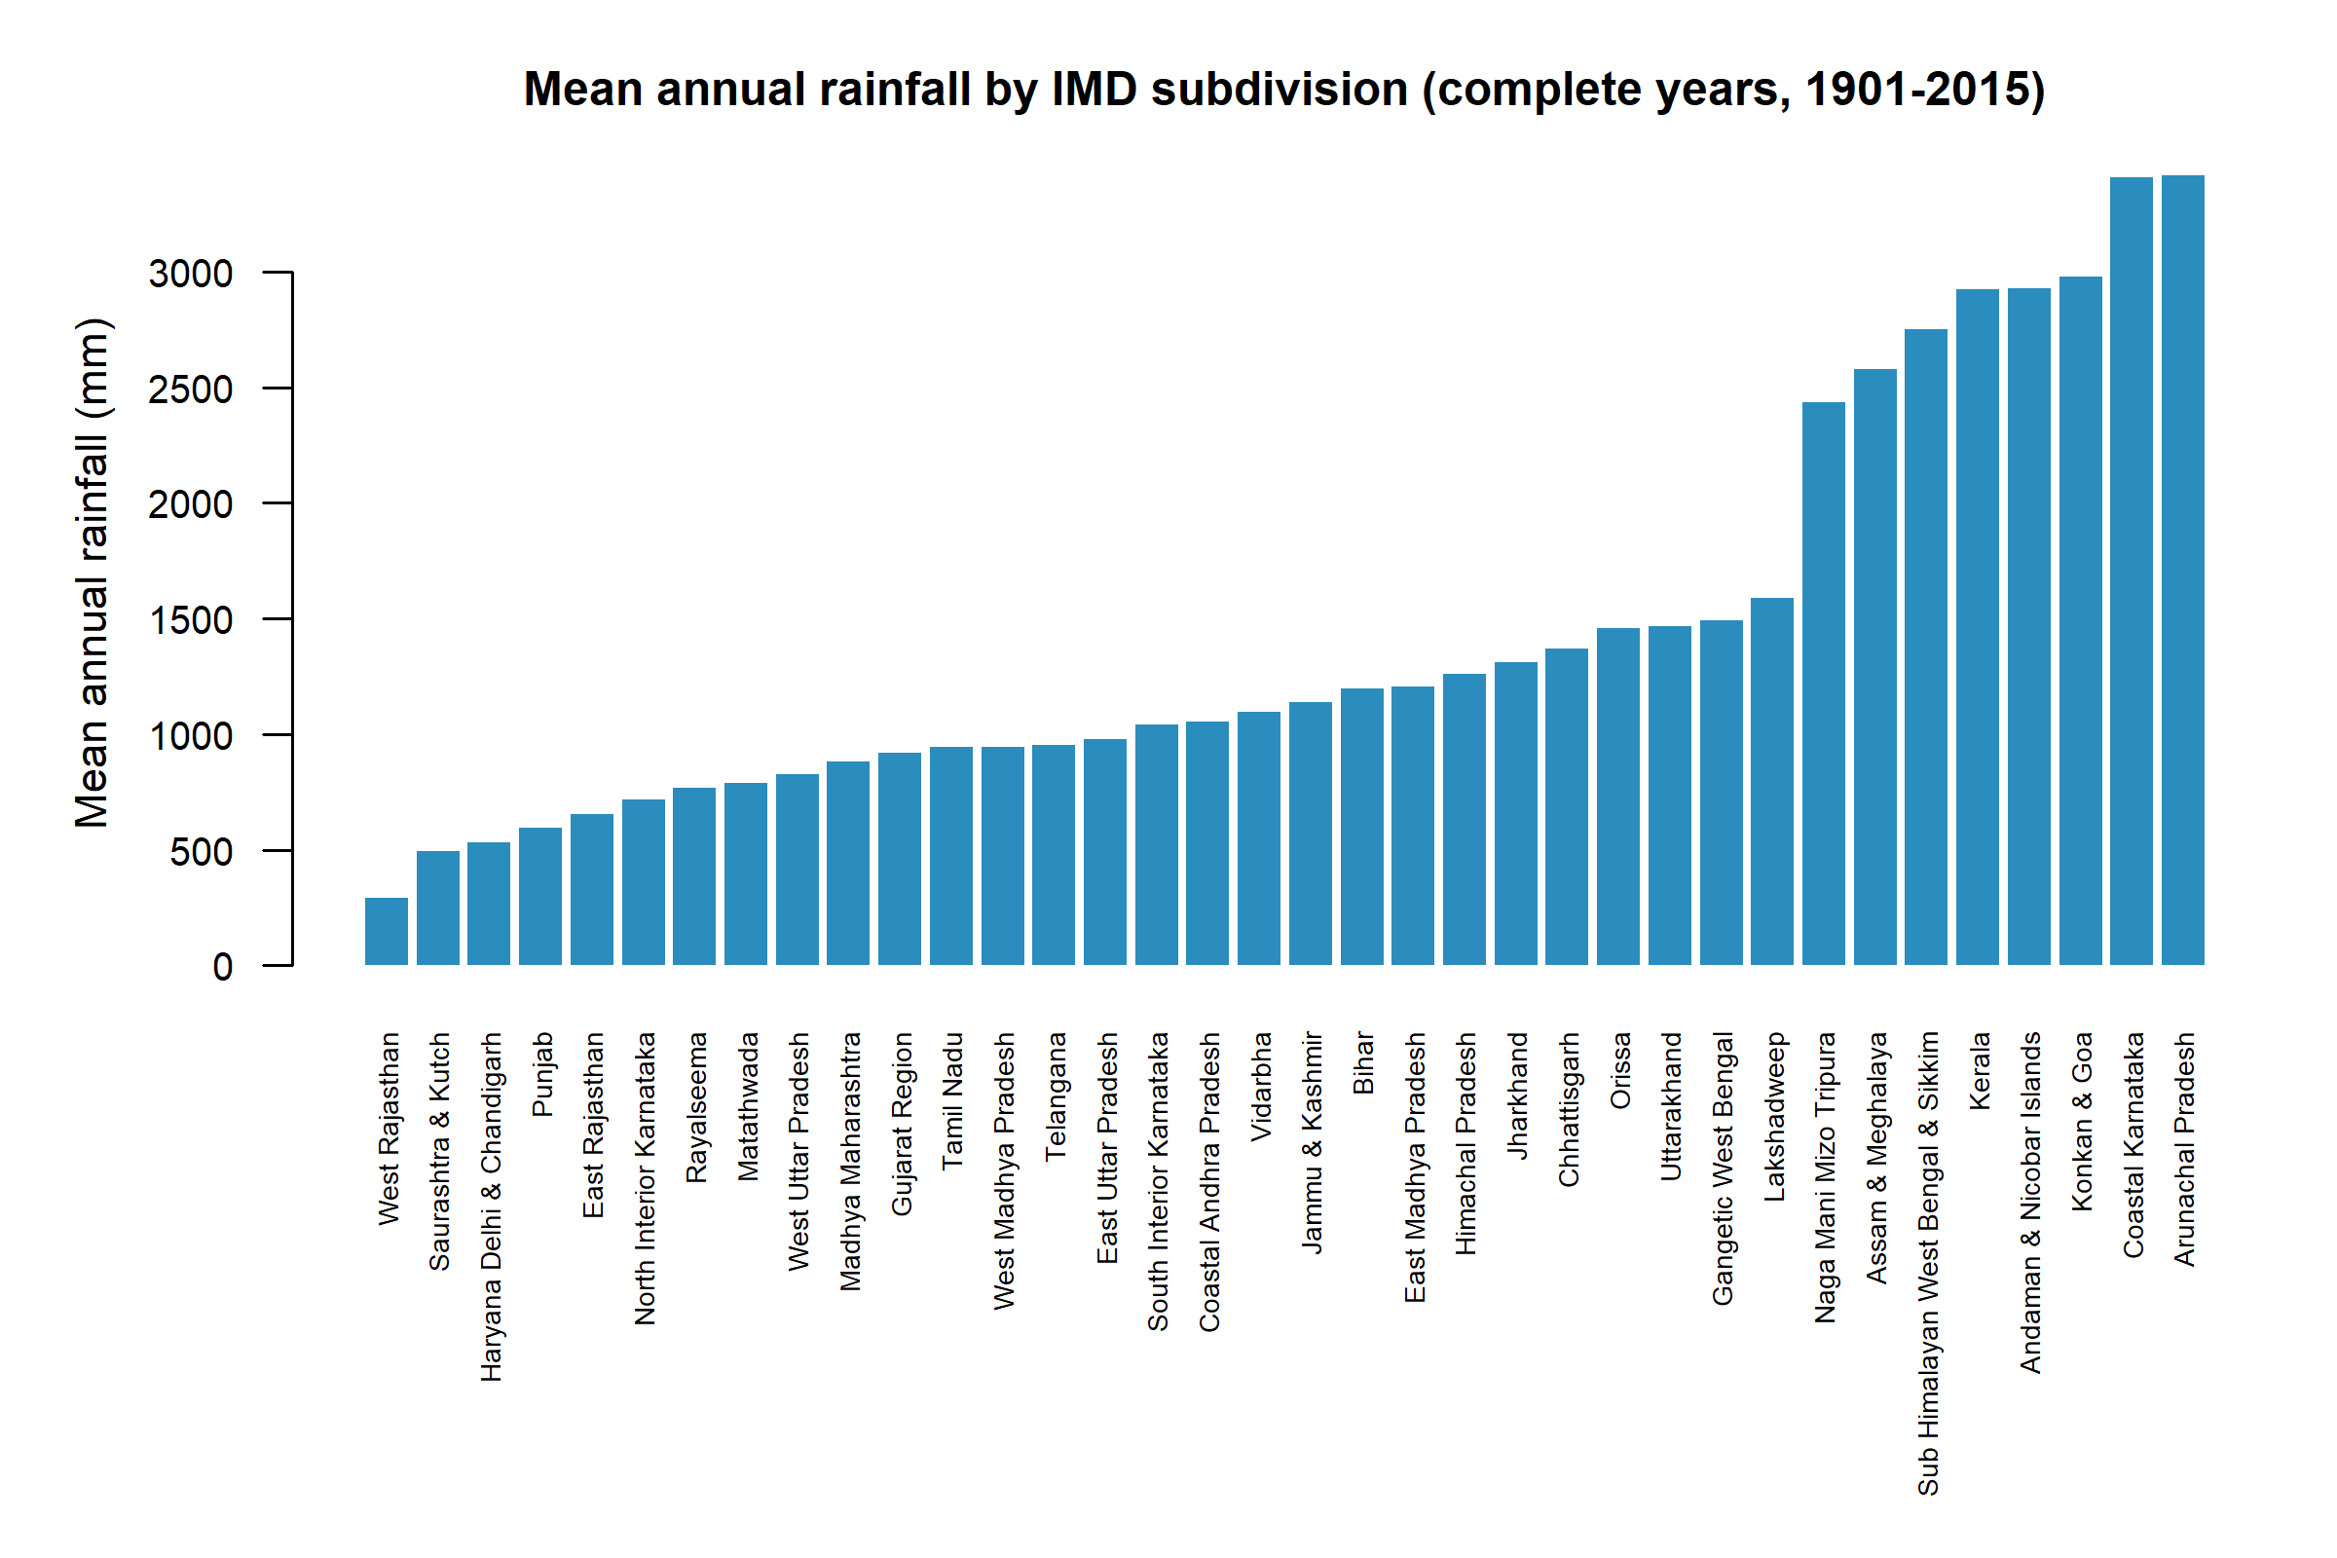
Figure 15. Mean annual rainfall (mm) by IMD subdivision, complete years 1901–2015.
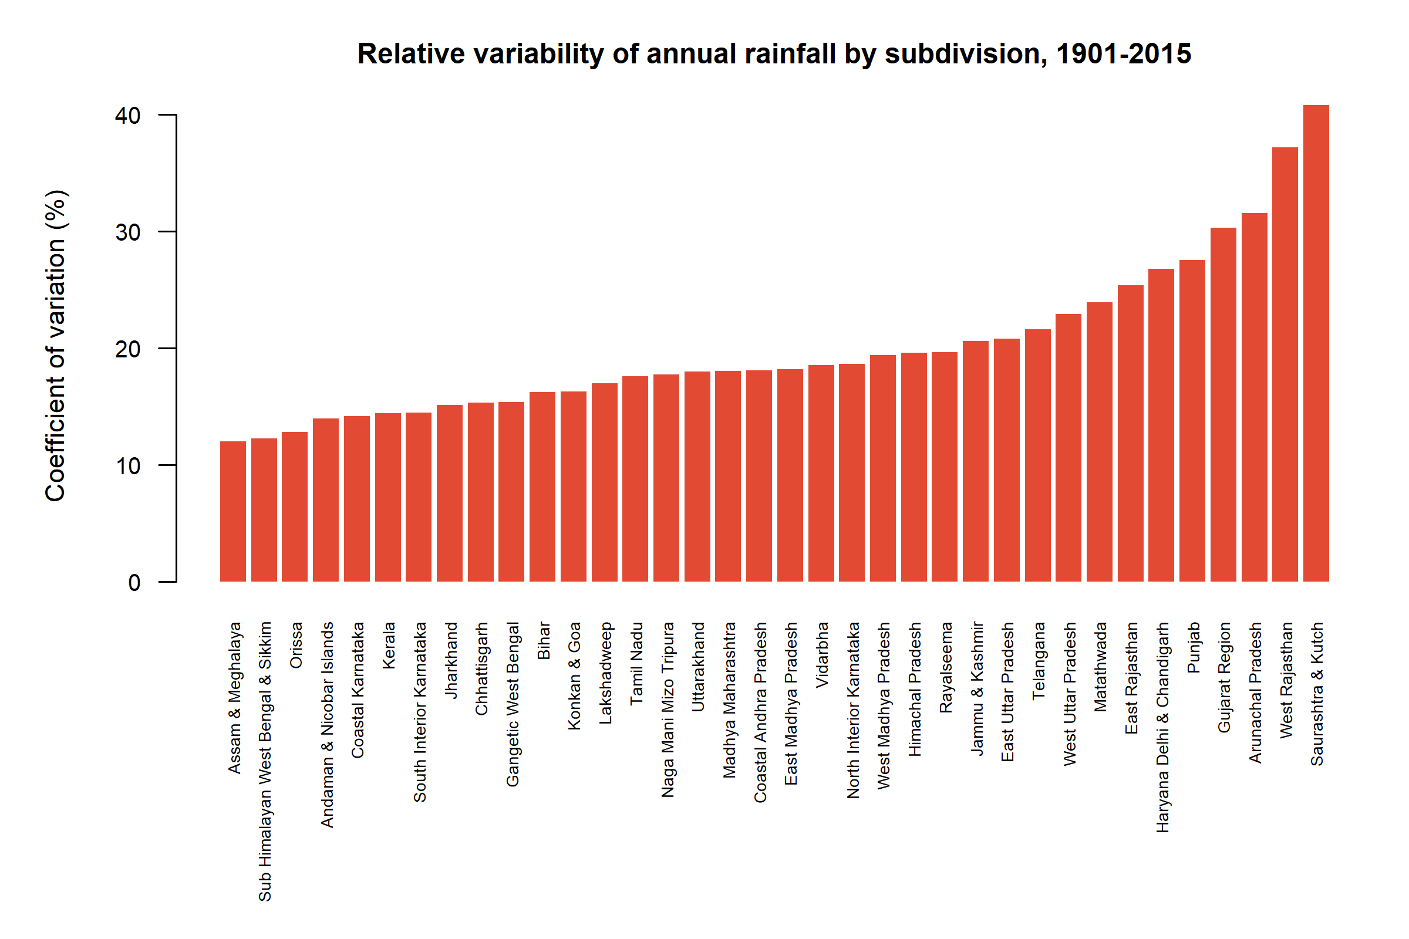
Figure 16. Coefficient of variation (%) of annual rainfall by subdivision, 1901–2015. Arid subdivisions are more variable relative to their mean.
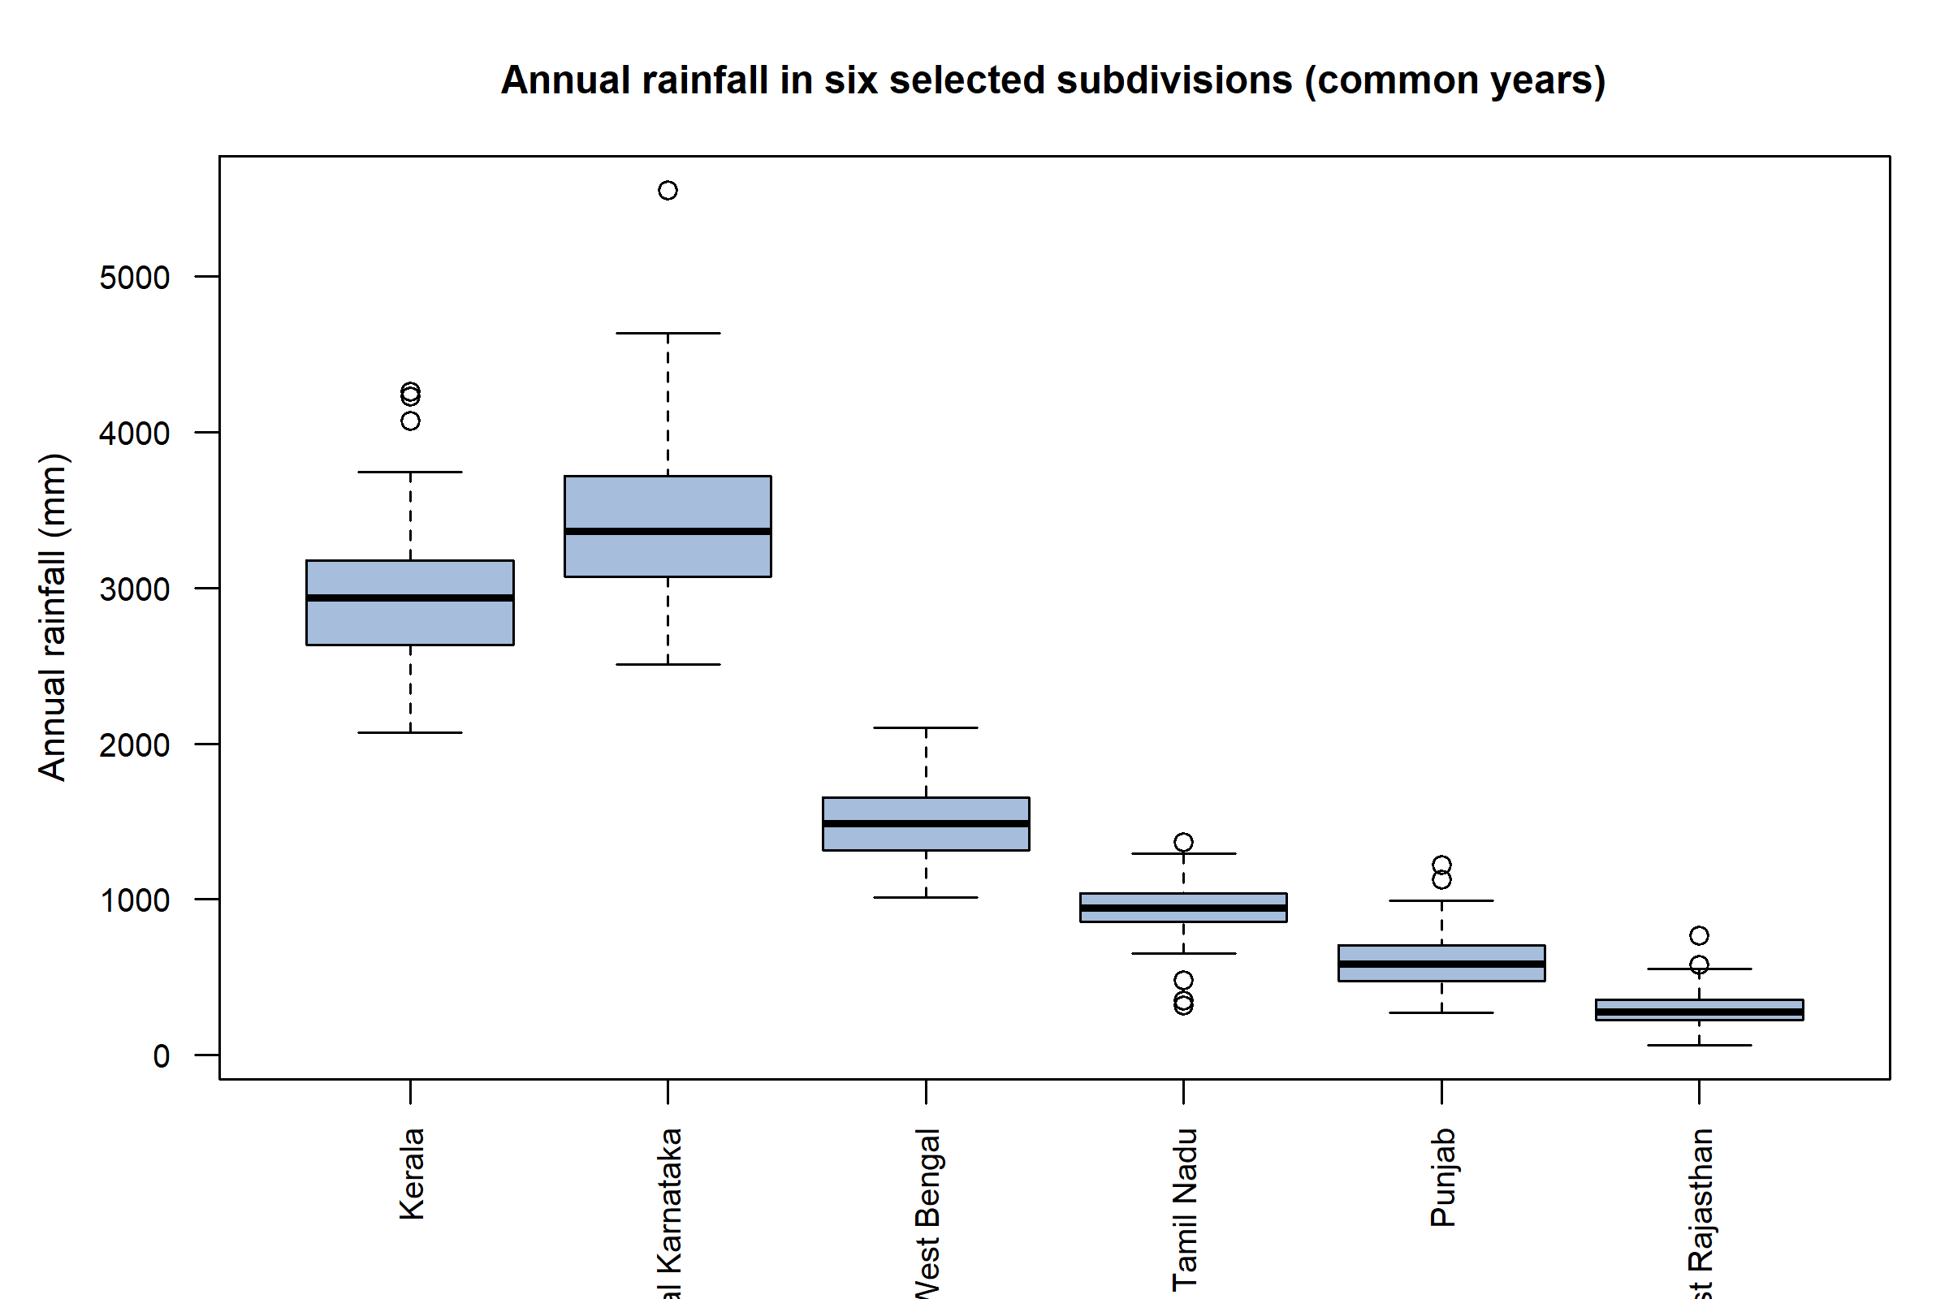
Figure 17. Annual rainfall (mm) in six selected subdivisions over common years. Spreads differ; Welch methods are appropriate.
Figures 15–17 show both the mean gradient (Western Ghats and north-east versus north-west India) and the CV gradient. West Rajasthan’s high CV (37.19%) versus Kerala’s (14.43%) is why a single national CV of 9.36% cannot describe every region.

Time-series and trend analysis
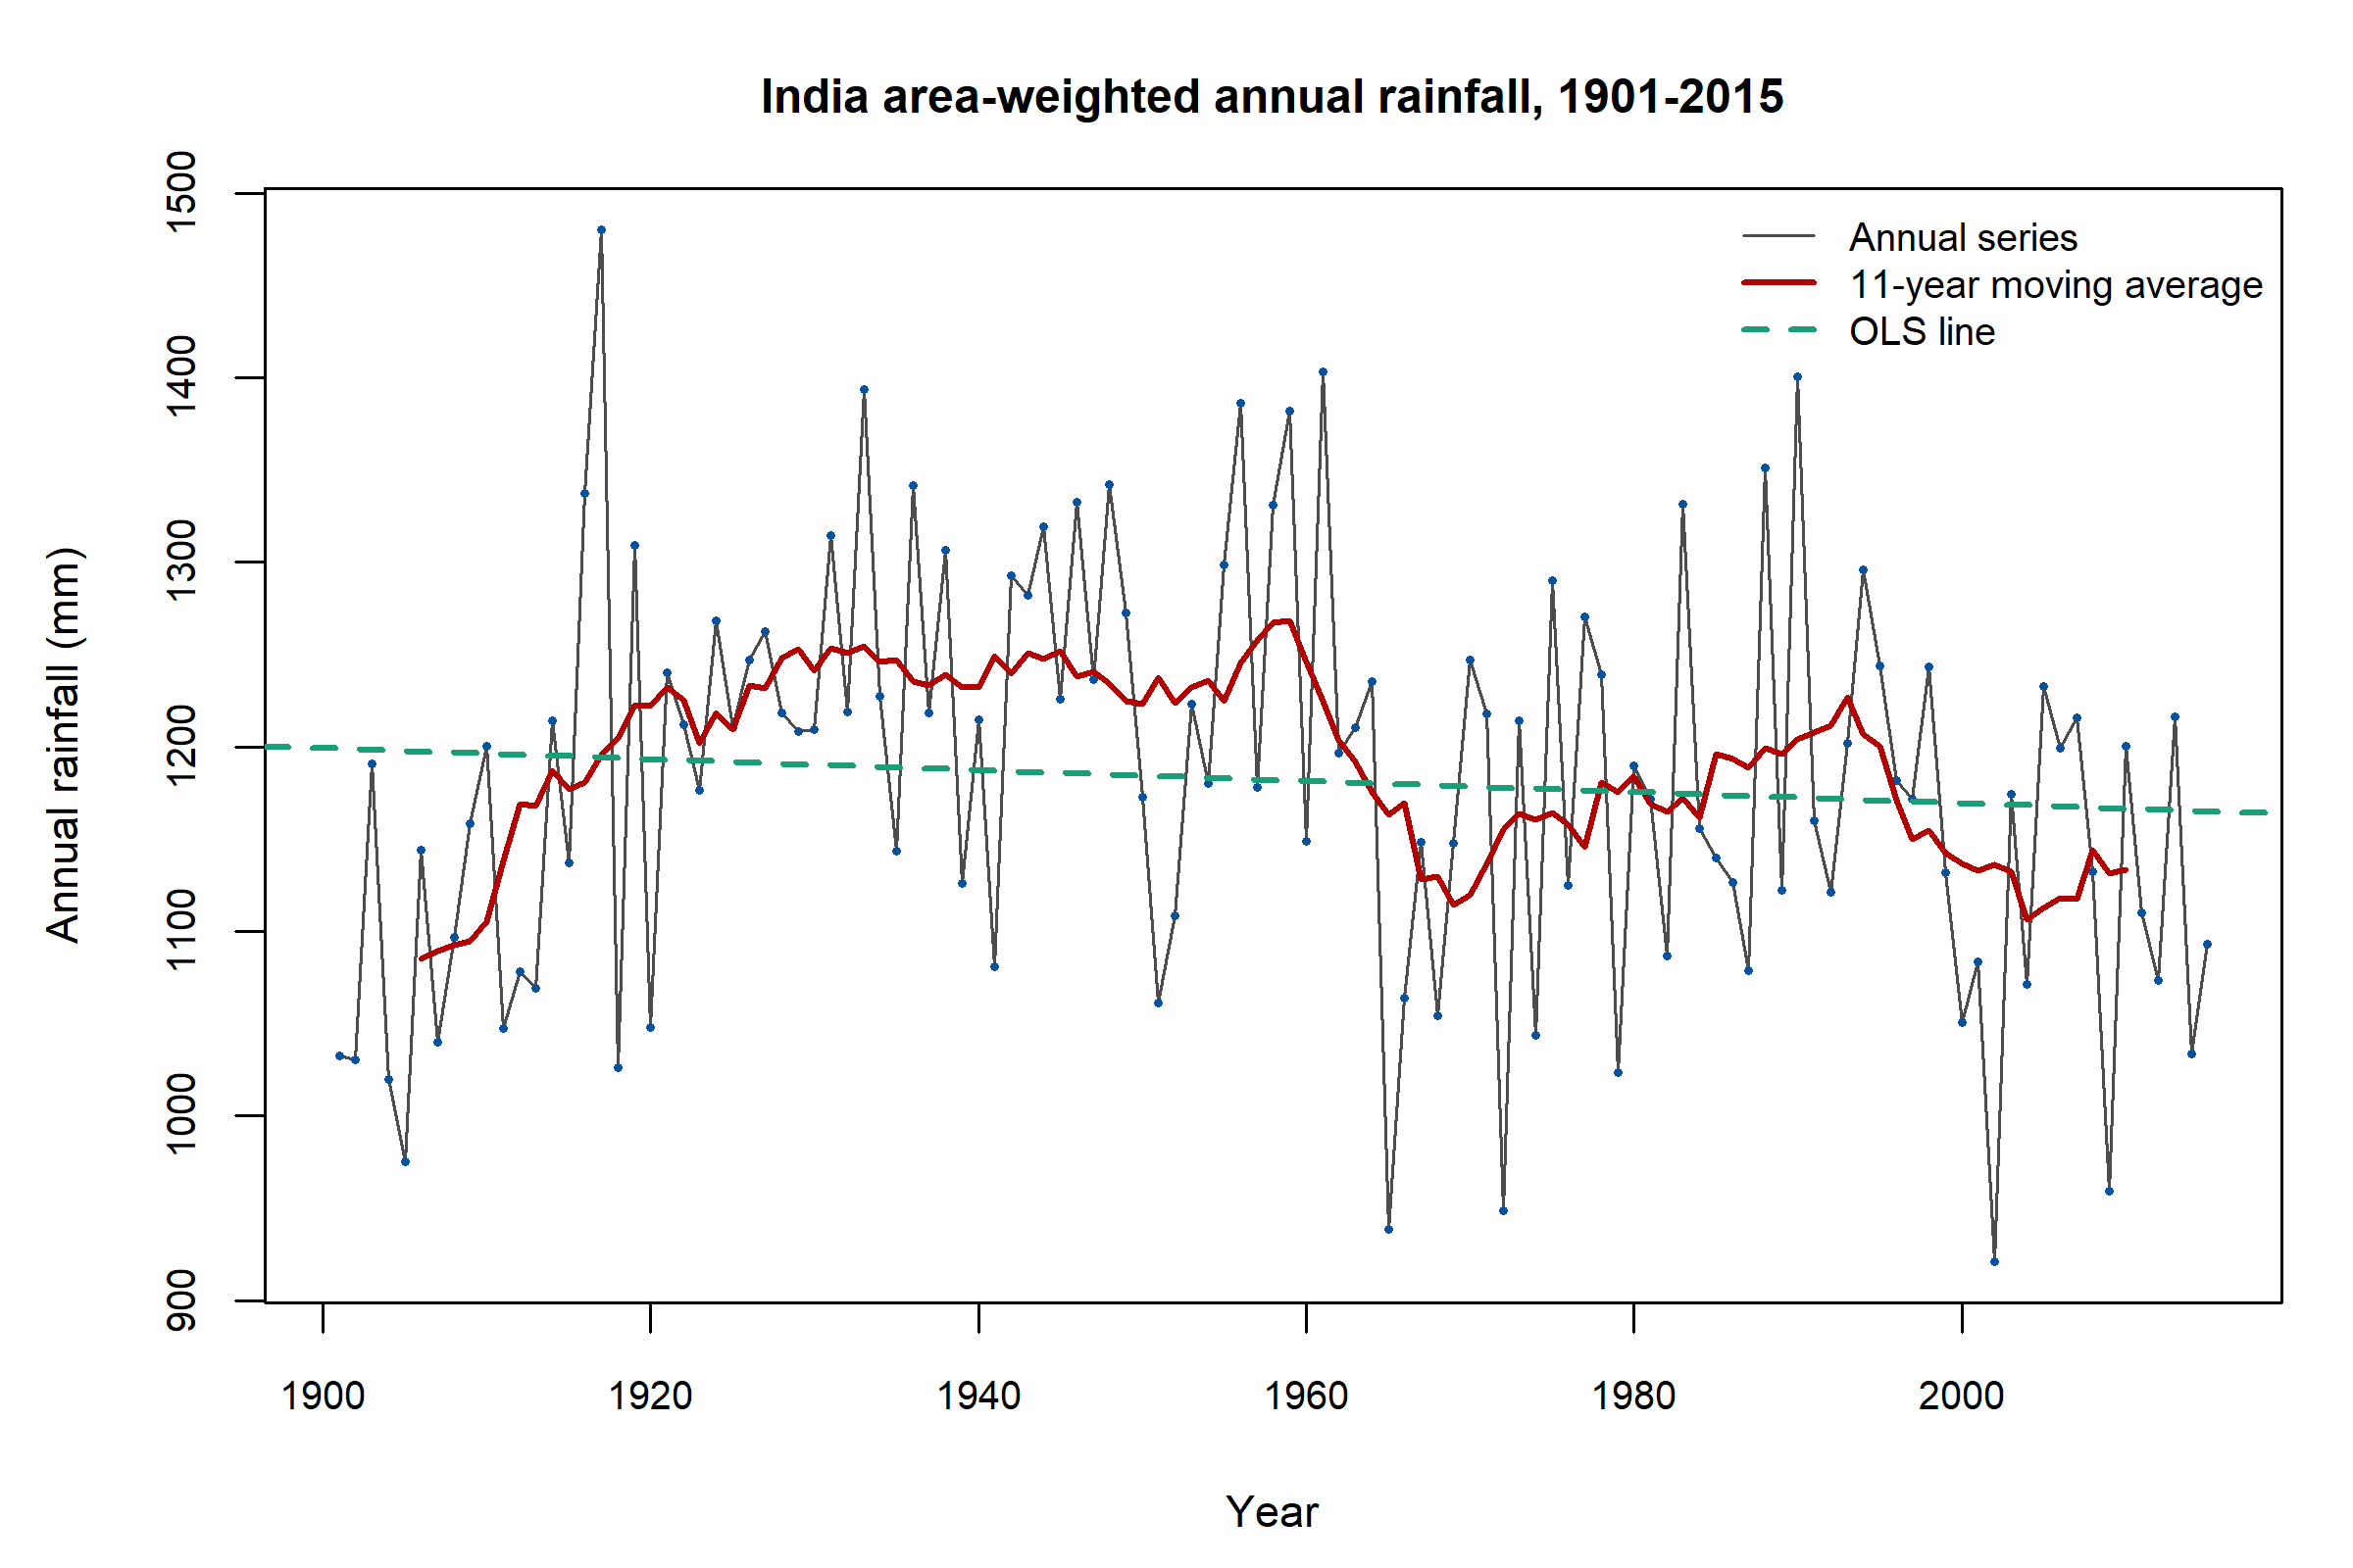
Figure 18. All-India annual rainfall (mm), 1901–2015, with an 11-year moving average and the OLS line. The smoother is descriptive; end years are missing because the window is incomplete.
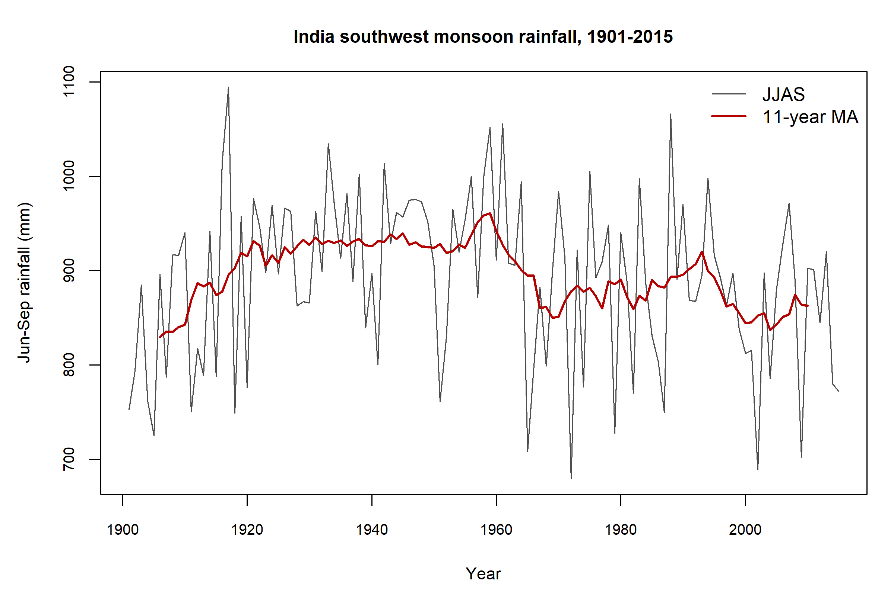
Figure 19. All-India June–September rainfall (mm) and 11-year moving average, 1901–2015.
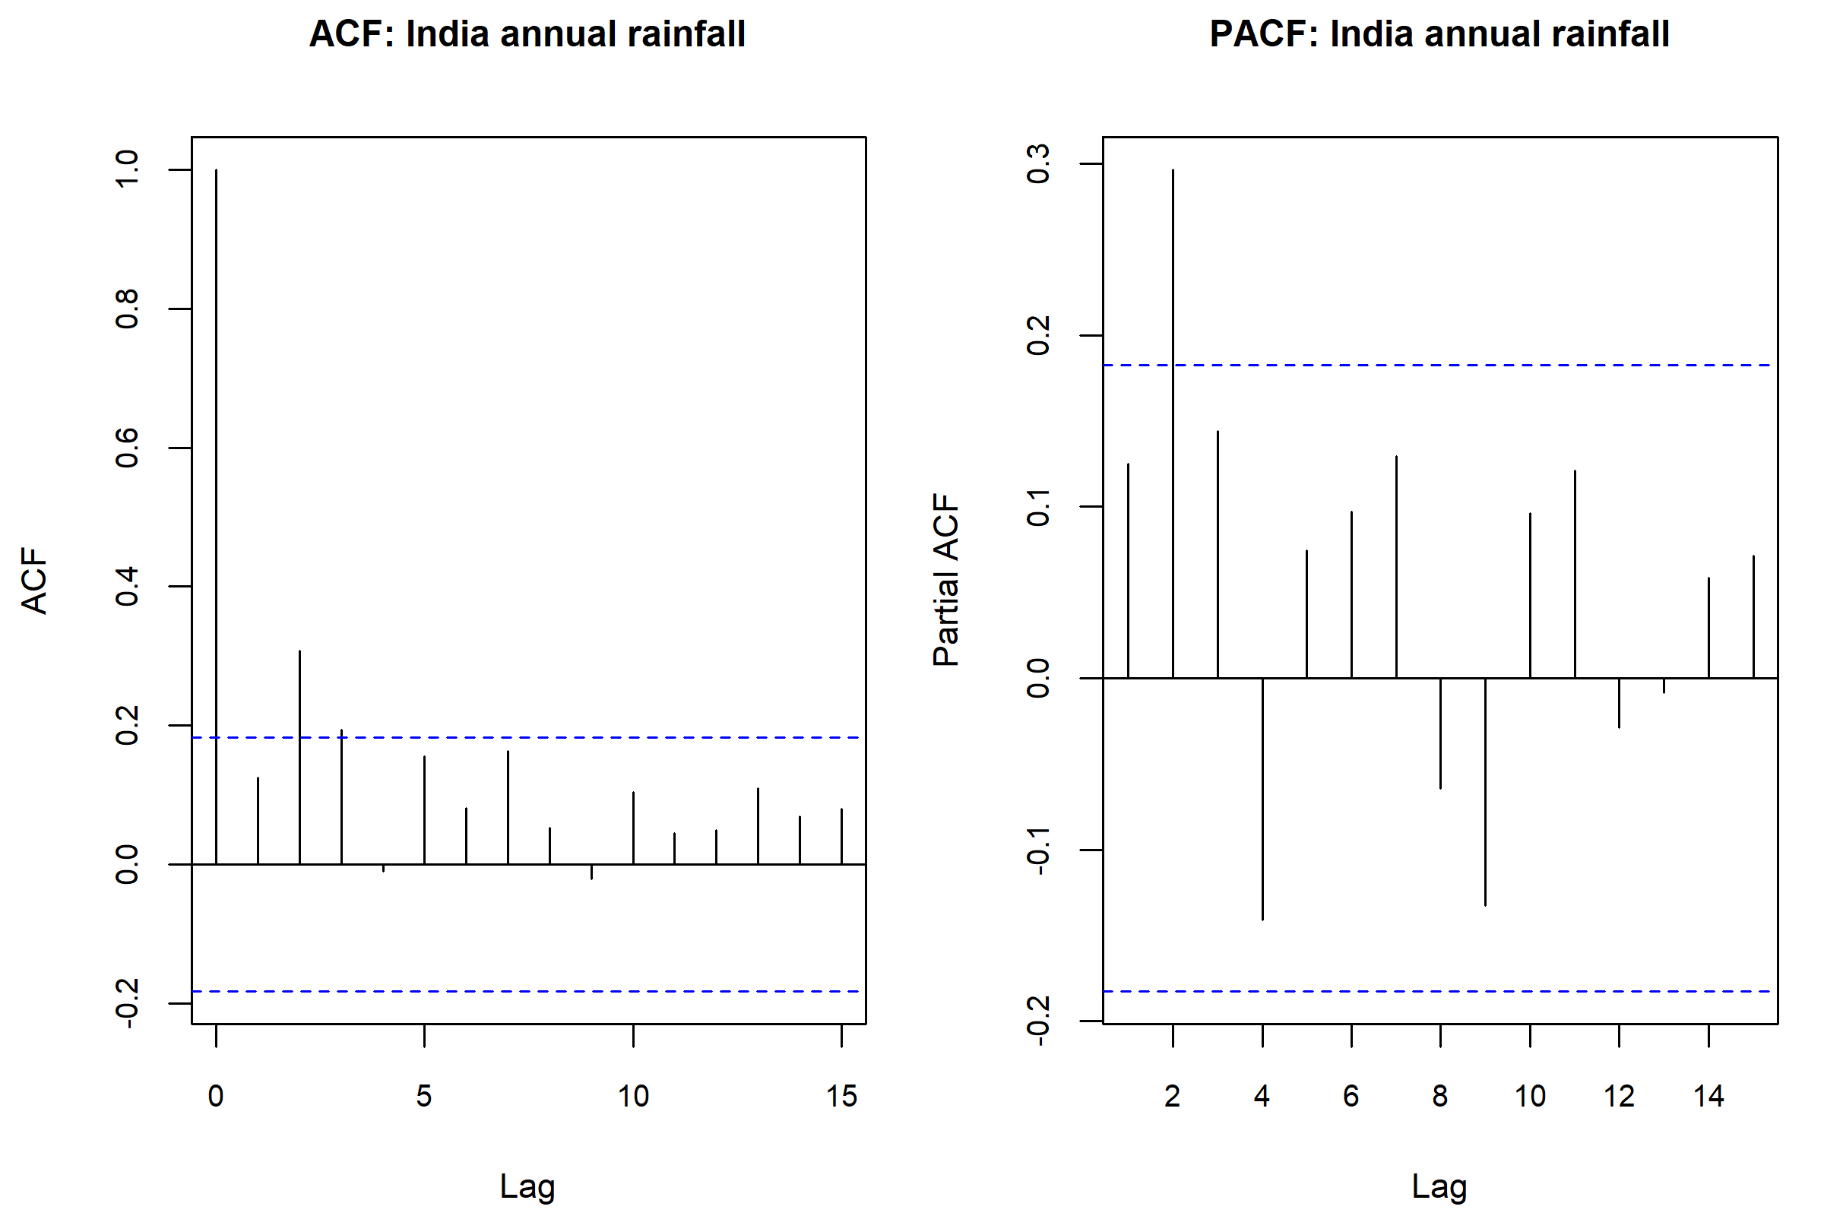
Figure 20. Sample ACF and PACF of all-India annual rainfall. The lag-2 autocorrelation exceeds the approximate white-noise bound.
The 11-year moving average is a smoother, not a test. Lag-1 sample ACF of annual rainfall is 0.125 (inside the approximate $1.96/\sqrt{n}≈0.183$ bound). Lag-2 ACF is 0.308, outside that bound, so years are not a pure white-noise series. Mann–Kendall’s simple variance formula is therefore an approximation; a borderline $p$-value would not be treated as decisive.
Table 11. National trend summaries. Mann–Kendall and Sen’s slope are the preferred inferential summaries when OLS assumptions are doubtful.
series | n | ols_slope_mm_per_year | ols_slope_p | pearson_r_with_year | mann_kendall_S | mann_kendall_Z | mann_kendall_tau | mann_kendall_p | sen_slope_mm_per_year | sen_intercept | durbin_watson_ols
India annual | 115 | -0.2967 | 0.3423 | -0.089 | -357 | -0.861 | -0.054 | 0.3895 | -0.2722 | 1725.2 | 1.742
India Jun-Sep | 115 | -0.2261 | 0.3692 | -0.085 | -418 | -1.008 | -0.064 | 0.3135 | -0.2536 | 1398.7 | 1.875
All-India annual. OLS slope -0.2967 mm year$​^{−1}$, $p=$ 0.3423. Mann–Kendall $S=$ -357, $τ=$ -0.054, $Z=$ -0.861, $p=$ 0.3895. Sen’s slope -0.2722 mm year$​^{−1}$. Do not reject “no monotonic trend” at 5%.
June–September. Mann–Kendall $p=$ 0.3135; Sen slope -0.2536 mm year$​^{−1}$. Same decision.
Selected regional Mann–Kendall tests (complete years) do not all point the same way: Kerala $τ=$ -0.135, $p=$ 0.0326 (negative Sen slope); Coastal Karnataka $p=$ 0.0027 (positive); Gangetic West Bengal $p=$ 0.0234 (positive); Tamil Nadu, Punjab and West Rajasthan are not significant at 5%. Mixed regional signs, plus multiple testing, forbid a single “India is drying/wetting” slogan. None of these tests identifies a cause.

Results and discussion
Putting the pieces together:
- Monsoon dominance is quantitative, not rhetorical. June–September is about 75.3% of mean annual rainfall and was the wettest IMD season in all 115 years.
- All-India annual rainfall is relatively stable year to year (CV 9.36%) and surprisingly close to a normal (and to a large-shape gamma) model. Local December rainfall in West Rajasthan is not: more than one-third of those months are dry zeros.
- Textbook 1180 mm is compatible with this series mean (1182.03 mm; 95% CI 1161.59–1202.48 mm).
- Regions are not interchangeable. Kerala minus West Rajasthan is about 2630 mm in mean annual rainfall; Welch and rank tests reject equality by an enormous margin. Relative variability is larger in arid subdivisions.
- Seasons of the same year are not independent groups; pairing was used for monsoon versus post-monsoon. Winter and monsoon totals are only weakly and non-significantly correlated nationally.
- Deficient-monsoon years are about 22% of this record under a 90%-of-sample-mean rule. Early versus late period is not associated with that classification in a chi-square test ($p=$ 0.8456).
- National trend tests are negative at 5%. OLS $R^{2}≈0.008$; Mann–Kendall $p=$ 0.3895. Some subdivisions show their own slopes; they do not add up to an attributed national climate signal.
These findings are about this IMD record, under the assumptions stated. They are suitable for a viva if the student can explain why pairing, Welch, bootstrap KS, and Mann–Kendall were chosen.

Limitations
- One climate path. The 115 years are not a simple random sample of hypothetical years.
- Temporal dependence. Lag-2 autocorrelation of annual totals violates strict iid assumptions behind SEs, $t$ intervals, OLS $p$-values and unmodified Mann–Kendall variance.
- LPA analogue. Deficient/excess classes use this sample mean, not the official IMD LPA window.
- Unbalanced regional panel. Missing years were not invented; ANOVA used a common complete-year window.
- National versus regional support. Area-weighted India $≠$ mean of 36 boxes.
- No daily data. Spell lengths, intensity and true waiting-time exponential models cannot be studied.
- IQR outlier flags. Monthly rainfall is skewed, so many subdivision months are flagged; flags are not deletions.
- Multiple regional tests. Six Mann–Kendall tests were not family-wise error controlled; significant regional slopes are exploratory.
- No causation. Correlation, regression on year, and period $×$ category tables do not identify physical drivers.
- Exponential model was never a serious candidate for annual totals; it is a teaching counter-example.
- Chi-square GOF for wettest season has expected counts $>5$ but observed zeros in three cells; the rejection is still obvious from the 115–0–0–0 table.
Analyses that were not done, because they would not be justified: chi-square tests on raw millimetres; independent $t$-tests of two seasons from the same year; correlating annual totals with June–September; deleting extremes to “clean” monsoon; imputing missing monthly rain; claiming proof of climate change.

Conclusion
Official IMD millimetre records, cleaned without fabrication, show an all-India climate whose annual total averages about 1182.03 mm, is dominated by June–September, and is compatible with a 1180 mm benchmark. Probability models that respect positivity (gamma) and models that do not (normal) both describe the national annual series reasonably; exponential does not. Regional India is another story: means and CVs differ by an order of magnitude, and Welch ANOVA rejects a common mean among six representative subdivisions. National linear and Mann–Kendall trends over 1901–2015 are not significant at 5%. The honest statistical conclusion is descriptive and comparative, not causal.

References
- India Meteorological Department (IMD), Ministry of Earth Sciences, Government of India. Area-weighted monthly, seasonal and annual rainfall series for India, 1901–2015. Data file: rainfall_area-wt_India_1901-2015.csv.
- India Meteorological Department (IMD), Ministry of Earth Sciences, Government of India. Rainfall for meteorological sub-divisions of India, records through 2017. Data file: Sub_Division_IMD_2017.csv.
- India Meteorological Department. Operational practice of classifying southwest monsoon seasonal rainfall as deficient, normal or excess relative to a long-period average (LPA). This project uses 90% and 110% of the sample mean as an analogue, not a substitute for the official LPA.
- Wilcoxon, F. (1945). Individual comparisons by ranking methods. Biometrics Bulletin, 1(6), 80–83.
- Mann, H. B. (1945). Nonparametric tests against trend. Econometrica, 13(3), 245–259.
- Kendall, M. G. (1975). Rank Correlation Methods. Charles Griffin.
- Sen, P. K. (1968). Estimates of the regression coefficient based on Kendall’s tau. Journal of the American Statistical Association, 63(324), 1379–1389.
- Shapiro, S. S., and Wilk, M. B. (1965). An analysis of variance test for normality. Biometrika, 52(3–4), 591–611.
- Lilliefors, H. W. (1967). On the Kolmogorov–Smirnov test for normality with mean and variance unknown. Journal of the American Statistical Association, 62(318), 399–402.
- Welch, B. L. (1947). The generalization of ‘Student’s’ problem when several different population variances are involved. Biometrika, 34(1–2), 28–35.
- Durbin, J., and Watson, G. S. (1950). Testing for serial correlation in least squares regression. I. Biometrika, 37(3–4), 409–428.
- Cook, R. D. (1977). Detection of influential observation in linear regression. Technometrics, 19(1), 15–18.
- Wilks, D. S. (2011). Statistical Methods in the Atmospheric Sciences (3rd ed.). Academic Press.
- Helsel, D. R., and Hirsch, R. M. (2002). Statistical Methods in Water Resources. U.S. Geological Survey.
- R Core Team (2026). R: A Language and Environment for Statistical Computing. R Foundation, Vienna. Version 4.6.1.

Appendix

A. Project layout and how to rerun
From the folder that contains data/ and R_code/, in RStudio:
source("R_code/01_data_inspection.R")
source("R_code/02_data_cleaning.R")
source("R_code/10_run_phase2.R")
source("R_code/11_render_report.R")
Scripts 03–09 produce tables and figures; 11 knits this file to Word (and PDF if LaTeX is installed). Relative paths are used throughout.

B. Concept coverage
See results/tables/concept_coverage_matrix.csv for the mapping from statistical technique to script, table, figure and report section.

C. Selected implementation notes
- Gamma MLE uses nlm on the negative log-likelihood, started at method-of-moments estimates.
- Bootstrap KS re-fits the candidate law on each simulated sample of size $n$ and compares the KS statistic to the observed statistic.
- Mann–Kendall and Sen’s slope are implemented in R_code/00_project_helpers.R (base R; no extra packages).
- Cleaning never overwrites data/.

D. Additional output files
Hypothesis write-ups: results/statistical_outputs/hypothesis_testing_report.txt.
Distribution notes: results/statistical_outputs/distribution_fit_notes.txt.
Trend notes: results/statistical_outputs/time_series_trend_notes.txt.
Regional notes: results/statistical_outputs/regional_anova_notes.txt.
The appendix does not reprint entire scripts; faculty can open R_code/ in RStudio. Student name, roll number and a signed originality statement should be added on the title page before binding.

