1 在U盘新建1个文件夹，BELMONT_BMP_12345678  
2 在\\Win-keun5a6fn27\d项目存档\陈妍薇\项目资料\5寸7寸\牙科测试专用图片_243张_800480这个文件夹中拷贝243张图片到第一步U盘新建的文件夹中。

3 U盘接入新唐PCB,新唐PCB poweron。

4 PC上打开串口工具“”。  
5 设置波特率。

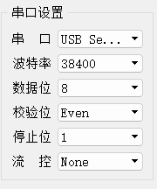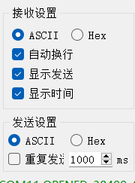  
6 对话框输入“@07P0FFFF*”后点发送  
 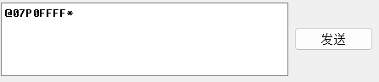  
7 大概18分钟后写入完成。这步不能关机，关机的话，现象会消失！  
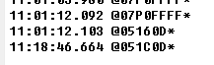  
8 连续发送以下Q命令  
@F7Q0060A,060B,060C,060D,060E,070A,070B,070C,070D,070E,080A,080B,080C,080D,080E,090A,090B,090C,090D,090E,160A,160B,160C,160D,160E,170A,170B,170C,170D,170E,180A,180B,180C,180D,180E,190A,190B,190C,190D,190E,0600,0601,0602,0603,0604,0605,0606,0607,0608*（49张）

@8EQ10609,0700,0701,0702,0703,0704,0705,0706,0707,0708,0709,0800,0801,0802,0803,0804,0805,0806,0807,0808,0809,0900,0901,0902,0903,0904,0905,0906*（28张）

@F7Q10907,0908,0909,1600,1601,1602,1603,1604,1605,1606,1607,1608,1609,1700,1701,1702,1703,1704,1705,1706,1707,1708,1709,1800,1801,1802,1803,1804,1805,1806,1807,1808,1809,1900,1901,1902,1903,1904,1905,1906,1907,1908,1909,1111,2222,3333,F902,F802,F702*(49张)

@93Q1F602,E902,E802,E702,E602,D901,D801,D701,D601,C901,C801,C701,C601,B900,B800,B700,B600,A900,A800,A700,A600,9903,9803,9703,9603,8907,8903,8807,8803*(29张)

@20Q18707,8703,8607,8603,7907,7808*（6张）

9 出现第一个NG.  
黄色标注部分回了正常ACK两次。  
正常情况是因为装不下回复301。  
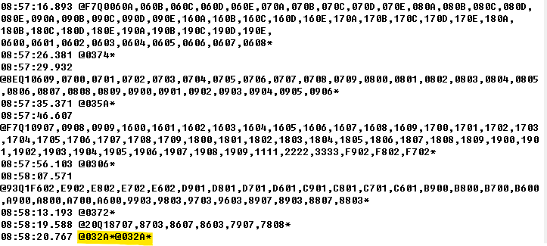

10 连续发送以下Q命令。  
@F7Q00600,0601,0602,0603,0604,0605,0606,0607,0608,0609,060A,060B,060C,060D,060E,0700,0701,0702,0703,0704,0705,0706,0707,0708,0709,070A,070B,070C,070D,070E,0800,0801,0802,0803,0804,0805,0806,0807,0808,0809,080A,080B,080C,080D,080E,0900,0901,0902,0903*

@F7Q10904,0905,0906,0907,0908,0909,090A,090B,090C,090D,090E,1111,1600,1601,1602,1603,1604,1605,1606,1607,1608,1609,160A,160B,160C,160D,160E,1700,1701,1702,1703,1704,1705,1706,1707,1708,1709,170A,170B,170C,170D,170E,1800,1801,1802,1803,1804,1805,1806*

@F7Q11807,1808,1809,180A,180B,180C,180D,180E,1900,1901,1902,1903,1904,1905,1906,1907,1908,1909,190A,190B,190C,190D,190E,2222,2604,260A,260B,260C,2704,2705,2804,2805,2904,2905,3333,3604,3605,3606,3704,3706,3804,3806,3904,3906,4605,4606,4609,460A,4705*

@F7Q14709,470A,470B,470C,4805,4809,480A,480B,480C,4909,490A,490B,490C,5609,560C,560D,5706,5709,570A,570B,570C,570D,5809,580A,580C,580D,5905,5908,5909,590A,590C,590D,6608,660B,660D,6708,670D,6806,6808,680B,680D,6906,6908,690D,7607,7608,7707,7708,7807*

@EDQ17808,7907,790B,8603,8607,860E,8703,8707,870E,8803,8807,880E,8903,8907,890E,9603,960E,9703,970E,9803,980E,9903,990E,A600,A700,A800,A900,B600,B700,B800,B900,C601,C701,C801,C901,D601,D701,D801,D901,E602,E702,E802,E902,F602,F702,F802,F902*

11   
出现了第二个NG.  
第4条命令一直不能回文。触摸屏幕，没有回文，推测死机了。关机，LED-D2灭后再次点亮，LED-D4不能点亮，推测不能进入掉电处理。  
此处如果没有出现NG的话,可重复第10步操作：  
