C360 INSIGHTS
Report Engine User Guide
Step by step, for every feature: reports, formulas, charts, dashboards, AI, sharing and delivery
10 parts, 77 topics. Built 2026-10-22 from the in-app help, so it matches what the help panel shows.
Each topic says who can use it, then the steps in order. Names in bold are what you see on the screen: a button, a menu item or a field. The screenshots show the screens with sample data.

Contents
Part 1 Getting Started
What Insights Is For · Who Can Use It · The Datasets · Make a Report · The Four Views · Read a Report (the Viewer)
Part 2 Measures and Comparisons
Use a calculated measure in a report · Compare a measure with an earlier period · Year to date, a moving average, a rank, a target · Keep the top values and fold the rest into Others (Top N) · Set your fiscal year (Settings → Fiscal Year) · Add measures from a linked dataset
Part 3 Custom Fields and Formulas
Group values into a field of your own (Custom Fields) · Work out a value for each row with a formula · Write a measure formula, such as a rate or a filtered total · Show a share of the total, a rank, year to date or last year in a measure formula · On a MySQL 5.7 Database · Share a formula with every report on a dataset · Certify a shared formula · The formula language at a glance · Function Reference
Part 4 Charts and Views
Stack the bars, or combine bars and a line · Show a report as a pie or a funnel · Use a scatter, bubble, treemap or waterfall chart · Show one figure: a KPI card or a gauge · Put the numbers on a map · Show every value side by side in a pivot (matrix) · Repeat a chart per value (small multiples) · Colour the numbers · Add a forecast line, or flag unusual points
Part 5 Exploring the Data
Drill down in a chart · Drill in a pivot or a hierarchy · Open a detail report from a value (drill-through) · Show another report when someone hovers a value (Tooltip Report) · Find what drives a value (Key Influencers) · Break a value down step by step (Decomposition Tree) · Ask a question before a report runs (Parameters) · Show the SQL
Part 6 Your Own Data
Report on a CSV or Excel file (Uploaded Files) · Connect a database · Set how reports treat a database · Connect a database from New Report · Map a dataset from a table · Join tables in a dataset · Add a calculated measure · Build a report from a query
Part 7 Dashboards
How a Dashboard Works · Add slicers to a dashboard · Filter a dashboard with slicers · Slice a dashboard by a range of numbers or dates · Cross-filter by clicking · Save a dashboard view (bookmarks) · Spread a dashboard over pages · Lay a dashboard out freely (Free Canvas) · See and shape the phone layout · Give a dashboard a theme · Add text to a dashboard · Add a button that opens a saved view, a page or a report · Add a written summary to a dashboard
Part 8 AI Features
Ask for a Report · Add a spec or images to a prompt · Ask about a database's tables not mapped yet · Use AI in your workspace · Explain This Report, with AI · Change a report with a prompt, with AI
Part 9 Sharing, Delivery and Exports
Share a report or a dashboard · Limit what a person sees (Report Access) · Embed a report or a dashboard on another site · Comment on a report or a dashboard, and pin a note to a value · Get an email when a value crosses a threshold (Alerts) · Email a Report on a Schedule · Export to PowerPoint · Print a report on numbered pages (Print-Ready PDF)
Part 10 Administration and Troubleshooting
See what people open (Usage) · The Run Log · How Fresh Is the Data · When Something Does Not Run

PART 1

Getting Started
What Insights is, who can use which part of it, the data it reports on, and how a report is made and read.

What Insights Is For
Insights is the suite's reporting app. It lets you build your own reports on the data C360 already keeps, your messages, the orders they led to, your contacts and your journeys, see them as a grid, a chart, a hierarchy or a pivot, put them on a dashboard with one period for all of them, export them as CSV, Excel or PDF, and have them emailed on a schedule. Nothing is collected for it; it reads what the rest of the suite records.
Where to find it: Insights, in the app launcher (the grid icon at the top left), and the Insights item in Engagement's menu, which opens the same reports.
Its menu: Reports, Dashboards, Scheduled, Uploaded Files and Shared Formulas (for people who build reports), and Run Log and Usage (for report administrators).

Who Can Use It
Permission | What it allows
Reports · View (report.view) | Open and run the reports and dashboards shared with the workspace, export them, star favourites, switch a report's view.
Reports · Edit (report.edit) | Make and change your own reports, dashboards, folders and schedules; delete your own.
Report Admin (report.admin) | Everything on every report, dashboard, folder and schedule in the workspace; build on personal-data fields; see the Run Log.
User Admin (user.admin) | Also builds on personal-data fields.

The workspace needs the Insights component switched on by the platform team; without it the menu does not offer Insights.

The Datasets
A report is built on one dataset. Each offers dimensions (things to group by, such as Campaign, Channel or Sent month) and measures (numbers to total, such as Sent Count or Revenue). The datasets today:
Dataset | One row per | Typical use
Messages | Every email and text a campaign sent | Sends, deliveries, opens and clicks by campaign, channel or month.
Attributed Orders | Every order the shop reported and the campaign it was credited to | Revenue by campaign, channel, store or month.
Contacts | Every contact in the workspace | Contacts by city, region, source or consent.
Journey Enrolments | Every customer in a journey | Enrolments, completions and conversions by journey.

Fields marked PII carry personal data (a customer's identifier, an email address). Building on them needs Report Admin or User Admin. When you open a shared report that has such a column and you lack the right, its values are masked and the grid says so.
Your workspace can add its own datasets too: uploaded CSV and Excel files, and tables or queries from its own databases (Part 6).

Make a Report
Who: Anyone who can build reports
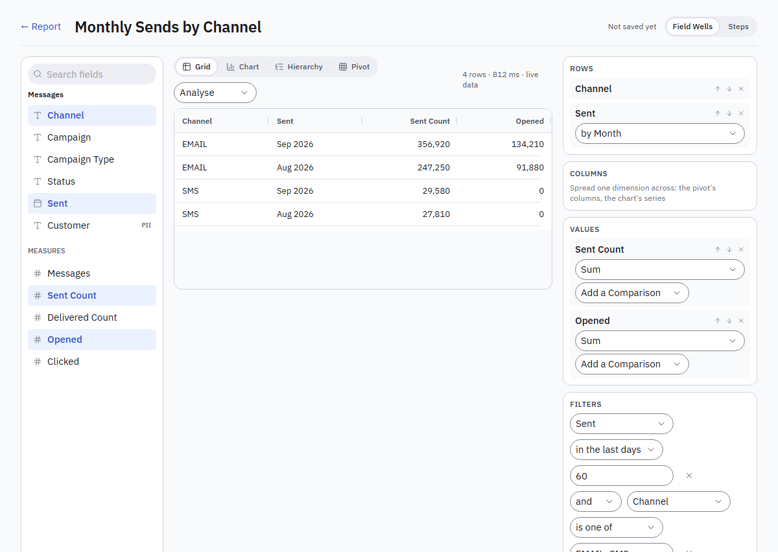
Figure 1. The report editor with Field Wells: the fields on the left, the result in the middle, Rows, Columns, Values and Filters on the right.
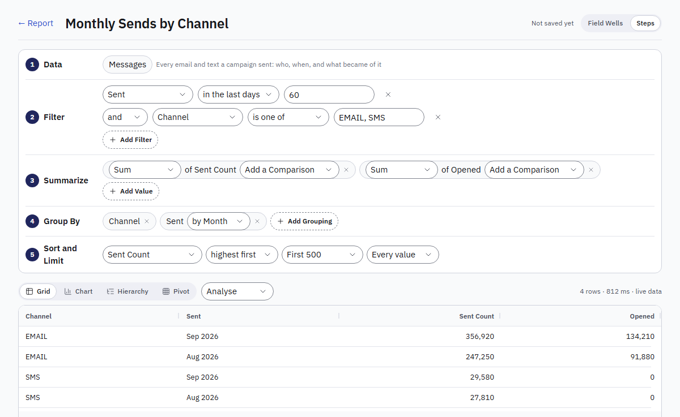
Figure 2. The same report in the Steps editor: Data, Filter, Summarize, Group By, Sort and Limit, with the result underneath.
- Open Insights → Reports and press New Report. Pick a dataset and give the report a name. It opens in the editor with the dataset's first columns.
- Choose an editor at the top right; your choice is remembered. Field Wells: the fields on the left, the result in the middle, the wells on the right. Steps: the question written as numbered steps (Data, Filter, Summarize, Group By, Sort and Limit), each with an Add button.
- Click or drag a field into Rows (one line per value), Columns (one dimension spread across, for the pivot and the chart's series) or Values (a number to total). Group a date by Day, Week, Month, Quarter or Year.
- Pick each measure's calculation: Sum, Count, Distinct Count, Average, Min or Max. Add a Comparison sits under it (Part 2).
- Add Filters: one rule per row (field, operator, value), joined with and or or. A list is comma-separated, a range is from..to, and "in the last days" takes a number. Dates are in the workspace's time zone.
- Watch the preview: it runs as you build. The line above it says how many rows, how long the run took and how fresh the data is.
- Press Save to write a new version, or Cancel to drop the changes.
Find it later: Insights → Reports lists every report you can open, grouped by the component whose data it uses. Press the star on a row to make it a favourite (favourites come first); folder chips at the top filter the list, and the search finds a report by name.

The Four Views
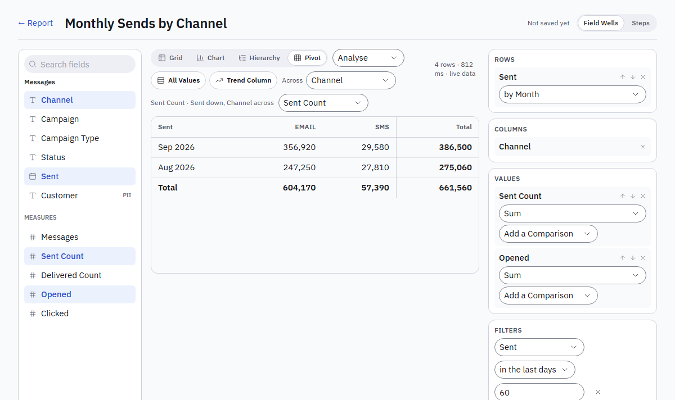
Figure 3. The Pivot view: Sent by month down the side, Channel across, a total on both edges.
Any report switches between the views without losing its fields; the switch sits above the result, in the editor and in the viewer. The editor saves the choice; the viewer switches for a look.
View | What it shows | What it needs
Grid | One row per record or group, sortable and resizable columns | Anything
Chart | Bars, lines or area: the first dimension along the bottom, a series per value of the dimension across (else one per measure), the legend to show and hide, Show the Numbers under it. Stacked and 100% Stacked: the series on top of each other in one bar per category, as numbers or as shares. Combo: the first value as bars and the others as lines, a line in another format (such as a rate) read on a scale on the right. Pie: the first measure by the first dimension as shares, the total in the middle, more than eight slices folded into Other. Funnel: the rows in the report's order as stages, each with its share of the first and the drop from the one before | A dimension and a measure
Hierarchy | The dimensions in their order, each group folding over the next, a subtotal per group, Expand All and Collapse All | Two dimensions and a measure
Pivot | The dimension across as columns, one measure in the cells (a select when there are several), a total on both edges | A dimension down, one across, a measure

Subtotals and totals come from the engine, so averages and distinct counts are exact, and a report longer than the page still totals everything. A comparison column is not added up into a subtotal.
Calculated measures. Some measures are made from others: Delivered Rate is Delivered ÷ Sent × 100, Average Order Value is Amount ÷ Orders. They sit among the measures with the one calculation Calculated, and the engine computes the formula in every view, subtotal and figure, so a rate of a group is the rate of its totals, never an average of rates. A rate with nothing to divide by reads as empty. Your platform team adds them to the platform datasets; a workspace administrator adds them to a mapped dataset under Calculated Measures on the mapping page (Part 6).

Read a Report (the Viewer)
Opening a report runs it and shows the saved view. Above the rows: the view switch; under the title: what the run says (rows, time, freshness, version) and, once scheduled, the schedule line. The buttons:
Button | What it does
Folder | Files the report in a folder, or in a new one (owner or administrator).
Versions | Every saved version with who, when and the note. Open shows one as it was, read-only, with Back to Current. Restore makes it the current version again, as a new version; nothing is lost.
Schedule | Emails the report on a schedule (below).
Edit | The editor (owner or administrator).
Export CSV, Export Excel, Export PDF | The report as a file: CSV the rows; Excel the view with its totals first and the rows after, with number formats; PDF the view styled for paper.
Delete | Removes the report and its versions (owner or administrator).

PART 2

Measures and Comparisons
Totals, rates and the comparisons that set a number against an earlier period, a target or the rest.

Use a calculated measure in a report
Who: Anyone who can build reports
- Open Insights → Reports → New Report and pick a dataset, such as Messages.
- Drag a rate, such as Delivered Rate, into Values. Its calculation reads Calculated and is the only choice.
- Add a dimension to Rows, such as Channel. The rate is worked out per row and in every total, as a rate of the totals.
- A rate with nothing to divide by shows as empty.
Workspace administrators add calculated measures to their own datasets (Part 6); your platform team adds them to the platform's datasets.

Compare a measure with an earlier period
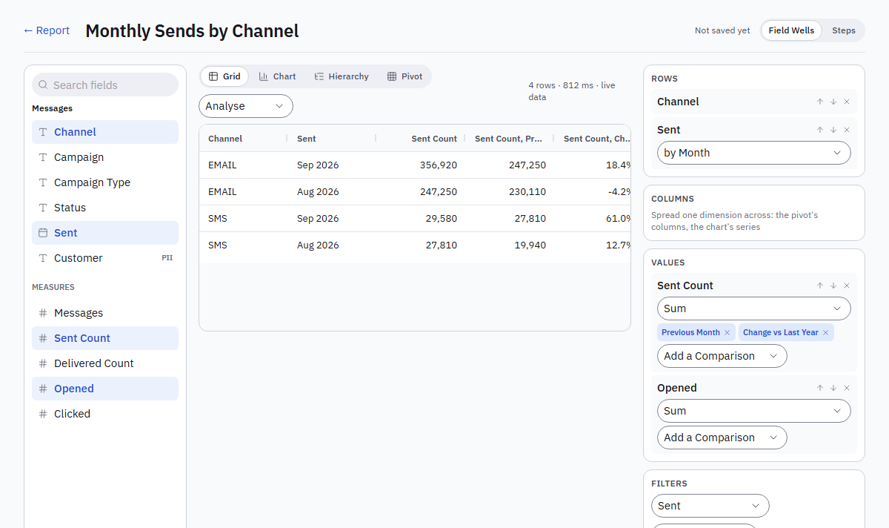
Figure 4. Sent Count with Previous Month and Change vs Last Year: each comparison is a column after its measure.
- In the editor, group the report by a date: drag the date into Rows and choose by Month (or Day, Week, Quarter, Year).
- Under a measure in Values (or in Summarize in Steps), open Add a Comparison and pick one: Previous Month, Last Year, Change vs Previous Month, Change vs Last Year, Running Total or % of Total. The names follow the date's grouping: Previous Week on a weekly report.
- Each comparison is a column after its measure, named in words, such as Sent Count, Change vs Last Year. A change and a share read as percentages.
- Up to four per measure; the cross on a comparison removes it. Running Total and % of Total add up sums and counts only, and an option the report cannot take says why.
- The earlier figures come from the same report moved back in time, so the first month of the period has its previous month too.

Year to date, a moving average, a rank, a target
- With the report grouped by a date, open Add a Comparison under a measure and pick Year to Date or Quarter to Date (the measure added up from the start of each year or quarter), or Moving Average (3 Months) (the month and the two before it).
- Rank numbers the rows from the largest, per month when the report has other dimensions too.
- % of Target and Difference to Target compare with a number: type it in Target beside the comparisons.
- Year and quarter to date add up sums and counts only, and start from the year's or the quarter's first day even when the report's dates start later.

Keep the top values and fold the rest into Others (Top N)
- Put a dimension first in Rows and a measure in Values, sorted the way you want to rank them.
- Under the rows, choose Top 3, 5, 10 or another number. Show the rest as Others adds one Others line per value of the next dimension; untick it to leave the rest out. Every value takes the limit off.
- Sums, counts, minimums and maximums add up in Others; averages and comparisons show empty there.

Set your fiscal year (Settings → Fiscal Year)
Who: Workspace administrators
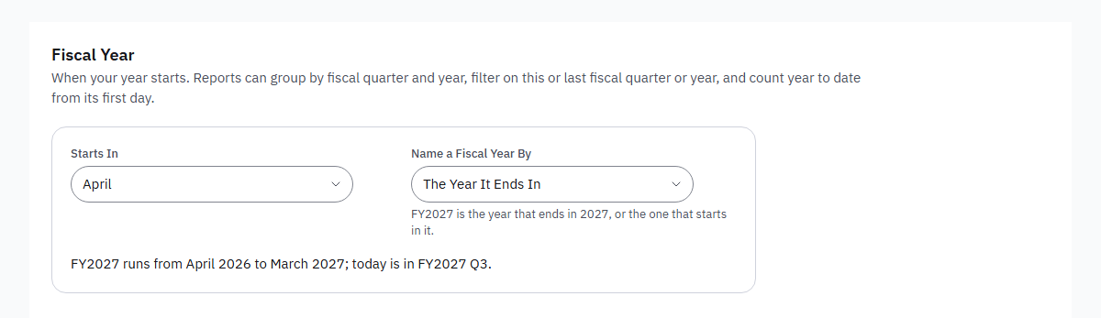
Figure 5. Settings → Fiscal Year: the month it starts in and how the year is named, with an example.
- Open Settings → Fiscal Year and choose the month it Starts In, such as April. It saves at once.
- Choose whether to Name a Fiscal Year By the year it ends in (April 2026 to March 2027 is FY2027) or the year it starts in (FY2026). The page shows an example.
- In the editor, a date then also groups by Fiscal Quarter and by Fiscal Year, read as FY2027 Q1. Filters offer in this fiscal year, in last fiscal year, in this fiscal quarter and in last fiscal quarter.
- Year to Date and Quarter to Date comparisons count from the fiscal year's first day. Dashboards offer Fiscal Quarter and Fiscal Year periods (to date).

Add measures from a linked dataset
- In the editor of a report on Messages, press Linked Measures. The button is there when the platform team has linked the dataset to another one, such as Attributed Orders.
- Tick the measures to add, such as Amount, choose how each is totalled, and press Apply.
- The report may group only by what both share: Campaign, Channel, and the send date by a period. Each side is totalled on its own, then matched by those groups; a row with no orders shows the measure empty.
- Filters on shared fields apply to both sides; filters on other fields apply to the report's own data only, and the viewer says so. A report with linked measures has no comparisons, no Top N and no hierarchy.

PART 3

Custom Fields and Formulas
Fields of your own: groups, bands and labels, formulas for each row, measure formulas, and formulas shared with every report on a dataset.

Group values into a field of your own (Custom Fields)
- In the editor, press Custom Fields.
- Name the field and choose how it is made. Groups names sets of values (North is Downtown, Riverside). Number Bands cuts a number at edges you type (100, 1000 gives Under 100, 100 to under 1,000, 1,000 and over). If-Then Labels gives the label of the first condition a row meets (Amount at least 500 is Gold), and a label for the rest.
- Press Add Field, then Done. The field is in the field list like any other: drag it into Rows, Columns or Filters.
- A custom field belongs to its report. Removing it removes its columns and filters too.

Work out a value for each row with a formula
Who: Anyone who can build reports
- In the editor, press Custom Fields, then Add a Custom Field. Give it a Name and choose the Kind Formula (Each Row).
- Write the formula. Put a field in square brackets, such as [Revenue] - [Cost], or click a field under Fields to put it in where the cursor is. Click a function under Functions to put it in, such as IF(.
- The line under the formula checks it as you type. It says what it works out and which fields it reads, or what is wrong, with the place marked.
- A number formula is A Measure (Adds Up) or A Dimension (Groups): choose a dimension for a year or a code. Choose how a number shows under Show As: Whole Number, Decimal, Money or Percentage.
- Press Add Field. The formula is then a field like any other: drag it into Rows or Values, filter on it, or group a date formula by month.
Examples: IF([Amount] >= 500, "Gold", "Standard"), YEAR([Sent]) & "-" & TEXT(MONTH([Sent])), DATEDIFF([Ordered], TODAY(), "day"), COALESCE([Discount], 0).

Write a measure formula, such as a rate or a filtered total
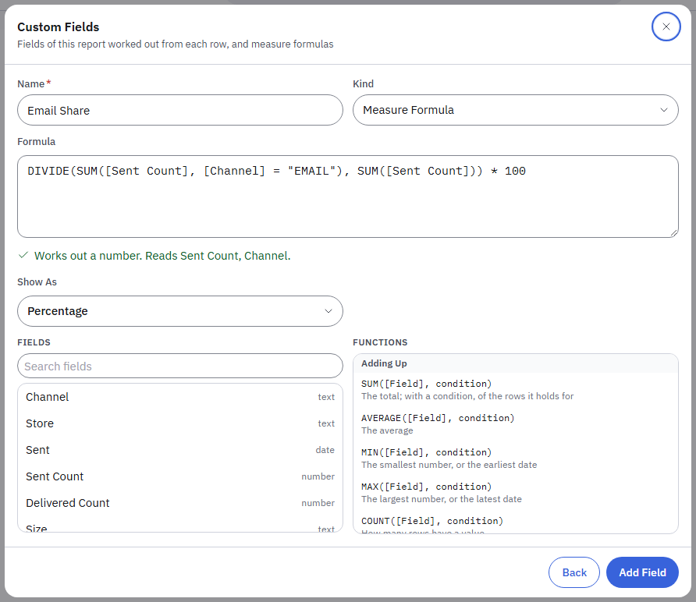
Figure 6. A measure formula in Custom Fields: the line under it says what it works out; fields and functions to put in sit below.
- In Custom Fields, add a field of the Kind Measure Formula.
- A measure formula adds up the rows of each group, so every field goes inside SUM, AVERAGE, MIN, MAX, COUNT or DISTINCTCOUNT, or you count rows with COUNTROWS().
- Give an aggregate a condition to add up only some rows: SUM([Sent Count], [Channel] = "EMAIL") is the email sends of each group.
- Divide safely with DIVIDE: DIVIDE(SUM([Delivered Count]), SUM([Sent Count])) * 100 is empty, not an error, where nothing was sent. Choose Percentage under Show As.
- A measure formula may use the dataset's calculated measures and the measure formulas above it by name, such as [Delivered Rate] / 100.
- Add it to Values: it is worked out for every row, in the totals, the pivot and the charts. Comparisons (previous period, last year) work on it as on any measure.

Show a share of the total, a rank, year to date or last year in a measure formula
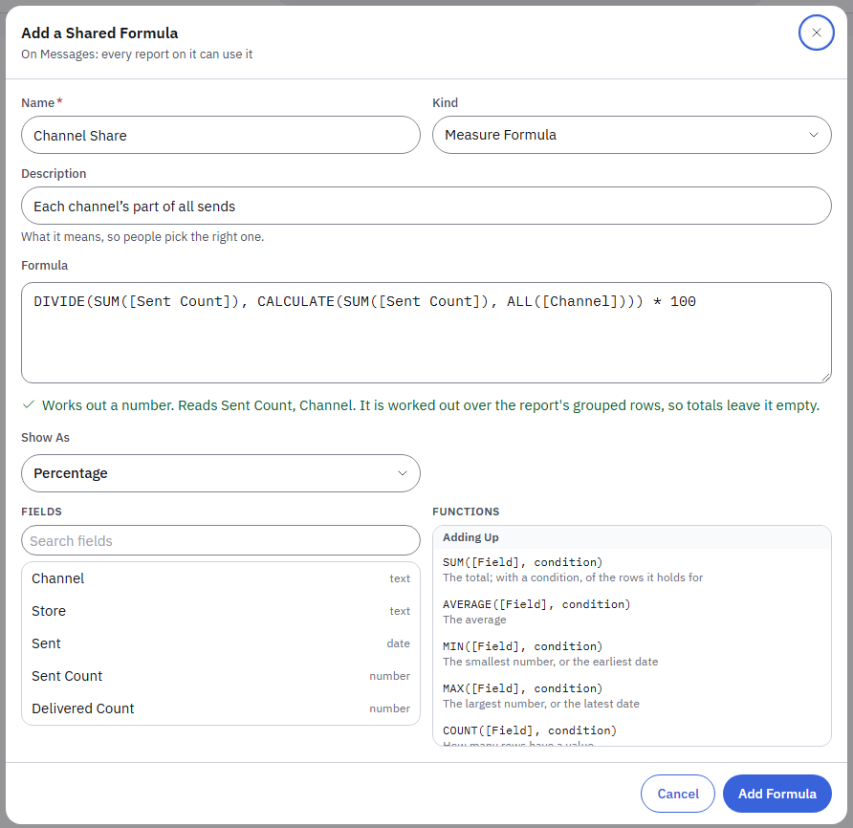
Figure 7. A share of the total with CALCULATE and ALL. The check says it is worked out over the report's rows.
- In Custom Fields, add a Measure Formula.
- A share of the parent: DIVIDE(SUM([Sent Count]), CALCULATE(SUM([Sent Count]), ALL([Channel]))) * 100 is each channel's part of its month's sends when the report shows Sent by Month and Channel. ALL names the fields to look past; ALL() looks past all of them, for a share of the grand total. Choose Percentage under Show As.
- CALCULATE also narrows: CALCULATE(SUM([Amount]), [Kind] = "REFUND") adds up the refunds only.
- A rank: RANKX(SUM([Amount])) numbers the rows from the largest, 1 first; RANKX(SUM([Amount]), "asc") from the smallest. RANKX is a measure formula of its own; it does not go inside a sum.
- Time: put a date in the report's Rows, such as Ordered by Month. Then TOTALYTD(SUM([Amount])) is the year to date (from your fiscal year's first day), TOTALQTD(...) the quarter to date, SAMEPERIODLASTYEAR(SUM([Amount])) the same month a year before, PREVIOUSPERIOD(SUM([Amount])) the month before, and PARALLELPERIOD(SUM([Amount]), -3, "month") three months before. Mix them: SUM([Amount]) - SAMEPERIODLASTYEAR(SUM([Amount])) is the change on last year.
- The line under the formula says when a formula is worked out over the report's rows. Such a formula shows in each row; the report's totals row leaves it empty.
- The report keeps its date filter: last year's figures are read even when the report shows only this year.

On a MySQL 5.7 Database
MySQL 5.7. A dataset from a MySQL 5.7 database cannot run CALCULATE with ALL, RANKX or the time functions (TOTALYTD, TOTALQTD, SAMEPERIODLASTYEAR, PREVIOUSPERIOD, PARALLELPERIOD): that version has no window functions. The formula editor leaves them out of its list there, and the line under the formula says so if one is typed. CALCULATE with a condition, SUMX and the other functions work. A database on MySQL 8.0 or PostgreSQL runs them all.

Share a formula with every report on a dataset
Who: Anyone who can build reports
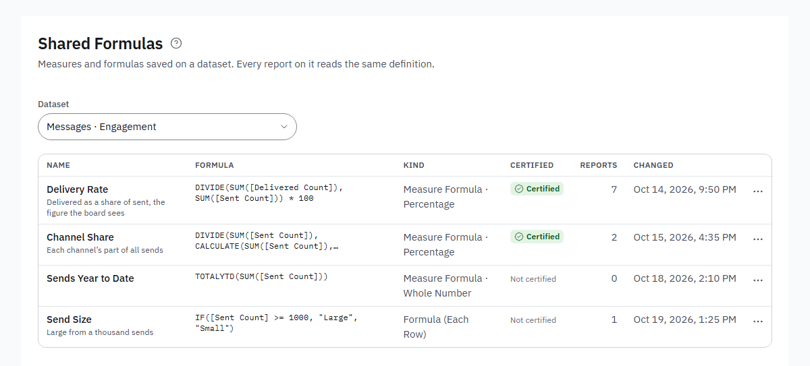
Figure 8. Insights → Shared Formulas: each formula with its kind, its Certified mark and the reports that use it.
- Open Insights, then Shared Formulas, and choose the Dataset.
- Press Add a Formula. Give it a Name, choose Measure Formula or Formula (Each Row), and add a Description that says what it means.
- Write the formula as in Custom Fields. It may use the dataset's fields and the shared formulas above it. Press Add Formula.
- Every report on that dataset now lists it among the fields. It shows the word Shared next to its name, or a tick when it is certified.
- To share a formula you wrote in a report: in the report's Custom Fields, press Share With Every Report next to it, then Add Formula. The report then uses the shared formula in place of its own.
- A formula that reports use cannot be removed: the Reports column shows how many. Renaming one asks first, because a report may call it by name.

Certify a shared formula
Who: Report administrators
- In Shared Formulas, open the … menu on a formula and press Certify. It shows Certified, with your name and the time when you point at the mark.
- Only a report administrator changes or removes a certified formula. Anyone else who needs a different version saves it under another name.
- Press Remove Certification to take the mark off.

The formula language at a glance
- Fields: [Field Name] (the name you see; the field's key also works). Text: "EMAIL" or 'EMAIL'. Yes and no: TRUE, FALSE. Empty: BLANK.
- Operators: + - * / (dividing by zero gives an empty value), & joins text, = <> < <= > >= compare, AND, OR, NOT.
- Adding up (measure formulas only): SUM, AVERAGE, MIN, MAX, COUNT, DISTINCTCOUNT, each with an optional condition, and COUNTROWS(condition). SUMX, AVERAGEX, MINX, MAXX and COUNTX are the same, for a value worked out per row: SUMX([Quantity] * [Price]).
- Share, rank and time (measure formulas only): CALCULATE with ALL, RANKX, TOTALYTD, TOTALQTD, SAMEPERIODLASTYEAR, PREVIOUSPERIOD, PARALLELPERIOD (see the steps below).
- Naming parts: VAR Sent = SUM([Sent Count]) VAR Delivered = SUM([Delivered Count]) RETURN DIVIDE(Delivered, Sent) * 100.
- Logic: IF, SWITCH, ISBLANK, COALESCE. Numbers: DIVIDE, ROUND, ABS, FLOOR, CEILING, INT, MOD, POWER, SQRT, EXP, LN, LOG, SIGN, VALUE (text to a number).
- Text: CONCAT, UPPER, LOWER, TRIM, LEFT, RIGHT, MID, LEN, FIND, CONTAINS (any case), REPLACE (or SUBSTITUTE), TEXT.
- Dates: YEAR, QUARTER, MONTH, DAY, WEEKDAY (1 is Sunday), WEEKNUM, HOUR (in your workspace's time zone), EOMONTH, DATE(year, month, day), TODAY, NOW, DATEDIFF(start, end, "day" | "month" | "year"), DATEADD(date, number, "day" | "month" | "year").
- A formula can use the custom fields above it in the list, and the dataset's shared formulas. A formula that reads personal data is personal too.

Function Reference
Every function the formula editor lists, by group. Measure only means it adds up the rows of a group, so it goes in a measure formula.

Adding Up
Function | Written as | What it gives
SUM  Measure only | SUM([Field], condition) | The total; with a condition, of the rows it holds for
AVERAGE  Measure only | AVERAGE([Field], condition) | The average
MIN  Measure only | MIN([Field], condition) | The smallest number, or the earliest date
MAX  Measure only | MAX([Field], condition) | The largest number, or the latest date
COUNT  Measure only | COUNT([Field], condition) | How many rows have a value
DISTINCTCOUNT  Measure only | DISTINCTCOUNT([Field], condition) | How many different values
COUNTROWS  Measure only | COUNTROWS(condition) | How many rows
SUMX  Measure only | SUMX([Quantity] * [Price]) | The total of a value worked out for each row (also AVERAGEX, MINX, MAXX, COUNTX)

Share, Rank and Time
Function | Written as | What it gives
CALCULATE  Measure only | CALCULATE(SUM([Field]), ALL([Channel])) | With ALL, the total across every value of a field: the parent of a share
ALL  Measure only | ALL([Field], …) | Inside CALCULATE: ignore these fields of the report (none named: all of them)
RANKX  Measure only | RANKX(SUM([Field]), "asc") | The row's place, 1 for the largest (asc: the smallest); a measure of its own
TOTALYTD  Measure only | TOTALYTD(SUM([Field])) | Year to date, from your fiscal year's start; needs a date in the report
TOTALQTD  Measure only | TOTALQTD(SUM([Field])) | Quarter to date
SAMEPERIODLASTYEAR  Measure only | SAMEPERIODLASTYEAR(SUM([Field])) | The same month, quarter or week a year before
PREVIOUSPERIOD  Measure only | PREVIOUSPERIOD(SUM([Field])) | The period before, at the report's date grouping
PARALLELPERIOD  Measure only | PARALLELPERIOD(SUM([Field]), -3, "month") | Moved by months, quarters or years (minus: earlier)

Naming Parts
Function | Written as | What it gives
VAR | VAR Sent = SUM([Sent Count]) RETURN … | Name a part once and use it by name after RETURN

Logic
Function | Written as | What it gives
IF | IF(condition, then, else) | One value or another
SWITCH | SWITCH([Field], value, result, …, else) | The result for the first value that matches
ISBLANK | ISBLANK([Field]) | Whether a value is empty
COALESCE | COALESCE([Field], 0) | The first value that is not empty

Numbers
Function | Written as | What it gives
DIVIDE | DIVIDE(a, b, if zero) | a ÷ b, empty (or the third value) when b is 0
ROUND | ROUND(number, places) | Rounded to the places given
ABS | ABS(number) | Without its sign
FLOOR | FLOOR(number) | Rounded down
CEILING | CEILING(number) | Rounded up
INT | INT(number) | The whole number, rounded down
MOD | MOD(number, divisor) | The remainder
POWER | POWER(number, power) | Raised to a power
SQRT | SQRT(number) | The square root
EXP | EXP(number) | e to the power
LN | LN(number) | The natural logarithm
LOG | LOG(number, base) | The logarithm, base 10 unless given
SIGN | SIGN(number) | 1, 0 or -1
VALUE | VALUE(text) | Text as a number (empty when it is not one)

Text
Function | Written as | What it gives
CONCAT | CONCAT(a, b, …) | Joined together, like a & b
UPPER | UPPER(text) | In capitals
LOWER | LOWER(text) | In small letters
TRIM | TRIM(text) | Without spaces at either end
LEFT | LEFT(text, count) | The first letters
RIGHT | RIGHT(text, count) | The last letters
LEN | LEN(text) | How many letters
CONTAINS | CONTAINS(text, "part") | Whether it holds the part, in any case
REPLACE | REPLACE(text, "old", "new") | With every old part replaced (also SUBSTITUTE)
MID | MID(text, start, count) | The letters from a place, the first is 1
FIND | FIND("part", text) | Where the part starts, 0 when it is not there
TEXT | TEXT(value) | A number or a date as text

Dates
Function | Written as | What it gives
YEAR | YEAR([Date]) | The year, in your time zone
MONTH | MONTH([Date]) | The month, 1 to 12
DAY | DAY([Date]) | The day of the month
QUARTER | QUARTER([Date]) | The quarter, 1 to 4
WEEKDAY | WEEKDAY([Date]) | The day of the week, 1 for Sunday
WEEKNUM | WEEKNUM([Date]) | The week of the year (ISO weeks, from Monday)
HOUR | HOUR([Date and Time]) | The hour, 0 to 23
EOMONTH | EOMONTH([Date], months) | The last day of the month, moved by months
DATE | DATE(2026, 12, 31) | A date from a year, a month and a day
TODAY | TODAY() | Today's date
NOW | NOW() | The date and time now
DATEDIFF | DATEDIFF(start, end, "day") | Days, months or years between two dates
DATEADD | DATEADD([Date], 30, "day") | A date moved by days, months or years

PART 4

Charts and Views
Every way a report can be drawn, and how to colour, forecast and flag its numbers.

Stack the bars, or combine bars and a line
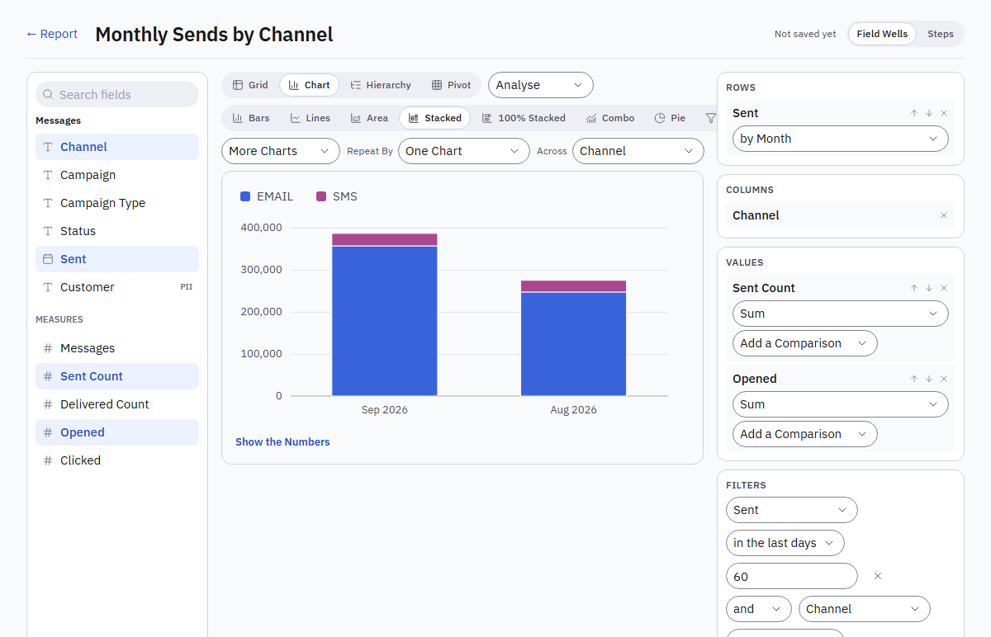
Figure 9. A stacked chart: each month one bar, the channels on top of each other. Combo and 100% Stacked sit beside it.
- Choose Chart, then Stacked to put each series on top of the other in one bar per category, or 100% Stacked to show each series as its share of the bar.
- The series come from the dimension in Columns (for example Channel), else from the values.
- Choose Combo to show the first value as bars and the others as lines, such as Sent Count as bars with Open Rate as a line. A line in another format or of a very different size is read on a scale on the right.

Show a report as a pie or a funnel
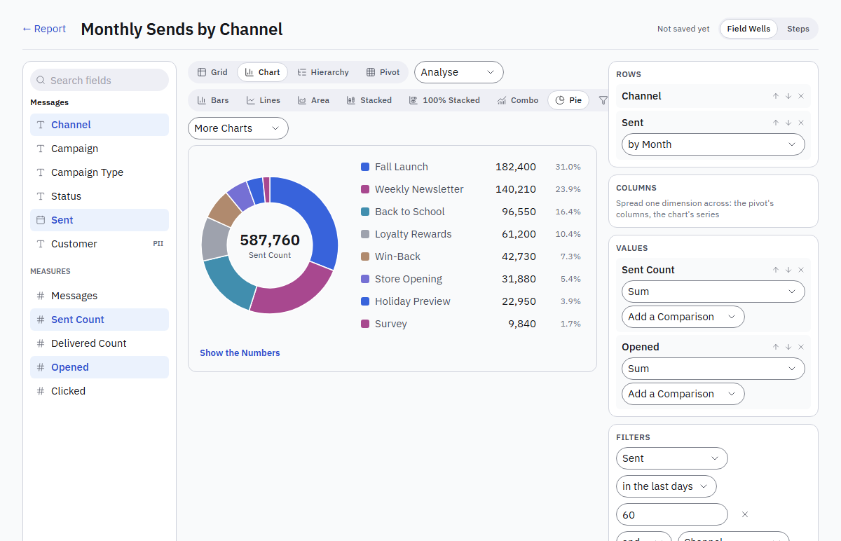
Figure 10. A pie by campaign: the total in the middle, each value with its share in the legend.
- In the report editor or viewer, choose Chart, then Pie or Funnel.
- Pie shows the first measure by the first dimension. The total sits in the middle, and the legend gives each value with its share. More than eight slices fold into Other.
- Funnel shows each row as a stage, in the report's sort order, with its value, its share of the first stage and the change from the stage before. Sort the report into the order the stages should run.
- Press Save in the editor to keep the choice.

Use a scatter, bubble, treemap or waterfall chart
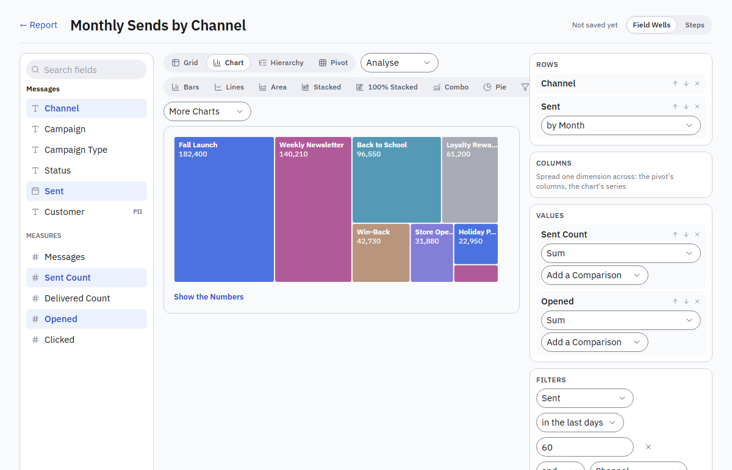
Figure 11. A treemap from More Charts: boxes sized by their share, the largest first.
- Choose Chart, then pick one from More Charts beside the chart kinds. The one you pick joins the switch.
- Scatter: one point per value of the first dimension, the first value along the bottom and the second up the side, such as Sent Count and Opened per Campaign. Bubble adds a third value as the point's size.
- Treemap: the first value by the first dimension as boxes sized by their share, the largest first. More than 24 fold into Other.
- Waterfall: the first value by the first dimension, in the report's order, as steps from the running total. Rises are blue, falls plum, and the total grey at the end.
- Hover a mark to read it, or press Show the Numbers for the table. Save in the editor to keep the choice.

Show one figure: a KPI card or a gauge
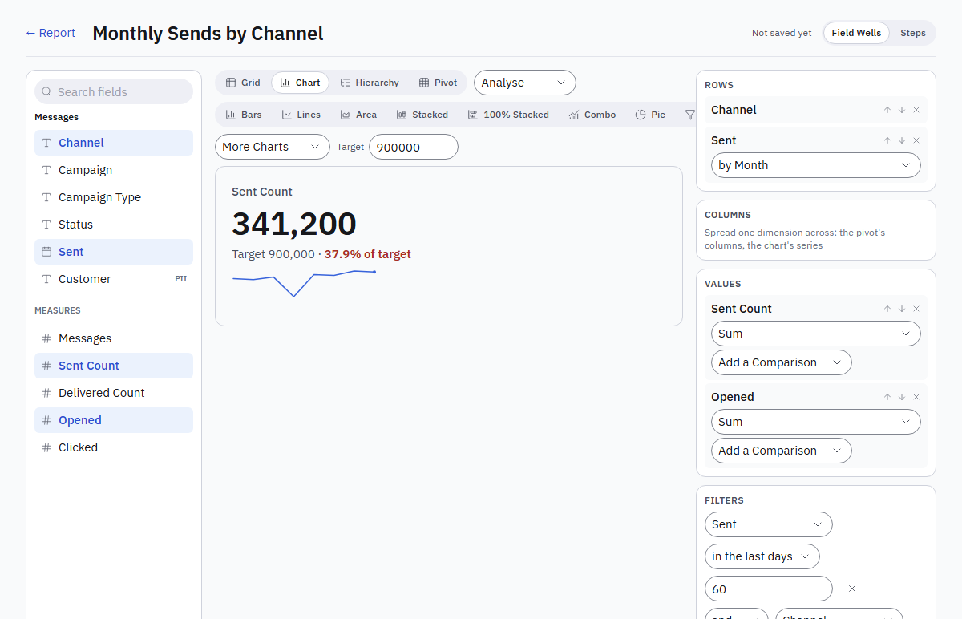
Figure 12. A KPI card with a target: the value, the share of target and a small trend line.
- Choose Chart, then KPI Card or Gauge from More Charts.
- Type a Target. The card shows the value for the whole report, the target and the share of target, green when it is met and red when not. When the report runs along dates, a small trend line sits under the figure.
- The gauge fills an arc to the value and marks the target on it.
- On a dashboard, add the report as a Chart tile to show the card or the gauge.

Put the numbers on a map
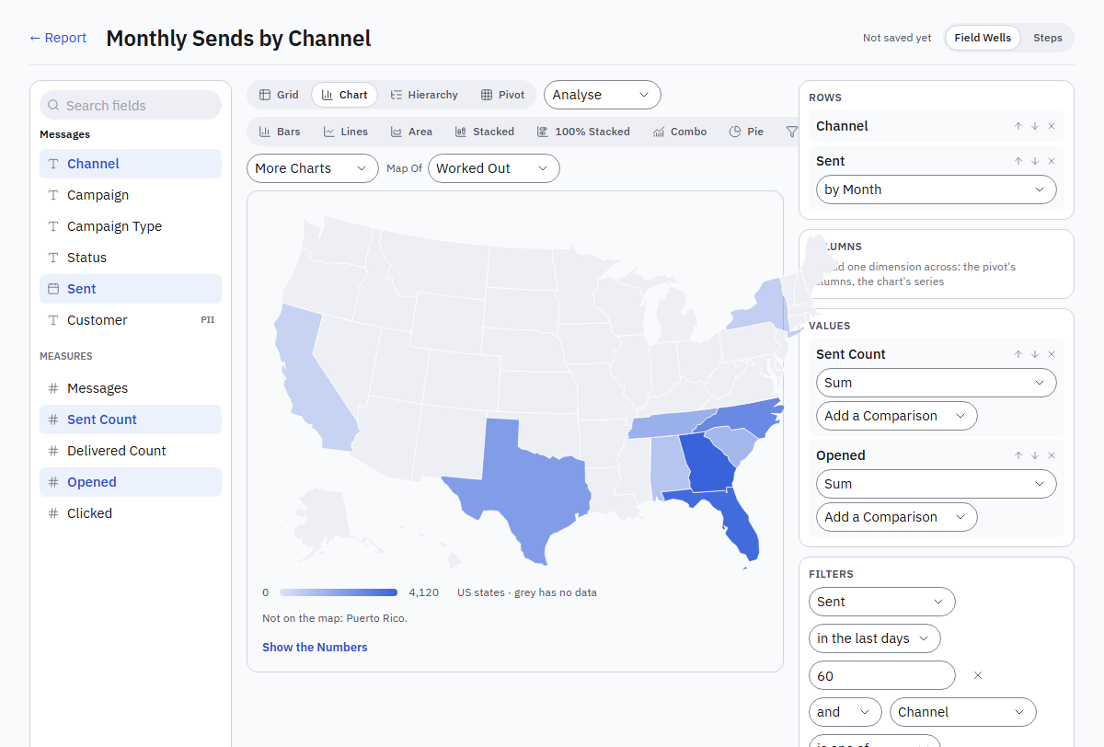
Figure 13. A map of US states: darker blue is more, grey has no data; Map Of picks states or countries.
- Build a report with a place and a value, such as Contacts by Region (US states) or by Country.
- Choose Chart, then Map from More Charts. States match by their two-letter code or name; countries by their two- or three-letter code or name.
- Map Of picks US States or Countries when the guess is wrong. Darker blue is more; grey has no data.
- Values that match no place are listed under the map. Click a place to filter a dashboard by it.

Show every value side by side in a pivot (matrix)
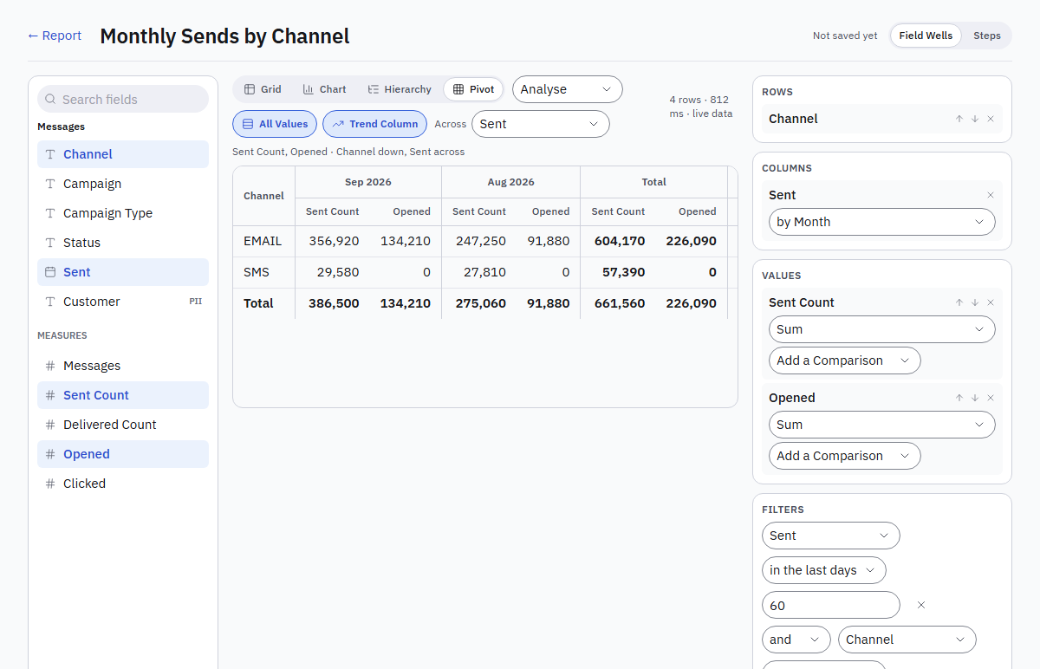
Figure 14. All Values and Trend Column: every value under each month, with a total for each.
- Choose Pivot and a dimension across, such as Sent by Month.
- Press All Values: each value of the report gets its own column under each month, with a total for each.
- Press Trend Column to add a small line per row showing how each value moves across the columns.

Repeat a chart per value (small multiples)
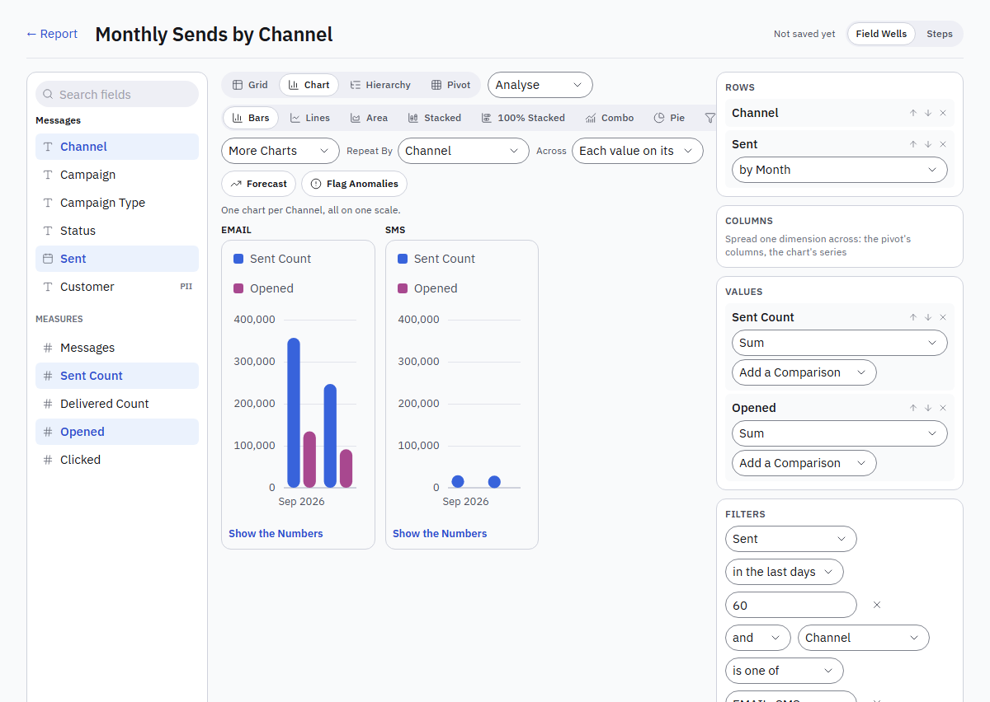
Figure 15. Repeat By Channel: one small chart per value, all on one scale.
- With a bar, line, area, stacked or pie chart and at least two dimensions, choose a dimension in Repeat By, such as Channel.
- One small chart per value appears, up to 12, all on one scale so they compare at a glance.
- Choose One Chart to go back.

Colour the numbers
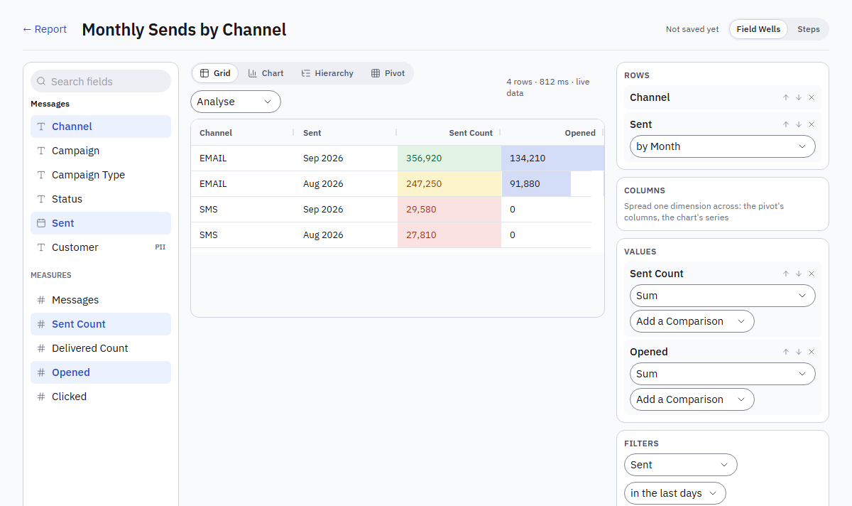
Figure 16. Rules colour Sent Count good, warning or bad; data bars sit behind Opened.
- In the editor, with the Grid, Pivot or Hierarchy view, press Format Values.
- For each value (and each of its comparisons), choose Colour Scale (light to strong blue from the lowest to the highest), Data Bars (a bar behind each number) or Rules.
- For rules, say when and how: More than, At least, Less than, At most or Equal to a number, shown as Good, Warning or Bad. Add Rule adds up to five; the first rule a number meets colours its cell. A change or a share is in percent: 10 means 10%.
- Press Apply, then Save. The formatting shows in the viewer and on dashboards; totals stay plain, and exports carry the numbers without the colours.

Add a forecast line, or flag unusual points
- Show the report as a Chart with Bars, Lines or Area, along a date grouped by day, week, month, quarter or year.
- Press Forecast to add a dashed line carrying the trend of the first series three periods on, and Flag Anomalies to ring the points far off that trend in red. Hover a ringed point to read how far off it is.
- A line under the chart says how they were worked out. A forecast is a straight-line trend, not a promise. Save in the editor to keep the choice.

PART 5

Exploring the Data
Going down a level, opening the rows behind a value, asking a question before a report runs, and finding what drives a number.

Drill down in a chart
- Open a report with more than one level, such as Sent by Year then Channel, and choose Chart.
- The line above the chart says what a click drills to. Click a bar, a slice or a stage: the chart shows the level below for that value, such as the quarters of 2026, then their months, then their days, then the next dimension.
- The path above the chart shows where you are. Click any step to go back to it, or Up One Level.
- On a dashboard, turn on Drill Down in a chart tile's header first: while it is on, a click drills that tile instead of filtering the others. Turn it off to go back to the top and to cross-filtering.

Drill in a pivot or a hierarchy
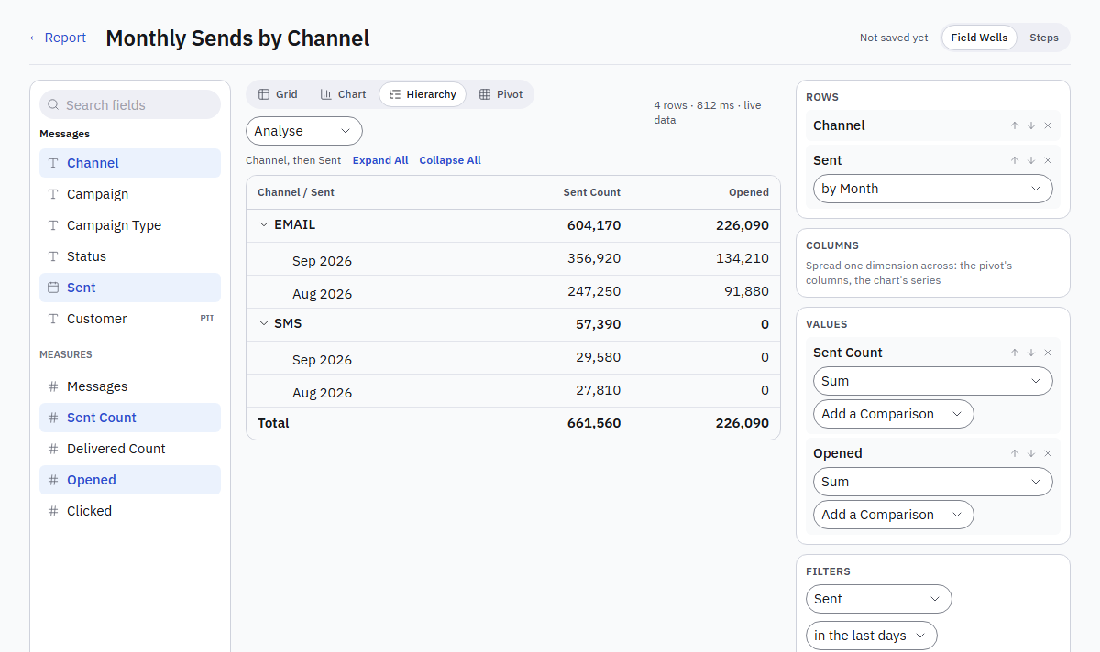
Figure 17. The Hierarchy view: each channel folds over its months, with a subtotal per group.
- Open a report with more than one level, such as Sent by Year, then Channel, then Campaign, and choose Pivot or Hierarchy.
- In a pivot, click a row's label; in a hierarchy, press the arrow beside a top-level group (Drill into that value). The table shows the level below for that value, such as the quarters of 2026, and keeps the levels under it, so Channel and Campaign still nest inside.
- The path above the table shows where you are. Click a step to go back to it, or Up One Level.

Open a detail report from a value (drill-through)
- Make the detail report: in its editor press Detail Report, tick the fields it can be opened through (such as Channel or Store), Apply, then Save.
- In any other report or dashboard tile on the same data, right-click a value of that field: a bar, a slice, a stage or a cell in a grid.
- The menu lists the detail reports for the field. Pick one: it opens filtered to that value, and the line above the rows says where it was opened from.
- Show All Rows shows the detail report without the filter.

Show another report when someone hovers a value (Tooltip Report)
- Make the report to show on hover a detail report: in its editor press Detail Report, tick the field the chart runs along (such as Campaign), Apply, Save.
- In the chart's report, press Tooltip Report in the editor, pick that report, Apply, then Save.
- In the viewer or on a dashboard, rest the pointer on a value of the chart for a moment: a card shows the first rows of the tooltip report for that value.

Find what drives a value (Key Influencers)
- Open a report with a rate or an average, such as Delivered Rate, and choose Analyse → Key Influencers.
- Raises It and Lowers It list the groups whose value sits furthest from the whole report, such as "When Channel is SMS". Each line gives the group's value, how far it is from the whole, and its number of rows.
- A sum is read per row of the data, such as Sent Count per message. A plain count cannot be explained.
- With more than one value, choose which in Explain. Read the lines as leads, not causes.

Break a value down step by step (Decomposition Tree)
- Choose Analyse → Decomposition Tree. The total of the value shows first.
- Press Split By and choose a field, such as Channel. The values under it appear, largest first.
- Pick one, such as EMAIL, and Split By again to break it down by another field. High Value and Low Value let AI pick the field whose largest or smallest part goes furthest.
- A level's cross removes it and the levels after it; Start Again clears the tree.

Ask a question before a report runs (Parameters)
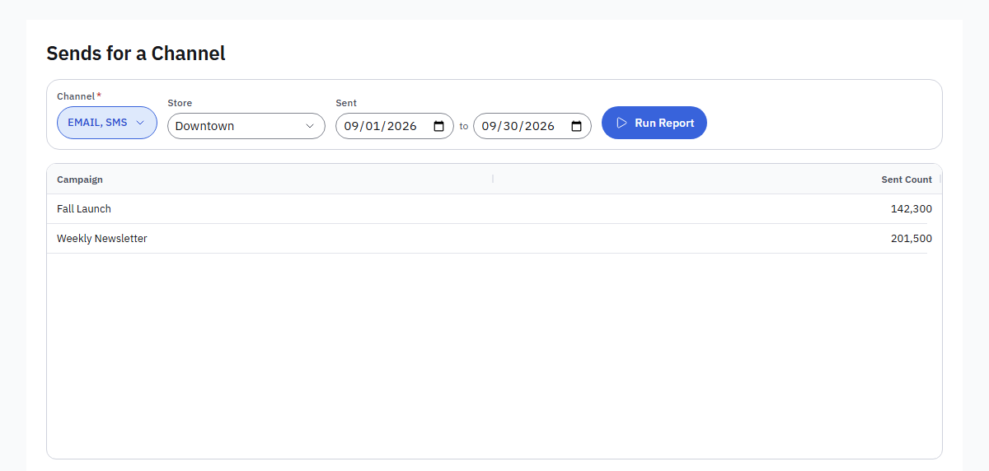
Figure 18. The questions above a report: pick the answers and press Run Report.
- In the editor, press Parameters, then Add Parameter. Choose the Field, then how it is Asked As: Any of Several Values, One Value, At Least, At Most, A Range or The Last Few Days.
- Give it a Label, an optional Default, and tick An Answer Is Required if the report should not run without one. A report asks up to five questions. Press Apply, then Save.
- People opening the report see the questions above the rows. A text field offers its own values to pick from. They choose the answers and press Run Report. A required question with no answer and no default waits for one.
- The answers are kept in the page's address, so a link opens the report with them. Exports, the Print-Ready PDF and Explain use the answers too.
- A dashboard tile, a schedule or an alert runs the report with the defaults. A question with no default then leaves its filter out.

Show the SQL
- In the viewer, open the More actions menu (the three dots) and choose Show the SQL; in the editor, press Show the SQL beside the row count.
- The dialog shows the statement the engine runs for you, with the values written in, and the linked dataset's statement when the report has one. Your row access rules are in it.
- Copy puts a statement on the clipboard. Nothing runs from this dialog.

PART 6

Your Own Data
Reports on a CSV or Excel file, and on a MySQL, PostgreSQL or ClickHouse database of your own, read-only.

Report on a CSV or Excel file (Uploaded Files)
Who: Anyone who can build reports
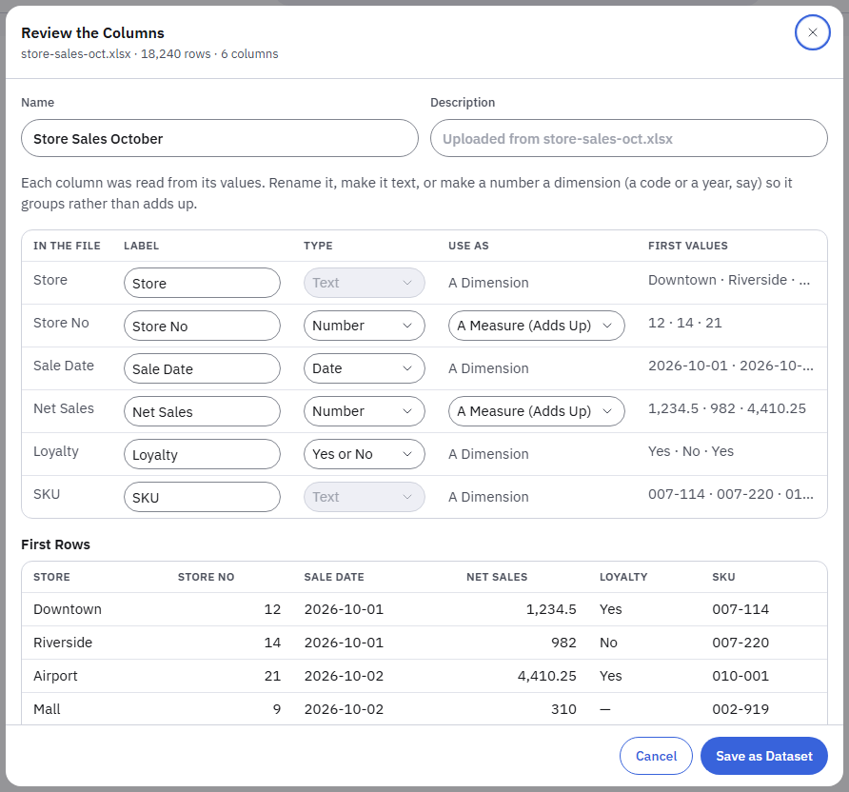
Figure 19. Review the Columns: each column's label, type and use, with the first rows of the file.
- Open Insights → Uploaded Files and press Upload a File, or drop the file on the page. The first row names the columns; in an Excel workbook the first sheet is read. Up to 100,000 rows, 50 columns and 20 MB; save an older .xls as .xlsx first.
- Review the Columns opens. Each column's type was read from its values: Text, Number, Date, Date and Time, or Yes or No. Rename a column under Label, make it Text if it is a code, and set a number to A Dimension (Groups) when it should group rather than add up, such as a year or a store number. The first values show beside each column.
- Give the dataset a Name and press Save as Dataset. New Report opens with your file picked under Your Files. It also offers Upload a File.
- Dates like 03/04/2026 are read with the day first when any day in the column is over 12, otherwise with the month first. A date and time with no zone is your workspace's time. Codes with leading zeros, such as 007, stay text.
- To refresh the rows, open the file's menu (the three dots) and choose Replace File. The new file must have the same column names, in any order, and the reports on it read the new rows at once. A file with reports built on it cannot be deleted.

Connect a database
Who: Workspace administrator
- Ask your database administrator for an account that holds SELECT and nothing else; the page shows the exact statements for MySQL, PostgreSQL and ClickHouse.
- Open Settings → Report Databases and press Connect a Database. Give it a name, pick the engine (MySQL 5.7, MySQL 8.0, PostgreSQL or ClickHouse), enter the host, port, database, the schema for PostgreSQL, the user and the password, and choose SSL. Find Databases (on PostgreSQL Find Schemas) lists the databases the account can see with their table counts, so you pick one instead of typing it; it reads names only.
- Press Test Connection. Four facts come back: reached and the version, what the account can read, whether it is read-only, and the server's time zone. A ✕ on the read-only line names what the account holds beyond SELECT; have the account fixed before mapping anything.
- Press Save. The password is stored encrypted and never shown; leave it empty on a later edit to keep it.

Set how reports treat a database
Who: Workspace administrator
- Open Settings → Report Databases and press Edit on the database's card (or set it while you connect it).
- Under How Reports Treat This Database, pick what kind of database it is: Standard for a reporting copy or a small database (the workspace's limits, usually 15 seconds and 4 reports at once); Large or Slow for big tables or a server behind a slow link (60 seconds, 2 at once); Live Production Database for the database the business runs on (60 seconds, 1 at once); or Custom to set the Time Limit (5 to 110 seconds) and Reports at Once (1 to 4) yourself.
- Press Save. The next report uses it; nothing restarts. The card shows the choice and its two values.
A report that needs longer than the time limit is stopped, with a message that names the database and its limit. A report that finds the database busy with as many reports as it allows waits up to 10 seconds for its turn, then asks you to try again. Reading the database's list of tables and columns may take at least 60 seconds, or the time limit when that is longer.

Connect a database from New Report
Who: Report author
- Open Insights → Reports → New Report. Under Your Databases, press Connect a Database. A panel opens over the page.
- Fill in the same fields as above and press Test Connection. Save and Continue is offered only once the test shows the account read-only; if it can write, the panel says what it holds and asks for an account that can only read.
- Pick a table or view (search narrows the list) and press Create Report. The table becomes a dataset with every readable column, labelled from its name, the first date as its time field; the report opens in the editor. A table mapped before keeps its dataset. Or press write a query to open the query window on the database.

Map a dataset from a table
Who: Workspace administrator
- On the database's card, press Map a Dataset. The list on the left holds every table and view by name, read live from the database when the page opens (one statement that opens no table; nothing about the database is stored). A large database opens on your pinned tables and on folded groups by name prefix (sales_, inv_ ...); type part of a name to search them all, narrow the matches with the chips, and press Show 50 More for the next ones. The star pins a table to the top for everyone who maps datasets here. Reload the List reads the names again after the database changed. Pick a table or view: its columns and row estimate are read then, for that table only.
- Name the dataset and describe it. Choose the Row Key (what one row is) and the Time Field (the date a period filter applies to).
- For each column: tick it to keep it, give it a label, check its type and role, pick the calculations a measure allows, and set the sensitivity (Personal is masked for readers without the right, Confidential is hidden from everyone).
- Watch the preview under the fields update with your labels, then press Save Dataset. It appears in New Report under Your Databases.

Join tables in a dataset
- On the mapping page, press Add a Join, or Join to this on a table's card in the diagram.
- Choose what to join to (the base, or a table already joined), the table, and whether to keep every row (Left) or only the rows that match (Inner).
- Say which columns are equal; the first pair is suggested from the names. Press Check the Join to see how many rows match and whether the join multiplies rows, then Add.
- The joined table appears as a card with the key drawn to it; its columns are fields labelled with the table's name. Up to five joins; removing one removes the joins chained to it.

Add a calculated measure
Who: Workspace administrator
- On the database's card press Map a Dataset, or Edit Fields beside an existing dataset.
- Mark the numbers you need as Measure.
- Under Calculated Measures, press Add a Calculated Measure and give it a label, such as Delivered Rate.
- Pick the left side and its calculation, such as Sum of Delivered.
- Pick the operation: Divided by, Minus, Plus or Times.
- Pick the right side: another measure, or A number… to type a value.
- Set the Scale (100 for a percentage) and the Format, and mark it Personal if it uses personal data. The formula is spelled out under the label as you build it.
- Press Save Dataset, or Save Fields for a dataset made from a query. Report authors find it among the measures with the calculation Calculated.

Build a report from a query
Who: Anyone who can build reports
- Open Insights → Reports → New Report and, under Query a Database, press the database.
- Visual: press From beside a table on the left, add columns with their calculations and aliases, add conditions and sorts; the group by is set for you and the SQL shows underneath. SQL: write or paste the SELECT; click a table or column on the left to insert its name.
- Write It for Me: describe the query in words, pick the model, and press it; the SQL lands in the window for you to read. It counts as one prompt.
- Press Run to preview the rows. A second statement, a write word or a file function is refused with the reason before anything runs.
- Name the report and press Create Report. The report opens in the editor on the query's result, where you group, sort, switch views, export and schedule as with any report.
- Administrators reach the same window from Query on a database card; there it ends with Use as Dataset, and a dataset from a query shows Edit Query beside Edit Fields.

PART 7

Dashboards
Pages of tiles on one period, with slicers, cross-filtering, saved views, pages, a free canvas, a phone layout and themes.

How a Dashboard Works
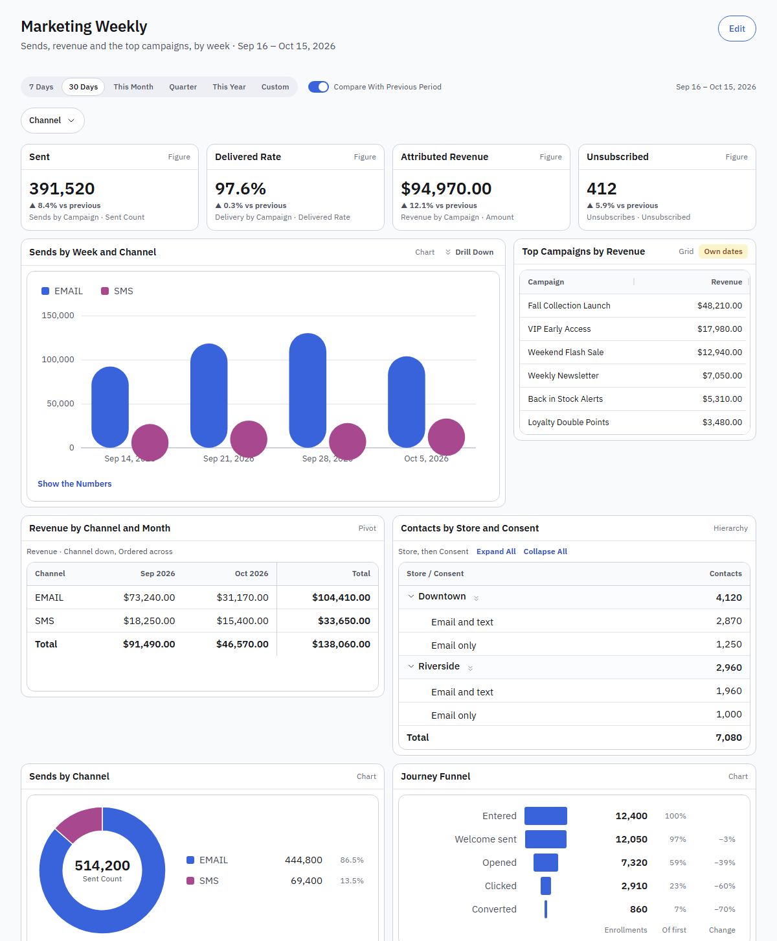
Figure 20. A dashboard: figures, charts, a grid, a pivot and a hierarchy on one period, with a Channel slicer under it.
A dashboard is a page of tiles, each tile a saved report in one of its views or one of its figures, on one period that applies to every tile.
- Insights → Dashboards lists them, favourites first, with their tiles, owner and sharing.
- New Dashboard opens an empty one in the editor. Name it, choose who can open it (only you, or the workspace), and Add Tile: pick a report, then how to show it, one of its views or one figure, a measure totalled over the period. Each new tile goes into the last row with room, else a new row.
- A dashboard is rows of tiles: one to four across of equal width, or wide and narrow. The row bar sets the width and moves or removes the row; a tile's controls move it left or right, rename it or remove it. Nothing overlaps or leaves a gap. Done saves the layout as a version.
- The period: 7 Days, 30 Days, This Month, Quarter, or Custom dates, in the workspace's time zone, applied to every tile through its dataset's date. A report with its own date filter keeps it and the tile says Own dates. Compare With Previous Period adds the change to every figure.
- Slicers: in the editor, Add Slicer picks a dimension the tiles' datasets share (Channel, Store, Campaign…), up to six. Viewing, each slicer is a chip under the period; open it, tick values and Apply, and every tile whose data has that field runs narrowed to them. A tile without the field says Not sliced by it. Clear takes the values off.
- Cross-filtering: click a bar, a slice of a pie, a stage of a funnel or a cell in a grid tile, and the other tiles narrow to that value. When the field is not one of the dashboard's slicers, a chip appears for it with a cross to take it off. Clicking the same value again clears it.
- Viewing a dashboard, you can switch the period, the comparison and the slicers for a look without saving; nothing of a selection is saved, and a PDF or a scheduled delivery is the dashboard as saved.
- Export PDF gives the dashboard with its tiles on its saved period; Schedule emails it as PDF.

Add slicers to a dashboard
Who: Its owner or a report administrator
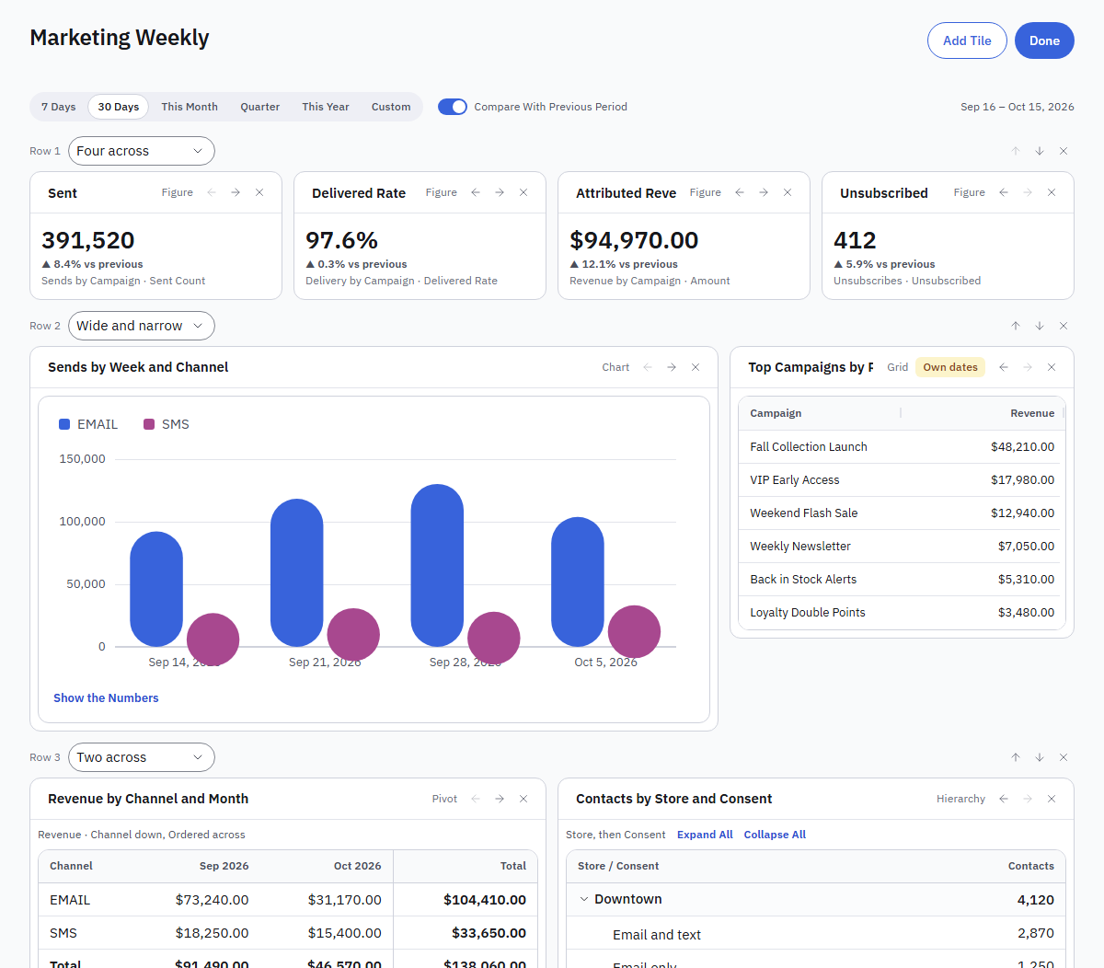
Figure 21. The dashboard editor: Add Tile, the row controls and each tile's controls.
- Open the dashboard and press Edit.
- Under the period, press Add Slicer and choose a dimension, such as Channel or Store. The list shows the dimensions of the tiles' datasets, up to six.
- Remove one with its cross, then press Done.

Filter a dashboard with slicers
- Each slicer is a chip under the period. Open it, search, tick values and press Apply.
- Every tile whose data has that field narrows to those values. A tile without the field says Not sliced by that field.
- Clear takes the values off.

Slice a dashboard by a range of numbers or dates
- Edit the dashboard, press Add Slicer and choose a number (such as Sent Count) or a date that is not the dashboard's period. It becomes a range slicer.
- In the viewer, open the slicer, type From, To or both, and press Apply. The chip says the range, such as Sent Count: 100 to 500.
- Clear takes it off. A tile without the field says it is not sliced by it.

Cross-filter by clicking
- Click a bar, a pie slice, a funnel stage or a cell in a grid tile. The other tiles narrow to that value.
- If the field is not one of the dashboard's slicers, a chip appears for it; its cross takes the filter off.
- Clicking the same value again clears it. Dates cannot be clicked this way, since the period already covers them.
- Slicer and click selections are never saved. A PDF export or a scheduled delivery always shows the dashboard as saved.

Save a dashboard view (bookmarks)
- Set the dashboard the way you want it: the period, the comparison, the page, slicer values and drills.
- Open Views and press Save the Current View. Name it, and tick Share with everyone who opens this dashboard if others should have it too.
- Later, open Views and pick it: everything comes back as it was. The chip shows the view in use.
- Remove a view with its cross. A saved view never changes the dashboard itself.

Spread a dashboard over pages
- Edit the dashboard and press Add Page. The tiles so far become Page 1, and Page 2 starts empty.
- Click a page's tab to work on it. Type its name in Page title, or press Remove Page to remove it with its tiles. Add Tile adds to the page in view, and Done saves.
- In the viewer the pages are tabs above the tiles. The PDF and scheduled deliveries carry every page, each tile titled with its page.

Lay a dashboard out freely (Free Canvas)
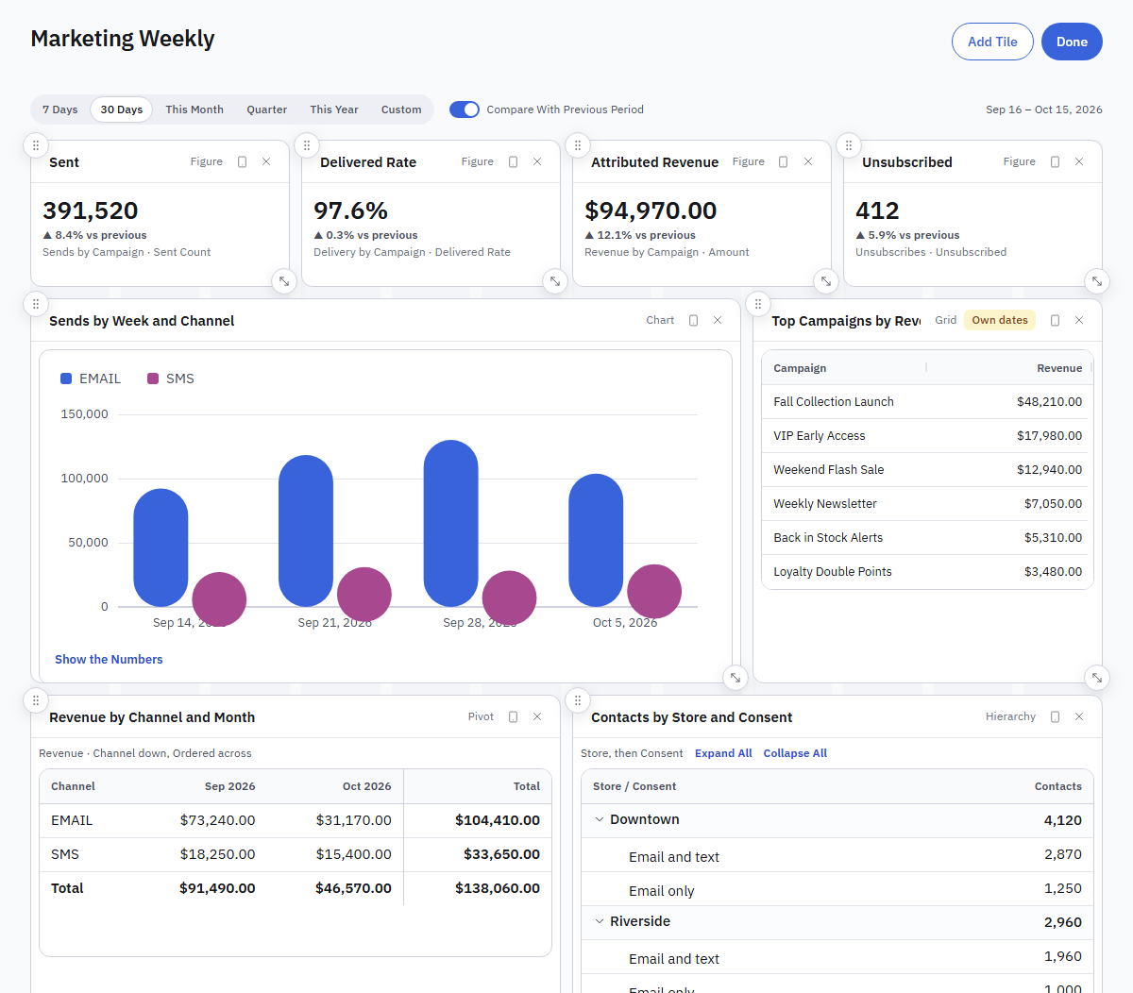
Figure 22. Free Canvas: drag a tile by its grip to move it and by its handle to resize it.
- Edit the dashboard and choose Free Canvas above the tiles. The rows become places on a 12-column grid, as they were.
- Drag a tile by its grip (top left) to move it, and by its handle (bottom right) to resize it. With the keyboard, focus the grip and use the arrow keys to move, or Shift and the arrows (or the handle) to resize. Tiles may overlap; the later one sits on top.
- Each page has its own layout. Rows turns a canvas back into rows, read top to bottom.
- Press Done to save.

See and shape the phone layout
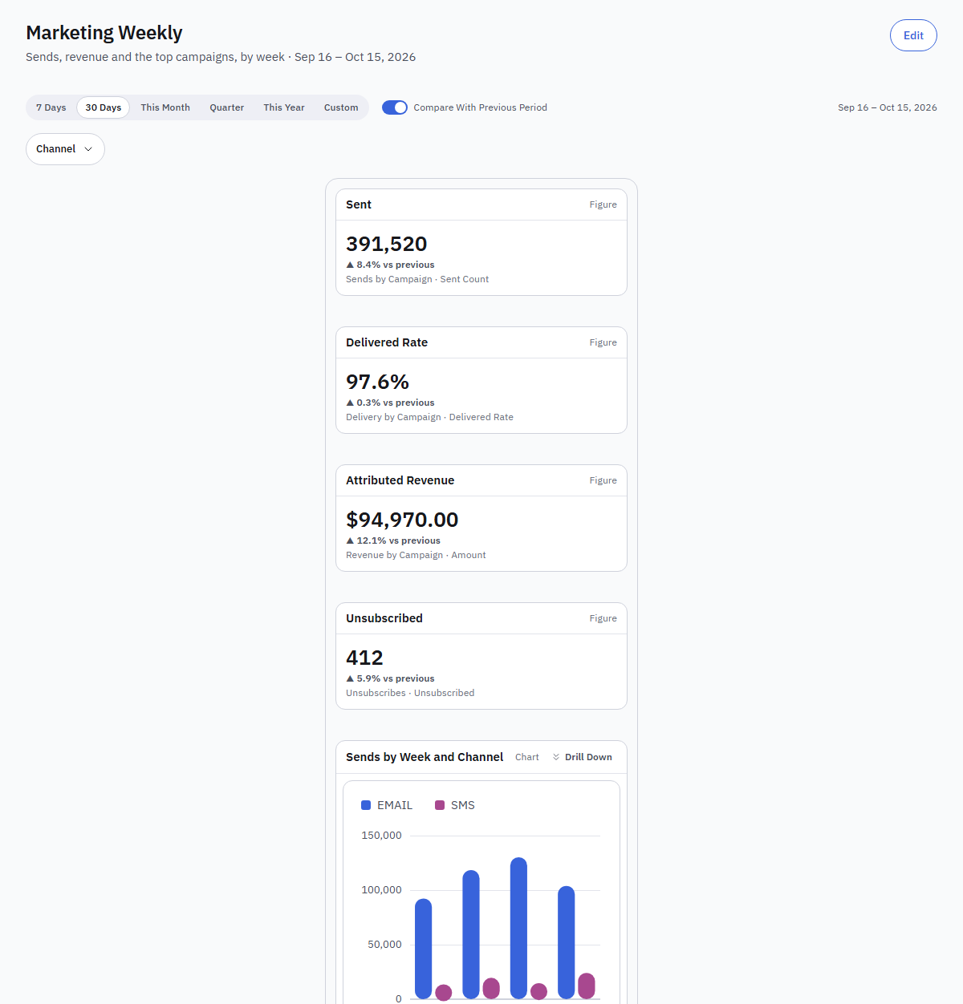
Figure 23. The phone layout: the tiles stacked top to bottom, tiles hidden on a phone left out.
- On a canvas page, press Phone Preview: the tiles stack top to bottom as a phone shows them.
- Press a tile's phone icon to leave it out on a phone (Hide on Phone); the preview says how many are hidden.
- On a narrow screen, every dashboard on a canvas reads this way. Rows stack on their own.

Give a dashboard a theme
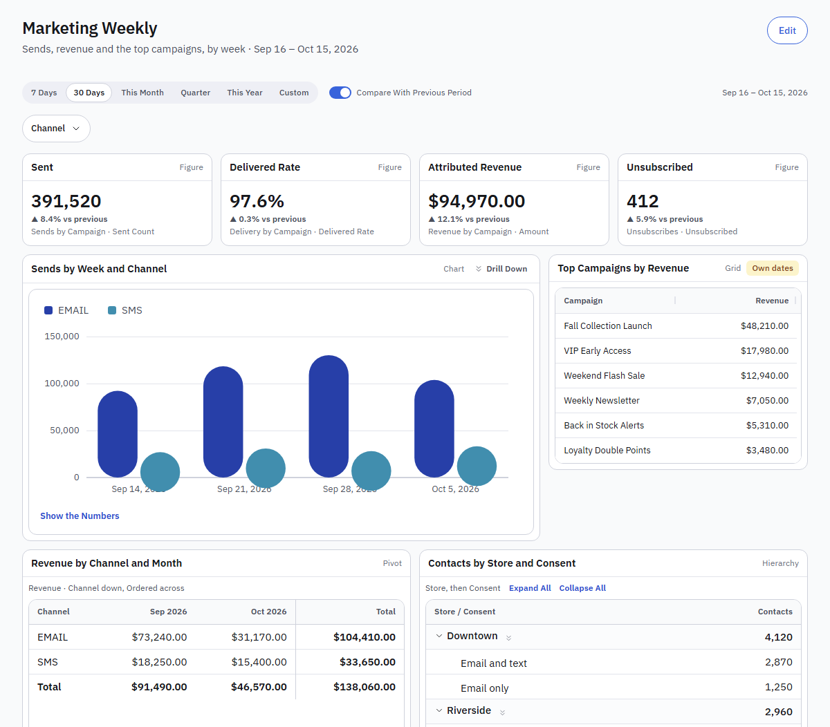
Figure 24. The Navy theme: every chart on the dashboard takes its colours.
- Edit the dashboard and choose a Theme: Classic, Navy, Earth, Berry or Greyscale.
- The theme sets the colours of every chart on the dashboard, in the viewer, in an embed link and in the editor. The PDF and PowerPoint keep the classic colours.

Add text to a dashboard
- Edit the dashboard and press Add Text.
- Give it an optional Title and the Text: a blank line starts a paragraph, a line starting with - is a bullet, and words between two stars on each side are bold.
- Press Add to Dashboard. Its pencil changes the words later. The text shows in the PDF and PowerPoint too.

Add a button that opens a saved view, a page or a report
- Save the view first if the button should open one (Views → Save the Current View).
- Edit the dashboard, press Add Button, give it a Label, choose When Pressed (Open a Saved View, Go to a Page or Open a Report) and which one.
- Press Add to Dashboard. In the viewer, pressing the button applies the view, opens the page or opens the report.

Add a written summary to a dashboard
- Edit the dashboard, press Add Tile, pick a report and choose Written Summary.
- When the dashboard opens, the tile shows a few sentences from AI on the report's rows for the period, with the main points. It needs the workspace's Explain This Report switch (Settings → AI Assistant).
- A summary counts as one prompt and is kept for six hours for the same period and slicers, so opening the dashboard again costs nothing. The PDF carries the kept summary; an embed link does not write one.

PART 8

AI Features
Reports from a sentence, explanations of a report, and changes to a report in words. Each is there once your platform offers an AI provider and your workspace allows it.

Ask for a Report
Who: Anyone who can build reports
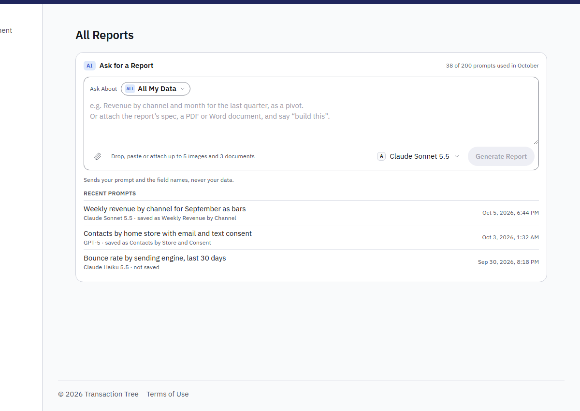
Figure 25. Ask for a Report above the report list, with the model to use and your recent prompts.
- Open Insights → Reports. The Ask for a Report box sits above the list; it is there once your platform has switched on an AI provider and your workspace allows it.
- Choose what the prompt is about with Ask About at the top of the box: All My Data, the platform's datasets (C360), one of your Report Databases, or your Uploaded Files. The model then reads only those fields, so its answers are sharper. Your choice is remembered.
- Write what you want to see in your own words, pick a model at the bottom of the box, and press Generate Report (or Ctrl+Enter).
- Read what comes back. A draft: check its name, view, data, rows, columns, values and filter, then Open in Editor to make it a private report of yours and open the editor. One question first: press the answer that fits; answering does not cost a prompt. No field for this: pick one of the closest prompts, or ask your platform team to map the data.
- Your recent prompts sit under the box, each with the report it became. The line at the top right counts the month's prompts against your plan; only a draft counts.

Add a spec or images to a prompt
Who: Anyone who can build reports
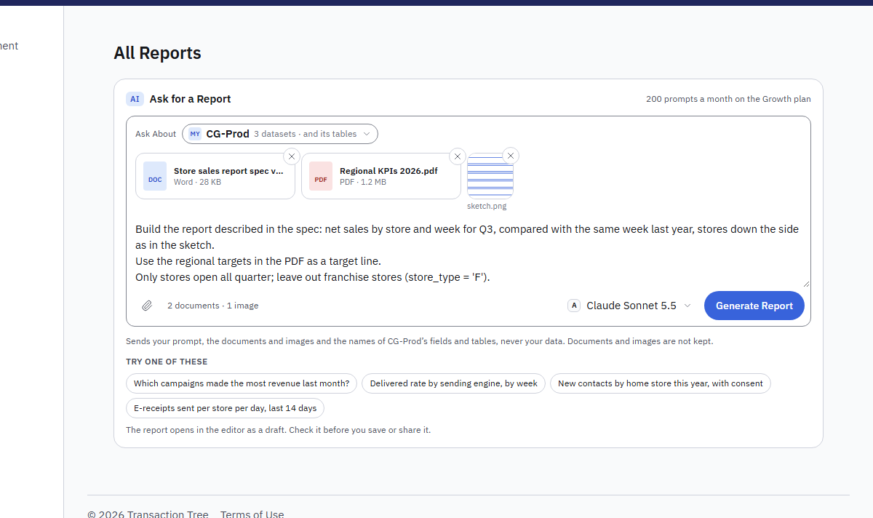
Figure 26. A Word spec, a PDF and a sketch attached to a prompt, on CG-Prod. They go to the model with the prompt and are not kept.
- In Insights → Reports, write your prompt in the Ask for a Report box. Say what the files are for: "Build the report described in the spec", "A chart like this sketch, by month", "Use the targets in the PDF".
- Add up to three documents (the report's spec as a PDF, a Word .docx, a text or a Markdown file) and up to five images (PNG, JPEG, GIF or WebP), whichever way is handiest: drag them from your computer onto the Ask for a Report panel and let go when the box shows Drop images or documents here; or press the paperclip at the bottom left of the box and choose the files; or copy an image, such as a screenshot, and paste it into the box with Ctrl+V.
- Check the attachments at the top of the box: each document as a tile with its kind and size, each image as a thumbnail. The line beside the paperclip says how many there are ("2 documents · 1 image"); remove one with its ✕. A fourth document or a sixth image is left out with a note under the box.
- Press Generate Report (or Ctrl+Enter). The documents and images go to the model with your prompt and the field names. They stay in the box, so Try Again sends them again. The draft's top line says what the model read.
A document may be up to 10 MB, PDFs up to 100 pages together, and the documents and images up to 20 MB together. An old Word file (.doc) needs saving as .docx first. A large image is scaled down in your browser before it is sent. Another kind of file is refused with a note under the box. Documents and images are not kept: only your prompt is saved with the draft. The prompt itself may run to 100,000 characters (about 25,000 words); the counter under the box appears from 90,000. A longer spec goes in as a document.

Ask about a database's tables not mapped yet
Who: Anyone who can build reports
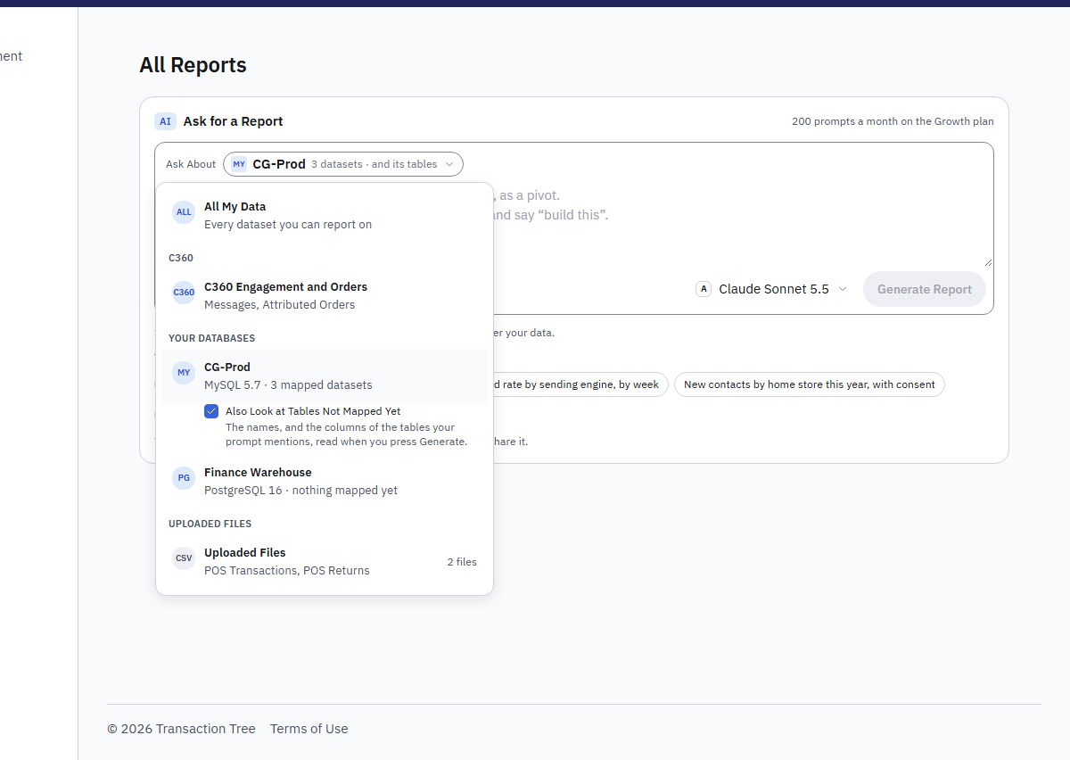
Figure 27. Ask About: all your data, the platform's datasets, each database (with its tables not mapped yet) and the uploaded files.
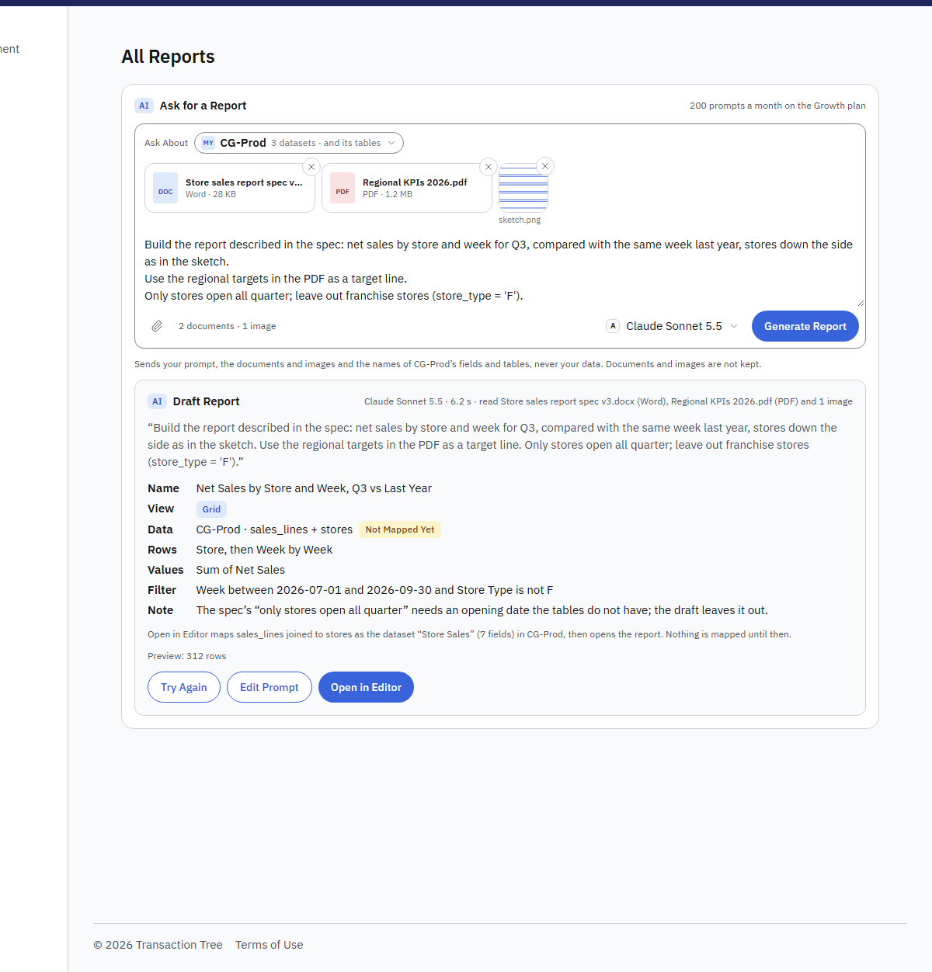
Figure 28. A draft on tables not mapped yet: Open in Editor maps them as a dataset first. The top line says what the model read.
- In the Ask for a Report box, open Ask About and pick one of your Report Databases.
- Under it, keep Also Look at Tables Not Mapped Yet ticked (it is by default). The model is then told the names of the database's tables and, when you press Generate, given the columns of the tables your prompt or its documents name (up to 20). It may ask for more tables' columns once. Nothing is stored.
- Name the tables you mean when you know them: "Net sales from sales_lines joined to stores, by store and week".
- A draft on such tables says Not Mapped Yet beside its data, with the tables it joins. Open in Editor maps them as a dataset with the fields the report needs (as Map a Dataset would), then opens the report. Until then nothing is mapped. Your administrator can rename the dataset's fields later under Settings → Report Databases.

Use AI in your workspace
Who: Workspace administrator
- Open Settings → AI Assistant. Use AI in Reports is on by default; switch it off to hide every AI feature and keep every prompt inside CEP.
- For each provider, allow or disallow it with its switch, or press Use Your Own Key (or Add Your Own Key when the platform does not offer it) to enter the workspace's own key and the two models, then Check Connection. The workspace's key wins over the platform's, and prompts on it are not counted against the plan.
- Explain This Report decides whether a report's totals may be sent to the model; personal-data fields are never sent.
- AI Prompts This Month shows the count against the plan.
Write It for Me in the query window is described in Part 6, Build a report from a query.

Explain This Report, with AI
- Open a report and press Explain. The button is there when the platform allows it and the workspace's Explain This Report switch is on (Settings → AI Assistant).
- A panel above the rows says what they show in a few sentences, with the main points and what the rows cannot tell. The model reads the report's name, its columns and up to 100 of the rows you see; masked personal data is left out.
- Each explanation counts as one prompt. Check the figures before you act on them.

Change a report with a prompt, with AI
- In the editor, write the change in the box above the result, such as "by channel only, as a bar chart" or "only email, last 30 days", and press Change.
- The editor shows the changed report at once, not saved yet. Undo puts the one before back; Save keeps it as a new version.
- The model reads the dataset's fields and the report, never rows. A change counts as one prompt; a question back or "no field for this" does not.

PART 9

Sharing, Delivery and Exports
Who sees what, links for other sites, comments, alerts, scheduled emails and every file a report can become.

Share a report or a dashboard
- Open it and press Share (the owner, or a report administrator).
- Choose who can open it: You and the people and roles below, or Everyone in the workspace.
- Find a person or a role and add them. Give each Can View or Can Edit; Can Edit lets someone who builds reports change it. A role reaches everyone holding it.
- Press Save. The list shows a private report as shared.

Limit what a person sees (Report Access)
- Open Settings → Report Access (report administrators).
- Press Add a Rule, find the person or the role, choose the dataset and the field (such as Store), and write the values they may see, one per line.
- Press Add Rule. From then on, every report, dashboard, export and delivery on that dataset shows them only those rows, and the viewer tells them so.
- Edit changes the values; Remove lets them see every row again. People without a rule see every row of what they can open.

Embed a report or a dashboard on another site
- Open it. For a report, choose More actions → Embed on Another Site; for a dashboard, press Embed (its owner, or a report administrator).
- Add a label for where it goes, choose when it expires, and press Make a Link.
- Copy the Address, or the Code to paste into a page (an iframe). The link is shown only once.
- Anyone with the link sees the item read-only, without signing in, as you see it: your row access rules apply and personal data is always masked. Revoke stops a link at once.

Comment on a report or a dashboard, and pin a note to a value
- Open the report or dashboard and press Comments. Write in the box at the bottom and press Add Comment.
- To pin a note to a value, right-click it on a chart or a table and choose Comment on This Value. The chart then marks that value, and hovering it shows the note.
- On a dashboard, a tile's speech-bubble icon opens comments on that tile, with the count beside it.
- Resolve puts a thread among the resolved; Open again brings it back. You change or delete your own comments; the owner and report administrators delete any.

Get an email when a value crosses a threshold (Alerts)
- Open the report and press Alerts.
- Under New Alert, choose the value (When), the Condition (falls below, is at or below, rises above, is at or above) and the Threshold. For a percentage, 90 means 90%.
- Choose Check: Every Day at a time, or Every Hour. Add the addresses to email (people without the right to build reports alert themselves only), and an optional name. Press Set Alert.
- The value is the report's value over its own filters. When it crosses the threshold you get one email; you are emailed again only after it goes back and crosses again.
- Check Now reads the value at once. Pause, Resume and Delete are on each alert; Insights → Scheduled lists all your alerts.

Email a Report on a Schedule
Who: Anyone who can build reports
Press Schedule on a report or a dashboard:
Field | Meaning
Every | Day, Weekday, Week (on a day) or Month (on a day of the month, 1 to 28).
At | The time, in the workspace's time zone.
Send as | Excel, CSV or PDF for a report; a dashboard goes as PDF.
To | Up to twenty addresses; Enter, a comma or a space adds one.
Subject | Optional. {date} becomes the sending date. Empty: the report's name and the date.
Note | Optional, at the top of the email.

The email goes out through the workspace's own mail server (Settings → Email Server; a workspace without one cannot schedule), built at the moment of sending with the rights and masking of whoever scheduled it, the file attached. Under the title the schedule line shows what, when, to how many, the last sending and the next, with Change and Pause. Send a Test Now, on a saved schedule, sends the email to you at once. Insights → Scheduled lists every schedule you may see, with Pause, Resume and Delete. Three failures in a row pause a schedule; Resume starts it again.

Export to PowerPoint
- For a report, open More actions (the three dots) and choose Export PowerPoint. For a dashboard, press Export PowerPoint.
- The deck has a cover, then a slide per tile (or for the report's view): bars, lines, areas, stacks, pies and funnels as charts you can edit in PowerPoint, figures as large numbers, text and summaries as words, other views as tables.
- A schedule can send PowerPoint too: choose it under Send as.

Print a report on numbered pages (Print-Ready PDF)
- Open the report, open More actions and choose Print-Ready PDF.
- Choose the Paper (A4 or Letter) and the Orientation. Tick A section per the first field to start each value on a new page with its subtotals.
- Press Download PDF: every row (up to 20,000), the header row on each page, the filters on the first page, and Page 3 of 12 at the foot of each page.

PART 10

Administration and Troubleshooting
What people open, every run, how fresh the data is, and what the messages mean.

See what people open (Usage)
- Open Insights → Usage (report administrators).
- Choose 7, 30 or 90 days. Most Opened and Who Opens the Most rank the reports, dashboards and people; the table gives each item's openings, people, openings through embed links and when it was last opened.
- Reports Nobody Opened lists the reports no one opened in the period: candidates to tidy away. Opening the same item again within ten minutes counts once.

The Run Log
Insights → Run Log, for report administrators: every preview, run, export and delivery of the last 7 or 30 days, with the report and its version, the kind, who, the outcome with its reason when it is not OK, the rows and the time, filterable by outcome, person and report name, with a summary of the period.

How Fresh Is the Data
The line under a report's title says it. Live data: the report reads the workspace's database as it is. Data as of the last quarter hour: the workspace reports on the analytics engine, which the platform team loads from the database every fifteen minutes; new sends show on the next load. The platform team decides which engine a workspace is on; the pages and the figures are the same either way.

When Something Does Not Run
Message | What it means
The report took longer than 15 seconds and was stopped | Narrow it with a filter or a shorter period.
X is personal data: building a report on it needs the report administration right | Ask an administrator to build that part, or to grant the right.
This workspace's reports are moving to a new engine | The platform team is switching the engine; try again shortly.
This workspace has no mail server yet | Set one up under Settings → Email Server before scheduling.
Insights is not part of this workspace | Ask the platform team to switch the component on.

