About this template
This is a sample release document for the iCRM Release Notes site. Upload it as-is to see how it looks, or copy it for a new release. Everything in this blue section is ignored by the upload, up to the release title below.
Required (the upload won't work without these)
- The version number in the title, for example “iCRM Release 11.1”.
- At least one change, as a bullet under a heading such as What’s New, Improvements, Bug Fixes or Security, or as a row in the Jira table.
Optional
- Status and planned date: “Status: Coming soon” and “Planned release: October 2026” for a release that hasn’t shipped. For a shipped release, write “Status: Released” and “Released on October 15, 2026” instead.
- A summary paragraph straight after the status lines.
- Highlights, Known issues and Upgrade notes sections: one bullet each.
- A Jira ID at the start of a change (CT-363, CS-6421…) becomes a link to Jira. Bold text at the start becomes the title; the rest becomes the description. Indented bullets are extra detail.
- Screenshots: Insert → Pictures. A picture straight after a change belongs to that change; pictures under Screenshots go into the release’s gallery. Put a line starting “Screenshot:” under a picture for its caption. PNG or JPEG, up to 5 MB each.
- A Jira list table with the columns Jira, Category, Title and Description.
After uploading you can correct anything in the preview before publishing. Tip: publish an upcoming release with “Mark as the latest release” switched off, then upload it again with Status: Released when it ships.
Section | Required? | What goes in it
Title with version | Required | iCRM Release 11.1
Changes | At least one | Bullets under What’s New / Improvements / Bug Fixes / Security, or Jira table rows
Status, planned date | Optional | Status: Coming soon · Planned release: October 2026
Summary | Optional | One paragraph about the release
Highlights | Optional | 3–5 short points shown at the top
Known issues | Optional | Problems readers should know about
Upgrade notes | Optional | Steps to take before or after upgrading
Screenshots | Optional | Pictures for the release gallery

iCRM Release 11.1
Status: Coming soon
Planned release: October 2026
iCRM 11.1 is planned for October 2026. It brings Citi Custom Field and Loyalty enhancements, layaway and campaign improvements, production stability fixes, and a new release notes site with sign-in, Jira access control and an audit log.

Highlights
- Release notes for every iCRM version on one page, with search, filters and screenshots.
- Citi Custom Field API gains searchGroup support and clear error codes.
- Fix for updateCustomerB returning E112 on first email pushes.
- Jira details are limited to admins and approved users, and every view is audited.

What’s New
- iCRM Release Notes site – Release notes for every version on one page, with a version list, search and filters by type.
  - Each change links to its Jira ticket and can include screenshots. Admins publish new releases from a Word document like this one.
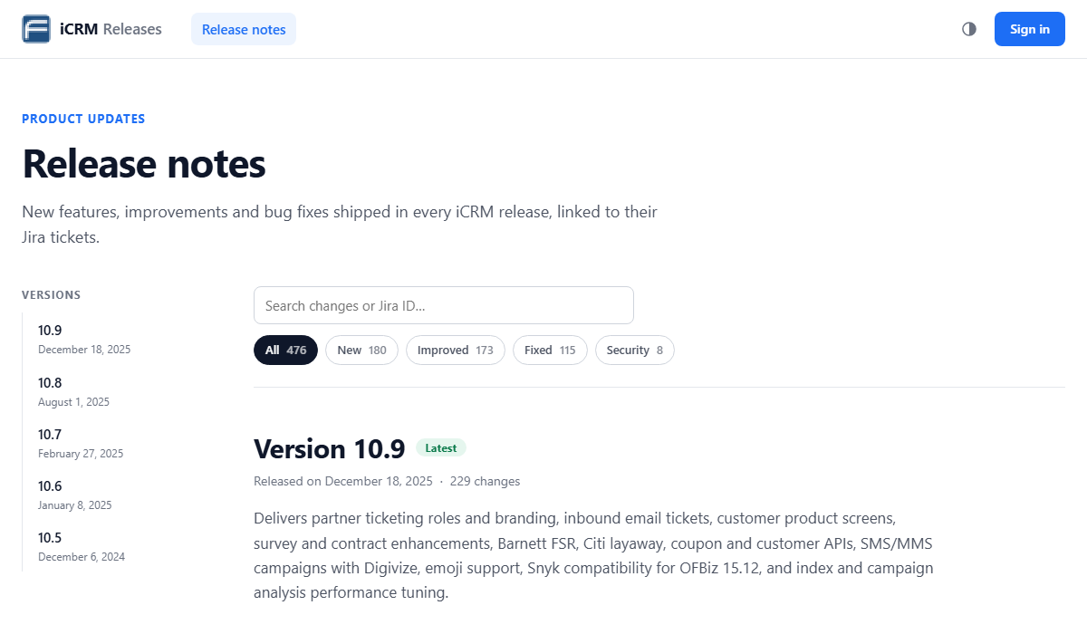
Screenshot: Release notes with the version list, search and type filters
- Choose your background colour – Each person can choose a white, black or any custom background; text adjusts automatically.
  - The choice is saved in each person’s browser, so everyone can use the look they prefer.
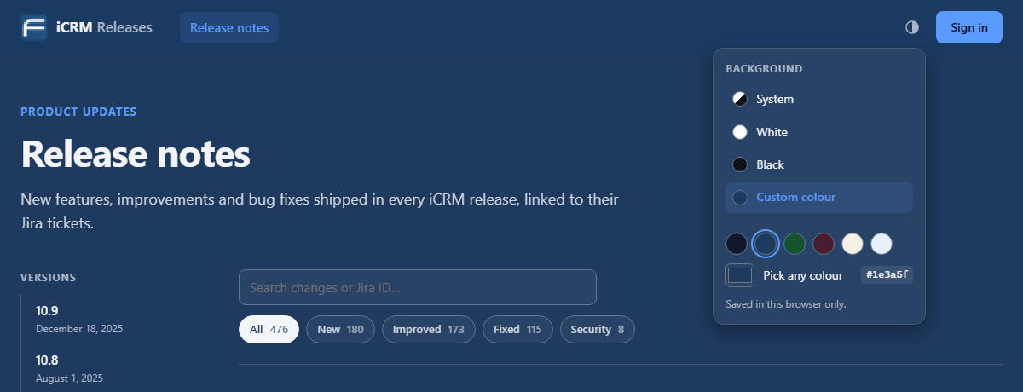
Screenshot: The background picker with preset and custom colours
- CT-363: Citi – Custom Field API: searchGroup and error codes for custom fields
  - The Custom Field API used by Citi can now look up custom fields by group (searchGroup). Requests that can’t be completed return specific error codes, so calling systems can tell what went wrong.
- CT-381: Citi – Loyalty ID generation logic for loyalty customers
  - Changes how loyalty IDs are generated for Citi loyalty customers, following the logic confirmed with the client. New loyalty customers receive IDs created with the updated logic.
- CT-378: Seed data for Custom Field terms and conditions
  - Adds the seed data that sets up terms and conditions as custom fields. New and upgraded environments get this set-up automatically.

Improvements
- CS-6429: OFBiz visit, visitor and server-hit statistics turned off on all environments
  - Stops these tables growing (about 152 GB on one server). Waiting for sign-off.

Bug Fixes
- CT-377: updateCustomerB no longer returns E112 on first email pushes (duplicate PARTY_CONTACT_MECH_PURPOSE key)
  - In Citi production, updateCustomerB returned error E112 on about 47% of first-time email pushes because a duplicate PARTY_CONTACT_MECH_PURPOSE key was created. The customer’s first email is now saved without the error.
- INKT-116: Citi – Custom Field API logging issue
  - Fixes a logging problem in the Citi Custom Field API, so its requests are recorded correctly in the API logs. This helps support teams trace Custom Field API calls.
- CS-6421: PB – crash loop and worker-pool stall
  - A fix is planned for a PB production problem where iCRM went into a crash loop and all worker threads stalled. The problem recurred after 7 September 2026 and has been confirmed with a thread dump.

Security
- Jira access control – Only admins and people an admin approves in Settings can open Jira issues.
  - Every sign-in and every Jira issue viewed is recorded in the audit log, with the time and IP address.
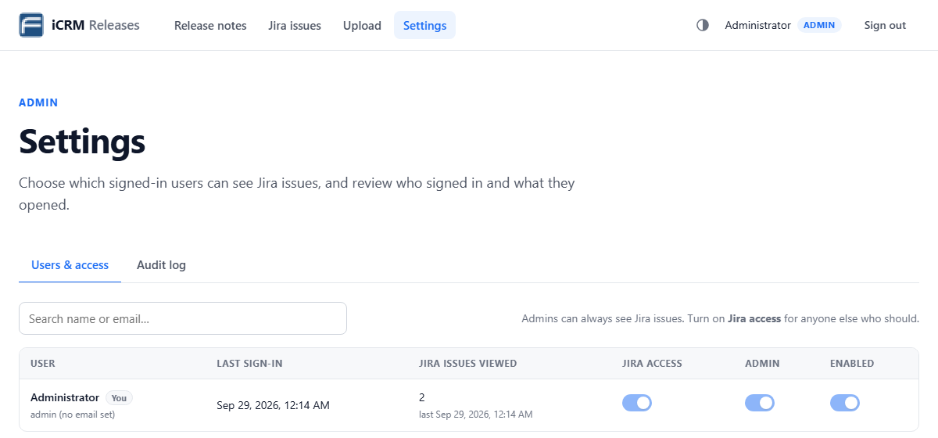
Screenshot: Settings → Users & access: Jira, admin and enabled switches per person
- CT-373: Loyalty – flag eligibility terms-and-conditions check can no longer be bypassed
  - Closes a gap that allowed the terms-and-conditions check for loyalty flag eligibility to be bypassed. The check now has to be met before a customer is flagged for loyalty.

Jira list
Jira | Category | Title | Description
CS-6267 | New | Campaign start and end dates in the call record master | The campaign’s start and end dates are now stored with each call record in the call record master, so every call record shows the campaign period it belongs to.
CT-374 | Improvement | Layaway – UX corrections | Corrects user-experience issues on the Layaway screens, so layaway information is easier to read and use.
IBP-1706 | Improvement | Sonar – code quality issues fixed | Fixes code-quality issues reported by SonarQube, which lowers maintenance risk and keeps the code within the project’s quality rules.

Known issues
- The October 2026 date is a plan and may change; this page is updated when 11.1 ships.
- CS-6429 is waiting for sign-off. If it isn’t approved, the OFBiz statistics stay switched on.

Upgrade notes
- Run the release-11.1 SQL group scripts (sql_group repository) before starting the new build.
- Load the CT-378 seed data before using Custom Field terms and conditions.
- Sign-in to the release notes site now uses email. Accounts without an email keep signing in with their username until one is set.

Screenshots
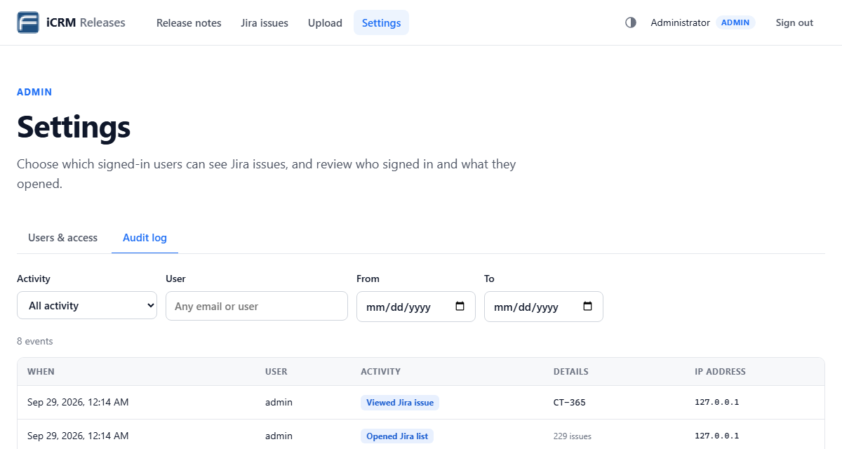
Screenshot: Settings → Audit log: sign-ins and Jira views with time and IP address

