Arabian Kitchen
Sales & Operations — Analysis and Recommendations
Prepared by Bharathy S · Data Analyst · Chennai
Self-initiated case study — independent project, not a real client engagement.

Executive Summary
This report analyzes 18 months of order-level data (March 2025 – August 2026) for Arabian Kitchen, a simulated Middle Eastern restaurant in Chennai serving dine-in, takeaway, and delivery customers. The dataset was cleaned from ~80,000 raw records down to 79,052 valid sales transactions, then analyzed for demand patterns, revenue drivers, and menu profitability.
₹2.28 Cr  Total revenue | 39,547  Total orders | 12:00 PM  Peak hour | Delivery (50%)  Top channel

Sales Patterns
Weekend revenue (Friday–Sunday) runs roughly 80% higher than weekday revenue, driven by both higher order volume and larger group orders. Lunch hour (12:00 PM) is the single highest-revenue hour of the day, ahead of the dinner window — a detail worth reflecting in staffing schedules.
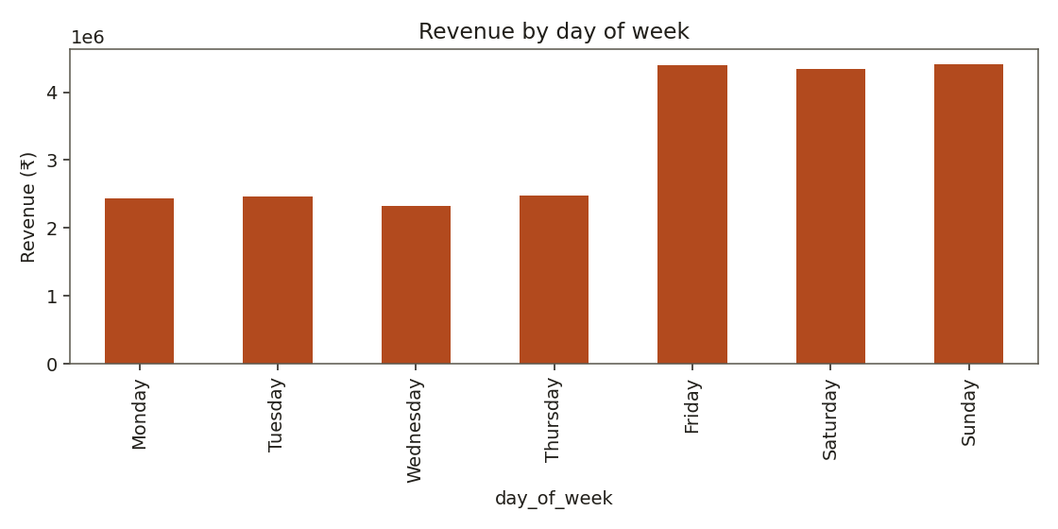
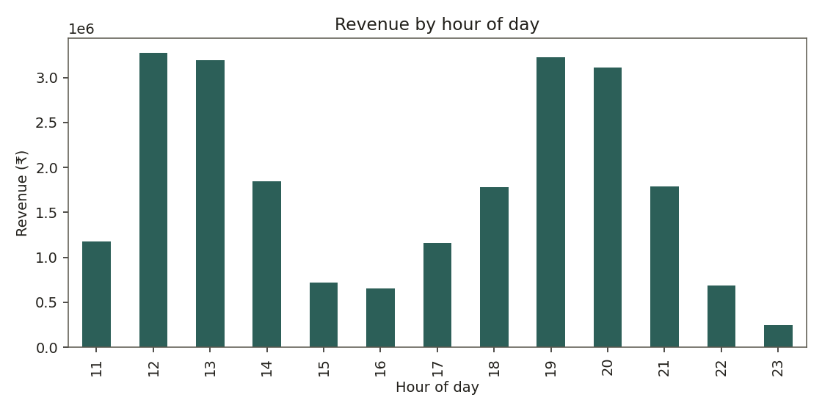

Order Channel Mix
Delivery accounts for just over half of total revenue (50.2%), split roughly evenly between Swiggy and Zomato, with a small share coming through direct/phone orders. Dine-in contributes 35%, and takeaway the remaining 15%.
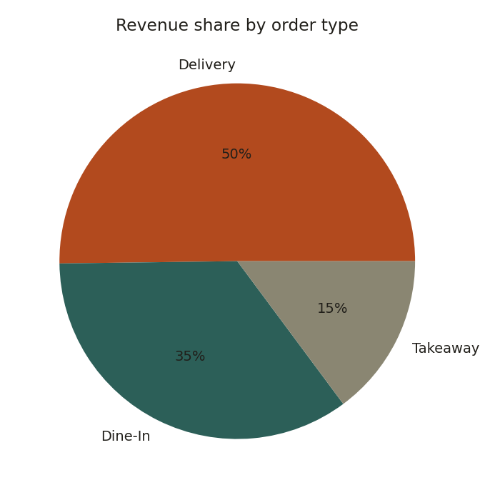

Menu Engineering: What to Promote vs. Drop
Each menu item was classified using the standard restaurant menu-engineering framework — popularity (units sold) against estimated contribution margin per unit — into four groups:
- Stars — high popularity, high margin: protect and promote, never discount
- Plowhorses — high popularity, thin margin: candidates for a small price increase
- Puzzles — high margin, underordered: reposition on the menu or push via staff recommendations
- Dogs — low popularity, low margin: candidates to simplify, rework, or drop

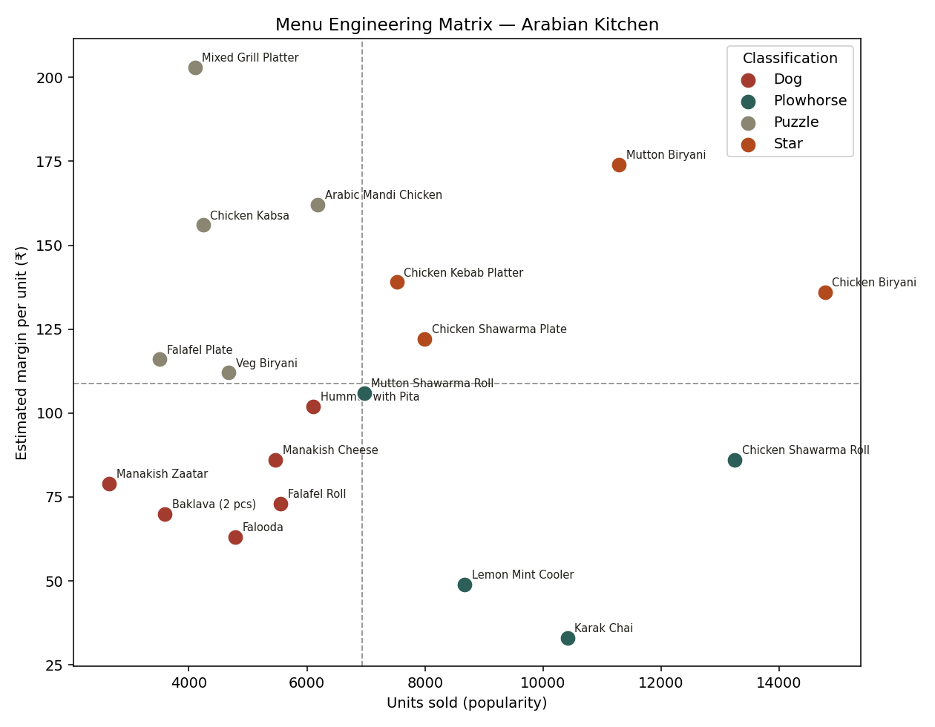

Item | Classification | Units sold | Est. margin/unit
Chicken Biryani | Star | 14772 | ₹136
Mutton Biryani | Star | 11282 | ₹174
Chicken Kebab Platter | Star | 7522 | ₹139
Chicken Shawarma Plate | Star | 7990 | ₹122
Chicken Shawarma Roll | Plowhorse | 13250 | ₹86
Mutton Shawarma Roll | Plowhorse | 6969 | ₹106
Lemon Mint Cooler | Plowhorse | 8672 | ₹49
Karak Chai | Plowhorse | 10413 | ₹33
Arabic Mandi Chicken | Puzzle | 6185 | ₹162
Mixed Grill Platter | Puzzle | 4102 | ₹203
Chicken Kabsa | Puzzle | 4241 | ₹156
Veg Biryani | Puzzle | 4672 | ₹112
Falafel Plate | Puzzle | 3502 | ₹116
Hummus with Pita | Dog | 6110 | ₹102
Manakish Cheese | Dog | 5465 | ₹86
Falafel Roll | Dog | 5552 | ₹73
Falooda | Dog | 4791 | ₹63
Baklava (2 pcs) | Dog | 3593 | ₹70
Manakish Zaatar | Dog | 2651 | ₹79

Recommendations
- Protect the four Star items (Chicken Biryani, Mutton Biryani, Chicken Kebab Platter, Chicken Shawarma Plate) — they drive the bulk of profit and should stay prominent on the menu without discounting.
- Consider a modest price increase on Plowhorse items, especially Chicken Shawarma Roll and Karak Chai — both sell in very high volume but carry thin margins, so demand is likely to absorb a small price move.
- Give Puzzle items better placement or staff recommendations — Mixed Grill Platter and Arabic Mandi Chicken carry the highest margins on the menu but are comparatively underordered; a menu redesign or upsell script could meaningfully lift profit with little added cost.
- Review the Dog items (Manakish Zaatar, Baklava, Falooda, Falafel Roll) for simplification — either rework the recipe/cost, bundle with a Star item, or phase out to streamline kitchen operations.
- Shift toward digital payments — cash still leads payment mode over UPI and card, which is unusual for a delivery-heavy business; encouraging UPI/card adoption would simplify reconciliation.
- Align staffing with the lunch peak (12:00 PM) and weekend surge (Fri–Sun) rather than assuming dinner is the busiest period.

Next Steps
This analysis is based on a simulated dataset built to mirror realistic restaurant operations. Fine-tuning is still in progress — planned next steps include refining the interactive dashboard, validating the food-cost assumptions used for margin estimates, and expanding the analysis to cover customer repeat-order behavior.

