SEE THE WORK.
UNDERSTAND THE AGENT.
A real-time, interactive workspace that makes coding-assistant activity visible.

THE PRODUCT IN ONE SENTENCE
A local-first developer tool that turns the observable activity of AI coding assistants into a live, navigable visual environment—showing what the agent is doing, which parts of the codebase it is touching, what has changed, what is waiting, and what needs human attention.

Initial assistants: Claude Code • OpenAI Codex • GitHub Copilot
Product concept brief | Version 1.0 | 29 October 2026

1. Executive summary
AI coding assistants can plan, inspect files, invoke tools, edit code, run tests, and iterate quickly. Yet the developer often experiences this work through a scrolling transcript, scattered terminal output, tool-call logs, and a final summary. The activity is visible in fragments, but its relationship to the repository and the task is difficult to understand at a glance.
The proposed product—working name: Agent Activity Visualizer—adds a live visual layer to these workflows. Instead of presenting the agent as a black box or merely decorating its transcript, it maps observable events to meaningful areas of a software workspace: repository exploration, planning, implementation, testing, debugging, dependency work, and review. Selecting an area opens a detailed drill-through panel with the underlying events, affected files, commands, test results, timestamps, and evidence.
CORE PRODUCT PRINCIPLE
Visualize evidence of work, not imagined internal thoughts. The system should distinguish observed events, inferred activity, and unavailable information so the experience is useful without pretending to expose hidden reasoning.

2. The problem

What developers experience today
- Low situational awareness: it can be hard to tell whether an assistant is planning, reading files, editing, testing, or stuck.
- Fragmented context: task instructions, terminal commands, file changes, test output, and approvals may live in different places.
- Weak progress signals: a spinner or high-level status does not explain what has actually changed or what remains.
- Expensive debugging: when an agent loops, fails, or makes an unexpected edit, reconstructing the sequence takes time.
- Limited trust and oversight: developers need a clear view of consequential actions without having to inspect every log manually.

The opportunity
Create a shared visual operating picture for human-plus-agent development. The product should help developers answer five questions quickly: What is happening now? Where is it happening? What evidence supports that status? What changed? What requires my attention?

3. Product vision and experience
The main interface is a live, gamified-but-professional map of a software project. It borrows the spatial clarity of a simulation dashboard: distinct zones represent work areas, and live labels or activity indicators show state and counts. The visual layer is interactive rather than decorative. Clicking a zone focuses the view and opens a detailed panel.

Example workspace zones
Zone | What it represents | Possible live signals
Task / Mission Control | Current user request and execution state | Task status, elapsed time, active phase
Repository Explorer | File discovery and code reading | Files opened, directories inspected, search queries
Planning Desk | Visible plan or task checklist | Plan items, completed steps, unresolved questions
Implementation Zone | File edits and generated changes | Files modified, diff size, last edit, change status
Test & Build Lab | Tests, lint, type checks, builds | Pass/fail counts, running command, duration
Debugging / Repair Bay | Failure investigation and retries | Failure event, related files, retry count
Dependencies & Tooling | Package managers and external tools | Install commands, tool calls, exit status
Human Approval Gate | Actions waiting for developer permission | Pending approval, risk category, requested action
Review / Delivery | Final diff, summary, and handoff | Changed files, checks completed, outstanding risks

Interaction model
- Live overview: see the current task, agent state, active work area, and recent events.
- Focus on selection: clicking a zone, file, command, test, or event zooms/focuses the relevant area.
- Drill-through details: inspect the event timeline, source evidence, file diffs, command output, and linked artifacts.
- Trace navigation: move from task → phase → event → file/command/test → resulting change.
- Time travel: pause the live feed and replay a session to understand how a result was reached.
- Attention cues: highlight failures, repeated retries, long-running commands, permission requests, and unreviewed changes.
- Accessible alternative: provide a searchable event list and conventional timeline so the visual map is never the only way to use the product.

4. Example user journey
- The developer starts a task in Claude Code, Codex, or Copilot and launches or connects the visualizer.
- The visualizer detects the session and displays a new task card with the assistant, repository, branch, and connection status.
- As observable events arrive, the overview updates: repository exploration lights up first, then implementation, then testing.
- The developer clicks the Implementation Zone and sees the files being changed, the latest diff summary, and a chronological event list.
- A test fails. The Test & Build Lab changes state, links to the failing command and output, and the Debugging Zone shows the subsequent investigation.
- A risky or approval-gated action is surfaced explicitly; the visualizer does not silently approve or execute it.
- When the assistant finishes, the Review area summarizes changed files, checks observed, unresolved failures, and actions the developer should verify.

5. Target users and jobs to be done
- Individual developers: understand progress without constantly reading terminal output.
- Power users of coding agents: diagnose loops, failed tool calls, repeated edits, and test regressions.
- Engineering leads and reviewers: inspect a session’s actions and outcomes during review or debugging.
- Teams adopting agentic workflows: build confidence through traceability and clear human-approval boundaries.
The first release should optimize for individual developers and fast local adoption. Team analytics, centralized session storage, and organization-level policy dashboards can come later, after the event model and trust model are proven.

6. Scope: first release versus later
First release (MVP) | Later candidates
- Local-first desktop or localhost web UI  - One canonical event schema for all integrations  - Initial adapters for Claude Code, Codex, and Copilot where supported by available hooks, logs, or extension APIs  - Live overview, event timeline, zone focus, searchable drill-through  - File activity and diffs, command lifecycle, test/build outcomes when observable  - Session replay from locally retained events  - Clear source labels: observed, inferred, unavailable  - Redaction controls and local data retention settings | - Multi-agent comparison and orchestration views  - Team collaboration and shared session playback  - Cross-session analytics and productivity metrics  - IDE-native 3D/2D immersive environments  - Custom zones and plug-in ecosystem  - Policy analytics and organization-wide governance  - Cloud synchronization and long-term storage (opt-in)  - Advanced anomaly detection and workflow recommendations

7. Integration strategy and feasibility
The product should not assume that every assistant exposes the same events or makes its internal reasoning available. Each integration needs a capability matrix and a tested adapter. Prefer documented, stable integration surfaces over scraping terminal text or relying on undocumented internals.
Assistant | Integration approach to investigate | Important constraint
Claude Code | Hooks, lifecycle events, supported CLI output/logging, filesystem and process events where permitted | Do not equate exposed hooks or transcripts with hidden model reasoning.
OpenAI Codex | Supported CLI/app event surfaces, logs, configuration, and available extension mechanisms | Validate the exact Codex product surface and version before committing to an adapter.
GitHub Copilot | Supported IDE extension APIs, agent/session events, terminal and workspace events where permitted | Copilot experiences differ by editor and mode; avoid assuming one universal event stream.

Recommended architecture
- Assistant adapters: translate provider-specific events into a stable internal event schema.
- Local event bus: normalize, timestamp, order, deduplicate, and correlate events to a task/session.
- Context collectors: optionally observe workspace changes, Git diffs, command exit codes, and test results; require explicit permissions and minimize collection.
- Session state engine: derive understandable phases such as exploring, editing, testing, waiting for approval, blocked, and completed.
- Visualization client: render the spatial map, activity indicators, timeline, details panel, filters, and replay controls.
- Local persistence: retain session metadata and events on-device by default, with configurable retention and export.
- Security layer: redact secrets, restrict collection to the selected workspace, and make integrations and permissions visible.

Canonical event model
Every adapter should map to a shared event shape. A practical initial model includes:
- event_id, session_id, task_id, timestamp, sequence_number
- source_assistant, adapter_version, event_type, lifecycle_status
- phase, actor (assistant / tool / user / system), and confidence/source_class
- resource references such as file path, command, test, URL, or tool name
- safe summary, structured payload, duration, exit status, and error category
- correlation IDs linking a command to its output, a test failure to a repair attempt, and an edit to its diff
- redaction metadata and links to locally stored evidence

8. Data truthfulness: observed versus inferred
This is a foundational design rule. A visual system can accidentally create false confidence by making a guessed state look like a directly observed fact. Every displayed signal should carry a source classification.
Class | Meaning | Example
Observed | Directly received from a supported event or verified local artifact | A command started; file X changed; test command exited with code 1.
Inferred | Derived from multiple signals and labeled as an estimate | Likely debugging phase based on a failed test followed by edits.
Unavailable | The provider does not expose the information or collection is disabled | Private internal reasoning or an unsupported tool event.
IMPORTANT PRODUCT BOUNDARY
The product should visualize observable actions, artifacts, state transitions, and carefully labeled inferences. It should not promise a complete view of a model’s private chain-of-thought or invent a narrative for missing events.

9. UX and visual design principles
- Spatial but legible: use a clear 2D/isometric map or modular workspace before attempting a heavy 3D environment.
- Motion communicates state: animate only when an event changes; avoid constant movement that obscures important information.
- Progress is evidence-based: counts and statuses must map to real events or be explicitly labeled estimates.
- Details on demand: the overview remains calm; deep technical detail appears after a click or keyboard selection.
- Consistent visual language: distinct zones, predictable state colors, text labels, icons, and accessible contrast.
- Fast escape hatch: searchable event log, keyboard navigation, filters, and a conventional timeline.
- Respect reduced motion and support smaller screens, screen readers, and high-contrast modes.

10. Privacy, security, and trust
- Local-first by default: session events and workspace metadata remain on the developer’s machine unless export or sync is explicitly enabled.
- Least privilege: observe only selected repositories and the minimum event surfaces needed for the feature.
- Secrets protection: redact tokens, credentials, environment values, and sensitive command arguments before display or persistence.
- Transparent collection: show what sources are connected, what is captured, and how long it is retained.
- No silent control: the visualizer should not approve commands, modify agent instructions, or take over execution in the MVP.
- Auditability: preserve timestamps, source labels, and links to evidence; do not rewrite an inference as a fact.
- Safe export: provide preview and redaction before sharing a session trace.

11. Success metrics
Area | Metric | Why it matters
Activation | Time from install to first live session | Measures ease of adoption.
Reliability | Event capture coverage by assistant and event type | Shows whether the visualization reflects reality.
Usefulness | Time to identify current phase, changed files, or a failure cause | Tests the core value proposition.
Engagement | Sessions viewed, drill-through usage, replay usage | Indicates whether the visual layer earns repeat use.
Trust | User-reported mismatches; percentage of inferred signals clearly labeled | Protects against misleading representations.
Performance | CPU/memory overhead and event-to-UI latency | Ensures it does not disrupt development.
Growth | Install-to-activation conversion and voluntary sharing/referrals | Supports a developer-led distribution strategy.

12. Key risks and mitigations
Uneven assistant integrations — Start with a capability matrix and implement adapters incrementally. Show degraded/partial visibility honestly.
False sense of transparency — Label observed, inferred, and unavailable states; never market the tool as revealing private model thoughts.
Visual novelty without practical value — Pair the environment with a strong timeline, diff viewer, failure details, and replay.
High implementation complexity — Build the event schema and one end-to-end adapter first; keep the renderer independent from providers.
Privacy concerns — Local-first storage, explicit source permissions, secret redaction, and retention controls from day one.
Too much noise — Aggregate repetitive events, surface meaningful transitions, and let users filter by phase, file, tool, and severity.
Provider changes break adapters — Version adapters, test against supported versions, and treat provider integration as a maintained compatibility layer.

13. Recommended build roadmap

Phase 0 — Validate
Prove that real events can be captured reliably.
- Inspect official and supported integration surfaces for each target assistant.
- Build a capability matrix: event types, reliability, version constraints, permissions, and gaps.
- Collect representative traces for normal, failed, interrupted, and approval-waiting sessions.

Phase 1 — Event foundation
Create the shared data contract.
- Define event schema, state machine, correlation rules, and source-confidence labels.
- Implement local event ingestion, redaction, persistence, and replay.
- Create adapter contract tests and synthetic event fixtures.

Phase 2 — First end-to-end slice
Deliver one useful live experience.
- Integrate the strongest-supported assistant first.
- Show task state, file changes, command lifecycle, and test outcomes where observable.
- Ship an overview, searchable timeline, details panel, and session replay.

Phase 3 — Spatial visual layer
Add the interactive environment.
- Map event categories to zones and live indicators.
- Implement click-to-focus and drill-through navigation.
- Validate that the map improves comprehension versus timeline-only UI.

Phase 4 — Expand integrations
Broaden compatibility without changing the core model.
- Add remaining assistant adapters based on verified supported surfaces.
- Expose capability differences and partial coverage in the UI.
- Publish integration tests and a compatibility matrix.

Phase 5 — Polish and adoption
Make it safe and easy to keep using.
- Add onboarding, privacy controls, redaction preview, accessibility, performance budgets, and issue reporting.
- Package the app and document installation, troubleshooting, and supported versions.
- Measure activation and real task-comprehension improvements.

14. Product decisions to make early
- Form factor: localhost web application, desktop shell, or IDE extension. Recommended: local web UI for the first prototype, with a thin local collector.
- First adapter: choose based on verified event access and quality, not brand popularity alone.
- Visual metaphor: start with a 2D/isometric workspace; validate comprehension before investing in richer 3D rendering.
- Collection boundaries: decide exactly which file, process, command, and output data is captured and how secrets are redacted.
- Session identity: define how a user attaches to the correct assistant run and handles multiple concurrent sessions.
- Evidence retention: choose a local retention policy and a safe, user-controlled export format.

15. Initial acceptance criteria
- A developer can install and launch the visualizer without configuring a hosted backend.
- The UI clearly identifies the connected assistant, repository, and active session.
- Incoming events appear in a timestamped timeline with source labels and sensible ordering.
- The current phase is derived from documented rules and can be inspected.
- Selecting a zone or event opens the underlying details and associated evidence.
- File changes and test outcomes are shown only when confirmed by captured events or local artifacts.
- The session can be paused, filtered, searched, and replayed.
- Missing event coverage is visible; the UI does not imply that unobserved work did not occur.
- Secrets are redacted according to documented rules, and local retention is configurable.
- The visualizer does not execute or approve agent actions in the MVP.

16. Closing perspective
The strongest version of this idea is not simply a cute animated map of an AI agent. It is an observability and interaction layer for agentic software development: visual enough to understand at a glance, technical enough to investigate failures, and honest enough to earn developer trust.
The strategic advantage will come from the event model, integration quality, traceability, and interaction design—not from the isometric environment alone. Build the reliable event pipeline first, then let the visual world become the most memorable way to explore that evidence.

Appendix A. Visual references supplied with the concept
These images are treated as experience references rather than specifications. The first suggests a clean, illustrated workspace; the second demonstrates the more important interaction pattern: a spatial environment with named areas, live status labels, and drill-through potential.
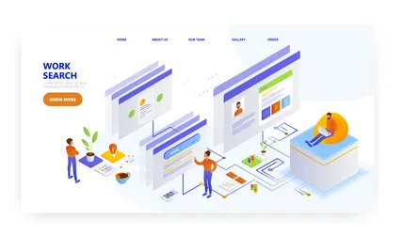
Reference 1 — Clean illustrated workspace and simplified navigation.
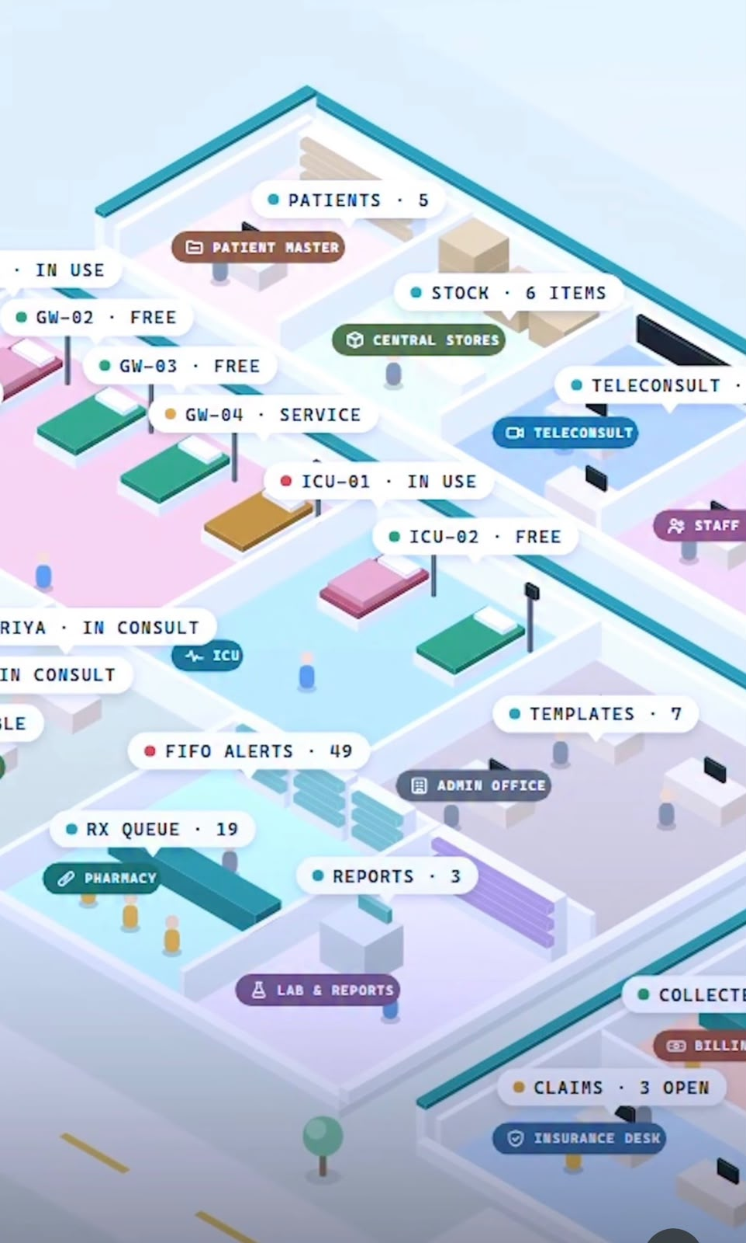
Reference 2 — Spatial operations map with live labels and domain-specific zones.

