
Ministry of education
Imam Muhammad Ibn Saud Islamic University
Deanship of Preparatory Programs

Data exploration report
Covid-19

By group 1:
Abdulaziz Nasser Alashqer
Fawaz Ibrahim Albahussein
Abdulwahab Abdullah Almutairi
Yazeed Mohammed Alobaidan

Supervised by:
DR. Ahmed Adnan Alshaibani

Introduction to computer programming

1442 هـ
2020 – 2021 م
As a group we wanted to choose an interesting data set to explore so we chose the Covid-19 virus.


What is covid-19.
In December 2019, a virus named COVID-19 emerged in the city of Wuhan, China. In early 2020, the COVID-19 virus spread in all continents of the world except Antarctica, causing widespread infections and deaths due to its contagious characteristics and no medically proven treatment. The COVID-19 pandemic has been termed as the most consequential global crisis since the two World Wars. The first line of defense against the COVID-19 spread are the non-pharmaceutical measures like social distancing and personal hygiene. The great pandemic affecting billions of lives economically and socially has motivated the scientific community to come up with solutions based on computer-aided digital technologies for diagnosis, prevention, and estimation of COVID-19. Some of these efforts focus on statistical and Artificial Intelligence-based analysis of the available data concerning COVID-19.

Firstly, let’s check the cases of infection by the date.

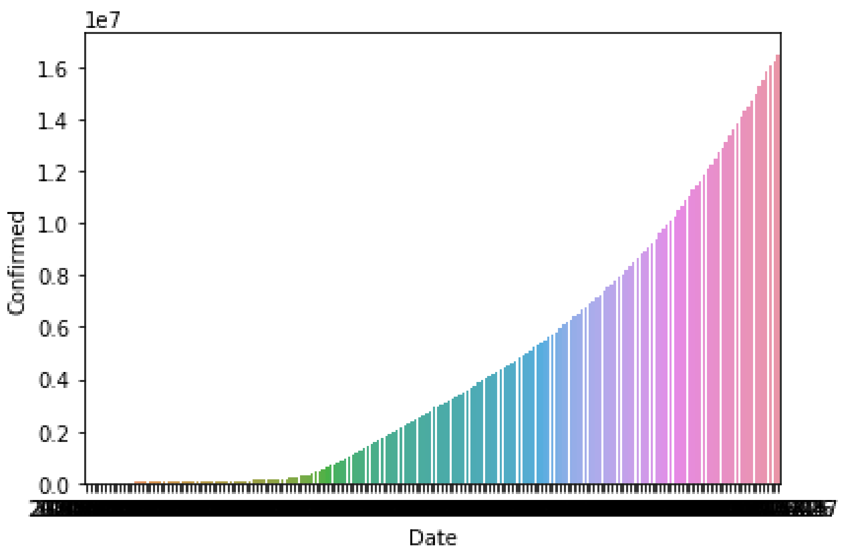

The first date was 2020/1/22. As you can see in the graph above, we found out that the viruses growth rate increased by the day. With every day having more cases than the prior day. While not showing any signs of decrease.

Then we wanted to see who the highest 10 countries with the number of cases were.

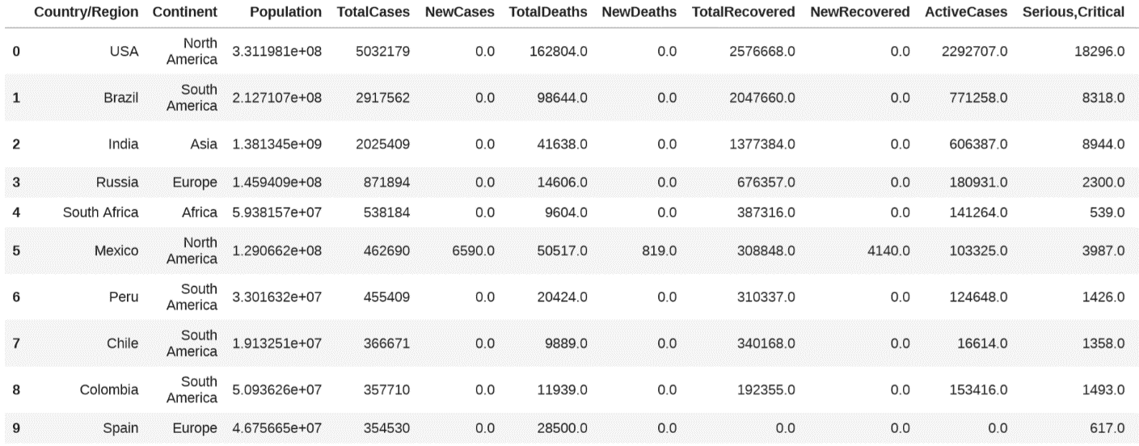

We found out that the united states of America had the most amount of cases even though some countries had more population like India which had more than 1 billion difference in population, while having less than half of the cases. This might be because the USA has a greater number of tourists, another factor might be because that the wearing of masks in the USA became a political matter with the republicans believing that the virus is a hoax. Another important piece of information that we found was that countries like Peru and Chile had more cases than a lot of countries even though they have a small number of citizens, this might be because of the financial state of the country and the people, which means most people don’t have health care, and they still had to go to work so that they don’t suffer during the pandemic.

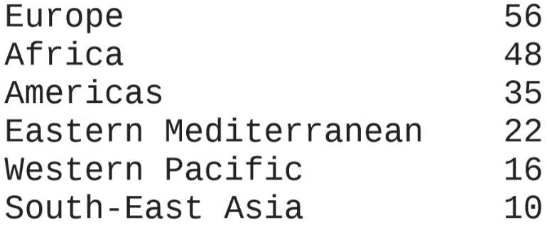
Let’s now look at the how many countries are in different regions.

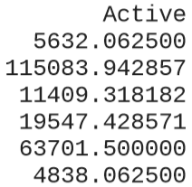
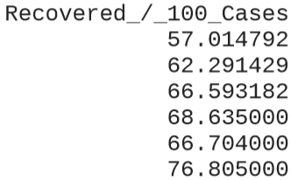
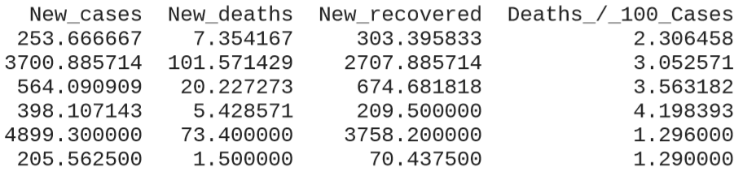
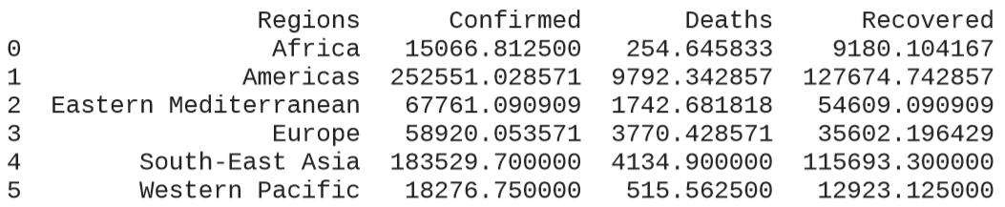
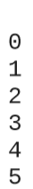
After that we wanted to know differences in cases between all the regions.
What caught our attention at first was that Africa had the lowest amount of confirmed cases of Covid-19 but they had the highest percentage of active cases to confirmed, we found out that this was mostly because the virus took longer to reach Africa compared to other regions that have more tourist attractions like the Americas.
Another key piece of information that we found was that Europe had the highest confirmed cases to death ratio. We also found out that Europe had the worst recovered per 100 cases and the highest deaths per 100 cases.
On the other hand, Western Pacific had the best recovered per 100 cases and the lowest death per 100 cases.
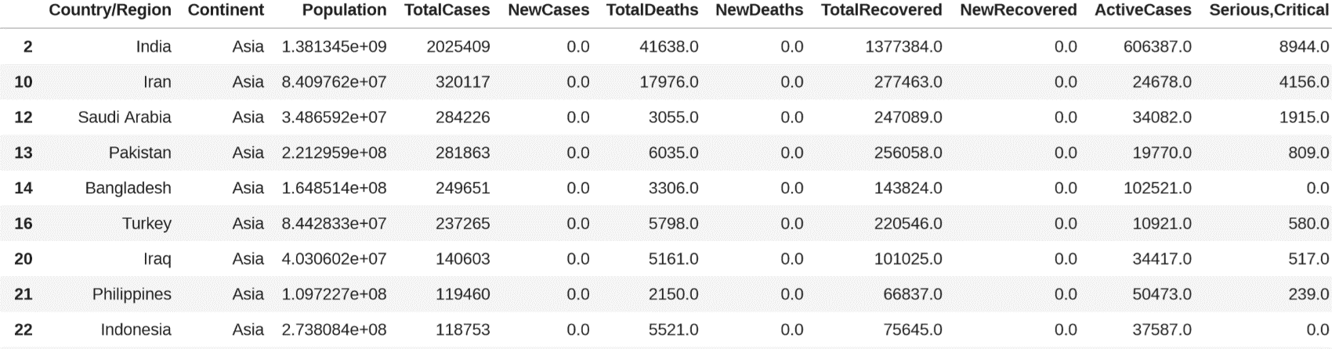
Now let us see the most cases in Asia.

we can see in the table above that India has the most cases in Asia yet the percentage of total deaths to total cases is lower than Iran which has almost a tenth of the amount of cases that India has while having about a third of their total deaths and half the amount of serious cases.
Another piece of information is that Saudi Arabia was more prepared than both India and Iran because we can see that Saudi Arabia has four thousand (4000) cases less than Iran while having almost a sixth of Iran’s total deaths but Saudi Arabia still had more active cases than Iran.
And through the table we saw that Turkey and Bangladesh only had a one thousand (1000) cases difference, but Turkey had more than two thousand (2000) deaths, this might be because of two Reasons: the first might be because Turkey has 8 times the amount of citizens. The second is because Turkey is a popular tourist attraction. We can also see that they had eight thousand (8000) more recoveries than Bangladesh. And the that might be because Turkey is more developed than Bangladesh.
we also found out that the Philippines had the lowest percentage of total deaths to total cases while Indonesia had the highest percentage of total recovered to total cases.
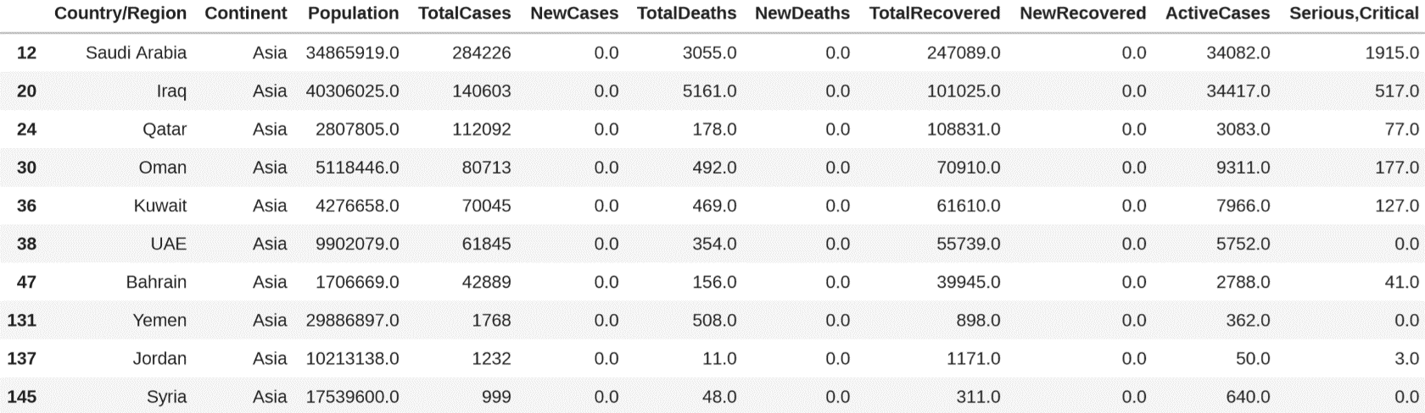
After that we wanted to see some neighboring countries.

First we wanted to look at Saudi Arabia and Iraq, we can see above that Iraq has more citizens but they have less cases, yet even though they have less cases than Saudi Arabia they still have more deaths caused by the virus, we think that the main reason for this is that Iraq has been in a war for more than twenty years which caused the Iraqi economy to crash, and that lead to a lot of people not having health care while still having to go to work during the pandemic. On the other hand, Saudi Arabia has a good economy and a great government that gave all citizens free Covid-19 tests and treatments and now they are giving their people free Covid-19 vaccines.
We can also see that Qatar has a lot of cases, but they have 1 death per 1000 cases and that is considered the best in the world.
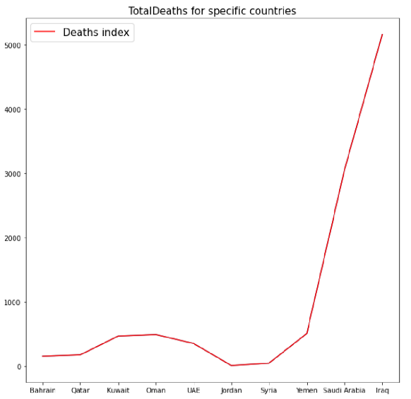
We can see that Yemen has a small number of cases, but they have a high number of deaths, with a third of Covid-19 cases ending in death. The leading factor in this might be the war in Yemen that has started by the Houthi terrorist group they destroy hospitals and steal money and supplies from people, leading to people not being able to get the treatment they need and causing them to flee the country.
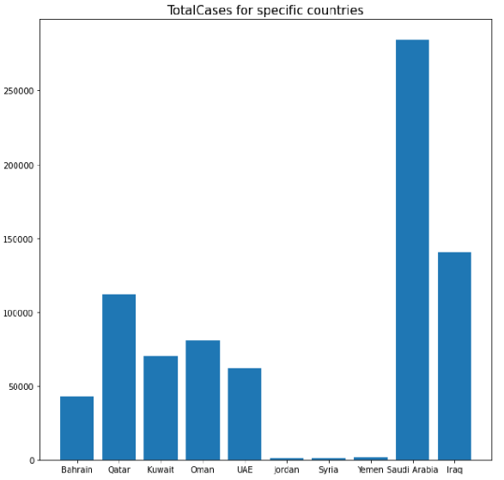
We found out that Bahrain which has less than 8 times the number of citizens of the UAE. But they only have less than 1 third of UAE’s total cases.

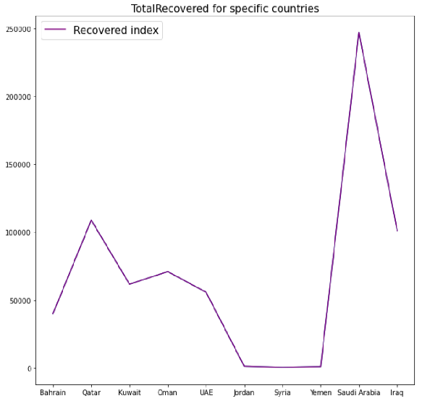
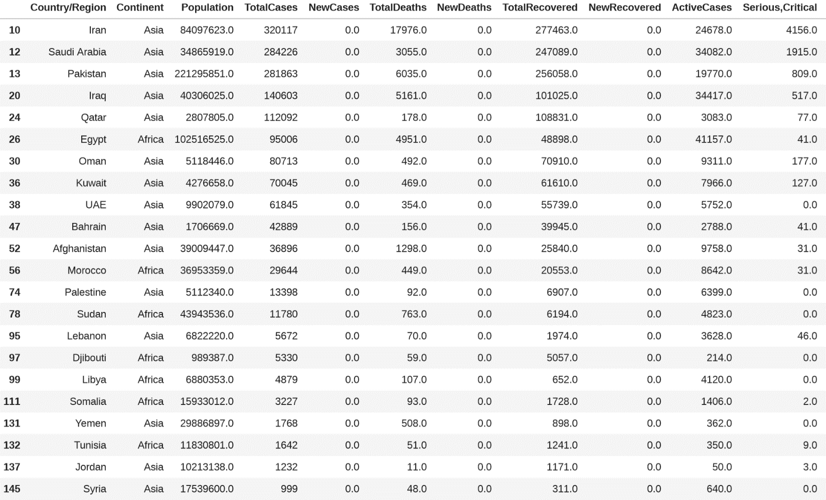
after that, we wanted to look at the total amount of data in the Middle East.
After calculating the sum of total Middle East population, it came out to be 732007690 which is 10.65% of the Global population.
Next was the total amount of cases and it was 1605866.
Then we wanted to know the total number of deaths and recovered cases and we found out that the total number of deaths was 42376 which is about 2.6% of the total cases. And the total number of recovered cases were 1340094 which was about 83.44% of the total cases.
After that let us look at the total number of active cases and serious cases and we found out that the total number of active cases was 223396 which is about 13.91% of the total cases. And the total number of serious cases were 7982 which was about 0.49% of the total cases.
Lastly, we wanted to look at the number of Covid-19 test which came out to be 19885783.

Let’s compare Saudi Arabia to the Middle East.
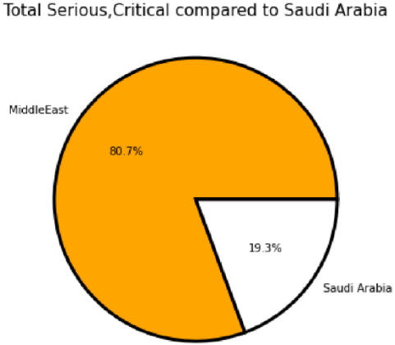
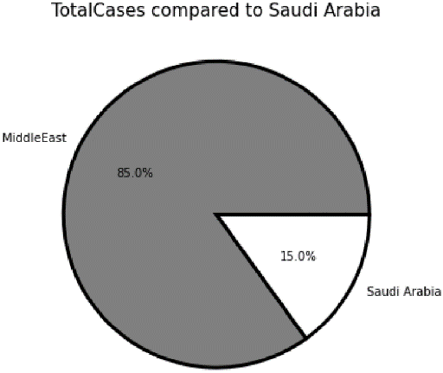
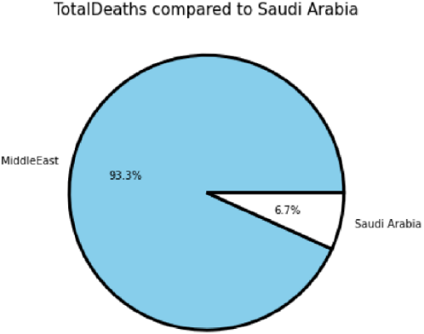
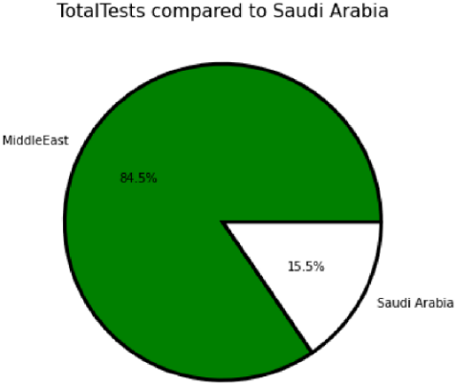
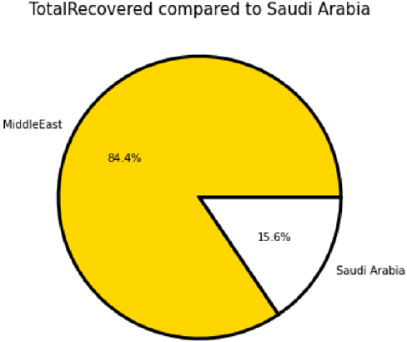
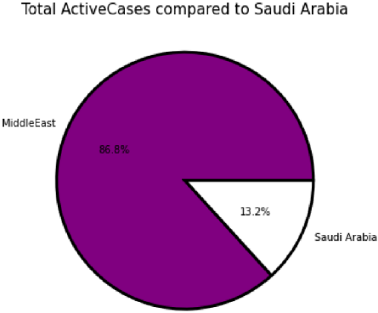
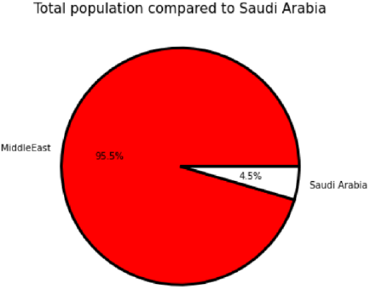

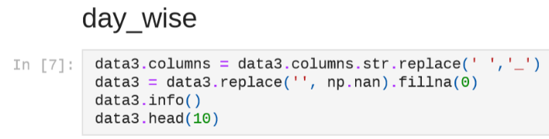
Pictures of the code we used and their results.

