Poc_7_sonarqube_integration  
<https://www.coachdevops.com/2024/02/how-to-integrate-sonarqube-with-github.html>

on:

push:

branches:

- main

workflow_dispatch:

jobs:

build:

runs-on: ubuntu-latest

steps:

- name: Checkout code

uses: actions/checkout@v2

- name: Set up JDK 11

uses: actions/setup-java@v2

with:

distribution: 'adopt'

java-version: '11'

- name: SonarQube Scan

uses: sonarsource/sonarqube-scan-action@v2

with:

projectBaseDir: .

args: >

-Dsonar.organization=sonarqube-gitaction

-Dsonar.projectKey=sonarqube-gitaction_sonarqube-scan

-Dsonar.sources=.

env:

SONAR_TOKEN: ${{ secrets.SONAR_TOKEN }}

SONAR_HOST_URL: ${{ secrets.SONAR_HOST_URL }}

* Added the token and url
* 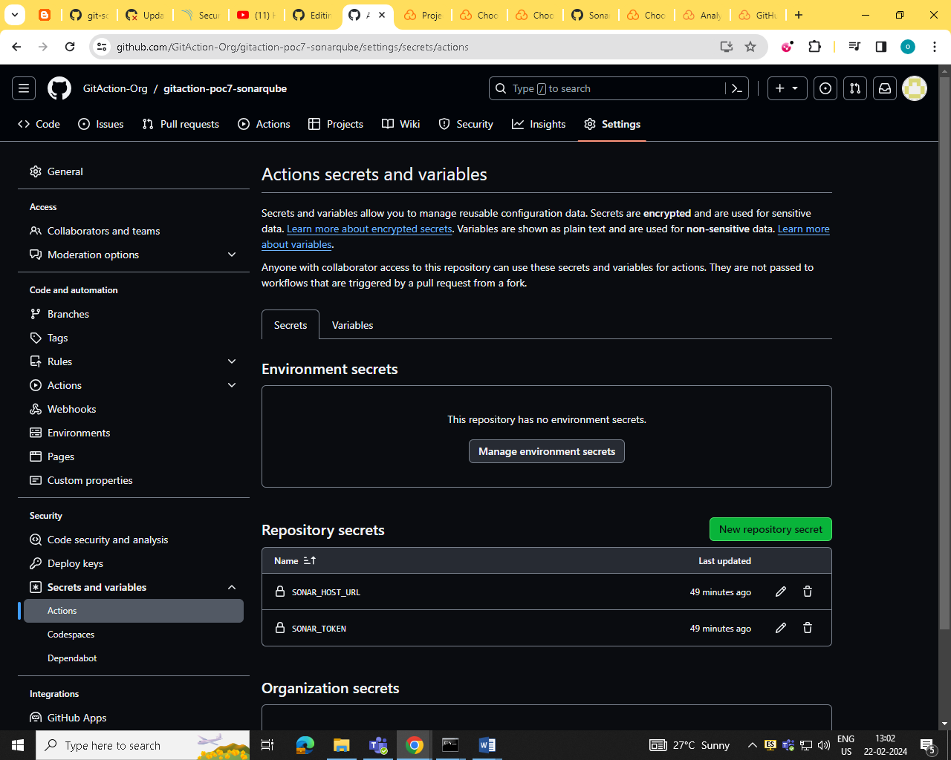  
    
  analysis the project in sonarcloud  
    
  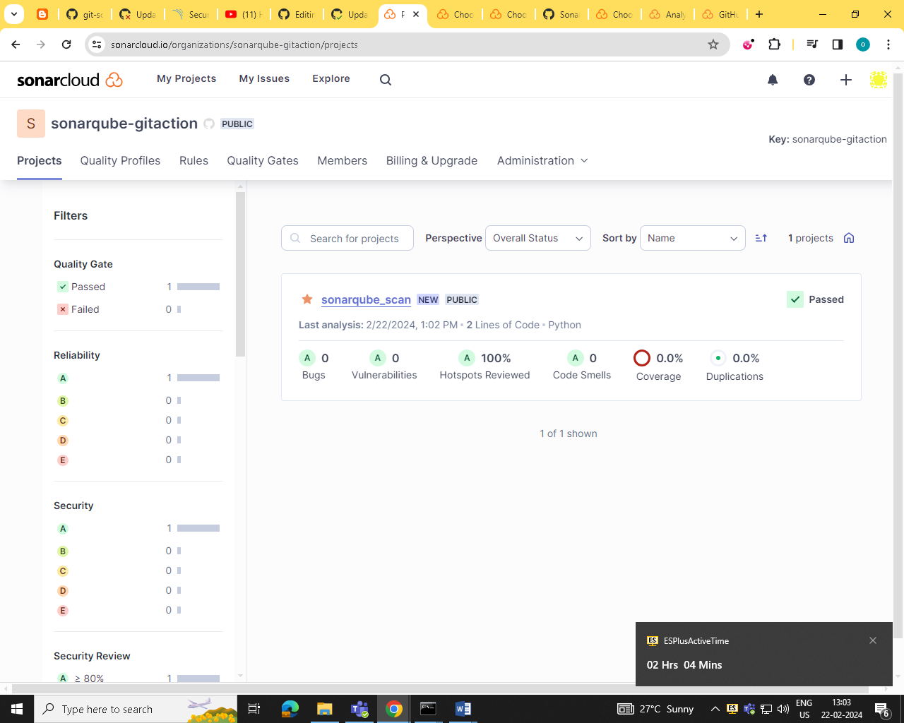  
    
  yml file  
    
  