Performance

1. Make Main-Interface and Menu as one (removed iframe)
2. Remove Session Refresh of materials
3. Singular Modules Selections
4. Export to Excel
5. Export to CSV
6. Lookup to JSON >> remove HTML sending
7. Lookup JS filtering
8. Toolbox data single binding

Allowed DLL’s  
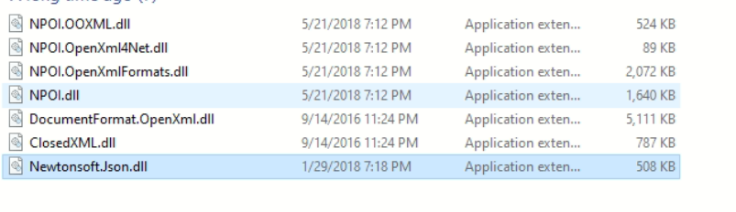

Codes to be changed / removed  
init_request();

JS  
nwInterfaceMode

if (getParameterByName("nwsec") == "p8sec") { nwSec = true; nwInterfaceMode = true; }

if (getParameterByName("a2z4i7e") == "silver")

nwInterfaceMode = true;  
  
  
dimbgNW

try

{

string strCheck = Request.QueryString["a2z4i7e"].ToString();

if (strCheck.Trim().ToLower() == "silver")

based.isInterface = true;

else based.isInterface = false;

//based

}

catch { }