**Preston Club**

**Requirement:**

* Visual Studio 2019
* SQL Server

**Default Admin Credential:**

* Username : [admin@gmail.com](mailto:admin@gmail.com)
* Password : 123456

**Screenshot:**

**Login:**



**Register:**

**Runners Details**

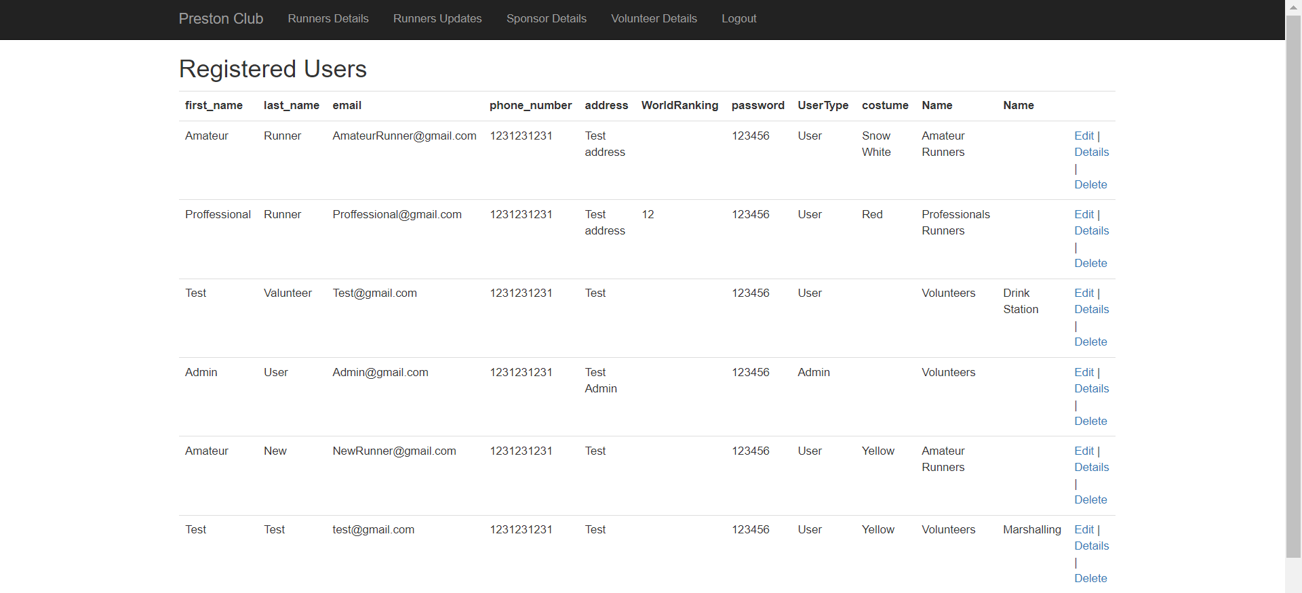

**Runners Status**

**Sponsor List**

**Volunteer List**

**Sponsorship Form**

